Statement of Originality

I certify that this paper titled
Virtual Reality reduce the pollution in Taman Menteng Park in Jakarta
has not previously been submitted for a publication or seminar except as fully acknowledged within the text.
I also certify that the paper is an original work of myself / joint publication of International Symposium on cultural heritage*. The research was funded by Akkapurlaura, Tommy Hari Prihatanto, Wegig Murwonugroho**
I also declare that, to the best of my knowledge, this paper does not infringe upon anyone’s copyright nor violate any proprietary rights. Any ideas, techniques, quotations, information, or any other material from the literature or work of other people included in the paper, published or otherwise, are fully acknowledged in accordance with the standard referencing practices. Any help that I have received in the research and the preparation of the paper itself has been acknowledged.

Signature:
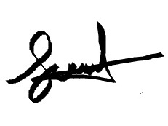
Akkapurlaura
Date:
24 Setember 2022
*select one
** Please acknowledge if the research is a collaboration or funded by second/third party

