AESTHETIC SYMBOL OF KAWUNG MOTIF AS AN ICON OF IDENTITY IMAGE OF NEW AIRPORT IN YOGYAKARTA

RC. Permatasari
Interior Design Department, Faculty of Design and Creative Arts, Mercu Buana University,
Jl Meruya Selatan no 1, Kec. Kembangan Jakarta 11650
e-mail correspondence: Chandrarezky@mercubuana.ac.id

ABSTRACT
The existence of the airport as a gateway to national tourism whereas a public space must be able
to convey a sense of place and provide individual experiences to space users, therefore the airport must also be able to function as a means that represents the identity of the cultural image of the local area. Aesthetic Elements The symbol of the kawung motif through visual language in airport public spaces does not only function aesthetically but has a deep new meaning as an icon of the identity of the image of the New Airport in Yogyakarta. The purpose of this study is to identify the transformation of the shape of the kawung motif and its application to the interior building elements of New Yogyakarta International Airport (NYIA) The transformation of the shape of the kawung motif symbol contains physiological and cosmological values in an architectural interior work and is a unity of form that cannot be separated and always follows the development of the times related to the modernity process of socio-cultural transformation that occurs in society. This research was conducted using a qualitative method with a culture studies approach and the ATUMICS transforming tradition theory was used to examine how the application of the kawung motif symbol was applied to the design of the Architecture and Interior of the New Airport in Yogyakarta. The results showed that the transformation of the kawung motif symbol form that was applied to produce an icon of the identity of the cultural image of the past was able to transform new in the present without changing the essence of meaning as a symbol of immanence, its presence not only produced an expression of beauty, but communicated messages containing the cultural acculturation of the locality of the Javanese cultural community and the form of cultural symbols of the present Yogyakarta palace to interact with each other in the public space of the new airport in Yogyakarta

Key Words : Kawung Motifs, Aesthetic Symbols, icons, identity images, Airport Public Spaces

A. INTRODUCTION
The airport is an air transportation facility that connects one region to another, both between provinces and internationaly. As a gateway for domestic and international tourists, the airport also functions as a means to represent the identity of the local cultural image. Therefore, applying aesthetic elements that carry local wisdom is a potential identity for the cultural image of the airport. For this reason, identity is needed to give a strong impression of the architectural and interior characters. (Purnomo, 2020) .The identity in concern is the identity produced at YIA Kulon Progo Airport by the aesthetic elements of local wisdom. Additionally, identity is a part of an image (Nooradin, 2012). Likewise, the new airport in Kulon Progo Yogyakarta, namely Yogyakarta International Airport (NYIA), has an image identity formed by aesthetic elements of local wisdom. According to Transportation Minister Budi Karya Sumadi (developer, 2017) .The design of the New Yogyakarta International Airport (YIA) accommodates the Javanese cultural values prevalent in the city of Yogyakarta. One of them is the application of the kawung motif symbol to the building and interior of NYIA Airport.
Batik artworks are very popular to foreign countries and are assets of the nation's cultural heritage that must be preserved. International recognition by UNESCO since 2009 so as to spur the Indonesian people to always interpret preserving cultural heritage as an icon of identity of the cultural image of the Indonesian nation. So it can be said that now batik has become an identity of the nation.
The Kawung Batik motif itself is an ancient traditional batik motif in which it is full of symbolic meanings. The Kawung motif itself is inhabited by palm trees or palms whose fruits are round oblong in clear white or called kolang kaling. When reviewed according to the description of palm fruit or kolang kaling, the kawung motif is full of symbolic meanings, namely :
1). The symbol of the economic system in rural areas is based on mutual aid, harmony and welfare in rural areas. Judging from the pattern of four oblong motifs with a center in the middle symbolizes five villages that are close to each other in five days alternating selling agricultural products on the day of the Market. In addition, people in inland areas far from the palace know the Kawung pattern..
2). The system of government in which the Ceplok pattern is one of the variations in Kawung has to do with the beliefs held by the Javanese in the pre-Hindu era, namely kejawen. In the kawung or Ceplok pattern, it is reflected that the ruler or king is the center of power in the world. Which is considered the incarnation of a god. The center of power is surrounded by four spherical shapes surrounding the center, which is the source of the energy of the universe. That is, the East is connected with the rising of the sun as the source of life. West of the direction of sunset, the source of energy causes life to decline. The south is connected with Zenith or the top of everything. The north is the direction of death of the source of life.
3) Good human symbolization, Kawung motifs are inspired by palm trees or palms whose fruits are round oblong kolang kaling which is very beneficial for human life. So that the Kawung motif has a deep symbolic meaning so that sipemakai becomes a superior human being in his life is expected to be useful and useful for many people..
4). Symbolization of the value of wisdom where geometric patterns contained the philosophy of wisdom and governance at that time. The Kawung motif is a symbolization of the concept of Panca-Pat which always symbolizes the sum of 4 (four) equal shapes and one center. (Parmono, 2013)

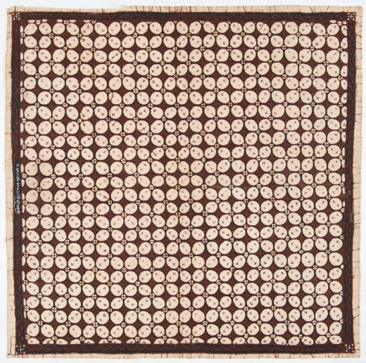

Figure 1. Kawung Symbols

(source https://id.wikipedia.org/wiki/Batik_Kawung)

Batik in its development undergoes a process of changing shape following the development of the era, both in terms of changes in the media material, shape and technically making it. In fact, the development of the use of batik motifs is part of the aesthetic element in the scope of Architecture and Interior Design, especially in public spaces. According to Sachari

( 2002) in the understanding of design review, aesthetic value is understood as an integral part of a functional object form. In the observation of cultural transformation, the aesthetic value of a design work will be assessed as meaningful if it is a sign of a cultural dialogue process or a process of cultural synthesis.

According to Setyaningrum in Laksitarini (2021), the use of batik motifs in architectural and interior buildings with a modern concept can be said to be a form of returning the values contained in local culture. This refers to the assumption that local culture can be eroded by the rapid currents of globalization so that it can become a threat to the balance of existence and result in loss of identity.

Yogyakarta's residents are part of the Javanese society, which has deep ties to the Keraton culture. According to Herusatoto in sachari ( 2002), Javanese aesthetics possesses a wealth of philosophical values of Javanese culture, particularly those related to aesthetic expressions that have the main characteristics of being (a) Contemplative-transcendental, notably where Javanese society in expressing a sense of beauty always associates with the most profound contemplation of the Almighty, devotion to the king, love for the State, appreciation of nature, and the embodiment of the mystical world. Revealing something always means glorifying it in a manner determined by religion, cultures, places, methods, resources, and norms. b) Symbolic in character, in that every act of expression by the Javanese community bears a symbolic meaning. As in real life, the puppet figures are symbolic representations of life. (c) Philosophical, in which the Javanese base each of their activities on an attitude that is expressed philosophically. This also influences Java's aesthetic idea, which is usually philosophical in nature.

Aesthetic elements in architectural interior works are an inseparable whole that always follows the development of the times in relation to the socio-cultural change of society. The aesthetics of architectural interior design are based on explicable features and design concepts. Aesthetics is a blend of philosophy and science. Aesthetics is derived from the Greek aishetikos or aishtanomai, which means observing with the senses (Cayne, 1987). .Aesthetics, according to jelantik, is a field of study that examines everything linked to beauty, i.e., all aspects of what is known as beautiful (Djelantik, 1999). In such a case, the artist's or designer's biography becomes crucial.

The background of this research is the airport's function as a gateway for national tourism; yet, a public space must be able to express a sense of place and provide unique experiences to space users; hence, the airport must also be able to serve as a representation of the local cultural identity. In addition, it was discovered that the aesthetic symbol of locality is closely related to functional and decorative aesthetic elements, which contain physiological and cosmological values, so that they can synergize in an interior architectural work so that it becomes a unified form that cannot be separated and always follows the times associated with the transformation process. Susanne K. Langer, in her book Philosophy in a New Key (2009), defines an aesthetic symbol as a total creation with its own meaning and message to be received, rather than a structure or building. However, there are values to be transmitted in the message. (Langer, 2009). Therefore, aesthetic works are always hidden by the artist's or designer's subjectivity as a determining factor.

This research was conducted using a qualitative method with a culture studies approach and the theory of transforming tradition ATUMICS is used to examine how the application of the kawung motif symbol is applied to the design of the Architecture and Interior of the New Airport in Yogyakarta as a public space.

B. METHOD

This study uses an exploratory qualitative descriptive method both from primary data obtained from the field and secondary data obtained from literature studies and data from resource persons planning experts involved in the planning of YIA Airport. The Moleong method consists of three stages, the data collection stage, the data research stage, and the data analysis stage. (Moleong).

At the primary data collection stage, it is done by observing and studying the existence and application of architectural aesthetic elements that are related to and contain local wisdom content. Field observations covering architectural forms and other aesthetic elements show the cultural identity of local wisdom of the Kawung motif and their application at NYIA airport

In addition, data was also obtained through interviews with planning consultant speakers. And secondary data obtained from the results of literature studies in the form of books, journals, scientific proceedings, professional seminars on YIA airport and previous research related to theories and data about YIA airport. The presentation of the results of the analysis in this study uses formal and informal methods. The informal method is presented in sentences and paragraphs, while the formal method uses tables (Creswell, 2011).

This research focused on identifying the application of aesthetic elements of kawung motifs as elements of local wisdom that make the identity of the iconic image of NYIA Airport. The kawung motif symbol is aesthetically reviewed in shape and interpreted with the approach of culture studies theory and ATUMICS transforming tradition theory is used to examine how the application of kawung motif symbols is applied to the design of architecture and interiors of the New Airport in Yogyakarta.

According to Adhi Nugraha in Mira Zulia (2014) the Transforming Tradition theory was developed in an effort to maintain traditions. As a parameter in a transforming form is the ATUMICS method, Transforming tradition. The Autimic Method stands for Artifact, Technique-Utility-Material-Icon-Concept-Shape (Nugraha, 2012). The main principle of the ATUMICS method is about the combination, integration or mixture of unsusr-elements of tradition with modernity.

- RESULT AND DISCUSSION
Yogyakarta's tourism may benefit from the presence of Kulon Progo's YIA Airport. Considering the airport serves as a gateway to national tourism, it is essential that it can transmit a sense of location and provide travelers a range of unique experiences. The image is not far from the use, but more spiritual level, and the image refers to the cultural level, while the guna points more at the skill/ability aspect. (Mangunwijaya, 2009) . In this context, it shows that the beauty of architectural works shows elements of the image that radiates from the cultural level of human works with elements of truth and functions, where the image is formed from elements of nature, culture, material, technology that surrounds it and has an identity character.

NYIA Basic Philosophy of NYIA Airport Design Concept
According to Benjamin at a professional webinar (Nugroho., 2021), YIA Airport Design Concept Philosophy contains four fundamental needs for Passenger Experience, namely:
1). Hassle-free, No barriers in any aspect or psychological or physical condition
2). Eco-friendly, looking for a natural and harmonious way for humans and other organisms
3). Act Smile, A code of ethics to maximize customer satisfaction by serving them through a positive attitude.
4) Lively, Service provider attitude and emotional benefit to passengers
These four fundamental requirements must be accomplished for YIA Airport to become something new and entertaining, as well as an active "healing-port" that serves as a balancer for all aspects.
These four requirements serve as the foundation for the development of the YIA airport concept, which represents one of its aesthetic elements, namely the unique charm of batik in the actualization of airport design that reflects the traditional hospitality of Javanese cultural local identity packaged in the modern luxury of YIA Airport Architecture.
According to Mangunwijaya (2009) if we use architecture, which means language with space and gatra, lines and planes, materials, and the atmosphere of the place, it is only natural for us to have a cultural architecture with the conscience and responsibility of using an excellent architectural language. The context shows the role and responsibility of an architect or designer in producing balanced works, in harmony with elevating the socio-cultural elements of the local environment so that it has a character that shows local identity or cultural identity in an architectural and design work. According to Mangunwijaya in Yamanto (2003), architectural forms are mentioned as cosmological symbols. In contrast, architectural forms embody inspired symbols based on the depth of the soul that has a sensitivity to cosmological dimensions. Cosmology is the appreciation of the cosmic and mystical or religion. In the primary stage of human thought and appreciation, cosmic appreciation is not just something aesthetic (an assessment seen as beautiful in terms of enjoyment).
It was revealed that the main framework of the master plan was taken from the symbol of Gunungan. The philosophical meaning of Gunungan is the earth or the world for every living thing in it. Gunungan is the primary framework (backbone) in preparing the Jogjakarta International Airport scenario, where life at the airport is the world itself as a new civilization by building something new (Renaissance). (Angkringan, 2020) .
The airport concept is presented in an imagined speech situation at YIA Airport that represents the everyday life of the Javanese. In a philosophical dimension, the idea of a North-South imaginary line characterizes the Keraton Yogyakarta as a replica of the cosmos with centrifugal force in its surroundings, including people as micro-cosmos. The shape of the Keraton Yogyakarta planology building incorporates symbols of human existence that represent human ties with God and the cosmos. In addition to elements of horizontal human connections with one another. This is shown by the existence of structures that give metaphysical and anthropological philosophical knowledge.
The form of the Keraton is derived from a Hindu-Javanese concept of life. The Hindu-Javanese thinking regards human existence as inextricably linked to the universe's cosmology (Wardani, 2009). Harmony may be created between the kingdom and the cosmos by organizing the kingdom in miniature universe form, as detailed below :
The layout of the Keraton Ngayogyakarta Hadiningrat is based on macro and microcosmological concepts, including both geographical and temporal dimensions: outer and inner, as well as beginning and end. The Keraton region, which spans more than 5 kilometers, is a cosmological unit of AUM (Agni/Mount Merapi, Udaka/South Sea, and Maruta/Free or pure air), raised as a manifestation of human dignity by the favor of God Almighty. Godlike, honoured as Khalifatullah (leader). This is the characteristic of Mother Earth. All of Angkasaa's fathers, Surya, Candra, and Kartika, are vital components of Hamengku Buwana's name and designation. The pattern of the formation of the city of Yogyakarta is essentially an implementation of Prince Mangkubumi's concept from 1755, which is based on the form of the human body. The city of Yogyakarta is divided into two regions, with the southern region representing spiritual symbols and the northern region representing material symbols (Khairuddin, 1995).
This is implemented into a spatial zone pattern at YIA Airport, representing the three main elements forming the imaginary axis of Yogyakarta in the passenger terminal building (Mount Merapi, Yogyakarta Palace, and the South Sea). Meanwhile, the south side of the Terminal area is likened to the life of the city of Yogyakarta. And the connecting corridor is symbolized by the city of Malioboro. The philosophy is that an imaginary centrifugal line connects humans with God and the universe.

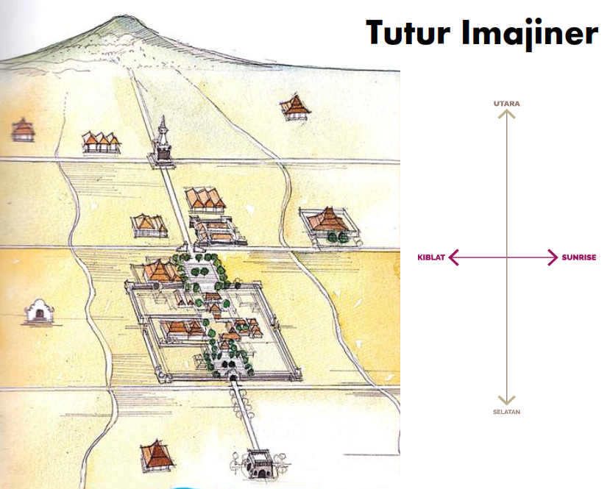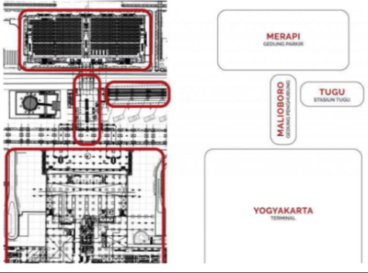
Figure 2. Imaginary Speech of the YIA Airport design concept.
(Source : https://www.artcab.id/portfolio/yia-airport/ May 9th, 2022)

Kawung theme attractive features on skylights, walls, and floors
Symbol Forms – A symbol of the unique charm of kawung batik on an airport roof that produces an atmosphere in the context of space that is felt as a cosmological symbol. Meanwhile, from the air, the kawung symbol makes the image of local identity visible to airplane passengers, who see it as a symbol of the existence of the YIA airport area. Kawung Batik has a high philosophical value resulting from creativity, creativity, taste, and intention as a reflection of the reality of life. The pattern of the four directions tangent to each other is centered on the core (divinity) as the center for controlling lust in humans so that there is a balance in thinking (spiritual) and acting (rational) (Angkringan, 2020)

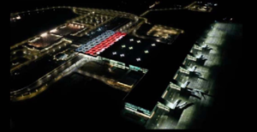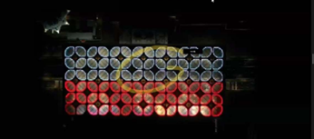
Figure 3 :The Kawung motif as a sign of identification for the Gate of the Face of Indonesia
(Source : Webinar HTII)

The shape of the Kawung motif symbol on the roof of the building provides a function of marking its existence; the airport's position as seen from the sky when the plane is about to land. The material and technology elements applied to the roof form the Kawung motif to produce ambiance and atmosphere in the space within the airport. The existence of the Kawung motif in the airport terminal concept has the meaning of a symbol of the spirit communicating with God. At the same time, the supporting building can be analogized as an accomplice.

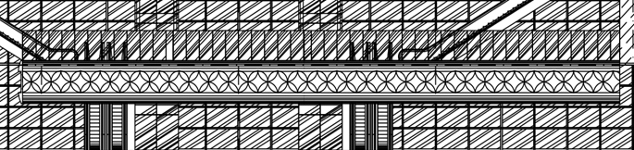
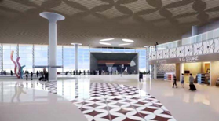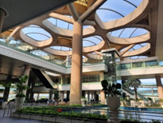
Figure 4 Implementation of the kawung motif on walls, floors, and ceilings
( Source : Viramakarya 2021 dan Personal 2022)
According to Dr. Wiendu Nuryanti in Ave (2007), it is said that the use of batik as an aesthetic element of the interior can make a major contribution in creating a local identity of each different tourist destination. This is closely related to the existence of the airport as a gateway for domestic and international tourists. At NYIA Airport itself in Kulonprogo as an effort to adapt to modern architectural buildings, the kawung batik motif symbol that was applied underwent changes both from the elements of shape, color and material technology used In maintaining the tradition of culture in an effort to visualize local identity into the public sphere, it can be done by developing and transforming forms and related concepts in them.
Transforming forms, forms and materials is an effort to make adjustments that can be made so that cultures continue to live in the era of globalization as it is today. (Nugraha, 2012) The ATUMICS method is a method used as a parameter for a form of transformation seen from aspects as artefact, technical aspects, utility, material, Icon, concept, shape. Through the ATUMICS variable from transforming tradition theory, it is identified regarding the Kawung motif symbol and its application to NYIA airport as follows: :
Tabel 1 . Tabel ATUMICS Simbol Motif Kaung Pada Bandara NYIA
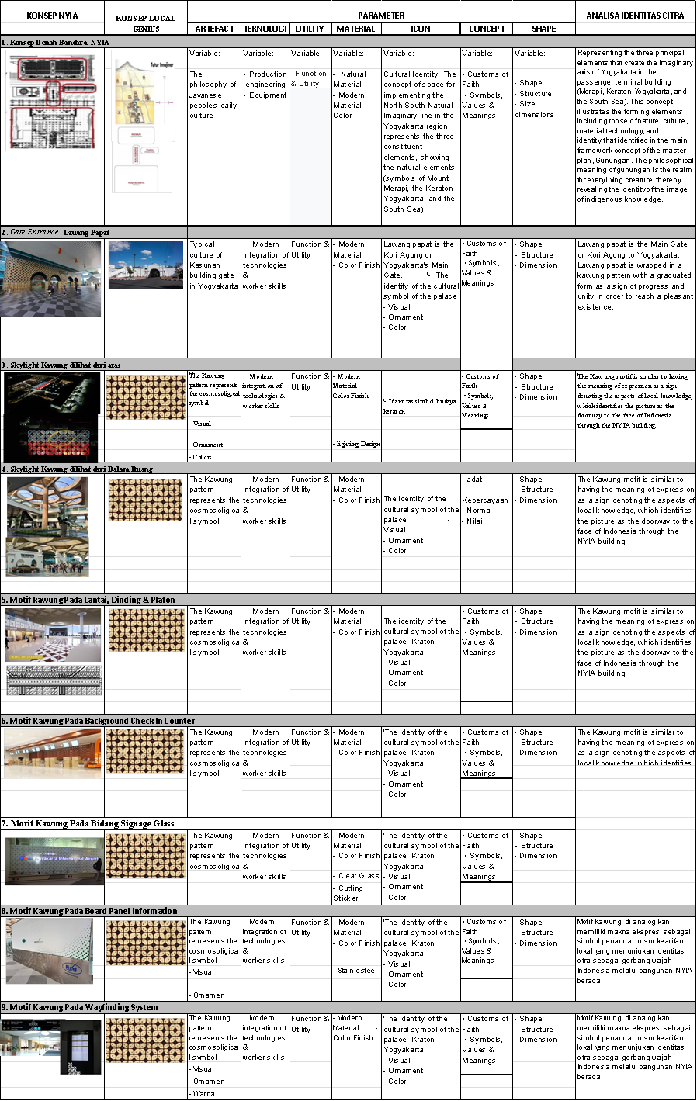

- CONCLUSION

From the research it can be concluded that as follows

From the results and discussion, we can see that

1) The airport is one of the media that can display the local wisdom values ​​of an area or region, and

2) That local wisdom is formed from the ideologies contained in society and the values ​​of historical culture.

3) The application of aesthetic elements that contain elements of local content which is very strong, the image of its identity icon is felt in its implementation starting from the arrival of prospective passengers from the air side and from the land side. From the air side, the application of the aesthetic elements of the kawung motif is implemented containing material elements, high technology, cultural elements and the natural environment of Javanese culture as a symbol of the identity of the iconic image of the existence of a city.

4) The application of the Kawung Motif at NYIA Airport is identified in the aesthetic elements attached to the floor, wall and ceiling buildings, both functional and decorative.

5) The application of the Kawung motif is also identified in the Wayfinding System element

6) Identity of Local Wisdom at NYIA airport can already be identified from above the presence of the kawung motif on the skylight of the airport roof as a marker of the position of NYIA Airport.

7) The message implied by the implementation of the Kawung motif at NYIA airport shows that the identity image of local wisdom is able to transform the shape of the symbol of the kawung motif that is applied to produce an identity icon of past cultural images capable of transforming into the present without changing the essence of meaning as an immanent symbol, its presence not only produces expressions beauty, but communicating messages that contain local cultural acculturation of the Javanese cultural community and the manifestation of the present day cultural symbols of the Yogyakarta palace to interact with each other in the public space of the new airport in Yogyakarta.

- ACKNOWLEDGEMENT (if any)
. Thank you to those who have helped in this research, especially those from Angkasa Pura I and PT Viramakarya as resource persons.

- REFERENCE
Angkringan. (2020). 2020 © Artcab, All rights reserved. Retrieved Mei 9, 2022, from Yogyakarta International Airport: https://www.artcab.id/portfolio/yia-airport/
Ave. J., H. M. ( 2007). Grand Batik Interior. Jakarta.
Cayne, B. S. (1987). The new lexicon Webster's dictionary of the English language. Lexicon Pub.
Creswell, J. W.-C. (2011). Choosing a mixed methods design. Designing and conducting mixed methods research. (2, Ed.)
developer. (2017, oktober 10). upperline, https://upperline.id/profile/developer. Retrieved Mei 10, 2022, from https://upperline.id/post/.
Djelantik, A. A. ( 1999). Estetika: Sebuah pengantar.[Aesthetics: An introduction]. Bandung, Indonesia: MSPI.
Khairuddin, H. (1995). Filsafat Kota Yogyakarta. . Liberty.
Laksitarini, N. &. (2021, April). PENERAPAN RAGAM HIAS BATIK PECAH KOPI PADA INTERIOR HOTEL BERKONSEP MODERN SEBAGAI REPRESENTASI IDENTITAS BUDAYA LOKAL JAWA BARAT. . In SENADA (Seminar Nasional Manajemen, Desain Dan Aplikasi Bisnis Teknologi), 4, 210-215.
Langer, S. K. (2009). Philosophy in a new key: A study in the symbolism of reason, rite, and art. Harvard University Press.
Mangunwijaya, Y. B. (2009). Wastu citra: pengantar ke ilmu budaya bentuk arsitektur, sendi-sendi filsafatnya, beserta contoh-contoh praktis. PT Gramedia Pustaka Utama.
Moleong, L. J. (n.d.). Metodologi Penelitian Kualitatif. Bandung: Remadja.
Nooradin, H. (2012). Architectural Identity in Era of Change. 2(10), 81-96.
Nugraha, A. (2012). Transforming Tradition: A Method for Maintaining Tradition in a Craft Design Contex. Aalto University Publication Series, doctoral dissertations, Helsinki .
Nugroho., B. A. (2021, Desember 25). Desain Interior Bandara dengan pendekatan Teknologi dan Budaya, Bedah Karya Yogyakarta International Airport. HDII Webinar . Jakarta.
Parmono, K. (2013). Nilai kearifan lokal dalam batik tradisional Kawung. Jurnal Filsafat, 23(2), 134-146.
Purnomo, A. D. (2020). Penerapan Elemen Estetik Sebagai Identitas Budaya Lokal Pada Elemen Interior Terminal Penumpang B IJB Kertajati. 6(1), 19-24.
Sachari, A. ( 2002). Estetika: makna, simbol dan daya. . Bandung : Penerbit ITB.
Suriastuti, M. Z. (2014). Kajian Penerapan Konsep Kearifan Lokal Pada Perancangan Arsitektur Balaikota Bandung. Jurnal Rekarupa, 2(2).
Wardani, L. K. (2009). Planologi Keraton Yogyakarta.
Yamanto, H. (2003). TEKTONIKA DALAM SEMIOTIK ARSITEKTUR Studi Karya YB Mangunwijaya (Doctoral dissertation, Program Pendidikan Pasca sarjana Universitas Diponegoro).

