ANALYZING THE QUALITY OF PHOTOS USING THE MACRO-PHOTOGRAPHY TECHNIQUE WITH CYLINDRICAL GLASS
Vidi Putra Hagiansyah¹,
Silviana Amanda A Tahalea²
Erlina Novianti³
Faculty of Art & Design
Universitas Trisakti
silviana@trisakti.ac.id²
ABSTRACT
Photography has grown rapidly. Currently, photography enthusiasts have penetrated various circles of society. One of the streams in photography is nature photography. This kind of photography has respective approaches. One of them is applying macro photography, in which the object of the photo is a small animal or plant, such as an insect. Macro photography requires special equipment, namely macro lenses that are used by professional photographers. However, the equipment is quite expensive which becomes a barrier for novice photographers. This study aims to use an alternative technique by utilizing cylindrical glass to produce macro photos with the same detail and sharpness as those generated from a macro lens. In this study, the researchers employed an experimental method, in which the research objects were macro photos using cylindrical glass. In this study, the researchers conducted photo shoot experiments with cylindrical glass on plant objects. Results indicated that the cylindrical glass produces photo sharpness that can rival that of a macro lens quite accurately.

Keywords: alternative technique, cylinder, macro photography, nature photography.
- INTRODUCTION
In line with the development of the times, photography has grown rapidly over the years. Currently, photography has spread to all corners of the world and penetrated various circles of enthusiasts. Photography is a medium easier to use. In addition, it has documentation value, making it easier to remember than writing. Furthermore, it can record something that cannot be repeated. Technological advances have had a huge influence on the world of photography, in which photographic equipment has developed in the aspect of cameras and the art of photo editing. Currently, photography enthusiasts are not only professional photographers but also hobbyists.
Photography is one of the best forms of nonverbal communication to overcome existing problems. Photos can expand what ones see and think. Additionally, they may make people amazed, entertained, and even feel magic and love every time they see them (Barnbaum, 2017, pp. 1–2).
The term “media” usually refers to the materials for making art objects. Descriptive statements for the media of images are usually called photography. In general, talking about photography also includes a discussion about the type of film used, the size of the film used, the size of the work, the results in color or black and white, the characteristics of the camera used, and other technical information. It also includes how the photographer shoots, whether there is a retouching process or not, and whether the cropping is made directly on camera or through a light room (Tahalea, n.d.).
Nature photography is a genre of photography, in which its main objects are animals and plants. Furthermore, this kind of photography is usually carried out in nature or a certain place. Nature photography has several approaches to the creation of its work. One of them is macro photography, in which objects have small sizes, such as insects. This shooting technique is carried out at very close distances to get high detail but does not require the help of an optical magnifying tool, such as a microscope. However, macro photography requires special equipment, such as a 100mm macro lens, which is generally used by professional photographers.
Macro photography at this time has many enthusiasts from various circles ranging from hobbyists, nature lovers, and beginner photographers to professional photographers. There are quite a lot of macro photography enthusiasts. However, some of them are still hindered or have not undergone macro photography due to the expensive equipment available to create photo works. This problem arises because the macro lens equipment on the market is quite expensive. Although some brands have issued more affordable products, the photo quality between cheap and expensive lenses is still far.
Macro photography produces a recorded image on the camera sensor or film that has a ratio as large as the original object (1:1) or at least half of the original object (1:2) (Nugroho, 2006, p. 209).
There are alternative techniques or tools in macro photography to produce a photo that is good and not inferior in terms of results compared to the tools commonly used in macro shooting. This technique or tool is used to make it easier for photographers to produce quality macro photos. The use of this alternative tool is much more affordable in terms of price and also provides more creative power to photographers when they suddenly have to do macro shots. This alternative equipment can be used in urgent conditions.
In this study, researchers analyzed the quality of photos produced from alternative macro photography tools (i.e., cylindrical glass) to make photos that have detail and sharpness. This study was conducted to provide alternative techniques for photographers to be able to create cheaper and more efficient macro photography works. The equipment used was a camera and standard lens (a 50mm lens) added with a cylindrical magnifying glass of 25 times as an alternative tool.

- METHODS
In this study, the researchers employed an experimental approach by analyzing photos created using an alternative technique. This study was experimental, in which the researchers took macro photography shooting using a cylindrical glass and compared the results with those taken using a special macro lens. The objective of this study is to provide an alternative technique for novice photographers to produce macro photography works that have quality photo standards. According to Jaedun (2011), experimental research is generally carried out in a laboratory. However, it can also be conducted in the social realm based on the positivist paradigm which was initially widely applied to the hard sciences, such as biology and physics, and was later adopted in other fields, including social and educational sciences. Experiments are essentially observations of the causal relationship between the effect (dependent variable) and cause (independent variable) through a deliberate effort made by the researchers (Soendari, 2010).
- RESULTS AND DISCUSSION
The work of literature that becomes the main reference for research on an alternative macro photography technique is a book entitled “The Use of Reverse Lens Techniques in Macro Photography Shooting” (Indonesian: “Penggunaan Teknik Reverse Lens dalam Pemotretan Fotografi Makro”) written by R. Sulistiyo Wibowo (2016). In this book, its author describes the reverse lens technique, explains the development of this alternative reverse lens technique for being used, and elaborates on the anxiety of novice photographers in doing macro photography because they are hindered by the high price of special equipment used in macro photography. In the creation of this project, the researchers took a nature photography approach, which is considered appropriate in creating the work because the expected result is a nature photo that uses macro photography as a shooting technique. According to SP. Soedarso (2006, p. 101), the work that is produced in this type of photography is a work of art whose existence is used for other purposes, other than aesthetic expressions, such as practical needs in everyday life.
Experiment
Based on the photos taken, macro photography using cylindrical glass can produce quality photos similar to macro lenses in general. In addition, the sharpness obtained is the same as macro lenses, which are 2-5 cm closer to objects (in this case, plants). The resulting color also becomes more intense. The researchers obtained that the colors displayed with this cylindrical glass are concentrated so that the resulting colors are solid. It creates high contrast for the photos created from macro photography. Furthermore, shooting can be carried out at a very close distance of up to 2-5 cm, thereby resulting in works in which objects with small sizes look normal.
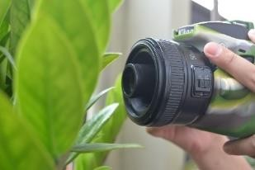
Figure 1. Macro Shooting Using Cylindrical Glass
- Technicality
In the process of creating the works in this project, the researchers used a Nikon D3300 camera and one lens (i.e., Yongnuo 50mm f/1.8). The researchers chose the Nikon D3300 camera because it is fairly light in weight and the type is a DSLR, thereby being able to replace a regular lens with a 50mm f/1.8 lens. The lens used was 50mm f/1.8 because it has a wide aperture. The depth of field used was f/1.8 which can produce a narrow focus space, thereby helping the cylindrical glass in narrowing the focus space by bringing the camera closer to the subject to get the right detail and sharpness. The wide aperture of the lens also helps in lighting. By using a glass cylinder, the light entering the lens will decrease by ½-1 stop. It facilitates the use of high ISO and low shutter speeds. The lighting used in the creation of the work is available lighting because the shooting was carried out in the morning and evening so that the lighting produced was natural and could display attractive colors when exposed to sunlight. The available light in the works came mainly from sunlight.
- Conceptuality
The researchers conducted macro photography shoots using cylinder glass to provide alternative techniques to novice photographers and hobbyists. This method only requires tools that are easier to obtain and less expensive but can create more efficient macro photography works.
- Shooting Process
The researchers did two photo shoots, namely in the morning and evening. In the first photo shoot, the researchers got photos with natural light that is quite soft but has high contrast. The sharpness produced by light with a soft character can display a broad sharpness so that all light spreads throughout the object. In the morning, the researchers used a fairly narrow diaphragm due to strong lighting. In contrast to the second photo shoot (i.e., in the afternoon), the lighting obtained is quite bright and changes the white balance on the camera so that the resulting color is different which has a slightly orange color. However, in the afternoon, the contrast produced tends to be low but the bright parts of the photo are slightly overexposed which results in reduced detail.

- Daisies
Table 1.
No. | Photos | Tools | Technical Data
1. | 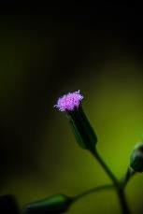 | 50mm f/1.8 Lens with Cylindrical Glass | Shutter Speed:1/320  Diafragm: F/5.0  ISO: 100  White Balance: Auto
2. | 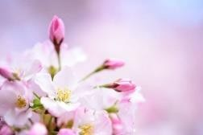 | Sigma 105mm f/2.8 EX DG OS HSM Macro Lens | Shutter Speed:1/320  Diafragm: F/4.5  ISO: 100  White Balance: Auto
This section is a description of the work taken by photographing daisies. This photo was taken on November 10, 2020, at 13:48 at Tomang Park. In this photo, the researchers displayed an attractive visual impression by presenting a small flower that looks normal or large. The object in these photos is daisies that are still growing, thereby having a size of approximately 1-2 cm.
- Shooting Distance
The photograph was taken from a distance of 3-4 cm from the object so that the details produced in this photo using the cylindrical glass technique have very good sharpness. On the flower petals and plant stems, the details can be seen clearly. When using a macro lens (i.e., Sigma 105mm f/2.8), the results obtained have a wider focal length and the shooting distance between the object and the lens is only about 2-3 cm. By employing this technique, the resulting depth of field is sharp from the main object to the back of the object.
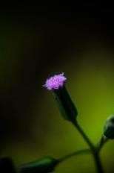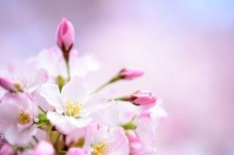
Figure 2. The Distance in Shooting the Photo of “Daisies”
- Lighting
Concerning the lighting in this photo, the researchers used available light so that natural light that is evenly distributed throughout the object will produce maximum detail. As with the Sigma 105mm f/2.8 lens, the light obtained can provide sharp details. The photograph was taken during the day to produce even lighting so that the details that appear on each part of the plant can be seen well.

Figure 3. The Lighting in Shooting “Daisies”
- Color
The color produced is dense with high contrast due to the use of cylindrical glass which has a glass layer that can alter the color of the photo to become more contrasting. Meanwhile, with the use of the Sigma 105mm f/2.8 lens, the colors that appear look more normal, making them more natural. The pink color on the object looks subtle in photos taken using a Sigma 105mm f/2.8 lens. Meanwhile, on the cylindrical lens, the resulting pink color tends to turn purple due to the concentrated color produced.
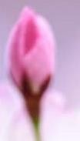
Figure 4. The Color Differences of the Photo of “Daisies”
- Vignette
In the use of cylindrical glass, the resulting vignette effect is a black circle on the right and left of the photo. However, this effect can be overcome by cropping the photo.
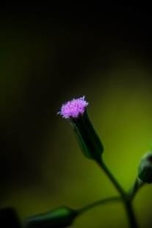
Figure 5. Vignette of the Photo of “Daisies”
- Growth
Table 2.
No. | Photos | Tools | Technical Data
1. | 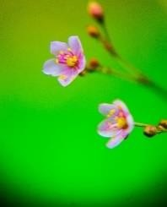 | 50mm f/1.8 Lens with Cylindrical Glass | Shutter Speed:1/200  Diafragm: F/7.1  ISO: 100  White Balance: Auto
2. | 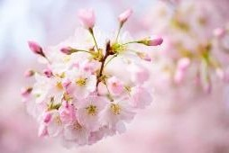 | Sigma 105mm f/2.8 EX DG OS HSM Macro Lens | Shutter Speed:1/400  Diafragm: F/4  ISO: 200  White Balance: Auto
The following is a description of the works on the photo entitled “Growth”. This photo was taken on November 10, 2020, at 13.50, at Tomang Park. This photo shows two main objects, namely small plants. However, in this photo, the two flowers are shown looking big. In fact, the objects in this photo have a size of 2 cm, in which the flowers have not fully grown so that their small size will be difficult to see with the eye.
- Shooting Distance
The sharpness of the photos can display the details of flowers well, in which the shooting distance between the lens and the object is only 3 cm so that small details on the flower can be seen well even though the flower at the bottom of the focus is slightly off the mark due to the narrow depth of field produced using a 50mm lens with f/1.8 diaphragm and coupled with a glass cylinder. In contrast, the use of the Sigma 105mm f/2.8 macro lens may produce the sharpness that already has a standard that is suitable for macro shooting, in which the distance between the lens and the object can be 1-2 cm further but still can produce sharp details. This is very good because, for macro shooting with live objects, photographers can take photos of live objects more freely.
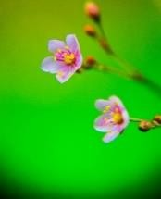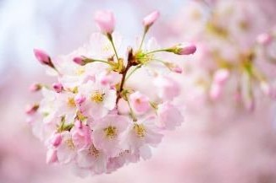
Figure 6. The Distance in Shooting the Photo of “Growth”
- Lighting
This photo shoot was carried out during the day, in which the sunlight at that time produces harsh lighting on the object so that the light provides comprehensive detail to the object. As with the Sigma 105mm f/2.8 lens, the light obtained can provide sharp details.
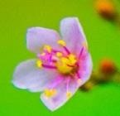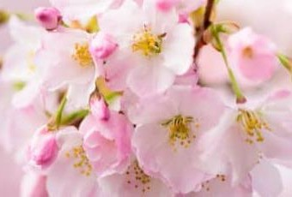
Figure 7. Light Difference in the Photo of “Growth”
- Color
The color of the resulting photo is quite dense even though editing has not been done. In addition, a black vignette appears on the right and left of the photo. It is different from the results of photos using a Sigma 105mm f/2.8 macro lens, in which this kind of thing is not found. As seen in the green section, the resulting color is dark green. Compared to the green color produced by the Sigma 105mm f/2.8 macro lens, the resulting color is more natural and does not have high color contrast. The same thing happens to the yellow part of the pistil.
- Vignette
The resulting vignette can be a drawback or an advantage, in which researchers used this effect as a supporting element that can make photos more attractive. The vignette effect in this photo is visible on the bottom side of the photo. As seen, there is a black effect that appears due to the use of cylindrical glass.
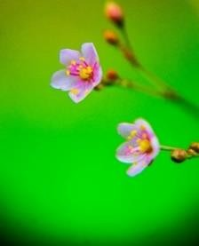
Figure 8. The Vignette of the Photo of “Growth”
- Water Drops
Table 3.
No. | Photos | Tools | Technical Data
1. | 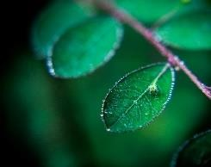 | 50mm f/1.8 Lens with Cylindrical Glass | Shutter Speed: 1/200  Diafragm: F/7.1  ISO: 100  White Balance: Auto
2. | 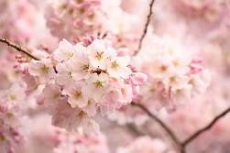 | Sigma 105mm f/2.8 EX DG OS HSM Macro Lens | Shutter Speed:1/250  Diafragm: F/5.0  ISO: 100  White Balance: Auto
The following is a description of the work on the photo entitled “Water Drops”. These photos were taken on November 25, 2020, at 09:57, at Tomang Park. This photo shows how far the depth of field can be produced by using a 50mm f/1.8 lens with cylindrical glass for an object that has a size of 2 cm.
- Shooting Distance
It can be seen that the resulting depth of field is very narrow so that the plants that are the objects of the photo are only focused on one object. The plants on the back look blurry and lack detail. In contrast to the photo produced by the macro lens, the distance from the lens can be 1-2 cm further than using a cylindrical glass which must be closer to 2-5 cm. It causes the sharp space that appears on the macro lens to be wider so that the shape of the object behind is more clearly visible and has texture. Even though it has a very narrow depth of field, this photo still produces sharp details, in which the details of the water in the plants can still be seen and become an interesting element in the photo.
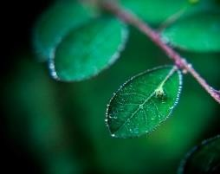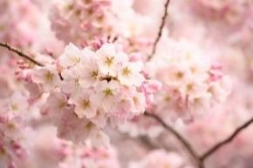
Figure 9. The Comparison of Shooting Distance
- Color
The resulting color is more intense with high contrast. When compared to the use of a macro lens, the resulting color has low contrast and is not too dense so that no color change occurs in the object of the photo.
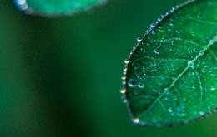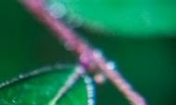
Figure 10. The Vignette of the Photo of Daisies
- Lighting
Regarding the lighting in this photo, the researchers used available light that appears from the right side of the object so that natural light is evenly distributed throughout the object to produce maximum detail. As with the Sigma 105mm f/2.8 lens, the light obtained can provide sharp details. However, on the Sigma 105mm f/2.8 lens, the results obtained have a wider exposure so that the light produced is more homogeneous. The photo shoot was carried out in the morning, featuring soft and subtle lighting but still having a wide spread of light throughout the object so that the resulting detail is sharp.
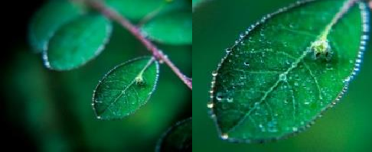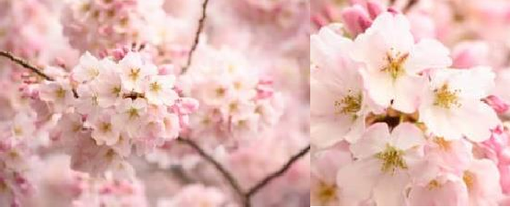
Figure 11. The Lighting in the Photo of “Water Drops”
- Vignette
In the use of cylindrical glass, the resulting vignette effect is black circles on the right and left of the photo. The vignette in this photo can be seen on the right and left sides of the photo, in which the black effect appears. At a shooting distance of 2-5 cm, the resulting vignette is quite strong.
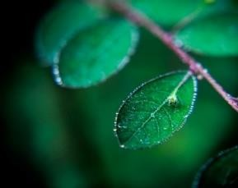
Figure 12. The Resulting Vignette Effect
- Sunday Morning
Table 4.
No. | Photos | Tools | Technical Data
1. | 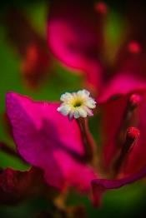 | 50mm f/1.8 Lens with Cylindrical Glass | Shutter Speed: 1/250  Diafragm: F/7.1  ISO: 100  White Balance: Auto
2. | 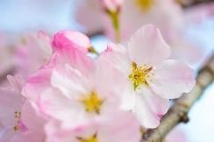 | Sigma 105mm f/2.8 EX DG OS HSM Macro Lens | Shutter Speed: 1/250  Diafragm: F/6.3  ISO: 100  White Balance: Auto
The following is a description of the works on the photo entitled “Sunday Morning”. This photo was taken on November 30, 2020, at 09.09, at Tomang Park. In this photo, the researchers displayed a visualization of the plant along with the growing stems and leaves. The object in the photo has a size of about 2-3 cm. The researchers used all parts of the plant, starting from the stems to the leaves as interesting elements in the photo.
- Shooting distance
In taking the photo, the researchers used a 50mm glass cylindrical lens using a narrow aperture of f/7.1. The distance between the lens and plant objects is 3-4 cm so that the depth of field produced in this photo is different from previous photos that used small apertures, such as f/1.8. The sharp field generated by the use of this technique becomes wider even though the results obtained using a macro lens with a smaller aperture of f/6.3 are still wider when compared to a cylindrical lens.
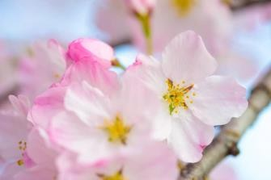
Figure 13. The Shooting Distance in the Photo of “Sunday Morning”
- Color
The resulting color is intense even though using f/7.1. As we can see, the pink and green colors in this photo are contrasting due to the use of cylindrical glass which has a layer that can affect the color quality of the photo. The pink color produced by the cylindrical glass is more intense than the pink color produced by the Sigma 105mm f/2.8 macro lens. It also affects the yellow color in the flower pistil which looks more concentrated than the yellow color produced by the Sigma 105mm f/2.8 macro lens.


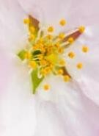
Figure 14. Color Difference
- Lighting
In this photo, the researchers used a subtle available light from the morning sun to produce soft light and high contrast in which the shadows on the object look hard. This makes the sharp detail in this photo look maximal. In contrast to macro lenses, the exposure is smoother and the resulting contrast is lower.

Figure 15. The Light Produced by the Cylindrical Glass
- Vignette
The vignette produced by the use of cylindrical glass can be seen on the side of the photo, especially the top right and left of the photo. As we can see, there are dark circles. This is influenced by the distance between the lens and the subject, in which shooting at a distance of 2-3 cm will produce a vignette that will be clearly visible.
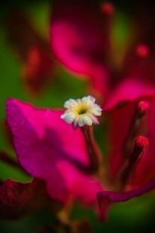
Figure 16. Vignette Produced by Cylindrical Glass
- Grain Reflection
Table 5.
No. | Photos | Tools | Technical Data
1. |  | 50mm f/1.8 Lens with Cylindrical Glass | Shutter Speed: 1/320  Diafragm: F/75.0  ISO: 100  White Balance: Auto
2. |  | Sigma 105mm f/2.8 EX DG OS HSM Macro Lens | Shutter Speed: 1/250  Diafragm: F/6.3  ISO: 160  White Balance: Auto
The following is a description of the work on the photo entitled “Grain Reflection”. This photo was taken on November 11, 2020, at 13.50, at Tomang Park. This photo shows the stem of a plant with water droplets on the branches. The size of the grain is about 0.5 mm.
- Shooting distance
This photo was taken using a 50mm cylindrical glass lens which shows sharp detail on the water droplets and plant stems. The distance between the lens and the object in this photo is 4-5 cm. With this distance, researchers have succeeded in producing details in a close-up photo, namely reflections on water droplets.
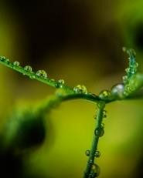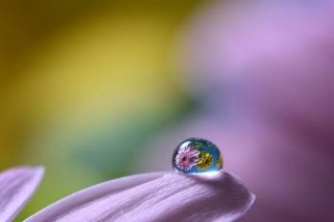
Figure 17. Differences in Shooting Distance
- Color
The appearance of the water droplets on the plant parts creates a reflection that is presented by the water itself. Therefore, the water that appears has interesting textures and details. The results of the photos using a macro lens and cylindrical glass both produce a glass effect on the water droplets. However, a few things make the difference. In photos using cylindrical glass, the resulting reflection is quite blurry because the color is too dense in the water droplets. Meanwhile, on a macro lens, the reflection results are clearer and have very sharp details.
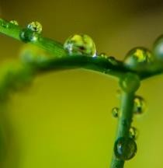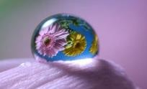
Figure 18. Color Comparison
- Lighting
The photograph was taken during the day using available light to produce dense colors and high contrast. At the back of the photo, the light displayed is very contrasted so that the details in the photo are less visible. The depth of field in this photo is very narrow in which the researchers bring the lens close to the object from the back so that the depth of field is thorough to the back of the object and produces a blurry appearance on the front of the object. Meanwhile, in the photo using a macro lens, the sharp space that is produced is quite wide starting from the front to the object at the back. The AF-S VR Micro-Nikkor 105mm f/2.8G IF-ED macro lens is capable of producing fairly harsh lighting but does not provide the high contrast effect that cylindrical glass produces.
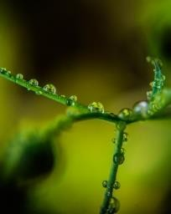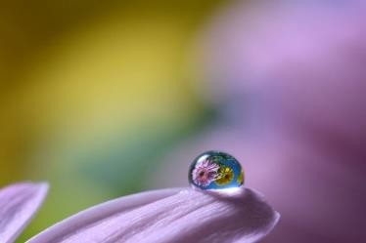
Figure 19. Light Comparison
- Vignette
The vignette produced by the use of cylindrical glass can be seen on the side of the photo. In this photo, the resulting vignette is not very strong because the 4-5 cm distance used in shooting affects the vignette.
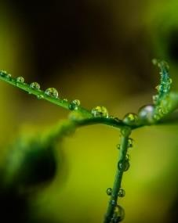
Figure 20. Vignette Produced by Cylindrical Glass
- CONCLUSION
In this study, the researchers analyzed the photo quality resulting from using the macro photography technique with cylindrical glass. The work produced from macro photography using a cheaper alternative tool is quite good. This method can be applied by novice photographers and is an option in certain circumstances. Based on the problems faced by novice photographers regarding expensive macro photography equipment, the presence of this alternative technique using cylindrical glass can be the answer for them so that the quality of the macro photos they create can compete with the photos made by macro lenses in terms of quality, efficiency, and affordability. This alternative macro technique is expected to facilitate and provide choices for photographers in creating macro photo works. Regarding efficiency, the tool used is small so that it can fit into a pocket and can be carried anytime and anywhere. However, this alternative technique still has drawbacks, in which the presence of a vignette on the right and left sides of the photo is still a nuisance for some photo works. In addition, this technique creates several effects. For example, the resulting color is very contrasting or there is a decrease in light entering the camera up to ½-1 stop. It is something that still needs to be developed in further research.
- REFERENCES
Anif Putramijaya. (2009). Teori Dasar Fotografi Makro | Macro Photography Theory.
Fotografi Net. https://www.fotografer.net/ isi/artikel/lihat.php?id=1161 Aziz, A. (2009). Mensiasati Penggabungan Lensa Untuk Pemotretan Makro.
Barnbaum, B. (2017). The Art of Photography: A Personal Approach to Artistic Expression. Rocky Nook, Inc.
Jaedun, A. (2011). Metodologi penelitian eksperimen. Fakultas Teknik UNY, 12. Karyadi, B. (2017). Fotografi: Belajar Fotografi. NahlMedia.
Lutfi, A. (2014). Indonesia Macrophotobook. Elex Media Komputindo. Nugroho, R. A. (2006). Kamus fotografi. Yogyakarta: Andi.
Soelarko, R. M. (1978). Komposisi Fotografi, Bandung: PT. Indira.
Soendari, T. (2010). Metode penelitian eksperimen. Diakses Dari: Http://File. Upi. Edu/Direktori/FIP/JUR.PEND.LUAR.BIASA/195602141980032-TJUTJU
Soendari/Power Point Perkuliahan/Eks Perimen/Penelitian Eksperimen. Ppt% 5BCompatibility Mode% 5D. Pdf [2013, 30 Mei].
SP. Soedarso. (2006). Trilogi Seni : Penciptaan Eksistensi dan Kegunaan Seni.
Yogyakarta : BP ISI Yogyakarta, 2006.
Sukarya, D. G. (2009). Kiat sukses Deniek G. Sukarya dalam fotografi dan stok foto buku panduan fotografi. Jakarta : Elex Media Komputindo , 2009.
Tahalea, S. (n.d.). View of Kritik Fotografi_ Mendeskripsikan Sebuah Foto Dari Sisi Subjek, Bentuk, Media Dan Gaya.Pdf.

