PRE-WEDDING PHOTO SESSIONS USING TRADITIONAL JAVANESE STYLE WITH A MODERN TOUCH
Syafiq Maulana Eryandy¹
Silviana Amanda A Tahalea²
Erlina Novianti³
Faculty of Art & Design
Universitas Trisakti
silviana@trisakti.ac.id²
ABSTRACT
Photography serves as a medium to capture important moments in life. One of the derivative branches that arise from this function is pre-wedding photography. It is a photo shoot activity carried out before the wedding takes place and the photos will be displayed at the wedding reception. The objective of this study was to determine the main forming factors in holding a pre-wedding photo session with traditional Javanese style and modern touch and to gain additional insight for photographers in pre-wedding photography. In this study, the researcher applied an observation method with interviews and a literature study. Results indicated that several forming factors in the presentation of pre-wedding photos are careful concept planning, choosing a pre-wedding style that suits the bride and groom, paying attention to supporting aspects of the photo shoot, and doing post-production (editing) effectively and maximally.
Keywords: photography, pre-wedding, pre-wedding photo sessions, pre-wedding style.
- INTRODUCTION
Photography is principally used as a medium to capture an event. It has a main function as a method to capture important moments in life. Technological developments have resulted in fragmentation in the world of photography into two streams. These two are wedding documentation photography and pre-wedding photography. The pre-wedding photography means taking pictures before the wedding. Pre-wedding photography is an activity carried out before the wedding takes place and the photos will be displayed at the wedding reception. These photos present the intimacy of the bride and groom in beautiful clothes.
In late 1990, the interest in the need for pre-wedding photo sessions began to grow. To this date, it has become a phenomenon in society. Furthermore, the interest in the need for pre-wedding photo sessions currently begins to grow in Indonesia. In addition, the style of clothing used in pre-wedding photo sessions is very varied. Some styles in the use of clothing during these photo sessions are casual style, glamor style, traditional style, and professional dress style. Nowadays, people tend to like styles that have to do with their personal life (in this case, the bride and groom). For example, couples – who like to spend time in cafes – will likely choose the casual style because the clothes they often wear are casual. However, it does not mean the development of the style used in the pre-wedding photo sessions is limited to that point (Tahalea, 2019).
In recent years, public interest has begun to arise in combining the styles they like. For instance, they combine traditional styles with rigid and formal poses using the background of classic city buildings. The style of pre-wedding photos using modern traditional clothes combined with an urban setting is a popular theme in today’s society. Economic growth and social changes affect the development of this style. Traditional Javanese clothes with a modern touch are defined as the traditional dresses that have been modified due to the displacement of the Javanese to the island of Sumatra and are influenced by local culture. The difference is in some elements, such as color and ornaments. However, it does not eliminate the main elements and still has the characteristics of traditional Javanese clothes. Therefore, the researcher in this study addressed the topic of pre-wedding photo sessions using traditional Javanese style with a modern touch.

- METHODS
The methods applied were observation with interviews and literature study. Interviews were carried out to find out what styles are currently in demand by consumers/communities. Furthermore, these interviews were conducted with couples who wanted to do a pre-wedding photo session and resulted in the opinion that the majority liked that the photo session was done outdoors, for example in an urban area or a background that has a unique view. In addition, the styles that were in demand were traditional styles with traditional clothes and casual styles that could show a glimpse of the couple’s personality.
The literature study was carried out by reading journals related to the pre-wedding work process. In addition, the researcher also read several journals that provide knowledge about how to make a good pre-wedding photo concept and various factors to consider, such as poses, clothing, and place settings. Some of the insights obtained from this literature study are a better understanding of the phenomenon of pre-wedding photo activities, an ability to interpret the factors of making pre-wedding photos, and a better comprehension of the current style of pre-wedding photos.

- RESULTS AND DISCUSSION
The results of this study show that there are several important forming factors in presenting pre-wedding photos with traditional Javanese added with a modern touch, namely as follows.
- Careful concept planning, namely making ideas, stories, and concepts intended to convey into the visuals of the pre-wedding photos. Ideas and concepts must be able to display the characteristics and personality of a couple. The purpose is that the visuals can tell stories and convey meaning about the couple.
- Choosing the right and appropriate pre-wedding style. After the ideas and concepts have been agreed upon, the next step is choosing what kind of style can convey the visual meaning of the photo and is suitable for use in revealing the identity of the bride and groom.
- Considering the supporting aspects of photo shooting, namely preparing all things related to the technicalities and tools used in the shooting. The choice of shooting location must also be considered because it is a visual support aspect of pre-wedding photos.
- Post-production/editing that is carried out effectively and maximally.

Table 1. A Procedure in Making Works
No | Working Processes | Objective
1 | Ideas and concepts | Determining the right concept
2 | Literature observation | A guide in making works
3 | Experimentation | Shooting technique
4 | Making works | Shooting planning
5 | Editing process | Improving the visuals of the photos
6 | Description of works | Explaining the works

The table is a procedure for the work process of producing traditional Javanese pre-wedding photos with a modern touch. The following is its further explanation.
- Ideas and concepts
Determining ideas about the concept that will be used is the first stage in making pre-wedding photo works. This stage aims to produce mature conceptualization, consisting of ideas, stories, and concepts that the photographers together with their clients want to convey into the visuals of pre-wedding photos. These ideas and concepts must be able to display the characteristics and personality of a couple with the aim that the visuals can tell stories and convey meaning about the couple. The selection of concepts must be adjusted to the characteristics and the visuals of the bride and groom. Furthermore, the purpose of the search for the right ideas and concepts is to produce photos with good visual meanings and make the prospective bride and groom feel comfortable and confident by delivering the concept of pre-wedding photos.
- Literature observation
In conducting a study, guidance and support are needed from previous studies with similar topics. The observation was carried out by reading works of literature, such as journals and scientific papers, aiming at enriching views about making pre-wedding photos. One of the papers that become the reference of the researcher entitles "The Phenomenon of Identity Construction in Making Pre-wedding Photos” by Jim N. Mahameruaji. His paper describes the main function of having pre-wedding photos and also explains the reasons for choosing a pre-wedding style that is associated with the personality of the couple. He adds that finding out the identity of the couple who will get married is carried out by choosing the pre-wedding style preferred by the couple. For understanding the selection of the right and good poses in pre-wedding photo shoots, the researcher read thesis entitled “The Culture of Holding Pre-wedding Photo Sessions in an Islamic View” by Irfan Helmi. The writer concludes that the poses used in pre-wedding photo shoots should have a very important role in bringing the atmosphere experienced by the couples. Choosing the right pose and matching it with the pre-wedding concept and the personality of the bride and groom can result in a deep emotional message in the photo because the selection of the right expression and pose can evoke the mood/atmosphere and can radiate the emotions and happiness that the couple feels. The researcher also read another paper entitled “Ideal Aesthetics of Prewedding Photo Session with Balinese Style” by Cokorda Istri Puspawati & I Nyoman Anom. The paper contains insights regarding the aesthetic aspects of presenting pre-wedding photos.
- Experimentation
In this case, experimentation is related to the technicality of tools used in making works. In making traditional Javanese pre-wedding photos with a modern touch, the researcher used a digital camera with the specification of Full Frame Mirrorless Sony Alpha 7 Mark IV and a zoom lens of 24-70 mm. The researcher chose to use this type of camera because it has the best sensor in its class, namely 33 megapixels, which makes photos have very good detail. In addition, this camera has accurate color calibration and good cropping due to its full-frame camera feature. The lens used is a Sony 24-70 mm zoom lens because it has good flexibility and can be used in various conditions. This lens is also chosen because it has good stability and the latest optics, making it able to produce photos with extraordinary quality.
- Making works
Making works discusses the planning of the shooting process that will be carried out, such as determining lighting diagrams and storyboards.
  - Lighting diagrams
The following is a lighting diagram used in the shooting process. In the photo shoot, the researcher used available light with a sunlight source.


Figure 1. Lighting diagrams

  - Lighting
Lighting is the main element in photography. Without light, photography would never exist. In addition, light can shape the character in a photo. It provides information about the structure of the object to be photographed. The lighting used in the making of traditional Javanese pre-wedding photos with a modern touch is sunlight or available light or natural light (Maulina et al., 2020).
Natural light is a type of lighting from nature, in which the light is produced from all elements of nature. The main element in natural lighting comes from sunlight. The sunlight has certain hours that are good to use as a light source in the shooting. In the morning, it is between 08.00 and 10.00. Meanwhile, in the afternoon, it is from 15.00 to sunset. At these hours, the strength of the sun is not too strong and the lighting angle is even.
  - Storyboard
The following is a storyboard used by the researcher in the shooting process of traditional Javanese pre-wedding with a modern touch. The displayed storyboards present the position and pose simulation of the subject of the photos.

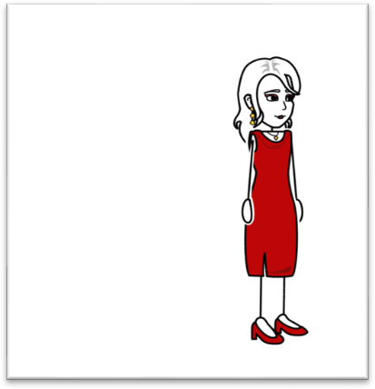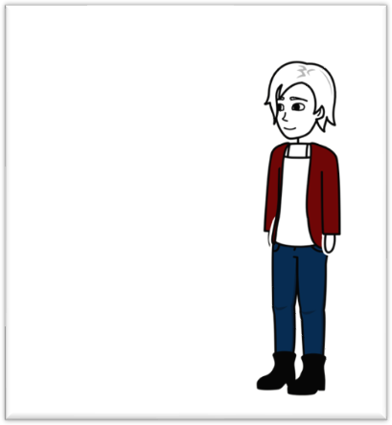
Figures 2 & 3. Storyboard


Figure 4. Storyboard

- Editing process
Editing on pre-wedding photo sessions has the aim of making the visuals in the photo perfect. It is because the photo will be printed and displayed at the wedding reception. In addition, it also makes the colors in the photo look alive without being excessive so that the aesthetic purpose or beauty in pre-wedding photos can be realized.
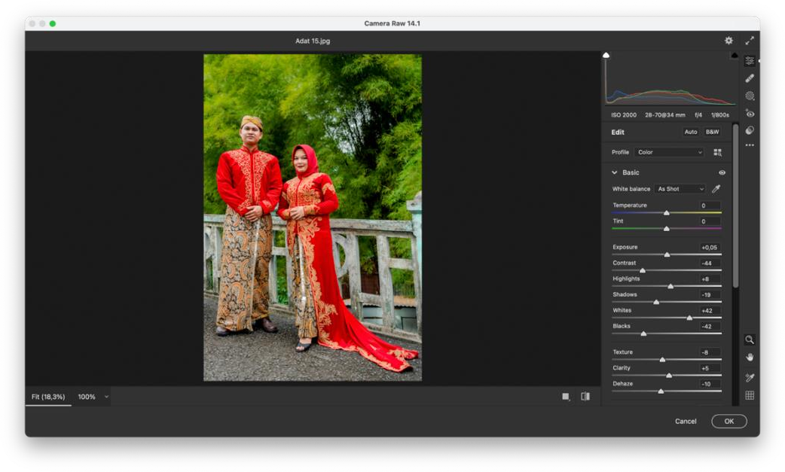
Figure 5. Basic editing
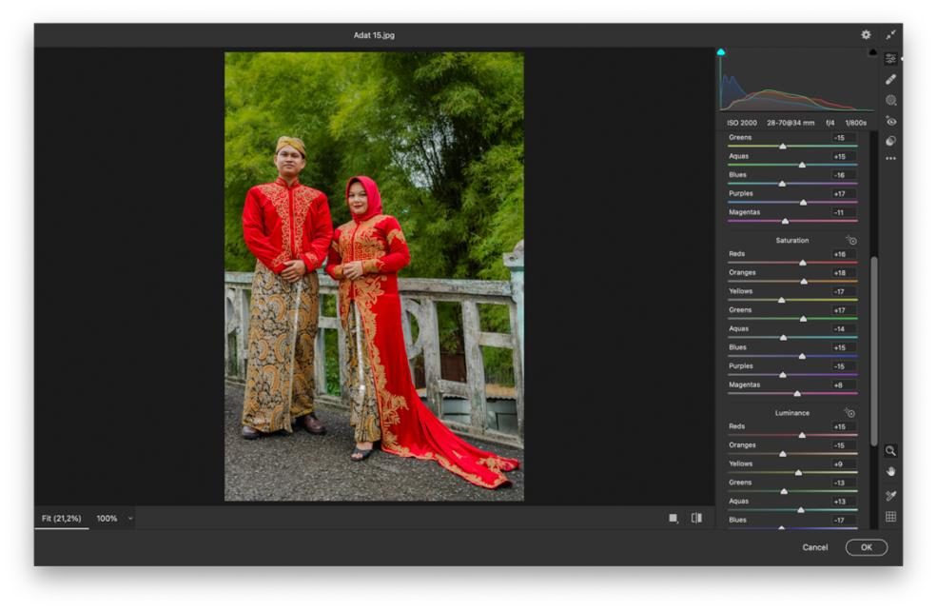
Figure 6. Color correction
The researcher did the editing process in Adobe Photoshop software using the feature “camera raw 14.1”. According to the researcher, editing using this feature can result in photos with the RAW file format properly and make the work process lighter. The editing process began with basic editing which aims to improve exposure, highlight, shadow, contrast, and the dark side of the photo.
In the second editing stage, the researcher adjusted the colors so that the photos can bring out the colorful characters from traditional clothes with the aim that the colors do not look dim, especially in saturation and luminance. This color correction helps the researcher in setting what colors to highlight and what colors to dim.
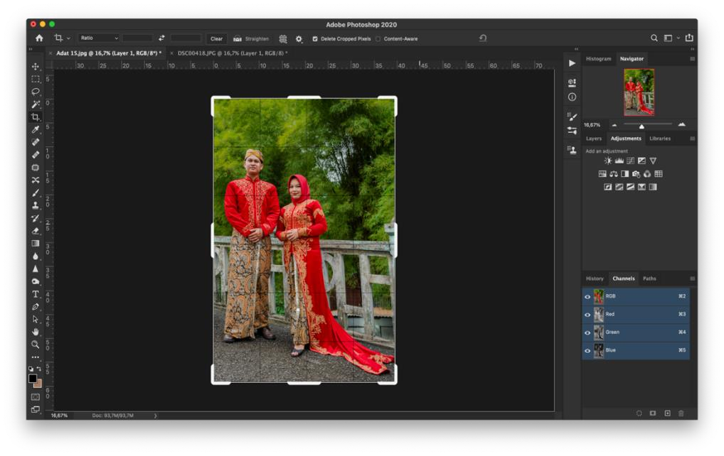
Figure 7. Cropping
The last process in editing that the researcher did is cropping, aiming at minimizing the appearance in a frame to focus on the visuals of the photo intended to display.
- Description of the works
The description is the process of collecting data and facts about the subject, the overview of the situation, activities, and the subject’s dress style in a photo. The purpose of the description of the work of traditional Javanese pre-wedding photos with a modern touch is to identify and interpret the forming factors in making pre-wedding photo works and to understand the background of the chosen style. The explanation of the traditional Javanese clothes that have undergone modernization due to the mixing of cultures will also be presented in the description of the works. The main goal of this step is that the meaning contained in the visuals of the photos can be conveyed to everyone seeing them (Tahalea, 2019).
  - The Bride
The first or the opening photo is entitled “The Bride”. It shows a single portrait of the bride. As seen, the poses are elegant and polite because the couples want to convey an elegant visual in a photo. The fabric of the back of the shirt is also arranged in such a way to support the visuals that look luxurious. Her expression symbolizes the beauty and grace of the bride.

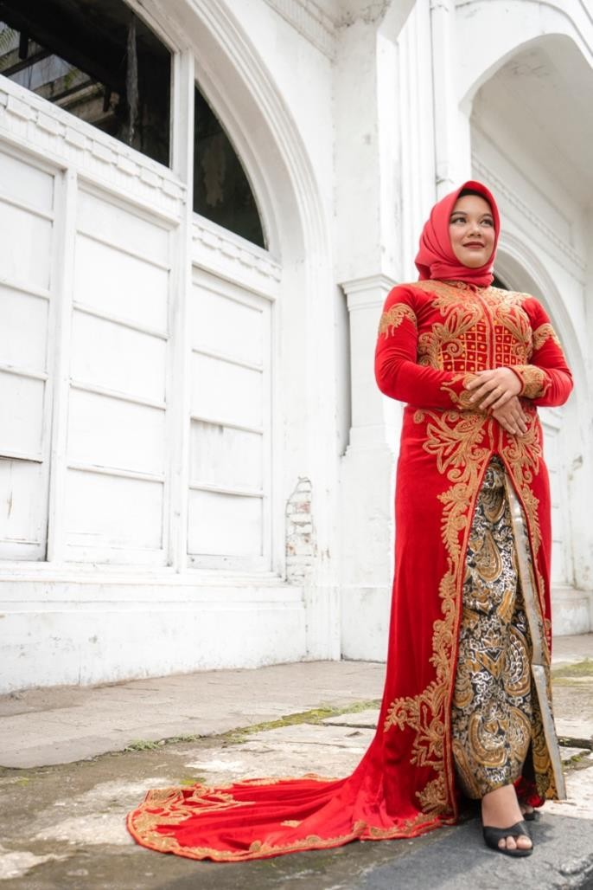
Figure 8. The Bride

Furthermore, the traditional Javanese clothes worn have been modernized to represent the identity construction of the bride. Modernized Javanese traditional clothing is a social phenomenon that often occurs in the city of Medan because the Javanese are an immigrant tribe on the island of Sumatra which results in a combination of customary habits. The choice of colors and original motifs of traditional Javanese clothing has been developed following traditional customs on the island of Sumatra. For example, the color of traditional Javanese clothing which is usually dark and calm (black) is modified to a light color but the motifs on the fabric still symbolize typical traditional Javanese clothing.
  - The Groom
The photo entitled “The Groom” features a single portrait of the groom which is shown after the single photo of the bride. The separate presentation of photos of the bride and the groom aims that the subject of pre-wedding photos can be displayed as an individual in the photo frame. The pose shown is dashing and serious with a friendly and happy facial expression. In the photo, the groom holds a kris while looking to the right. The purpose of holding a kris is to display one of the cultural elements of the traditional Javanese clothes worn.

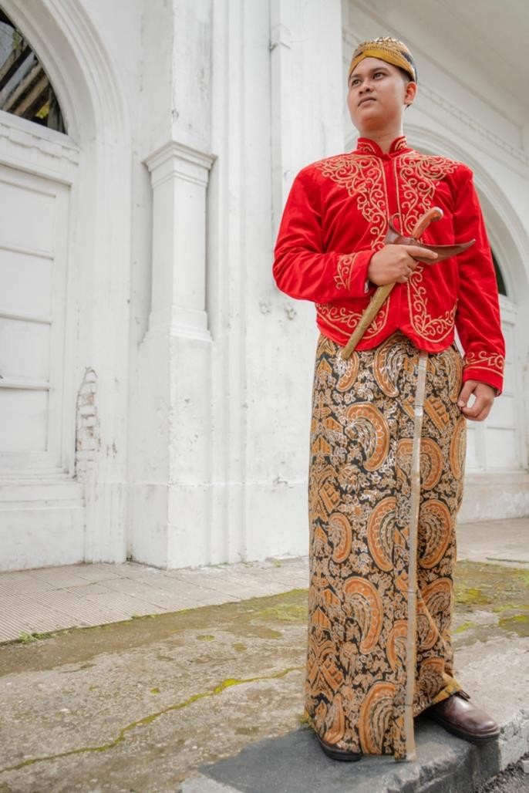
Figure 8. The Groom

The use of modernized Javanese traditional clothing represents the identity construction of the groom. As aforementioned, traditional Javanese clothes worn have been modernized because the Javanese are an immigrant tribe on the island of Sumatra which results in a combination of traditional habits. The choice of colors and original motifs from traditional Javanese clothing has been developed following the traditional customs on the island of Sumatra. The use of classic buildings is to correlate traditional clothes that have historical value from a custom, in which old buildings also have a respective history.
  - Happy Couple
These photos entitled “The Happy Couple” have meaning and message to show the happiness of the bride and groom. The poses and expressions displayed on each of the bride and groom aim to get the purpose and visual meaning of the photo. Their body poses are imbued with polite style, reflecting traditional/cultural standards because the clothes worn are inspired by a custom/culture.

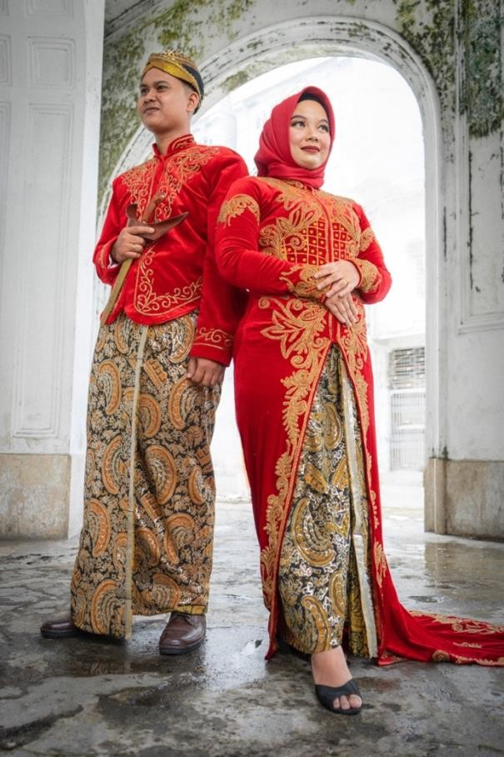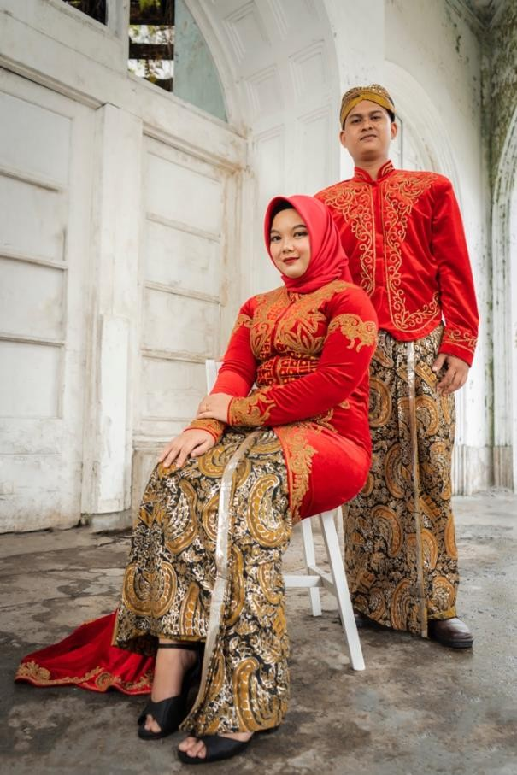
Figure 9. Happy Couple

These photos with the theme “Happy Couple” show both the groom and the bride in one photo frame. The feeling to be conveyed in the photo visual is happy. As seen, the facial expressions of the bride and groom convey the meaning intended to be conveyed by them in the photo. Furthermore, the clothes worn remain the same, namely traditional Javanese clothes with a modern touch because of the mixing of Javanese culture with the original culture of the island of Sumatra.
The background used is the front porch of an old classic house (located in the Cultural District of Medan) with moss patterns on the side walls. The use of classic buildings is to correlate traditional clothes that have historical value from a custom, in which old buildings also have their respective history.
  - New Life Path
This photo is the back cover of their wedding photo album and the ending of the process of presenting a photograph. The title “New Life Path” symbolizes the couple’s readiness in terms of views, thoughts, personalities, and goals that have been mature and will be shared. The feeling to be conveyed in the visual of the photo is seriousness, firm attitude, and the beauty of the bride and groom. As seen, the facial expressions and gazes of the couple can convey the meaning intended to be conveyed by the photo.

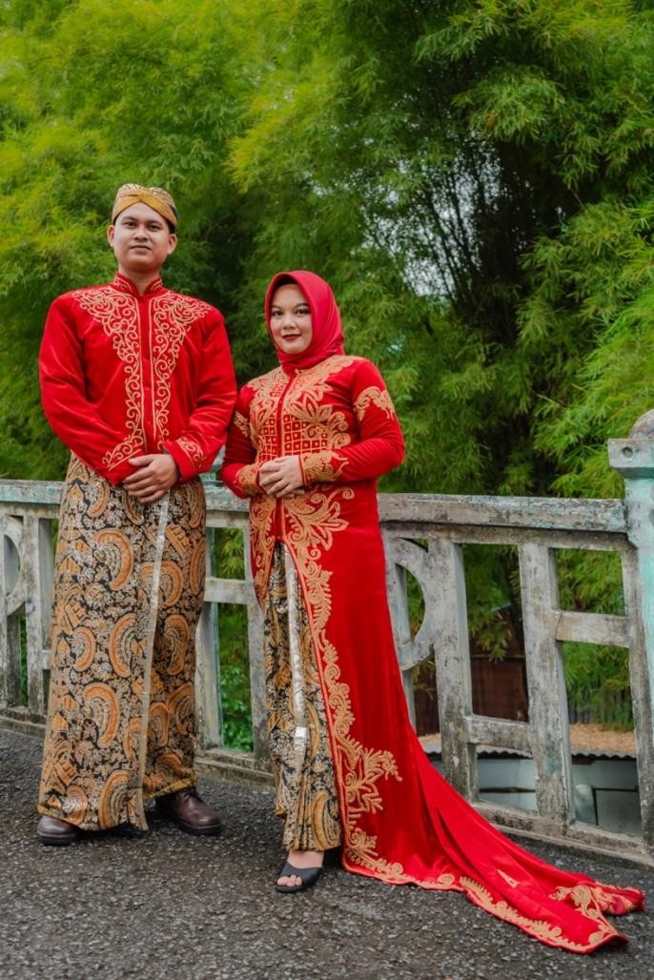
Figure 9. New Life Path
The visual of the photo with the green leaves as the background and the graceful poses of the bride and groom symbolize the aesthetics of the beauty of the bride and groom. The happiness of married life that will be lived with full preparation and maturity by the bride and groom is what photographers want to convey from the visuals of the photos. The meaning behind wearing traditional clothes is still the same.
The location of the photo is the side of the old bridge (in the Cultural District of Medan City) with faded paint colors. The use of a classical-themed setting is to correlate traditional clothing that has a historical value from a custom with an old building that also has a significant history.

- CONCLUSION
This study concludes that there are several important forming factors in organizing pre-wedding photo sessions with traditional Javanese style added with a modern touch. Those are as follows.
- Careful concept planning, namely making ideas, stories, and concepts intended to convey into the visuals of the pre-wedding photos. Ideas and concepts must be able to display the characteristics and personality of a couple. The purpose is that the visuals can tell stories and convey meaning about the couple.
- Choosing the right and appropriate pre-wedding style. After the ideas and concepts have been agreed upon, the next step is choosing what kind of style can convey the visual meaning of the photo and is suitable for use in revealing the identity of the bride and groom.
- Considering the supporting aspects of photo shooting, namely preparing all things related to the technicalities and tools used in the shooting. The choice of shooting location must also be considered because it is a visual support aspect of pre-wedding photos.
- Post-production/editing that is carried out effectively and maximally.
In the shooting process carried out based on the concept that has been created, a photographer needs to be able to make the couple – who are the main subject in the photo – look very comfortable and confident with the concept and style of the photo that will be taken. Therefore, it can be concluded that before doing a pre-wedding photo session with any style, a photographer must master all the photo-forming factors.

- REFERENCES
Cokorda Istri Puspawati Nindhia, & Setiawan, I. N. A. F. (2019). ESTETIKA lDEATIONAL FOTO PREWEDDING STYLE BALI. Jurnal Bahasa Rupa, 3(1), 42–47.
https://doi.org/10.31598/bahasarupa.v3i1.423
Hamdan, F. (2014). Pengertian Fotografi. 8–24. http://repository.unpas.ac.id.
Mahameruaji, J. N. (2014). Fenomena Konstruksi Identitas Pada Foto Pre-Wedding. Jurnal Kajian Komunikasi, 2(1), 44–52. https://doi.org/10.24198/jkk.vol2n1.4
Maulina, A. A., Sari, L. S., & Novianti, E. (2020). Fotografi Cerita Naratif Pada Give Birth Photography. Jurnal Dimensi DKV Seni Rupa Dan Desain, 5(2), 195–210. https://doi.org/10.25105/jdd.v5i2.7955
Pujiwidodo, D. (2016). Skripsi budaya foto prewedding dalam pandangan hukum islam (Studi Kasus Aris Fotografer, Jl. Harvest Citi Blok Ob 1V No.15, Cibubur)
Raman, S., & Lampung, K. (2018). Skirpsi prewedding dalam pandangan hukum islam (studi kasus di desa rukti harjo kecamatan seputih raman kabupaten lampung tengah).
Tahalea, S. (2019). Kritik Fotografi: Mendeskripsikan Sebuah Foto Dari Sisi Subjek, Bentuk, Media Dan Gaya. Jurnal Dimensi Seni Rupa Dan Desain, 16(1), 85–96. https://doi.org/10.25105/dim.v16i1.6165

