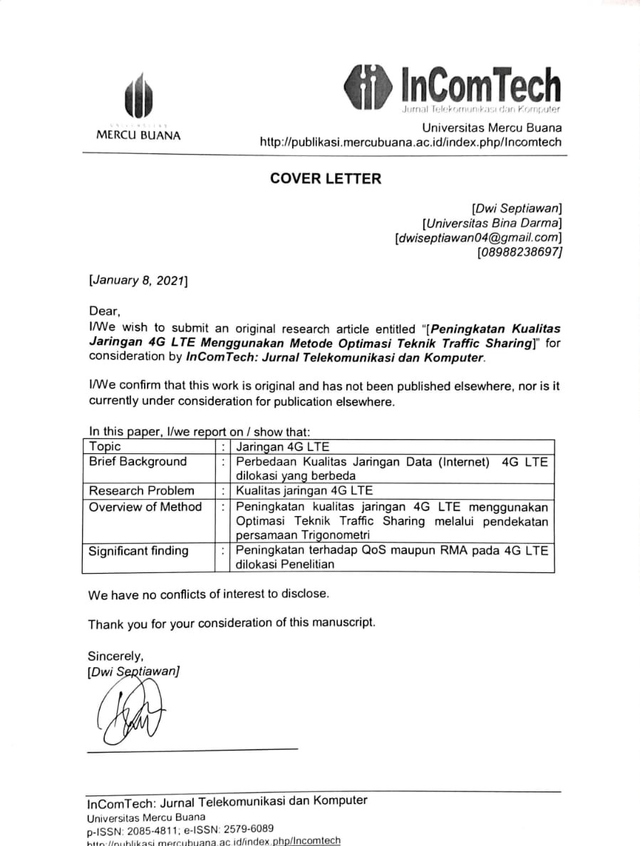

AUTHORSHIP STATEMENT

I/We wish to submit an original research article entitled ““[Peningkatan Kualitas Jaringan 4G LTE Menggunakan Metode Optimasi Teknik Traffic Sharing]” for consideration by InComTech: Jurnal Telekomunikasi dan Komputer

All persons who meet authorship criteria are listed as authors, and all authors certify that they have participated sufficiently in work to take public responsibility for the content, including participation in the concept, design, analysis, writing, or revision of the manuscript.

Author 1
Name | : | Dwi Septiawan
Affiliation | : | Universitas Bina Darma
Email Address | : | dwiseptiawan04@gmail.com
Author 2
Name | : | Dedy Syamsuar
Affiliation | : | Universitas Bina Darma
Email Address | : | dedy_syamsuar@binadarma.ac.id
Author 3
Name | :
Affiliation | :
Email Address | :
Author 4
Name | :
Affiliation | :
Email Address | :

POTENTIAL REVIEWERS

Please submit 3 (three) potential reviewers (that have not listed in InComTech: Jurnal Telekomunikasi dan Komputer) to speed up the review process that competent for the topic and has a good reputation in that area.

Reviewer 1
Name | : | Bengawan Alfaresi, M.T.
Affiliation | : | Universitas Muhammadiyah Palembang
Email Address | : | begawan_alfarezi@um-palembang.ac.id
Reviewer 2
Name | :
Affiliation | :
Email Address | :
Reviewer 3
Name | :
Affiliation | :
Email Address | :

