Optimization BLE power beacon
for indoor locations static smart device
with Gaussian filter

Fanda Lyta Suzanayanti  554170007  Masters of Electrical Engineering  at Mercu Buana University, Jakarta, Indonesia  fandalyta@gmail.com | Mudrik Alaydrus, Prof., Dr. Ing.  Master of Electrical Engineering  at Mercu Buana University, Jakarta, Indonesia mudrikalaydrus@mercubuana.ac.id

Abstract— BLE beacon in an indoor location, battery efficiency usage must be right. Power beacons as one of the keys that need to be optimized. The decrease in power beacons will decrease in the accuracy of the estimated distance from an indoor location based on the RSSI value. Therefore, additional method are needed to recovery the accuracy value of the estimated distance due to the reduced power. In this paper, the method for recovery accuracy is by using a gaussian filter. Measurements were made at the same position on 3 BLE signals from multipower transmitters which differed in their transmit power (TX power -1 dBm, -9 dBm and -20 dBm). The first six points are selected with the position of line of sight as environment 1 and the second six points are chosen with the position of non-line of sight as environment 2 (obstructed). The first point of each environment is used as a reference. In environment 1, transmit power reduce 24 dB effect to decrease in accuracy distance estimation. The effectiveness Gaussian filter for improvement accuracy at all measurement points or 100%. In the environment 2, reduce power transmit 12 dB is not followed by a decrease in accuracy distance estimation. The effectiveness of Gaussian filter for improve accuracy is 60% of the number of measurement points. Finally, gaussian filter in the power optimization can recovery accuracy distance estimation is 80% from measurement sample for environment 1 and environment 2.
Keywords-Optimization, Indoor Location, Gaussian filter

Introduction
The Internet of Things has the objective to connect all objects with the Internet. Smart city, home automation, hospital automation, logistics management, item tracking etc. are examples of how devices are connected to the internet [1]. Internet connection that is possible only by using wireless. The wireless technology used must be low power, availability, inexpensive, reliable, especially interference problems [2]. Bluetooth Low Energy (BLE) is widely used for these solutions.
Like GPS in outdoor coverage, indoor also requires a navigation system. One method is based on RSSI for calculating distance estimation. RSSI in indoor is very fluctuating due to multipath. One of the propagation modeling for indoor radio coverage is log normal shadowing [3]. The fluctuation of RSSI value due to multipath fading at a distance that is normally distributed random Gaussian variable. So with the selection of Gaussian Filters for RSSI stability in accordance with the characteristics of the indoor radio coverage propagation model itself.
The latest BLE technology is multi-power beacons where one beacon can transmit more than one power. In reference [4], which discusses indoor location estimation with BLE multi power. RSSI fluctuations can be reduced by decreasing the transmit power. With the operation of RSSI around the threshold to provide a smaller RSSI deviation value. The position of the transmitter is on the ceiling of the room to minimize diffraction. This method is very difficult to implement because it really depends on the environment. In reference [5], an analysis was made due to the use of a BLE multipower in an indoor position. The decrease in power affect to decrease in accuracy in the indoor position. To stabilize the RSSI use the Kalman filter and low pass filter. The process of predicting its position uses the triangular Centroid Minimum Approval and Mean Square Error. The results of his study Kalman filter gives a good value of accuracy and precision compared to low pass filter.
RSSI processing in indoor position is very dependent on the type of application. In reference [6] analyzed the optimization of the BLE indoor position with smart devices for static device conditions. From the results of the analysis, RSSI stabilization with the Kalman filter is better than the Gaussian filter, feedback filter and filter average. In reference [7], indoor position for tracking system applications, the method is using a double Gaussian filter. The first Gaussian filter for RSSI stabilization and the second Gaussian filter for stabilization distance estimation.
The process of reducing the transmit power of BLE with the aim of signal optimization to improve battery efficiency and interference on radio channels will affect to decrease in the accuracy of distance estimation. Therefore, accuracy recovery needed due to the power optimization.
In this paper, taking into consideration the application is a static smart device [6], the method to recovery accuracy of distance estimation is using a double filter [7]. The first filter for RSSI stabilization uses a Gaussian filter as in reference [6] [7]. The second filter for stabilization of distance estimation uses average filter [6].

Theory

Log Distance Shadowing Pathloss Model
Generally, radio propagation modeling is obtained from a combination of analytic and measurement results. Both in theory and measurement results, that the average received power will be reduced logarithmic functions of distance. Pathloss, which is the difference between transmit & receive power in dB is expressed as a function of distance and exponential pathloss ƞ [3].
$PL\left(d\right) ∞ ({\frac{d}{do})}^{ƞ} or PL\left(d\right)= PLo\left(do\right)+ 10.ƞ.log\frac{d}{do}$ | (1)
ƞ is the exponential factor of the increase in path loss due to distance. do is the measurement with distance close to the transmitter as a reference. d is the distance between the transmitter and receiver.
The choice of do position is very important because it is a reference to pathloss. The selection of the position of the reference point must be in the far field area of ​​the transmitter antenna. Generally, the reference distance for outdoor propagation is 1 Km and for indoor propagation is 1m. The pathloss reference is used with the exponential factor at distance d to get the estimated pathloss at distance d. Table I is a typical exponential pathloss ƞ for some radio propagation. In building Line of sight means indoor propagation, that meets the clearance criteria of the Fresnel zone. [3]
Table I. Pathloss exponential factor
Environment | Path loss exponential, $ƞ$
Free space | 2
Urban area cellular radio | 2.7 to 3.5
In building line-of-sight | 1.6 to 1.8
Obstructed in building | 4 to 6
Obstructed in factories | 2 to 3

From the measurement results, there is a difference with the average estimation results in equation (1). Empirical results show that PL (d) multipath fading pathloss at a distance is normally distributed around the average shadowing measurement. The formulation of the log-normal shadowing model is in equation (2) [3]:
$$PL\left(d\right)= PLo\left(do\right)+ 10.ƞ.\left(\frac{d}{do}\right)+ N\left(0,σ_{ch}\right)$$ | (2)

With$N\left(0,σ_{ch}\right)$ is a random gaussian variable with zero mean and standard deviation of $σ_{ch}$obtained from the measurement results.

Distance Estimation with RSSI
Exponential factor η is the ratio between increasing path loss base on measurement in selected several distance with the distance factor. In general, the value of d is multiply by 1 meter. So the exponential factor value is in equation (3) [8]
$$ƞ =\frac{\sum_{i = 1}^{k}{}\left[P_{LM}-P_{L}(do)\right]}{\sum_{i = 1}^{k}{}10\log_{10}(\frac{d}{do})}$$ | (3)
Estimated distance between the transmitter and receiver can use the equation (4) [6]

$$d ={10}^{\frac{RSSI-A}{10η}}$$ | (4)

Gaussian filter RSSI
In the previous discussion, the signal propagation in indoor shadowing experience and use a Gaussian distribution for modeling RSSI fluctuations. The formula for the Gaussian distribution is equation (5). Where m is the average RSSI and $σ^{2}$ is the variance defined by equation (6) [6]:
$$f\left(RSSI\right)= \frac{1}{\sqrt{2πσ^{2}}}e^{\frac{{- (RSSI-m)}^{2}}{{2σ}^{2}}}$$ | (5)

As for the variant formula, it is:
$$σ^{2}=\frac{1}{n-1}\sum_{i = 1}^{n}{}{({RSSI}_{i-}m)}^{2}$$ | (6)

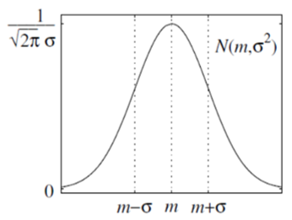
Figure 1. PDF Gaussian random variable.
The PDF graph of the random variable Gaussian from equation (5) is in Figure 1. A Gaussian filter is used to eliminate noise with a normal distribution.
$$P\left(μ-σ <RSSI <μ + σ\right)= \int_{μ-σ}^{μ + σ}{}f\left(RSSI\right)dRSSI = 0.682$$ | (7)

The function of the Gaussian filter is to pass the RSSI value in the range of one standard deviation from the average. As in equation (7). RSSI values ​​outside this range are not taken into account

Research Method

Framework
The work diagram of this study is in Figure 2. Starting with the determination of the RSSI measurement location with a predetermined distance. The next process is collecting RSSI values ​​from three types of BLE signals with transmit power that is configure in the transmitter device of -1 dBm, -9 dBm and -20 dBm. RSSI data obtained, calculated average values ​​and used to determine the exponential factor calculation. Therefore, distance estimation calculated form RSSI data and exponential factor.
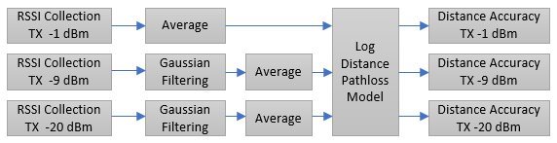
Figure 2. Diagram of research work.
By comparing the accuracy of calculations on RSSI TX -1 dBm, TX -9 dBm and TX -20 dBm, it can be identified the decrease in accuracy due to changes in power BLE. Gaussian filter calculation and average filter to process RSSI data for RSSI TX -9 dBm and RSSI TX -20 dBm. Then recalculate the accuracy of the estimated distance from the Gaussian filter and average Gaussian filter data. By comparing the accuracy data, it can be evaluate the success of recovery accuracy estimation with Gaussian filter due to BLE power optimization.

Measurement.
The measurement map shown in Figure 3. The measurement path 1-2-3-4-5-6 with a horizontal pattern called environment 1 with line of sight characteristics. Position at diagonal pattern is called environment 2 with obstruct characteristics.
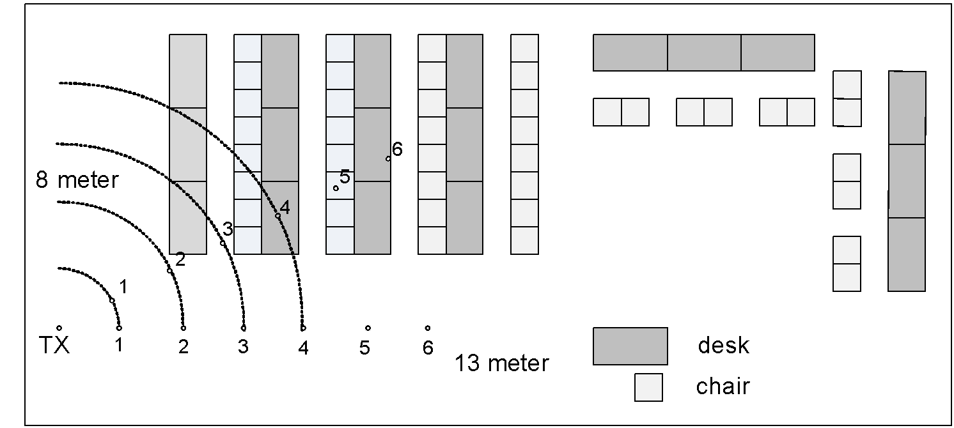
Figure 3. Map of measurement location.
The front view of the environment 2 measurement as shown in Figure 4. Where point 1-2 is still in the line of sight position, while points 3- 4-5-6 are in non-line sight condition.
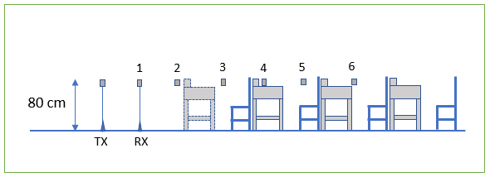
Figure 4. Front view of environment measurement 2.

Devices
The list of devices used in the measurement of this experiment is in table III. Beacon BLE for advertisement mode, requires the main parameters namely UUID, period and transmit power. In this study using a setting with a period of 250 ms. Transmitted data TX UUID xx91xx -1 dBm, TX UUID xx92xx -9 dBm and TX UUID xx93xx -20 dBm. Testing at close to zero distance using a smartphone and scanner application from nRF connect. As for the raspberry, it is configured to be a BLE scanner. With the consideration of static devices, the time taken for data collection in raspberry is 7 minutes for each measurement point. Therefore, the number of Bluetooth signals configured on the device for each measurement sample is 1680.
Table II. Devices used in the measurement of
Device Name | Function | Application
Samsung J6 + | TX | nRF connect -  Nordic semiconductor | Advertise BLE
Oppo A6 | RX test |  | BLE Scanner
Raspberry pi 3b + | RX | bluez - hcitool
Laptop | Post data processing
Tripod | Equipment holder

Results And Discussion

Measurement of Coverage Area
Optimization of power with a decrease in power will affect to the coverage area. By comparing the number of RSSI samples before and after the decrease in power, we can identify a coverage area.
Percentage of coverage area of environment 1 is in Figure 5. The percentage RSSI count graph explains the comparison between RSSI received at a point with the device settings on a Bluetooth transmitter. From this figure, starts from a distance of 1 to 6 between TX -1 dBm and TX -20 dBm have same pattern. RSSI min is the smallest RSSI value obtained at that distance. The RSSI min value at points 1-2-3-4-5-6 has no effect on the percentage RSSI count. From these observations, it can be concluded that the coverage TX -20 dBm at 1-2-3-4-5-6 point is 100%. The lowest RSSI min value in environment 1 is -97 dBm at point 3. Therefore, for environment 1 power optimization is by changing TX -1 dBm to TX -20 dBm.

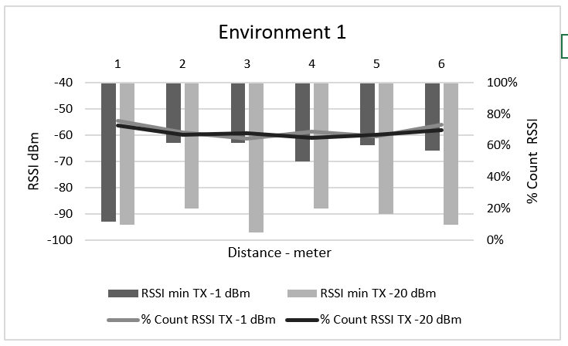
Figure 5. Coverage area of ​​environment 1 TX-20 dBm
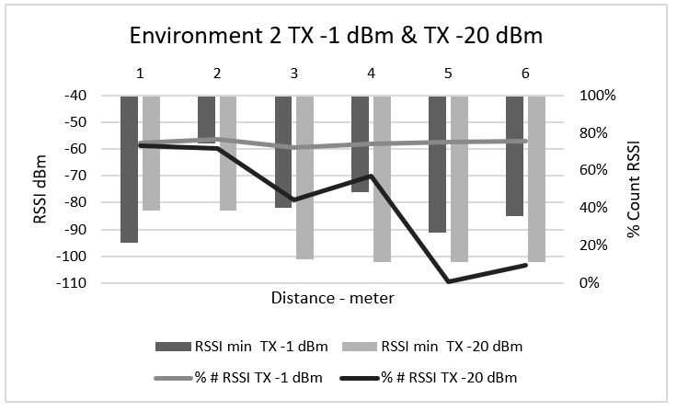
Figure 6. Coverage area of ​​environment 2 TX -20 dBm
Measurement of coverage area of ​​environment 2 for TX -20 dBm compared to TX -1 dBm is in Figure 6. Percentage of RSSI for TX -1 dBm from point 1-2-3-4-5 -6 on a pattern that remains flat. The minimum RSSI value of TX -1 dBm is at least -90 dBm. From this observation the coverage area of ​​TX -1 dBm for points 1-2-3-4-5-6 is 100%. Whereas for TX -20 dBm at point 3-4-5-6, the percentage pattern of RSSI is getting smaller. At point 5, the percentage of RSSI is close to 0%. From this observation the coverage area of ​​TX -20 dBm does not reach point 6. The RSSI value of min TX -20 dBm measured in environment 2 is -102 dBm.
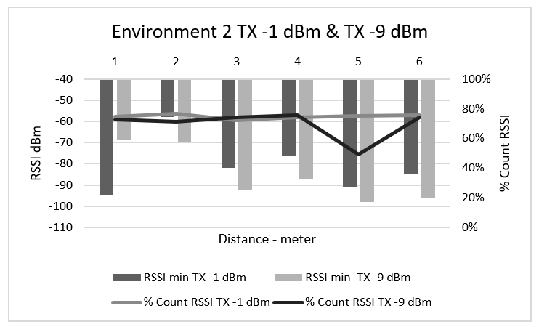
Figure 7. Coverage area of ​​environment 2 TX -9 dBm.
Measurement of the TX -9 dBm coverage area for environment 2 is shown in Figure 7. The percentage of the number of RSSI for TX -9 dBm compared to TX -1 dBm has the same pattern at points 1-2-3-4-6. While at point 5, there was a decline of up to 26%. RSSI value min TX -9 dBm for environment 2 is -98 dBm. The influence of the fifth point on TX -9 dBm will be further analyzed. Therefore, for environment 2 power optimization is by changing TX -1 dBm to TX -9 dBm.

Gaussian Filter Calculation
RSSI data at each point is calculated statistically so that the standard deviation σ and the average m are obtained. The definition of a normal distribution Gaussian is in the range (σ - m) to (m + σ). One example of the calculation results is the RSSI TX -20 dBm for point 1 environment 1 as shown in Figure 8. The RSSI data that is processed are at level intervals of -54 dBm to -98 dBm with a difference of 36 dB. While the RSSI value after the Gaussian filter is -63 dBm to -78 dBm with a difference of 15 dB. Therefore, the Gaussian filter at point 1 for TX -20 dBm can reduce the data deviation by 20 dB.
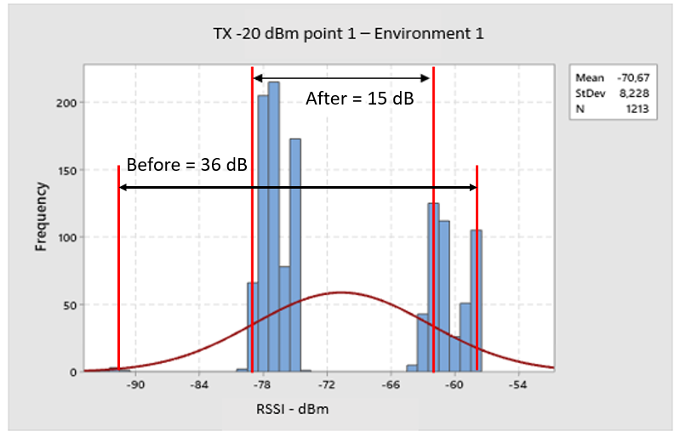
Figure 8. Histogram distance to environment 1
Comparison of statistical analysis between data before and after the Gaussian filter for environment 1 is in figure 9. RSSI delta is different between minimum RSSI and maximum RSSI (dB). From the RSSI delta graph, the picture shows the effectiveness of the Gaussian filter. At point 1-2-3-4-5-6 there is a decrease in the RSSI deviation.
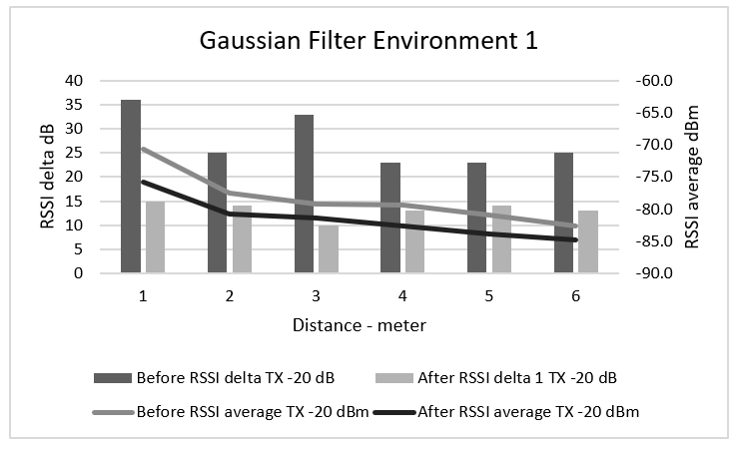
Figure 9. RSSI before and after Gaussian filter environment 1
The reduction of RSSI delta impact to decrease the average RSSI. By comparing the average RSSI graph before and after the Gaussian filter, at point 1 the highest decrease is 5 dB. This is in accordance with the measurement in Figure 8, which is that many RSSI data samples with large values ​​are included in the category rejected by the Gaussian filter.
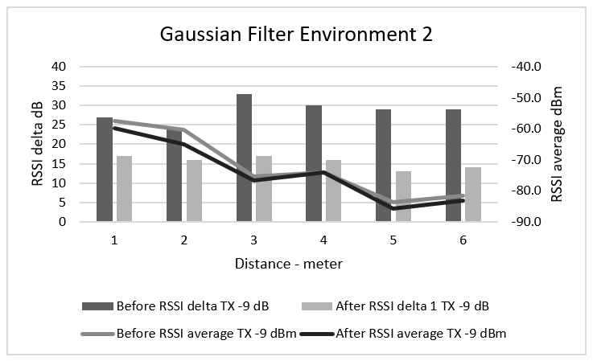
Figure 10. RSSI before and after the Gaussian filter environment 2.
The results of the calculation of the RSSI Gaussian filter for environment 2 are in Figure 10. The Gaussian filter is already functioning, RSSI delta value after the Gaussian filter decreases minimum of 10 dB. From average RSSI graph before and after Gaussian filter, the average RSSI point 1-2-3-5-6 after Gaussian filter have same pattern power reduction. However, at point 4 the average value before and after Gaussian filter is still the same value. Therefore, it needs to be check the distribution of RSSI values ​​at the point 4.
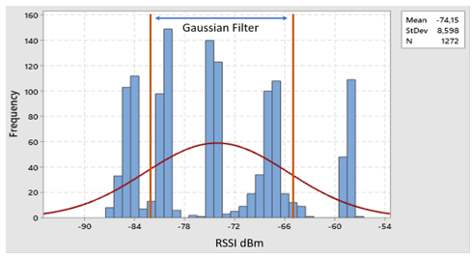
Figure 11. RSSI Histogram at point 4 environment 2.
The distribution of RSSI at point 4 environment 2 as shown in figure 11, it appears there are two RSSI with a large number of samples that are precisely at the average value. Besides that, a balanced distribution pattern between the RSSI > average and RSSI < average also can be seen. This causes the average value before and after the Gaussian filter to equal -74.1 dBm. From Figure 4, point 4 is located behind the obstacle of desk 2.

Exponential Factor Calculation Exponential factor
Calculation requires an average RSSI value of TX -20 dBm for environment 1 and TX -9 for environment 2 as shown in figure 12. The average RSSI value has a descending pattern according to increasing distances. For Gaussian filter, the average values ​​using data in figures 9 and 11.
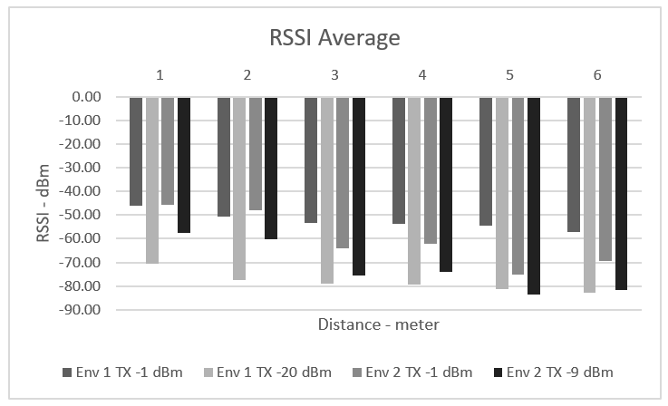
Figure 12. RSSI average for exponential calculations.
Table III. Exponential factors
Data Type | Environment | Exponential Factor
TX - 1 dBm | 1 | 1.39
TX - 20 dBm | 1 | 1.62
TX - 20 dBm & GF | 1 | 1.21
TX - 1 dBm | 2 | 3,16
TX - 9 dBm | 2 | 3.09
TX - 9 dBm and GF | 2 | 3.03

The results of the exponential factor calculation are in table III. The calculation results are compared with table I. The results are still suitable where for line of sight conditions the exponential factor value is between 1,6 to 1,8 for TX -20 dBm. Meanwhile according to [5], a decrease in transmit power will affect an increase in exponential factors. From the calculation also shows the same thing, the exponential factor value increases when transmit power is reduced from TX -1 dBm to TX -20 dBm. However, this does not apply to environment 2.

Calculation of distance accuracy
Distance estimation for the environment 1 using the exponential factor as in table III and the average value in the figure 12. The reference RSSI value at point 1 for environment 1 is -45.9 dBm for TX -1 dBm, -70.67 dBm for TX -20 dBm and -75.77 dBm for TX -20 dBm with a Gaussian filter. The calculation results of error distance estimation for RSSI TX -1 dBm, RSSI TX -20 dBm and RSSI TX -20 dBm with Gaussian filter for environment 1 are in Figure 13.
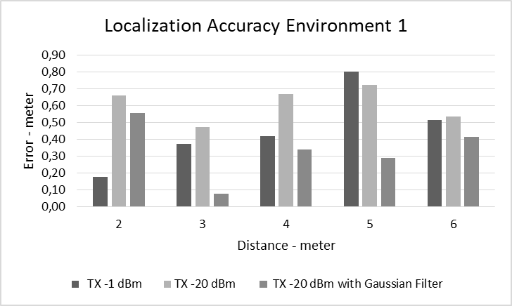
Figure 13. Error accuracy of distance environment 1.
By comparing the accuracy of TX -1 dBm and TX -20 dBm in figure 13, 4 out of 5 points accuracy error increase. For environment 1, a decrease in power will result in a decrease in accuracy of 80%. Comparison of TX -20 dBm and TX -20 dBm with Gaussian filter, 5 of 5 points have improved accuracy. So it can be concluded that the improvement of Gaussian filter for environment 1 is 100%. Meanwhile, when compared between TX -1 dBm with TX -20 dBm - gaussian filter, there is an 80% improvement.
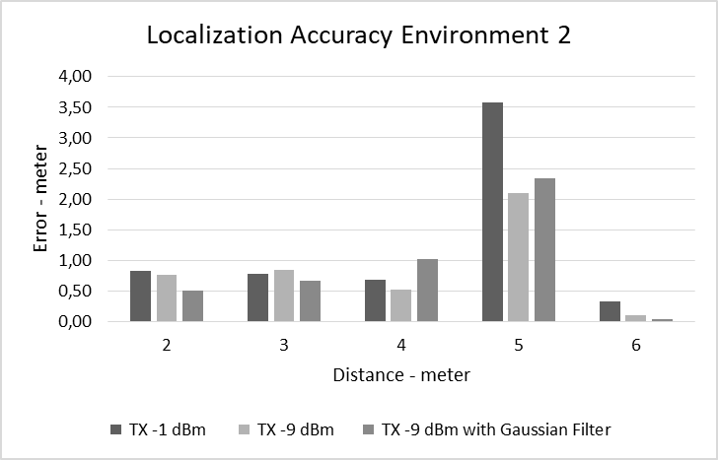
Figure 14. Error for accuracy of environment distance 2
Distance estimation calculation in the environment 2 uses exponential factors as in table III and the average value in figure 12. The RSSI reference value at distance 1 for environment 2 is -45.71 dBm for TX -1 dBm, -57.38 dBm for TX -9 dBm and -59.70 dBm for TX -9 dBm with a Gaussian filter. The calculation results of the error estimation of distance estimation for RSSI TX -1 dBm, RSSI TX -9 dBm and RSSI TX -9 dBm with a Gaussian filter for environment 2 are in Figure 14.
By comparing the accuracy of TX -1 dBm and TX -9 dBm in figure 14, 4 out of 5 points of TX -9 dBm accuracy value is better than TX -1 dBm. So for case environment 2, a decrease in power transmit does not cause a decrease in the accuracy of the distance estimate. By comparing accuracy between TX -9 dBm and TX -9 dBm -gaussian filter, 3 out of 5 points indicate an accuracy error improvement. So it can be concluded that the improvement of Gaussian filter for environment 2 is 60%. Meanwhile, when compared between TX -1 dBm with TX -9 dBm - gaussian filter, there is an 80% improvement.

Conclusion
From the results of the above study, the optimization of the reduction in transmit power from BLE by 24 dB for environment 1 and the effectiveness of the 100% gaussian filter is able to provide an 80% accuracy improvement from the observation point. While the reduction of 12 dB power for environment 2 and the effectiveness of the gaussian filter 60% can provide 80% accuracy improvement from the observation point.

References

[1] | Towards a definition of the Internet of Things (IoT), Revision 1 – Published 27MAY 2015, iot.ieee.org.
[2] | Mahmoud Elkhodr, Seyed Shahrestani, and Hon Cheung. Emerging wireless technologies in the internet of things: a comparative study. arXiv preprint arXiv: 1611.00861, 2016 ...
[3] | Theodore S Raparot, "Wireless Communication Principle & Practice", Prentice Hall Communication Engineering and emerging technology series 1996.
[4] | "Min-Kun Sie and Chih-Hung Kuo," Indoor Location Estimation Using BLE Beacons with Multiple Transmission Power Levels ", 2017 IEEE International Conference on Consumer Electronics - Taiwan (ICCE-TW)".
[5] | "Umair Mujtaba Qureshi, Zuneera Umair and Gerhard Petrus Hancke," Evaluating the Implications of Bluetooth Low Energy (BLE) Transmission Power Levels on Wireless Indoor Localization Accuracy and Precision ", Sensors 2019, 19, 3282;".
[6] | Quang Huy Nguyen, Princy Johnson, Trung Thanh Nguyen and Martin Randles, "Optimized Indoor Positioning for static mode smart devices using BLE", IEEE 2017 ...
[7] | "Jae Gu Lee, Jin Kim, Seon Woo Lee and Young Woong Ko, "A Location Tracking System using BLE Beacon Exploiting a Double-Gaussian Filter", KSII TRANSACTIONS ON INTERNET AND INFORMATION SYSTEMS VOL. 11, NO. 2, Feb. 2017 NNEBE. ".
[8] | "NNEBE Scholastica .U," Pathloss Prediction Model of a Wireless Sensor Network in an Indoor Environment ", International Journal of Advanced Research in Electrical, Electronics and Instrumentation Engineering; Vol. 3, Issue 9, September 2014.".

