DECISion Of Queuing Models
And Layout DESIGN At A Gas Station

Abstract. This study aims to analyze the accuracy of the queuing models and the application of layout design at the gas station in Ngasinan Wonosobo, Indonesia. Fuel service providers are encouraged to optimize service space as the number of motorized vehicle customers grows. The focus of attention in gas station management is not only on the queuing model but also on a suitable and sufficient layout design for customers. This study is focused on a motorbike rider who is refueling with pertalite. The object of this study was a motorcyclist who was doing pertalite refueling. The types of data used are quantitative data and qualitative data. The types of data used are quantitative data and qualitative data. Purposive sampling was utilized as the sampling method in this study, which is a non-probability sampling strategy. The analytical method used is descriptive analysis and analysis of the Multi channel-Single phase (M/M/S) queuing model. The results of this study indicate that long queues can interfere with the activities of other facility users for other customers at the gas station. Recommendations and study findings are explored as a queuing model and layout design in the future.
Keywords: Queue Model; Layout Design; Gas Station; Multi Channel-Single Phase.
Abstrak. Penelitian ini bertujuan untuk menganalisis akurasi model antrian dan penerapan desain layout pada SPBU Ngasinan Wonosobo, Indonesia. Penyedia layanan BBM didorong untuk mengoptimalkan ruang layanan seiring dengan bertambahnya jumlah pelanggan kendaraan bermotor. Fokus perhatian dalam pengelolaan SPBU tidak hanya pada model antrian tetapi juga pada desain layout yang sesuai dan memadai bagi pelanggan. Penelitian ini difokuskan pada pengendara sepeda motor yang sedang mengisi bahan bakar dengan pertalite. Objek penelitian ini adalah pengendara sepeda motor yang sedang melakukan pengisian bahan bakar pertalite. Jenis data yang digunakan adalah data kuantitatif dan data kualitatif. Purposive sampling digunakan sebagai metode pengambilan sampel dalam penelitian ini, yang merupakan strategi non-probability sampling. Metode analisis yang digunakan adalah analisis deskriptif dan analisis model antrian Multi Channel-Single Phase (M/M/S). Hasil penelitian ini menunjukkan bahwa antrian yang panjang dapat mengganggu aktivitas pengguna fasilitas lain bagi pelanggan lain di SPBU. Rekomendasi dan temuan studi dieksplorasi sebagai model antrian dan desain tata letak di masa depan.
Kata kunci: Model Antrian, Desain Tata Letak, POM bensin, Multi Saluran-Fase Tunggal.

Introduction
Currently, all activities must be carried out quickly and precisely. This is due to the increasing number of people in the world. Technological developments are also taking place rapidly. Service companies or manufacturing companies must provide good service and fast service (Ginting, 2014). There are several leading sectors in the Indonesian economy, namely the trade and service sectors (Indriani, L. & Mukhyi, A.M., 2013). One of the service companies is a gas station. Gas Stations, often called Fuel Gas, is a business unit to business activities that distribute and sell fuel oil to the community to meet vehicle fuel needs. The Downstream Oil and Gas Regulatory Agency stated that the number of gas stations in Indonesia was around 6,000 to 7,000 units. This number shows that the increasing population in Indonesia will impact the number of Gas Stations in Indonesia.
Every year, the Indonesian population grows, causing an increase in the purchase of motorized vehicles. As a result, market demand for car gasoline has increased. The Indonesian Ministry of Transportation reports that the number of people who own a motor vehicle is extremely high. After the United States and Turkiye, Indonesia is one of the three countries with the biggest motorcycle ownership in the world. To satisfy rising consumer demand for fuel, the number of gas stations in many cities and towns is increasing as well. With the ever-increasing consumption of motorized vehicles, every company must be able to make improvements and increase the effectiveness of their performance by utilizing reliable human resources so as to optimize the service system that must be adjusted.
With the increasing number of consumers, increasing facilities and creating ease and speed in service are necessary. Gas Stations must provide good quality service to consumers. The level of service quality can be assessed from the suitability of consumer expectations with what is provided by the company or organization (Ramseook-Munhurrun, P. et al., 2010). The best service is the main thing that producers must provide to consumers in meeting their needs so that consumers feel satisfied (customer satisfaction). The services provided by gas station employees to consumers, such as distributing fuel to vehicles and directing them to use the facilities at the gas station, can provide convenience and comfort for consumers while at the Gas Stations.
Gas Stations are one of the public places that can cause long queues of motor vehicles. Consumers who need service simultaneously will form a queue (Bahar, S. et al., 2018). A queue is one or more customers waiting in a system to get service (Krajewski, Lee J., et al., 2010). The occurrence of queues is one form of an example of poor service. The phenomenon of long queues at Gas Stations can be overcome by implementing a queuing system. The queuing system is a collection of customers, waiters, and a rule that regulates customer arrival. In the Gas Stations business, long queues can be reduced by adding a refueling channel pump or a gas station is served by two employees and separating for two-wheeler riders and four wheels.
The accuracy of the layout also influences the queuing model at Gas Stations. The layout is a physical structure in equipment and supplies from a component based on a production process. An arrangement of the facility lies in the production process that will regulate the flow of material, productivity, and relationships between people. Preparation of a good layout ensures safety and worker satisfaction. This happens because the work process is well structured to carry out activities more economically (Putri & Ismanto, 2019). Good facility layout planning can determine the efficiency and effectiveness of operational activities and determine a company's success. Gas Stations must design a suitable layout to improve their services (Casban, C., & Nelfiyanti, N., 2019). This article aims to examine how to model the proper queue in a gas station service and develop a convenient layout design for everyone interested in gas stations.
LITERATURE REVIEW
Queuing System
Queues can form any place when there is a high demand for customer service and restricted the number of servers available. In such a case, it is critical to building a queuing model that considers that customer traffic in gas stations has a significant impact on customer convenience. As a result, queuing system theory offers much potential in this sector (Stojčić, M. et al., 2018). A vehicle queue at a gas station is a way of operating vehicle services described as a queuing system. Incoming characteristics consist of vehicle flow as a stochastic process, service intensity, maximum allowed queue length, and the number of service units determined. Queue theory is a helpful science for manufacturing companies or services to learn a queue that often occurs in the company (Grozev D. et al., 2020). The problem of a waiting line occurs when the need for service facilities is greater than the available service capacity.
The system is a series of interconnected components that interact to achieve a goal, where the system is divided into sub-systems that support a more extensive system (Romney, M.B., & Steinbart, 2015). The queue is one or more customers who are waiting in a system to obtain service. Based on the understanding of the system and queues description above, it can be concluded that the queuing system is a series of activities that occur in rows waiting for the service to provide a solution to solve the problem in the queue row, so it does not happen a long queue.
The queuing system is a collection of customers, waiters, and a rule that regulates the arrival of customers. Several factors affect the queuing system: a) Queue Discipline; b) Calling population; c) Arrival Rate; d) Service Rate.
Queuing Theory
Queuing theory has a long history and is used to solve problems in various fields, including gas stations, airports, repair workshops, transportation, manufacturing, service industry, communications, inventory control, and other common everyday examples. A queuing model is made up of three components: (1) arrivals or system inputs (also known as the caller population), (2) the queue (or the line itself), and (3) the service facility. Queues need to be appropriately managed so that queues can be identified and services can be well received by customers (Nacy, N. G., & Ibrahim, S. T., 2019). The time between two successive arrivals and the service time is commonly considered to follow a given probability distribution in queuing theory (Fazlollahtabar, H., & Gholizadeh, H., 2019).
There are four queuing structure models commonly used in queuing systems, namely: a) Single Channel-Single Phase is a queuing system that has one service line where the line only has one service station; b) Single Channel-Multi Phase is a queuing structure model that has one service line but gets service more than once in a row; c) Multi Channel-Single Phase is a queuing model that has more than one service facility with a single queue flow; d) Multi Channel-Multi Phase is a queuing model that has several service facilities in each stage so that several customers can be served at the same time. Each company provides a queuing model depending on the existing space facilities and funds to provide service equipment. When customers can be served efficiently, queue effectiveness occurs.
Layout Design
The layout design is a physical structure in the form of equipment and supplies for a work component, based on a production process and an arrangement of the facility in the production process that will manage material flow, productivity, and interpersonal interactions. Distance, time, and cost are all key factors to consider when designing the facility's layout. A lengthy distance of product transfer will result in a long enough period that the expenditures incurred will also be considered due to the length of the process. The layout process determines the arrangement of goods that have low production volumes and high production variations by similar grouping goods.
From some definition or understanding stated above, it can be concluded that the layout is crucial for the survival and the achievement of organizational goals or the company. By structuring the appropriate facility layout, the operational processes of a company can run smoothly and precisely. The work area is arranged in good order and according to the production, flow to improve their work performance and get comfortable while working.
Conceptual Framework of Queuing Model and Layout Design
The queuing model and layout of the gas station is a concept developed in this study. In the concept of the queuing model, many authors have discussed it, as well as about layout theory (Itoh, E., & Mitici, M., 2020; Zeng, J., & Wan, R., 2018). How queuing and layout models are implemented in business is a study that presents novelty to the body of knowledge in the field of service management. The decision of a queuing model and layout design is a responsibility carried out for gas station managers.
In a gas station, there are certain times when there is a very large number of motorbike arrivals. This of course will greatly disrupt the traffic in the gas station. In addition, the arrival of motorcycles seems less aesthetic, so it is necessary to make a flexible layout that does not interfere with vehicle traffic around the gas station.
METHODS OF RESEARCH
This study was carried out at the gas station in Ngasinan Wonosobo, Indonesia, for three days in mid-November 2020 between 06.00-08.00 am and 03.00-05.00 pm. This period was chosen as the observation time because it is time for people to go to work and begin their daily activities in the morning, while in the afternoon, it is time for people to go home from work. There are generally long lines at both times.
The participants in this study were all riding motorcycles in the queueing system of one of the pertalite fuel pump lines. This research employs both quantitative and qualitative methods. Purposive sampling is a non-probability sampling approach that was utilized. The data collection method by observation is by observing and measuring the average number of consumer arrivals (λ) and the average number of consumers served (µ) in the period (hours) on the gas station queue system. Then conduct interviews with managers of Gas Stations to obtain company data such as organizational structure, operational management, and others. The data analysis technique used in this research is descriptive analysis and queuing model analysis, namely Multi-Channel Single Phase.
Descriptive analysis is used in analyzing the layout design to describe the layout arrangement in the gas station. This analysis explains the suitability of the layout arrangement with the queuing model of motorized vehicles in the refueling service system. The service system at the gas station uses the Multi Channel-Single Phase queuing model. Customer arrivals were analyzed using Kolmogorov Smirnov to check that the data were Poisson distributed. Poisson distribution is used to calculate the probability according to the unit of time, space, or content and area and the binomial distribution if n-major (n ≥ 30) and a relatively small p (p ˂ 0.1).
Having proven the Poisson distributed, followed by optimizing the service process using the calculation model B or double-track queue model (M/M/S) with the following formula:
- The probability is 0 units in the system (empty service units)
Po = $\frac{1}{[\sum_{n=0}^{M-1}{\frac{1}{n!} ({\frac{λ}{µ})}^{n}]+ \frac{1}{M!}({\frac{λ}{µ})}^{M } \frac{Mµ}{Mλ- µ}}}$
- The average number of customers in the system
Cs = $\frac{λ µ ({\frac{λ}{µ})}^{M}}{\left(M-1\right)!{(M µ- λ)}^{2}}$ Po + $\frac{λ}{µ}$
- The average time spent in the system (waiting time plus service time)
Ts = $\frac{Ls}{λ}$
- The average number of customers waiting in a queue
Cq = Ls - $\frac{λ}{µ}$
- The average time customers spend waiting inline
Tq = $\frac{Lq}{λ}$
RESULTS
Descriptive Analysis
Observation of this research for 4 hours, 2 hours at 06.00-08.00 am and 2 hours at 03.00-05.00 pm for three days. Observations were made on one of the pertalite gas station lines; the number of motorcycles filling up with fuel was 1360. Then from samples taken at the study showed the average number of customer arrival (λ) of 340 motorcycles per hour, and the average number of customers served (μ) is 95 motorcycles per hour.
Queue Model Result
The queuing system analysis uses the Multi Channel-Single Phase (M/M/S) model with two refueling lines in a certain period. The results of the queuing system analysis can be seen in Table 1. It shows that the hours of 03.00-04.00 pm are busy hours of service on the pertalite fueling line for a motorcycle where the average consumer in the service system at that hour is 3,584 people, or it can be said that four motorcycles. Many consumers in the system result in a high level of service so that consumers spend a long time waiting for service. The average time for consumers to wait for service at the busiest hour is 0,99 minutes (Tq in the period 03.00-04.00 pm)
Table 1
QUEUE SYSTEM PERFORMANCE RESULTS (IN MINUTES)
Period | Po  Probability 0 unit | Cs  Customer in system | Ts  Time spent in system | Cq  Customer in queue | Tq  Time spent in queue
06.00-07.00 am | 0,347 | 1,030 | 0,750 | 0,170 | 0,120
07.00-08.00 am | 0,365 | 0,615 | 0,660 | 0,035 | 0,038
03.00-04.00 pm | 0,286 | 3,584 | 1,620 | 2,184 | 0,990
04.00-05.00 pm | 0,313 | 1,851 | 1,010 | 0,690 | 0,380

The results in Table 1 can be seen that at 07.00-08.00 am have a low level of service where the average number of consumers who are in the service system for that hour is less than other hours is 0.615 or 1 motorcycle (Cs in the period 07.00-08.00 am). The average time consumers in the queue to get services at 07.00-08.00 am in the shortest time than other hours is 0,038 minutes (Tq in the period 07.00-08.00 am).
Layout Design Result
The existence of a layout design for the Ngasinan Wonosobo gas station with a queuing system on the petalite refueling line for motorcycle lanes is illustrated in Figure 1. Several factors can influence the vehicle's capacity that will refill to avoid interfering with the comfort of other customers. The convenience of customers in the vicinity of the gas station must be considered, and the facilities must be well-organized. The enormous size of the gas station makes it easier to install facilities and plan the layout. It can be set up neatly and adequately so that it does not obstruct the convenience of other refueling customers.
Samples were taken from the average number of customers in the hourly queue system on channels1, petalite fueling lines for motorcycles. Vehicles that will be refueling petalite are directed to enter channels1. If one of the channels is filled, the vehicle will be directed to an empty channel or a lane with a looser queue. The line used for refueling petalite motorcycles has 2 servers or 2 channels with the same type of service and only goes through one service stage, so using the Multi Channel-Single Phase model.
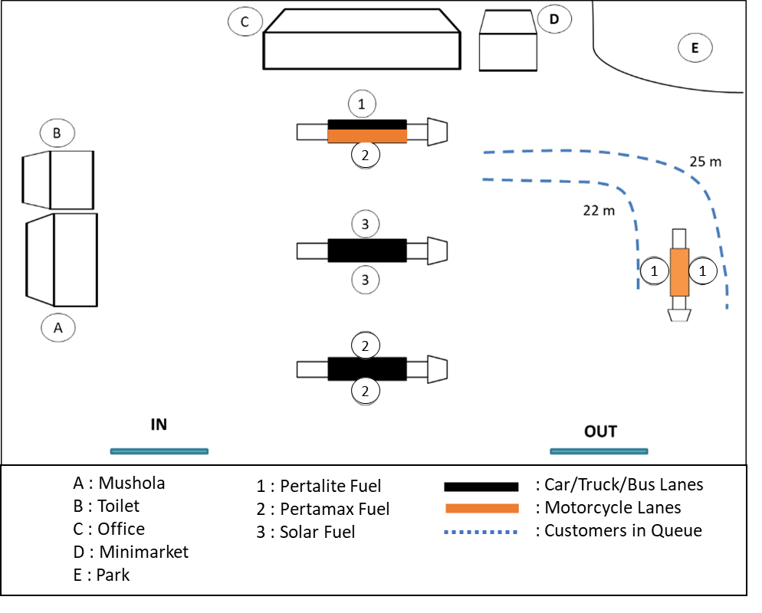

FIGURE 1
VISUALIZATION OF GAS STATION SERVICE FACILITIES
Figure 1 has several parameters based on measurements in the field as follows:
• The queuing system length of track (LT) on channels 1 are 22 m and 25 m.S
• Assuming the average length of a motorcycle is 2 m.
• Assuming the distance between vehicles in the queue is 0.5 m.
With these parameters it can be seen that the total length of a vehicle:
Total length per vehicle= L average + Distance between vehicles
= 2 + 0,5 m
= 2,5 m
From the calculation above, the vehicle's total length in the queuing system can be seen based on the analysis of queuing models every hour. The formula for calculating the total length of vehicles in the queuing system is:
The total length of vehicles in the system (LV)= Ls x total length of vehicles
= Ls x 2,5 m
The results of the study presented in Table 2 mean that there is a difference in the length of the overall vehicle in the queue system every hour. At 06.00-07.00 am, the average number of vehicles in the system is 2 motorcycles with a total length of vehicles in the system 5 m. Furthermore, at 07.00-08.00 am, the average number of vehicles in the system is 1 motorcycle with a total length of 2.5 m. This means that at 07.00-08.00 am. The queue is already looser than the queue at 06.00-07.00 am.
Table 2
LENGTH OF TRACK AND LENGTH OF VEHICLE
Period (Hours) | Length of Track (LT) |  | Total Length of Vehicle (LV) | Evidence
 | Channel 5 | Channel 6
06.00-07.00 am | 22 m | 25 m | 5 m | Feasible (LV < LT)
07.00-08.00 am |  |  | 2,5 m | Feasible (LV < LT)
03.00-04.00 pm |  |  | 10 m | Feasible (LV < LT)
04.00-05.00 pm |  |  | 5 m | Feasible (LV < LT)
At 03.00-04.00 pm, the average number of vehicles in the system is 4 motorcycles with a total length of vehicles in the system of 10 m. Meanwhile, at 04.00-05.00 pm, the average number of vehicles in the system is 2 motorcycles, with a total length of vehicles in the system is 5 m. This means that the queue that forms at 03.00-04.00 pm is longer than the queue that forms at 04.00-05.00 pm.
Based on the calculation above, it can be seen that the total length of the vehicle in the system does not exceed the length of the queue line on channel 5 and channel 6 (LV < LT, then the layout at Ngasinan Gas Station is declared eligible and no risk of resulting in the vehicle lane on another channel disturbed.
Discussion
The refueling service at the gas station, the conditions and situations faced change every day. The number of consumers who come to meet their daily fuel needs varies, so the queues that occur in the service system have different lengths. This queuing problem can be overcome by implementing a well-managed queuing system. Queuing system calculations can be used to determine the queue length according to the layout design of each gas station.
The calculation results with the multiple-lane queuing model show that the queuing system's performance on the motorbike refueling line at the Ngasinan Wonosobo gas station is effective. This can be seen from the queuing model's calculation results, which shows that in the period 06.00-08.00am and 03.00-05.00 pm, the average number of consumers in the queue system is 1-4 motorcycles.
This amount still includes the number of standard queues that occur in a service system. The results of the performance of the queuing system on the motorcycle refueling line at the Ngasinan Wonosobo Gas Station also have an efficient time for consumers to use in the queuing system. This is evidenced by the results showing consumers' time in the queuing system, the lowest is 0.038 minutes, and the highest is 0.99 minutes. The time still includes the standard time used in the service system.
The results of the performance of the queuing system show that the layout of the Ngasinan Wonosobo Gas Station is feasible and does not risk disturbing the path of other vehicles passing through the gas station area. The analysis results can prove this on system performance and the total length of vehicles in the queuing system for 2-wheeled vehicles. The results obtained are that the total length of vehicles in the queuing system does not exceed the length of the queue line. The queuing system at the Ngasinan Wonosobo gas station with a layout design is adequate. This can be seen from the queues in the period from 03.00 – 04.00 pm. Even though at 03.00-04.00 pm, the queue at the Pertalite gas station for motorbikes has the longest queue compared to other hour periods, which is 10 m. However, this is still considered normal, even though it causes queues of vehicles that reach the outer limits of the gas station area so that it can interfere with the activities of other consumers outside the gas station area.
CONCLUSION
This paper proposes a new approach in queuing-based modeling and layout design for service management in a gas station. Vehicle traffic entering the gas gas station area allows vehicle traffic disturbances (especially during peak hours) so that there needs to be good service management. The findings and analyses have been considered, and the following conclusions can be presented which the decisions made thus far in terms of queuing models have been appropriate. According to research conducted in the morning (07.00-09.00 am) and afternoon (03.00-05.00 pm), customers find lineups to be very acceptable. With the queue analysis result, it can be seen that the total length of vehicles in the system does not exceed the length of the queue line so that the queuing system does not interfere with another vehicle lane. The queuing system at 03.00-04.00 pm has adequate performance. The results of the queuing analysis prove that the total length of the vehicle in the system does not exceed the length of the queue so that the queuing system does not interfere with other vehicle lanes. However, the queue length can reach the gas station park to disturb the gas station park users who are next to the filling line.
This study was conducted during regular times. The study results' recommendation shows the gas station's performance, which is in a state of sufficient fuel, the country's economy is in good condition, and the monetary situation is stable. Future studies need to consider crisis management for gas station managers, aesthetics in layout design, and other service factors that allow convenience in gas station service decisions.

REFERENCES
Bahar, S., Mananohas, M. L., & Montolalu, C. (2018). Queue System Model Using Arrival Patterns and Service Patterns for SIM Applicants at the Manado Police Resort SIM Administration Unit. D'CARTESIAN. https://doi.org/10.35799/dc.7.1.2018.19549.
Casban, C., & Nelfiyanti, N. (2019). Analisis Tata Letak Fasilitas Produksi Dengan Metode FTC dan ARC untuk Mengurangi Biaya Material Handling. Penelitian dan Aplikasi Sistem dan Teknik Industri, 13(3), 262-274.
Fazlollahtabar, H., & Gholizadeh, H. (2019). Economic analysis of the M/M/1/N queuing system cost model in a vague environment. International Journal of Fuzzy Logic and Intelligent Systems, 19(3), 192-203.
Ginting. (2014). Queuing System Analysis and Optimization of Teller Services (Case Study at Bank X in Semarang City). https://doi.org/10.14710/jsmo.v11i1.13162.
Grozev, D., Milchev, M., & Georgiev, I. (2020). Study the work of specialized car service as queue theory. Mathematical Modeling, 4(1), 31-34.
Itoh, E., & Mitici, M. (2020). Analyzing tactical control strategies for aircraft arrivals at an airport using a queuing model. Journal of Air Transport Management, 89, 101938. https://doi.org/10.1016/j.jairtraman.2020.101938
Indriani, L., & Mukhyi, A. M. (2013). Leading Sector of the Indonesian Economy: Input-Output Approach. Proceeding PESAT (Psychology, Economics, Literature, Architecture & Civil Engineering)
Krajewski, Lee J., Larry, R., & Manoj, K.M. (2010). Operations Management Process and Supply Chains, 9th edition. New Jersey: Pearson Education, Inc
Nacy, N. G., & Ibrahim, S. T. (2019). Using queuing theory to solve the problem of momentum to issuing the driving licenses in Dohuk city. Academic Journal of Nawroz University, 8(4), 136-143.
Putri, R. E., & Ismanto, W. 2019. The Effect of Redesigning the Layout of Facilities in the 5s-Based Work Operational Area for Business Capital Application. Journal of Dimensi. https://doi.org/10.33373/dms.v8i1.1824.
Ramseook-Munhurrun, P., Lukea-Bhiwajee, S. D., & Naidoo, P. (2010). Service quality in the public service. International journal of management and marketing research, 3(1), 37-50.
Romney, M.B., & Steinbart. (2015). Accounting Information Systems. 13th Ed. England: Pearson Educational Limited
Stojčić, M., Pamučar, D., Mahmutagić, E., & Stević, Ž. (2018). Development of an ANFIS Model for the Optimization of a Queuing System in Warehouses. Information, 9(10), 240.
Zeng, J., & Wan, R. (2018). Multilevel Layout Planning of Port Space Designs in Marine Transportation Systems. Journal of Coastal Research, (82 (10082)), 163-167. https://doi.org/10.2112/SI82-023.1

