**The Influence of Digital Talent and Green Innovation on Digital Transformation and Its Impact on the MSME Business Model in the Metaverse Era**

**Reniati Reniati1);Endang Bidayani2);Sumiyati Sumiyati3)**

**1)**[**r3ni4ti@gmail.com**](mailto:r3ni4ti@gmail.com)**, Bangka Belitung University, Indonesia\***

**2)**[**endangbidayani@gmail.com**](mailto:endangbidayani@gmail.com)**, Bangka Belitung University, Indonesia**

**3)**[**sumiyati.lec2019@gmail.com**](mailto:sumiyati.lec2019@gmail.com)**, Bangka Belitung University, Indonesia**

*) Corresponding Author

**ABSTRACT**

The presence of globalization, the 4.0 industrial revolution, the digitalization of the economy, and the Covid-19 pandemic pose a formidable challenge to micro, small and medium enterprises (MSMEs) in Indonesia. The crisis that occurred during the last two years forced all business entities to think hard about how to carry out digital transformation. This condition, MSMEs are not fully ready to face this condition. The challenge for MSME actors is their low digital talent in carrying out the change. The presence of digital talent and green innovation is significant to keep businesses afloat in creating a market and getting out of competition, and that is not easy.

**Objectives**: Study this aim for Looking for MSME Business Models to Enter the Metaverse Era Through Digital Transformation With Increase Digital Talent and Green Innovation

**Methodology**:This type of research is quantitative research.A study was carried out in 5 regencies/cities on Bangka Island with respondents 10 2 SMEs. In this study, the author uses the analytical method used to test the PLS (Partial Least Square) variable using SmartPLS software. The path analysis model of all latent variables in Partial Least Square (PLS) consists of an outer model, convergent validity, and discriminant validity. Then carried out with a reliability test and a structural model consisting of Coefficient of Determination (R 2 Value), Effect Size (f 2), and Predictive Relevance (Q2 Value). Next, test the hypothesis and test the moderating effect.

**Conclusion**: The results of this study indicate that hypothesis testing concluded that two research hypotheses are accepted, and the other three are rejected. The accepted research hypotheses are H1: Digital Talent -> Digital Transformation and H4: Digital Talent -> MSME Business Model in the Metaverse Era. These results indicate that only digital talent currently contributes significantly to Digital Transformation and the MSME business model in the metaverse Era

**Keywords**: Metaverse, Digital Talent, Green Innovation, and Digital Transformation.

Submitted: Revised: Accepted:

**Article Doi:**

**INTRODUCTION**

The presence of globalization, the industrial revolution 4. o, the digitalization of the economy, and the Covid-19 pandemic pose a formidable challenge to micro, small and medium enterprises (MSMEs) in Indonesia. The crisis that occurred during the last two years forced all business entities to think hard about how to carry out digital transformation. The challenge for MSME actors is their low digital talent in carrying out the change even though the presence of digital talent is significant to keep the business afloat in creating a market and getting out of competition that is not easy. This condition, MSMEs are not fully ready to face this condition.

When viewed from the digital economy ecosystem in Indonesia, it still needs improvement. Indonesia's Digital Competitiveness or Index (DCI) ranking in 2020 ranks 56 out of 63 DCI countries. This index measures countries' ability, capacity, and readiness to adopt and export digital technology for economic transformation. The low digital competitiveness further sharpens the threat when global competitors enter the domestic market. As the dominant force in the Indonesian economy, it is very likely to reduce their income, increasing poverty and unemployment rates.

The rapid development of the disruptive era has now entered a period of Metaverse or 3D, which is known as an age that rests on four areas: immersive realism, ubiquitous access and identity, interoperability, and scalability (Dionisio et al., 2013). The current astonishing speed, coupled with the Covid-19 Pandemic, has made every organizational leader, both profit-oriented and non-profit-oriented, successful in facing a market full of uncertainty (VUCA). Digitalization has penetrated all aspects of life, and in the business world, it is not only for big businesses but also for small businesses that must innovate. Increasing digitization accelerates collaboration, and companies must be more democratic in their decision-making processes. The current uncertain and rapidly changing conditions require companies to adapt quickly and constantly to maintain market efficiency, strengthen and increase pressure to adapt and be innovative and agile, especially for what is of concern to MSMEs. Habicher et al., (2022) The main objective of digital transformation is redesigning an organization's business through the introduction of digital technology, achieving benefits such as increased productivity, reduced costs, and innovation. Digital transformation is the practical use of the internet in data-driven design, manufacturing, marketing, sales, presentation, and management models (Ulas, 2019).

Ismail Gulle, Chair of the Turkish Exporters Assembly, stated that the Covid-19 crisis changed the state's science, technology, and innovation (STI) policy, prioritizing resilience, environmental, and sustainability and encouraging innovation in tools. The new one.

Based on data from the Office of Industry and Trade 2021 in Province Bangka Belitung Islands, the number of SMEs is 20,403 units spread over seven regencies/cities. Of the number, the of course still dominated by -based industry food amounted to 13,908 classified in food and beverage-based commodities, followed by Chemicals and Building Materials amounting to 2,516 consisting of industries made from chemicals and building materials as well as furniture for households, then Metal and Electronics amounting to 1,598 related to metal mining and electronics industry, then there are 1,445 handicrafts which produce goods from hand skills and contain elements of art and added value, then the last is a clothing of 936 which is an industry related to the manufacture of clothing and apparel materials.

As seen from the growth of business units and personnel work, the condition of the Century pandemic continuously increased. However, of course, there is little experience decline in development. This matter needs to be anticipated by the related arena of digital talent, green innovation, and digital transformation to become imperative for SMEs.

**Table 1.** Growth and Percentage of Business Units and IKM Workers in the Province of the Bangka Belitung Islands 2016-2020

| Year | Growth of Small and Medium Industry Business Units in the Province of Bangka Belitung Islands 2016-2020 | Percentage of Growth of Small and Medium Industry Business Units in Bangka Belitung Islands Province 2016-2020 (%) | Growth of Small and Medium Industry Manpower in Bangka Belitung Islands Province 2016-2020 | Percentage of Labor Growth for Small and Medium Industries in Bangka Belitung Islands Province 2016-2020 (%) |
| --- | --- | --- | --- | --- |
| 2016 | 12.843 | 5,22 | 35.036 | 3,84 |
| 2017 | 15.219 | 18,50 | 37.990 | 8,43 |
| 2018 | 17.123 | 12,51 | 40.004 | 5,30 |
| 2019 | 18.544 | 8,30 | 41.954 | 4,87 |
| 2020 | 20.403 | 10,02 | 45.351 | 8,10 |

Sumber :Department of Industry and Trade of the Bangka Belitung Islands Province (2021)

**LITERATURE REVIEW**

**Metaverse**

The word Metaverse is a portmanteau of the prefix "meta" (meaning "beyond") and the suffix "verse" (short for "universe"). So literally means the universe beyond the physical world. More specifically, this "outer universe" refers to the computer-generated world, distinguishing it from metaphysical or spiritual concepts from domains outside the physical realm. Moreover, Metaverse refers to a fully immersive three-dimensional digital environment, in contrast to the more inclusive idea of cyberspace(Dionisio et al., 2013). Metaverse is a multi-user, real-time virtual space where individuals worldwide can connect through networks, coexist, socialize, and exchange value (Davis, 2021). Based on the book (Peters, 2021), "The Metaverse is a vast network of persistent 3D environments rendered in real-time that supports identities, objects, history, payments, and rights, and can be experienced simultaneously by an almost unlimited number of users. Limited, each with their sense of presence."

Corwen (2021)states that Metaverse can be characterized as a multi-user, real-time virtual world where individuals from all over the world can connect via networks, coexist, socialize, and exchange value. Metaverse distinguishes itself with the potential for users to create and exchange materials used to modify the environment around them in a more or less continuous state. A further statement on the Metaverse by (Russel, 2021), Metaverse is set to be a digital world that takes pieces from several other planets to create a world that includes everything from social media, online gaming, virtual reality, augmented reality, cryptocurrency, and even the physical world will unite to form the Metaverse. Metaverse is set to grow and create an online space where users interact in more multidimensional layers than today's technology supports. Augmented reality uses visual, sound, and other sensory input elements to provide the best user experience.

**Digital Talent**

Due to digitization, organizations across all industries aim to digitize products, services, and processes, leading to a significant increase in the demand for digital talent (Nafi’ah, 2021). To be able to process and do business digitally, there are several key capabilities that the organization must master. Some key capabilities include mastery of digital technology, application of digital culture, development of digital talent, and other essential characteristics of the digital era. In order to obtain and develop existing talents so that they become digital talents who are ready to contribute, large companies, to accelerate the acquisition of digital talent who are already working, are often assisted by several digital talent provider partners. In some practices, these companies may cooperate with more than 1 (one) partner provider. Over time, it is necessary to periodically evaluate the quality of digital talents supplied by the existing partners so that in the future, it can be prioritized in the collaborative process of procuring digital talent with these partners so that the order of procurement priority can be carried out based on the ranking of the provider partners—existing digital talent (Kurniawan, 2020).

According to (Fai Pun, 2006), digital talent is a cluster of human resources in an organization that values digital skills at the advanced and expert levels and has high digital business judgment skills. In 2020 it was estimated that the global average composition of digital talent in an organization is 20%. In general, there are 5 (five) human resource clusters where what can be called digital talents are 3 (three) clusters, namely (1) digital bridge-builders, (2) digital experts, and (3) digital leaders. Below is a chart of digital talent clusters in an organization according to Caye:

**Figure 1.** Digital Talent Cluster

**Digital**

**business**

**appraisal**

**skills**

Digital Talent

5 groups of digital workface

1. Digital newcomer
2. Digital immigrants and digital natives
3. Digital bridge construction

* Good understanding of devices and software
* Non-IT main profession, support digital product development

1. Digital Expert

* Experts across the digital value chain
* Provide digital experts to build digital products

1. Digital leader

* Lead and develop digital initiatives/strategies, communicate digital ideas

Not perfect

Base

Advanced

Expert

**Digital Skills**

Source: Caye, 2015

Many pre-digital companies are trying to recruit digital talent in response to the lack of digital competence in the workforce. For example, to develop more than 60 percent of its internal operating system, Volkswagen hopes to increase its IT professional staff from 2,000 employees in 2019 to more than 10,000 by 2025 (Menzel, 2020). However, as demand for digital talent far exceeds supply, many pre-digital companies have struggled with digital transformation. Given that one of the tasks of recruitment is to produce a large number of qualified candidates who meet the requirements of the company (Barber, 1998), it becomes clear that recruitment also plays a role in the digital transformation of pre-digital companies; This means that recruitment needs to support digital transformation by attracting digital talent. However, pre-digital organizations have found it challenging to recruit digital talent for at least two reasons: First, the limited supply of digital talent, combined with high demand, is leading to a 'war for digital talent' (Gilch & Sieweke, 2021) between the two. -digital and born-digital organizations. Second, unlike digital-born organizations, pre-digital organizations are somewhat unfamiliar with the new target group of digital talent. These skilled workers are also unfamiliar with these pre-digital organizations. As a result, attracting digital talent is a challenge, especially for pre-digital organizations.

**Green Innovation**

The concept of green innovation was first proposed by Fussler and James (1996), which refers to improvements and innovations in product processes that enhance a firm's environmental performance. In addition, Borghesi et al. (2015) refer to green innovation as an innovative process and use of resources that can reduce production costs and improve organizational performance. Previous studies have illustrated the importance of green innovation on firms' economic, environmental, and social performance and enhancing organizational excellence (Asadi et al., 2020;Tamayo-Orbegozo et al., 2017).

(Luo et al., 2005) point out the importance of leveraging green innovations by adequately allocating resources that reduce harmful environmental impacts. In particular, some scholars assert that green entrepreneurial orientation includes environmental and social orientation (Guo et al., 2020). Further, GEO consists of social orientation and innovation. In particular, as a strategic move, green entrepreneurial orientation (GEO) can facilitate the production of innovative green products that will help improve sustainable business performance (Teece, 2016). Green innovation allows companies to develop and produce products that positively impact the environment (Huang & Li, 2017).

Green innovation involves using new products, methods, materials, etc. It reduces the use of natural resources and limits the release of toxic substances into the environment (Ghisetti et al., 2017). It can act as a possible solution to address the growing problems of SMEs. SMEs are trying tirelessly to implement green practices because effective implementation will result in a competitive advantage over others and is sustainable in the long term (Zhu & Sarkis, 2004). However, SMEs face many obstacles in implementing and eventually adopting green innovation practices.

Green innovation is the production, assimilation, or exploitation of a product, production process, service or management, or business method that is new to the organization (developing or adopting it) and results throughout its life cycle. In reducing environmental risks, pollution and other negative impacts of resource use (including energy use) are compared with relevant alternatives (Gupta & Barua, 2018). Similarly, green innovation is considered a new or modified process, product, or service that reduces environmental damage. Beise & Rennings, 2005; De Marchi, 2012. It is also defined as "the introduction of new or significantly improved products (goods or services), processes, organizational changes or marketing solutions that reduce the use of natural resources (including materials, energy, water, and land) and reduce the release of hazardous substances throughout the product life cycle world (Ghisetti et al., 2017).

Green innovation represents new processes, tools, systems, practices, products, and methods that add business value through minimizing negative impacts on the environment and promoting sustainable goals Leal-Millán et al., 2016;Oltra & Saint Jean, 2009. In the new era of the environment, green innovation practices (e.g., recycling, reuse, eco-design, etc.) have emerged as inevitable actions that positively contribute to the global struggle to eliminate carbon emissions and save energy, water, and natural resources. , seize toxic products and materials, and control the adverse effects of global warming on resource conservation. The adoption of green innovations has become an essential topic in the contemporary business and innovation literature due to greater awareness of sustainability and its impact on business performance and competitiveness (Cheng et al., 2014).

**Digital Transformation**

According to (Fitzgerald et al., 2014), digital transformation is the use of new digital technologies (social media, mobile, analytics, or embedded devices) to enable key business improvements such as improving customer experience, streamlining operations, or creating new business models. Meanwhile, (Liu, et al., 2011) define digital transformation as an organizational transformation that integrates digital technology and business processes in the digital economy. Digital transformation is not just about technology. It is also about strategy. In addition, the senior leadership team must find ways to take advantage of new and unexpected business model innovations that optimize customer needs and experience. So it can be concluded that digital transformation is a process or business for companies to facilitate the relationship between customers and the company itself, simplifying various processes by changing business models through the latest technology (Fachrunnisa et al., 2020).

Research by (Li, et al., 2018) on digital transformation in SMEs explains that SME actors carry out digital transformation by utilizing the availability of digital platforms, digital investment (ICT), social capital development (Torres, et al., 2018), building business team, and improve the capabilities of all members in the organization. Not only using technical capabilities to carry out digital transformation (Information Systems).

The digital transformation causes changes driven by technological developments in organizations and society, according to (Henry Lucas, et al, 2013). These changes are related to the adjustment of business processes and changes in the relationship between companies, employees, customers, and markets. Digital transformation and innovation of fundamental business models are changing the resulting expectations and behavior of consumers, suppressing traditional companies, and disrupting many markets (Verhoef, 2019). Ongoing changes in customer needs and behavior are forcing companies and public administrations to take the lead in digital transformation (Nachit & Belhcen, 2020).

The following is a picture of the framework of thought in the research. The independent variables are digital talent (X1) and Green Innovation (X2). In contrast, the dependent variable is digital transformation (Y) and is moderated by the MSME Business Model variable in the Metaverse Era (Z).

**Figure 2.** Framework of Thought

Talenta Digital (X1)

Model Bisnis UMKM di Era Metaverse (Z)

Green Innovation (X2)

Transformasi Digital(Y)

The hypotheses in this study are:

H1:There is an influence of digital talent on Digital Transformation

H2:There is an effect of green innovation on Digital Transformation

H3:There is an effect of Digital Transformation on the MSME business model in themetaverse era

H4:There is an influence of digital talent on the MSME business model in the metaverse era

H5:There is an effect of green innovation on the MSME business model in the metaverse era

**METHOD**

This research was conducted on MSMEs in Bangka Island's Regency/ City area. The variables measured in this study are Digital Talent, Green Innovation, and Digital Transformation of MSME Business Models in the Metaverse Era.This type of research is quantitative research. Data collection in this study was conducted by survey method with in-depth interviews and questionnaires, providing a list of statements to respondents.The population in this study is MSMEs in the Province of the Bangka Belitung Islands, with a sample of 102. Data collection methods used to obtain the data needed in this study are questionnaires and documentation. This study uses a research instrument in the form of questions on a closed questionnaire using a Likert scale (5 points).

In this study, the author uses the analytical method used to test the PLS (Partial Least Square) variable using SmartPLS software. The path analysis model of all latent variables in Partial Least Square (PLS) consists of an outer model, convergent validity, and discriminant validity. Then carried out with a reliability test and a structural model consisting of Coefficient of Determination (R 2 Value), Effect Size (f 2), and Predictive Relevance (Q2 Value). Next, test the hypothesis and test the moderating effect.

**Figure 3.** Path diagram with PLS

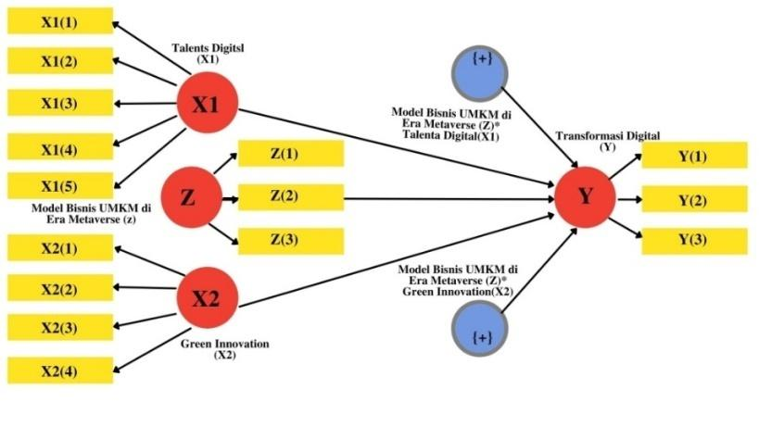

Source: Data processed, 2022

**RESULTS AND DISCUSSION**

**Results**

The items' validity analysis results are shown from the loading score. The intelligent method found two items whose loading factor value is less than 0.50, namely items X1.1 and X2.4. (Figure 4) These two items are invalid, with a z-count value of less than 1.96 (Figure 5). So it should be excluded from the analysis.

**Figure 4.** Initial Model (loading factors)

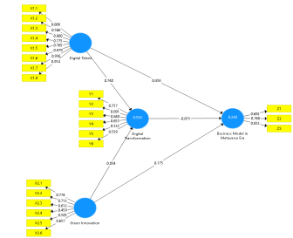

Source: Data processed, 2022

**Figure 5.** Initial model (z-values)

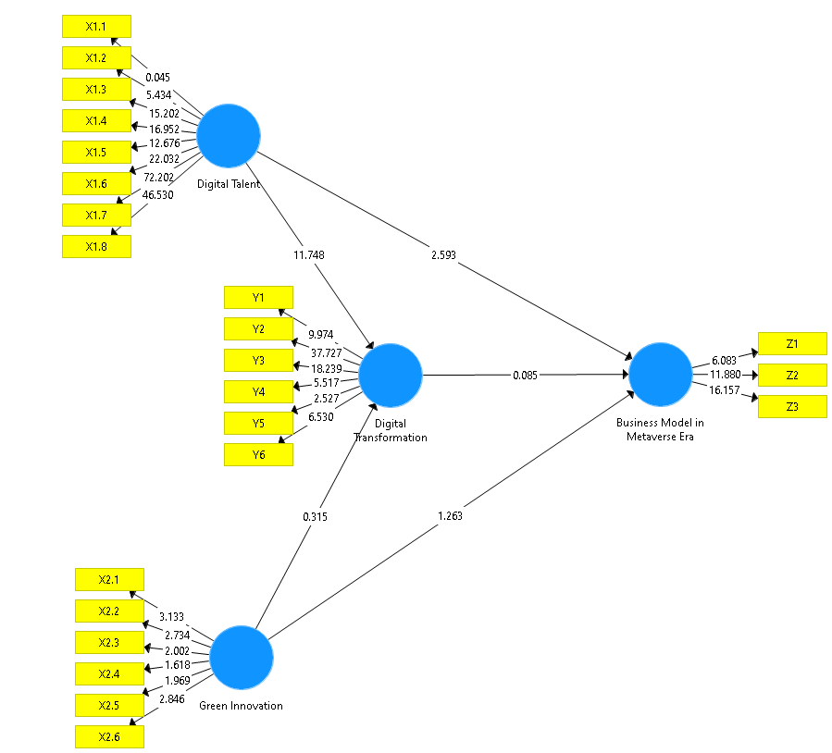

Source: Data processed, 2022

After being ejected from analysis, conducted reliability analysis using four statistics, namely Cronbach's Alpha, rho_A, Composite Reliability, and Average Variance Extracted (AVE). Analysis results find all variables have more Cronbach's Alpha, rho_A, and Composite Reliability significant from 0.60 to declare all instruments are reliable. Furthermore, both items were excluded from the analysis.

**Table 2.** Reliability

| Variables | Cronbach's Alpha | rho_A | Composite Reliability | Average Variance Extracted (AVE) |
| --- | --- | --- | --- | --- |
| MSME Business Model in the Metaverse Era | 0.647 | 0.660 | 0.809 | 0.587 |
| Digital Talent | 0.910 | 0.922 | 0.931 | 0.661 |
| Digital Transformation | 0.765 | 0.839 | 0.836 | 0.480 |
| Green Innovation | 0.677 | 0.683 | 0.790 | 0.434 |

Source: Data processed, 2022

Furthermore, discriminant reliability analysis was carried out. For the measurement of discriminant reliability, Fornel-Larcker criteria and cross-loading examination were used. The value of discriminant reliability (correlation between constructs) for each variable must be smaller than the square root of AVE. The analysis results show that all correlation values between constructs are smaller than the square root of AVE. So it can be concluded that the instrument has good discriminant reliability.

**Table 3.** Discriminant Reliability

|  | MSME Business Model in the Metaverse Era | Digital Talent | Digital Transformation | Green Innovation |
| --- | --- | --- | --- | --- |
| MSME Business Model in the Metaverse Era | 0.766 |  |  |  |
| Digital Talent | 0.458 | 0.813 |  |  |
| Digital Transformation | 0.341 | 0.745 | 0.693 |  |
| Green Innovation | 0.255 | 0.185 | 0.179 | 0.659 |

Source: Data processed, 2022

Table 3 describes the factor loadings for testing the research model. All items in external loading must be (>0.50). Furthermore, these values are depicted in Figure 6, and the z-count value is shown in Figure 7.

**Table 4.** Confirmatory Factor Analysis

| Indicators | Original Sample (O) | T Statistics (|O/STDEV|) | P Values |
| --- | --- | --- | --- |
| Digital Talent | | | |
| X1.2 <- Digital Talent | 0.564 | 5.129 | 0.000 |
| X1.3 <- Digital Talent | 0.802 | 14.927 | 0.000 |
| X1.4 <- Digital Talent | 0.773 | 16.451 | 0.000 |
| X1.5 <- Digital Talent | 0.765 | 13.065 | 0.000 |
| X1.6 <- Digital Talent | 0.880 | 22.326 | 0.000 |
| X1.7 <- Digital Talent | 0.936 | 76.142 | 0.000 |
| X1.8 <- Digital Talent | 0.915 | 49.561 | 0.000 |
| Green Innovation | | | |
| X2.1 <- Green Innovation | 0.781 | 3.343 | 0.001 |
| X2.2 <- Green Innovation | 0.717 | 3.032 | 0.003 |
| X2.3 <- Green Innovation | 0.579 | 2.257 | 0.024 |
| X2.5 <- Green Innovation | 0.528 | 2.136 | 0.033 |
| X2.6 <- Green Innovation | 0.658 | 2.657 | 0.008 |
| Digital Transformation | | | |
| Y1 <- Digital Transformation | 0.737 | 9.981 | 0.000 |
| Y2 <- Digital Transformation | 0.891 | 34.381 | 0.000 |
| Y3 <- Digital Transformation | 0.850 | 19.659 | 0.000 |
| Y4 <- Digital Transformation | 0.653 | 5.249 | 0.000 |
| Y5 <- Digital Transformation | 0.323 | 2.726 | 0.007 |
| Y6 <- Digital Transformation | 0.539 | 6.943 | 0.000 |
| MSME Business Model in the Metaverse Era | | | |
| Z1 <- MSME Business Model in the Metaverse Era | 0.694 | 5.790 | 0.000 |
| Z2 <- MSME Business Model in the Metaverse Era | 0.768 | 12.901 | 0.000 |
| Z3 <- MSME Business Model in the Metaverse Era | 0.831 | 16.530 | 0.000 |

Source: Data processed, 2022

**Figure 6.**Final Model (Loading factors)

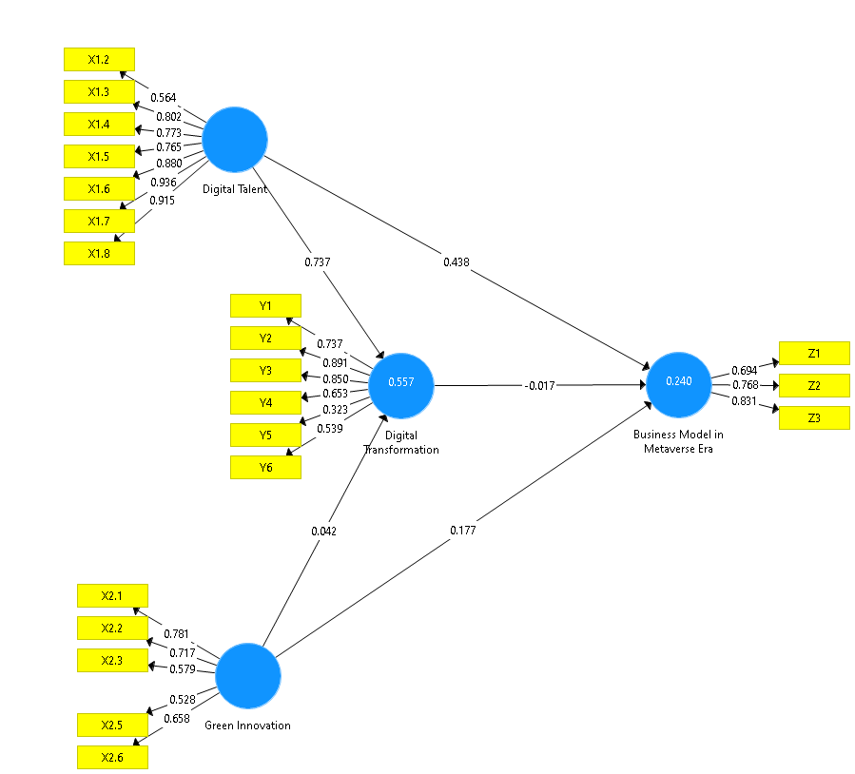

Source: Data processed, 2022

**Figure7.** Final Model (z-value)

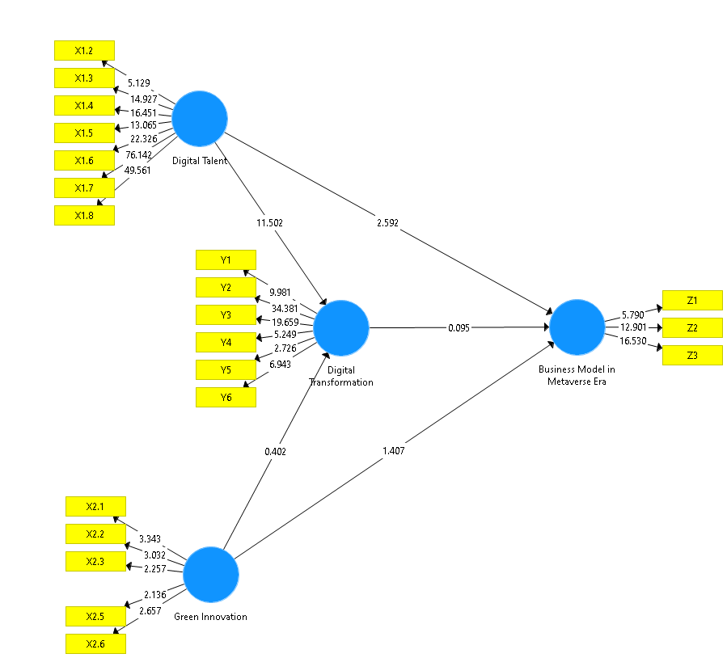

Source: Data processed, 2022

Figure 6 clearly shows all loading factor values greater than 0.50. Figure 7 shows that all z-values for each outer model have values greater than 1.96, indicating that all items are statistically valid. Subsequently, when testing the research hypothesis, the results which are shown in Table 5 below:

**Table 5.** Path Coefficient

| Hyphotesis | Original Sample (O) | T Statistics (|O/STDEV|) | P Values | Decision |
| --- | --- | --- | --- | --- |
| H1: Digital Talent -> Digital Transformation | 0.737 | 11.502 | 0.000 | Accept |
| H2: Green Innovation -> MSME Business Model in the Metaverse Era | 0.177 | 1.407 | 0.160 | Reject |
| H3: Digital Transformation -> MSME Business Model in the Metaverse Era | -0.017 | 0.095 | 0.924 | Reject |
| H4: Digital Talent -> MSME Business Model in the Metaverse Era | 0.438 | 2.592 | 0.010 | Accept |
| H5: Green Innovation -> Digital Transformation | 0.042 | 0.402 | 0.687 | Reject |

Source: Data processed, 2022

Based on the results of hypothesis testing, two research hypotheses were accepted, and the other three were rejected. The accepted research hypotheses are H1: Digital Talent -> Digital Transformation and H4: Digital Talent -> MSME Business Model in the Metaverse Era. These results indicate that only digital talent currently contributes significantly to Digital Transformation and the MSME business model in the metaverse era.

**Discussion**

**Digital talent affects digital transformation.**

Hypothesis testing with the PLS approach resulted in a direct coefficient of digital talent on digital transformation significantly with a path coefficient of 0.737 and a t-statistic of 11,502 at 5% (t-count value > t-table value = 1.96). Because t-count is greater than t-table and p-value < 5%, there is sufficient empirical evidence to accept H1 which states that digital talent affects digital transformation. Based on the perception of respondents to MSME actors on Bangka Island that the digital talent possessed by MSME actors is able to increase the current digital transformation. MSME actors are digital newcomers, have a good understanding of hardware and software, although their main profession is not as an IT expert, but supports the development of digital products, provides digital expertise to build digital, leads and develops digital initiatives, develops digital strategies, promote digital ideas, but it is still low as an expert on the whole digital chain. This is in accordance with the findings of research (Menzel, 2020).

**Green innovation doesn't affect the MSMe business model in the metaverse era.**

Hypothesis testing with the PLS approach resulted in the direct coefficient of green innovation on the MSMe business model of the Metaverse Era not being significant with a path coefficient of 0.177 and a t-statistic of 1.407 at 5% (t-count value < t-table value = 1 ,96). Because t-count is smaller than t-table and p-value < 5%, there is sufficient empirical evidence to reject H1 which states that green innovation has no effect on the MSME business model of the Metaverse Era. Based on the respondent's perception of MSME actors on Bangka Island that green innovation carried out by MSME actors is still very limited so that it has not become a business model to face the metaverse era. Among other things, the use of product equipment that has not used the green innovation concept, the product concept has not been green innovation, the added value of the product is not in accordance with the green innovation concept, and does not promote sustainable development goals. But it has always been implemented trying to minimize the negative impact on the environment. This is in accordance with the research of (Gupta & Barua, 2018).

**Digital transformation doesn't affect the msme business model in the metaverse era.**

Hypothesis testing with the PLS approach resulted in a direct coefficient of digital transformation of the MSME business model in the Metaverse Era not significant with a path coefficient of -0.017 and a t-statistic of 0.095 at 5% (t-count value < t-table value = 1 ,96). Because t-count is smaller than t-table and p-value < 5%, there is sufficient empirical evidence to reject H1 which states that digital transformation has no effect on the MSME business model of the Metaverse Era. The digital transformation that has not been carried out is a change in digital payments, 80% of product marketing is still offline and 20% online. As for what has been implemented, they have digitized, namely the process of converting analog data into digital format, MSMEs have also done digitization, namely the use of digital technology to change a business model and provide new income from value opportunities that generate or can be called the process of moving to digital business. MSMEs have also carried out digital transformation supported by leadership driven by challenges to corporate culture, as well as the use of technology that empowers employees. According to research by (Nachit & Belhcen, 2020).

**Digital talent influences the msme business model in the metaverse era.**

Hypothesis testing with the PLS approach resulted in a direct coefficient of digital talent on the Metaverse Era MSME business model significantly with a path coefficient of 0.438 and a t-statistic of 2.592 at 5% (t-count value > t-table value = 1.96). Because t-count is greater than t-table and p-value < 5%, there is sufficient empirical evidence to accept H1 which states that digital talent affects the MSME business model in the Metaverse Era. Based on respondents' perceptions of MSME actors on Bangka Island, the digital talent possessed by MSME actors is able to improve the MSME business model of the Metaverse Era better at this time. Based on the perception of respondents to MSME actors on Bangka Island that the digital transformation carried out by MSME actors is still very limited so that it has not become a business model to face the metaverse era. MSME actors still don't know what the metaverse era is, but they already have the desire to prepare for the metaverse era but they don't know how. This is in accordance with the research submitted by Corwen (2021).

**Green innovation doesn't affect digital transformation.**

Hypothesis testing with the PLS approach resulted in the direct coefficient of green innovation on digital transformation not being significant with a path coefficient of 0.042 and a t-statistic of 0.402 at 5% (t-count value < t-table value = 1.96). Because t-count is smaller than t-table and p-value < 5%, there is sufficient empirical evidence to reject H1 which states that green innovation has no effect on digital transformation. Based on respondents' perceptions of MSME actors on Bangka Island that green innovation carried out by MSME actors is still very limited so it does not encourage digital transformation. This is in accordance with the research of Li, et al (2018).

**CONCLUSION**

The results of the analysis found two items that were declared invalid, namely X1.1 (I am a digital newcomer) and X2.4 (Do the products produced provide a lot of added value (benefits) according to the concept of green innovation). The results of hypothesis testing found that the digital talent variable was the most dominant in explaining the Digital Transformation variable and the MSME business model in the metaverse era.

The results of this research are as follows:

1. There is an influence of digital talent on Digital Transformation
2. There is no effect of green innovation on Digital Transformation
3. Digital Transformation has no effect on the MSME business model in the metaverse era
4. Digital talent does not affect the MSME business model in the metaverse era
5. Green innovation has no effect on the MSME business model in the metaverse era

**SUGGESTION**

1. To the Provincial Cooperatives and MSMEs Office to assist MSME actors by increasing digital talent, which is still at the rudimentary level and essential to advanced and expert levels.
2. Green innovation is believed to be an essential variable in future business management. Therefore, this mindset needs to be built for MSME players to open new markets and have a long-term social and economic impact.
3. The metaverse era is necessary because it needs to be prepared by increasing digital talent so they can carry out digital transformation.

**REFERENCES**

Asadi, S., OmSalameh Pourhashemi, S., Nilashi, M., Abdullah, R., Samad, S., Yadegaridehkordi, E., Aljojo, N., & Razali, N. S. (2020). Investigating influence of green innovation on sustainability performance: A case on Malaysian hotel industry. *Journal of Cleaner Production*, *258*, 120860. https://doi.org/10.1016/j.jclepro.2020.120860

Barber, A. (1998). Recruiting Employees: Individual and Organizational Perspectives. *Thousand Oaks, CA: SAGE*.

Beise, M., & Rennings, K. (2005). Lead markets and regulation: A framework for analyzing the international diffusion of environmental innovations. *Ecological Economics*, *52*(1), 5–17. https://doi.org/10.1016/j.ecolecon.2004.06.007

Cheng, C. C. J., Yang, C. L., & Sheu, C. (2014). The link between eco-innovation and business performance: A Taiwanese industry context. *Journal of Cleaner Production*, *64*, 81–90. https://doi.org/10.1016/j.jclepro.2013.09.050

Corwen, S. (2021). *METAVERSE INVESTING FOR BEGINNERS*. Metaverse.

Davis, W. J. (2021). *Metaverse Explained for Beginners ; A Complete Guide to Investing in Cryptocurrency, NFT, Blokchain, Digitsl Assets, Web 3 & Future Technologies.*Metaverse.

De Marchi, V. (2012). Environmental innovation and R&D cooperation: Empirical evidence from Spanish manufacturing firms. *Research Policy*, *41*(3), 614–623. https://doi.org/10.1016/j.respol.2011.10.002

Dionisio, J. D. N., Burns, W. G., & Gilbert, R. (2013). 3D Virtual Worlds and The Metaverse: Current Status and Future Possibilities. *ACM Computing Surveys*, *45*(3), 1–38. https://doi.org/10.1145/2480741.2480751

Fachrunnisa, O., Adhiatma, A., Lukman, N., & Ab Majid, M. N. (2020). Towards SMEs’ Transformasi Digital: The role of agile leadership and strategic flexibility. *Journal of Small Business Strategy*, *30*(3), 65–85.

Fai Pun, K. (2006). Determinants of environmentally responsible operations: a review. *Journal of Quality & Reliability Management*, *23*(3), 279–297.

Fitzgerald, M., Kruschwitz, N., Bonnet, D., & Welch, M. (2014). Embracing digital technology: A new stra¬tegic imperative. *MIT Sloan Management Review*, *55*(2), 1–12.

Ghisetti, C., Mancinelli, S., Mazzanti, M., & M Zoli. (2017). Financial barriers and environmental innovations: evidence from EU manufacturing firms. *Firms Clim Pol*, *17*(1), S131–S147.

Gilch, P. M., & Sieweke, J. (2021). Recruiting Talenta Digital: The strategic role of recruitment in organisations’ Transformasi Digital. *German Journal of Human Resource Management*, *35*(1), 53–82. https://doi.org/10.1177/2397002220952734

Guo, Y., Wang, L. F., & Chen, Y. (2020). Green Entrepreneurial Orientation and Green Innovation: The Mediating Effect of Supply Chain Learning. *SAGE Open*, *10*(1). https://doi.org/10.1177/2158244019898798

Gupta, H., & Barua, M. K. (2018). A grey DEMATEL-based approach for modeling enablers of green innovation in manufacturing organizations. *Environmental Science and Pollution Research*, *25*(10), 9556–9578. https://doi.org/10.1007/s11356-018-1261-6

Habicher, D., Erschbamer, G., Pechlaner, H., Ghirardello, L., & Walder, M. (2022). Transformation and Design Thinking: Perspectives on Sustainable Change, Company Resilience and Democratic Leadership in SMEs. *Leadership, Education, Personality: An Interdisciplinary Journal*. https://doi.org/10.1365/s42681-022-00028-x

Henry Lucas et al. (2013). Impactful Research on Transformational Information Technology: An Opportunity to Inform New Audiences. *MIS Quarterly*, *37*(2), 82–371. https://regional.kompas.com/read/2020/07/06/13520971/pertama-kali-dalam-sejarah-babel-ekspor-12-ton-lidi-nipah-ke-nepal?page=all

Huang, J. W., & Li, Y. H. (2017). Green Innovation and Performance: The View of Organizational Capability and Social Reciprocity. *Journal of Business Ethics*, *145*(2), 309–324. https://doi.org/10.1007/s10551-015-2903-y

Kurniawan, A. (2020). *Peringkatisasi Mitra Penyedia Talenta Digital Menggunakan Metode Analytic Hierarchy Process (AHP) Pada Tribe Enterprise Wholesale Digitization*. *1*(1), 13–29.

Leal-Millán, A., Roldán, J. L., Leal-Rodríguez, A. L., & Ortega-Gutiérrez, J. (2016). IT and relationship learning in networks as drivers of green innovation and customer capital: evidence from the automobile sector. *Journal of Knowledge Management*, *20*(3), 444–464. https://doi.org/10.1108/JKM-05-2015-0203

Li, L., Su, F., Zhang, W., & Mao, J. Y. (2018). Digital trans¬formation by SME entrepreneurs: A capability per¬spective. *Information System Journal*, *28*(6), 1129–1157.

Liu, D. Y., Chen, S. W., & Chou, T. C. (2011). Resource fit in Transformasi Digital. *Management Decision*, *49*(10), 1728–1742. https://doi.org/10.1108/09590550710728110

Luo, X., Zhou, L., & Liu, S. S. (2005). Entrepreneurial firms in the context of China’s transition economy: An integrative framework and empirical examination. *Journal of Business Research*, *58*(3 SPEC. ISS.), 277–284. https://doi.org/10.1016/S0148-2963(03)00159-0

Menzel, S. (2020). *VW-software-Einheit startet im Juli - Betriebssystem soll bis 2024 kommen*.

Nachit, H., & Belhcen, L. (2020). Transformasi Digital in Times of COVID-19 Pandemic: The Case of Morocco. *SSRN Electronic Journal*, *1*. https://doi.org/10.18202/jamal.2015.12.6031

Nafi’ah, B. A. (2021). Kesiapan Kebijakan Talenta Digital Di Indonesia. *Public Administration Journal of Research*, *3*(1), 17–28.

Oltra, V., & Saint Jean, M. (2009). Sectoral systems of environmental innovation: An application to the French automotive industry. *Technological Forecasting and Social Change*, *76*(4), 567–583. https://doi.org/10.1016/j.techfore.2008.03.025

Peters, L. (2021). *NFT Metaverse & DEFI "The Complete Guide To Invest And Build Wealth in a Decentralized World-How to Lend, Trade & Invest in Crypyocurrency and Digital Assets*. NFT.

Russel, J. (2021). *Metaverse for Beginners: A Complete Guide on How to Invest in the Metaverse*.

Tamayo-Orbegozo, U., Vicente-Molina, M. A., & Villarreal-Larrinaga, O. (2017). Eco-innovation strategic model. A multiple-case study from a highly eco-innovative European region. *Journal of Cleaner Production*, *142*, 1347–1367. https://doi.org/10.1016/j.jclepro.2016.11.174

Teece, D. J. (2016). Dynamic capabilities and entrepreneurial management in large organizations: Toward a theory of the (entrepreneurial) firm. *European Economic Review*, *86*, 202–216. https://doi.org/10.1016/j.euroecorev.2015.11.006

Torres, A. P., Marshal, M. I., & Sydnor, S. (2018). Does social capital pay off? The case of small business resilience after Hurricane Katrina. *Journal of Con¬tingencies and Crisis Management*, *27*(2), 168–181.

Ulas, D. (2019). Transformasi Digital Process and SMEs. *Procedia Computer Science*, *158*(137), 662–671. https://doi.org/10.1016/j.procs.2019.09.101

Verhoef Peter, et al. (2019). Transformasi Digital: A Multidisciplinary Reflection and Research Agenda. *Journal of Business Research 122(July 2018): 889–901.*, *122*(july), 889–901. https://swa.co.id/swa/csr-corner/yuswohady-ukm-harus-manfaatkan-perkembangan-digital

Zhu, Q., & Sarkis, J. (2004). Relationships between operational practices and performance among early adopters of green supply chain management practices in Chinese manufacturing enterprises. *Journal of Operations Management*, *22*(3), 265–289. https://doi.org/10.1016/j.jom.2004.01.005