Output artikel MA, MO

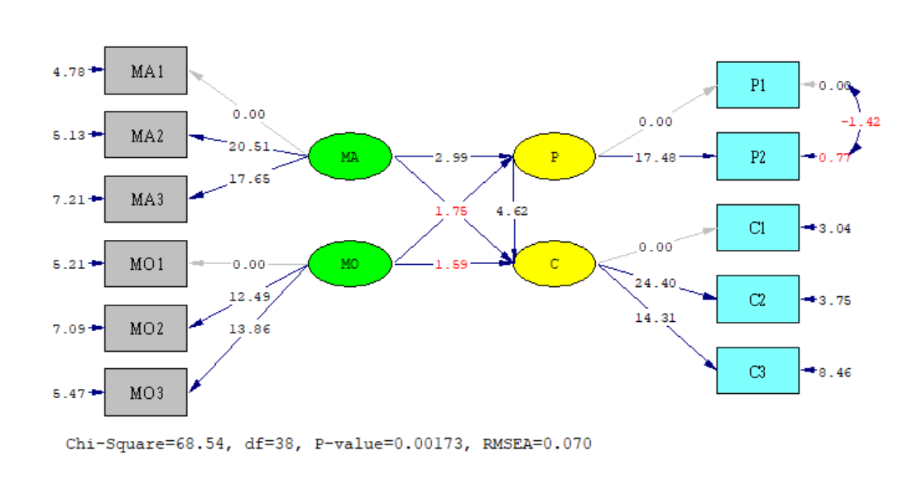

DATE: 1/12/2020
TIME: 10:03

L I S R E L 8.80

BY

Karl G. Jöreskog & Dag Sörbom

This program is published exclusively by
Scientific Software International, Inc.
7383 N. Lincoln Avenue, Suite 100
Lincolnwood, IL 60712, U.S.A.
Phone: (800)247-6113, (847)675-0720, Fax: (847)675-2140
Copyright by Scientific Software International, Inc., 1981-2006
Use of this program is subject to the terms specified in the
Universal Copyright Convention.
Website: www.ssicentral.com

The following lines were read from file D:\IIS241019\PATH1modif.spj:

Raw Data from file D:\IIS241019\DATA2910x.psf
Latent Variables EO MA LO MO DC P C

sample size =165
Relationships
MA1 = 1*MA
MA2-MA3 = MA

MO1 = 1*MO
MO2-MO3 = MO

P1 - P2 = P
set correlation between P2 P1 FREE

C1-C3 = C

P = MA MO
C = MA MO P

Path Diagram
Set the error variance of P1 to 0
Admissibility Check = Off
End of Problem

Sample Size = 165

Covariance Matrix

P1 P2 C1 C2 C3 MA1
-------- -------- -------- -------- -------- --------
P1 1.00
P2 0.90 1.00
C1 0.52 0.51 1.16
C2 0.49 0.47 1.01 1.04
C3 0.49 0.45 0.80 0.75 1.00
MA1 0.43 0.36 0.39 0.32 0.42 1.00
MA2 0.40 0.34 0.36 0.31 0.41 0.87
MA3 0.36 0.29 0.30 0.23 0.34 0.82
MO1 0.43 0.45 0.41 0.36 0.27 0.35
MO2 0.42 0.42 0.32 0.26 0.37 0.40
MO3 0.42 0.44 0.34 0.31 0.33 0.38

Covariance Matrix

MA2 MA3 MO1 MO2 MO3
-------- -------- -------- -------- --------
MA2 1.00
MA3 0.81 1.00
MO1 0.37 0.31 1.00
MO2 0.39 0.39 0.71 1.00
MO3 0.43 0.34 0.77 0.70 1.00

Number of Iterations = 7

LISREL Estimates (Maximum Likelihood)

Measurement Equations

P1 = 1.00*P,, R² = 1.00

P2 = 0.97*P, Errorvar.= 0.065 , R² = 0.94
(0.055) (0.085)
17.48 0.77

C1 = 1.04*C, Errorvar.= 0.086 , R² = 0.93
(0.028)
3.04

C2 = 0.97*C, Errorvar.= 0.097 , R² = 0.91
(0.040) (0.026)
24.40 3.75

C3 = 0.78*C, Errorvar.= 0.40 , R² = 0.60
(0.054) (0.047)
14.31 8.46

MA1 = 1.00*MA, Errorvar.= 0.13 , R² = 0.87
(0.026)
4.78

MA2 = 0.99*MA, Errorvar.= 0.14 , R² = 0.86
(0.048) (0.027)
20.51 5.13

MA3 = 0.93*MA, Errorvar.= 0.24 , R² = 0.76
(0.053) (0.033)
17.65 7.21

MO1 = 1.00*MO, Errorvar.= 0.22 , R² = 0.78
(0.043)
5.21

MO2 = 0.91*MO, Errorvar.= 0.35 , R² = 0.65
(0.073) (0.050)
12.49 7.09

MO3 = 0.99*MO, Errorvar.= 0.24 , R² = 0.76
(0.072) (0.043)
13.86 5.47

Error Covariance for P2 and P1 = -0.06
(0.044)
-1.42

Structural Equations

P = 0.25*MA + 0.45*MO, Errorvar.= 0.70 , R² = 0.30
(0.084) (0.094) (0.080)
2.99 4.78 8.81

C = 0.38*P + 0.15*MA + 0.16*MO, Errorvar.= 0.70 , R² = 0.30
(0.081) (0.088) (0.10) (0.086)
4.62 1.75 1.59 8.07

Reduced Form Equations

P = 0.25*MA + 0.45*MO, Errorvar.= 0.70, R² = 0.30
(0.084) (0.094)
2.99 4.78

C = 0.25*MA + 0.33*MO, Errorvar.= 0.80, R² = 0.20
(0.093) (0.10)
2.69 3.26

Covariance Matrix of Independent Variables

MA MO
-------- --------
MA 0.87
(0.11)
7.81
MO 0.39 0.78
(0.08) (0.11)
4.97 6.85

Covariance Matrix of Latent Variables

P C MA MO
-------- -------- -------- --------
P 1.00
C 0.51 1.00
MA 0.39 0.35 0.87
MO 0.45 0.35 0.39 0.78

Goodness of Fit Statistics

Degrees of Freedom = 38
Minimum Fit Function Chi-Square = 66.04 (P = 0.0032)
Normal Theory Weighted Least Squares Chi-Square = 68.54 (P = 0.0017)
Estimated Non-centrality Parameter (NCP) = 30.54
90 Percent Confidence Interval for NCP = (11.21 ; 57.71)

Minimum Fit Function Value = 0.40
Population Discrepancy Function Value (F0) = 0.19
90 Percent Confidence Interval for F0 = (0.068 ; 0.35)
Root Mean Square Error of Approximation (RMSEA) = 0.070
90 Percent Confidence Interval for RMSEA = (0.042 ; 0.096)
P-Value for Test of Close Fit (RMSEA < 0.05) = 0.11

Expected Cross-Validation Index (ECVI) = 0.76
90 Percent Confidence Interval for ECVI = (0.64 ; 0.93)
ECVI for Saturated Model = 0.80
ECVI for Independence Model = 13.04

Chi-Square for Independence Model with 55 Degrees of Freedom = 2116.77
Independence AIC = 2138.77
Model AIC = 124.54
Saturated AIC = 132.00
Independence CAIC = 2183.94
Model CAIC = 239.51
Saturated CAIC = 402.99

Normed Fit Index (NFI) = 0.97
Non-Normed Fit Index (NNFI) = 0.98
Parsimony Normed Fit Index (PNFI) = 0.67
Comparative Fit Index (CFI) = 0.99
Incremental Fit Index (IFI) = 0.99
Relative Fit Index (RFI) = 0.95

Critical N (CN) = 152.88

Root Mean Square Residual (RMR) = 0.043
Standardized RMR = 0.043
Goodness of Fit Index (GFI) = 0.93
Adjusted Goodness of Fit Index (AGFI) = 0.88
Parsimony Goodness of Fit Index (PGFI) = 0.54

The Modification Indices Suggest to Add an Error Covariance
Between and Decrease in Chi-Square New Estimate
C2 C1 8.3 0.29
MO1 C3 17.5 -0.12
MO2 C3 11.8 0.11

Time used: 0.031 Seconds

