Application of the Resource Sharing Innovation Model in Addressing the High Unemployment Rate in a Sustainable Way
Bambang Dwi Susesno^{1*}, Furtasan Ali Yusuf ², Syamsul Hidayat³, Dewi Surani⁴
¹Universitas Bina Bangsa, Banten Indonesia, bambangds_mm@binabangsa.ac.id
²Universitas Bina Bangsa, Banten, Indonesia, faysaabadi@gmail.com
³Universitas Bina Bangsa, Banten, Indonesia, mastersyah@gmail.com
⁴Universitas Bina Bangsa, Banten, Indonesia, suranidewiahead@gmail.com
*) Corresponding author

ABSTRACT
Objectives: The current study tries to explore the novelty of resource sharing innovation variable as a mediating variable to solve several contradictions regarding the correlation between vocational school graduates and industrial human competitiveness. Such exploration also aims to offer a new viewpoint regarding two variables namely skill development center and training revolving fund.
Methodology: The current study applied Research and Development (R&D) method which involved apprentice learners as the samples, who were selected from certain companies which were inviting apprentice learners graduated from vocational schools. Further data processing was performed through the software of IBM AMOS 2.2.
Finding: The study results were further anyzed in the form of triangulation for finding confirmation towards certain officers who managed apprenticeship program at the seven companies involved. The readiness towards Resource Sharing Innovation (RSI) was found to have a significant effect on the Industrial People Competitiveness.
Conclusion: The study conclusion made based on study findings indicated evidence that the novelty of Resource Sharing Innovation (RSI) was able to support the industrial human competitiveness.

Keywords: Resource Sharing Innovation;, Unemployment; Sustainability.

Submitted: Revised: Accepted:
Article Doi:
http://dx.doi.org/10.22441/jurnal_mix.2022.v11.001
INTRODUCTION
Data derived from BPS showed an increase in the employment rate among residents in Banten Province in 2018-2019 as many as 5.62 million residents and 5.68 million residents, respectively. Of the total number of employment, the dominant sector was trading sector which involved 23.88% (1.36 million people), and then processing industry sector which involved 19.97 % (1.13 million people), followed by agriculture, mining and quarrying sector which involved 12.72 % (722,120 people) [1].
In contrast to employment rate in Banten, the unemployment data in the period of August 2019 indicated the highest rate in Indonesia of 8.11%, compared to the total unemployment rate in Indonesia of 5.28%. Such unemployment rate revealed that Banten Province has not been successful in creating employment opportunities compared to other provinces [2]. Many efforts have been performed by the Provincial Government of Banten to solve the unemployment rate problem. However, in fact the outcomes are not satisfactory since Banten was ranked 2nd regarding national unemployment rate in 2017. In the following years, namely in 2018 as well as 2019, there was still a high unemployment rate in Indonesia, though the rate showed a relative decrease by 0.14% from 8.25% to 8.11% [1].
The three main industrial areas of Serang District, Cilegon City and Tangerang District surely have a potential to increase the employment rate, since manufacturing industries are located in those areas. There are many company units in Serang District, Tangerang District and Cilegon City namely 847 units, 3,858 units, and 878 units, respectively [3]. Such contrast finding is interesting since those areas account for the highest number of unemployment in Banten Province. The first contributor was Serang District which accounted for 10.65%. The next contributor was Cilegon District which accounted for 9.68% and then Tangerang District which accounted for 8.91% [1].
The current study aims to reveal an answer and solution in the form of a creative and suitable policy model to solve the crucial unemployment problem found in Banten [4]–[7]. Pigou broke fresh ground of the classical theory regarding labor [8]. He explains that demand and supply of labor can be found in the labor market. The derivative characteristic of demand for labor is related to industrial requirements. Such demand is derived from a decrease in the share of the marginal product of labor. Unemployment problem have also been previously investigted by prevous researchers such as Alghofari [9], Baeti [10], Budiani [11], Hadroj [12], Heriansyah, Nuraini, and Kusuma [13], Imsar [14], Machin and Manning [15], Santoso [16], Setiyawati and Hamzah [17], Winardi [18], and also Yacoub [19].

LITERATURE REVIEW
Training Revolving Fund
The government has made a lot of efforts to provide loans for job seekers which payments can be paid through installments. One way to overcome the risk of default due to layoffs is through a revolving training fund (TRF) which is protected by guarantee and insurance companies. Regional companies have an important role in implementing this assistance, especially in solving the problem of the large number of unemployed in the province of Banten more significantly. TRF has been widely applied in a sustainable and systematic manner in various other countries such as Malaysia, Singapore and France as well as 60 other countries. TRF has several schemes. One of the schemes is wherein the industrial sector contributes funds and further these funds are simultaneously managed by companies, industry associations and representatives of trade union [16]. TRF scheme can also be applied is the existence of a special institution established to manage government funds. This special institution has the obligation to distribute TRF to various company training centers which later must be used to organize programs for workers according to the needs of the company. Of course, such program is also closely related to the recruitment selection pattern which is based on the qualification standards set by companies [20].
Competence of Vocational School Graduates
Pigou was the first figure to explain the mechanism of labor supply and demand [8]. In his opinion, the competency-related requirements demanded of job seekers are always set by the industry. Another figure also expresses a slightly contradictory opinion, namely Mouhammed [21]. He states that the problem of unemployment almost always arises when the competence of graduates does not match the needs or demands of the industry, and this is a problem that almost always exists. A study conducted by Alghofari [9] and Baeti [10] presented other evidence related to the competency gap where the competency gap had damaged the relationship between employment and job availability. Hadroj [12] also put forward a similar argument that the gap between competence and labor market demand is the main factor that causes difficulties for school graduates to find work. This definitely drives the high unemployment rate which in the future can cause bigger problems.
Resources Sharing Innovation
Penros is the first figure to explain the theory of Resource Base Theory or abbreviated as RBV [22]. According to him, one of the drivers of internal expansion applied by every organization is managerial resources. This theory is supported by Barney [23] who explains that the factors that influence organizational excellence are assets, capabilities, and competencies. An organization can remain superior if it can have and maintain certain values ​​that cannot be imitated or replaced, rare, and also valueable. These factors can be called as company diversification which is recognized as the main thing that is able to encourage company expansion into various sectors (Rubin [24], Teece [25]). However, it cannot be denied that the internal managerial role is very important as the main determinant of the company's success in its expansion.
In the opinion of Shirado, et al [26], the rapid changes in the environment along with technological developments surely determine the operationals of the company. This is supported by collaboration between companies or between individuals who are recognized as being able to determine the success of resource management. To support the running of the company, it is necessary to have resource sharing activities where various parties exchange resource requirements or rent one another. In addition, making joint purchases and efforts to achieve the same economies of scale are also things that need to be performed since they can strengthen the production resources of each company [23].
The concept of sharing economy is recognized as a necessity in global economic activities. Related to this, success in adapting the dynamics of meeting customer needs is largely determined by efficiency and speed. The concept of sharing is a very decisive thing and should not be ignored in an effort to reduce the unemployment rate in Banten Province.
The gap between the skills acquired during the period of study and training in educational institutions is still often not in accordance with the competencies demanded by the industrial world. This is also expected by most job seekers in Banten Province. Technology, equipment, practice materials and instructors must be managed properly with the aim of increasing the competence of job seekers. This requires a large amount of funds, and apparently, the local government is unable to provide the budget to support this. In this article, the current study aims to present a novelty in the form of resource-sharing innovation that is jointly managed by manufacturing companies and training institutions.
The 3 in 1 concept (training, apprenticeship, certification and job placement) is a new approach presented in this study, which aims to overcome obstacles to the procurement of tools, materials and practicum instructors. The cooperation expected to emerge is training activities carried out at the company's training center (TC), accompanied by apprenticeship programs carried out in the production line. In addition, instructors/tutors and practical materials are provided by the company, and competency tests are an advanced stage carried out by professional certification bodies. After completing the training and internship, the participant's portfolio and competencies will be delivered to the company's human resource manager, who will provide an overview of the details of the participants' performance, hard skills and soft skills. It is also possible that participants who have certificates from companies can apply to companies in other business fields, so this program opens up wide opportunities for participants to get jobs.
Resource sharing innovation can then be applied in a concrete action plan in the form of a 3 in 1 approach. In such approach, the government facilitates the financing of a revolving fund which will then be paid in installments by the participants from their income. The one who manages this installment is the revolving fund management agency formed by the Banten Provincial government. Resource sharing innovation has a main function in providing competency-based training or education program services and workforce competency certification which of course must be in accordance with user needs (demand driven). The main focus or emphasis of the user-based training model is the process of mastering skills that are made in accordance with competency and/or work standards and procedures required by certain companies, in actual conditions, so that they remain relevant for the industry demands. This soft governance model [23] does not require investment in equipment and instructor training, because the equipment and instructors have been prepared by the industry in their daily routine activities.
Skill Development Center
Revitalization of vocational schools and the involvement of various stakeholders across sectors and the business world is one way to overcome unemployment, as explained in Presidential Instruction No. 9 of 2016 which is described in various derivative policies. Policies to control the open unemployment rate are largely determined by the characteristics of the open unemployment rate. One good program is the KOMPAK (Community Collaboration and Services for Welfare) Program, which was launched by the National Development Planning Agency which seems to be able to encourage collaboration between the Australian and Indonesian Governments since January 2015.
Skill Development Center (SDC) is a certain site to coordinate, communicate, and synchronize various programs and activities for developing workforce skills. Such center involves three main elements of stakeholders in the labor sector, for example the government (central and regional), training and education centers, and the industrial or business world [27]. SDC has three objectives. First, it integrates cooperation between educational and training institutions with the business or industrial world. Second, it aims to improve collaboration, communication and synchronization between various programs and projects. Such collaboration is intended to improve the expertise and skills of the workforce by involving the central government, regional governments as well as several other elements (educational and training institutions, the business or industrial world, including the community). Third, it is intended to improve the workforce expertise and also skills and to be in line with the demand and needs of the business or industrial world. SDCs are established at the provincial/district/city level based on the governor's/regent's/mayor's decree. SDC summarizes several areas of expertise based on potential priority areas. This program is implemented and developed based on the needs and demands of the business or industrial world [27].
Industrial Human Competitiveness
Several figures such as Jonung [28] and Mouhammed [21] state that one of the causes of cyclical unemployment is bad capital investment. Such capital investment in question is a condition capital investment in regions with low returns. A study conducted by Mouhammed [21] revealed that job availability was the best assessment tool for assessing the cyclical unemployment rate. Long term unemployment will certainly lead to a bad mental attitude of society [15]. Therefore, real efforts are needed to increase the competitiveness of job seekers who come from school and university graduates.
Human resources (HR) management faces significant challenges through technological advances in the network era. In addition, the availability of supply sources and high quality production produced by the manufacturing sector in the global market should also become a concern. A study conducted by Tjiparuro found several conditions for the lack of training and human resource development programs and the salary level that was less attractive than the average salary in other industrial sectors. Furthermore, a study conducted by Srivastava [29] revealed several challenges of human resources in the manufacturing sector. Those challenges involved quality as an innovator which is rarely found in prospective workers during recruitment, high turnover rates and global competition to recruit skilled human resources.
Based on the review through the 5 (five) theoretical frameworks above, the following hypotheses were developed:
H1: Big Training Revolving Fund will lead to high Competence of Vocational School graduates
H2: Big Training Revolving Fund will lead to strong Skill Development Center.
H3: High competence of Vocational School graduates will lead to strong Skill Development Center.
H4: High competence of Vocational School graduates, will lead to strong Resource Sharing Innovation.
H5: Strong Resource Sharing Innovation will lead to strong Skill Development Center.
H6: Strong Resource Sharing Innovation will lead to high Industrial Human Competitiveness.
H7: Strong effect of Skill Development Center will lead to high Industrial Human Competitiveness.
Based on the hypothesis presented, the experimental model of the current study is provided in the following figure 1.

H7
H5
H4
Resource Sharing Innovation

H5: Semakin cepat Resource Sharing Innovation maka akan semakin kuat Skill Development Center.
H6: Semakin cepat Resource Sharing Innovation maka semakin tinggi Daya Saing Insani Industri.
H7: Semakin kuat Pengaruh Skill Development Center maka akan semakin tinggi Daya Saing Insani Industri.
Training Revolving Fund
Industrial Human Competitiveness
Skill Development Center
Competence of Vocational School Graduates
H1
H6
H2
H3

Figure 1. The Experimental Model

METHODOLOGY
The study sites included Serang District, followed by Tangerang District and also Cilegon City in West Java Province. Those areas were considered as the largest industrial regions located in Banten Province. A purposive sampling technique in accordance to Sekaran and Bougie was applied to find the study samples [30]. Variables investigated included: (1) Rolling Fund for Training; (2) Competence of Vocational School Graduates; (3) Skill Development Center; (4) Resource Sharing Innovation; and also (5) Industrial Human Competitiveness. Those variables were developed into several indicators to further made statements and questions which were further formulated in a questionnaire. An online questionnaire was made to explore the perceived apprentice program of the study samples. The online questionnaire was delivered to the respondents via google form in order to collect data derived from apprentice learners of VHS graduates in seven selected companies. The experimental model was validated prior to hypotheses test.
217 respondents filled out the study questionnaire. Data collected were further processed using IBM Amos version 2.2. The main stakeholders in the selected company as the study samples had a triangulation. The main stakeholders in question were represented by the officers responsible for apprenticeship program at PT. Eagle Nice (Foreign Company come from Taiwan) which is located in Serang District, followed by PT. Stanley Indonesia (Foreign Investment Company come from Japan), PT. Sungidas (Foreign Investment Company come from South Korea), PT. Sanken Argadwija ​​(Domestic Investment Company) and PT. Tomang Mas (Domestic Investment Company) which are located in Tangerang District and Cil T. Dover (Foreign Investment Company come from Singapore) and PT. Krakatau Steel (SOE) which are located in Cilegon City.

RESULTS AND DISCUSSION
Results
The CFA model was applied to analyze the indicators in each latent variable as well as the correlation between latent variables. Loading value of the indicators on the entire latent variables was explored. Such investigation was also performed for exogenous as well as endogenous variables. The outcome for a loading value of >0.5 derived form standardized regression calculation indicated that all indicators were valid. Therefore, those indicators were eligible to analyze the respective latent variables. In addition, the CFA model indicated certain value of correlation between latent variables. Such correlation was applied for exogenous and also endogenous latent variables.
Hypothesis test revealed a significant correlation value regarding the estimated correlation value between the latent variables of the Skill Development Fund or TRF, SDC, RSI, Workforce (Vocational school graduates) Competence, as well as Industrial Human Competitiveness. Such finding was indicated based on tests performed for the structural model previously developed according to the study hypotheses.

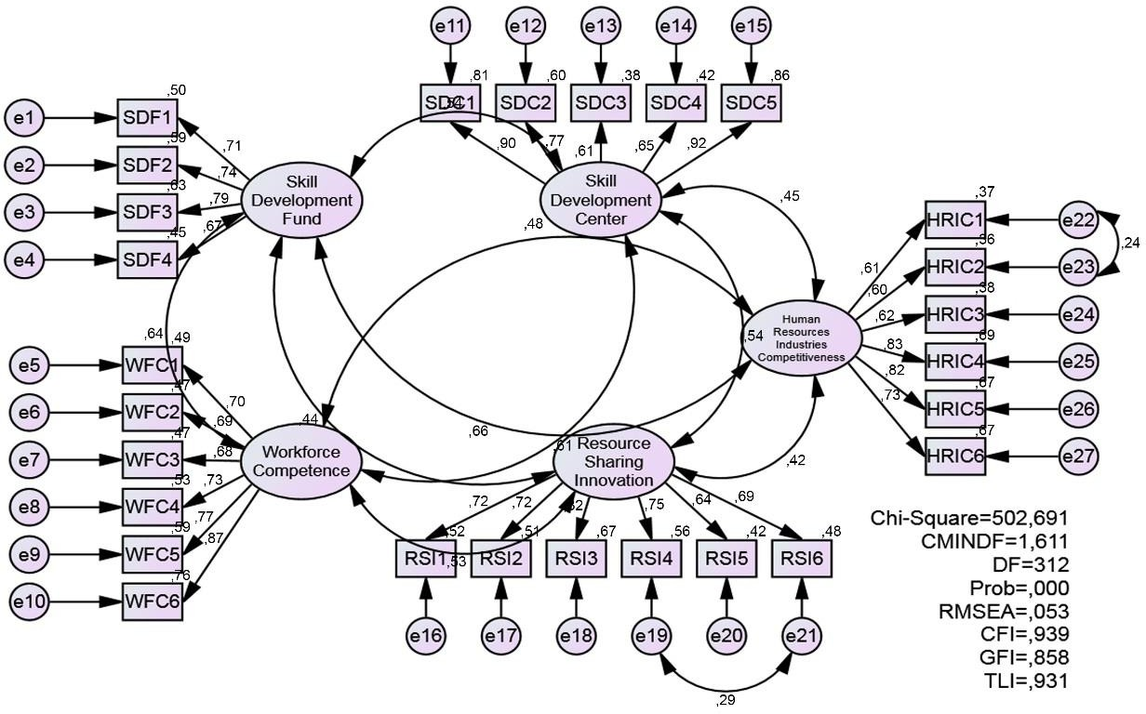
Figure 2. CFA Model
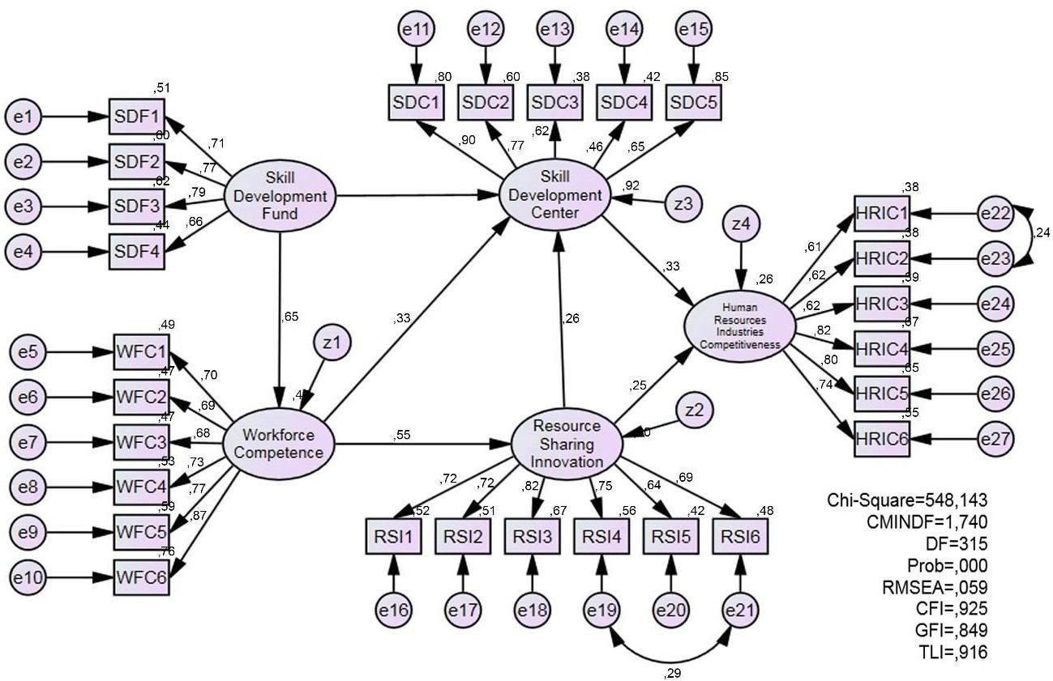
Figure 3. Full Structural Model
The outcome of the hypothesis test revealed a correlation value thay was considered significant based on the estimated correlation value between the latent variables of Skill Development Fund or TRF, SDC, RSI, Workforce (Vocational school graduates) Competence, and Industrial Human Competitiveness. Such finding was indicated based on tests performed for the structural model previously developed according to the study hypotheses
Table 1. Outcomes of Hypothesis Test
Influence path |  |  | Estimate | S.E. | C.R. | P | Outcome
Workforce_Competence | ← | Skill_Development_Fund | ,615 | ,087 | 7,075 | *** | Significant
Resource _Sharing _Innovation | ← | Workforce_Competence | ,570 | ,089 | 6,413 | *** | Significant
Skill_Development_Center | ← | Skill_Development_Fund | ,307 | ,122 | 2,512 | ,012 | Significant
Skill_Development_Center | ← | Workforce_Competence | ,478 | ,145 | 3,296 | *** | Significant
Skill_Development_Center | ← | Resource _Sharing  _Innovation | ,370 | ,108 | 3,443 | *** | Significant
Human_Resource_Industries_Co mpetitiveness | ← | Skill_Development_Center | ,230 | ,061 | 3,766 | *** | Significant
Human_Resource_Industries_Co mpetitiveness | ← | Resource _Sharing  _Innovation | ,247 | ,087 | 2,839 | ,005 | Significant
*** Sig. <0.001

Discussion
This discussion section explained the seven findings of the current study, which are formulated in each paragraph of this section. The statistical test regarding the influence of Skill Development Fund or TRF on Workforce Competence found an estimated value of 0.615. Furthermore, the statistical test also found a CR value of 7.075 and a p-value of 0.000. In general, graduates from vocational school came from families with a low purchasing power. This means that the revolving training fund will only be an alternative when they are willing to gain higher competencies demanded by manufacturing industries. Such finding was in line with the conclusion proposed by the previous study [27] [29].
The statistical test regarding the influence of Skill Development Fund or TRF on Skill Development Center found an estimated value of 0.307. Furthermore, the statistical test also found a CR value of 2.512 and a p-value of 0.012. A conclusion to be formulated in light of such findings was a significant positive influence of training revolving fund on Skill Development Center at the significance level of 5%. VHS graduates should be prepared competently and mentally through the brand new manufacturing industry standards [21]. Such atmosphere can be provided by integration of funding [31] and training through apprenticeship program.
The statistical test regarding the influence of Workforce Competence on Skill Development Center found an estimated value of 0.478. Furthermore, the statistical test also found a CR value of 3.296 and a p-value of 0.000. A conclusion to be formulated in light of such findings was a significant positive influence of Competence of Vocational School Graduates on Skill Development Center at the significance level of 5%. Resource sharing among the vocational schools, manufacturing institutions and government should be made as an effort to strengthen workforce competence [32]. In short, institutional strengthening is crucial and significant [23]
The statistical test regarding the influence of Workforce Competence on Resource Sharing Innovation found an estimated value of 0.570. Furthermore, the statistical test also found a CR value of 6.413 and a p-value of 0.000. A conclusion to be formulated in light of such findings was a significant positive influence of Competence of Vocational Education Graduates on Resource Sharing Innovation at the significance level of 5%. The mean competency achievement of VHS graduates in Banten Province was still low and could not meet the requirements of the manufacture companies. A strong desire to perform RSI which is supported by development budget provided by the government will be the main driver both for VHS graduates and manufacture companies [32]. Those aspects will surely encourage the enthusiasm of VHS graduates to develop their competencies [1]
The statistical test regarding the influence of Resource Sharing Innovation on Skill Development Center found an estimated value of 0.370. Furthermore, the statistical test also found a CR value of 3.443 and a p-value of 0.000. A conclusion to be formulated in light of such findings was a significant positive influence of Resource Sharing Innovation on Skill Development Center at the significance level of 5%. Such findings revealed coordination and collaboration as the main obstacles in the development of industrial human competitiveness in the manufacturing industry [20], which also accompanied with continuous innovation in various changes, both internally and externally. Thus, RSI may become the continual solution for the high unemployment rate [32].
The statistical test regarding the influence of Skill Development Center (SDC) on Human Resources Industries Competitiveness found an estimated value of 0.230. Furthermore, the statistical test also found a CR value of 3.776 and a p-value of 0.000. A conclusion to be formulated in light of such findings was a significant positive influence of Skill Development Center on industrial human competitiveness at the significance level of 5%. Such conclusion revealed that Skill Development Center was a most inportant bridge for collaboration [20].
The statistical test regarding the influence of Resource Sharing Innovation on Human Resources Industries Competitiveness found an estimated value of 0.247. Furthermore, the statistical test also found a CR value of 2.839 and a p- value is 0.005. A conclusion to be formulated in light of such findings was a significant positive influence of Resource Sharing Innovation (RSI) on Industrial Competitiveness at the significance level of 5%. Such conclusion revealed that willingness to be involved in resource sharing will lead to an obvious technology transfer process [4], [18] in the manufacturing industry.
CONCLUSIONS
The study conclusion made based on study findings indicated evidence that the novelty of Resource Sharing Innovation (RSI) was able to support the industrial human competitiveness. The study findings has an obvious significance for the conceptual dvelopment of human resource management theory, specifically in the area of training and development of the business actors as well as the strategic management concept which involve and consider the competitive advantage of the resource demands. Inaddition, the current study also offers managerial implications regarding a continual solution for the high unemployment rate in a certain area through Resource Sharing Innovation applied by surrrounding institutions by preparing business convenience incentives.
ACKNOWLEDGEMENT
The current project was admitted by Kementerian Riset Dan Teknologi/Badan Riset Dan Inovasi Nasional (RISTEK/BRIN) based on Letter No. 29/INS-1/PPK/E4/2020. This article was declared the best paper at The 9th National Conference on Applied Business (NCAB-9) Master of Management Study Program of STIE YKPN Yogyakarta on March 27, 2021. MIX (Scientific Management Journal, UMBJ) was chosen as one of our partners to publish the current paper. We would like to deliver our sincere appreciation to the reviewers at such conference for their in-depth reviews and positive recommendations for the better papers in the future.

REFERENCES
[1] BPS, “Keadaan Ketenagakerjaan Banten Agustus 2019,” Banten, 2021.
[2] B. Rifa’i, “Pengangguran di Banten Tertinggi se-Indonesia, Ini Sebabnya,” detikFinance2, Nov. 2019.
[3] B. D. Suseno, “The strength of justified knowledge sharing on good manufacturing practices: Empirical evidence on food beverage joint venture company of Japan – Indonesia,” Qual. - Access to Success, 2019.
[4] B. D. Suseno and C. Dwiatmadja, “Technology transfer motive of managers in Eastern Asia: Empirical results from manufacture industry in Banten province, Indonesia,” Probl. Perspect. Manag., vol. 14, no. 2, 2016, doi: 10.21511/ppm.14(2).2016.04.
[5] F. A. Yusuf and D. Suseno, “Sustainability Innovativeness Agility as an Intervening Variable in the Managerial Competence to Business Performance Relationship of a Family-Owned Company,” Int. J. Innov. Creat. Chang., vol. 13, no. 9, pp. 479–498, Jul. 2020, [Online]. Available: www.ijicc.net.
[6] B. D. Suseno, F. A. Yusuf, and S. Pawirosumarto, “The Citizenship Engagement Quality in ASEANand the Sustainability of ASEAN Economic Community Performance,” Int. J. Psychosoc. Rehabil., vol. 24, no. 2, pp. 2808–2820, 2020, doi: 10.37200/IJPR/V24I2/PR200578.
[7] B. D. Suseno, F. A. Yusuf, S. Hidayat, and D. Surani, “Implementing the Resource Sharing Innovation Model to Sustainably Address the High Unemployment Rate,” KnE Soc. Sci., 2021, doi: 10.18502/kss.v5i5.8855.
[8] A. . Pigou, The Theory of Unemployment. Frank Cass And Company Limited, 1933.
[9] F. Alghofari, “Analisis Tingkat Pengangguran di Indonesia Tahun 1980-2007,” Universitas Diponegoro, 2010.
[10] N. Baeti, “Pengaruh Pengangguran, Pertumbuhan Ekonomi, Dan Pengeluaran Pemerintah Terhadap Pembangunan Manusia Kabupaten/Kota Di Provinsi Jawa Tengah Tahun 2007-2011,” Econ. Dev. Anal. J., vol. 2, no. 3, pp. 85–98, 2013, doi: 10.15294/edaj.v2i3.1984.
[11] N. W. Budiani, “Efektivitas Program Penanggulangan Pengangguran Karang Taruna " EKA TARUNA BHAKTI " Desa Sumerta Kelod Kecamatan Denpasar Timur Kota Denpasar,” Ekon. dan Sos. INPUT, vol. 2, no. 1, pp. 49–57, 2005.
[12] A. Hadroj, “Unemployment – theoretical overview,” in International Scientific Conference-ERAZ, 2016, pp. 564–571.
[13] R. D. Heriansyah, I. Nuraini, and H. Kusuma, “Analisis Pengaruh Jumlah Industru Dan Indejs Pembangunan Manusia Terhadap Jumlah Pendudukan Miskin Di Kabupaten/Kota Provinsi Banten Tahun 2012-2016,” J. Ilmu Ekon., vol. 2, no. 3, pp. 453–463, 2018.
[14] Imsar, “Analisis Faktor-Faktor Yang Mempengaruhi Tingkat Pengangguran Terbuka Di Provinsi Lampung (Periode 1989-2016),” Hum. Falah, vol. 5, no. 1, pp. 144–164, 2018.
[15] S. Machin and A. Manning, “Chapter 47 The causes and consequences of longterm unemployment in Europe,” Handb. Labor Econ., vol. 3 PART, no. 3, pp. 3085–3139, 1999, doi: 10.1016/S1573-4463(99)30038-9.
[16] M. B. Santoso, “Kompetensi Lokal Dalam Menanggulangi Kemiskinan Di Daerah Industri,” Share Soc. Work J., vol. 4, no. 2, 2014, doi: 10.24198/share.v4i2.13076.
[17] A. Setiyawati and A. Hamzah, “Analisis Pengaruh Pad, Dau, Dak, Dan Belanja Pembangunan Terhadap Pertumbuhan Ekonomi, Kemiskinan, Dan Pengangguran: Pendekatan Analisis Jalur,” J. Akunt. dan Keuang. Indones., vol. 4, no. 2, pp. 211–228, 2007, doi: 10.21002/jaki.2007.11.
[18] Winardi, “Dampak Pembangunan Kawasan Industri Terhadap Output, Penyerapan Tenaga Kerja, Distribusi Pendapatan dan Kemiskinan Rumah Tangga di Provinsi Jawa Barat,” Institut Pertanian Bogor, 2017.
[19] Y. (Universitas T. P. Yacoub, “Pengaruh Tingkat Pengangguran terhadap Tingkat Kemiskinana Kabupaten/Kota di Provinsi Kalimantan Barat,” J. EKSOS, vol. 8, no. 3, pp. 176–185, 2012.
[20] S. B. Brojonegoro, “Skill Development Fund,” 2019.
[21] A. H. Mouhammed, “Veblen’s theory of unemployment and public policies,” Int. Res. J. Financ. Econ., vol. 70, no. 5, pp. 217–226, 2011.
[22] Penros, The Theory of the Growth of the Firm. New York: John Wiley, 1959.
[23] A. Abreu and J. M. F. Calado, “Risk Model to Support the Governance of Collaborative Ecosystems,” IFAC-PapersOnLine, 2017, doi: 10.1016/j.ifacol.2017.08.1313.
[24] Rubin, Linking and loving: An Invitation to Social Psychology. Holt: Rinehart & Winston, 1973.
[25] Teece, “Towards an economic theory of the multy product firm,” J. Econ. Behav. Organ., vol. 3, no. 2, pp. 39–63, 1982.
[26] H. Shirado, G. Iosifidis, L. Tassiulas, and N. A. Christakis, “Resource sharing in technologically defined social networks,” Nat. Commun., vol. 10, no. 1, p. 1079, 2019, doi: 10.1038/s41467-019-08935-2.
[27] B. D. Suseno, A. Yuniawan, and C. Dwiatmadja, “The model of capability soft governance in family business: Empirical study in bus transportation industry in Jakarta, Indonesia,” J. Econ. Coop. Dev., 2019.
[28] L. Jonung, “Knut Wicksell on unemployment,” Hist. Polit. Econ., vol. 21, no. 1, pp. 27–42, 1989.
[29] R. Srivastava, “HR development in manufacturing sector,” People Matter Magazine, Aug. 2020.
[30] Uma Sekaran & Bougie, Research Method for Business: A skill Building Approach, 6th edition.Wiley&Son Ltd. 2013.
[31] S. Bahagijo, “Skill Development Revolving Fund dan Penerapnnya,” 2018.
[32] B. D. Suseno et al., “SIGNIFICANCE OF RESOURCES SHARING INNOVATION IN INDUSTRIAL HUMAN COMPETITIVENESS : EMPIRICAL STUDY AT THE MANUFACTURING INDUSTRIES,” PalArch’s J. Archaeol. Egypt/Egyptology, vol. 17, no. 7, pp. 6550–6561, 2020.

