EFFECT OF WORK-FAMILY CONFLICT, WORK OVERLOAD, AND PERCEIVED ORGANISATIONAL SUPPORT TOWARDS WORK STRESS AND ITS IMPACT ON TURNOVER INTENTIONS IN PRIVATE BANK EMPLOYEES

ABSTRACT
Objectives: The objective of this research is to determine how work-family conflict, work overload, and perceived organizational support affect work stress and subsequently influence turnover intentions in private bank employees
Methodology: The study employs a quantitative approach to test known hypotheses and involves collecting data via questionnaires from 120 participants in Sorong, West Papua, Indonesia. The data is analyzed using a structural equation model (SEM) with the aid of smart PLS
Finding: The results indicate that work-family conflict and work overload have significant positive effects on work stress and turnover intentions. Additionally, perceived organizational support has a significant positive impact on both work stress and turnover intentions. The study further finds that work stress mediates the relationship between work-family conflict, work overload, perceived organizational support, and turnover intentions. Therefore, it is crucial for organizations to address work-family conflict, work overload, and provide perceived organizational support to reduce work stress and turnover intentions among their employees
Conclusion: The implications according to this research results are managers should implement measures to minimize work-family conflicts and workload to enhance employee well-being and reduce their intentions to leave the organization and need to ensure that employees perceive support from the organization in different aspects such as compensation, promotion, and recognition

Keywords: perceived organisational support, turnover intentions, work-family conflict, work overload, work stress

Submitted: Revised: Accepted:

Article Doi:
http://dx.doi.org/10.22441/jurnal_mix.2022.v11.001

INTRODUCTION
Humans precisely can choose several jobs as their profession for living necessities. One type of job that is in great demand is a job as a bank employee. Many people have the notion that working at a bank will provide good financial and non-financial contributions (Balasubramanian et al., 2019). This condition causes many people to try their luck working in banking service companies.
At their workplace, employees anticipate that their personal needs will be met. When employed at a banking service firm, workers hold an optimistic outlook that all of their necessities, such as salary, benefits, job position, personal growth, positive relationships with co-workers and superiors, and more, will be satisfied. Nevertheless, there is a weighty responsibility attached to working at a bank, despite the competitive advantages (both monetary and non-monetary) that can be gained. The workload at a banking service company is classified as arduous, and only dependable and capable employees can thrive and persist in this field (Andreani & Petrik, 2016).
Most researchers acknowledge that motivation varies among individuals and can impact their reaction to workloads (Virgana, 2021). In the banking industry, employees are burdened with multiple responsibilities and workloads, resulting in stress (Abdul Majid et al., 2021), which can affect their job performance. The high workload in banking requires fast, precise, and accurate work, causing immense pressure on employees, potentially leading to increased work stress. If prolonged, work stress can hinder bank employees from fulfilling their job requirements. Thus, it is crucial to conduct research that explores factors that can mitigate work stress (Daniel, 2019).
Various studies have focused on identifying the factors that contribute to work-related stress. According to Lambert et al. (2017), work-family conflict is one of the factors that can cause work stress, especially among police officers in India. The study found that higher levels of work-family conflict are associated with greater work stress. Work-family conflict arises when there is an imbalance between work and family responsibilities, as noted by Kusumanegara et al. (2018). Inadequate time and energy for family activities due to long working hours and heavy workloads are clear indicators of potential work-family conflict. Bank employees, for example, may experience work-family conflict as they struggle to balance work and household responsibilities. Consequently, this can lead to family conflicts that cause stress due to the heavy workload (Damayanti, 2019).
In addition, Mittal & Bhakar (2018) research reveals that work overload impacts significantly and positively work stress experienced by female employees in Indian banks. Work overload occurs when employees work excessively long hours, under heavy pressure, and without sufficient time off. In the industrial world, work overload is prevalent when a job demands fast work pace, high output, and intense concentration from employees. Excessive workload can lead to employee fatigue due to imbalances or discrepancies between task demands and the time available to complete them (Astvik & Melin, 2013).
Furthermore, Saadeh & Suifan, (2019) research suggests that perceived organizational support (POS) can alleviate work stress among hospital employees in Amman, Jordan. POS refers to the employees' experience of policies, norms, procedures, and organizational actions that impact them positively or negatively. The extent to which employees perceive that an organization values and supports them is influenced by a variety of factors that contribute to Perceived Organizational Support (POS). Thus, an increase in POS can reduce work stress among bank employees.
The studies conducted by oleh Lambert et al., (2017), Mittal & Bhakar, (2018), and Saadeh & Suifan, (2019) examine only a limited number of variables that affect work stress. This research aims to add a mediating variable, turnover intention, to determine if work-family conflict, work overload, and perceived organizational support affect work stress more effectively when passing through the turnover intention. The study will focus on private bank employees in Sorong, West Papua, whereas previous research involves police in India, female employees at Indian banks, and hospital employees in Amman, Jordan. The aim of this study is to investigate the relationship between work-family conflict, work overload, perceived organizational support, work stress, and turnover intentions (Rahman & Syahrizal, 2019).
Turnover intention refers to the intention or desire of an employee to leave their current job and search for better opportunities elsewhere. It is a significant problem that companies face, as higher turnover intention is indicative of low employee welfare. Companies are therefore motivated to improve facilities and services to reduce the impact of turnover intention, as this can decrease work stress and improve service quality to consumers (Harimurti & Suryani, 2019). The primary aim of this study is to investigate how work-family conflict, work overload, and perceived organizational support are associated with work stress and how they contribute to turnover intentions among employees working in private banks.
LITERATURE REVIEW
Work-Family Conflict
Work-family conflict is a situation where the demands or expectations of work and family roles are incompatible, causing tension or difficulty in managing both aspects of life (Barriga Medina et al., 2021). This conflict is often caused by long working hours and heavy workloads, which leave employees with limited time and energy for family activities (Obrenovic et al., 2020). Soomro et al. (2018) define work-family conflict as a conflict between the roles of employees in their work and family life, which arises when they struggle to balance their duties in both domains. This creates difficulty in distinguishing whether family responsibilities are interfering with work or work is interfering with family. The former is referred to as family interference with work, where employees spend most of their time and attention on family matters, leaving less time for work. Conversely, family interference with work occurs when employees spend most of their time and attention on family matters, which can interfere with their work.
Table 1. Work Familiy Conflict Indicators
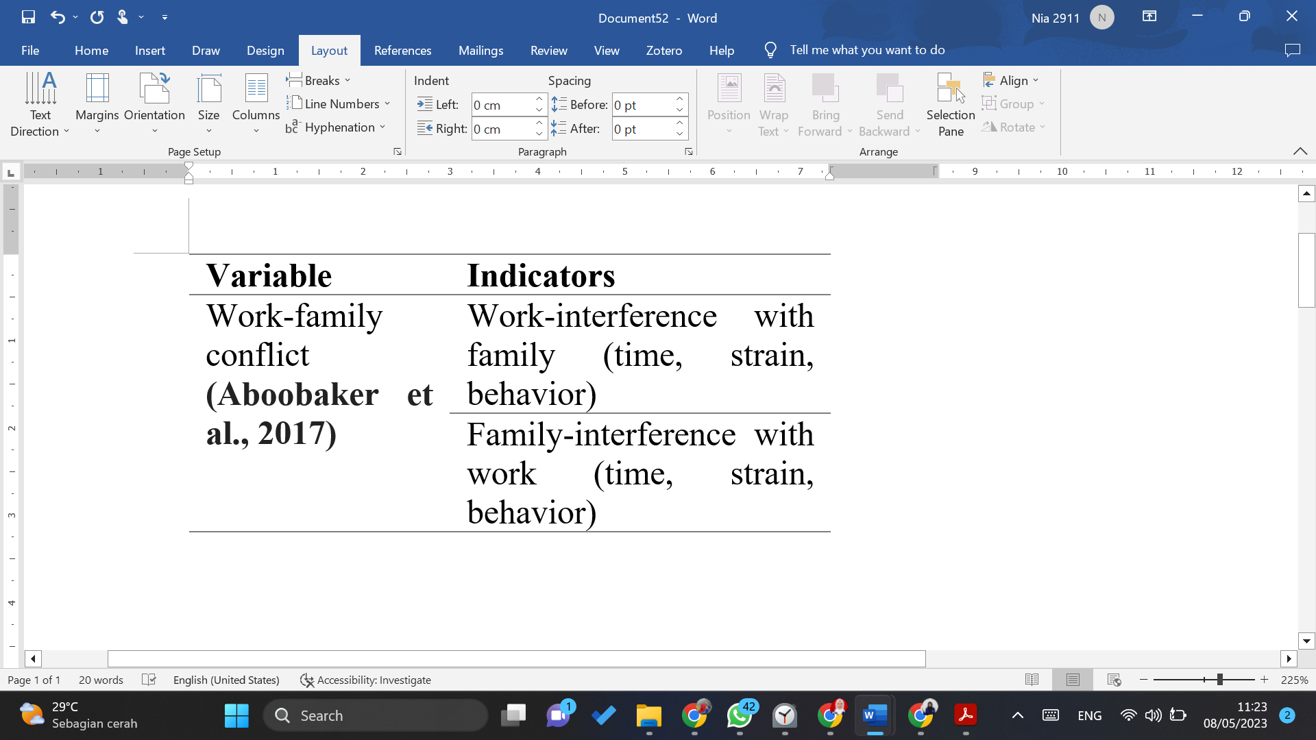

Work Overload
Work overload refers to a situation where employees have to work on several tasks at the same time, and the workload is excessive and beyond their capabilities. As a consequence, it can result in stress and lack of concentration, which hinders employees' ability to perform their tasks and meet their obligations. According to Jeon et al., (2022), work overload can result in fatigue due to imbalances or discrepancies between task demands and the available time to complete them, as well as other factors such as role authority, role conflict, and lack of work support that contribute to work stress. Kimura et al. (2018) observed that work overload happens when an employee is assigned with an excessive amount of work but lacks the time and skills to accomplish it. (Pluta & Rudawska, 2021) found that work overload can be measured along three dimensions: time load, mental load, and psychological stress of workers. Finally, Schick et al. (1990) explained that work overload can happen when workers are given too much work that exceeds their available time and abilities (Gibran & Suryani, 2019).
Table 2. Work Overload Indicators
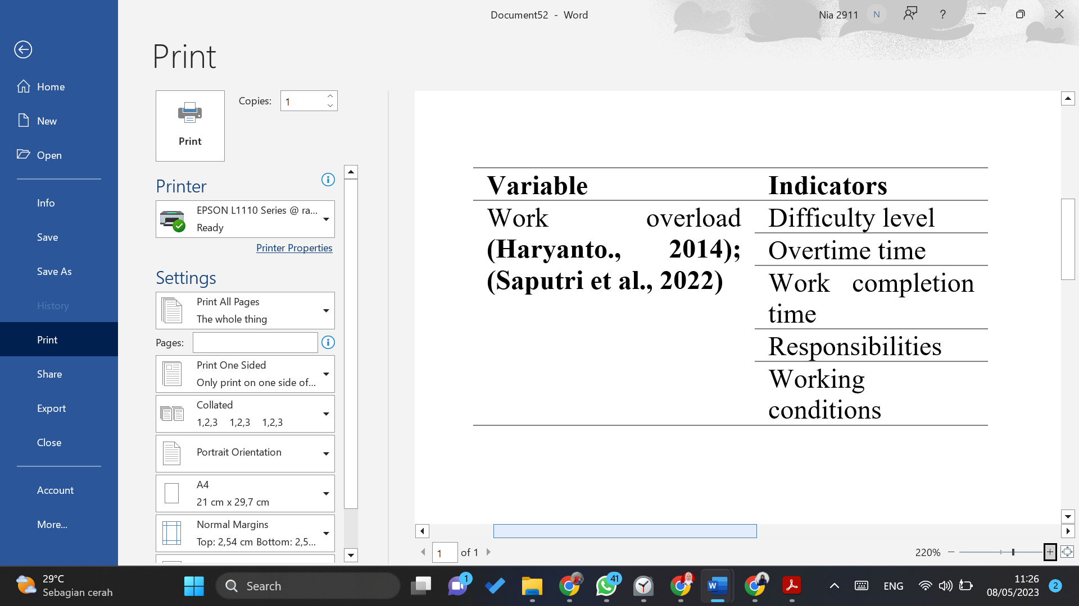
Perceived Organisational Support (POS)
POS is a type of organizational support that assures employees that their contributions are appreciated and their well-being is valued by the organization they work for. According to (Jeong & Kim, 2022), POS is a way for organizations to show their support for employees. Rhoades and Eisenberger also noted that POS is an assessment of how much attention the organization pays to employee welfare, how fairly employees are treated, and how much attention is given to employees' concerns (Mascarenhas et al., 2022). The level of perceived organizational support is seen as a factor that affects the attitudes of employees towards their work and the organization they work for. Essentially, perceived organizational support refers to an employee's perception of how much their organization values their contributions and cares for their overall well-being.
Table 3. POS Indicators
Variable | Indicators
Perceived Organisational Support (Mohamed & Ali, 2015); (Rhoades & Eisenberger, 2002); (Yolanda & Said, 2022) | Procedural justice
 | Superior support
 | Organisational benefits and working conditions
 | Procedural justice

Work Stress
Stress is a natural reaction to the demands, threats, or pressure that a person experiences, which can affect their behavior and mental state. Stress can have both physical and emotional effects on a person. In the workplace, employees often experience work-related stress, which can lead to changes in their behavior. This condition is not always negative, and the stress may subside once the challenge is overcome.
Maulina & Wicaksono (2021) refer to King's definition of work stress as a state of tension that arises from a psychological and physical imbalance and affects an employee's emotional and cognitive processes, as well as their general well-being. Job stress refers specifically to stress related to work. Based on the above understanding, work stress occurs when employees face challenging situations that can create tension and affect their behavior. Job stress can lead to emotional changes, physical and psychological imbalances, changes in thought processes, and may affect employee performance.

Table 4. Work Stress Indicators
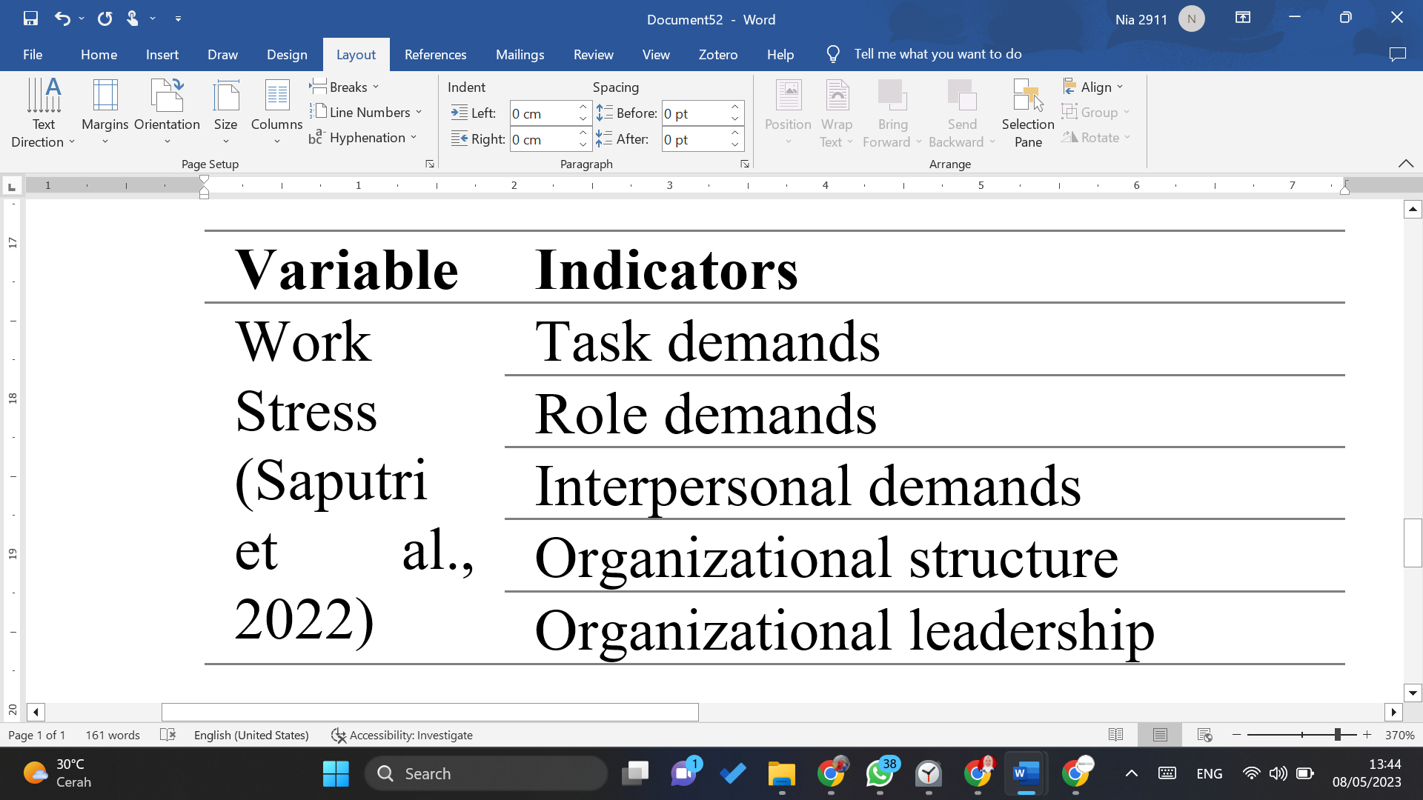
Turnover Intentions
Desire or intention refers to an individual's inclination or willingness to perform a specific action. Turnover, on the other hand, is when an employee voluntarily leaves their job or moves to a different workplace. Turnover intention, as defined by (K. Hussain et al., 2020), is the inclination of employees to quit their current jobs. Employee turnover, or simply turnover, is the movement of employees in and out of an organization or company (Kurniawaty et al., 2019). According to (Aburumman et al., 2020), turnover pertains to the frequency of employees departing from an organization and necessitating the recruitment of new staff. Meanwhile, Mobley et al. (cited by (Romão et al., 2022)) define turnover intention as the desire or tendency of employees to voluntarily leave their jobs or move to another workplace of their choosing. The intention to leave a company, also known as turnover intentions, represents the extent to which an employee wishes to quit their current organization. There can be various factors leading to such intentions, including the pursuit of better job opportunities (Serhan et al., 2022).
Table 5. Turnover Indicators
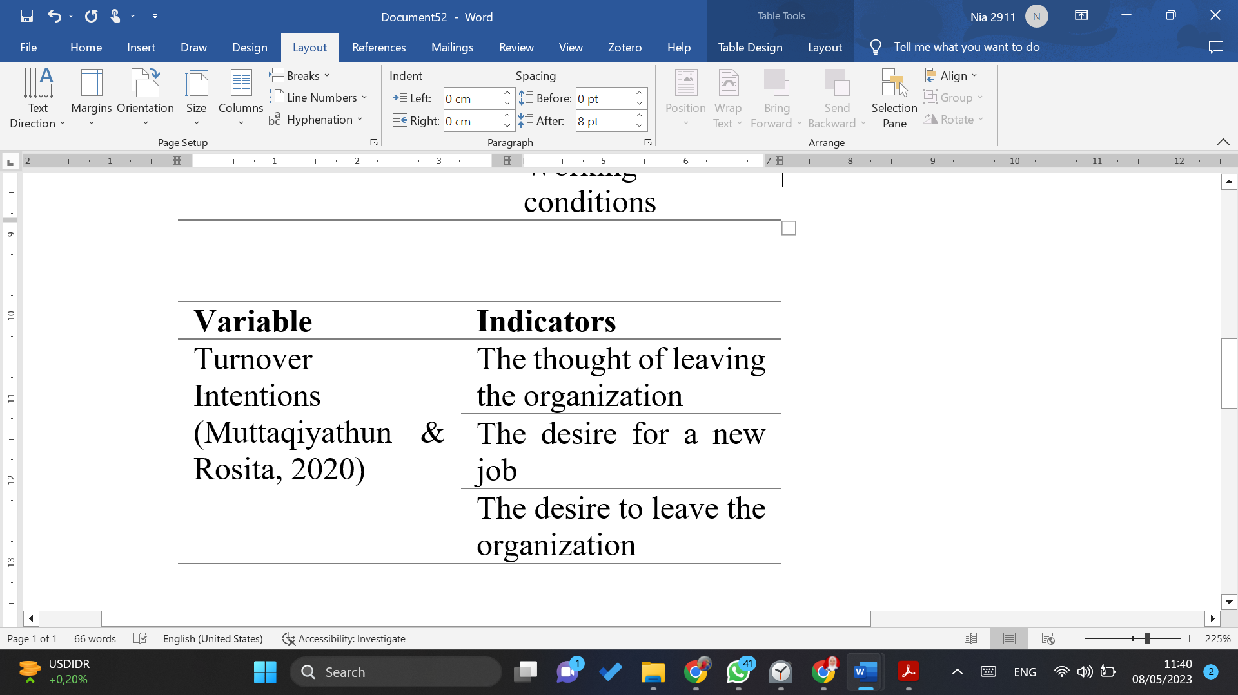

METHOD
Study Design
The study utilized quantitative techniques to test a pre-existing hypothesis. This approach involves collecting numerical data through a questionnaire to measure the variables under investigation.

Research Subject
The research subject of this study is the employees of private bank in Sorong, West Papua, Indonesia. The participants was taken by the simple random sampling and gained 120 private bank employees who participated for this study.

Data Collected Method
The data for this research was collected through questionnaire instrument which indicators are gained from credible sources. The indicators of each variable is in the following.

Operational Definition
Table 6. Operational Definition
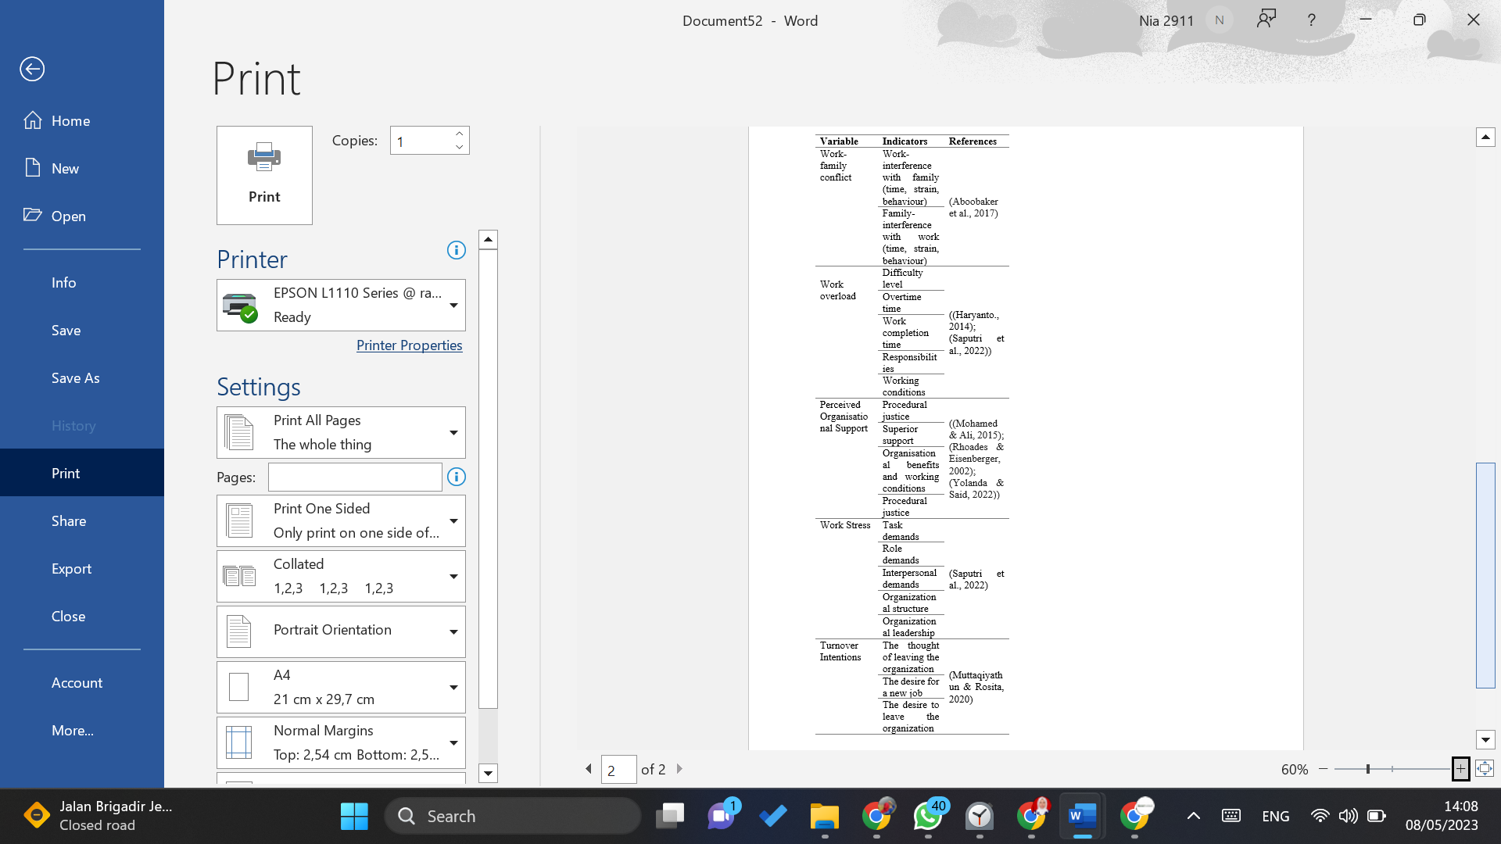
Data Analysis Method
Smart Partial Least Squares (PLS) was used to conduct a structural analysis of the Equation Model int his study (Ghozali, 2018). The aspects of SEM model is indicated (1) outer model analysis (validity & reliability test); (2) r-square; (3) inner model analysis or hypothesis test.
- Ha: t-statistic > 1.96 with p-values < 0.05, indicating that the hypothesis is accepted.
- H0: t-statistic < 1.96 with p-values > 0.05, indicating that the hypothesis is rejected.

Figure I. Thinking Framework

H1: Work-family conflict affects work stress positively and significantly
H2: Work overload affects work stress positively and significantly
H3: Perceived organizational support affects job stress positively and significantly
H4: Turnover intentions affects work stress positively and significantly
H5: Work overload affects turnover intentions positively and significantly
H6: Work-family conflict affects turnover intentions positively and significantly
H7: Perceived organizational support affects turnover intentions positively and significantly
H8: Turnover intentions mediate work-family conflict on work stress
H9: Turnover intentions mediate work overload on work stress
H10: Turnover intentions mediate perceived organizational support on work
RESULTS AND DISCUSSION
Outer Model Analysis
Validity Test
In order to assess the validity of the questionnaire used in this study, the researchers employed convergent validity and AVE. Convergent validity is a technique used to assess the measurement model of reflective indicators by calculating the correlation between item scores and component scores using PLS. If the correlation between an individual reflective measurement and the construct being measured is over 0.7, it is considered high. However, according to Dahri, (2017), if a measurement scale is in the early stages of development, a loading value of 0.5 to 0.6 is adequate.
Table 8. Validity Test Results
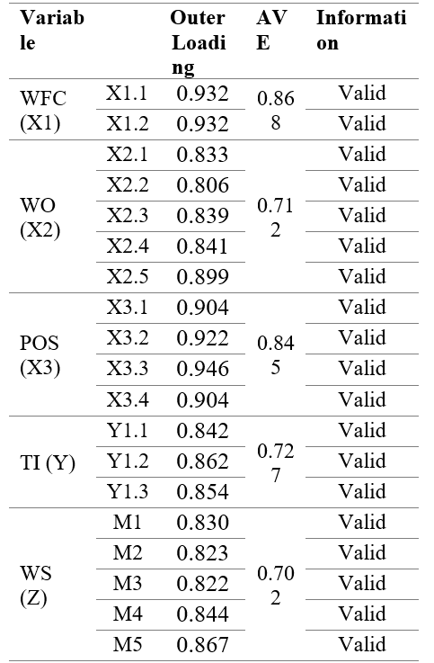
Reliability Test
Two methods were used to test the reliability of the measurements in this study: the Cronbach Alpha test and the Composite Reliability Test. The Cronbach Alpha test measures the minimum reliability of a variable, with a value greater than 0.7 considered reliable. Meanwhile, the Composite Reliability Test measures the actual reliability value, and a score greater than 0.7 is indicative of high reliability.
Table 9. Reliability Test Results
 | Cronbach's Alpha | rho_A | Composite Reliability
POS (X3) | 0.939 | 0.940 | 0.956
WS (Z) | 0.894 | 0.895 | 0.922
TI (Y) | 0.813 | 0.816 | 0.889
WFC (X1) | 0.848 | 0.848 | 0.930
WO (X2) | 0.899 | 0.903 | 0.925

The results of the tests indicate that all the instruments used in the study are reliable, as their Cronbach Alpha scores and Composite Reliability values are greater than 0.7.
Convergent Validity Test after Modification
After removing indicators that did not meet the loading factor value criteria, the results of the PLS SEM model computation are presented in the figure below. As shown in the figure, all the indicators in each variable have loading factor values above 0.6, indicating good measurement quality. Consequently, the study proceeds to perform a Discriminant Validity test.
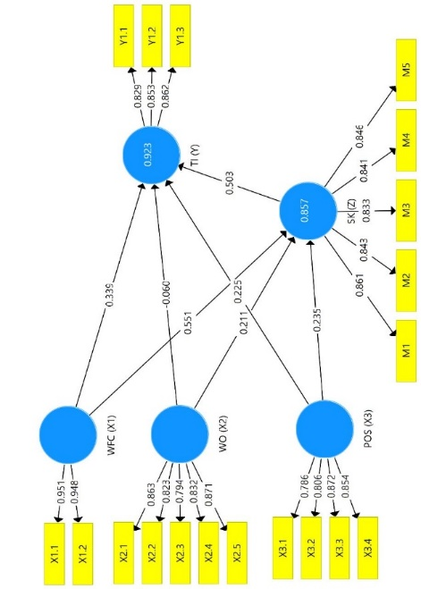
Figure 2. Convergent Validity Test after Modification

Uji R-Square
The study employed the R-Square coefficient determination test to evaluate the influence of exogenous variables on endogenous variables. The SmartPLS software was used for data analysis, and the resulting R-Square values are presented in the table below.
Table 10. R-Square Test Results
 | R Square | R Square Adjusted
WS (Z) | 0.825 | 0.822
TI (Y) | 0.900 | 0.897

The findings reveal that Turnover Intentions are impacted by Work-Family Conflict, Work Overload, Perceived Organizational Support, and Work Stress, which account for 90% of the variance. The remaining 10% is influenced by other factors not included in this study. The R-Square value for Turnover Intentions is 0.900. Additionally, the results indicate that Work Stress is influenced by Work-Family Conflict, Work Overload, and Perceived Organizational Support by 82.5%, while the remaining 17.5% is influenced by unexplained factors. The R-Square value for Work Stress is 0.825.
Hypothesis Test Results
The assessment of hypothesis testing involves examining the t-statistic and probability values. For a significance level of 5%, the t-value is compared with the critical t-value in the t-table. If the t-statistic is greater than the critical t-value, the hypothesis is rejected. On the other hand, if the p-value is less than 0.05, the hypothesis is accepted based on the level of probability.
Table 11. Hypothesis Test Results
 | Original Sample (O) | T Statistics (|O/STDEV|) | P Values
POS (X3) -> SK (Z) | -0.019 | 2.488 | 0.026
POS (X3) -> TI (Y) | -0.025 | 2.793 | 0.028
SK (Z) -> TI (Y) | 0.579 | 5.952 | 0.000
WFC (X1) -> SK (Z) | 0.522 | 7.773 | 0.000
WFC (X1) -> TI (Y) | 0.272 | 3.473 | 0.001
WO (X2) -> SK (Z) | 0.433 | 6.098 | 0.000
WO (X2) -> TI (Y) | 0.128 | 2.165 | 0.031
POS (X3) -> SK (Z) -> TI (Y) | -0.011 | 4.762 | 0.034
WFC (X1) -> SK (Z) -> TI (Y) | 0.303 | 4.533 | 0.000
WO (X2) -> SK (Z) -> TI (Y) | 0.251 | 5.069 | 0.000

Discussion
Work-Family Conflict on Turnover Intentions
The hypothesis testing results on the relationship between Work-Family Conflict and Turnover Intentions suggest that the p-value, which is 0.001, is less than the significance level of 0.05. Moreover, the t-statistic value of 3.473 is greater than the critical value of 1.660, and the beta score of 0.272 indicates a positive effect. These results confirm that Work-Family Conflict has a significant and positive impact on Turnover Intentions. Work-family conflict refers to a type of conflict between work and family roles that creates pressure, making it difficult for employees to fulfill their responsibilities in both domains. When employees devote more time and energy to one role, they may find it challenging to meet the requirements of the other role, leading to role conflict and increased pressure. The study's findings are consistent with prior research, such as Babakus et al., (2016), Yousef & Danial, (2012), which show that work-family conflict has a significant negative impact on organizational commitment. Additionally, Aboobaker et al. (2017) demonstrates that work-family conflict has a significant positive effect on turnover intention.
Work-Family Conflict on Work Stress
According to the results of testing the hypothesis on the influence of Work-Family Conflict on work stress, the p-value is found to be 0.000 which is smaller than the threshold of 0.05. Additionally, the t-statistic value is 7.773, greater than the critical value of 1.660, and the beta score is 0.522. Thus, it can be concluded that Work-Family Conflict has a significant positive impact on work stress. This implies that the conflict experienced by an employee can lead to increased work stress, and the higher the conflict, the higher the level of work stress. These findings are consistent with previous studies conducted by Hammer et al., (2004), dan (Bazana & Dodd, 2013), which show that work-family conflict has a positive effect on work stress. This is due to the potential increase in work stress experienced by employees as the conflict level rises.
Work Overload on Turnover Intentions
The findings of the hypothesis testing for the impact of Work Overload on Turnover Intentions reveal that the p-value is 0.031, which is less than 0.05, indicating a significant relationship. Moreover, the t-statistic value of 2.165 is greater than 1.660, and the beta coefficient is 0.128. Therefore, it can be concluded that Work Overload has a significant positive effect on Turnover Intentions, as explained earlier. This research aims to analyze and assess how work overload influences employees' intention to leave their job. Work overload refers to a scenario in which employees are assigned tasks that exceed their capacity while working for a company. This study aligns with Nisa & Malik (2016)’s research, which demonstrates that work overload has a significant impact on turnover intention. Continuous work overload can result in prolonged fatigue, which is a dominant factor that employees cannot tolerate, leading to an increased desire to leave their job (turnover intention).
Work Overload on Work Stress
The hypothesis test results on the impact of Work Overload on work stress show that the p-value is 0.000, which is less than 0.05. Furthermore, the t-statistic value is 6.098, which is greater than 1.660, and the beta score is 0.433. Therefore, it can be concluded that Work Overload has a significant positive effect on work stress. The findings of this study align with previous research conducted by Karimi et al., (2014) and (Malik, 2011), indicating that higher levels of work overload lead to higher levels of work stress. These results offer practical guidance to employees who struggle to manage their workload effectively, as excessive workloads can negatively impact their stress levels.
Perceived Organizational Support on Turnover Intentions
The hypothesis testing results on the relationship between Perceived Organizational Support and Turnover Intentions show that the p-value is less than 0.05 at 0.028, with a t-statistic value of 2.793, which is greater than 1.660, and a beta score of -0.025. As such, it can be concluded that Perceived Organizational Support has a significant negative effect on Turnover Intentions. Prior research by Shams et al., (2020) and Aulia (2012) both found that higher levels of perceived organizational support are linked with lower rates of employee turnover. Additionally, Dhar, (2014) suggests that the relationship between workers and their organization is based on reciprocity, and when employees perceive positive reciprocation from their organization, they tend to reciprocate by reducing their level of turnover intention. These findings suggest that future research on this topic is necessary.
Perceived Organizational Support on Work Stress
The findings of the hypothesis testing on the impact of Perceived Organizational Support on work stress suggest that there is a significant positive effect. The p-value of 0.026 is less than the predetermined significance level of 0.05. Additionally, the t-statistic value of 2.488 exceeds the critical value of 1.660, and the beta score is estimated at -0.019. Therefore, it can be concluded that Perceived Organizational Support has a considerable impact on work stress. As per previous research by Shams et al., (2020) and Aulia (2012), higher levels of perceived organizational support can lead to reduced turnover intention among employees. Hence, it is important to further investigate the relationship between Perceived Organizational Support and work stress to identify ways to reduce stress levels in the workplace. One way employees reciprocate the organization's valuation is through continued engagement, fostering a sense of organizational belongingness that is integral to employee identity. When employees feel valued, experience fairness, and are comfortable with their working conditions, the likelihood of work stress is reduced. The results align with the research carried out by (Devita, 2021).
Work Stress on Turnover Intentions
The hypothesis testing results indicate that Turnover Intentions are significantly influenced by work stress, as demonstrated by the p-value of 0.000, t-statistic value of 5.952, and beta score of 0.579. This finding is consistent with previous studies conducted by Hopkins et al., (2010), Firth et al., (2004), and Parvaiz et al., (2015), all of which found that work stress and role stressors are primary factors that affect employee turnover intention. Hopkins et al., (2010) noted that work environment and role stress have a significant impact on employee stress and lead to turnover intention, while Firth et al., (2004) found that role stress is not only linked to reduced job satisfaction but is also the most influential variable in organizational turnover intention. Parvaiz et al., (2015) found that role stressors, including role ambiguity, conflict, and overload, significantly impact employee turnover intention. These findings underscore the need for organizations to address work stress and role stressors to reduce turnover intention and improve employee retention.

Work Stress Mediate Work-Family Conflict on Turnover Intentions
The hypothesis testing revealed that Work-Family Conflict has a significant positive impact on Turnover Intentions when Work Stress is the mediator. This is supported by a p-value of 0.000, which is below the significance level of 0.05, as well as a t-statistic value of 4.533, which is greater than 1.660. Additionally, the beta score of 0.303 further confirms the significant positive influence of Work-Family Conflict on Turnover Intentions, when Work Stress is the mediator. Previous studies have highlighted job stress as a distinct mediator of turnover intention. For instance, Gull et al., (2023) found that work fatigue, as a mediator of work-family conflict, significantly and positively impacts turnover intention. Work stress serves as a precursor to turnover intention and has unique characteristics.
Work Stress Mediate Effect of Work Overload on Turnover Intentions
Based on the results of the hypothesis testing, it is demonstrated that Work Overload has a significant positive effect on Turnover Intentions when mediated by work stress, as indicated by the p-value of 0.000 (less than 0.05), t-statistic value of 5.069 (greater than 1.660), and beta score of 0.251. Work overload is a prevalent stressor in the work environment that arises from the excessive demands of work-related tasks and time constraints, leading to prolonged fatigue and ultimately employee intentions to leave. Previous research has shown that work overload is a dominant factor in contributing to work stress and turnover intention, particularly in industries that demand fast-paced work, high work quality, and concentration from their employees. These findings align with Nahrisah et al., (2021)’s research.
Work Stress Mediate Perceived Organizational Support on Turnover Intentions
The p-value for the test of the effect of perceived organizational support on intentions to leave the company, which is mediated by work stress, is 0.000, which is less than 0.05. Additionally, the beta score is -0.011 and the t-statistic value of 4.762 is higher than 1.660. The aforementioned justification demonstrates that Perceived Organizational Support significantly influences Turnover Intentions through the medium of Work Stress. This research aligns with the findings of Eisenberger et al., (1986) cited in Hussain & Asif, (2012), which proposes that the level of organizational support perceived by employees affects their attitudes and performance towards the organization, and ultimately their intention to leave. When employees receive adequate support from the organization, their positive attitude is reflected in their improved performance, as measured by Key Performance Indicators (KPIs). This, in turn, reduces their intention to leave the organization, as confirmed by the results of unstructured interviews with the average employee receiving a good KPI rating.

CONCLUSION
According to results gained in this study, Work-Family Conflict has a significant positive impact on both Turnover Intentions and work stress. Similarly, work overload is observed to increase work stress, whereas perceived organizational support has a positive effect on both turnover intentions and work stress. Furthermore, the study reveals that work stress has a considerable positive influence on turnover intentions. Additionally, it implies that the association between work-family conflict and turnover intentions, as well as the relationship between work overload and turnover intentions, is mediated by work stress.
The implications according to this research results are; firstly, it is important for private banks in Indonesia to acknowledge the influence of work-family conflict and work overload on work stress, which can result in increased turnover intentions among employees. Consequently, managers must take action to mitigate work-family conflicts and reduce workloads to improve employee welfare and decrease the likelihood of them leaving the organization.
Secondly, the research emphasizes the significance of perceived organizational support in influencing both turnover intentions and work stress. It is crucial for organizations to ensure that their employees feel supported by the organization in various areas such as compensation, promotion, and recognition. This can improve employee well-being and commitment, leading to reduced turnover intentions and work stress.
Other than that, this research only focuses on the turnover intentions aspects by intervening the work family conflict, work overload, organizational support, and work stress. Therefore, further research to understand other factors that can enhance the possibility of higher turnover intention of private bank employees need to developed. In addition, the subject of this research involves the private bank employees in Sorong, West Papua, Indonesia. Therefore, to determine more aspects of subjects in gaining knowledge of turnover intentions, other subjects also needed to conduct for future research.

REFERENCES
Abdul Majid, A. H. Bin, Thamotharan, N., & Jamaluddin, N. A. (2021). INFLUENCE OF QUALITY OF WORK LIFE, PERCEIVED UNION EFFECTIVENESS AND JOB SECURITY ON UNION COMMITMENT AMONG BANK EMPLOYEES. Jurnal Manajemen Dan Kewirausahaan. https://doi.org/10.9744/jmk.23.1.76-83
Aboobaker, N., Edward, M., & Pramatha, K. P. (2017). Work–family conflict, family–work conflict and intention to leave the organization: Evidences across five industry sectors in India. Global Business Review, 18(2), 524–536.
Aburumman, O., Salleh, A., Omar, K., & Abadi, M. (2020). The impact of human resource management practices and career satisfaction on employee’s turnover intention. Management Science Letters. https://doi.org/10.5267/j.msl.2019.9.015
Andreani, F., & Petrik, A. (2016). Employee performance as the impact of transformational leadership and job satisfaction in PT Anugerah Baru Denpasar. Jurnal Manajemen Dan Kewirausahaan, 18(1), 25–32.
Astvik, W., & Melin, M. (2013). Coping with the imbalance between job demands and resources: A study of different coping patterns and implications for health and quality in human service work. Journal of Social Work, 13(4), 337–360.
Babakus, E., Yavas, U., Westbrook, K. W., Grant, C. C., Deitz, G. D., & Rafalski, E. (2016). An investigation of service quality—willingness to recommend relationship across patient and hospital characteristics. Journal of Health Management, 18(1), 49–69.
Balasubramanian, S. A., GS, R., & Natarajan, T. (2019). Modeling corporate financial distress using financial and non-financial variables: The case of Indian listed companies. International Journal of Law and Management, 61(3/4), 457–484.
Barriga Medina, H. R., Campoverde Aguirre, R., Coello-Montecel, D., Ochoa Pacheco, P., & Paredes-Aguirre, M. I. (2021). The influence of work–family conflict on burnout during the covid-19 pandemic: The effect of teleworking overload. International Journal of Environmental Research and Public Health. https://doi.org/10.3390/ijerph181910302
Bazana, S., & Dodd, N. (2013). Conscientiousness, work family conflict and stress amongst police officers in Alice, South Africa. Journal of Psychology, 4(1), 1–8.
Dahri, M. (2017). jenis variabel dan skala pengukuran, perbedaan statistik deskriptif dan inferensial. Ejournal Preprints.
Damayanti, D. (2019). Pengaruh Konflik Pekerjaan Keluarga Dan Konflik Keluarga Pekerjaan Terhadap Niat Keluar Dengan Komitmen Afektif Sebagai Variabel Moderasi. Universitas Muhammadiyah Magelang.
Daniel, C. O. (2019). Effects of job stress on employee’s performance. International Journal of Business, Management and Social Research, 6(2), 375–382.
Devita, H. (2021). Pengaruh Beban Kerja dan Perceived Organizational Support Terhadap Stres Kerja pada Karyawan PT Perkehunan Nusantara V PKS Sei Tapung. Universitas Negeri Padang.
Dhar, R. L. (2014). Effects of stress, LMX and perceived organizational support on service quality: Mediating effects of organizational commitment. Journal of Hospitality and Tourism Management, 21, 64–75.
Eisenberger, R., Huntington, R., Hutchison, S., & Sowa, D. (1986). Perceived organizational support. Journal of Applied Psychology, 71(3), 500.
Fakhrana, D. (2016). Efisiensi Media Filter (Zeolit Dan Ijuk) Dalam Mengelola Limbah Tinja (Black Water). Jurnal Teknologi Lingkungan Lahan Basah, 4(1).
Firth, L., Mellor, D. J., Moore, K. A., & Loquet, C. (2004). How can managers reduce employee intention to quit?. Journal of Managerial Psychology, 19(2), 170–187.
Ghozali, I. (2018). Aplikasi Analisis Multivariate Dengan Program IBM SPSS 25 (Sembilan). In Semarang, Universitas Diponegoro.
Gibran, S. K., & Suryani, I. (2019). Pengaruh Work Overload dan Intimidasi Terhadap Kinerja Karyawan Account Officer PT. Bank Aceh Syariah. Jurnal Manajemen Dan Inovasi.
Gull, N., Asghar, M., Bashir, M., Liu, X., & Xiong, Z. (2023). Does a family-supportive supervisor reduce the effect of work-family conflict on emotional exhaustion and turnover intentions? A moderated mediation model. International Journal of Conflict Management, 34(2), 253–272.
Hammer, T. H., Saksvik, P. Ø., Nytrø, K., Torvatn, H., & Bayazit, M. (2004). Expanding the psychosocial work environment: workplace norms and work-family conflict as correlates of stress and health. Journal of Occupational Health Psychology, 9(1), 83.
Harimurti, R., & Suryani, T. (2019). THE IMPACT OF TOTAL QUALITY MANAGEMENT ON SERVICE QUALITY, CUSTOMER ENGAGEMENT, AND CUSTOMER LOYALTY IN BANKING. Jurnal Manajemen Dan Kewirausahaan. https://doi.org/10.9744/jmk.21.2.95-103
Haryanto. (2014). Job Performance Assessment and Employee Development. BPFE.
Hopkins, P. F., Croton, D., Bundy, K., & Khochfar, S. (2010). Mergers in ΛCDM: Uncertainties in theoretical predictions and interpretations of the merger rate. The Astrophysical Journal, 724(2), 915.
Hussain, K., Abbas, Z., Gulzar, S., Jibril, A. B., & Hussain, A. (2020). Examining the impact of abusive supervision on employees’ psychological wellbeing and turnover intention: The mediating role of intrinsic motivation. Cogent Business and Management. https://doi.org/10.1080/23311975.2020.1818998
Hussain, T., & Asif, S. (2012). Is employees’ turnover intention driven by organizational commitment and perceived organizational support. Journal of Quality and Technology Management, 8(2), 1–10.
Jeon, M. K., Yoon, H., & Yang, Y. (2022). Emotional Dissonance, Job Stress, and Intrinsic Motivation of Married Women Working in Call Centers: The Roles of Work Overload and Work-Family Conflict. Administrative Sciences. https://doi.org/10.3390/admsci12010027
Jeong, Y., & Kim, M. (2022). Effects of perceived organizational support and perceived organizational politics on organizational performance: Mediating role of differential treatment. Asia Pacific Management Review. https://doi.org/10.1016/j.apmrv.2021.08.002
Karimi, R., Omar, Z. B., Alipour, F., & Karimi, Z. (2014). The influence of role overload, role conflict and role ambiguity on occupational stress among nurses in selected Iranian hospitals. International Journal of Asian Social Science, 4(1), 34–40.
Kimura, T., Bande, B., & Fernández-Ferrín, P. (2018). Work overload and intimidation: The moderating role of resilience. European Management Journal. https://doi.org/10.1016/j.emj.2018.03.002
Kurniawaty, K., Ramly, M., & Ramlawati. (2019). The effect of work environment, stress, and job satisfaction on employee turnover intention. Management Science Letters. https://doi.org/10.5267/j.msl.2019.3.001
Kusumanegara, I. S., Asmony, T., & Numayanti, S. (2018). Work-family conflict on turnover intention regarding work stress as intervening variable. International Journal of Social Sciences and Humanities, 2(2), 141–154.
Lambert, E. G., Qureshi, H., Frank, J., Keena, L. D., & Hogan, N. L. (2017). The relationship of work-family conflict with job stress among Indian police officers: A research note. Police Practice and Research, 18(1), 37–48.
Malik, H. (2011). Determinants of insurance companies profitability: an analysis of insurance sector of Pakistan. Academic Research International, 1(3), 315.
Mascarenhas, C., Galvão, A. R., & Marques, C. S. (2022). How Perceived Organizational Support, Identification with Organization and Work Engagement Influence Job Satisfaction: A Gender-Based Perspective. Administrative Sciences. https://doi.org/10.3390/admsci12020066
Maulina, A. R., & Wicaksono, D. A. (2021). Pengaruh Work Overload dan Perceived Organizational Support dengan Job Stress Pegawai Bank di Masa Pandemi. Buletin Riset Psikologi Dan Kesehatan Mental (BRPKM). https://doi.org/10.20473/brpkm.v1i1.26952
Mittal, M., & Bhakar, S. S. (2018). Examining the impact of role overload on job stress, job satisfaction and job performance-a study among married working women in banking sector. International Journal of Management Studies, 2(7), 01.
Mohamed, S. A., & Ali, M. (2015). The influence of perceived organizational support on employees’ job performance. International Journal of Scientific and Research Publications, 5(4), 1–6.
Muttaqiyathun, A., & Rosita, D. A. (2020). The Effect of Work Satisfaction and Work Stress on Employees’ turnover Intention In PT. Telkom Indonesia Yogyakarta. Manajemen Dan Bisnis, 19(1).
Nahrisah, E., Muhar, A. M., Miraza, Z., & Ramadani, F. (2021). Dampak Work Overload Terhadap Stres Kerja dan Turnover Intention dengan Leadership Support sebagai Variabel Moderasi. Jurnal Akutansi Manajemen Ekonomi Kewirausahaan (JAMEK), 1(3), 131–139.
Nisa, N. H., & Malik, N. (2016). Pengaruh work overload dan work family conflict terhadap turnover intention yang dimediasi oleh work exhaustion. Journal of Innovation in Business & Economics, 7(1), 67–76.
Obrenovic, B., Jianguo, D., Khudaykulov, A., & Khan, M. A. S. (2020). Work-Family Conflict Impact on Psychological Safety and Psychological Well-Being: A Job Performance Model. Frontiers in Psychology. https://doi.org/10.3389/fpsyg.2020.00475
Parvaiz, L., Batool, S., Khalid, A., & AftabFarooqi, Y. (2015). Impact of stressors (role conflict, role overload, leadership support and organizational politics) on job stress and its subsequent impact on turnover intention. International Journal of Business and Management Invention, 4(10), 52–63.
Pluta, A., & Rudawska, A. (2021). The role of the employees’ individual resources in the perception of the work overload. Journal of Organizational Change Management. https://doi.org/10.1108/JOCM-08-2020-0241
Rahman, A., & Syahrizal, S. (2019). Effect of compensation and career development on turnover intention: Job satisfaction as a mediation variable. In 2nd Padang International Conference on Education, Economics, Business and Accounting (PICEEBA-2 2018). 187–193.
Rhoades, L., & Eisenberger, R. (2002). Perceived organizational support: A review of the literature. Journal of Applied Psychology, 87(4), 698–714. https://doi.org/doi: 10.1037/0021- 9010.87.4.698.
Romão, S., Ribeiro, N., Gomes, D. R., & Singh, S. (2022). The Impact of Leaders’ Coaching Skills on Employees’ Happiness and Turnover Intention. Administrative Sciences. https://doi.org/10.3390/admsci12030084
Saadeh, I. M., & Suifan, T. S. (2019). Job stress and organizational commitment in hospitals: The mediating role of perceived organizational support. International Journal of Organizational Analysis, 28(1), 226–242.
Saputri, D., Masjid, M. S. A., & Halimatussakdiah. (2022). The Role Of Work Stress In Mediating The Influence Of Workload And Work Balance On Employee Performance of The Regional Development Planning Agency Of Aceh Province During The Covid-19 Pandemic. International Journal of Scientific and Management Research, 5(6), 143–155.
Serhan, C., Nehmeh, N., & Sioufi, I. (2022). Assessing the effect of organisational commitment on turnover intentions amongst Islamic bank employees. ISRA International Journal of Islamic Finance. https://doi.org/10.1108/IJIF-01-2021-0008
Shams, M. S., Niazi, M. M., & Asim, F. (2020). The relationship between perceived organizational support, employee engagement, and organizational citizenship behavior: application of PLS-SEM approach. Kardan Journal of Economics and Management Sciences, 3(1), 35–55.
Soomro, A. A., Breitenecker, R. J., & Shah, S. A. M. (2018). Relation of work-life balance, work-family conflict, and family-work conflict with the employee performance-moderating role of job satisfaction. South Asian Journal of Business Studies. https://doi.org/10.1108/SAJBS-02-2017-0018
Virgana, V. (2021). THE EFFECT OF JOB PERFORMANCE THROUGH ORGANIZATIONAL CULTURE, WORK ENVIRONMENT, PERSONALITY, AND MOTIVATION. Jurnal Manajemen Dan Kewirausahaan. https://doi.org/10.9744/jmk.22.2.87-98
Yolanda, E., & Said, L. R. (2022). Perceived organisational support to increase teachers’ commitment and performance through work engagement: a case study of an Indonesian vocational school. International Journal of Management in Education, 16(5), 485–506.
Yousef, J. M., & Danial, E. N. (2012). In vitro antibacterial activity and minimum inhibitory concentration of zinc oxide and nano-particle zinc oxide against pathogenic strains. J Health Sci, 2(4), 38–42.

