Table 1. Relationship Value Dimension
RV Dimension | Indicators | Source
Product Enhancement (PE) | Improvement in the quality of products | Menon et al. (2005), Ulaga & Eggert (2005)
Product Enhancement (PE) | Relevant and innovative product features. | Menon et al. (2005), Ulaga & Eggert (2005)
Product Enhancement (PE) | Seller's support for product improvements | Menon et al. (2005), Ulaga & Eggert (2005)
Product Enhancement (PE) | Product differentiation that aligns with distributor needs. | Menon et al. (2005), Ulaga & Eggert (2005)
Delivery Efficiency (DE) | Timeliness of product delivery as promised. | (Ulaga & Eggert, 2005; Wilson & Jantrania, 1994)
Delivery Efficiency (DE) | Accuracy of product delivery | (Ulaga & Eggert, 2005; Wilson & Jantrania, 1994)
Delivery Efficiency (DE) | Minimization of errors in deliveries. | (Ulaga & Eggert, 2005; Wilson & Jantrania, 1994)
Delivery Efficiency (DE) | Efficient handling of backorders. | (Ulaga & Eggert, 2005; Wilson & Jantrania, 1994)
Delivery Efficiency (DE) | Effective coordination to prevent delays. | (Ulaga & Eggert, 2005; Wilson & Jantrania, 1994)
Seller Expertise (SE) | Seller's knowledge and experience | Lefaix-Durand et al. (2009), Nguyen & Nguyen (2011)
Seller Expertise (SE) | Seller's ability to provide technical solutions | Lefaix-Durand et al. (2009), Nguyen & Nguyen (2011)
Seller Expertise (SE) | Seller's expertise in developing new products or services. | Lefaix-Durand et al. (2009), Nguyen & Nguyen (2011)
Seller Expertise (SE) | The ability to provide reliable product support | Lefaix-Durand et al. (2009), Nguyen & Nguyen (2011)
Seller Expertise (SE) | Seller's ability to anticipate market trends | Lefaix-Durand et al. (2009), Nguyen & Nguyen (2011)
Service Quality (SQ) | Seller's responsiveness to distributor complaints | Badenhorst-Weiss & Tolmay (2016), Zhang et al. (2016)
Service Quality (SQ) | Seller's ability to provide technical support | Badenhorst-Weiss & Tolmay (2016), Zhang et al. (2016)
Service Quality (SQ) | Distributor satisfaction with after-sales service | Badenhorst-Weiss & Tolmay (2016), Zhang et al. (2016)
Service Quality (SQ) | The ability to resolve issues quickly | Badenhorst-Weiss & Tolmay (2016), Zhang et al. (2016)
Dependence on Seller (DS) | Distributor's trust in the seller's ability | Anderson, J.C. & Narus, 1998; Čater & Čater, 2009)
Dependence on Seller (DS) | Distributor's dependency on the seller for product availability. | Anderson, J.C. & Narus, 1998; Čater & Čater, 2009)
Dependence on Seller (DS) | Market information from principals to help develop business strategies | Anderson, J.C. & Narus, 1998; Čater & Čater, 2009)
Dependence on Seller (DS) | Distributor's reliance on the principal in marketing activities | Anderson, J.C. & Narus, 1998; Čater & Čater, 2009)
Time to Market (TM) | The speed at which new products are made available | (Badenhorst-Weiss & Tolmay, 2016) (Eggert & Ulaga, 2002)
Time to Market (TM) | The ability of the seller to adapt and release products quickly | (Badenhorst-Weiss & Tolmay, 2016) (Eggert & Ulaga, 2002)
Time to Market (TM) | The reduction in lead time for product availability | (Badenhorst-Weiss & Tolmay, 2016) (Eggert & Ulaga, 2002)
Time to Market (TM) | Efficiency in bringing products from development to market launch. | (Badenhorst-Weiss & Tolmay, 2016) (Eggert & Ulaga, 2002)
Personal Interaction (PI) | Frequency of direct communication with the seller. | (Biggemann & Buttle, 2012; Cui & Coenen, 2016)
Personal Interaction (PI) | The quality of personal engagement | (Biggemann & Buttle, 2012; Cui & Coenen, 2016)
Personal Interaction (PI) | The level of trust established through personal interactions. | (Biggemann & Buttle, 2012; Cui & Coenen, 2016)

Table 2. Demographics
Demographics | Number of Respondents | Percentage (%)
Industry Sector
Manufacturing | 112 | 58%
Consumer goods | 42 | 22%
Raw materials | 23 | 12%
Others | 16 | 8%
Operational Location
Local (within 1 province) | 151 | 78%
Regional (some provinces) | 42 | 22%
Number of Employees
Less than 20 | 93 | 48%
20 - 50 | 67 | 35%
More than 50 | 33 | 17%
Length of Operation
Less than 5 years | 42 | 22%
5 - 10 years | 64 | 33%
More than 10 years | 87 | 45%

Table 3. Convergent Validity
ITEM | DE | DS | PE | PI | TM | SE | SQ | ST
1 | 0.845 | 0.836 | 0.800 | 0.735 | 0.861 | 0.763 | 0.833 | 0.827
2 | 0.849 | 0.874 | 0.831 | 0.825 | 0.883 | 0.734 | 0.810 | 0.781
3 | 0.778 | 0.897 | 0.850 | 0.835 | 0.852 | 0.825 | 0.873 | 0.850
4 | 0.754 | 0.723 | 0.678 | 0.873 | 0.770 | 0.813 | 0.774 | 0.838
5 | 0.748 | - | 0.804 | - | - | 0.786 | - | 0.776
6 | - | - | - | - | - | - | - | 0.830
AVE | 0.634 | 0.698 | 0.632 | 0.670 | 0.710 | 0.616 | 0.678 | 0.668
CR | 0.857 | 0.854 | 0.854 | 0.834 | 0.863 | 0.844 | 0.842 | 0.901

Table 4. Heterotrait-Monotrait Ratio
 | DE | DS | PE | PI | SE | SQ | TM | ST
DE
DS | 0.495
PE | 0.703 | 0.617
PI | 0.554 | 0.660 | 0.827
SE | 0.683 | 0.731 | 0.682 | 0.703
SQ | 0.674 | 0.574 | 0.768 | 0.626 | 0.691
TM | 0.661 | 0.569 | 0.711 | 0.522 | 0.707 | 0.850
ST | 0.516 | 0.831 | 0.636 | 0.610 | 0.823 | 0.740 | 0.695

Table 5. Hypotheses Testing of Initial Model
Hypotheses | Relationship | Std. Beta | Standard Deviation | t-values | Confidence Interval Bias Corrected
 |  |  |  |  | 5.00% | 95.00%
H1 | DE → ST | 0.601 | 0.051 | 11.866 | 0.519 | 0.686
H2 | DS→ST | 0.627 | 0.055 | 11.307 | 0.535 | 0.718
H3 | PE → ST | 0.586 | 0.057 | 10.314 | 0.497 | 0.682
H4 | PI → ST | 0.591 | 0.056 | 10.622 | 0.498 | 0.680
H5 | SE → ST | 0.591 | 0.051 | 11.550 | 0.509 | 0.677
H6 | SQ → ST | 0.604 | 0.059 | 10.187 | 0.506 | 0.699
H7 | TM → ST | 0.731 | 0.037 | 19.668 | 0.670 | 0.792
Notes: *p < 0.05.
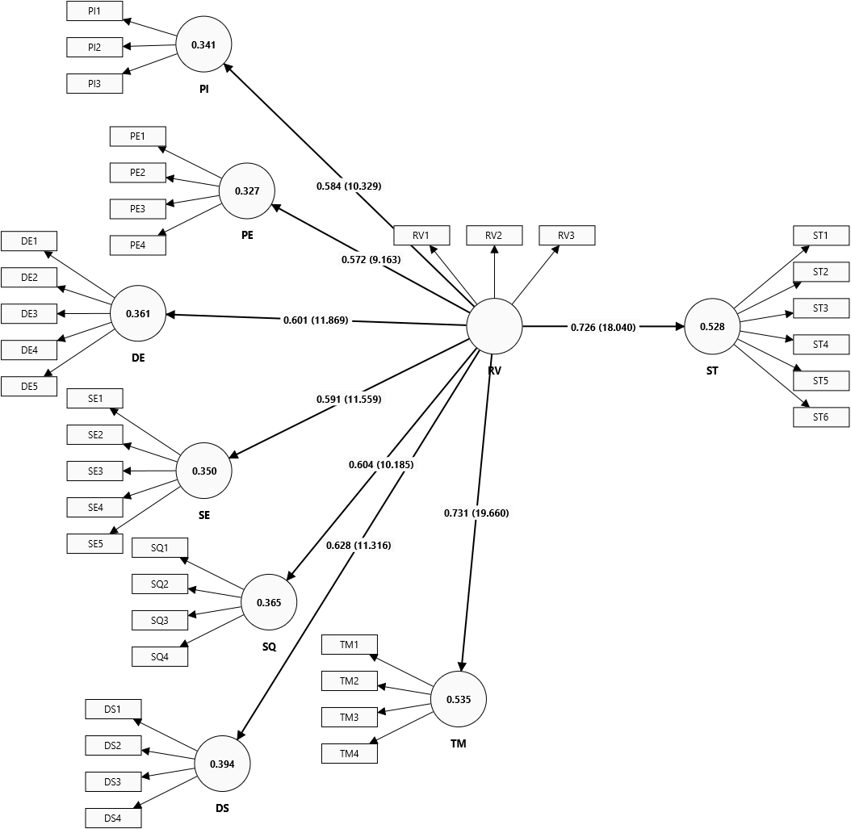
Figure 1. Hypothesised PLS Path Model
Table 6.Latent Variable Index Values and Performance
 | DE | DS | PE | PI | SE | SQ | TM
Latent variable  Index values | -0.064 | 0.213 | -0.015 | 0.023 | 0.273 | 0.076 | 0.492
Latent variable Performance | 59.078 | 62.224 | 69.298 | 60.88 | 66.956 | 63.315 | 71.461

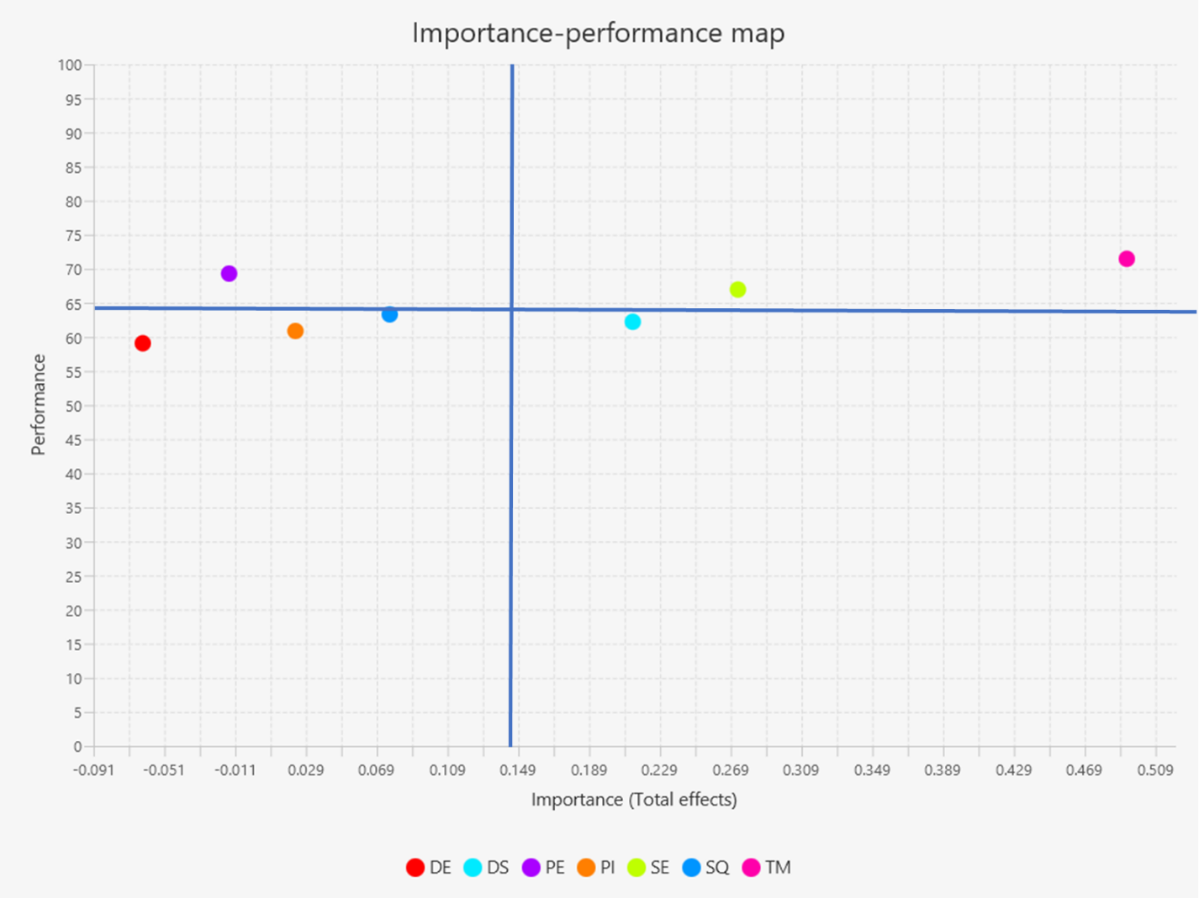

Figure 2. IPMA of the Target Construct

Table 7. Indicator's Index Values and Performance
ITEM | DE | DS | PE | PI | TM | SE | SQ
1 | -0.0186  (8.221) | 0.065  (71.157) | -0.004  (64.940) | 0.007  (58.549) | 0.145  (71.848) | 0.060  (68.048) | 0.022  (62.522)
2 | -0.0166  (7.703) | 0.065  (68.394) | -0.004  (72.366) | 0.007  (61.399) | 0.154  (72.021) | 0.064  (70.466) | 0.019  (64.076)
3 | -0.0116  (4.421) | 0.071  (54.145) | -0.004  (69.430) | 0.006  (61.140) | 0.146  (75.389) | 0.074  (66.494) | 0.029  (64.594)
4 | -0.0234  (5.596) | 0.053  (56.218) | -0.003  (73.057) | 0.007  (62.694) | 0.138  (65.630) | 0.075  (65.630) | 0.021  (61.658)
5 | -0.0116  (1.485) | -0.004  (67.530) |  | 0.073  (64.421)

