Python Programming Implementation

in Food Catalogue Creation

Using GUI

Brilian Danuarta & Rabbyson Raynold
¹Fakultas Ilmu Komputer, Universitas Mercu Buana, Jakarta, 11650, Indonesia,
danubrillian@gmail.com, Hujanraja799@gmail.com

Abstract

Dalam dunia pemrograman modern, pengembangan aplikasi antarmuka pengguna (GUI) sangat penting. Sebuah aplikasi GUI sederhana dapat diimplementasikan menggunakan bahasa pemrograman Python dan modul-modul standar seperti Tkinter, Pandas, dan os, seperti yang dijelaskan dalam jurnal ini. Dengan menggunakan aplikasi ini, pengguna dapat melihat katalog produk, menambahkan produk ke keranjang belanja, dan melakukan pembayaran. Akan ada catatan transaksi dalam file Excel setelah pembayaran selesai. Pembaca akan mempelajari konsep dasar pengembangan aplikasi GUI menggunakan Python melalui pendekatan praktis ini. Mereka juga akan mempelajari cara menggunakan fitur dasar seperti pengelolaan file, interaksi dengan pengguna, dan manipulasi data. Artikel ini dapat berfungsi sebagai panduan bagi pemula dalam mengembangkan aplikasi GUI menggunakan Python.

In the modern world of programming, the development of user interface (GUI) applications is very important. A simple GUI application can be implemented using the Python programming language and standard modules such as Tkinter, Pandas, and os, as described in this journal. Using this application, users can view the product catalogue, add products to the shopping cart, and make payments. There will be a record of the transaction in an Excel file after the payment is completed. Readers will learn the basic concepts of GUI application development using Python through this practical approach. They will also learn how to use basic features such as file management, user interaction, and data manipulation. This article can serve as a guide for beginners in developing GUI applications using Python.

KEYWORDS : APPLICATION FOOD CATALOGUE, TKINTER, GUI

1. INTRODUCTION

User interface (GUI) application development has become an important part of the modern programming world as it allows users to interact with software easily and efficiently. Python is one of the most commonly used programming platforms for developing GUI applications as it has many modules and libraries that support the construction of feature-rich and responsive interfaces.

This article describes the development of a simple GUI application built using Python, focusing on the use of Tkinter, Pandas, and os modules. The application aims to help people manage item catalogues, make purchases, and record payment transactions. The user-friendly user interface makes it easy for users to browse the item catalogue, add items to the shopping cart, and initiate the payment process.

This article will discuss in detail every aspect of developing this app in this context, including the code structure, functionality, and implementation of key features. In addition, this article will explain practical steps for using the Tkinter module to build graphical interfaces and how to use the Pandas module to properly manage and transform data.

This case study will teach readers the basic concepts of GUI application development using Python. They will also learn how to use the various modules and libraries available to create useful and effective applications in the real world.

A catalog is a list or book that includes details about different products or services that a company or retailer sells. Images, descriptions, and costs of the products or services are typically included. Typically, the purpose of these catalogs is to persuade prospective clients to buy those products or services. They are available for printing as well as digital access via apps and websites. A variety of products and services, including apparel, electronics, and home furnishings, are available through catalogs.

"Graphical User Interface" (Antarmuka Pengguna Grafis) is the acronym for GUI. This pertains to the visual elements used in computer programs to enable users to interact with the wild through graphic elements such as buttons, menus, and icons. GUI provides a more intuitive way for users to communicate with a lunak penangkat than antarmuka teks based on perintah baris. Examples of GUIs include modern desktop computers like Windows, macOS, and various desktop environments running various Linux distributions, as well as mobile devices like Android and iOS.The graphical user interface (GUI) enables users to perform many tasks such as opening files, launching applications, editing documents, and many more by utilizing input from keras devices like a mouse, keyboard, or touch screen.

Python is a high-level programming language that is widely used and easy to learn. Python, which was developed by Guido van Rossum and first published in 1991, has grown to become one of the most widely used programming languages worldwide due to its robust syntax, ease of use, and impressive computational power. Python is utilized in various fields such as web development, game development, data analysis, kecerdasan manufacturing, linguistic analysis, and many more.

2. METHOD
The Tkinter module is a standard Python module used to create user interface (GUI) graphics. Use Tkinter to create a window for a website or application.

2.1*Class Catalog App:*

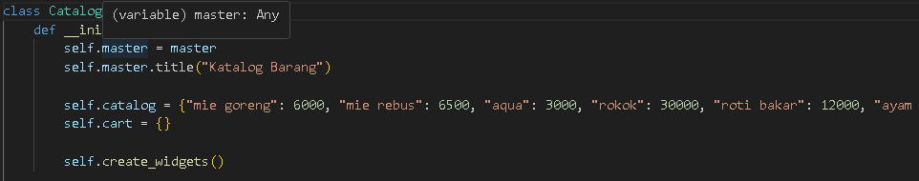
This is the main class that creates the barang catalog application. Use the __init__() method to initialize the CatalogApp object. In this case, the main application is customized, and the create_widgets() function is used to generate user interface elements.

2.2*Create_widgets() method:*
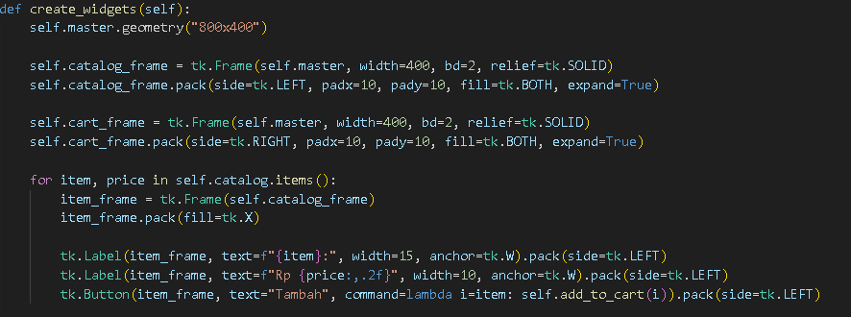
This method creates GUI elements such as product descriptions and pricing lists. Product catalogs are stored in catalog_frame, whereas product specifications are stored in cart_frame. Every item in the barang catalog has a label, a price, and "Tambah" button to indicate its current state. Decision Support System is a computer- based system that can support semi-structured decision making, by utilizing data and then processing it into information in the form of suggestions

2.3*Add_to_cart()and remove_from_cart()
methods:*
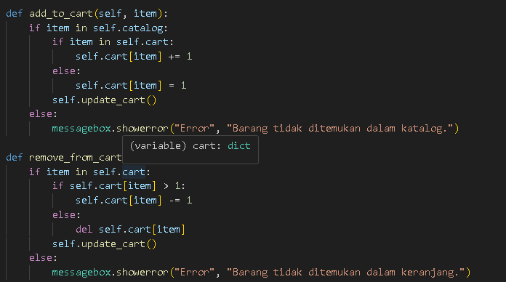
These methods help in the insertion and removal of items from the belanja keranjang. When a user selects the "Tambah" button next to an item in the catalog, add_to_cart() is invoked to add the selected item to the queue. When a user wants to remove an item from the cart, remove_from_cart() can be used to reduce the quantity or remove the item from the cart.

2.4*Reset cart() method:*
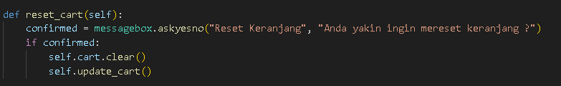
This method is activated when the user presses the “Reset Keranjang” button. This opens aconfirmation popup using messagebox.askyesno() to confirm whether the user actually wants to set a default. If confirmed, the cart will be dissolved.

2.5*Update_Cart() Method:*
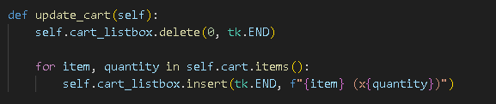
This method is used to adjust the cart shop tampilan every time there is a change in the cart. This creates a new widget for each item in the keranjang and then moves all of the widgets in the cart_frame.

2.6 *Building a Tkinter application:*
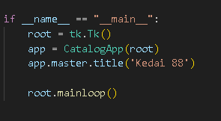
Create an instance of tk.Tk() as the primary window.
Creating a CatalogApp instance with the aforementioned primary key. Use root.title() to set the JND title.Use PIL to create a GIF image as a universal icon by using Image.open() and ImageTk.PhotoImage(). Append the image to the JP icon using root.tk.call().

3. RESULT & OUTPUTS

3.1 Creating a user interface (GUI)
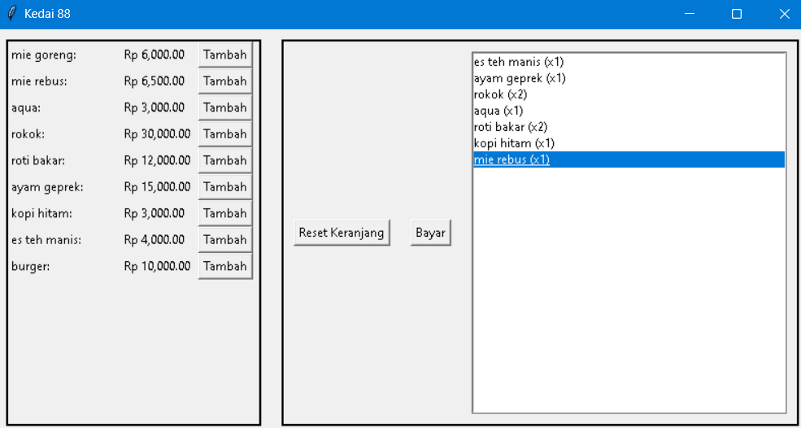

- The user interface is created by using Tkinter elements such as LabelFrame, Label, Button, and Frame. Utilizing a loop through each item in the catalog, the daftar barang is displayed.
Every object has a "Tambah" button that enables users to attach objects to cart.

- 3.2. Payment and receipt of the transaction:
- 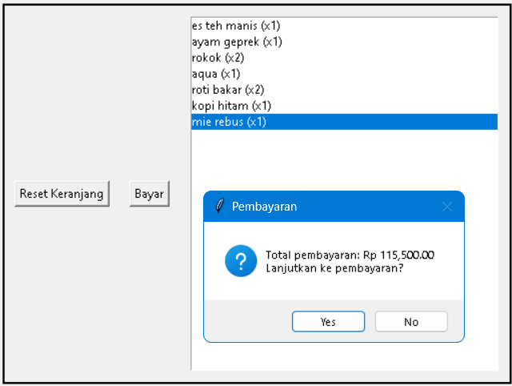
- When the user makes a payment, the total amount is determined by the item's price and quantity in the store. Pengguna will be questioned in order to confirm the payment before completing the transaction. After payment confirmation, the transaction will be recorded in an Excel file.

- 3.3. Integral Reliances:
- 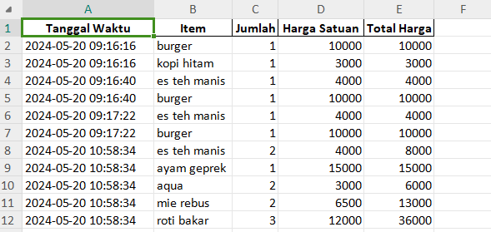
This code uses external modules like datetime, os, and pandas to do operations like copying data to an Excel file and setting the time and date.

4. CONCLUSION
In summary, this code is a clean implementation of a barcode katalog application using Python's Tkinter library. This application allows users to view product descriptions, add items to a belanja keranjang, organize keranjang items, sort keranjang items, and complete payments. To improve this code's quality and functionality, it is advised to increase code complexity, code maintenance, user input validation, user antarmuka, work efficiency, document augmentation, and unit testing. By implementing these strategies, the group can become more robust and able to be manipulated.

Daftar Pustaka

Python, W. (2021). Python. Python releases for windows, 24.
Martinez, W. L. (2011). Graphical user interfaces. Wiley Interdisciplinary Reviews: Computational Statistics, 3(2), 119-133.

Prehanto, Dedy Rahman, and Maya Lailatul Fitriah. "RANCANG BANGUN SISTEM INFORMASI PEMESANAN KATERING
BERBASIS WEB (Studi Kasus Pada Katering Jelita)." Inovate: Jurnal Ilmiah Inovasi Teknologi Informasi 1.1 (2016).
PREHANTO, Dedy Rahman; FITRIAH, Maya Lailatul. RANCANG BANGUN SISTEM INFORMASI PEMESANAN KATERING BERBASIS WEB (Studi Kasus Pada Katering Jelita). Inovate: Jurnal Ilmiah Inovasi Teknologi Informasi, 2016, 1.1.
HEYDT, Michael. Learning pandas. Packt Publishing Ltd, 201

