ASPECTS OF FINANCIAL RATIO TOWARD STOCK RETURN ON TOURISM, HOTEL AND RESTAURANT SECTOR LISTED AT INDONESIA STOCK EXCHANGE
JOURNAL
Submitted to Fulfill The Requirements for Bachelor Degree in Faculty of Economics and Business, Majoring in Management

Universitas Mercu Buana

Name : Marliyana Setiyani Muliasari
Student ID : 43114010148

Management International Class Program
FACULTY OF ECONOMICS AND BUSINESS
UNIVERSITAS MERCU BUANA
JAKARTA
2018

ANALYSIS OF CURRENT RATIO, PRICE EARNING RATIO, NET PROFIT MARGIN AND PRICE BOOK VALUE ON STOCK RETURN

( Case Study Tourism, Hotel and Restaurant Sector in Indonesia
Stock Exchange Period 2012 – 2016 )

THESIS

Submitted to Fulfill The Requirements for Bachelor Degree in Faculty of Economics and Business, Majoring in Management Universitas
Mercu Buana

Name : Marliyana Setiyani Muliasari
Student ID : 43114010148

Management International Class Program FACULTY OF ECONOMICS AND BUSINESS UNIVERSITAS MERCU BUANA
JAKARTA
2018

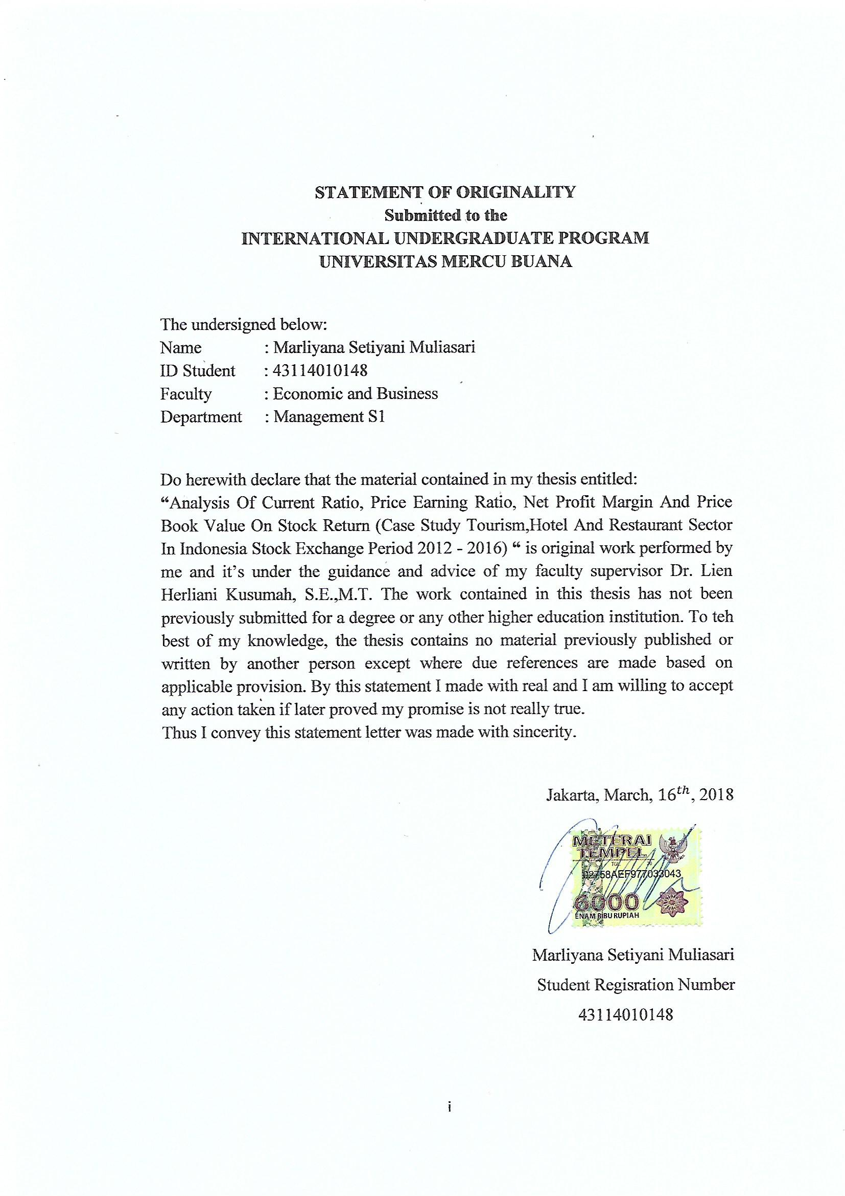

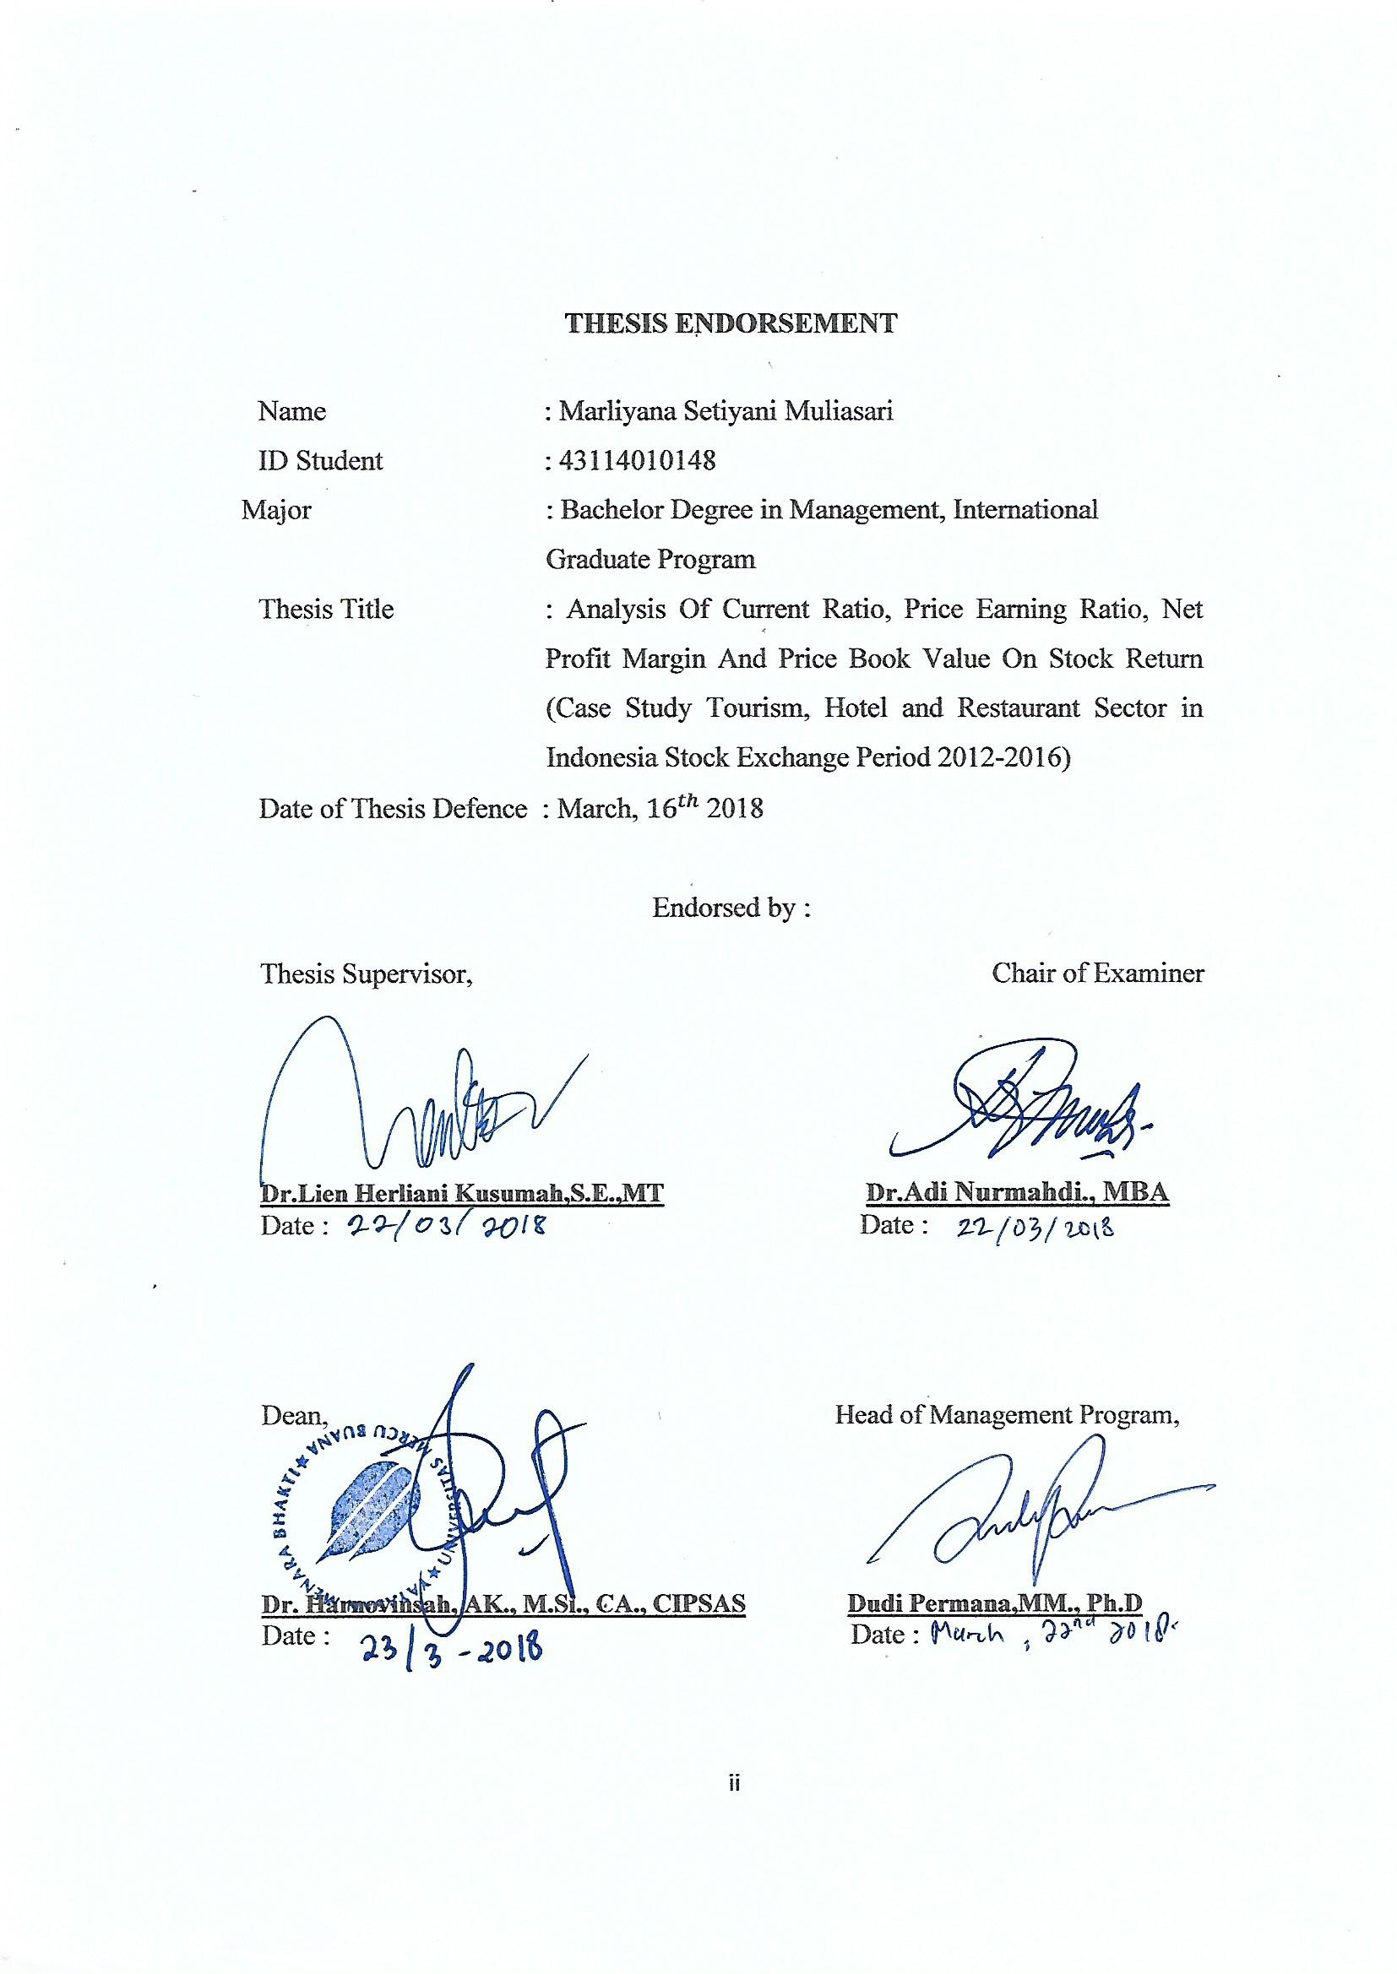

ASPECTS OF FINANCIAL RATIO TOWARD STOCK RETURN ON TOURISM, HOTEL AND RESTAURANT SECTOR LISTED AT INDONESIA STOCK EXCHANGE
$${Lien Herliani Kusumah}^{1}$$
lien.herliani@mercubuana.ac.id
$${Marliyana Setiyani Muliasari}^{2}$$
marlianasty26@gmail.com

ABSTRACT
This research aims to determine the effect of the Current Ratio (CR), Price Earning Ratio (PER), Net Profit Margin (NPM), Price Book Value (PBV) of the Stock Return on sub sector of tourism, hotels and restaurant listed in Indonesia Stock Exchange since 2012-2016. Research use secondary data and purposive sampling method. Data processing was performed using EVIEWS version 9 with fixed effect methode obtained based on Chow test and Hausman test. The results based on t-test showed that variable CR has negative insignificant effect on Stock Return, PER has negative significant effect on Stock Return, NPM has positive insignificant effect on Stock Return and PBV has positive significant effect on Stock Return. Based on coefficient determination as much 46% of variation variable stock returns can be explained by CR, PER, NPM, PBV while 54% on Stock Return variable variation explained by other factors.

Keywords: Stock Return, Financial Ratio Aspects, Current Ratio, Price Earning Ratio, Net Profit Margin, Price Book Value

- INTRODUCTION

Financial ratios in the investment are important among several other factors for investors in choosing stock to invest. Choosing a stock using financial ratios is a fundamental technique that can be applied in analyzing financial data to evaluate the company's position. Fundamentals come from companies that issue stock (issuers). According Sudarsono & Sudiyatno (2016) if the company issuing stock in good condition performance, stock prices will tend to increase and if the stock price increases then the return received also increased. Return is the rate of return on investment. Return can be a key variable in investing for investors, the higher the stock price will result in greater capital gain and interest by investors.
For investors it is important to understand the risk and the rate of return before making an investment decision (Upadhyay, 2017). According Fama & French (2011) returns provide passable descriptions of local average returns for portfolios formed on size and value versus growth. In this case, investors who invest in the capital market would expect a large return (stock return). Investors will tend to look for companies that are currently increasing their competitive advantage. Several sectors are currently experiencing rapid development, one of them is service sector. Within the service sector there are tourism, hotel and restaurant sector where several years in the period 2012-2016 attract investors to invest their stocks. According to the Investment Coordinating Board, investment interests for the tourism sector and the Special Economic Zone increased to 102.89 percent in the period from October 2014 to June 2015. The value of tourism investment has contributed to a total national investment of 2.4 percent. (www.bkpm.com). On the other hand, the contribution of the tourism sector, hotel and restaurant to the economy also continues to increase in line with the growth rate of this sector which is above the average growth of gross domestic product (GDP) (www.kemenpar.go.id).
However, in this study, based on the average movement of stocks, hotels and restaurants sector has fluctuations that tend to decline in the last 5 years, which means this stock returns trend leads to a decreasing rate of return. In the year 2015 Stock Return has minimum decreased as 12,53%, even though in 2016 increased by 24.29 %. This case is in line with Statistics of Foreign Direct Investment Realization based on Capital Investment Activity Report. The hotel & restaurant sector in 2012 is investing 768.2 million US dollars, in 2013 of 462.5 million US dollars, in 2014 of 513.1 million US dollars, in 2015 of 650.2 million US dollars, in 2016 at 887.8 million US dollars (www.bkpm.go.id) .
Other than, financial ratio is one factor in the movement of Stock Retun. According to Zubir (2013), the risk factors for decreasing the ratio will affect the return in investment, one of which is financial risk, which is the financial risk associated with the capital structure used to finance the company's activities. If the company has large debts and unstable income it will affect investors to invest their shares. As a result, the company's stock is not attractive to be an investment instrument and its stock price will go down. Investors therefore often use some financial ratios with consideration of choosing stocks. Some ratios used in this research are Current Ratio (CR), Price Earning Ratio (PER), Net Profit Margin (NPM) and Price Book Value (PBV).
Many researchers have conducted research on the aspect of financial ratios on stock return. Research conducted by Asmi (2015), Pinradee and Suppanunta (2014) show CR have a significant positive effect on stock return. In PER ratio, Hasintongan (2010) shows that PER has a positive impact on stock return. Anwar (2016), Dita & Murtaqi (2014) found that NPM has a positive influence on stock returns. Also, Akbar (2015) point out that PBV has influenced on stock returns. Some of researchers have found insignificant impact and some found that significant positive impact and some found significant negative impact aspect financial ratio on stock return. The problem is still present there that what should be the actual impact of financial ratio on stock return. This paper will examine if there is a significant effect of Tourism, Hotel & Restaurant sector determined by financial ratio on Stock Return for the period 2012-2016, and how the results will approve the results of previous studies.

- LITERATURE REVIEW

Stock
According Hermuningsih (2014), stock are one of the securities traded on the capital market ownership. Meanwhile, according to Susilo (2009), stock can be defined as a sign of capital participation of a person or party (business entity) in a company or limited liability company. According Hermuningsih (2012), the types of shares can be reviewed in several aspects are common stock and preferred stock.
Stock Return
Gitman, et.al (2015) stated stock return is the total gain or loss experience on an investment over a given period of time. It commonly measured as the change in value plus any cash distributing during period of time, expressed as a percentage of the beginning period investment value. Return is the result of investment. Returns or more often referred to as returns are rewards earned from investments made. This return is divided into two, i.e actual returns calculated based on historical data, and expected returns (Expected Return - ER) will be obtained in the future. The components of the return include Capital gains and Yield. Capital gains for investors obtained from excess purchase price above the selling price, both of which occur in the secondary market. Yield is the income or cash flow that the investor receives periodically, for example in the form of dividends or interest. Yield is expressed as a percentage of the invested capital. The formula to calculate stock return is:
Stock Return = $\frac{Pt-Pt-1}{Pt-1}$ (1)
Current Ratio
The liquidity ratio used to measure the effect on Stock Return is Curent Ratio (CR). CR is a comparison between current assets and current liabilities (Keown, et.al, 2008). This ratio can be formulated as follows:
$CR= \frac{current assets}{current liabilities}$ (2)
Current current ratio is usually considered to indicate the occurrence of liquidation problems, otherwise the current ratio is too high is also not good, because it shows the amount of idle funds that can ultimately reduce the company's profitability. In other words, a low CR will cause a fall in market prices from the stock price in question so that it will affect the level of purchases of shares in the sector and may decrease the profit earned. This hypothesis is supported by Purnamasari & Satriawan (2015) state that CR has a positive effect on stock return. Based on the aurgument, it is proposed that:
Hypothesis – 1: CR has a significant positive effect on stock return
Price Earning Ratio
Price Earning Ratio (PER) is a measure of stock performance based on the comparison between stock market price to earnings per share (EPS). According to Halim (2007), the market value ratio is used to measure how much management's ability to achieve market value exceeds cash expenditure. This ratio can be formulated as:
$PER= \frac{market price per share}{earning per share}$ (3)
PER is useful to see how the market appreciates the performance of a company's share of a company's performance as reflected by earning per share. The focus of PER calculation is the net income of the issuer, so if it already knows the PER of an issuer then the investor can know whether the price of a stock is reasonable or not real and also investors can know the time required to get the return from the capital that has been issued. Thus, the higher the PER ratio, the higher the profit growth expected by the investor. This hypothesis is supported by Hasintongan (2010), Risdiyanto (2016) which states that PER has a positive effect on stock return. Therefore, it is proposed that:
Hypothesis – 2: PER has a significant positive effect on stock return.
Net Profit Margin
According to Dendawijaya (2015) net profit margin (NPM) is a ratio that describes the level of profit earned bank compared with income received from operational activities. NPM aims to find out the net profit directly. This ratio can be formulated as:
$NPM= \frac{net profit after tax}{sales } X 100\%$ (4)
According to Susilowati (2011) the higher of NPM ratio means the profits generated by the company is also getting bigger then it will attract investors. Increasing profits (net profit after tax) will reflect the share of earnings in the form of dividends and capital gains received by investors also increases. Based on research conducted by Anwaar (2016) showed the results of NPM effect on Stock Return, it is proposed that:
Hypothesis – 3: NPM has a significant positive effect on stock return.
Price Book Value
Price Book Value (PBV) is the ratio of the stock market price to the value of the book. The larger of PBV ratio can make the higher value of the company, because the larger PBV shows the stock market price of these shares is increasing. The formula is:
$PBV= \frac{Price per share}{book value of equity per share}$ (5)

In general, a well-operated company will have a PBV ratio more than one (> 1). This is due to the increasingly large PBV shows the price of these shares is increasing. So, better the prospect of an issuer and favored by many investors the higher PBV of the stock and the higher this ratio means the market believes in the prospect of the company. This is in line with researchers from Akbar & Herianingrum (2015) and Indriani, et.al. (2014). Based on the above explanation, it is proposed that:
Hypothesis – 4: PBV has a significant positive effect on stock return.

- METHODS
This empirical research is causal method. Due to the data consist of cross section type and time series type, than the method that will be used in this research is panel data. Total population in this research were 21 companies by using secondary data. Sampling was done by purposive sampling method, the number of samples used by 14 companies. In this research, the independent variables is Price Earning Ratio (PER), Current Ratio (CR), Net Profit Margin (NPM) and Price Book Value (PBV). While the dependent variable is Stock Return in the tourism, hotels and restaurants sub sector listed in Indonesia Stock Exchange (IDX) periode 2012 untill 2016.
Based on dependent and independent variable that have been discussed previously the equation model that will be used in this research are as follows:
${SR}_{i,t}=a_{t}+ β_{1}{CR}_{it}+β_{2}{PER}_{it}+β_{3}{NPM}_{it}+β_{4}{PBV}_{it}+ εi$ (6)
Where :
i = cross-section data of Stock Return
T = time series data of Stock Return
${CR}_{it}$ = CR i in year t
${PER}_{it}$ = PER i in year t
${NPM}_{it}$ = NPM i in year t
${PBV}_{it}$ = PBV i in year t
$εi$ = error

- FINDINGS AND ARGUMENT
Descriptive Statistics
Descriptive statistics are ways to describe and present an information from a large amount of data. The variables are implemented in value, mean, medium, maximum, minimum, probability and standard deviation. There are follows:

Table 4.1 The Values of Descriptive Statistics Between Variables
 | STOCK_RETURN | CR | PER | NPM | PBV
Mean | 0.213571 | 1.747829 | 106.8426 | 0.152477 | 1.384286
Median | 0.085000 | 1.523037 | 16.80472 | 0.066487 | 1.085000
Maximum | 3.020000 | 5.407323 | 2263.636 | 1.902667 | 5.580000
Minimum | -0.840000 | 0.647810 | -300.0000 | -0.236041 | 0.250000
Std. Dev. | 0.594180 | 0.924606 | 386.7441 | 0.324484 | 0.980347
Skewness | 1.920959 | 1.832408 | 4.845922 | 4.323478 | 1.756800
Kurtosis | 9.099576 | 6.870714 | 26.55248 | 23.26455 | 6.902301
Observations | 70 | 70 | 70 | 70 | 70

Table 4.1 shows the values of descriptive statistics. The maximum and highest mean values have been observed in this case of Stock Return, following that, the maximum value of stock return is 3.02 and the minimum value is -0.84 while mean value is 0.213571 having standard deviation of 0.594180. The maximum value in case of current ratio is 5.40 and the minimum value is 0.64 while mean value is 1.747829 having standard deviation of 0.924606. The maximum value in case of price earning ratio is 2263.6 and the minimum value is -300.00 while mean value is 106.8426 having standard deviation of 386.7441. The maximum value in case of net profit margin is 1.90 and the minimum value is -0.24 while mean value is 0.152477 having standard deviation of 0.324484. The maximum value in case of price book value is 5.58 and the minimum value is 0.25 while mean value is 1.384286 having standard deviation of 0.980347.
Stationary Test
Stasioneritas is one of the important requirements in econometric model for time series data. The value of profitability usually depends on the value of α, the value of α used is 5%. If Augmented Dicky-Fuller (ADF) statistics are larger then it needs to be done differencing maximum is two, so the data is ready to be processed.
Table 4.2 Stationary Test
Augmented Dickey-Fuller test statistic | Prob.*
Stock Return | 0.0000
CR | 0.0000
PER | 0.0004
NPM | 0.0000
PBV | 0.0120

From result of Table 4.2 shows that Stock Return variable has probability value smaller than α (5%) that is 0,0000 < 0,05, then H0 is rejected. CR is 0,0000 < 0,05, then H0 is rejected, PER is 0.0004 < 0,05, then H0 is rejected. NPM is 0,0000 < 0,05, then H0 is rejected and PBV 0.0120 < 0,05, then H0 is rejected. So, Stock Return, CR, PER, NPM and PBV variable is stationary or not exposed to unit root.
Panel Regression Estimation Model
The decision making can be indicated from probability value more than 5%, the right model used is the Common Effect model. If using Fixed Effect model will be continued Hausman test to determine whether the model Fixed Effect or Random Effect model. If probability value is lower than 5% it’s means the right model is the Fixed Effect model.

Table 4.3 The Result of Chow Test
Effects Test |  | Statistic | d.f. | Prob.
Cross-section F |  | 2.737471 | (13,52) | 0.0050
Cross-section Chi-square |  | 36.497315 | 13 | 0.0005

Table 4.4 The Result of Hausman Test
Test Summary | Chi-Sq. Statistic |  | Chi-Sq. d.f. |  | Prob.
Cross-section random | 31.598157 |  | 4 |  | 0.0000

From the Table 4.3 of chow test, the probability is 0,0005 which means the probability value < 5%, it is means H0 is rejected and HA is accepted which means the Common Effect is not a suitable method, so the suitable method is Fix Effect Model, because from the Chow test H0 is rejected. Then, the test to be continued in Hausman test, to determine the model who the best between Fixed Effects or Random Effects. Based on Table 4.4 the probability of Hausman Test is 0,0000 which means probability value < 5%. It is means that H0 is rejected and H1 is accepted, which shows that Fixed Effect Model is the best mode forthe study.

Table 4.5 The Values of Fixed Effect Model
Variable | Coefficient | Std. Error | t-Statistic | Prob.
C | -0.528200 | 0.290662 | -1.817231 | 0.0749
CR | -0.038199 | 0.134953 | -0.283054 | 0.7783
PER | -0.000620 | 0.000241 | -2.576817 | 0.0128
NPM | 0.085840 | 0.313530 | 0.273787 | 0.7853
PBV | 0.622508 | 0.111585 | 5.578791 | 0.0000
 | Effects Specification
Cross-section fixed (dummy variables)
R-squared | 0.460820 | Mean dependent var |  | 0.213571
Adjusted R-squared | 0.284550 | S.D. dependent var |  | 0.594180
S.E. of regression | 0.502582 | Akaike info criterion |  | 1.678920
Sum squared resid | 13.13464 | Schwarz criterion |  | 2.257105
Log likelihood | -40.76221 | Hannan-Quinn criter. |  | 1.908582
F-statistic | 2.614283 | Durbin-Watson stat |  | 2.323170
Prob(F-statistic) | 0.004064

The basic of making decision for this test area. Based on profitability value:
- If the probability < 0,05, so H0 rejected
- If the probability > 0,05, so H0 accepted
From the data Table 4.5 we get the equation of fixed effect:
Stock Return :-0.528200 - 0.038199 CR - 0.000620 PER + 0.085840 NPM + 0.622508 PBV
T-Statistic : -1.817231 - 0.283054 CR - 2.576817 PER + 0.273787 NPM + 5.578791 PBV
F-Statistic : 2.614283
Prob (F-Statistic) : 0.004064

From the Table 4.5 it can be seen that all the independent variables, namely CR, PER, NPM, and PBV on the dependent variable is the stock return. By looking at the Table 4.5 the results of panel data, it can be conclude that:
- The coefficient vaue of CR is -0.038199, which mean that 3.8% negative variation of stock returns has been explain by the variation of CR. If one unit increases in CR than stock return will decrease at 0.03 units. Partially, CR has got insignificant negative effect on stock return. It can be seen from the probability for the CR to the stock return is -0.038199 with a probability of 0.7783. So Sig. t > 5 % (0.7783 > 0,05).
- The coefficient vaue of PER is -0.000620, which mean that 0.06% negative variation of stock returns has been explain by the variation of PER. If one unit increases in PER than stock return will decrease at 0.0006 units. Partially, PER significant negative effect on stock return. It can be seen from the probability for the PER to the stock return is -0.000620 with a probability of 0.0128. So Sig. t < 5 % (0.0128 < 0,05).
- The coefficient vaue of NPM is 0.085840, which mean that 8.5% variation of stock returns has been explain by the variation of NPM. If one unit increases in NPM than stock return will increase at 0.08 units. Partially, NPM has got insignificant positive effect on stock return. It can be seen from the probability for the NPM to the stock return is 0.085840 with a probability of 0.7853. So Sig. t > 5 % (0.7853 > 0,05).
- The coefficient vaue of PBV is 0.622508, which mean that 6.2% variation of stock returns has been explain by the variation of PBV. If one unit increases in PBV than stock return will increase at 0.62 units. Partially, PBV has got significant positive effect on stock return. It can be seen from the probability for the PBV to the stock return is 0.622508 with a probability of 0.0000. So Sig. t < 5 % (0.0000 < 0,05).

Based on Table 4.5 the results obtained by analysis of the coefficient of determination (R²) of 0.460820 means, the effect of independent variables (current ratio, price earning ratio, net profit margin and price book value) to dependent variable (the stock return) of 46.08% and the effect of other variables of 53.92% which is not included in the model.
So based on above result this research accepts or rejects the following hypothesis:
Hypothesis – 1: There is significant impact of Current Ratio on Stock Return (Rejected)
Hypothesis – 2: There is significant impact of Price Earning Ratio on Stock Return (Accepted)
Hypothesis – 3: There is significant impact of Net Profit Margin on Stock Return (Rejected)
Hypothesis – 4: There is significant impact of Price Book Value on Stock Return (Accepted)

- CONCLUSION AND SUGGESTION

Conclusions
Based on the result of analysis and data processing can be summed up several things as follows:
- Current Ratio (CR) partially has got insignificant negative effect on Stock Return in tourism, hotels and restaurants sector. The results of this study indicate that during the period of research in 2012-2016 investment decision-making by investors is not influenced by current asset and current liabilities of the company.
- Price Earning Ratio (PER) partially has significant negative affect on Stock Return in tourism, hotels and restaurants sector. It is means that PER ratio can provide clues as to what investors think about past company performance and future prospects.
- Net Profit Margin (NPM) has got insignificant positive effect on Stock Return. The positive direction on coefficient of NPM shows means the more value of NPM then the Stock Return will increase but in this study the value of NPM ratio has fluctuative in every year. So,this indicates that investors tend not to take into account the size of NPM ratio.
- Price Book Value (PBV) has got significant positive affect on Stock Return in tourism, hotels and restaurants sector. The positive value of PBV will make investors interested because it will make the higher the company's performance in obtaining profit.

Suggestion
This research in the future will be expected to present more qualified results with some inputs on several things including:
- PER and PBV ratios can be used to explain the Stock Returns in the tourism, hotel and restaurant industries, so that when this ratio increases/decreases it can be a consideration for investors to analyzing company performance affecting stock return.
- This study period is only 5 years with the sample used only from one industry. It is expected for future research using longer period of study and sample used from several different industries for its research result.
- Based on the limitations in this study, researchers provide suggestions for further research should add macro and non-economic variables that are expected to give more influence to the fluctuation on stock returns, using samples other than in tourism, hotels and restaurants sector.

REFERENCES
Akbar, R., & Herianingrum, S. (2015). Pengaruh Price Earning Ratio (PER), Price Book Value (PBV) dan Debt to Equity Ratio (DER) Terhadap Return Saham (Studi Terhadap Perusahaan Properti dan Real Estate yang Listing di Indeks Saham Syariah Indonesia). Jurnal Ekonomi Syariah Teori dan Terapan, 2(9).
Anwaar, M. (2016). Impact of Firms Performance on Stock Returns (Evidence from Listed Companies of FTSE-100 Index London, UK). Global Journal of Management And Business Research, 16(1).
Asmi, T. L. (2014). Current Ratio, Debt To Equity Ratio, Total Asset Turnover, Return On Asset, Price To Book Value Sebagai Faktor Penentu Return Saham. Management Analysis Journal, 3(2).
Dendawijaya, L. (2015). Manajemen Perbankan. Jakarta: Ghalia Indonesia.
Dita, A. H., & Murtaqi, I. (2014). The Effect of Net Profit Margin, Price to Book Value and Debt to Equity Ratio to Stock Return in the Indonesian Consumer Goods Industry. Journal of Business and Management, 3(3), 305-315.
Fama, E. F., & French, K. R. (2012). Size, value, and momentum in international stock returns. Journal of financial economics, 105(3), 457-472.
Gitman, L. J., Juchau, R., & Flanagan, J. (2015). Principles of Managerial Finance. Pearson Higher Education AU.
Halim, A. (2007). Akuntansi Sektor Publik Akuntansi Keuangan daerah, Edisi Revisi, Jakarta, Salemba Empat.
Hasintongan, R. R. (2010). Analysis of the Influence of Accounting Variables on Stock Returns. Thesis. University of Amsteram
Hermuningsih, S. (2014). Pengaruh Profitabilitas, Size Terhadap Nilai Perusahaan Dengan Sruktur Modal Sebagai Variabel Intervening. Jurnal Siasat Bisnis, 16(2).
Indriani, T., Prabawa, S. A., & Kananlua, P. S. (2014). Analisis Pengaruh DER, PBV, dan PER Terhadap Return Saham Perusahaan Manufaktur Yang Terdaftar Di Bursa Efek Indonesia Periode 2008-2012 (Studi Kasus Pada Perusahaan Dalam Kategori Consumer Goods Industry, Food And Beverages, Tobacco Manufactur, Papper, Dan Pharmaceuticals) (Doctoral Dissertation, Universitas Bengkulu).
Keown, A. J., Martin, J. D., Petty, J. W., & Scott Jr, D. F. (2008). Manajemen Keuangan: Prinsip dan Penerapan. Edisi Kesepuluh. Jakarta: PT Indeks.
Petcharabul, P., & Romprasert, S. (2014). Technology industry on financial ratios and stock returns. Journal of Business and Economics, 5(5), 739-746.
Purnamasari, K., Dp, E. N., & Satriawan, R. A. (2015). Pengaruh Current Ratio (Cr), Debt to Equity Ratio (Der), Return on Equity (Roe), Price Earning Ratio (Per), Dan Earning Per Share (Eps) Terhadap Return Saham Pada Perusahaan Property and Real Estate Yang Terdaftar Di Bursa Efek Indonesia Tahun 2009-2011. Jurnal Online Mahasiswa (JOM) Bidang Ilmu Ekonomi, 1(2), 1-15.
Ridley, D. (2012). The literature review: A step-by-step guide for students. Sage.
Risdiyanto, R. (2016). Pengaruh ROI, EPS dan PER terhadap Return Saham pada Perusahaan. Jurnal Ilmu & Riset Manajemen, 5(7).
Sudarsono, B., & Sudiyatno, B. (2016). Faktor-Faktor Yang Mempengaruhi Return Saham Pada Perusahaan Property Dan Real Estate Yang Terdaftar Pada Bursa Efek Indonesia Tahun 2009 S/D 2014. Jurnal Bisnis dan Ekonomi, 23(1), 30-51
Susilo, B. (2009). Pasar modal: mekanisme perdagangan saham, analisis sekuritas, dan strategi investasi di Bursa Efek Indonesia (BEI). UPP STIM YKPN.
Susilowati, Y. (2011). Reaksi signal rasio profitabilitas dan rasio solvabilitas terhadap return saham perusahaan. Dinamika Keuangan dan Perbankan, 3(1), 17-37.
Upadhyay, R. K. (2017). Modelling Stock Returns in India: Fama and French Revisited.
Zubir, Z. (2011). Manajemen Portofolio: Penerapannya dalam investasi saham. Jakarta: Salemba Empat.
Badan Koordinasi Penanaman Modal. October 12, 2017 http://www.bkpm.go.id/en/statistic/foreign-direct-investment-fdi//
Kementerian Pariwisata. October 22, 2017 http://www.kemenpar.go.id/asp/ringkasan.asp?c=111//

