THE INFLUENCE OF E-WOM AND DESTINATION IMAGE ON VISIT DECISION IN THE MUSEUM NASIONAL (MUSEUM GAJAH) Jakarta
Gorbi Najogi - 43115010394
Universitas Mercu Buana

ABSTRACT
The study aims to examine the influence of e-wom and destination Image on visit decision in the Museum Nasional (Museum Gajah) Jakarta. The respondents of this research are public people in Jakarta. This research survey conducted on 135 respondents by using quantitative approach. SEM-PLS had been used for data analysis. The result of this research stated that the coefficient of determination is 0.404, which means the percentage contribution of independent variables (e-wom and destination image) to the dependent variable (visit decision) is 40.4%. The remaining 59.6% is influenced or explained by other variable not included in this research model. The result of this study showed that e-wom and destination image has been significantly influenced for visit decision in museum nasional (museum gajah).
Keyword: electronic word of mouth (e-wom), destination image, visit decision.

I.INTRODUCTION
Tourism is one of the most for countries in increasing their sources of income outside of oil, gas and taxes. At present Indonesia as one of the developing countries has begun to promote its country to attract the eyes from other worlds, this is so that Indonesia is increasingly famous for citizens / residents of other countries to visit Indonesia. Promotions carried out were selling the diversity of tourism and Indonesian culture, this was positively responded to by the large number of foreign tourists visiting Indonesia. Indonesia, which has abundant cultural and tourist diversity, is able to overcome fundamental problems with economic strengthening from its foreign exchange income / regional income, as a country with abundant diversity Indonesia can develop its potential, for example in terms of tourism because tourists visiting Indonesia are looking for or enjoying the beauty of Indonesian tourism so as to provide a domino effect for domestic and foreign countries, if from outside our country is getting more famous then for domestic countries we can increase foreign exchange to raise the welfare of the people that exist today (Rani, 2014).
A museum is an institution dedicated to the general public. The museum serves to collect, maintain and present also preserve the cultural heritage of the community for the purpose of study, research and pleasure or entertainment. Based on RI Government Regulation No. 19 of 1995, the museum is an institution, a place of storage, care, security and utilization of material evidence of the results of human culture and nature and its environment in order to support efforts to protect and preserve the wealth of national culture. (https://www.arsitur.com, 2015)
The National Museum or Elephant Museum is present as an alternative museum tour. Standing in the center of Jakarta, the Elephant Museum offers educative cultural and historical tours. Until now, Gajah Museum has 141,899 objects, consisting of 7 types of collections namely prehistory, archeology, ceramics, numismtik - heraldik, history, ethnography and geography. Interestingly, this first and largest museum in Southeast Asia has a collection of relics from various eras. Through these relics, you can get to know other civilizations (https://lifestyle.sindonews.com, 2015).
"Two or three years ago, the total number of visitors from the National Museum was one hundred thousand a year, which is already good," said Head of the Indonesian National Museum (MNI) Intan Mardiana to CNN Indonesia. Intan's a little efforts paid off. Last year, MNI visitors recorded 250 thousand visitors. And for this year, Intan’s targets as many as 300 thousand people to crowd the national museum collection (www.cnnindonesia.com, 2015). Oting Rudy said “in 2014 number of visitors is 245.848 people. In 2015 reached 287.134 visitors and in 2016 there are 399.618”. “From period January to June 2017, the visitors is 149.621” said Oting.
Table 1.1
Total Visitors in Museum Nasional (Museum Gajah) Jakarta
Number | Total Visitors | Year | Information
1 | 192.166 | 2013 | First data
2  3  4  5 | 245.848  287.134  399.618  315.654 | 2014  2015  2016  2017 | Increase (+)  Increase (+)  Increase (+)  Decrease (-)
*source: (https://jakarta.bps.go.id, www.beritajakarta.id, & lakip from www.museumnasional.co.id)
Based on the data above, it can be concluded every year the number of visitors who come to visit Museum Nasional (Museum Gajah) Jakarta, is increase start 2013 until 2016, but the fact data in 2017 the visitor is decrease. So from that problem which is the visitors decrease in 2017, it can be seen how important E-WOM and Destination Image to Visit Decision in Museum Nasional (Museum Gajah) Jakarta. It can be seen how important E-WOM and the Destination Image to Visit Decision. This research is also to find out how the public people in Jakarta to determine the Visit Decision in Museum Nasional (Museum Gajah) Jakarta. On the basis of the background description above, the authors are interested to examine more with the title: “THE INFLUENCE OF E-WOM AND DESTINATION IMAGE ON VISIT DECISION IN THE MUSEUM NASIONAL (MUSEUM GAJAH) Jakarta”.

II.LITERATURE REVIEW
Consumer behavior is a process that is passed by someone / organization in finding, buying, using, evaluating, and disposing of products or services after being consumed to meet their needs. Consumer behavior will be shown in several stages, namely the stage before purchase, purchase, and after purchase (Balqiah & Setyowardhani, 2014). And other told about consumer behavior is Consumer behavior will be shown in several stages, namely the stage before purchase, purchase, and after purchase (Balqiah & Setyowardhani, 2014).
Tourism is one of the driving forces of the world economy which is proven to be able to contribute to the prosperity of a country. Tourism development is able to stimulate business activities to produce significant social, cultural and economic benefits for a country. When tourism is well planned, it should be able to provide benefits to the community at a destination. The success of tourism is seen and government revenues from the tourism sector can encourage other sectors to develop (Utama, 2017).Tourism is a social phenomena or symptom concerning human, society, group, organization, culture, etc. which is a sociological study. The definition of tourism that is general in nature is the overall activities of the government, business world and society to organize, administer, and serve the needs of tourists (Gunawan & Endang, 2016).
(Kietzmann & Canhoto, 2013), E-WoM refers to any statement based on positive, neutral, or negative experiences made by potential, actual, or former consumers about a product, service, brand, or company, which is made available to a multitude of people and institutions via the Internet (through web sites, social networks, instant messages, news feeds). (Song, Hwang, Kim, & Kwak, 2013:457). “E-WoM marketing can be considered as a social exchange activity that involves the sharing of information through internet-based community networks”.
A destination image is a perception that is formed from various information received by tourists. Every tourism destination has a certain image that contains beliefs, impressions, and perceptions about a destination (Utama, 2016). Prospective visitors will be more interested in visiting a destination with a positive image, while visitors who have succeeded in being satisfied with the positive image make it possible to make a repeat visit will recommend the destination to other potential (Isnaini, & Abdillah, 2018).
Basically a visit decision is a decision taken by someone before visiting some place or region by considering several factors. In this case the visiting decision theory is taken from the theory of purchasing decisions on a product, so that in several categories of visiting decisions applied from the model of purchasing decisions (Jannah, B. 2014). The visit decision is a purchasing activity for tourism products in the form of a tourist village destination, then the theory used is theories related to purchasing decisions by consumers (tourists) and behavior (Priatmoko, 2017).

FRAMEWORK

H₁

E-WOM
VISIT DECISION

DESTINATION IMAGE
H₂

III.RESEARCH METHOD
This research process take time on February - June 2018, in the Museum Nasional (Museum Gajah) Jakarta. This research approach is causal research. Researcher using distribution of online questionnaires was conducted through social media such as line, whatsapp, e-mail and others that were spread through to public people who want to visit Museum Nasional (Museum Gajah). The population of visitors to the Museum Gajah (Museum Gajah) is not known in detail by researchers, so the population in this study were public people who had the decision to visit the Museum Nasional (Museum Gajah). In this study, the sample size was 27 samples, based on the number of indicators multiplied by 5 (5 x 27 = 135) and the maximum sample was 10 x 27 = 270. Based on the number of indicators multiplied by 5, the number of samples was 135 samples.
Variable Measurement
Variabel used in this research are as folows:
- E-WOM
The word E-WOM (electronic word of mouth) is a form of written memos on the web that are usually posted by experience or previous consumers (A Mohammed Abubakar et al., 2017).
- Destination Image
A destination image is a perception that is formed from various information received by tourists. Every tourism destination has a certain image that contains beliefs, impressions, and perceptions about a destination (Utama, 2016).
- Visit Decision
Basically a visit decision is a decision taken by someone before visiting some place or region by considering several factors (Jannah, 2014).
Table 3.1
Operational Variable of EWOM
Variable | Dimension | Indicators
E-WOM | Intensity | - The frequency of accessing information on social networks  - The frequency of interactions between users of social networks  - The number of reviews written by users of social networks
 | Valence of opinion | - Positive comments from social network users  - Consumer recommendations from social networks  - Negative comments from social network users
 | Content | - Destination quality information on social networking sites  - Price information offered on social networking sites  - Information on comfort, cleanliness, destination services on social networking sites
Source: Goyette, I., Ricard, L., Bergeron, J. & Marticotte, F (2010).
Table 3.2
Operational Variable of Destination Image
Variables | Dimension | Indicator
Destination Image | Cognitive Image | - Quality of experience  - Tourist attractions  - Environment & Infrastructure  - Entertainment & cultural traditions
 | Unique Image | - Natural environment  - Destination exploration
Variables | Dimension |  | Indicator
 | Affective Image | - Feelings obtained when at a destination
Source: Hailin Qu, Lisa Hyunjung Kim, Holly Hyunjung Im. 2011.
Table 3.3
Operational Variable of Visit Decision
Variables | Dimension | Indicator
Visit Destination | Destination Area | - Relevance of tourism destination with visitors’ needs.  - Information availability concerning tourism destinations.
 | Traveling Mode | - Accessibility of transportation to reach tourism destinations.  - Diversity of available tourism transportation.  - Convenience of available tourism transportation.

Variables | Dimension | Indicator
 | Time and Cost | - Punctuality of operational hour in tour destinations, including opening time and closing time of tourism destinations.  - Dependence to the established touring and traveling cost.  - Dependence to leisure time to go traveling.
 | Travel Agent | - Dependence to travel agent when traveling.
 | Service Source | - Diversity of provided service, such as tourism guides, souvenir centers, photographies, etc
Source: Hurriyati, R. (2015).
Data analysis method in this research using component or variance based Structural Equation Modeling (SEM) where in data processing using Smart-Partial Least Square (Smart-PLS) version 3.0 program. PLS (Partial Least Square) is a model of variance based SEM. PLS is intended for causal predictive analytics in situations of high complexity and low theory support (Ghozali, 2014).
IV.RESULT AND DISCUSSION
Measurement Evaluation (Outer Model)
- Convergent Validity
Testing Convergent Validity of each construct indicator. According to Chin in Ghozali (2014), an indicator is said to have well valid if its value is greater than 0.70, while loading factor 0.50 to 0.60 can be considered sufficient. Based on these criteria when there is loading factor below 0.50 it will be dropped from model.

Figure 4.1
PLS Algorithm Result
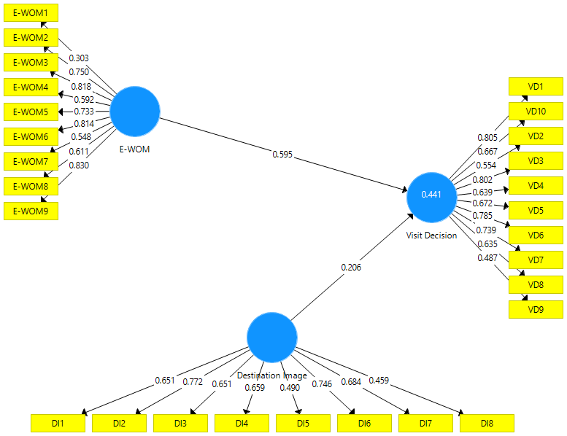
Source : PLS Output
Based on figure 4.1, it can be seen that some indicators have values above 0.50 and are declared valid. And some indicators have a value of 0.50 and are declared invalid.
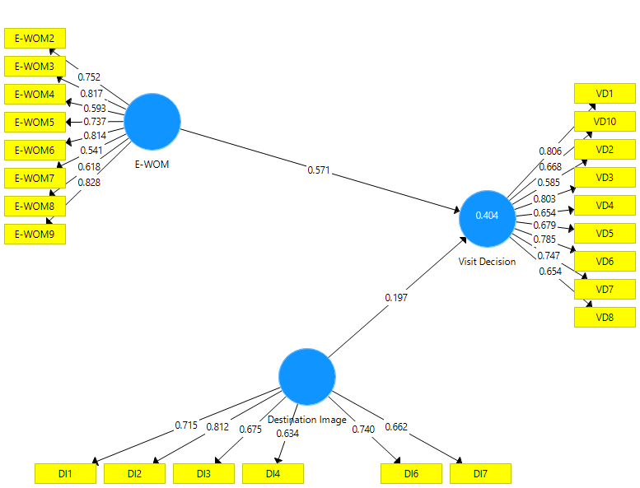

- Discriminant Validity
Discriminant validity is done to ensure that each concept of each latent variables is different from other variables. Constructs that have good discriminant validity if each loading factor value of each indicator of a latent variable has the largest loading factor value with another loading value against other latent variables.
Table 4.1
Discriminant Validity Test (Fornell Larcker).
 | E-WOM | Destination Image | Visit Decision
Destination Image | 0.709
E-WOM | 0.175 | 0.720
Visit Decision | 0.297 | 0.606 | 0.713
Source : Output PLS
From table 4.1 above can be seen that some value of loading factor for each indicator of each latent variable has a loading factor that is not the greater value than loading if associated with other latent variables. This means that each latent variable has good discriminant validity in which some latent variables still have a high correlation meter with other constructs.
- Composite Reliability and Cronbach’s Alpha
Testing composite reliability and cronbach alpha aims to test the reliability of the instrument in a research model. If all variabellaten values have composite reliability or cronbach alpha ≥ 0.7 it indicates that the construct has good reability or the questionnaire used as the tool in this research is consistent. Here is the value of composite reliability and cronbach's alpha on output.
Table 4.2
Composite Realibility and Cronbach’s Alpha Test Result
Variable | Composite Reliability | Cronbach’s Alpha
Destination Image | 0.857 | 0.802
E-WOM | 0.894 | 0.865
Visit Decision | 0.902 | 0.880
Source : Output PLS
Based on table 4.2 above can be seen that the results of composite reliability testing and cronbach alpha show satisfactory value, that is all latent variables have been reliable because all values of latent variables have a value of composite reliability and cronbach alpha ≥ 0.70. So it can be concluded that, the questionnaire used as a tool of this study has been reliable or consistent.
Structural Model/Hypotesis Test (Inner Model)
Inner model testing is the development of concept-based models and theories in order to analyze the relationship of exogenous and endogenous variables has been elaborated in a conceptual framework.
- Goodness of Fit Model
Goodness of Fit test of structural model in inner model using predictive relevance value (Q2). A Q-square value greater than 0 (zero) indicates that the model has a predictive relevance value.

Table 4.3
R² Value Endogen Variable
Endogen Variable | R Square
Visit Decision | 0.404
Sumber : Output PLS
The predictive relevance value is obtained by the formula:
Q2 = 1 - (1 - R1)
Q2 = 1 - (1 - 0,404)
Q2 = 1 - (0,5960
Q2 = 1 - 0,596
Q2 = 0,404
The above calculation results show the predictive relevance value of 0.404 > 0. It means that 40.4% of variation in the Visit Decision variable (dependent variable) is explained by the variables used, thus the model is said to be feasible to have the relevant predictive value.
- Hypothesis Testing Results (Line Coefficient Estimation)
Estimated value for path relation in structural model should be significant. This significant value can be obtained by bootstrapping procedure. See the significance of the hypothesis by looking at the value of the parameter coefficients and the significance value t statistics on the algorithm bootstrapping report. To know significant or not significant seen from t-table at alpha 0.05 (5%) = 1.96. Then t-table compared with t-count (t-statistic).
Table 4.14
Hypothesis Testing Results
 | Original Sample | Sample Mean (M) | Standard Devian (STDEV) | T Statistics (|O/STDEV|) | P Values
DI -> VD | 0.197 | 0.208 | 0.073 | 2.709 | 0.007
E-WOM -> VD | 0.571 | 0.576 | 0.063 | 9.085 | 0.000
Source: Output PLS
From table 4.14 above described some things as follows:
- E-WOM and Destination Image has positive and significant effect on Visit Decision. Because, T statistics > T tables (9.085 > 1,96), and T statistics > T tables (2.709> 1,96) and also hypotheses are accepted, meaning that if E-WOM and Destination Image is given well, then it can increase the Visit Decision of visitor.

Discussion
The Influence of E-WOM on Visit Decision
Based on hypothesis test in this research, result shows that E-WOM has positive significant influence to Visit Decision. The result of this study strengthen the research by (Sari and Pangestuti, 2018) who said The results of path analysis show that the E-wom variable has a significant influence on Visiting Decisions. Visiting decisions or can be said as a purchasing decision is to buy or choose one of the alternatives in accordance with the wishes of buyer. According to (Mulyati, 2018) This indicates that the more information that spreads through electronic word of mouth, the visit decision will increase. Where if communication electronic of word of mouth that occurs on social media about tourist destinations in the city of Bukit Tinggi is often done then by itself the decisions of domestic tourists will increase. According to (Illah, Sularso, and Irawan, 2019) Based on the results of the study, electronic word of mouth has an influence on the probability of visit decisions indicated by significance values that are smaller than the determined significance value of 5% or (0.05), it can be concluded that electronic word of mouth variables significantly affect the probability visiting decision. This shows that the trust, positive experience and satisfaction of tourists who have visited the tourism object B29 in Lumajang Regency where they expressed their positive feelings on Instagram social media so that it could cause potential tourists to be affected and a visitation decision occurred. This shows that E-WOM has a positive influence to choose the desires of visiting decisions and improve the decision to visit the Museum Nasional (Museum Gajah) Jakarta.
The Influence of Destination Image on Visit Decision
Based on hypothesis test in this research, result shows that Destination Image has positive significant influence to Visit Decision. The result of this study strengthen the research by (Priyanto, Widiartanto, and Listyorini, 2016) This indicates that the higher the destination image, the higher the decision to visit. Other authors (Putra, Yuliana, and Suyuthie, 2017) said better the destination image in Carocok Painan Beach attractions, the better the tourists' decision to visit Carocok Painan Beach attractions. Then the worse the destination image in Carocok Painan Beach attractions, the smaller the visitors' desire to decide on their visit to go to Carocok Painan Beach.

V.CONCLUSION AND SUGGESTION
Conclusion
After the researchers conducted the research and discussion in the previous chapter regarding The Influences of E-WOM and Destination Image on Visit Decision Museum Nasional (Museum Gajah) then conclusions can be taken as follows:
- From the results of the data analysis in the previous chapter, it is known that the E-WOM variable has a significant influence on Visit Decision on Museum Nasional (Museum Gajah).
- From the results of the data analysis in the previous chapter, it is known that the Destination Image variable has a significant influence on Visit Decision on Museum Nasional (Museum Gajah).
Suggestion
Suggestions for further research can be used as additional information, knowledge and also be used as a reference for further research which should multiply statement instruments and variables taken to be tested, from the results of the study there are still some percentages that can be reviewed again by independent and dependent variables unknown, so that the results of the study are more accurate, such as: Price, Accessibility, Promotion and so on.
BIBLIOGRAPHY
Abubakar, A. M., Ilkan, M., Al-Tal, R. M., & Eluwole, K. K. (2017). eWOM, revisit intention, destination trust and gender. Journal of Hospitality and Tourism Management, 31, 220-227.
Balqiah, T. E., & Setyowardhani, H. (2014). Perilaku Konsumen.
Ghozali, I. (2014). SEM Metode Alternatif dengan menggunakan Partial Least Squares (PLS). Semarang: Badan Penerbit Universitas Diponegoro.
Goyette, I., Ricard,L.,Bergeron,J. & Marticotte, F (2010). e-WOM Scale: Wordof-Mouth Measurement Scale for e-Services Context, Canadian Journal of Administrative Sciences,27(1),5-23.
Gunawan, A. S., Hamid, D., & Wi Endang NP, M. G. (2016). Analisis Pengembangan Pariwisata Terhadap Sosial Ekonomi Masyarakat (Studi Pada Wisata Religi Gereja Puhsarang Kediri). Jurnal Administrasi Bisnis, 32(1), 1-8.
Hailin Qu, Lisa Hyunjung Kim, Holly Hyunjung Im. (2011). A model of destination Branding : Integrating the concepts of the branding and destination image. Original research Article Tourism Management. Vol 32 Issue 3, 465- 476.
https://www.arsitur.com/2015/11/pengertian-definisi-museum-dan.html
http://www.beritajakarta.id/read/47661/pengunjung-museum-nasional-alami-peningkatan#.XWYgV-gzbIU
https://www.cnnindonesia.com/gaya-hidup/20150920150911-269-79856/akhir-pekan--museum-nasional-menyedot-perhatian-pengunjung
https://jakarta.bps.go.id/statictable/2017/01/30/158/jumlah-kunjungan-wisatawan-ke-obyek-wisata-unggulan-menurut-lokasi-2011-2015.html
https://lifestyle.sindonews.com/read/1056152/156/museum-gajah-museum-pertama- terbesar-di-asia-tenggara-1445827969
http://www.museumnasional.or.id/wp-content/uploads/2018/09/lakip-2017-ttd.pdf
Hurriyati, R. (2015). An analysis of place branding to enhance the image of Bandung city and its implications toward the decisions to visit tourism destination. Sosiohumanika, 8(1)
Illah, A. N., Sularso, R. A., & Irawan, B. (2019). Pengaruh Citra Destinasi dan E-WOM di Media Sosial Instagram serta Persepsi Konsumen Terhadap Keputusan Berkunjung ke Objek Wisata B29 di Kabupaten Lumajang. e-Journal Ekonomi Bisnis dan Akuntansi, 6(2), 164-170.
Isnaini, P. R., & Abdillah, Y. (2018). Pengaruh Citra Merek Destinasi Terhadap Keputusan Berkunjung Dan Kepuasan Pengunjung Serta Dampaknya Pada Minat Kunjung Ulang (Survei Pada Pengunjung Taman Rekreasi Selecta Kota Batu Yang Termasuk Dalam Kategori Generasi Millennial). Jurnal Administrasi Bisnis, 55(2).
Jannah, B. (2014). Pengaruh City Branding dan City Image Terhadap Keputusan Berkunjung Wisatawan ke Banyuwangi. Jurnal Administrasi Bisnis, 17(1).
Kietzmann, Jan and Canhoto, Ana. (2013). Bittersweet! Understanding and Managing Electronic Word of mouth: Journal of Public Affairs. Published online in Wiley Online Library.
Mulyati, Y. (2018). Pengaruh Electronic Word of Mouth terhadap Citra Destinasi serta Dampaknya pada Minat dan Keputusan Berkunjung Wisatawan Domestik pada Destinasi Wisata Kota Bukittinggi. Jurnal Ekonomi dan Bisnis Dharma Andalas, 20(1), 168
Priatmoko, S. (2017). Pengaruh Atraksi, Mediasosial, Dan Infrastruktur Terhadap Keputusan Berkunjung Wisatawan Ke Desa Wisata Pentingsari Yogyakarta. Khasanah Ilmu-Jurnal Pariwisata Dan Budaya, 8(1).
Priyanto, R., Widiartanto, W., & Listyorini, S. (2016). Pengaruh Produk Wisata, Destination Image, dan Word of Mouth Terhadap Keputusan Berkunjung (Studi Kasus pada Pengunjung Objek Wisata Goa Kreo Semarang). Jurnal Ilmu Administrasi Bisnis, 5(1), 217-226.
Putra, E. S., Yuliana, Y., & Suyuthie, H. (2017). Pengaruh citra destinasi terhadap keputusan berkunjung di objek wisata pantai carocok painan. E-Journal Home Economic and Tourism, 15(2).
Rani, D. P. M. (2014). Pengembangan potensi pariwisata kabupaten sumenep, madura, jawa timur (studi kasus: pantai lombang). Jurnal Politik Muda, 3(3), 412-421.
Sari, F., & Pangestuti, E. (2018). The influence of electronic word of mouth (e-wom) on visiting interest and visiting decisions (Study on Tourism Coban Rais BKPH Pujon). Jurnal Administrasi Bisnis, 54(1), 189-196.
Song, K., Hwang, S., Kim, Y., & Kwak, Y. (2013). The effects of social network properties on the acceleration of fashion information on the web. Multimedia Tools and Applications, 64(2), 455-474.
Utama, I. G. B. R. (2016). Keunikan Budaya dan Keindahan Alam sebagai Citra Destinasi Bali menurut Wisatawan Australia Lanjut Usia. Jurnal Kajian Bali (Journal of Bali Studies), 6(1), 149-172.
Utama, I. G. B. R. (2017). Pemasaran Pariwisata. Penerbit Andi.

