

Available online at: http://publikasi.mercubuana.ac.id/index.php/ijiem
IJIEM (Indonesian Journal of Industrial Engineering & Management)
ISSN (Print) : 2614-7327 ISSN (Online) : 2745-9063

Analysis of Service Quality on Sustainable MSME Customer Satisfaction with the Customer Satisfaction Index (CSI) and Importance Performance Analysis (IPA) Methods

Fransisca Debora^{1*}, Nadia Fasa ², Hamdani Aris³, Astrie Apriliani⁴
^{1,2}Teknik Industri, Universitas Singaperbangsa Karawang, Karawang, Indonesia
^{3,4}Teknik Industri, Politeknik META Industri Cikarang, Cikarang, Indonesia

Article Information |  | ABSTRACT
Article history:  Received:  Revised:  Accepted:  Category: select one (Research paper, Review paper, View point, Technical paper, Conceptual paper) |  | UMKM Lestari Seserahan is a business unit engaged in offering services, utilizing business digitalization to promote its business to achieve customer satisfaction. Customer satisfaction can of course be influenced by a variety of factors such as the number of manufacturers offering in the same field, the price and quality offered, as well as the location of available business locations. Based on this, MSME business actors want to know the factors that can influence customer satisfaction so that there are no wrong steps in determining what strategy will be used to make improvements and maintain the level of customer satisfaction using the Customer Satisfaction Index (CSI) method and Importance Performance Analysis. (IPAs). The purpose of the CSI method is to determine the level of customer satisfaction, while the IPA method aims to identify attributes based on their respective importance and is illustrated using a Cartesian diagram. The results of calculations using the CSI method yield results of 92.20% and are included in the "Very Satisfied" category. Followed by the IPA method which is described in the Cartesian diagram that there are no attributes included in Quadrant I (Top Priority). In Quadrant II (Maintain Achievement), namely attributes 1, 2, 3, 9, 10, 11, 12, 13, 14, 15, 17, and 19. In Quadrant III (Low Priority), namely attributes 4, 5, 6 , 7, 16, and 18. In Quadrant IV (Excessive) there is only 1 attribute that is included in the plotting of this quadrant, namely attribute 8.
Keywords:
Customer Satisfaction,
Customer Satisfaction Index (CSI),
Importance Performance Analysis (IPA)
*Corresponding Author  Fransisca Debora  E-mail: fransisca.debora@ft.unsika.ac.id |  | This is an open access article under the CC–BY-NC license.  

- INTRODUCTION
Business digitalization has begun to penetrate Micro, Small and Medium Enterprises (MSMEs). Businesses using social media as a means of promotion tightens competition between competitors. Business actors try their best to be able to maintain their business, one of which is by getting customer satisfaction (Kusumadiningrum, 2020).

UMKM Lestari Seserahan, which is engaged in the service sector, utilizes business digitization to promote its business, and of course, it is very closely related to customer satisfaction. Lestari Seserahan is one of the MSME businesses experiencing intense competition, and many businesses have sprung up in the same field. Customers consider price, service quality, and business location when choosing delivery services. Thus, UMKM Lestari Seserahan seeks to make improvements to its services to increase customer satisfaction, which is to be able to influence the company's profit level (Sihotang, 2022) (Choriah, 2021).

Several studies have been conducted to measure customer satisfaction by implementing the Customer Satisfaction Index (CSI) method, Importance Performance Analysis (IPA) (Umam, 2018) (Purba et al., 2021). The CSI method measures the level of customer satisfaction, while the IPA method determines the importance of each variable (Devani, 2016).

- LITERATURE REVIEW
A. SERVICE QUALITY
Service quality has an essential role in achieving customer satisfaction. According to Kotler (2005), service quality is part of efforts to appropriately fulfil customer needs and desires with a guarantee of meeting customer expectations and satisfaction. In the development of service quality, 5 factors determine service quality (Tjiptono, 2006):
- Reliability
namely the ability to provide services according to promises in a timely and reliable manner
- Physical evidence (tangible)
namely evidence in realizing an actual appearance (facilities and infrastructure) as proof to customers.

- Responsiveness
namely a willingness to help and provide fast and appropriate services to the community by conveying clear information.
- Guarantee (assurance)
namely the employees' knowledge and courtesy and ability to generate public trust and confidence in the institution.
- Empathy
namely, giving sincere and individual or personal attention to the community by trying to understand the community's wishes.

B. Customer Satisfaction
Customer satisfaction is a target in running a business because if customer satisfaction can be fulfilled, the customer strategy is successful. One of the advantages of customer satisfaction is fulfilled is that customers may make transactions again. According to Kotler in Halim et al. (2021), customer satisfaction is a person's feeling of pleasure or disappointment that arises from comparing the performance prepared by the product (results) to their expectations. If performance matches expectations, the customer will be satisfied, and if performance does not match expectations, the customer will be dissatisfied or happy.

Several kinds of methods in measuring customer satisfaction, according to (Kotler, 2005), are as follows:
- Complaint and suggestion system
The role of a system for submitting complaints and facilities is part of customer-oriented or customer-oriented activities to provide opportunities for customers to submit their suggestions, opinions and complaints. This can be information for business units/organizations to respond quickly to customer expectations.
- Ghost shopping
One way to determine customer response is to employ people who act as customers on competing products. This can affect the "ghost shopper", who can provide information about the strengths and weaknesses of competitors' products based on their experience in purchasing or using these products.
- Lost customer analysis
The company tries to get back in touch with customers who last bought their products long ago, so they can find out and understand the background and reasons why customers stop buying products.
- Customer satisfaction survey
Surveys can be carried out most commonly using interview techniques. This makes the company get responses and feedback from customers and positively influences customers because the company pays attention to customers. There are several methods for processing survey results, including:
  - Customer Satisfaction Index (CSI)
According to (Massnick, 1997) (Hidayat, 2020), CSI, or the consumer satisfaction index, measures customer satisfaction based on specific attributes adapted to company conditions. There are five steps in the CSI calculation, namely:
- Determine the value of MIS (Mean Importance Score) and MSS (Mean Satisfaction Score).
MIS and MSS are obtained from each respondent's average level of importance and performance.
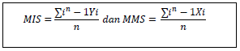
Where:
n = number of respondents
Yi = importance value of the attribute
Xi = performance value of the attribute

- Calculate the Weight Factors (WF)
WF weights are used to obtain a presentation of the MIS value per attribute.
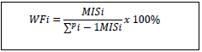
where:
P = number of importance attributes
i = the attribute
- Calculate the weight of WS (Weight Score)
The WS weight is the multiplication of WF and MSS

Where :
i = the i-th attribute
- Determine WT (Weighted Total)
Summing WS of all attributes:

- Determine the CSI (Customer Satisfaction Index) value.
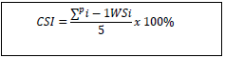
where:
P = Number of important attributes
5 = Number of scales

After getting the results from the calculations above, adjust the results or values with the criteria from CSI as in Table 1 (Asfary, 2018)

Table 1. CSI Value Criteria
No | CSI Value | CSI Criteria
1 | 0.81 – 1.00 | Very satisfied
2 | 0.66 – 0.80 | Satisfied
3 | 0.51 – 0.65 | Quite satisfied
4 | 0.35 – 0.50 | Less satisfied
5 | 0.00 – 0.34 | Not satisfied

  - IPA (Importance Performance Analysis) Method
The IPA method is a concept derived from the concept of Service Quality (SERVQUAL). This method is used to find out what the customer wants to be able to know the most important attributes (Supranto, 2001) in Asfary (2018) (Alghifari, 2019).
The stages in calculating IPA (Hirzan, 2019) are as follows:
  - Calculates the performance scores and importance for each item of attributes
  - Calculating the average value of the level of importance and level of customer performance for each item of attributes and gaps
  - Create a Cartesian diagram

- RESEARCH METHOD
This study uses the CSI and IPA methods with the initial stages of collecting data using a questionnaire with several questions or statements concerning the Quality of Service at "Lestari Seserahan" SMEs. Only customers who have used the services of Lestari Seserahan will be the respondents. The attributes used in this study refer to 5 factors/dimensions that can determine service quality, namely reliability, tangibles, responsiveness, assurance, and empathy. The assessment on the questionnaire uses a Likert scale of 1 (one) to 5 (five) to measure the response from customers. Making a questionnaire is done by utilizing Google's features, namely Google Form. Using the Google Form feature, distribution is also carried out using social media or electronic messages. Based on the results of the questionnaire, further processing is carried out, including:

A. DATA ADEQUACY TEST
This step was carried out to determine the adequacy of the data obtained from the questionnaire distribution process. Data adequacy test can be done with the formula:
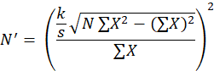
Where:
k = confidence level
s = degrees of accuracy
N = the amount of actual observation data
N' = amount of data theoretically

Data will be considered sufficient if it meets the requirements of N' < N; in other words, the amount of data theoretically is smaller than the amount of actual observational data according to (Wignjosoebroto, 1995) (Darmawan, 2009).

B. DATA UNIFORMITY TEST
This stage is carried out to determine the uniformity of the data obtained by comparing the data with the lower control and upper control limits. If the data is outside the upper control limit or lower control limit, then the data can be removed and entered into the following process. The data uniformity test is carried out with the formula (Lestari, 2018):
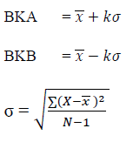
Where:
BKA = Upper Control Limit
BKB = Lower Control Limit
𝑥 = Average value
σ = Standard deviation
k = confidence level

C. VALIDITY TEST
The next step is to test the validity of the data by comparing the Rcount and Rtable values. If r count > r table, the question items or indicators are declared valid. If r count <r table, the question items or indicators are declared invalid (Herlina, 2019).

D. RELIABILITY TEST
In the next stage, a reliability test was carried out to find out whether the data was reliable or not, taking into account the value of Cronbach's Alpha (Herlina, 2019):
    - Cronbach's alpha < 0.6 = Poor reliability
    - Cronbach's alpha 0.6 - 0.79 = Reliability accepted
    - Cronbach's alpha > 0.8 = Good reliability

E. CUSTOMER SATISFACTION INDEX (CSI)
The next stage is to process the data using the formula from the CSI method. This method determines customer satisfaction with MSME services "Lestari Seserahan".

F. IMPORTANCE PERFORMANCE ANALYSIS (IPA)
The next step is to process the data using the IPA method to find out the location of the attribute quadrants to find out the most critical attributes that become a business improvement strategy.

- RESULT AND DISCUSSION
A. RESULTS OF DATA ANALYSIS
Research questionnaires were distributed to Lestari Seserahan customers and found 43 respondents with gender and occupation identities. In gender identity, there were 9 respondents with male characteristics or 21% and 34 with female characteristics (79%). As for the characteristics of the respondents based on occupation, there were 24 private employee respondents (56%), 10 housewives (23%), 5 workers (12%) and 4 others (9%).
The research variables that are owned consist of 5 dimensions with 19 statements shown in Table 2. (Rusmawati, 2021):

Table 2. Research Variables
Dimensions | Statements
Reliability | - Friendliness of business actors in serving customers
 | - Skills and competence of business actors in receiving customers
 | - Business actors provide various services according to what is marketed on social media
Tangible | - Business locations in flats are easy to access by customers
 | - The business location in the flat is very strategic
 | - The parking area is quite large
 | - The location of the business in the flat is clean and comfortable
 | - The appearance of business actors is clean and neat
Responsiveness | - Business actors respond quickly to the chat feature
 | - Business actors respond well to complaints and suggestions
 | - Entrepreneurs carry out work according to the specified time limit
Assurance | - Business actors respond politely to the chat feature
 | - Trust and security of customer goods
 | - Business actors are skilled in handling customers
Empathy | - Business actors can understand customer desires
 | - Business actors pay attention to customers
 | - Seriousness of business actors in providing services
 | - Business actors always face customers with a smile
 | - Business actors in serving customers do not look at social status

The first step is to test the adequacy of the data. The following is a calculation of the data adequacy test of interest level and performance level.
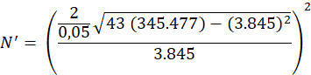

Based on these results, because N' < N, the results with 43 data are sufficient, so there is no need to distribute the questionnaire again.

Furthermore, a data uniformity test was carried out to determine whether the data was uniform. The following are the results of the uniformity test of importance and performance level data, which are shown in Figure 1 and Figure 2.

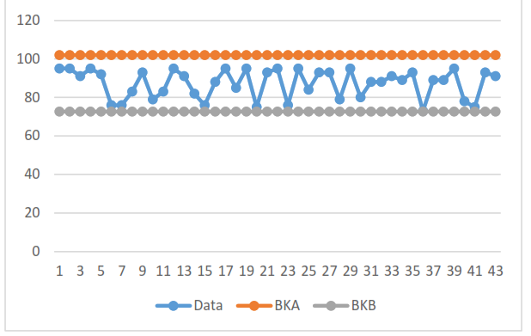
Figure 1. Graph of Interest Level Data Uniformity Test

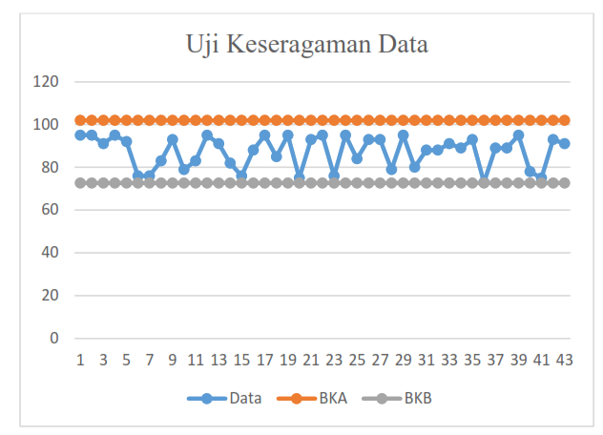
Figure 2. Graph of Performance Level Data Uniformity Test

The graphic image above states the data uniformity test for the statement variable's level of interest and performance level. The results obtained showed that the variables were uniform.

Furthermore, the validity test was carried out in this research. The validity test was carried out using SPSS on data from 43 respondents. The results are for the level of interest and satisfaction with a significance level of 0.05 or 5%, and the data is said to be valid, as shown in Tables 2 and 3.

Table 2. Interest Level Data Validity Test
No | Dimensions |  | R Count | R Table | Classifi-  cation
1 | Reliability | A1 | 0.434 | 0.308 | Valid
2 | Reliability | A2 | 0.789 | 0.308 | Valid
3 | Reliability | A3 | 0.524 | 0.308 | Valid
4 | Tangible | A4 | 0.684 | 0.308 | Valid
5 | Tangible | A5 | 0.691 | 0.308 | Valid
6 | Tangible | A6 | 0.639 | 0.308 | Valid
7 | Tangible | A7 | 0.851 | 0.308 | Valid
8 | Tangible | A8 | 0.888 | 0.308 | Valid
9 | Responsive-ness | A9 | 0.490 | 0.308 | Valid
10 | Responsive-ness | A10 | 0.632 | 0.308 | Valid
11 | Responsive-ness | A11 | 0.526 | 0.308 | Valid
12 | Assurance | A12 | 0.537 | 0.308 | Valid
13 | Assurance | A13 | 0.485 | 0.308 | Valid
14 | Assurance | A14 | 0.514 | 0.308 | Valid
15 | Empathy | A15 | 0.651 | 0.308 | Valid
16 | Empathy | A16 | 0.681 | 0.308 | Valid
17 | Empathy | A17 | 0.770 | 0.308 | Valid
18 | Empathy | A18 | 0.688 | 0.308 | Valid
19 | Empathy | A19 | 0.475 | 0.308 | Valid

Table 3. Performance Level Data Validity Test
No | Dimensions |  | R Count | R Table | Classifi-  cation
1 | Reliability | B1 | 0.612 | 0.308 | Valid
2 | Reliability | B2 | 0.725 | 0.308 | Valid
3 | Reliability | B3 | 0.690 | 0.308 | Valid
4 | Tangible | B4 | 0.698 | 0.308 | Valid
5 | Tangible | B5 | 0.633 | 0.308 | Valid
6 | Tangible | B6 | 0.615 | 0.308 | Valid
7 | Tangible | B7 | 0.806 | 0.308 | Valid
8 | Tangible | B8 | 0.815 | 0.308 | Valid
9 | Responsive-ness | B9 | 0.592 | 0.308 | Valid
10 | Responsive-ness | B10 | 0.747 | 0.308 | Valid
11 | Responsive-ness | B11 | 0.568 | 0.308 | Valid
12 | Assurance | B12 | 0.690 | 0.308 | Valid
13 | Assurance | B13 | 0.622 | 0.308 | Valid
14 | Assurance | B14 | 0.670 | 0.308 | Valid
15 | Empathy | B15 | 0.627 | 0.308 | Valid
16 | Empathy | B16 | 0.700 | 0.308 | Valid
17 | Empathy | B17 | 0.866 | 0.308 | Valid
18 | Empathy | B18 | 0.736 | 0.308 | Valid
19 | Empathy | B19 | 0.673 | 0.308 | Valid

The following process is the reliability test using SPSS, as shown in Tables 4 and 5.

Table 4. Case Processing Summary
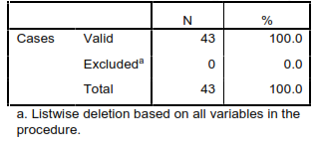

Table 5. Reliability Statistics
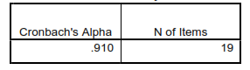

Based on Table 4, information was obtained that the sample or respondent (N) totalled 43 respondents with a valid number of 100%, meaning that the respondent answered all questions without missing anything. In Table 5, Cronbach's Alpha value is 0.910, so it is concluded that the data is reliable or included in the excellent reliability category.

The results of the data reliability test at the performance level are shown in Table 6 and Table 7.

Table 6. Case Processing Summary
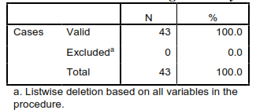

Table 7. Reliability Statistics
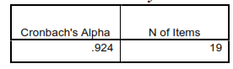

The data reliability test at the performance level obtained the results in Table 6, showing that the sample or respondent (N) totalled 43 respondents with a valid number of 100%. Meanwhile, Table 7 shows that Cronbach's Alpha value is 0.924, so it is concluded that the data is reliable or included in the excellent reliability category.

B. ANALYSIS OF CUSTOMER SATISFACTION INDEX (CSI)
After the data testing is complete, the next step is a data processing to find out how satisfied customers are with the service at the UMKM Lestari Seserahan business using the CSI method. Following are the results of CSI calculations, which are shown in Table 8.

Table 8. CSI Calculation Results
Dimensions | Statements | MIS | MSS | WF | WS
Reliability | - Friendliness of business actors in serving customers | 4.91 | 4.84 | 5.49 | 26.54
 | - Skills and competence of business actors in receiving customers | 4.79 | 4.77 | 5.36 | 25.54
 | - Business actors provide various services according to what is marketed on social media | 4.86 | 4.81 | 5.44 | 26.17
Tangible | - Business locations in flats are easy to access by customers | 4.4 | 3.93 | 4.92 | 19.32
 | - The business location in the flat is very strategic | 4.02 | 3.70 | 4.50 | 16.64
 | - The parking area is quite large | 4.42 | 4.35 | 4.94 | 21.49
 | - The location of the business in the flat is clean and comfortable | 4.44 | 4.35 | 4.97 | 21.60
 | - The appearance of business actors is clean and neat | 4.65 | 4.60 | 5.20 | 23.95
Responsiveness | - Business actors respond quickly to the chat feature | 4.86 | 4.72 | 5.44 | 25.66
 | - Business actors respond well to complaints and suggestions | 4.86 | 4.77 | 5.44 | 25.91
 | - Entrepreneurs carry out work according to the specified time limit | 4.84 | 4.84 | 5.41 | 26.17
Assurance | - Business actors respond politely to the chat feature | 4.91 | 4.81 | 5.49 | 26.42
 | - Trust and security of customer goods | 4.91 | 4.70 | 5.49 | 25.78
 | - Business actors are skilled in handling customers | 4.88 | 4.79 | 5.46 | 26.17
Empathy | - Business actors can understand customer desires | 4.74 | 4.63 | 5.31 | 24.55
 | - Business actors pay attention to customers | 4.6 | 4.56 | 5.15 | 23.47
 | - Seriousness of business actors in providing services | 4.74 | 4.74 | 5.31 | 25.17
 | - Business actors always face customers with a smile | 4.7 | 4.58 | 5.25 | 24.07
 | - Business actors in serving customers do not look at social status | 4.88 | 4.84 | 5.46 | 26.42
TOTAL |  | 89.42 | 87.33 | 100
WEIGHT TOTAL |  |  |  |  | 461.04

Based on the calculation results above, the CSI value is 92.20% or 0.9220, meaning that the customer satisfaction index for Lestari Seserahan services is included in the CSI value criteria in the scale range 0.81 - 1.00 or included in the "Very Satisfied" value criteria .

C. IMPORTANCE PERFORMANCE ANALYSIS (IPA)
Furthermore, data processing using the IPA method obtained the following results:

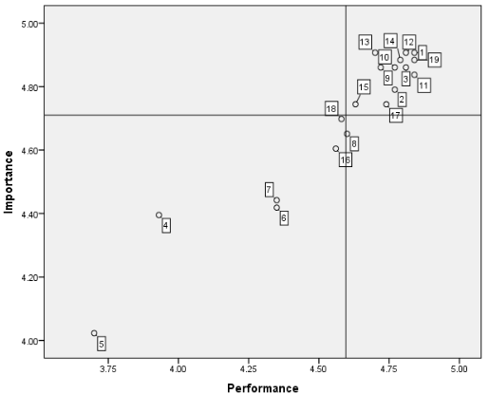
Figure 3. Cartesian diagram

The Cartesian diagram has an explanation for each quadrant, namely:

- Quadrant I: Top Priority (Concentrate Here)
This quadrant must be repaired first by the business actor, but based on Figure 3, there are no attributes that are plotted in this quadrant, meaning that there are no attributes that need to be prioritized first.

- Quadrant II: Maintain Achievement (Keep Up The Good Work)
In this quadrant, many attributes are in quadrant II plotting. Quadrant II is a quadrant with a positive value because the customer gives a high value or score at the level of importance and performance. So, as much as possible, business actors must maintain their good performance or even provide even better ones to customers. The attributes included in quadrant II plotting are 1, 2, 3, 9, 10, 11, 12, 13, 14, 15, 17, and 19, as shown in Table 8.

Table 8. Quadrant II Attributes
Dimensions | Statements
Reliability | - Friendliness of business actors in serving customers
 | - Skills and competence of business actors in receiving customers
 | - Business actors provide various services according to what is marketed on social media
Responsiveness | - Business actors respond quickly to the chat feature
 | - Business actors respond well to complaints and suggestions
 | - Entrepreneurs carry out work according to the specified time limit
Assurance | - Business actors respond politely to the chat feature
 | - Trust and security of customer goods
 | - Business actors are skilled in handling customers
Empathy | - Business actors can understand customer desires
 | - Seriousness of business actors in providing services
 | - Business actors in serving customers do not look at social status

- Quadrant III: Low Priority
In this quadrant, low Priority is an attribute that is not too important or not expected by customers. Businesses can prioritize or pay less attention to the attributes in quadrant III plotting. The attributes included in quadrant III are attributes 4, 5, 6, 7, 16, and 18, as shown in Table 9.

Table 9. Attributes of Quadrant III
Dimensions |  | Statements
Tangible | - Business locations in flats are easy to access by customers
 | - The business location in the flat is very strategic
 | - The parking area is quite large
 | - The location of the business in the flat is clean and comfortable
Empathy | - Business actors pay attention to customers
 | - Business actors always face customers with a smile

- Quadrant IV: Possibly Overkill
Quadrant IV is a quadrant that is not too important for customers, but business actors perform very well on this attribute, so this quadrant is called redundant. The attributes included in this quadrant are attribute 8, as shown in Table 10.

Table 10. Quadrant IV Attributes
Dimensions | Statements
Tangible | - The appearance of business actors is clean and neat

- CONCLUSION
Based on the results and discussion of the research that has been conducted at UMKM Lestari Seserahan, it can be concluded that:
    - The level of customer satisfaction with the quality of service provided by "Lestari Seserahan" with the CSI method is 92.20%, or it can be said that it is included in the "Very Satisfied" category
    - The attributes that become Excellence based on the IPA Method are attributes 1, 2, 3, 9, 10, 11, 12, 13, 14, 15,17, and 19. Table 4.10 shows Attributes of Quadrant II (Maintain Achievement).
    - There are no attributes that are a priority to be considered and improved by MSME businesses that are by the wishes of customers because there are no attributes that are included in Quadrant 1 (Top Priority).
    - The location of the business in the flat area is not a problem for customers in the "Lestari Seserahan" MSME business.

REFERENCES
Alghifari. (2019). Mengukur Kualitas Layanan dengan Indeks Kepuasan, Metode Importance Performance Analysis (IPA) dan Model Kano. BPFE.

Asfary, O. R. (2018). Analisis Kepuasan Pelanggan menggunakan Pendekatan Importance Performance Analysis dan Customer Satisfaction Index. Universitas Islam Indonesia.
Choriah, & Nurmiati, E. (2021). Analisis Kepuasan Pengguna Whatsapp Sebagai Media Knowledge Sharing Menggunakan Metode Pieces. Jurnal Teknologi, 14(1), 61–68. https://doi.org/10.24853/jurtek.14.1.61-68

Darmawan, S. B. (2009). Perancangan Meja dan Kursi Pada Alat Pemotong Bulu Industri Shuttle Cock Merk T3 Berdasarkan Pendekatan Antropometri di Kelurahan Serengan Surakarta. Universitas Sebelas Maret.

Devani, V., & Rizko, R. A. (2016). Analisis Kepuasan Pelanggan dengan Menggunakan Metode Customer Satisfaction Index (CSI) Dan Potential Gain In Customer Value (PGCV). Jurnal Rekayasa Dan Manajemen Sistem Informasi, 2(2), 24–29.

Halim, F., Kumiullah, Z., Butarbutar, M., Efendi, Sudarso, A., Purba, B., Lie, D., Sisca, Simarmata, H. M. P., Permadi, L. A., & Novela, V. (2021). Manajemen Pemasaran Jasa. Yayasan Kita Menulis.

Hardi Purba, H., Debora, F., Jaqin, C., & Adiyatna, H. (2021). Service Quality Analysis: An Empirical Study of Customer Satisfaction in a Healtcare. Jurnal Teknologi Dan Manajemen, 19(1), 33–40. https://doi.org/https://doi.org/10.52330/jtm.v19i1.22

Herlina, V. (2019). Panduan Praktis Mengolah Data Kuesioner Menggunakan SPSS (P. A. M. Komputindo (ed.)).

Hidayat, F. N. P. (2020). Analisis Tingkat Kepuasan Nasabah Terhadap Kualitas Pelayanan BRI Syari’ah Dengan Metode
Importance Performance Analysis (IPA) dan Customer Satisfaction Index (CSI). Institut Agama Islam Negeri (IAIN).

Hirzan, A. (2019). Analisis Kepuasan Pelanggan PT. Samudera Surabaya Logistik Dengan Implementasi Marketing Mix 4P Menggunakan Metode Importance Performance Analysis. Politeknik Perkapalan Negeri Surabaya.

Kotler, P. (2005). Manajemen Pemasaran. PT. Prenhallindo.

Kusumadiningrum, R. (2020). Analisis Kualitas Pelayanan untuk meningkatkan Kepuasan Pelangggan pada Kantin ITN Malang Kampus 1 menggunakan Metode Service Quality. Jurnal Valtech (Jurnal Mahasiswa Teknik Industri), 3(2), 177–182.

Lestari, S., & Pratama, S. A. (2018). Analisis Tingkat Kepuasan Pelanggan Di Pasar Sore Purijaya Tangerang Dengan Metode Swot. Jurnal Teknik: Universitas Muhammadiyah Tangerang, 7(2), 95–101.

Rusmawati DJ, Y., Nur Azizah, L., & NajiahEvi, F. (2021). Total Quality Management. CV Media Sains Indonesia.

Sihotang, F. P., & Oktarina, R. (2022). Penggunaan Metode Importance Performance Analysis (IPA) dan Customer Satisfaction Index (CSI) Dalam Menganalisis Pengaruh Sistem E-Service Terhadap Tingkat Kepuasan Pelanggan. Jurnal Teknologi Sistem Informasi, 3(1), 1–12.

Tjiptono, F. (2006). Manajemen Jasa. Andi Offset.

Umam, R. K., & Hariastuti, N. P. (2018). Analisa Kepuasan Pelanggan dengan menggunakan Metode Customer Satisfaction Index (CSI) dan Importance Performance Analysis (IPA). Seminar Nasional Sains Dan Teknologi Terapan VI, 339–344.

