

Available online at: http://publikasi.mercubuana.ac.id/index.php/ijiem
IJIEM (Indonesian Journal of Industrial Engineering & Management)
ISSN (Print) : 2614-7327 ISSN (Online) : 2745-9063

Shift Work System Analysis Of Store Employee Fatigue Using The Subjective Self Rating Test And Independent Sample T Test Methods (Case Of Sports Station Plaza Surabaya)

Ahmad Reza Baihaqi^{1*}, Ir, Akmal Suryadi, MT ²
Department of Industrial Engineering, Universitas Pembangunan Nasional “Veteran” Jawa Timur, Jl Rungkut Madya No.1, Gunung Anyar, Surabaya 60294, Indonesia

Article Information |  | ABSTRACT
Article history:  Received:  Revised:  Accepted:  Category: Research Paper |  | This study analyzed the initial symptoms of fatigue and measured the level of fatigue with the subjective self rating test method as a subjective method, the CVL (Cardiovascular Load) method as an objective method, and the independent sample t test at the Plaza Surabaya sports station shop. Shift work in shops has the potential to cause health risks of fatigue due to differences in physical workload experienced in each shift. The Sports Station Plaza Surabaya store faces problems with ergonomic risky work activities, with several worker complaints due to work shifts that only carry out rotational shifts per month and unclear employee jobdesk placement. The Subjective Self Rating Test method is used to identify early symptoms of employee fatigue by filling in a questionnaire, the CVL method is used to measure pulse to obtain the level of physical workload fatigue experienced by employees. While the independent sample t test test is to find out whether there is a significant difference in the level of shift fatigue at the Sports Station Plaza Surabaya store. ergonomics factor. By identifying the problem of employee fatigue, the sports station plaza Surabaya store can implement work improvement proposals to overcome employee fatigue in a more ergonomic way to improve employee comfort and health.
Keywords:
Fatigue
Subjective Self Rating Test
CVL (Cardiovascular Load)
Independent Sample T Test

*Corresponding Author  Ahmad Reza Baihaqi and Ir, Akmal Suryadi, MT  E-mail: rezbau99@gmail.com and akmal.suryadi65@gmail.com |  | This is an open access article under the CC–BY-NC license.  

- INTRODUCTION
Early symptoms of work fatigue are a common problem that we often encounter in workers at work. The word fatigue refers to different physical and mental states of the body, but all of them result in a decrease in working power and a decrease in the body's resistance to work. The causes of work fatigue vary according to internal factors that come from oneself and external factors that come from outside or the work environment (Nerva, 2021). Work fatigue is not only experienced by workers who carry out physical activities such as work in factories, namely moving material from conveyors, storing unit items in warehouses. But it is also experienced by workers whose activities provide services to the community, one example is shop workers. Fatigue can be caused by physical or mental stress. One of the causes of fatigue is sleep disturbance, which among other things can be affected by lack of sleep and disturbance due to work shifts (Rahmaniyah, 2019).
Shift work as a method of working from an organization where workers succeed with each other at work so that they can operate longer than normal working hours, for workers is a workload that must be borne as workers. A worker with shift work is someone who works outside normal working hours for a certain period of time.
Sports Station Indonesia is a private store engaged in product sales services to end consumers, specifically selling sports equipment and supplies. The products offered by the company can be a part of the process of forming consumer perceptions and motivation to create a consumer purchase. This company offers quality products from various well-known brands in the world and also offers affordable prices for the public.
Based on an initial survey conducted by the author of the workers at the Sports Station Plaza Surabaya shop, it can be seen that the workforce in the field works on a permanent shift system per month, which is divided into 2 shifts, namely shift I starting with working time at 10.00-18.00 WIB, shift II starts with working time at 14.00-23.00 WIB. There are 30 employees in the shop divided into two work shifts, 20 people in the first shift and 10 people in the second shift. Each employee experiences one shift by providing workers only once a week off. Apart from working selling products in stores, employees experience a work system that is not the same in each shift, for shift I they do more movements because products arrive almost every day and they have to unload and also organize their goods in the store, then, for shifts II does not require more energy because it only closes or calculates sales financial reports per day. Each employee experiences fatigue in each shift, especially the arrangement of the morning shift and afternoon shift which does not meet the standard of work, namely 9 hours of work and also the unclear positioning of employee jobdesk.
Based on the description above, the researcher is interested in conducting research on the initial symptoms of fatigue for each shift employee at the Sport Station Plaza Surabaya shop and analyzing the differences in fatigue levels for shift 1 and shift 2. The Subjective Self Rating Test method was chosen because it is a subjective method that can conducted to determine the initial symptoms of work fatigue. Then the objective method is carried out by using the CVL (Cardiovascular Load) method to find out the problem of the level of fatigue in the work system where, in this method, the pulse is carried out using a tool, namely an oximeter. Then, the independent sample t test test method was chosen because to find out the data test from filling out the subjective self rating test questionnaire whether there is a difference in the level of work fatigue among shop employees shift I (Morning) and Shift II (Afternoon) at the Sports Station Plaza Surabaya shop.

- LITERATURE REVIEW
- WORK FATIGUE
Work fatigue is a condition experienced by workers which can result in a decrease in work vitality and productivity. Work fatigue referred to in this study is general fatigue experienced by workers, characterized by slowed reaction times and feelings of tiredness (Suma'mur, 2019).

- SHIFT WORK
Shift work is defined as a period of time worked by a group of employees who start working when another group finishes. According to Muchinsky (2019), the definition of work shift is the division of work time based on a certain time.

- SUBJECTIVE SELF RATING TEST
Tarwaka (2004) states that the Subjective Self Rating Test from the Industrial Fatigue Research Committee (IFRC) Japan is one of the questionnaires that can measure the level of subjective fatigue. The level of subjective fatigue in question is the level of fatigue felt by the person himself. The questionnaire contains 30 questions consisting of:
A. Ten questions about impairment of activity (feeling of heaviness in head, whole body tired, heaviness in legs, yawning, messy mind, drowsiness, eyestrain due to radiation, awkward movements of legs, unsteady standing, and desire to lie down).
B. Ten questions about weakening motivation (difficulty thinking, tired of talking, stress, lack of concentration, difficulty concentrating, forgetfulness, reduced self-confidence, feeling anxious, difficulty controlling attitudes due to work stress, and not being diligent at work).
C. Ten questions describing physical fatigue (headache, stiffness in shoulders, back pain, shortness of breath, thirst, hoarse voice, feeling tired, eyestrain, lack of sleep, tremors in limbs, and feeling unwell).

- CVL (CARDIOVASCULAR LOAD)
Cardiovascular load is a method to determine the level of work fatigue. Recommended Weight Limit is a method to determine the recommended weight. To determine the classification of workload based on an increase in working heart rate compared to the maximum heart rate due to cardiovascular load (cardio-vascular load = % CVL) which is calculated using the following formula:

$$\%CVL:\frac{100 X (DNK-DNI)}{DNMak-DNI}$$

From the results of the %CVL calculation, it can then be compared with the clarification that has been applied which can be seen in the table below.

Table 1 CVL Fatigue Classification
(Source : Tarwaka, 2014)

- INDEPENDENT SAMPLE T TEST
According to Andri (2019) this test is to find out the average difference between two populations/groups of independent data. A case example of a study wishing to determine the relationship between smoking status of pregnant women and the weight of the baby born. Respondents were divided into two groups, namely those who smoked and those who did not smoke.
This independent T-test has assumptions/conditions that must be met, namely:
a. The data is normally distributed.
b. Both groups of data are independent (free)
c. The related variables are numerical and categorical (with only 2 groups).
According to (Nuryadi) 2017 the Independent Sample T-Test is a statistical test to find out the comparison between the averages of two unpaired or independent data groups. or different.

- RESEARCH METHOD
This research was conducted by taking a case study at the Sports Station Plaza Surabaya store. Data collection was only carried out on prominent employees, totaling 30 employees consisting of 20 shift 1 employees and 10 shift 2 employees. significant fatigue level between shift 1 and shift 2 at the sports station plaza surabaya store The dependent variable in this study is the early symptoms of employee fatigue and the level of employee fatigue while the independent variables in this study are unloading a lot of goods, lifting goods to the warehouse, arranging goods to the warehouse, stand a long time to serve customers. The research steps to solve the problem can be seen in Figure 1.

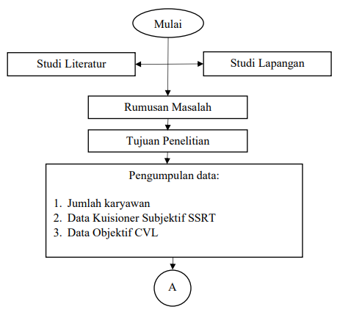

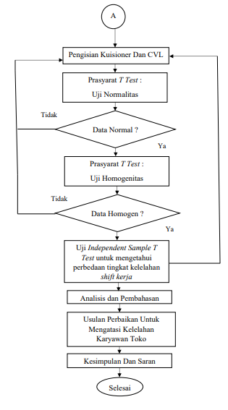
Fig. 1. Research Flowchart

- RESULT AND DISCUSSION
- SUBJECTIVE SELF RATING TEST
Based on the results of the subjective self-rating test questionnaire that was filled in by 30 store employees in shift 1 and shift 2 as respondents obtained a total score of 30 questions, the results can be seen as follows
Table 2.
Tabel 2. Results of Filling in the SSRT Questionnaire for Weakening Shift 1 Activities
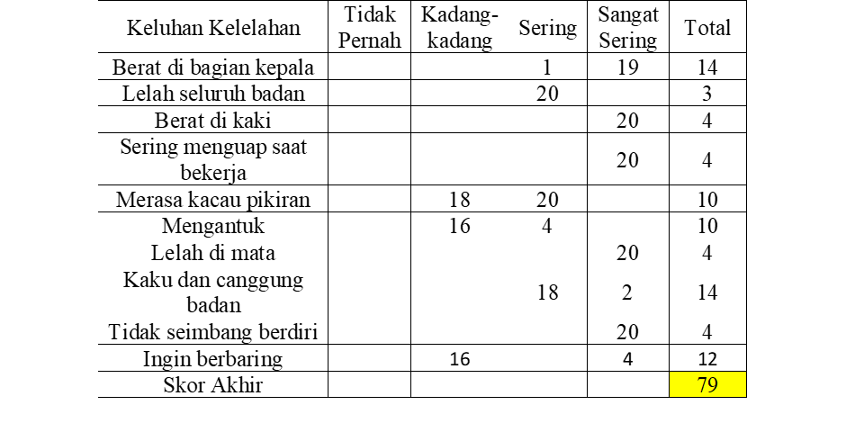
Tabel 3 Results of filling out the SSRT Questionnaire for Weakening Motivation in Shift 1
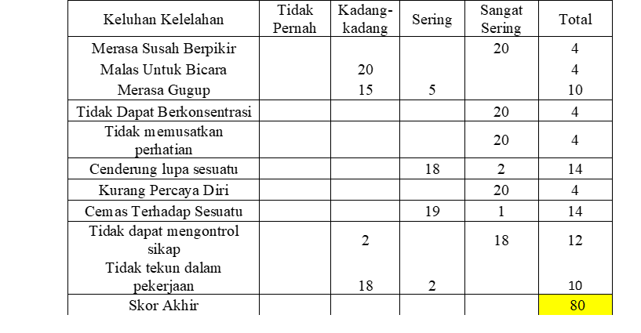
Tabel 4 Results of Filling in the SSRT Questionnaire for Shift 1 Physical Fatigue
based on the results of the subjective self-rating test questionnaire on shift 1 it can be stated that the initial symptoms of fatigue are highest in physical fatigue with a total score of 106.
Tabel 5 Results of Filling in the SSRT Questionnaire for Weakening Shift 2 Activities
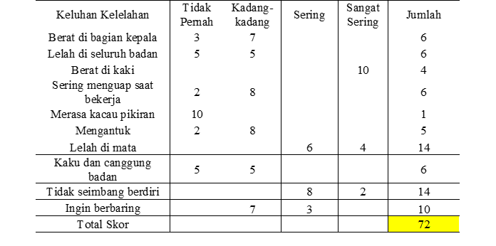
Tabel 6 Results of filling out the SSRT Questionnaire for Weakening Motivation in Shift 2
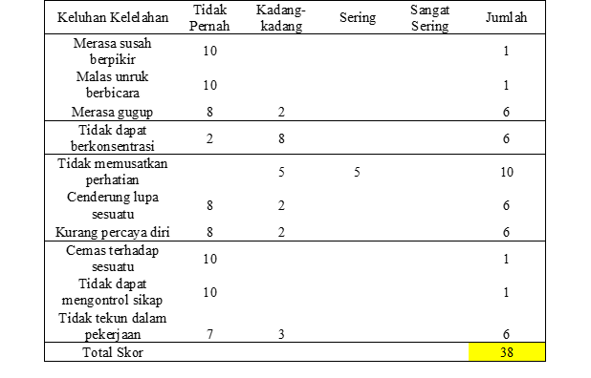

Tabel 7 Results of Filling in the SSRT Questionnaire for Shift 1 Physical Fatigue
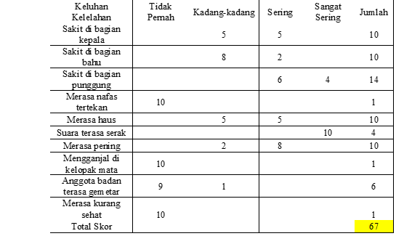
Based on the results of the subjective self-rating test questionnaire on shift 2, it can be stated that the initial symptoms of fatigue are highest in physical fatigue with a total score of 67.

- CVL (CARDIOVASCULAR LOAD) OBJECTIVE MEASUREMENT DATA
The results of the employee pulse data at the Sports Station Plaza Surabaya shop for Shift 1
Tabel 8 CVL Result Data for Shift 1 Store Employees

Based on the results of the CVL calculation for shift 1 store employees, which is classified as no fatigue. With a CVL value of 8, ], it needs improvement.
The results of the employee pulse data at the Sports Station Plaza Surabaya shop for Shift 2
Tabel 9 CVL Result Data for Shift 1 Store Employees

Based on the results of CVL calculations in the shift shop employee table 2, the highest rating level classification is felt, namely CVL of 23.96 which is classified as not experiencing fatigue in workers.

- INDEPENDENT SAMPLE T TEST
Based on the independent sample t test that has been tested through the SPPS statistical application. the variance of the data is normal and homogeneous, then the Equal variances assumed column is selected, and in the t-test for Equality of Means row, the value of t = 3.895, df = 28 and significant (2 tailed) is 0.01. It can be interpreted, if the value of Sig. (2 tailed) < 0.05, then H0 is rejected, Ha is accepted, then there is an average difference in the level of work shift fatigue among employees at the Sports Station Plaza Surabaya store.

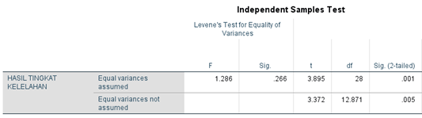

Fig. 2. Output Independent Sample T Test

- IMPROVEMENT PROPOSAL
Based on the results of calculations using the subjective method through a subjective self rating test questionnaire and calculating the objective CVL (Cardiovascular Load) method, employees at the Sprots Station Plaza Surabaya store, Shift 1 experience a high level of fatigue and receive a heavy physical workload. From the calculation of the two methods, it can be concluded that it is necessary to propose a shift work system improvement proposal at the Sports Station Plaza Surabaya store.
Shift work system arrangements that only experience rotation every month and shops that do not employ employee jobdesk placement are not clear, so that employees easily experience fatigue. The proposed improvements are:
1. Provide shift rotation every day
2. Provide clear employee jobdesk placement with positions such as Cashier, Warehouse Boy, Sales.
3. Providing additional work shifts to 3 work shifts to reduce excess workload with a morning, middle and afternoon shift work system.
4. Pay attention to the health of workers by providing medical check-ups once a month.

- CONCLUSION
Based on the results of the subjective method analysis by filling out a subjective self-rating test questionnaire with 30 questions that were worked on by 30 employees at the sports station plaza shop in Surabaya in shift 1 and shift 2, the highest total score in shift 1 was physical fatigue of 106 and it is known that the initial symptoms of fatigue are feeling thirsty, feeling dizzy, and feeling unwell with scores in the very often category of 20 employees and it can be concluded that these values ​​are categorized as very high levels of fatigue. While the highest score in shift 2 is physical fatigue of 67 and it can be seen that the initial symptoms of fatigue are hoarseness with a score in the very frequent category of 10 employees and it can be concluded that the value is categorized as moderate fatigue
Based on the results of the CVL calculation for shift 1 store employees, the highest rating level classification is felt, namely CVL of 38.32 which is classified as needed for repair but not urgent, while the lowest rating classification level is felt, namely CVL 17.21 which is classified as no fatigue. With a CVL value of 8, namely a score of <30% CVL <60, it is necessary to improve on this value, workers do their work in the 1 morning shift by unloading goods, arranging goods, and selling customers quickly, a significant difference that occurs compared to work in shift 2 where there is no work improvement.
Based on the independent sample t test that has been tested through the SPPS statistical application. significant (2 tailed) of 0.01. It can be interpreted, if the value of Sig. (2 tailed) < 0.05, then H0 is rejected, Ha is accepted, then there is an average difference in the level of work shift fatigue among employees at the Sports Station Plaza Surabaya store.

REFERENCES
Dyah, L., & Proboningrum, A. (2021). Analisis Faktor-Faktor Penyebab Kelelahan Kerja dengan Metode Subjective Self Rating Test ( SSRT ) ( Studi Kasus : Pekerja Bagian Cetak II ). Seminar Nasional Teknik Industri Universitas Gadjah Mada, September, 124–129.
Fadhilah, U. N., & Susanto, N. (2018) Analisis Kelelahan Kerja Dengan Metode Subjective Self Rating Test Pada Pekerja Bagian Produksi PT COCA COLA Amatil Indonessia Central Java. Jurnal Industrial Engginering Tanjungpura, 4(1), 205-2012
Ginting, M. C., & Silitonga, ivo maelina. (2019). Pengaruh Pendanaan Dari Luar Perusahaan dan Modal Sendiri Terhadap Tingkat Profitabilitas pada Perusahaan Property And Real Estate Yang Terdaftar di Bursa Efek Indonesia. Jurnal Manajemen, 5(2), 195–204. http://ejournal.lmiimedan.net/index.php/jm/article/view/69
Ica Ramadhanty, Rara Marisdayana, R. L. (2023). Perbedaan Tingkat Kelelahan Kerja Dan Beban Kerja Mental Pada Pekerja Mini Market Di Kecamatan Alam Barajo Tahun 2022. Jurnal Inovasi Penelitian, 3(9), 7697–7708. https://stp-mataram.e-journal.id/JIP/article/view/2467
Janiar, H. H., & Astuti, R. D. (2016). Analisis Sistem Kerja Shift Terhadap Tingkat Kelelahan Perawat di Bangsal Bedah RSUD Karanganyar Menggunakan Subjective Self Rating Test. Prosiding Seminar Nasional Teknik Industri Universitas Gadjah Mada, 18–24.
Kalangit, F. F., Kawatu, P., & Malonda, N. (2018). Perbedaan Kelelahan Kerja Pada Karyawan Shift Pagi Dan Shift Malam Di Bagian Produksi PT. Putra Karangetang Popontolen Minahasa Selatan. Jurnal Universitas Sam Ratulangi Manado, 01(02).
Nurmufidah, M., & Rumita, R. (2021). Analisis Kelelahan Kerja dengan Metode Subjective Self Rating ( Studi Kasus : Pekerja Bagian Produksi ) UD Kurnia Mandiri. Jurnal Ergonomi Dan K3, 6(2), 20–29.
Nuryadi, Astuti, T. D., Utami, E. S., & Budiantara, M. (2017). Buku Ajar Dasar-dasar Statistik Penelitian.
Onibala, A. G., Saerang, I. L., & Dotulong, L. O. H. (2017). Analisis Perbandingan Prestasi Kerja Karyawan Tetap dan Karyawan Tidak Tetap di Kantor Sinoede GMIM. Jurnal EMBA, 5(2), 380–387.
Paisal, Satyahadewi, N., & Perdana, H. (2021). Pengembangan aplikasi statistika berbasis web interaktif untuk analisis uji- t. Buletin Ilmiah Math. Stat. Dan Terapannya (Bimaster), 10(3), 331–340.
Penerapan, P., Operasional, S., Dan, P., Artha, S., & Intan, R. (2021). Pengaruh Penerapan Standar Operasional Prosedur Dan Kompetensi Terhadap Produktivitas Kerja Karyawan Divisi Ekspor Pt. Dua Kuda Indonesia. Jurnal Ilmiah M-Progress, 11(1), 38–47. https://doi.org/10.35968/m-pu.v11i1.600
Ratih, R. M., Muliatini, N., & Suhendi, R. M. (2020). Pengaruh Shift Kerja Terhadap Efektivitas Kerja Pegawai (Suatu Studi pada PT BKS (Berkat Karunia Surya) di Kota Banjar. Business Management and Entreprenuership Journal, 2(1), 66–77. https://jurnal.unigal.ac.id/index.php/bmej/article/download/2500/3145
Sianturi, R. (2022). Uji homogenitas sebagai syarat pengujian analisis. Jurnal Pendidikan, Sains Sosial, Dan Agama, 8(1), 386–397. https://doi.org/10.53565/pssa.v8i1.507
Sulaiman, & Asanudin. (2020). Analisis Peranan pendidikan dan pelatihan dalam Peningkatan Kinerjapegawai. Jurnal Akuntanika, 6(1), 38–45.
Swarjana, I. K. (2022). Konsep Pengetahuan Sikap, Prilaku, Persepsi, Stres, Kecamasan, Nyeri, Dukungan Sosial, Kepatuhan, Motivasi, Kepuasan, Pandemi Covid-19, Akses Layanan Kesehatan. Andi, 4, 3–12

