

Available online at: http://publikasi.mercubuana.ac.id/index.php/ijiem
IJIEM (Indonesian Journal of Industrial Engineering & Management)
ISSN (Print) : 2614-7327 ISSN (Online) : 2745-9063

Kaizen Implementation in the Motorcycle Tire Testing Stage with the PDCA Cycle

Popy Yuliarty^{1*}, Agung Soedidyo², Reza Afrizal³
^{1,2}Industrial Engineering Department,Universitas Mercu Buana,Jln.Meruya Selatan No.1 Kembangan, Jakarta Barat 11650 Indonesia
³ Informatic Department, Universitas Indra Prasta, Jln. Nangka Raya 007/05 Tanjung Barat, Jakarta Selatan 12530 Indonesia

Article Information |  | ABSTRACT
Article history:  Received: 9 August 2023  Revised: 2 October 2023  Accepted: 10 October 2023  Category: Research paper |  | The research was conducted at the tire trial stage at a motorcycle tire production company, which aims to reduce defects in the measurement results at the tire sample trial stage. The company policy stipulates that tire trials are carried out on 10 tire samples taken at random from each of the total production of 250 motorcycle tires. From the samples taken, it was found that the types of tire defects were Cut Sample and Crown Sample as well as tire dimension defects that did not match the target with dimensional defect types namely Pattern Bare and Bead Crack with a total of 60% defects. The method used for improvement with Kaizen through the PDCA cycle, shows several improvement steps based on Fishbone Diagram and 5W1H analysis. The result of this research is the reduction of defects to zero defects (0%), which means that the company's quality objectives can be achieved. With the principle of Kaizen through this PDCA cycle, the company gets very satisfying results, in line with its target of zero defects.
Keywords:
Kaizen
Motorcycle tire
Defect
Improvement
PDCA
DOI: 10.22441/ijiem.v4i3.20427

*Corresponding Author  Popy yuliarty  E-mail: popy.yuliarty@mercubuana.ac.id |  | This is an open access article under the CC–BY-NC license.  

1. INTRODUCTION
Car tires are one of the important parts of a motorized vehicle that functions to support the load, transmit thrust and braking, control the direction of the vehicle and dampen vibrations from the road surface (Ufriandi, 2021). Tire construction is also made based on the needs related to the 4 functions mentioned above . Quality plays an important role in increasing industrial competitiveness (Isniah et al., 2020). Quality issues have led to overall company tactics and strategies in order to have competitiveness and survive against global competition with other companies . The quality of a product is not a coincidence/Occur by Accident. Good quality will result from good processes and in accordance with predetermined standards based on market needs (Sunadi et al., 2020). In fact, even though the production process has been carried out properly, discrepancies are often found between the products produced and those expected. This is due to deviations from various factors, both originating from raw materials, labor, and the performance of production facilities. Quality standards are raw materials, production processes, and finished products. Therefore, these quality control activities can be carried out starting from raw materials, during the production process, to the final product and adjusted to predetermined standards. Paying more attention to quality will have a positive impact on business in two ways, namely the impact on production costs and the impact on income (Erviyana et al., 2022) . This research was conducted in a manufacturing industry engaged in the motorcycle tire industry sector where this company is one of the largest and best motorcycle tire manufacturers in Indonesia with high quality and is the first local company in Indonesia capable of producing high-speed radial motorcycle tires. The tire industry holds a key role in ensuring safe and efficient transport. With many of vehicles relying on tires for optimum performance, tire quality control is of paramount importance (T. Marcin, R.Isabela, 2023).
How to Cite: Yuliarty, P., Soedidyo, A., & Afrizal, R. (2024). Kaizen Implementation in the Motorcycle Tire Testing Stage with the PDCA Cycle. IJIEM (Indonesian Journal of Industrial Engineering & Management), 5(1), 51-57. https://doi.org/10.22441/ijiem.v4i3.20427

Before these tire products are produced in larger quantities/mass production, it is necessary to carry out a physical test to determine the quality of the tires by comparing them to quality standards in the company. The company conducted the first phase trial which consisted of 2 (two) types of testing, namely testing the type of tire defects and testing for tire dimensions compared to the standards set by the company. In the first test, namely to test the type of defects in tires, the test policy implemented by the company is to take random tire samples for the 10 tires that are made. The results of the 1st test can be seen in Table 1. below.

Table 1. Data on results of examination of types of tire defects
No. | Defects | Number of Defect
No. | Defects | 1frs Test (10 tires)
1 | Pattern Bare | 3
2 | Bead Crack | 3
Total Defect Percentange (%) |  | 60%

After the first test,a second test was carried out by taking 1 (one) tire product for testing to assess the dimensions of the Cut Sample and Crown Sample. Cut Sample is a sample produced from the process of cutting a test tire of a certain size which is cut into 3 parts without touching the connection of the material inside which is shaped according to the tire profile with the measurement points being Center, ¼ Point, Hump, Side, Turn Up 1P, Turn Up 2P while the Crown Sample is a sample produced from the same test tire cutting process as the Cut Sample which is cut into 3 rectangular sections with the measuring points of Cord Angle 1P, Cord Angle 2P, Driving Cord 1P and Driving Cord 2P. However, if a problem occurs in the product sample test 1 because the results of the inspection of the tires by the Inspector show defects and the results of the Cut Sample and Crown Sample dimensions are less or more than the specified criteria (Not Good / NG), repairs must be made.
The formulation of the problem in this research is how the application of Kaizen can overcome defects and dimensional problems of Cut Sample and Crown Sample on 80/80 size tires. The purpose of this research is to be able to overcome the problem of defects and the results of Cut and Crown measurements in the tire sample test process.

2. LITERATURE REVIEW
Kaizen is a philosophy from Japan that focuses on continuous or continuous development and improvement in business enterprises (Smalley, 2012) Kaizen comes from the Japanese word kai means change and zen means good (Asti Musman, 2019). In China Kaizen is called gaishan where gai means change or improvement and shan means good or benefit. So Kaizen can be interpreted as a change for the better (Tri et al., 2019). Kaizen is a simple everyday activity that aims to go beyond increasing productivity, it is also a process that when done properly will "humanize" the workplace, reduce excessive workload, and teach people to experiment in their work using scientific methods and how to learn to recognize and reduce waste in the work process. In principle, Kaizen supports workers in their relationship to recognize all unnecessary activities and eliminate production waste to achieve predetermined plans ((Sutrisno et al., 2022).

In Kaizen there are several methods that companies can use in making improvements, these methods are : 3M (Muda, Mura, and Muri), 5S movement (Seiri, Seiton, Seiso, Seiketsu and shitsuke), PDCA, and 5W+1H (Darmawan et al., 2018). Using PDCA Cycle and several improvement tools, can get to the root of the problem in identifying and looking for improvement solutions and Kaizen plays an important role in eliminating losses and waste in both production and non-production. The stages in the PDCA cycle are detailed in several stages, namely (Kartika, 2020) : (i) Develop a plan/Plan, (ii) Carry out the plan/Do, (iii) Checking or examining the results achieved /Checck, (iv) Perform adjustment actions when needed (Action). Fishbone Diagram is a visual tool to identify, explore, and graphically describe in detail all the causes associated with a problem. The basic concept of the Fishbone diagram is that the fundamental problem is placed on the right side of the diagram or on the head of the fishbone framework (Kholil, 2023). By utilizing the PDCA method, companies can improve product performance by reducing the number of defective products. PDCA is also a method that can be used for improvements in automotive manufacturers (Sumasto et al., 2023). Kaizen comes from Japanese which means "Kai" which is change and "Zen" which is wisdom, where this concept was first discovered by Masaaki Imai, an expert in organizational theory and Japanese management consultant, Masaaki Imai became known and popular because of his work on management. quality, this makes Kaizen in Japan a technique for applying and improving management skills and also encouraging personal growth (Shinta, 2022).

3. RESEARCH METHOD
In this research, researchers used descriptive research methods. Descriptive research is carried out by examining the analysis of work and activities on an object with the aim of making an accurate, factual, and systematic description of certain facts. Data collection was obtained from library research and tests on motorcycle tire samples to overcome defects and problems with Cut Sample and Crown Sample dimensions that did not meet companystandards. In this sample test, the process of making motorcycle tires starts from
the material to the tires, which will then be inspected visually by the Inspector.
The data collection method needed is to examine tire defects carried out by the Inspector and the test results are in the form of measuring 10 tires of Cut Sample and Crown Sample. Then, after the repairs were carried out, 250 tires were sampled again to be examined by the Inspector for defects in the tires, measuring the dimensions of the Cut Sample and Crown Sample and High Speed ​​testing. The data collection method needed is to examine tire defects carried out by the Inspector and the test results are in the form of measuring 10 tires of Cut Sample and Crown Sample. Then, after the repairs were carried out, 250 tires were sampled again to be examined by the Inspector for defects in the tires, measuring the dimensions of the Cut Sample and Crown Sample and High Speed ​​testing.The data collection process is carried out when testing tire samples in the form of visual inspection data by the inspector. The results of this data collection are presented in Table 1. the following :

Table 1. Test results for the cut sample and crown sample models

No. | Type of Tires Cut | Dimension Types | Standard (mm)
 |  |  |  | AVG | Decission
1 | Cut Sample | Center | 7.3 ± 0,2 | 9.3 | Defect
2 | Cut Sample | 1/4 Point | 7.3 ± 0.2 | 9.1 | Defect
3 | Cut Sample | Hump | 10.0 ± 0.2 | 11.7 | Defect
4 | Cut Sample | Side | 4.0 ± 0.2 | 3.1 | Defect
5 | Cut Sample | Turn Up 1P | 30 ± 3 | 35.3 | Defect
6 | Cut Sample | Turn Up 2P | 17 ± 3 | 23.6 | Defect
7 | Crown Sample | Cord Angle 1P | 29 ± 1 | 31.0 | Good
8 | Crown Sample | Cord Angle 2P | 29 ± 1 | 30.7 | Good
9 | Crown Sample | Driving Cord 1P | 21 ± 1 | 22.3 | Good
10 | Crown Sample | Driving Cord 2P | 21 ± 1 | 22.3 | Good

Furthermore, the test laboratory took 1 sample out of 10 tire samples to be tested with this type of destructive test, namely performing surgery/damaging/cutting the sample tires. The sample is cut to form a type of cutting called Cut Sample and Crown Sample to do a dimensional test of the tires that have been cut by comparing them with existing standards. The data on the results of the Cut Sample and Crown Sample inspection can be seen in Table 2. below this.

Table 2. Type of defect in 1 (one) sample tire
Type of Defects | Amount | (%)
Pattern bare | 3 | 50
Bead crack | 3 | 50
Total defect | 6 | 100

Pareto diagram can be seen in Figure 1. By eliminating these 2 defects (pattern bare and bead crack, the Cut Sample and Crown Sample can automatically be removed so that the company can continue to produce tires in large quantities.

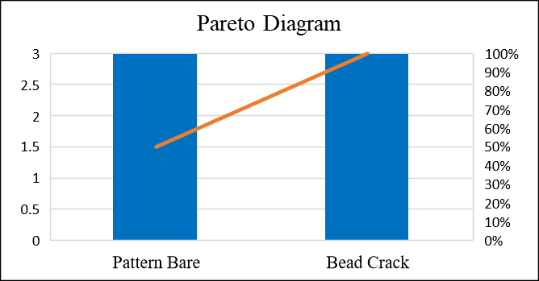
Figure 1. Pareto chart of defects in tires.

4.RESULT AND DISCUSSION
The Plan Stage
The Plan stage begins by identifying the problems that occur in the stage 1 tire sample test, namely defects in the trial tires which can be seen in Table 2. Bare Pattern defect is a type of defect that occurs on the outer surface of the tire (Tread), namely there is a scratch in the center around the tire surface while Bead Crack is a type of defect that occurs on the side of the tire Bead where there are cracks on the side Bead (Maukar et al., 2021). The next step is to set targets to be achieved through the improvements that will be made in this research. Based on the problems described above, two targets were set, namely:

1. Reducing Pattern Bare defects
2. Reducing the Bead Crack defect

The next stage of the Plan is to find the root causes of the defects above using the Fishbone Diagram method and 5 Why Analysis which can be seen in Figure 2.

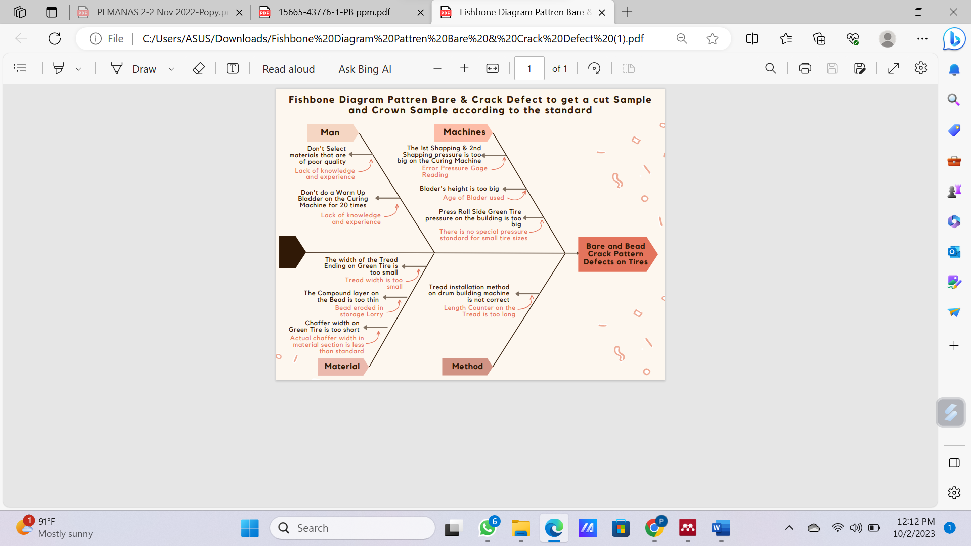
Figure 2. Fishbone diagram pattren bare & crack defect to get a cut sample and crown sample according to the standard

The Do Stage
In the implementation stage Do there are several things that need to be considered, namely the implementation of improvements, collecting and documenting data and recording problems, things that are unexpected and knowledge obtained during implementation. At the Do stage there are several things that need to be considered, namely the implementation of improvements, collecting and documenting data and recording problems, things that are unexpected and knowledge obtained during implementation. In the Do Stage, the following things are carried out: (1) Training on material samples by the Technical and Head of Section regarding suitable and non-standard material samples for all production Operators in the Materials section. (2) Curing machine Field Work Instruction Training, Technical and Head of Section Curing provide material regarding the work sequence on the Curing machine as stated in company documents, namely Field Work Instructions to the production Operator in the Curing section. (3) Replacement of Pressure Gage for 1st Shapping & 2nd Shapping by the Engineering Plant Pressure Gage replaced with a new one because the old one was damaged so that it was unable to show the actual 1st Shapping & 2nd Shapping pressure on the Curing machine. (4) Replacement with a new Bladder made by production in the Curing section. The old Bladder was replaced because the Bladder's technical age has reached the maximum limit of 350 Hours stated in the company's standard documents while the actual Bladder's age is 413 Hours. (5) Setting standards for small tires. The pressure standard for Press Roll Side on Green Tire will use a pressure of 1 kg/cm², previously all tire sizes used a pressure of 1.5 kg/cm². (6) Die Tread Repair. Repairs to the width of the Tread are carried out to increase the width of the Tread by making improvements to the Die which are carried out by people with special skills from the Material Section) who at the same time act as production operators. (7) Making Bead pads in storage Lorry. In an effort to repair it by making Bead pads in the storage Lorry using pieces of foam (Sponge) glued along the trunk of the storage Lorry where the Bead is located. (8) Increase the frequency of checking the actual width of the Chaffer. In setting and controlling the width of the Chaffer, this is done in the Material Section section of the Chaffer Slitter machine. The current condition is that checking the width of the Chaffer is only done once in one production process, namely at the beginning of the process. The improvement step taken is to increase the frequency of checking the actual width of the Chaffer by 5 times or every 10 meters in the Chaffer production process. Then it is entered into the Chaffer production process Checksheet. (9) Resetting the Length Counter on the Building machine which is done together with the Engineering team.

The Check Stage
After remedial efforts have been made to overcome the problem of defects in the tire sample and the Cut Sample and Crown Sample dimensions described above, an evaluation is then carried out by conducting another trial. The results of the Cut Sample and Crown Sample measurements after the Do stage can be seen in Table 3.

Table 3. Results of cut sample and crown sample measurements after repair
No. | Type of Tire Cut | Dimension | Standard (mm) | Measurement | Decission
 |  |  |  | AVG | Decission
1 | Cut Sample | Center | 8.3 ± 0.3 | 8.4 | Good
2 | Cut Sample | 1/4 Point | 8.3 ± 0,3 | 8.4 | Good
3 | Cut Sample | Hump | 11.0 ± 0,3 | 11.1 | Good
4 | Cut Sample | Side | 4.0 ± 0,3 | 4.0 | Good
5 | Cut Sample | Turn Up 1P | 31 ± 3 | 32.5 | Good
6 | Cut Sample | Turn Up 2P | 18 ± 3 | 18.0 | Good
7 | Crown Sample | Cord Angle 1P | 30 ± 1 | 31 | Good
8 | Crown Sample | Cord Angle 2P | 30 ± 1 | 30.3 | Good
9 | Crown Sample | Driving Cord 1P | 22 ± 1 | 22.7 | Good
10 | Crown Sample | Driving Cord 2P | 22 ± 1 | 22.7 | Good

Based on Table 3 above, after repairs are made, all dimensions are at the standards set by the company. Thus the problem of defects can be completely overcome by achieving zero defects.

The Action Stage
In this Action standardization will be determined for efforts to repair defect problems that are carried out so that they can be continued on a regular basis. The following fixes are set to standard: (1) Material sample training will standardize the frequency of training to 2 times in 1 month and an obligation to fill in attendance. (2) Curing machine Field Work Instruction Training to be 2 times in 1 month and given the obligation to fill participation attendance. (3) Replacement of Pressure Gage for 1st Shapping & 2nd Shapping in the Curing machine will be standardized by carrying out an inspection at the start of each work in each shift (Job Setup) by the Curing machine production operator. (4) The standardization of replacement with a new Bladder must be recorded on the Checksheet by looking at the data directly on the Curing machine display to control the age of use of the Bladder on the Curing machine. This checksheet will be completed and checked daily at the start and end of the work. (5) Standardization for small-sized tires by standardizing Press Roll Side Pressure for Green Tire as stated in the product sample trial specifications. (6) Tread width improvements will be standardized with Dies Man certification and their role as a production operator will be focused on repairing Die Treads and the new Tread width will be used as the new standard. (8) Standardization of Bead bearings in storage Lorry for all storage Lorry to support the Bead from being eroded. (9) Standardization Additional inspection frequency for the actual width of the Chaffer by adding the inspection frequency five times or every 10 meters in the Chaffer production process. (10) Standardization of rearranging the Length Counter on the Building machine by routinely checking at the beginning and end of work and documenting it with a checksheet Based on these steps, the initial production stage was set at 250 units of tires and the results of further sample checking showed that there were no defects in the production of 250 tires, which means that they met the criteria for standardization of tires at the company.

5.CONCLUSION
The conclusions in this study based on the description of the results and discussion above are as follows : (i) The application of the Kaizen concept with the implementation of the PDCA method has been able to provide significant results, namely eliminating defects in the initial stage of tire production of 250 tires, (ii) By recognizing and taking action before production begins, it can avoid the level of product defects during mass production which will be carried out after the tire sample trial stage.

REFERENCES
Asti Musman. (2019). TKaizen For Life Kunci Sukses Continuous Improvement di Era 4.0. Anak Hebat Indonesia.
Darmawan, H., Hasibuan, S., & Hardi Purba, H. (2018). Application of Kaizen Concept with 8 Steps PDCA to Reduce in Line Defect at Pasting Process: A Case Study in Automotive Battery. International Journal of Advances in Scientific Research and Engineering, 4(8), 97–107. https://doi.org/10.31695/ijasre.2018.32800
Erviyana, E., Yuliarty, P., & Wijayanti, A. I. (2022). Dmaic Dalam Menurunkan Scratch Komponen Produk Meter Cluster. Jurnal PASTI (Penelitian Dan Aplikasi Sistem Dan Teknik Industri), 16(3), 300. https://doi.org/10.22441/pasti.2022.v16i3.005
Isniah, S., Hardi Purba, H., & Debora, F. (2020). Plan do check action (PDCA) method: literature review and research issues. Jurnal Sistem Dan Manajemen Industri, 4(1), 72–81. https://doi.org/10.30656/jsmi.v4i1.2186
Kartika, H. (2020). Penerapan Lean Kaizen untuk Meningkatkan Produktivitas Line Painting pada Bagian Produksi Automotive dengan Metode PDCA. Jurnal Sistem Teknik Industri, 22(1), 22–32. https://doi.org/10.32734/jsti.v22i1.3251
Kholil, M. (2023). Implementation of Lean Manufacturing to Reduce Hold Types of Mission Case Products using DMAIC and KAIZEN Approach. The International Journal of Scientific and Academic Research, 03(02), 34–43. https://doi.org/10.54756/ijsar.2023.v3.2.4
Maukar, A. L., Runtuk, J. K., & Kamali, M. U. H. (2021). Perbaikan Cacat Udara Terperangkap Di Area Telapak Ban ( Blister Under Tread ) Pada Mesin Tire Building. Baut Dan Manufaktur, 03(1), 15–18. https://doi.org/https://doi.org/10.34005/bautdanmanufaktur.v3i01.1314
Shinta, N. (2022). Kaizen (1st ed.). CV.Solusi Distribusi Buku.
Smalley, I. K. & A. (2012). Toyota Kaizen Methods : 6 Langkah Perbaikan. Gradient Mediatama. https://doi.org/https://doi.org/10.1201/b11902-6
Sumasto, F., Maharani, C. P., Purwojatmiko, B. H., Imansuri, F., & Aisyah, S. (2023). PDCA Method Implementation to Reduce the Potential Product Defects in the Automotive Components Industry. 4(2), 87–98. https://doi.org/10.22441/ijiem.v4i2.19527
Sunadi, S., Purba, H. H., & Hasibuan, S. (2020). Implementation of statistical process control through pdca cycle to improve potential capability index of drop impact resistance: A case study at aluminum beverage and beer cans manufacturing industry in indonesia. Quality Innovation Prosperity, 24(1), 104–127. https://doi.org/10.12776/QIP.V24I1.1401
Sutrisno, B., Rimawan, E., & Sitorus, T. M. (2022). A Systematic Review of Kaizen Approach in Industries. IJIEM - Indonesian Journal of Industrial Engineering and Management, 3(2), 103. https://doi.org/10.22441/ijiem.v3i2.14131
T. Marcin, R.Isabela, M. D. (2023). applied sciences Revolutionizing Tire Quality Control : AI ’ s Impact on Research ,. 13(14), 2–13. https://doi.org/https://doi.org/10.3390/app13148406
Tri, D., Rakhmanita, A., & Anggraini, A. (2019). Implementasi Kaizen Dalam Meningkatkan Kinerja Pada Perusahaan Manufaktur Di Tangerang. Jurnal Ecodemica: Jurnal Ekonomi, Manajemen, Dan Bisnis, 3(2), 198–206. https://doi.org/10.31311/jeco.v3i2.6077
Ufriandi, A. (2021). Analisis Tingkat Keausan Terhadap Pemakaian Ban Merek a, B Dan C Menggunakan Ban Standar 90/90-14 46 P. Jurnal Surya Teknika, 8(1), 282–288. https://doi.org/10.37859/jst.v8i1.2678

