

Available online at: http://publikasi.mercubuana.ac.id/index.php/ijiem
IJIEM (Indonesian Journal of Industrial Engineering & Management)
ISSN (Print) : 2614-7327 ISSN (Online) : 2745-9063

The Development of Bioindustry Technology in Realizing IoT-Based Sustainable Agricultural Industry Waste Management in West Java

Grace Evelyn^{1*}, Aditya Vieri Saputra², Dinda Damarisa Anggadewi³, Uly Amrina⁴
Industrial Engineering Department, Universitas Mercu Buana Jakarta, Jl. Meruya Selatan No. 1 Kembangan, Jakarta Barat 11650

Article Information |  | ABSTRACT
Article history:  Received: 12 August 2023  Revised:  Accepted:  Category: Research paper |  | The threat of climate change is increasing, especially the damage to nature caused by pollution in the agricultural sector. The impact of agricultural waste that is not managed optimally can reduce ecosystem function and disrupt food security stability. This research/research aims to mapping, analyzing, and developing Internet of Things (IoT)-based bioindustry technology in order to create an efficient, green and sustainable agricultural industry. This research uses quantitative methods with agroecology theory related to the development of agricultural waste management systems. The benefits of anaerobically processing agricultural waste such as in the West Java region is to create an optimal, efficient and land-saving food production system. Biotechnology based on the IoT automation system is a technology that can control agricultural food production waste by composting waste into new product that can be used. Therefore, we conducted research on agricultural waste, namely husk waste and cow blood water from slaughterhouses. The end result of the waste treatment is Bokashi Fertilizer and Liquid Organic Fertilizer by using biotechnology technology.
Keywords:
Agriculture
Sustainable
Biotechnology
Internet of Things (IoT)
Green
*Corresponding Author  Grace Evelyn  E-mail: graceevelyn.pierre@gmail.com |  | This is an open access article under the CC–BY-NC license.  

- INTRODUCTION
In the era of the industrial revolution 4.0 and entering 5.0, industrial development and technological developments are a big challenge for the sustainability of natural ecosystems. There are many industrial developments that produce waste and pollution without proper management processes, which have become polemic. The problems of waste and pollution as well as the threat to the stability of food security are crucial issues that will disrupt the existence of nature and hamper the pace of the economy due to the crisis. Based on the 2022 World Meteorological Organization (WMO) report, observations show that there is a possibility of an increase in earth's temperature by up to 1.5°C in the next five years. This has resulted in a catastrophic climate change which has a major impact on food security and the sustainability of environmental ecosystems throughout the world. The Intergovernmental Panel on Climate Change (IPCC) reports that in 2019 79% of carbon emissions (CO2) came from the energy, industry, transportation and building sectors and 22% came from the agriculture and forestry sectors. These problems provide awareness that technological development, especially in the field of agricultural industrial waste treatment, needs to lead to a transition towards a more sustainable and renewable one. This innovation development research has a series of objectives including mapping agricultural waste problems, reviewing/analyzing, and developing based Internet of Things (IoT) bioindustry technology to create an efficient, green, and sustainable agricultural industry.

Bioindustry technology in the industrial era 4.0 is categorized as one of the implementation production system innovations from combining green industrial systems based on Internet of Things (IoT) automation systems. In terms of efforts to reduce industrial waste pollution and energy and land efficiency, biotechnology development research is a means of managing agricultural and livestock waste such as rice and cattle. Seeing the problem of agricultural waste that cannot be managed adequately, the development of a smart biotechnology system technology in green and sustainable agricultural waste management is a solution for implementing green industry. Combining IoT systems and biotechnology systems can be practiced by connecting an equipment system with the Internet to carry out various functions (Komaludin, 2018). Agricultural waste processing activities with the concept of biotechnology will definitely require supporting equipment for waste composting. IoT also makes it easier for employees/farmers in the agricultural industry to find out information in real-time on the protocols and equipment that will be used in processing the production waste. In the agricultural sector, production waste in the rice industry in the form of rice bran (husk) through biotech can be processed into new products in the form of bokashi fertilizer and animal feed.

The condition of agricultural and livestock waste disposal in most parts of Indonesia is still not properly resolved. The waste products of the agricultural industry have an impact on water, soil and air pollution which damages the environmental ecosystem (ecocentric). Every day, a cow can produce 10-15 kg of manure (Bojonegoro District Government, 2015). Waste from Slaughterhouses such as slaughter of cows in the form of their blood is still often found being dumped directly into rivers or soil which causes water and soil pollution.

The case of animal slaughter waste water pollution which has an impact on the surrounding community and the environment, for example what happened at the X Slaughterhouse in Bogor City, West Java. The pollution issue of waste from Slaughterhouse X in the Bogor area related to animal slaughter waste such as blood and animal feces seems to have disrupted the ecosystem in the Ciliwung watershed and has caused various diseases for the community around Slaughterhouse X. The stench and the emergence of diseases such as diarrhea as well as environmental pollution around the slaughterhouses occur due to blood slaughtering waste that is not managed optimally resulting in excessive microbial development. Improperly managed wastewater in the slaughterhouse may lead to a decline in the quality of water, soil, air, and the health of residents around the slaughterhouse area. The research study indicates that microbes from the decomposition of blood waste from Slaughterhouse X trigger an increase in the concentration of Biological Oxygen Demand (BOD), Chemical Oxygen Demand (COD), Ammonia (NH3), changes in pH, and Hydrogen Sulfide (H2S), resulting in a foul odor resembling sulfur or rotten eggs (Lubis et al., 2018). In 2018, there was research which showed that wastewater from slaughtering cows and other livestock had caused environmental pollution (a decrease in the quality of clean water, soil and air around the slaughterhouses) and disease disturbance for the people living around the slaughterhouses. The results of the research survey showed that around 100% of community respondents living around the X Slaughterhouse complained of the smell of slaughter wastewater and 40% of respondents also admitted to experiencing health problems in the form of nausea.

In addition, as an ASEAN country like Indonesia there are still many cases where grain milling waste is in the form of husks that are simply thrown away. Rice husk waste takes quite a long time and is difficult to decompose naturally, causing environmental pollution and also having an impact on human health (Agricultural Extension and Human Resource Development Agency, 2022). This concept has been practiced in Bojonegoro Regency, quoted from the report of the local Regional Government that so far cow dung and husks cannot be decomposed directly so that cow dung and husk waste processing activities are carried out using the EM4 method to produce bokashi fertilizer products. Making bokashi compost from cow dung uses a fermentation process with a composition of bacteria consisting of Azotobacter sp., Lactobacillus sp., yeast, photosynthetic bacteria and cellulose-degrading fungi (Bojonegoro Regency Government, 2015). The process of fermenting sewage is an application of biotechnology, this technology can be applied evenly to other areas, especially the Bogor area and around West Java. Comprehensive decision-making models are needed for the evaluation of green operations initiative (Amrina & Zagloel, 2019). The application of biotech-based green waste management and the support of the Internet of Things (IoT) automation system in the agricultural and livestock sectors can boost the MSME economy of local residents and reduce environmental pollution.

RPH wastewater can also be managed into liquid fertilizer with the help of biotechnology concepts. Cow slaughter blood waste can also be processed through the EM4 fermentation method which will produce liquid organic fertilizer. Based on previous research conducted by Diponegoro University students from Environmental Engineering and Industrial Engineering study programs in Kupang Village in 2019, the results of waste water from animal blood such as cow blood which is processed into liquid organic fertilizer can reduce the intensity of river and soil pollution of RPH, reduce use of chemical fertilizers, as well as being able to grow the economy of regional farming communities. In fact, since 2012, there has been research by Sylvi, a Chemical Analyst Middle School (SMK-SMAK) student in Padang, West Sumatra, which proves that Liquid Organic Fertilizer from cow blood waste can be used to fertilize rice, fruit crops, vegetables, etc.

- LITERATURE REVIEW
The first journal entitled "Empowerment of Kupang Rejo Village Communities Through Utilization of Slaughterhouse Cow Blood Waste to Become Environmentally Friendly Fertilizer" addresses a discussion related to processing techniques for Slaughterhouse cow blood waste using the anaerobic method of EM4 decomposition into liquid organic fertilizer. Utilization of Slaughterhouse cow blood waste into organic liquid fertilizer can reduce environmental pollution and also increase the economic welfare of farming communities (Pertiwi, et al, 2019). In a journal entitled "Management of Slaughterhouse Wastewater at the X Slaughterhouse, Bogor City, West Java Province" (Lubis, et al, 2018), RPH wastewater that is not managed optimally will lead to a decrease in the quality of water, soil, air, and health. residents around the RPH area. In two studies entitled "Mapping challenges in developing sustainable small and medium industries: Integrating lean and green principles" (Amrina et al., 2021), the application of the concept of green and clean production to small and medium enterprises (SMEs) has an important role in realizing sustainable and environmentally friendly industry. Then in the journal "Application Of Sustainable Productivity Management In Footwear Companies By Green Manufacturing Approach" states that the application of green production in the manufacturing industry is a company's obligation to achieve green and sustainable productivity (Amrina & Elisa, 2019).

Bioenergy is an alternative waste processing product sourced from biomass waste from agricultural, plantation, forestry, livestock and fisheries industries. Bioenergy is environmentally friendly because it does not increase the amount of carbon dioxide in the atmosphere and its cycle is available again within a year (Widya et al., 2021). Bioenergy can used as solid (biomass), liquid (biodiesel and bioethanol), or gas (biogas) fuel in the household, industrial, transportation and power generation sectors. The government has tried to support efficient use of energy as best as possible. This success is still needed through behavior, habits, discipline and awareness of energy saving. Environmental problems have a very integral unity with energy behavior problems.

In a study entitled "Waste Management Technology for Sustainable Agriculture", appropriate and safe waste treatment for industrial, agricultural, food and other waste can utilize anaerobic treatment techniques using the help of decomposing bacteria (Muzaffar et al., 2021). However, these five research studies seem to be inconsistent. discusses the application of agricultural industrial waste treatment systems on a large scale and tends to still use manual systems that are less efficient and economical so that in this study we researchers will try to develop bioindustry technology and design IoT-based automation systems in the agricultural industry. This research research focuses on the development of biotechnology in agricultural waste treatment. This research was taken from a number of references, among which were taken from research on the issue of the impact of pollution from husk waste and livestock manure which are difficult to decompose naturally without going through chemical decomposition and bioremediation processes. In previous research, it was explained that husk waste and livestock manure can be converted into fertilizer which has a much more profitable economic value, especially for the surrounding farming community, rather than being waste without processing. This research and agricultural waste treatment program uses the concept of bioremediation decomposition with EM4 decomposers which convert agricultural waste into organic fertilizer. The research concept is then used in this research plan as the basis for the development concept of biotech-based agricultural waste management technology.

In addition, according to previous research as described in a journal entitled "Management of Slaughterhouse Wastewater at the X Slaughterhouse, Bogor City, West Java Province", wastewater from slaughterhouses is a source of pollution problems for river ecosystems, soil, water, to the health of the surrounding community. This waste water problem is in accordance with research in the journal "Empowerment of Kupang Rejo Village Communities Through Utilization of RPH Cow Blood Waste to Become Environmentally Friendly Fertilizer" can be handled by means of integrated RPH wastewater treatment efforts such as blood from slaughtered cows which is processed through the EM4 decomposer into liquid organic fertilizer, which is a process similar to that used in the processing of husk waste and livestock manure. The research plan in this proposal encourages the application of biotechnology and the help of IoT automation systems on a large scale and comprehensively for the entire agricultural industry in Indonesia, especially in the West Java region. initially research on this proposal will begin with experiments on a household scale which will then be described in an agricultural industrial system with the help of an application.With the help of developing an IoT system in the agricultural waste treatment process, the issue of the impact of environmental pollution by agricultural industries in Indonesia can be handled more adequately as well as providing welfare for the surrounding community, especially from farmer groups.

The green production methodology in previous research journals is the basic concept used in this research as it was developed in realizing green industry principles for a more sustainable agricultural industrial sector. Our research focuses more on the discussion of bioindustry because we share the same concern, namely the lack of government efforts to promote bioindustry even though, in the 1999-2004 State Policy Guidelines (GBHN), for example agro-industry policies are developed as one of the industrial sub-sectors that fulfill two the main requirement is that it is based on local resources and is able to empower the people's economy. The advantage of agroindustry is the level of dependence on basic and raw materials as well as human resources and technology from outside, which is relatively small compared to other industries. However, the real form of this effort does not yet exist. therefore we have a goal that farmers are not only advanced in the agricultural sector but can also utilize agricultural waste to be used as fertilizer so that they can be resold and benefit from this waste.

- RESEARCH METHOD
In developing research on the application of bioindustry methods to agricultural industrial waste, the research methods to be used are quantitative methods and Research & Development (R&D). Quantitative methods function in analyzing and mapping the results of trials of microbial fermentation systems in the processing of rice husk waste and cow blood. The sewage treatment system will use the EM4 fermentation concept which consists of a series of bacteria and various supporting components for waste fermentation. Quantitative research methods with research on the development of bioindustry systems are accompanied by the concept of waste management of the agricultural industry and green and sustainable agricultural production with the theory of agroecology (Altieri, 1995). The development of biotech technology research complemented by the use of artificial intelligence aims to create a sustainable agricultural food waste processing output system supported by actual data and valid literature.

Research data was collected through several articles, scientific journals, books, interviews, reports from related institutions/ministry, as well as with the help of search keywords "biotechnology, bioindustry, agricultural industrial technology, climate change, water and soil pollution, agricultural industry waste management, waste management husk, cattle ranch waste management, fermentation, green building, sustainable green industrial development, industrial waste management, etc." In order to improve this scientific research, data analysis uses supporting accredited journals from Sinta, Indonesian Ministry of Agriculture, JSTOR, Elsevier, Academia, Zlibrary, Research Gate, Harvard Library, Cambridge Core, etc. To strengthen the validity of writing in research, the research team conducted interviews with several key informants related to the research idea, namely Prof. Dr. Bungaran Saragih Garingging as Minister of Agriculture for the 2000-2004 period and Professor of IPB University in the field of agribusiness.

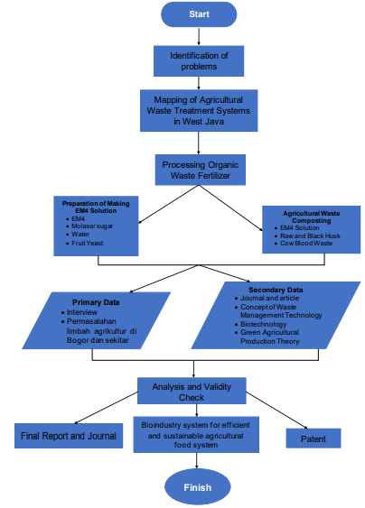

Figure 1. Research Flow Chart and Achievements

- RESULT AND DISCUSSION
The Indonesian agricultural industry is experiencing very rapid technological developments and has a significant influence on the national Gross Domestic Product (GDP). Agribusiness system technology in Indonesia has already developed the concept of environmentally friendly production and integrated and environmentally friendly waste treatment. Production efficiency that is minimal in carbon, for example by using cattle or buffalo power for processing agricultural land is one step to minimize the use of machines that can produce carbon emissions. Utilization of agricultural waste into products with new use values such as processing cow dung into a source of biogas has become an alternative in reducing hazardous waste to the environment. The design of an agricultural food production system for the livestock and agriculture sector which has been implemented in several regions in Indonesia, is as follows: (Yustri, 2019)
1. Build a cattle farm to produce milk and meat.
2. Build a cow urine shelter and process it into bottled liquid fertilizer and then sell it to farmers.
3. Building a reservoir for cow dung to be processed into biogas material and then distributing it to resident homes as cooking fuel with the provision of paying a biogas fee every month. This of course can help save money for less fortunate households in terms of cooking fuel.
4. Processing of livestock manure from biogas waste as organic solid fertilizer which can be sold to farmers as an environmentally friendly plant fertilizer.

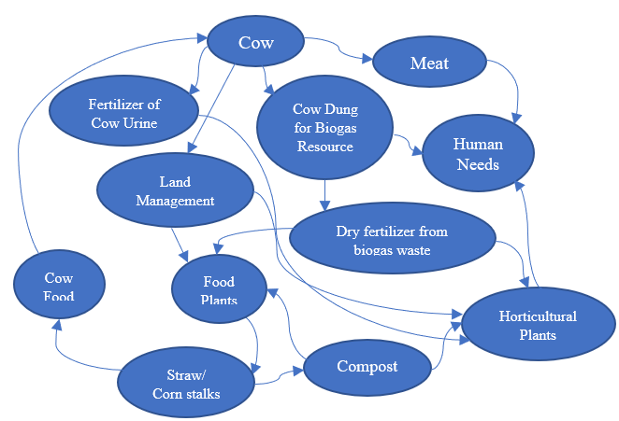
In addition, agribusiness systems and subsystems in West Java are still not adequately connected between one system and another, especially in the output (downstream) process. Research data shows that agribusiness systems and subsystems in Indonesia, especially the West Java region, still require technology that can integrate processes from upstream to downstream. The agribusiness sector has 4 subsystems that are connected to each other, namely on farm agribusiness (agriculture), upstream agribusiness (subsystem systems), downstream agribusiness (products), and service to agribusiness (services). The following is a mapping of the concept of agricultural food production systems in Indonesia.
Figure 2. Mapping of the Integrated Agricultural Food Production System in Indonesia (Source: Yusri, 2019)
Analysis and Development of Biotechnology Innovations based Internet of Things (IoT) in Agricultural Industry Waste Treatment Systems
Research on the development of biotechnology systems in the management of agricultural waste, especially rice bran or husk waste, is a breakthrough innovation in agribusiness systems. The concept of a sustainable green agricultural industry with the application of a bioindustry system can be an innovative solution to technology development in production systems (on farm agribusiness) and agricultural waste processing (downstream agribusiness). The development of bioindustry system based Internet of Things (IoT) in agricultural industrial waste management technology is an innovation aimed at reducing hazardous waste and realizing clean production efficiently and evenly throughout all subsystems. The IoT-based biotechnology concept has not been widely applied in the Indonesian agricultural industry, even though this concept is an alternative for time, effort and cost efficiency in reducing the impact of agricultural waste without harmful chemical processes and creating sustainable recycled products (Andalusia, 2018). Realization of the concept of bioindustry in this research design on waste management. A carbon pollution detector is installed in the production room and detects the pH level of the water in the food production waste storage tank at the output stage.

The composting technique of raw and burnt rice husk waste is processed by mixing a solution of EM4 mixture for agriculture which has previously been left standing for at least 2 days. The composition of the marine EM4 mix for agriculture includes 5 L of water for 100 ml of EM4 mix, 100 ml of EM4, 100 ml of molasses, Fruit yeast, Azotobacter sp., Lactobacillus sp., fungi and decomposing bacteria. According to research trial data, 5 kg of agricultural waste (husk) uses a mixture of 5 L - 8 L EM4 decomposer solution.

To make liquid organic fertilizer from cow's blood waste water requires the following composition: 100 ml of molasses, 200 ml of EM4 decomposer, 800 ml of water, and 5 L of cow's blood. The liquid organic fertilizer of cow's blood waste is quite harsh, so it is recommended to use it in the afternoon. Based on the results of the study, the development of plant subjects using the liquid organic fertilizer from cow blood waste was not very visible within 1 week, but the plants showed fairly good conditions after being watered with liquid organic fertilizer. However, the liquid organic fertilizer of cow blood waste has succeeded in reducing odors and the negative effects of concentrations of Biological Oxygen Demand (BOD), Chemical Oxygen Demand (COD), Ammonia (NH3), changes in pH, and Hydrogen Sulfide (H2S) which cause bad smells. In addition, the processing of cow blood waste water into liquid organic fertilizer also minimizes the impact of slaughterhouse (RPH) waste water which causes diarrhea on the surrounding community, as happened in Bogor.

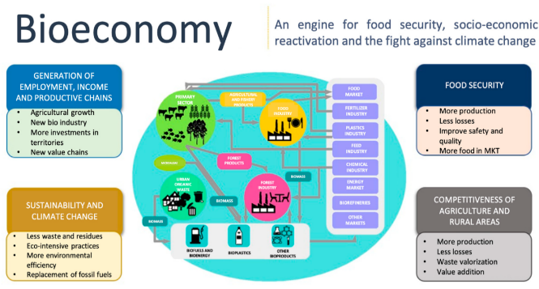

Table 1. Research Scale.
Low Carbon and Sustainable Agricultural Food Production System Diagram
According to the conditions above, it is necessary to have a solution that can reduce hazardous waste and production with energy and land efficiency. For the agricultural industry, especially those with concentrations of organic waste, an appropriate waste treatment system is needed by utilizing the activity of microorganisms or referred to as a biotechnology system that is connected to the Internet of Things (IoT) automation system. Based on the Research and Development (R&D) concept in this study, the smooth running of an adequate agricultural food production system requires relationships between research and technology development institutions, extension workers, farmers, the agricultural industry, and the government.

Biotechnology and IoT systems can be paired as pollution detection sensors in the production room and sensors in waste tanks at the end of production. Agricultural food industry companies should be able to cooperate with supplying farmers as buyers and recipients of fertilizer supplies from processed waste. Agricultural companies also need to improve relations with the government for the smooth running of the program by implementing policies and facilitating budgets in building waste production and treatment systems that have low-carbon and sustainable production efficiency values. The concept of bioindustry research in the agricultural food industry is mapped in a system diagram that contains processes from upstream to downstream. The system diagram below will help comprehensively map a green agricultural production system, examine the complexity of the relationship between input factors, production systems, strategies and policies, output (downstream), and services.
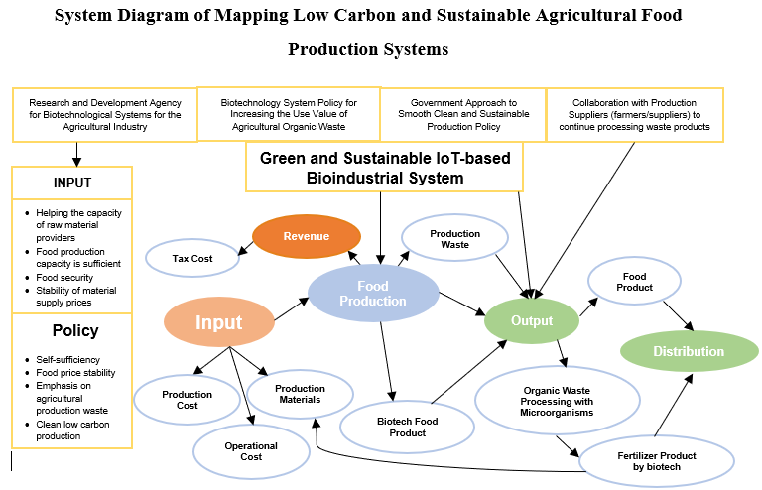
Figure 3. Green and Sustainable Bioindustrial System Model (Source: Andalusian Bioeconomy Strategy, 2018)
Figure 4. System Diagram for Mapping Low Carbon and Sustainable Agricultural Food Production Systems.
- CONCLUSION
From the results above research it can be concluded, as follows:
- From the results of mapping the agricultural food production system in Indonesia, especially in the West Java region, it seeks to analyze and describe the agricultural industrial system in West Java regarding the processing of production waste from the agricultural industry to increase effectiveness, efficiency and reduce the environmental impact of existing methods. So that waste treatment can be better and have a positive impact on environmental sustainability and economic growth in the West Java region.
- In the agricultural industry, waste treatment is included in the on farm agribusiness and downstream systems so that the application of the bioindustry concept for green production must also be connected to systems such as the Internet of Things (IoT). The development of IoT-based biotechnology systems in agricultural waste processing can increase production efficiency evenly. These concepts and systems are able to deal more adequately with the issue of the impact of environmental pollution by agricultural industries such as what happened in West Java and provide welfare for the surrounding community, especially from farmer groups.
- The diagram for the agricultural industry system shows that utilizing microorganism and IoT activities in a production waste management system can minimize harmful waste. The concept also raises awareness of clean, low-carbon and sustainable production. The application of bioindustry system technology in agribusiness is an alternative in implementing green building and production for agricultural industrial sectors.
- The research contributes to the academic world by providing insights into the development and application of bioindustry technology in agricultural waste management. It adds to the existing body of knowledge on sustainable production systems, waste treatment, and the integration of IoT in agribusiness. The research also has potential benefits for society, particularly in the agricultural industry. By implementing bioindustry technology, it can lead to more efficient, green, and sustainable agricultural practices.

REFERENCES
Albert S, Bloem E. 2023. Ecotoxicological methods to evaluate the toxicity of bio-based fertilizer application to agricultural soils – A review. Sci. Total Environ. 879 (March):163076.doi:10.1016/j.scitotenv.2023.163076.
Amrina U, Hidayatno A, & Zagloel TYM. 2021. Mapping challenges in developing sustainable small and medium industries : Integrating lean and green principles Journal of Industrial Engineering and Management, 14(2), 311–328. https://doi.org/https://doi.org/10.3926/jiem.3041
Amrina, U., & Elisa, N. 2019. Application Of Sustainable Productivity Management In Footwear Companies By Green Manufacturing Approach. Sainstech: Jurnal Penelitian Dan Pengkajian Sains Dan Teknologi, 29(2), 37–42. https://doi.org/1410 - 7104
Amrina U & Zagloel TYM. 2019. The Harmonious Strategy of Lean and Green Production: Future Opportunities to Achieve Sustainable Productivity and Quality. 2019 IEEE 6th International Conference on Industrial Engineering and Applications, ICIEA 2019, 187–192. https://doi.org/10.1109/IEA.2019.8714768
Andalusia, J. de. 2018. Estrategia Andaluza de Bioeconomía Circular. Junta de Andalusia.
Badan Penyuluhan dan Pengembangan Sumber Daya Manusia Pertanian. 2022. “Pemanfaatan limbah Sekam Padi”. Retrieved on March 29, 2023 from http://cybex.pertanian.go.id/artikel/99201/pemanfaatan-limbah-sekam-padi/
Bodhi Agustono, M. L. 2017. "Identifikasi Limbah Pertanian dan Perkebunan Sebagai Bahan Pakan Inkonvensional di Banyuwangi". Jurnal Medik Veteriner.
Citarum Harum.jabarprov.go.id. 2021. “Ratusan Ton Kotoran Hewan Cemari Citarum Setiap Hari, DKPP JABAR Siapkan Upaya”. Retrieved on March 30, 2023 from https://citarumharum.jabarprov.go.id/ratusan-ton-kotoran-hewan-cemari-citarum-setiap-hari-dkpp-jabar-siapkan-upaya/
Chandra AK. 2022. Biotechnology for Sustainable Agriculture: Enhancing Agricultural Productivity and Value-chain addition in Crops. Sci. Agric. Allied Sect. 2(2).
Chusna, Asmaul. 2021. “Limbah rumah potong hewan di Kediri diolah jadi pupuk organik”. Retrieved on March 29, 2023 from https://www.antaranews.com/berita/1946696/limbah-rumah-potong-hewan-di-kediri-diolah-jadi-pupuk-organik
Efendi, Y. 2018. "Internet Of Things (IOT) Sistem Pengendalian Lampu MENGGUNAKAN Rasberry PI Berbasis Mobile". Jurnal Ilmiah Ilmu Komputer, IV.
Fredy Susanto, N. K. 2022. "Implementasi Internet Of Things Dalam Kehidupan Sehari-hari". JURNAL IMAGINE, II.
Hermawan, A., Sudaryanto, B., Prayudi, B., Dyah Ariani, F., & Ambarsari, I. 2014. "Pengembangan bioindustri di tingkat petani". BPTP Jateng/IAARD PRESS. Retrieved on March 29, 2023 from http://repository.pertanian.go.id/handle/123456789/8733
Kanaujia N, Singh J. 2022. A review on waste-to-energy by anaerobic digestion: A sustainable approach for the agriculture waste management and energy production. J. Appl. Sci. Innovation Technology 1(2):70–74. 196 (January): 107402.doi:10.1016/j.ecolecon.2022.107402.
Komaludin D. 2018. Penerapan Teknologi Internet of Thing (IoT) pada bisnis budidaya tanaman Hidroponik sebagai langkah efisiensi biaya perawatan. Di dalam: Prosiding FRIMA (Festival Riset Ilmiah Manajemen dan Akuntansi). hlm. 682–690.
Pemerintah Kabupaten Bojonegoro. 2015. “Pembuatan Bokashi Pupuk Kandang Kotoran Sapi dan Arang Sekam menggunakan Dekomposer EM4”. Retrieved on March 29, 2023 from https://bojonegoro.bojonegorokab.go.id/berita/baca/3#:~:text=Bokashi%20merupakan%20pupuk%20kompos%20yang,sp.%2C%20Lactobacillus%20sp.%2C
Pertiwi K, Wulansari R, Nurullah, Amrullah I, Rezagama A, Atoillah F. 2019. Pemberdayaan Masyarakat Desa Kupang rejo Melalui Pemanfaatan Limbah Darah RPH Menjadi Pupuk Ramah Lingkungan. Pengabdian Masyarakat dan Inovasi Pengembangan Teknologi 1(3):154–159.
Peraturan Menteri. 2014. Peraturan Menteri Lingkungan Hidup Nomor 5 Tahun 2014 tentang Baku Mutu Air Limbah.
Peraturan Menteri. 2010. Peraturan Menteri Pertanian Nomor 13/ Permentan/ OT.140/1/2010 Tahun 2010 tentang Persyaratan Rumah Potong Hewan Ruminansia Dan Unit Penanganan Daging (Meat Cutting Plant).
Lubis I, Edhi TEB, Soemantojo RW. 2018. Pengelolaan Air Limbah Rumah Potong Hewan di RPH X ,Kota Bogor, Provinsi Jawa Barat (Wastewater Management of Slaughterhouse in Slaughterhouse X , Bogor City , West Java Province). Jurnal Manusia Dan Lingkungan, 25(1), 33–44. https://doi.org/10.22146/jml.35396
Manunggal.undip.ac.id. 2019. “Pupuk Cair Organik Berasal dari Limbah RPH untuk Berdayakan Masyarakat Kelompok Tani”. Retrieved on March 30, 2023 from https://manunggal.undip.ac.id/pupuk-cair-organik-berasal-dari-limbah-rph-untuk-berdayakan-masyarakat-kelompok-tani/
Muzaffar, A., Bhat, Adil, A., Sikander, B., & Lone, Y. 2021. Waste Management Technology for Sustainable Agriculture: Waste Management Waste Management Technology for Sustainable Agriculture. In Innovative Waste Management Technologies fo Sustainable Development (pp. 156–176). https://doi.org/10.4018/978-1-7998-0031-6.ch00
Ramachandran, P., Kim, T. S., & Lee, J. K. 2018. "Prospects of bioindustrial engineering: a perspective". Journal of industrial microbiology & biotechnology, 45(4), 277-287.
Rame R, Purwanto P, Sudarno S. 2023. Biotechnological approaches in utilizing agro-waste for biofuel production: An extensive review on techniques and challenges. Bioresour. Technol. Reports. 24:101662.doi:https://doi.org/10.1016/j.biteb.2023.101662.
Setiawan, Anton. 2022. “Pupuk dari Darah Sapi, Inovasi Limbah Menjadi Berkah”. Retrieved on March 30, 2023 from https://indonesia.go.id/kategori/komoditas/5232/pupuk-dari-darah-sapi-inovasi-limbah-menjadi-berkah?lang=1
Silvia Wulandari, F. F. 2015. "Pengaruh Berbagai Komposisi Limbah Pertanian Terhadap Kadar Air, Abu, dan Serat Kasar Pada Wafer". Jurnal Ilmiah Peternakan Terpadu, 3(3).
Shringarpure, N. 2022. Role Of Biotechnology in Agriculture. Interantional J. Sci. Res. Eng. Manag. 06(06). doi:10.55041/ijsrem14705.
Thakur M, Wang B, Verma ML. 2022. Development and applications of nanobiosensors for sustainable agricultural and food industries: Recent developments, challenges and perspectives. Environ Technology Innovation:102371 (26). doi:10.1016/j.eti.2022.102371.
The Intergovernmental Panel on Climate Change (IPCC). 2023. “Synthesis Report Of The IPCC Sixth Assesment Report (AR6)”. Retrieved on March 29, 2023 from https://report.ipcc.ch/ar6syr/pdf/IPCC_AR6_SYR_SPM.pdf
Widya C, Supriyani N, Andianti R, & Zulkifli M. 2021. Statistik Lingkungan Hidup Indonesia 2021 (Krismawati, C. Widya, & N. Supriyani (eds.)). Badan Pusat Statistik.
Wihardjaka A. 2018. Penerapan Model Pertanian Ramah Lingkungan sebagai Jaminan Perbaikan Kuantitas dan Kualitas Hasil Tanaman Pangan. Balai Penelitian Lingkungan Pertanian:1–10.
Yusri, Anggi Muhammad. 2019. "Penerapan Pertanian Berkelanjutan Berbasis Ramah Lingkungan". Retrieved on July 12, 2023 from
http://cybex.pertanian.go.id/artikel/69944/penerapan-pertanian-berkelanjutan-berbasis-ramah-lingkungan/

