

Available online at: http://publikasi.mercubuana.ac.id/index.php/ijiem
IJIEM (Indonesian Journal of Industrial Engineering & Management)
ISSN (Print) : 2614-7327 ISSN (Online) : 2745-9063

Comparative Study of RCCP and System Dynamics in Productivity Capacity

B. Handoko Purwojatmiko^{1*}, Raissa Annisa Cessari ², Laksmi Ambarwati³, Fredy Sumasto⁴
^{1,2,3,4}Automotive Industrial Engineering, Politeknik STMI Jakarta, Jl. Letjend Suprapto No. 26, Jakarta Pusat, 10510, Indonesia

Article Information |  | ABSTRACT
Article history:  Received:  Revised:  Accepted:  Category: select one (Research paper, Review paper, View point, Technical paper, Conceptual paper) |  | One of the manufacturing companies in Indonesia which is engaged in foundry has a production line for various types of automotive components and has produced 2051 types of products. One of the products produced is the Trunion Bracket. In the molding process, cores are needed that can provide cavities in the product. The current production process has not been able to meet demand because the production cycle time does not match the predetermined time. This discrepancy will affect consumer satisfaction. Therefore, it is necessary to make a schedule for the period July to December 2022, to assist companies in facilitating the scheduling of the production process using Rough Cut Capacity Planning and System dynamics. The calculation results from Rough Cut Capacity Planning indicate that the 5th workstation experienced a shortage of production time from July to September 2022, so an additional number of working hours had to be made. The addition of the number of working hours before improvement was 367 hours and after improvement was 112 hours. Meanwhile, the results of system dynamics modeling for the period July to December 2022, require an additional working hour before improvement by 308 hours and 205 hours after improvement are carried out. The companies can implement strategies based on the results of system dynamics simulations to identify, forecast, and plan production capacity requirements for the next.\
Keywords:
Manufacturing
Rough-Cut Capacity Planning
System Dynamics
Simulation
*Corresponding Author  B. Handoko Purwojatmiko  E-mail: bhandoko@stmi.ac.id |  | This is an open access article under the CC–BY-NC license.  

- INTRODUCTION
Industrial development in Indonesia leads to seven main sectors consisting of the food dan beverage, textile, automotive, electronics, chemical, medical devices, and pharmaceutical industries. Several industries that are in the spotlight in Indonesia have significant development prospects. The automotive industry is one of the industries that is growing rapidly in Indonesia (Nurcahyo & Wibowo, 2015). The development of the automotive industry is currently leading to automation and electrification. These advancements would present a substantial challenge to the industry's fundamental technology and the entrenched interests linked to substantial investments in factories, expertise, and supply networks (Chandra Setiawan et al., 2021). This was driven by the rapid increase in technological developments and the high attractiveness of products from the automotive industry. The companies engaged in the automotive industry are required to be able to meet the needs and desires of consumers with effective and efficient strategies. The companies are also required to make an improvement to get a positive view of customers. The process improvement that can be carried out include just in time which prioritizes customer orientation to obtain quality assurance, low operating cost and timely delivery are well fulfilled (Dallasega et al., 2016).

One of the manufacturing companies in Indonesia engaged in the foundry has a production for various types of automotive components. The total types of products produced by the company reached 2051 types of products. The products produced include flywheel assy and housing, shackle assy, brake assy, pressure plate, knuckle, manifold, hub, and drum brake assy, disc brake and trunnion bracket. In the production process there are several products that require cores during the molding process, such as trunnion brackets, flywheel assy and housing products. One of the products that use the core is BT1804 with a trunnion bracket. In the current conditions, the production process that is being carried out is still unable to meet customer demand. The core production process is not optimal because there is a difference in the production cycle time compared to the predetermined time. This condition is caused by an ineffective production process that can affect consumer satisfaction. This non-optimality drives the need for a change in determining a more appropriate capacity to avoid decreasing quality in the company.

With increased demand from customers, it is hoped that there will be improvements such as scheduling the production process to balance supply and demand. Product demand forecasting is determined to see which method is better. The forecasting method used is moving average (Seong, 2020; Wen et al., 2022). After obtaining the production demand forecasting, further analysis is carried out. Therefore, this research proposed to use Rough Cut Capacity Planning (RCCP) and system dynamics in solving production capacity problems. RCCP is proposed to be able to increase production capacity and balance customer demand by maximizing capacity elements such as workers and machines. Meanwhile, the system dynamics is used to see and understand possible problems. Meanwhile, the system dynamics is used to see possible problems, as well as analyze and predict problems that will occur in the future. The purpose of this research was to determine the design of the production capacity of BT1804 core to be able to meet customer demand using RCCP. In addition, the use of system dynamics is also used as a comparison in determining alternative improvements.

- LITERATURE REVIEW
Rough cut capacity planning (RCCP) is a strategic process used by organizations to assess their production capabilities and determine whether they have enough resources to meet future demand. It is an essential part of the overall capacity planning process and helps businesses make informed decisions about production levels, resource allocation, and potential constraints (Menezes et al., 2016). The main goal of RCCP is to provide an estimate of the capacity required while considering various factors such as workforce availability, machinery and equipment capacity, and available raw materials. Rough cut capacity planning plays a crucial role in ensuring that organizations have the necessary capacity to meet future demand, maintain customer satisfaction, and achieve their business objectives. By conducting regular RCCP assessments, businesses can anticipate and proactively address potential capacity constraints, minimize production disruptions, optimize resource allocation, and meet customer demands more effectively (Cherkaoui et al., 2015). The advantages of this RCCP can be used as a first step in carrying out definite planning. The planning that is made, can be in the form of estimates based on previous historical data so that problems related to capacity can be easily resolved.

System dynamics is a methodology for studying complex systems and understanding their behavior over time. It provides a framework for analyzing the interconnections and feedback loops within a system, allowing for a better understanding of how changes in one part of the system can affect other parts (Georgiadis, 2013). At its core, system dynamics focuses on the relationships and feedback loops between various components of a system. These relationships are typically represented using causal loop diagrams, which illustrate how different variables in the system interact and influence each other. The behavior of the system is then captured using mathematical equations that describe the rates of change of these variables overtime. System dynamics models allow for the simulation and experimentation of different scenarios to understand the long-term behavior of a system (Suryani et al., 2010). By adjusting the values of various parameters and observing the resulting changes in the system's behavior, analysts can gain insights into the underlying dynamics and make informed decisions about system improvement, policy interventions, or strategic planning. System dynamics is an effective method for analyzing and assessing the dynamic properties of a system (Sudarto et al., 2017). System dynamics are widely also used in supply chain, logistics and circular economy. The capacity problems in the production of BT1804 cores can be a case that is solved through system dynamics analysis by looking at how the variables are interrelated and giving each effect to the solution of the improvement.

- RESEARCH METHOD
To facilitate the implementation of this research, the data taken is secondary data. The secondary data used consists of demand data from January to June 2022, data on actual production results from January to June 2022, the company's effective working hours and the number of machines used. At the data collection stage, interview techniques were used to be able to analyze more deeply about the planning of BT1804 core production in the company. In data processing, the sequence of steps is arranged systematically to achieve the objectives of the research. The initial stage is to identify demand data and actual production results. The timeframe used for data collection is from January to June 2022. The next stage is to perform calculations to determine the amount of capacity needed using RCCP. Capacity calculation analysis using RCCP aims to be able to ensure the company does not accumulate material or overproduce products (Cherkaoui et al., 2015). The data collected is the processing time for each machine in hours. In addition, capacity data needed every month is also collected to schedule production based on demand. Calculation of the value of available capacity is also carried out to be able to determine the efficiency between demand and capacity who determined by the company. As a comparison, system dynamics is also used to estimate the planning rate of BT1804 core production in the future. The steps that must be taken in making system dynamics are determining the dependent and independent variables and creating model simulation scenarios assisted by Vensim PLE software.

  - Product Demand Forecasting
Product demand forecasting is a crucial process that helps businesses estimate the future demand for their products or services. It involves analyzing historical data, market trends, and various influencing factors to make informed predictions about the expected customer demand over a specific period (Silva et al., 2022). Forecasting is made by estimating the amount of consumer demand with consideration of historical data using moving averages. The focus of this forecast is on the master production schedule. Historical data used in determining forecasting was data from July 2021 to June 2022. Based on the data that has been collected, forecasting calculations are carried out based on actual demand in the previous period. Forecasting results using the moving average method are shown in Figure 1.

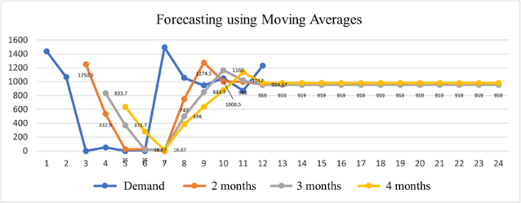
Figure 1. Moving Average Chart

  - Rough-Cut Capacity Planning
Preparation of a RCCP planning report involves data on the difference between capacity requirements and available capacity based on data for the period from January 2022 to June 2022. This data will later be used to forecast available capacity in the period July 2022 to December 2022. In the case of this study, there are 2 workstations that are of concern, because they have critical processes. Workstation number 5 is the final workstation for the assembly process, while workstation number 4 is the initial preparation process. Based on the results of data calculations, it was found that there was one workstation that experienced a shortage of production time from July 2022 to September 2022 as shown in figure 2.

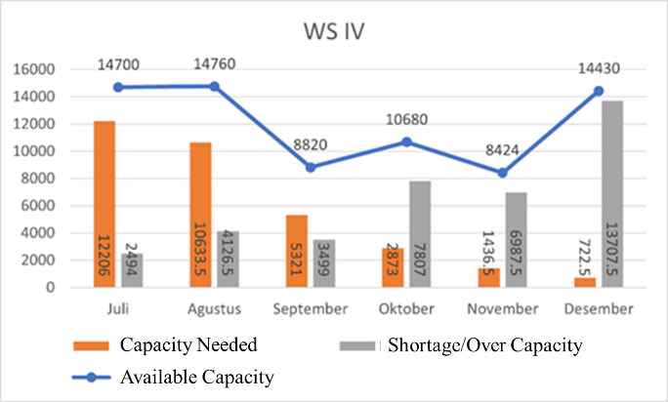
(a)
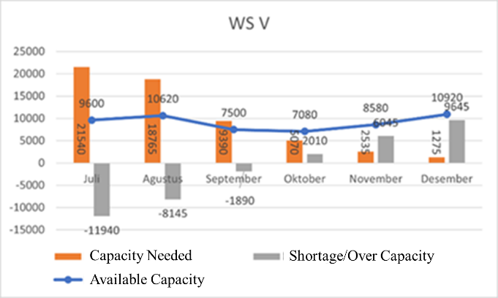
(b)

Figure 2. RCCP workstation report diagram (a) Workstation number 4 and (b) Workstation number 5

  - System Dynamics
In the analysis through system dynamics, it is necessary to make a basic causal loop diagram model to be able to describe the relationship between variables in the system to be modeled. The relationship that occurs is cause and effect between variables that can meet the demand for BT1804 core production. In the causal loop diagram model, there are several sub-models according to the conditions. The first sub model is the occurrence of order backlog and desired capacity. This variable determines the condition of the existing production capacity in the company. If the company cannot fulfill the demand, an order backlog will arise. This can be known by calculating the difference between the variable of shipment rate and the order rate. While the shipment rate is greater than the order rate, an order backlog will occur. To prevent backlog orders from occurring, a change in production capacity is required. The amount of change in capacity is determined based on the ratio of desired capacity to initial capacity. This first sub model can be seen in Figure 3.

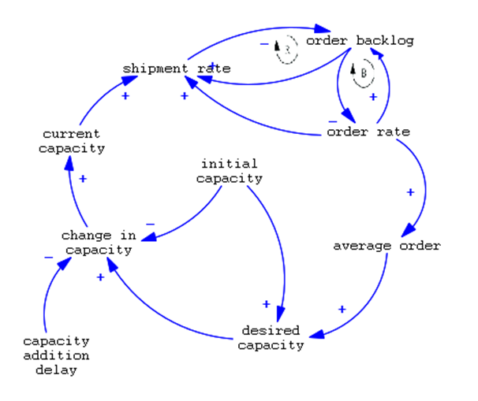
Figure 3. Sub-model of order backlog and desired capacity

The second sub model is about change in capacity. Change in capacity will be affected by several variables such as delivery delay, shipment rate, order backlog, desired delivery delay, pressure to expand and effect of pressure. All these variables influence each other towards changes in production capacity as illustrated in Figure 4.

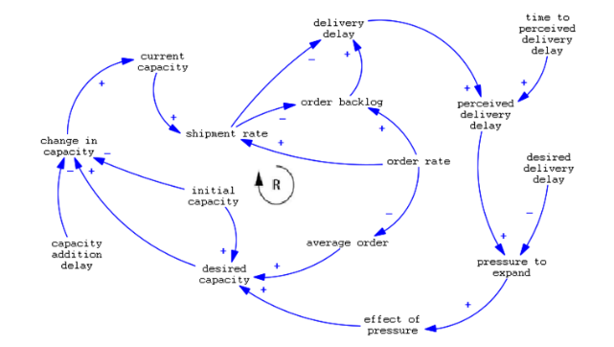
Figure 4. Sub-model change in capacity

The third sub-model is related to how much production capacity changes. These changes will have an impact on how good production planning is. Several variables such as working day added available with overtime work and workers changed. Determination of the number of working days added and worker change is done by means of change capacity in units multiplied by the standard time. The third sub-model involves working day added, worker changed, standard time, capacity change time and desired overtime variables owned by the company as illustrated in Figure 5

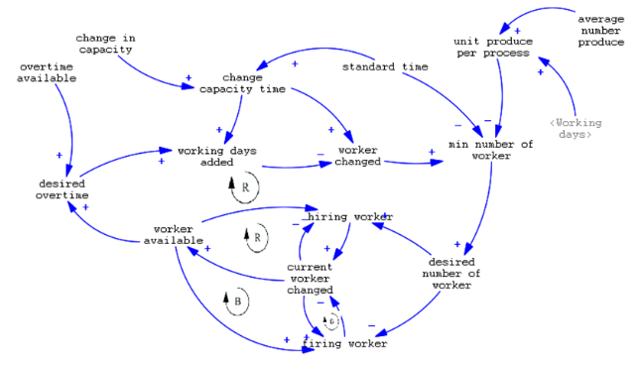
Figure 5. Sub-model production planning

After the causal loop diagram model is made, the next step is to do the Stock and Flow Diagram (SFD) modeling. This modeling was created to obtain patterns of behavior between variables with the aim of being able to carry out simulations for further verification and validation of the suitability of the model. The process of making a stock and flow diagram models, there are two SFD sub-models of Production Capacity and Changes in Total Production Capacity as illustrated figure 6. The model verification stage is carried out by running a simulation on the Vensim software. Based on the simulation results in the software, it is stated that the model used has been verified. For the model validation stage, statistical testing was carried out. The simulation results of the SFD model show that there is a decrease in backlog orders as shown in Figure 7.

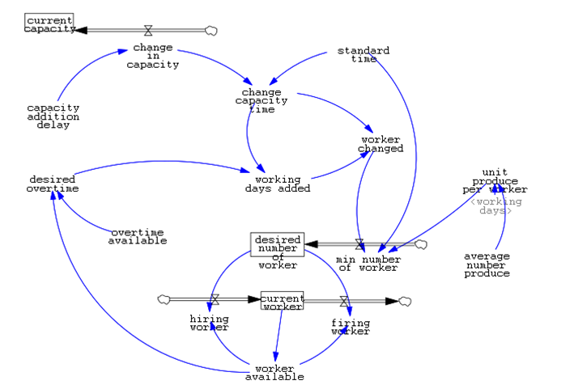
(a)
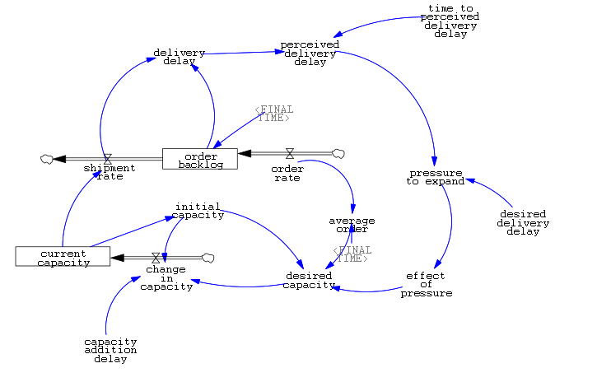
(b)

Figure 6. Sub-models of (a) Production capacity and (b) Change in Production Capacity

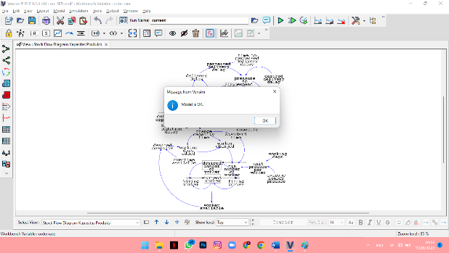
(a)
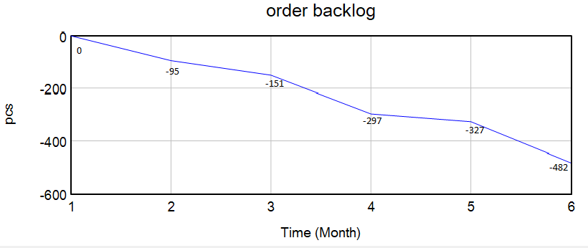
(b)

Figure 7. Verification of SFD model (a) and Validation of SFD model (b)

- RESULT AND DISCUSSION
  - Rough-Cut Capacity Planning Analysis
In the preparation of the rough-cut capacity planning report, it was discovered that the availability of capacity at workstation V experienced a shortage of production time from July to. September 2022. To be able to meet capacity requirements, an alternative decision is proposed that can support the production process so that it can produce products on time through improving work instructions. Improved work instructions are based on the previous condition where the fifth workstation requires more additional time to complete the process. The additional time is used by them to be able to assemble products from previous workstation results. So that improvements are made through work instructions to get a more optimal time according to customer demand. In addition to changing work instructions, additional working hours were also made as an alternative decision to be able to meet customer demands. The reason for the additional working hours is because it is to meet medium-term capacity needs so that it is still possible to carry out procurement. Based on the calculation of the additional number of working hours and overtime costs, the difference was obtained, namely before the repair there were 367 hours of overtime with an overtime fee of Rp 13.579.000. After the improvement was carried out, it was obtained 112 hours of overtime with an overtime fee of Rp 4.144.000.

  - System Dynamics Analysis
The desired overtime provided by the company can be affected by the overtime available and worker available, the greater the overtime available and worker available, the greater the desired overtime for the company. Working days added will be affected by desired overtime, changed capacity time, and will affect workers changed. Worked changed is influenced by changed capacity time and affects the minimum number of workers. Meanwhile, the desired number of workers is influenced by the minimum number of workers and affects the hiring of workers and affects the firing of workers. Standard time affects the minimum number of workers and affects change capacity time. Change in capacity is affected by capacity addition delay, initial capacity, current capacity, and desired capacity, so changing in capacity will affect change capacity time and will have an impact on changing workers and hiring workers. The size of the order backlog is the difference between the variable shipment rate and the order rate. If the shipment rate is greater than the order rate, there will be no order backlog, or it can be stated that the order rate is fulfilled. If the shipment rate is lower than the order rate, an order backlog occurs, which means that the order rate has not been met. The number of backlog orders that occur can be used as a reference or consideration for the company in determining the total production capacity of the company which affects the total shipment rate. The more backlog orders make the company increase the amount of production capacity. Production capacity is affected by order rate and order backlog. In SFD, the backlog is an integral of reducing the order rate and shipment rate. In addition to the order backlog, the level in the variable SFD is the current capacity with the variable change in capacity. The value of the current capacity is the integral of the variable change in capacity. Model formulation is done by providing units and formulas described in stock and flow diagrams derived from the relationships between variables, historical data, and constants used by the company. This formulation produces the output value after the simulation. For variables with stock/level type, model formulation is an integral result of the related variables and the time used for the simulation. The results obtained from this model, for the period July 2022 to December 2022, an additional 308 hours of working hours before repairs and 205 hours after repairs are needed. Figure 10 shows a stock and flow diagram.

  - Comparative Analysis
Comparative study results can be shown by comparing the results of RCCP calculations with the system dynamics model design. To be able to meet the demand for the period July to December 2022, an additional number of units in July, August and September is required of 796 pcs, 543 pcs and 126 pcs before improvement and an additional number of units in July and August of 476 pcs and 189 pcs after improvement. Based on the results of the system dynamics model design for the period August to. December 2022 requires an additional number of units before improvement of 117 pcs, 296 pcs, 151 pcs, 252 pcs, and 84 pcs. In addition of the number of units in August to December 2022 as many as 38 pcs, 70 pcs, 72 pcs, 90 pcs, and 87 pcs after improvement. The advantage of the simulation using the system dynamics model is that the addition of the number of units can be divided evenly each month so that there are no piles of production requests in certain months.

- CONCLUSION
Based on the previous explanation, it can be concluded that calculations using RCCP, and system dynamics have different results. The RCCP calculation results only focus on months that require additional working hours. This also occurs during simulations using system dynamics models, but there are differences in providing an overview of additional working hours and days, increasing the number of goods, required capacity, workforce requirements, number of working days, requests and deliveries, and others only by one work. In this case, system dynamics model analysis can be used as a company tool in anticipating possible occurrences and streamlining production time to increase production capacity.

REFERENCES
Chandra Setiawan, I., Indarto, & Deendarlianto. (2021). Quantitative analysis of automobile sector in Indonesian automotive roadmap for achieving national oil and CO2 emission reduction targets by 2030. Energy Policy, 150, 112135. https://doi.org/10.1016/J.ENPOL.2021.112135
Cherkaoui, K., Pellerin, R., Baptiste, P., & Haït, A. (2015). A Time Driven RCCP Model with Two Levels of Planning and a Reactive Planning Approach for Tactical Project Planning. Procedia Computer Science, 64, 257–264. https://doi.org/10.1016/J.PROCS.2015.08.488
Dallasega, P., Rally, P., Rauch, E., & Matt, D. T. (2016). Customer-oriented Production System for Supplier Companies in CTO. Procedia CIRP, 57, 533–538. https://doi.org/10.1016/J.PROCIR.2016.11.092
Georgiadis, P. (2013). An integrated System Dynamics model for strategic capacity planning in closed-loop recycling networks: A dynamic analysis for the paper industry. Simulation Modelling Practice and Theory, 32, 116–137. https://doi.org/10.1016/J.SIMPAT.2012.11.009
Menezes, M. B. C., Ruiz-Hernández, D., & Verter, V. (2016). A rough-cut approach for evaluating location-routing decisions via approximation algorithms. Transportation Research Part B: Methodological, 87, 89–106. https://doi.org/10.1016/J.TRB.2016.03.003
Nurcahyo, R., & Wibowo, A. D. (2015). Manufacturing Capability, Manufacturing Strategy and Performance of Indonesia Automotive Component Manufacturer. Procedia CIRP, 26, 653–657. https://doi.org/10.1016/J.PROCIR.2014.07.046
Seong, B. (2020). Smoothing and forecasting mixed-frequency time series with vector exponential smoothing models. Economic Modelling, 91, 463–468. https://doi.org/10.1016/J.ECONMOD.2020.06.020
Silva, M. H. de P. e., Costa, L. B. M., Paredes, F. J. G., Barretti, J. W., & Silva, D. A. L. (2022). The effect of demand forecasting choices on the circularity of production systems: a framework and case study. Resources, Conservation & Recycling Advances, 15, 200088. https://doi.org/10.1016/J.RCRADV.2022.200088
Sudarto, S., Takahashi, K., & Morikawa, K. (2017). Efficient flexible long-term capacity planning for optimal sustainability dimensions performance of reverse logistics social responsibility: A system dynamics approach. International Journal of Production Economics, 184, 179–192. https://doi.org/10.1016/J.IJPE.2016.12.013
Suryani, E., Chou, S. Y., Hartono, R., & Chen, C. H. (2010). Demand scenario analysis and planned capacity expansion: A system dynamics framework. Simulation Modelling Practice and Theory, 18(6), 732–751. https://doi.org/10.1016/J.SIMPAT.2010.01.013
Wen, D., Liu, L., Wang, Y., & Zhang, Y. (2022). Forecasting crude oil market returns: Enhanced moving average technical indicators. Resources Policy, 76, 102570. https://doi.org/10.1016/J.RESOURPOL.2022.102570

