Attachment 1. Interview Guide

Interview Guide
- When was Zaqiku Coffee Mojokerto founded?
Answer: Zaqiku Coffee was founded in February 2021
- What is the history of the founding of Zaqiku Coffee Mojokerto?
Answer: Zaqiku Coffee is a coffee shop that has a cafe theme filled with ornamental plants or what is usually called a garden. Zaqiku Coffee started its business in February 2021 and chose a construction location in front of the houseyard. Zaqiku itself is taken from the name of the owner's younger brother, Zaqi. Faris Febrianto, the business owner, built this cafe when the COVID-19 pandemic hit Indonesia, so to find an alternative business, Faris was helped by his family to build this coffee shop.
- What is the organizational structure of Zaqiku Coffee Mojokerto?
Answer: Zaqiku Coffee has an organizational structure in the form of an owner at the top. Then marketing, head bar, and head kitchen are under the owner.
- How many employees does Zaqiku Coffee Mojokerto have?
Answer: Zaqiku Coffee has 3 employees to date
- Where is the address of Zaqiku Coffee Mojokerto located?
Answer: Zaqiku Coffee is located at Jl. Ubalan Canal, Pacet, Mojokerto
- What are the operational hours for Zaqiku Coffee Mojokerto?
Answer: Zaqiku Coffee is open every day from 10:00-22:00
- What types of products are available at Zaqiku Coffee Mojokerto?
Answer: Zaqiku Coffee sells drinks and food. Drinks sold are cappuccino, latte, brewed coffee, bon-bon, gibraltar, Vietnamese drip, v60, americano, caramel latte, hazelnut latte, mocha latte, almond latte, red velvet, green tea, taro, chocolate, salted caramel, charcoal, tea, and lychee tea. The food sold is cwie noodles, fried chicken, tripe rice, potatoes, meatball tofu, cassava, samosas, chocolate bananas, platter
- What is the price range for Zaqiku Coffee Mojokerto products?
Answer: The prices sold at Zaqiku Coffee range from Rp. 8,000- Rp. 20,000
- What promotional media does Zaqiku Coffee Mojokerto use?
Answer: The promotional media used by Zaqiku Coffee is only via Instagram
- How does Zaqiku Coffee Mojokerto promote on Instagram?
Answer: Via Instagram feed, stories and reels
- What are the obstacles in carrying out promotions at Zaqiku Coffee Mojokerto?
Answer: According to the owner of Zaqiku, this is due to the lack of social media management who is willing and competent to manage it, resulting in promotions that have no results. Apart from that, Zaqiku Coffee Instagram managers are less active in making posts and the content they create is less interesting, especially on Instagram feeds.

Attachment 2. Research Questionnaire

DESIGNING INSTAGRAM FEED
AS PROMOTIONAL MEDIA USING CANVA PRO
AT ZAQIKU COFFEE MOJOKERTO

In this section, each answer is used for assessment. Give your responses to each question in this questionnaire honestly. There is no right or wrong answer for each of your answers. Choose the answer that best suits your opinion. Research criteria:
SD : Strongly disagree
D : Disagree
N : Neutral
A : Agree
SA : Strongly agree

Respondent Profile
- Name : …………………………………………………………
- Age : …………………………………………………………
- Gender : ☐ Male ☐ Female
- Status : ☐ Marketing Expert ☐ Computer Expert
☐ Owner/Employee ☐ Consumer

Put a mark (√) in the answer column provided
No. | Statement | SD |  | D | N | A | SA
No. | Statement | 1 |  | 2 | 3 | 4 | 5
A. | Empathy
1. | The feed design on Zaqiku Coffee's Instagram is memorable to me
2. | I like the feed design on Zaqiku Coffee's Instagram account
B. | Persuasion
1. | Feeds on Zaqiku Coffee's Instagram make me interested in products at Zaqiku Coffee
2. | The feed on Zaqiku Coffee's Instagram makes me want to purchase Zaqiku Coffee products.
C. | Impact
1. | The feed on Zaqiku Coffee's Instagram makes me aware of the products at Zaqiku Coffee.
2. | The feed design on Zaqiku Coffee's Instagram contains creativity
D. | Communication
1. | The feed on Zaqiku Coffee's Instagram contains clear information
2. | The feed on Zaqiku Coffee's Instagram is easy to understand

If the answer chosen is strongly disagree (SD) or disagree (D), please provide reasons for the answer!
………………………………………………………………………………………
………………………………………………………………………………………
………………………………………………………………………………………
………………………………………………………………………………………
………………………………………………………………………………………
………………………………………………………………………………………
………………………………………………………………………………………

Attachment 3. Cycle 1 Questionnaire Results
No. | Statement | STS |  | TS | N | S | SS
No. | Statement | 1 |  | 2 | 3 | 4 | 5
A. | Empathy
1. | Zaqiku Coffee's Instagram feed design works for me |  |  |  | 2 | 11 | 12
2. | I like the feed design on Zaqiku Coffee's Instagram account |  |  |  |  | 10 | 15
B. | Persuasion
1. | The feed on Zaqiku Coffee's Instagram got me interested in the products at Zaqiku Coffee |  |  | 1 | 3 | 9 | 12
2. | The feed on Zaqiku Coffee's Instagram makes me want to buy Zaqiku Coffee products |  |  | 1 | 2 | 10 | 12
C. | Impact
1. | The feed on Zaqiku Coffee's Instagram makes me aware of the products at Zaqiku Coffee |  |  | 1 | 2 | 13 | 9
2. | Feed design on Instagram Zaqiku Coffee contains creativity |  |  |  | 1 | 6 | 18
D. | Communication
1. | Zaqiku Coffee's Instagram feed contains clear information |  |  |  | 5 | 9 | 11
2. | The feed on Zaqiku Coffee's Instagram is easy to understand |  |  |  | 1 | 12 | 12

Cycle I Empathy Dimension Questionnaire Calculation Result
Statement |  | STS | TS | N | S | SS | Average Score per Item | Average Score per Indicator | Percentage |  |  |  |  | Total
 |  | 1 | 2 | 3 | 4 | 5 | Average Score per Item | Average Score per Indicator | STS | TS | N | S | SS | Total
Empathy | 1 | 0 | 0 | 2 | 11 | 12 | 4,4 | 4,5 | 0 | 0 | 8 | 44 | 48 | 100
Empathy | 2 | 0 | 0 | 0 | 10 | 15 | 4,6 | 4,5 | 0 | 0 | 0 | 40 | 60 | 100

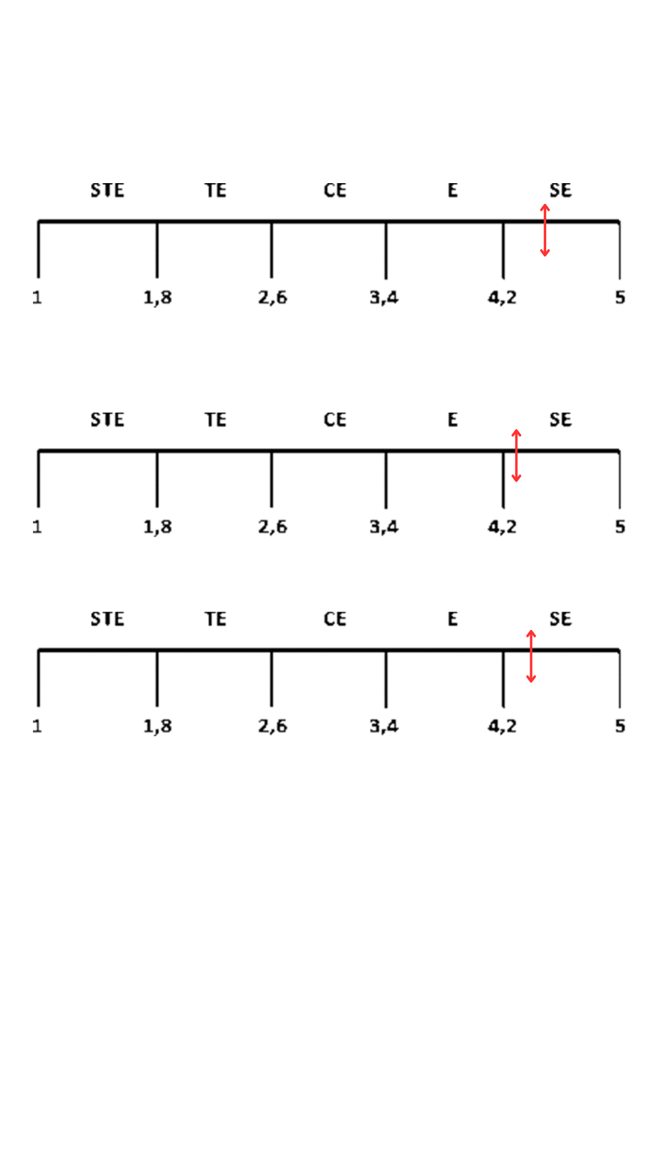
Cycle I Persuasion Dimension Questionnaire Calculation Result
Statement |  | STS | TS | N | S | SS | Average Score per Item | Average Score per Indicator | Percentage |  |  |  |  | Total
 |  | 1 | 2 | 3 | 4 | 5 | Average Score per Item | Average Score per Indicator | STS | TS | N | S | SS | Total
Persuasion | 1 | 0 | 1 | 3 | 9 | 12 | 4,28 | 4,3 | 0 | 4 | 12 | 36 | 48 | 100
Persuasion | 2 | 0 | 1 | 2 | 10 | 12 | 4,32 | 4,3 | 0 | 4 | 8 | 40 | 48 | 100

Cycle I Impact Dimension Questionnaire Calculation Result
Statement |  | STS | TS | N | S | SS | Average Score per Item | Average Score per Indicator | Percentage |  |  |  |  | Total
 |  | 1 | 2 | 3 | 4 | 5 | Average Score per Item | Average Score per Indicator | STS | TS | N | S | SS | Total
Impact | 1 | 0 | 1 | 2 | 13 | 9 | 4,2 | 4,44 | 0 | 4 | 8 | 52 | 36 | 100
Impact | 2 | 0 | 0 | 1 | 6 | 18 | 4,68 | 4,44 | 0 | 0 | 4 | 24 | 72 | 100

Cycle I Communication Dimension Questionnaire Calculation Result
Statement |  | STS | TS | N | S | SS | Average Score per Item | Average Score per Indicator | Percentage |  |  |  |  | Total
 |  | 1 | 2 | 3 | 4 | 5 | Average Score per Item | Average Score per Indicator | STS | TS | N | S | SS | Total
Communication | 1 | 0 | 0 | 5 | 9 | 11 | 4,24 | 4,34 | 0 | 0 | 20 | 36 | 44 | 100
Communication | 2 | 0 | 0 | 1 | 12 | 12 | 4,44 | 4,34 | 0 | 0 | 4 | 48 | 48 | 100

Cycle I EPIC Rate Scale Result

Attachment 4. Cycle II Questionnaire Result
No. | Statement | STS |  | TS | N | S | SS
No. | Statement | 1 |  | 2 | 3 | 4 | 5
A. | Empathy
1. | Zaqiku Coffee's Instagram Feeds design works for me |  |  |  | 2 | 6 | 17
2. | I like the Feeds design on Zaqiku Coffee's Instagram account |  |  |  |  | 6 | 19
B. | Persuasion
1. | The feed on Zaqiku Coffee's Instagram got me interested in the products at Zaqiku Coffee |  |  |  | 2 | 4 | 19
2. | The feed on Zaqiku Coffee's Instagram makes me want to buy Zaqiku Coffee products |  |  |  | 1 | 8 | 16
C. | Impact
1. | The feed on Zaqiku Coffee's Instagram makes me aware of the products at Zaqiku Coffee |  |  |  | 2 | 14 | 9
2. | Feed design on Instagram Zaqiku Coffee contains creativity |  |  |  |  | 7 | 18
D. | Communication
1. | Zaqiku Coffee's Instagram feed contains clear information |  |  |  | 3 | 11 | 11
2. | The feed on Zaqiku Coffee's Instagram is easy to understand |  |  |  |  | 13 | 12

Cycle II Empathy Dimension Questionnaire Calculation Result
Statement |  | STS | TS | N | S | SS | Average Score per Item | Average Score per Indicator | Percentage |  |  |  |  | Total
 |  | 1 | 2 | 3 | 4 | 5 | Average Score per Item | Average Score per Indicator | STS | TS | N | S | SS | Total
Empathy | 1 | 0 | 0 | 2 | 6 | 17 | 4,60 | 4,7 | 0 | 0 | 8 | 24 | 68 | 100
Empathy | 2 | 0 | 0 | 0 | 6 | 19 | 4,76 | 4,7 | 0 | 0 | 0 | 24 | 76 | 100
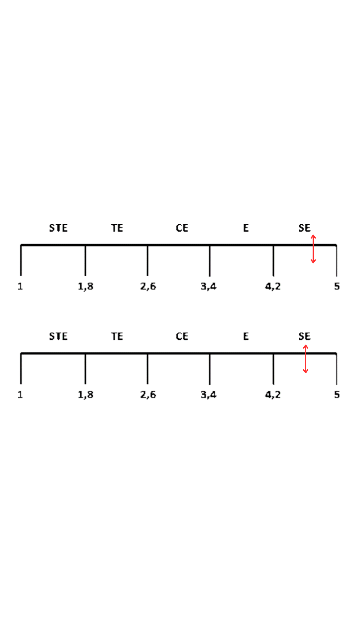

Cycle II Persuasion Dimension Questionnaire Calculation Result
Statement |  | STS | TS | N | S | SS | Average Score per Item | Average Score per Indicator | Percentage |  |  |  |  | Total
 |  | 1 | 2 | 3 | 4 | 5 | Average Score per Item | Average Score per Indicator | STS | TS | N | S | SS | Total
Persuasion | 1 | 0 | 0 | 2 | 4 | 19 | 4,68 | 4,64 | 0 | 0 | 8 | 16 | 76 | 100
Persuasion | 2 | 0 | 0 | 1 | 8 | 16 | 4,60 | 4,64 | 0 | 0 | 4 | 32 | 64 | 100

Cycle II Impact Dimension Questionnaire Calculation Result
Statement |  | STS | TS | N | S | SS | Average Score per Item | Average Score per Indicator | Percentage |  |  |  |  | Total
 |  | 1 | 2 | 3 | 4 | 5 | Average Score per Item | Average Score per Indicator | STS | TS | N | S | SS | Total
Impact | 1 | 0 | 0 | 2 | 14 | 9 | 4,28 | 4,5 | 0 | 0 | 8 | 56 | 36 | 100
Impact | 2 | 0 | 0 | 0 | 7 | 18 | 4,72 | 4,5 | 0 | 0 | 0 | 28 | 72 | 100

Cycle II Communication Dimension Questionnaire Calculation Result
Statement | STS |  | TS | N | S | SS | Average Score per Item | Average Score per Indicator | Percentage |  |  |  |  | Total
Statement | 1 |  | 2 | 3 | 4 | 5 | Average Score per Item | Average Score per Indicator | STS | TS | N | S | SS | Total
Communication | 1 | 0 | 0 | 3 | 11 | 11 | 4,3 | 4,4 | 0 | 0 | 12 | 44 | 44 | 100
Communication | 2 | 0 | 0 | 0 | 13 | 12 | 4,5 | 4,4 | 0 | 0 | 0 | 52 | 48 | 100

Cycle II EPIC Rate Scale Result

Attachment 5. Product Image
Product Image

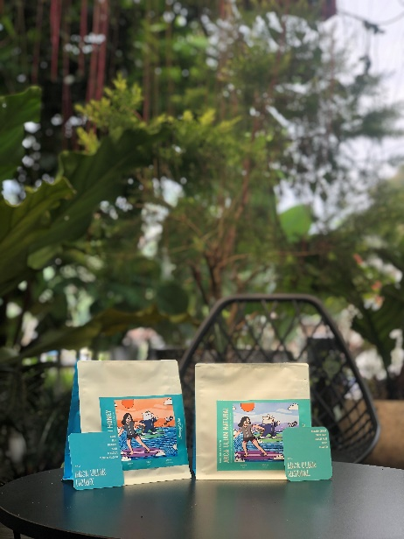
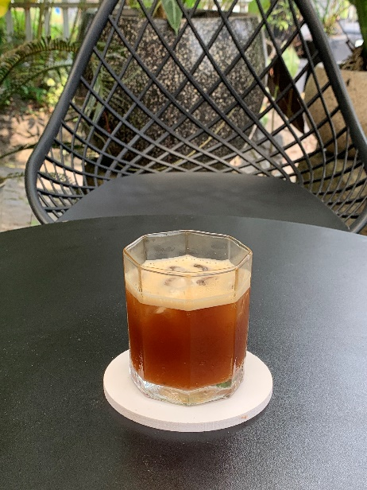
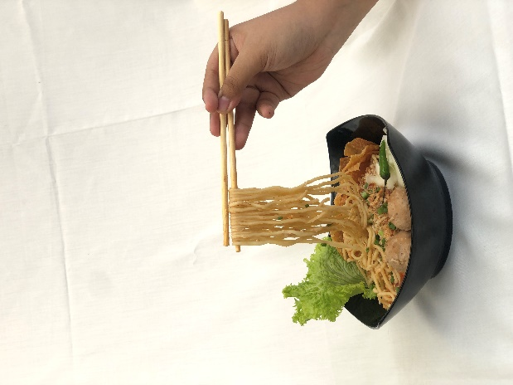

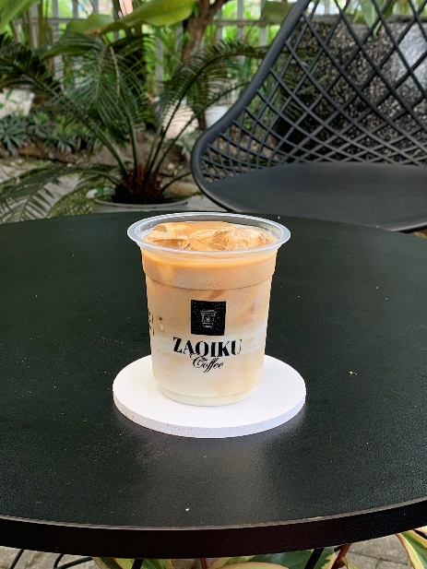

Attachment 6. Instagram Feed Design

Instagram Feed Design

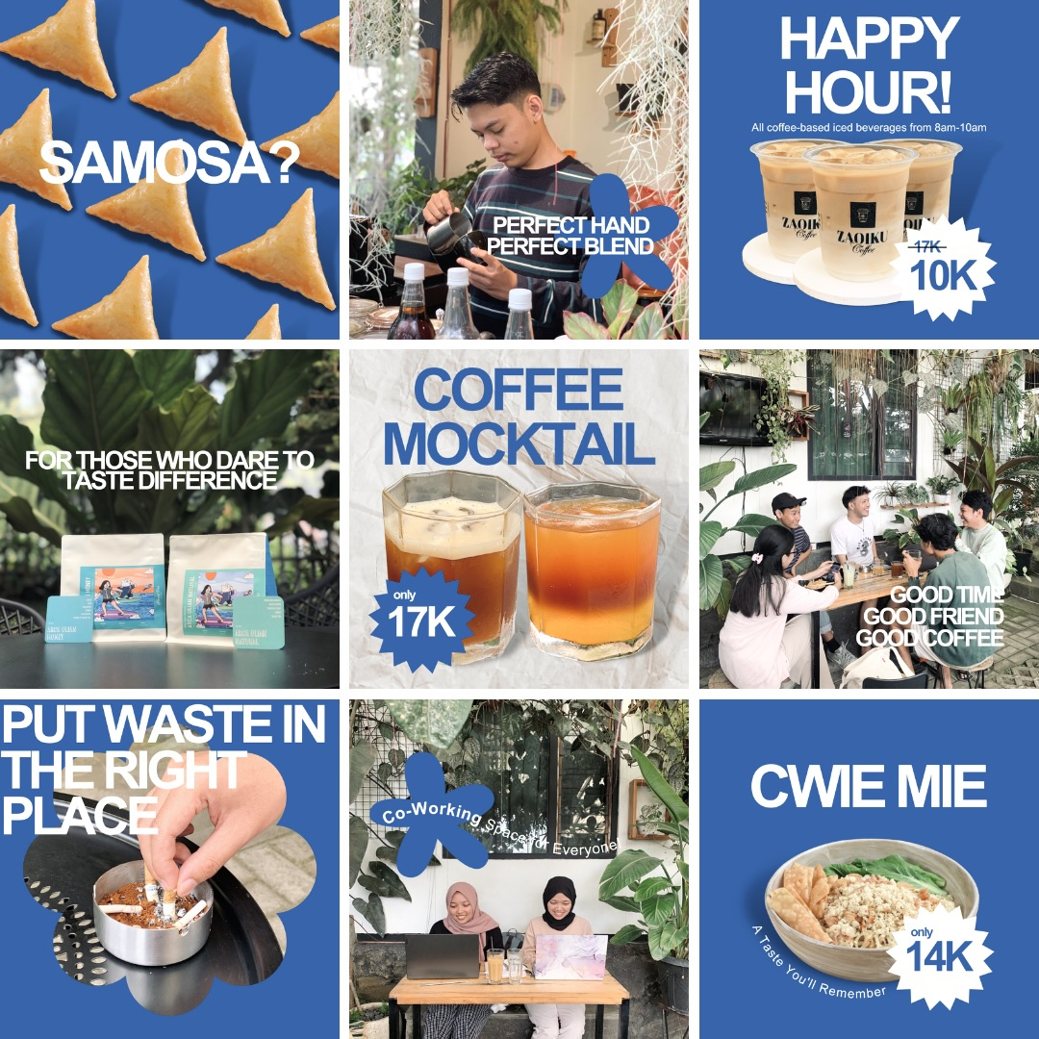

Attachment 7. Curriculum Vitae of Researcher

PERSONAL DATA
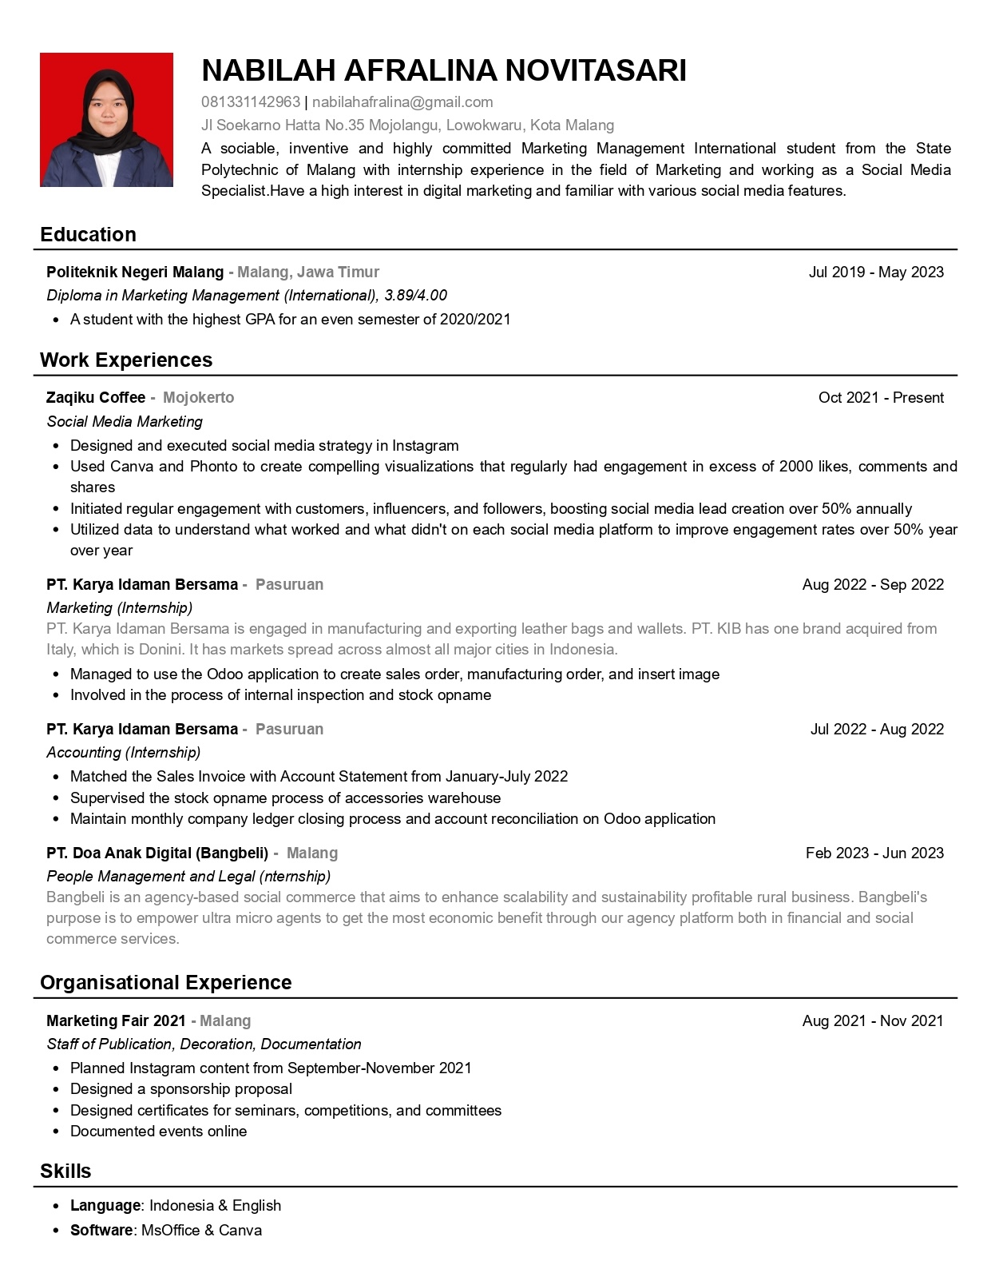
Attachment 8. Curriculum Vitae of Marketing Expert
CV of Marketing Expert I
1 | Nama Lengkap dengan gelar | Kartika Indah Permanasari, SE, MM
2 | Jenis kelamin | Perempuan
3 | Jabatan fungsional | -
5 | NIDN | 0718118505
6 | Tempat dan Tanggal Lahir | Malang, 18 November 1985
7 | E-mail | kartika.ip18@gmail.com
8 | No hp | 081997997880
9 | Mata kuliah yang diampu  Universitas Kanjuruhan Malang  (2012 – 2016) | - Riset Operasional
9 |  | - Matematika Ekonomi
9 |  | - Ekonomi Manajerial
9 |  | - Manajemen Risiko
9 |  | - Metodologi penelitian
10 | Mata kuliah yang diampu  Politeknik Negeri Malang  (2016 – 2022) | - Customer Relationship Management
10 |  | - Periklanan
10 |  | - Pemasaran Jasa
10 |  | - Manajemen Ritel
10 |  | - Manajemen Penjualan /Sales
10 |  | - Manajemen Pemasaran
10 |  | - Matematika Ekonomi
10 |  | - Pengantar Bisnis
10 |  | - Lembaga keuangan Bank dan non Bank
10 |  | - Perilaku Konsumen
10 |  | - Etika Bisnis
10 |  | - Manajemen Sumber Daya Manusia
10 |  | - Simulasi Pemasaran
10 |  | - Proyek Perencanaan Pemasaran
11 | Mata Kuliah yang diampu di Fakultas Ekonomi Universitas Negeri Malang  (Saat ini) | - Pemasaran Strategis
11 |  | - Pemasaran Media
11 |  | - Pengembangan Personal

B. RIWAYAT PENDIDIKAN
Nama Perguruan Tinggi | Universitas Negeri Malang, Fakultas Ekonomi | Universitas Brawijaya Fakultas Ekonomi
Bidang Ilmu | Manajemen Pemasaran | Manajemen Pemasaran
Tahun Masuk-Keluar | 2003-2008 | 2010-2012
Judul Skripsi/Tesis/Disertasi | Pengaruh Kualitas Layanan terhadap Kepuasan Nasabah Bank X | Pengaruh Komunikasi Pemasaran terhadap Keputusan Pembelian melalui Motivasi Konsumen Studi Kasus Konsumen Pengusaha Indosat
Nama Pembimbing/Promotor | - Dr. Sopiah, M.Pd, MM  - Dr. Agus Hermawan, M.Si, Grad Dip MGT, M.Bus | - Prof. Armanu, SE, MSc, Ph.D  - Dr. Christin Susilowati, SE, MM

Malang, 1 Oktober 2022


Kartika Indah Permanasari, SE, MM.
NIDN 0718118505

CV of Marketing Expert II
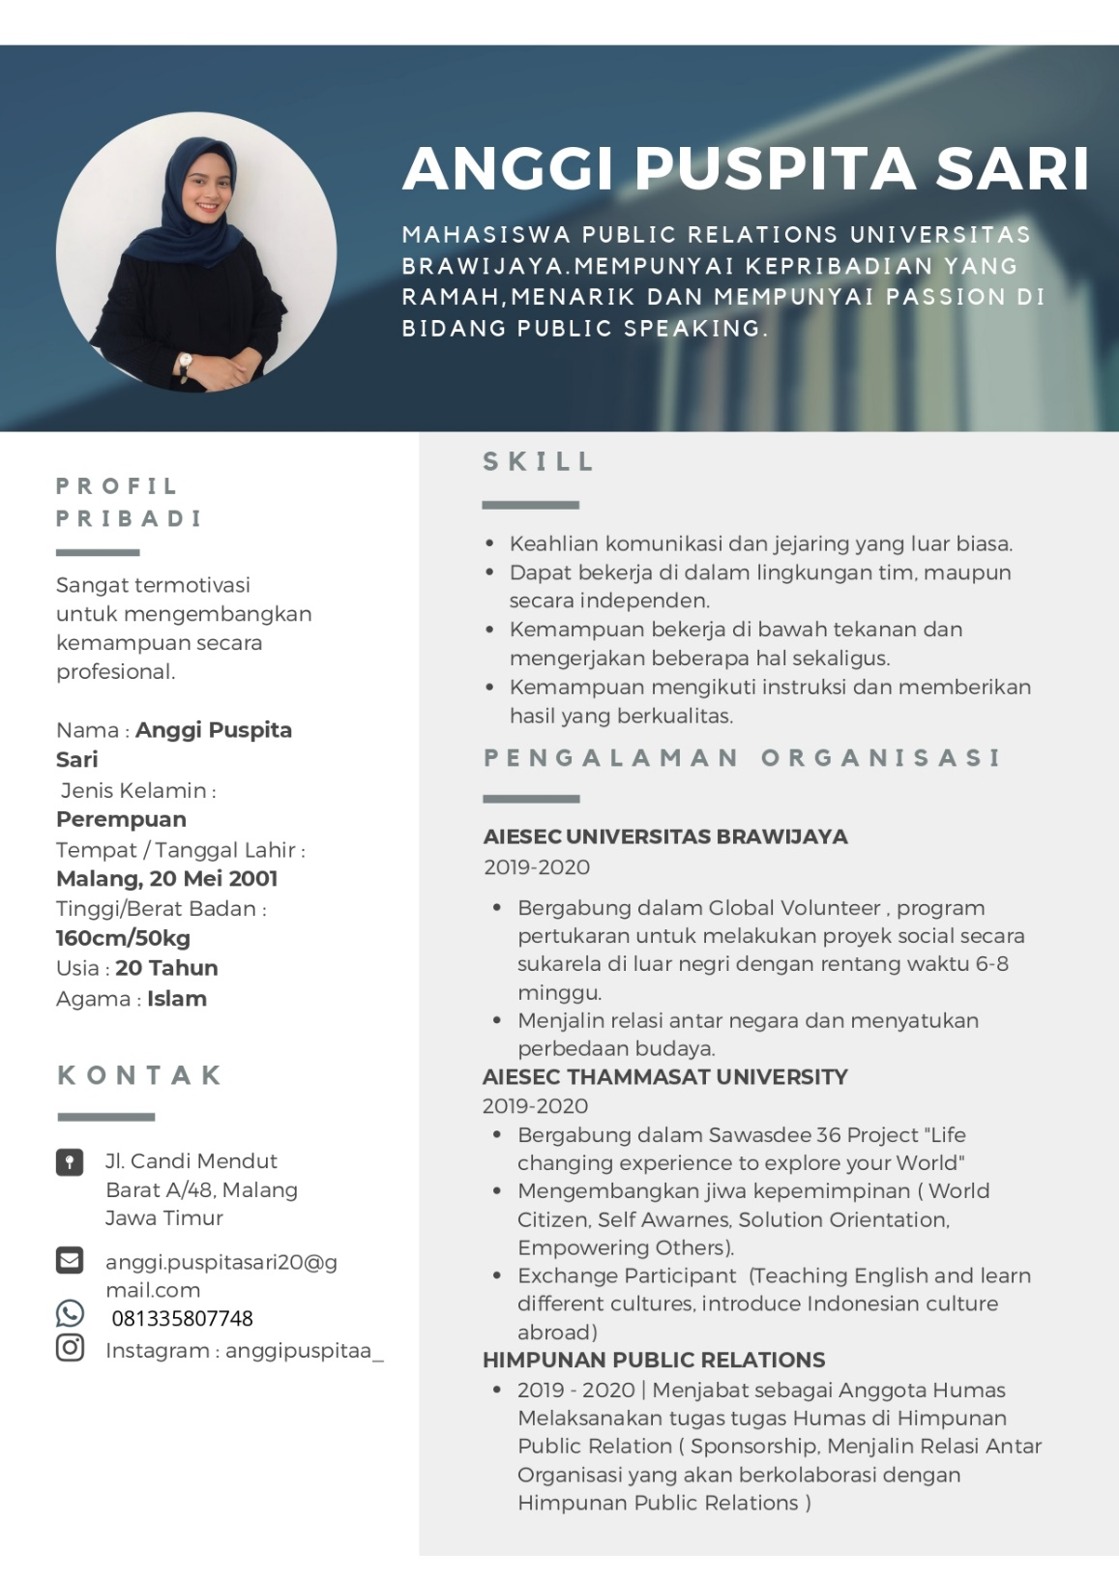

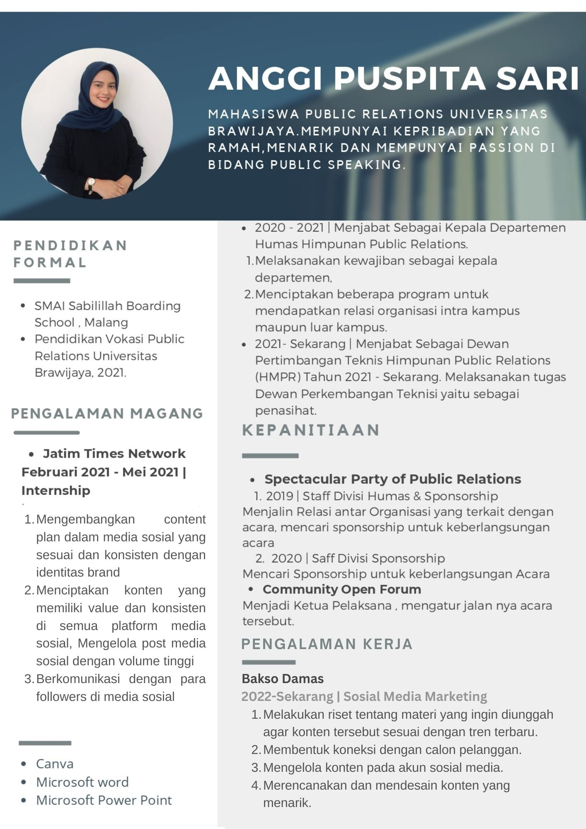

Attachment 9. Curriculum Vitae of Design Expert
CV of Design Expert I
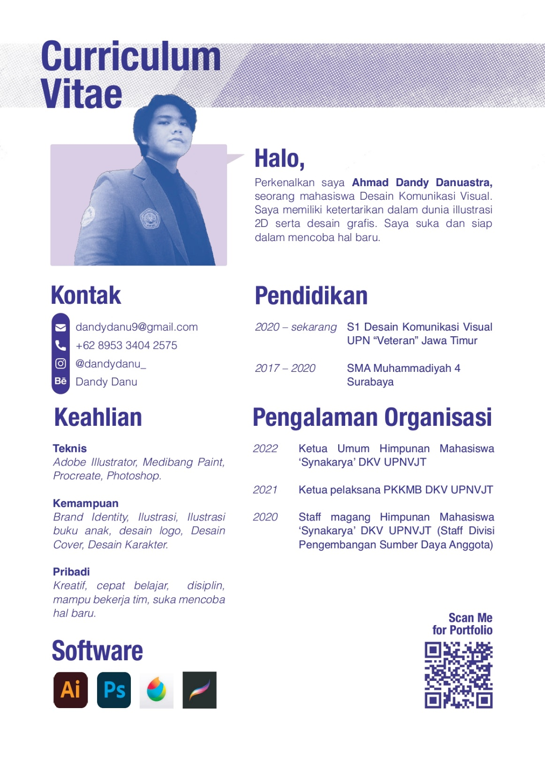

CV of Design Expert II


Attachment 10. Thesis Outline
Thesis Outline

VALIDITY SHEET
ABSTRACT
FOREWORD
TABLE OF CONTENT
LIST OF FIGURES
APPENDIX LIST
CHAPTER I INTRODUCTION
1.1 Research Background
1.2 Problem Formulation
1.3 Problem Limitation
1.4 Objectives and Benefits Research

CHAPTER II LITERATURE REVIEW
2.1 Theorical Review
2.2 Design Effectiveness Measurement
2.3 Previous Research
2.4 Similarities and Differences between Previous and Current Research
2.5 Conceptual Research

CHAPTER III RESEARCH METHODS
3.1 Research Scope
3.2 Types of Research
3.3 Analysis Unit
3.4 Data Types
3.5 Data Collection Methods
3.6 Questionnaire Development
3.7 Data Analysis Methods

CHAPTER IV IMPLEMENTATION OF ACTION RESEARCH AND DATA PRESENTATION
4.1 Company Overview
4.2 Action Research Implementation
4.3 Design Overview
4.4 Discussion
4.5 Implications

CHAPTER V CONCLUSION AND SUGGESTION
5.1 Conclusion
5.2 Suggestion

BIBLIOGRAPHY

ATTACHMENT

