Supplementary Document
Comparative Analysis of Cooling Load Calculations: CLTD Method vs. Carrier HAP 5.01 Software for Hotel HVAC Design
Madarif Prawibowo * and Komarudin
Department of Mechanical Engineering, Dian Nusantara University, Petamburan, Jakarta 11470, Indonesia
*Corresponding Authors: madarifprawibowo@gmail.com (MP)

Appendixes
Table 1. Standard CLTD cooling load

Table 2. Mid internal room CLTD cooling load
Table 3. Mid external room CLTD cooling load
Table 4. CLTD cooling loads for suite living rooms

Table 5. CLTD cooling loads for bedroom suite rooms
Table 6. Owner suite bedroom CLTD cooling loads
Table 7. CLTD cooling loads for owner suite living rooms
Table 8. HAP 5.01 standard room cooling load
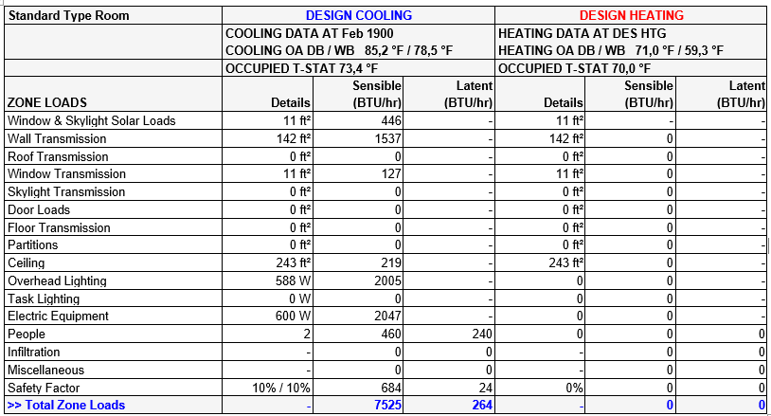
Table 9. HAP Cooling Load 5.01 Internal Mid Room
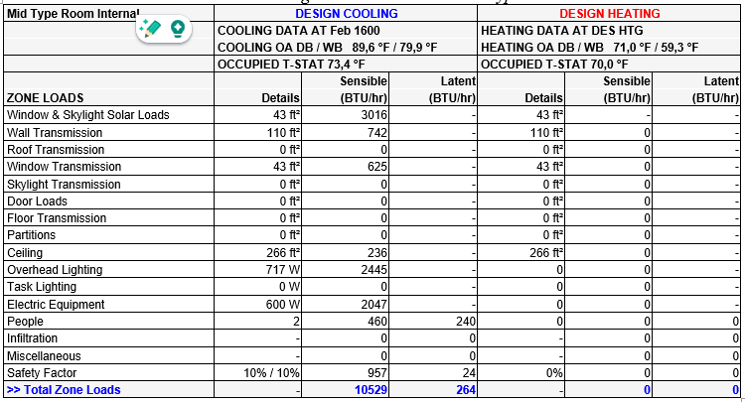

Table 10. HAP 5.01 mid external room cooling load
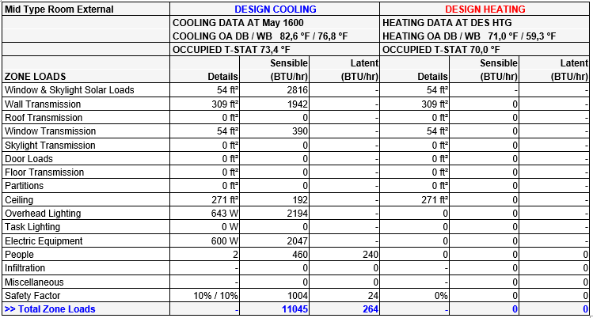
Table 11. HAP 5.01 suite living room cooling load
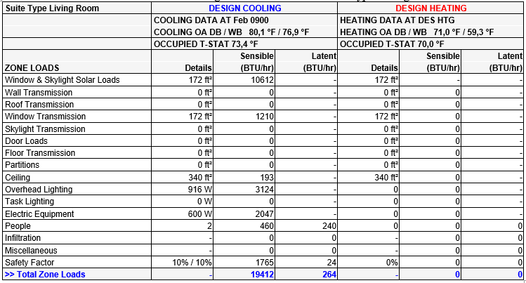

Table 12. HAP 5.01 bedroom suite room cooling load
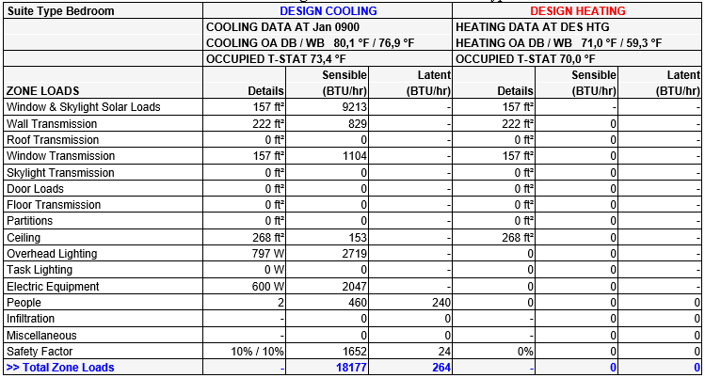
Table 13. HAP 5.01 owner suite living room cooling load
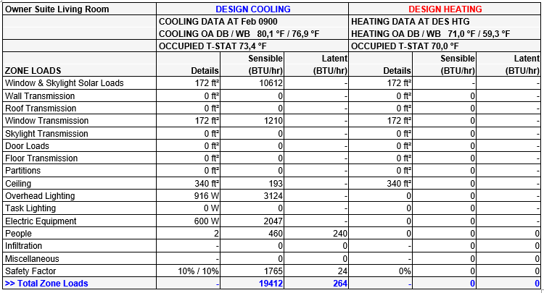

Table 14. HAP 5.01 owner suite bedroom cooling load
