Correlation Analysis of Capacity, Range, and Charging Time of Electric Vehicle Batteries Using Pearson Formula and MATLAB
Yasa Sanusi ¹*, Sri Pudjiwati ¹ and Kontan Tarigan¹

¹Mechanical Engineering Masters Study Program, Mechanical Engineering Faculty, Mercu Buana University, West Jakarta 11650 Indonesia
*Corresponding Authors: yasa.sanusi@gmail.com

Abstract  The increasing use of electric vehicles is in line with increasing global awareness regarding climate change and air pollution challenges. Considered a sustainable alternative, electric vehicles produce zero emissions and have the ability to reduce carbon and air pollution, especially when their charging energy is sourced from renewable resources. However, consumers face the challenge of high costs, especially those related to battery components which in fact are the energy source that drives the system of electric vehicles. In Indonesia, the batteries commonly used in electric vehicles are Lithium Ferro Phosphate (LFP) and Nickel Manganese Cobalt (NMC), each offering different characteristics and benefits. This study aims to evaluate the correlation of these two types of batteries in terms of capacity, range and charging time with Pearson correlation and MATLAB regression analysis simulation methods. The correlation results show a strong and significant relationship between parameters such as battery capacity, driving range, and charging time. Regression analysis provides a numerical model that can predict the relationship between variables with good accuracy. The average energy efficiency for LFP batteries is 7.53 km/kWh, and NMC 6.84 km/kWh, this shows that LFP shows consistent performance regarding energy efficiency compared to NMC. Energy efficiency provides important insights into optimizing the energy use of electric vehicles. Thus, these results can be used for planning and developing more efficient electric vehicle battery systems. The combination of these statistical analyses provides a solid basis for decision making in future electric vehicle research and development. |  | Article Info:  Received: xx xxx 2025  Revised: xx xxx 2025  Accepted: xx xxx 2025  Available online: xx xxx 2025  Keywords:  Electric Vehicle; Lithium Ferro Phosphate (LFP); Nickel Manganese Cobalt (NMC); Pearson Correlation  © 20XX The Author(s). Published by Universitas Mercu Buana (Indonesia). This is an open-access article under CC BY-SA License.  

1. Introduction
How to cite:
Y. Sanusi, S. Pudjiwati, K. Tarigan, " Correlation Analysis of Capacity, Range, and Charging Time of Electric Vehicle Batteries Using Pearson Formula and MATLAB " Int. J. Innov. Mech. Eng. Adv. Mater, vol. 6, no. 1, pp. 1-10, 2025
The global shift towards sustainable transportation has led to a significant increase in the adoption of electric vehicles (EVs) [1]. Rising concerns over climate change and air pollution have propelled governments and consumers worldwide to seek alternatives to fossil fuel-powered vehicles [2]. EVs are considered a viable solution due to their zero tailpipe emissions and potential to reduce greenhouse gas emissions, especially when powered by renewable energy sources [3]. In Indonesia, the transportation sector is a major contributor to carbon emissions and urban air pollution [4]. The Indonesian government has set ambitious targets to increase EV adoption as part of its commitment to reduce greenhouse gas emissions under the Paris Agreement. Despite these efforts, several challenges hinder the widespread adoption of EVs in Indonesia, particularly the high initial costs associated with battery technology [5][6].
Batteries are the most critical component of EVs, significantly affecting their performance, range, and cost [7]. Among the various battery technologies, Lithium Iron Phosphate (LFP) and Nickel Manganese Cobalt (NMC) batteries are the most used in EVs, each with distinct characteristics and advantages [8]. LFP batteries are known for their long lifespan, thermal stability, and safety. They offer lower energy density but are more cost-effective and have a longer cycle life compared to other lithium-ion batteries [9]. On the other hand, NMC batteries have higher energy density, providing longer driving ranges, but are more expensive and have concerns regarding thermal stability and the ethical sourcing of cobalt [10].
Previous research has explored the performance, efficiency, and longevity of both LFP and NMC batteries in electric vehicles. Studies by Tran, M.K. et al., Long, B. et al., and White, C. et al. have provided examined the performance characteristics of LFP and NMC batteries also analyzed the thermal behavior of LFP and NMC batteries under various operating conditions, highlighting the importance of thermal management in EV applications. The energy efficiency and degradation rates of LFP and NMC batteries, finding that LFP batteries offer better longevity but lower energy density [11][12][13].
Given these considerations, this study aims to evaluate the efficiency of LFP and NMC batteries in the context of EVs in Indonesia, that is capacity, range, and charging. This research seeks to provide insights into the advantages and disadvantages of each battery type, contributing to informed decision-making for consumers and policymakers in promoting sustainable EV adoption in Indonesia.

2. Methods

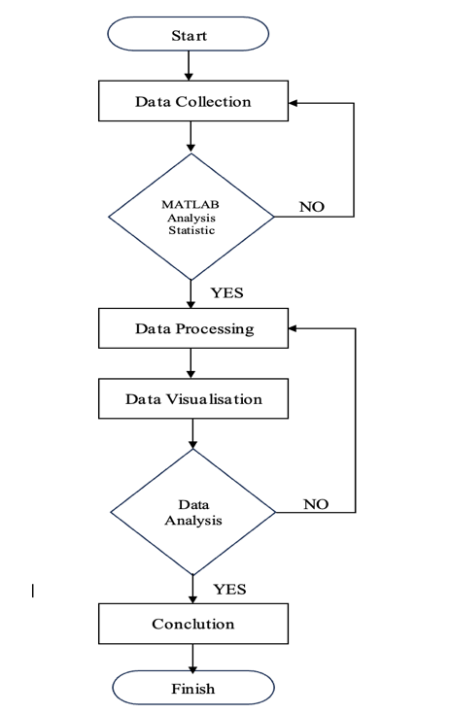
This research employs numerical methods with Pearson correlation and MATLAB regression analysis simulation methods. The approach combines MATLAB-based simulations with mathematical modeling to understand the correlation analysis of capacity, range, and charging time of electric vehicle batteries. The following is the methodology or flow in data processing and methodology that can be used in analyzing LFP and NMC battery efficiency using Pearson correlation analysis and MATLAB application:
Figure 1. Research Methodology

3. Results and Discussion
  - Data Collection
Table 1. Lithium Ferro Phosphate [14][15][16][17]
Model | Capacity | Range | Charging time
1 | 76,9 kWh | 605 km | 30 minute (DC Fast Charging)
2 | 50.6 kWh | 408 km | 30 minute (DC Fast Charging)
3 | 61,4 kWh | 450 km | 30 minute (DC Fast Charging)
4 | 51 kWh | 350 km | 30 minute (DC Fast Charging)
Table 2. Nickel Manganese Cobalt [18][19][20][21].
Model | Capacity | Range | Charging time
1 | 72,6 kWh | 430 km | 18 minute (DC Fast Charging)
2 | 77,4 kWh | 460 km | 18 minute (DC Fast Charging)
3 | 62 kWh | 560 km | 30 minute (Supercharger)
4 | 71,4 kWh | 460 km | 30 minute (DC Fast Charging)

  - Analysis Pearson Correlation (Numerical Methode)
- Pearson correlation analysis of capacity and range

To calculate the correlation between battery capacity and range parameters, use the Pearson correlation equation. From the data above it is known:

Variable X is the battery capacity: X = {76.9, 50.6, 61.4, 51.0, 72.76, 77.4, 62.0, 71,4}

Variable Y is the range: Y = {605, 408, 450, 350, 430, 460, 560, 460}

The following is Pearson correlation formula:

$r= \frac{\sum{\left(x_{i}- x̄ \right)\left(y_{i}-ȳ \right)}}{\left|\sqrt{\sum{{\left(x_{i}- x̄\right)}^{2}\sum{{\left(y_{i}-ȳ \right)}^{2}}}}\right|}$ (1)

Based on X and Y data, we get the values:

$\overline{X}=\frac{\sum{x}}{n}=65,41$ (2)

$\overline{Y}=\frac{\sum{Y}}{n}=456,38$ (3)

$\sum{\left(X_{i}-\overline{X}\right)\left(Y_{i}-\overline{Y}\right)=6399,37}$ (4)

$\sum{{\left(X_{i}-\overline{X}\right)}^{2}=1117,93}$ (5)

$\sum{{\left(Y_{i}-\overline{Y}\right)}^{2}=110856,25}$ (6)

correlation value between battery capacity and range is:

$$r= \frac{\sum{\left(x_{i}- x̄ \right)\left(y_{i}-ȳ \right)}}{\sqrt{\sum{{\left(x_{i}- x̄\right)}^{2}\sum{{\left(y_{i}-ȳ \right)}^{2}}}}} = \frac{6399,37}{\sqrt{1117,93-110856,25}}=0,576$$

Thus, the Pearson correlation efficiency shows a positive relationship between battery capacity and range, this is proven by calculation to have a positive value, that is 0.576. A positive value indicates a unidirectional relationship between battery capacity and distance traveled. In other words, as battery capacity increases, the distance a vehicle can travel also increases. With an r value of 0.576, this correlation is in the medium range. Although not very strong, this relationship is important enough to show that there is a relationship between the two variables.

- Pearson correlation analysis battery capacity and charging time

To calculate the correlation between battery capacity and charging time parameters, use the Pearson correlation equation. From the data above it is known:

Variable X is the battery capacity: X = {76.9, 50.6, 61.4, 51.0, 72.76, 77.4, 62.0, 71,4}

Variable Y is the charging time: Y = {30, 30, 30, 30, 18, 18, 30, 30}

The following is Pearson correlation formula:

$b_{1}= \frac{\sum{\left(x_{i}- x̄ \right)\left(y_{i}-ȳ \right)}}{\sum{{\left(x_{i}- x̄\right)}^{2}}}$ (7)

Based on X and Y data, we get the values:

$\overline{X}=\frac{\sum{x}}{n}=65,41$

$\overline{Y}=\frac{\sum{Y}}{n}=27$

$\sum{\left(X_{i}-\overline{X}\right)\left(Y_{i}-\overline{Y}\right)=-57,68}$

$\sum{{\left(X_{i}-\overline{X}\right)}^{2}=1117,93}$

Correlation value between battery capacity and charging time is:

$b_{1}= \frac{\sum{\left(x_{i}- x̄ \right)\left(y_{i}-ȳ \right)}}{\sum{{\left(x_{i}- x̄\right)}^{2}}}$ = $\frac{-57,68}{1117,93}= -0,0516$

Regression coefficient value can be determined by calculating the slope of b1:

$$b_{0}= \overline{Y}- b_{1}.\overline{X}=27-\left(-0,0516 x 65,41\right)=30,38$$

Substitute the slope value b1 into the regression formula:

$Y=b_{0}+b_{1}.X$ (8)

$Y=30,38-0,0516.X$

R-Square value is:

$R^{2}= \frac{SSR (Total sum of regression)}{SST (Total sum of square)}$ (9)

Based on X and Y data, we get the values:

$SSR= \sum{{({\hat{Y}}_{i}-\overline{Y})}^{2 }=2,14}$ (10)

$SST= \sum{{(Y_{i}-\overline{Y})}^{2 }=216}$ (11)

$R^{2}=\frac{SSR}{SST}= \frac{2,14}{216}=0,010$

Thus, the Pearson correlation efficiency shows a very weak negative correlation coefficient between charging time and battery capacity. This negative correlation implies that increasing battery capacity by 1 kWh typically results in a decrease in charging time of 0.0516 minutes, indicating that larger battery capacities are associated with slightly reduced charging times. However R-square value showed that only 1.0% of the variation in charging time can be explained by battery capacity and 99.0% of the variation may cause with another factor such as technology and efficiency charging, so the relationship between battery capacity and charging time is very weak.

- Pearson correlation analysis of range and charging time

To calculate the correlation between the parameters of range (R) and charging time (T), use the Pearson correlation equation. From the data above it is known:

Variable R_{LFP} is LFP battery range, [605, 408, 450, 350]

Variable T_{LFP} is LFP battery charging time, [30, 30, 30, 30]

Variable R_{NMC} is the NMC battery range, [430, 460, 560, 460]

Variable T_{NMC} is NMC battery charging time, [18, 18, 30, 30]

Based on R and T data, we get the values:

$r= \frac{\sum{\left(R_{i}- \overline{R} \right)\left(T_{i}-\overline{T} \right)}}{\sqrt{\sum{{\left(R- \overline{R}\right)}^{2}\sum{{\left(T_{i}-\overline{T}\right)}^{2}}}}}$ (12)

Based on X and Y data, we get the values:

${\overline{R}}_{LFPC}=\frac{\sum{R}}{n}=453,25$ ${\overline{T}}_{LFP}=\frac{\sum{T}}{n}=30$

${\overline{R}}_{NMC}=\frac{\sum{R}}{n}=477,5$ ${\overline{T}}_{NMC}=\frac{\sum{T}}{n}=24$

1) LFP Battery

$\sum{\left(R_{i}-\overline{R}\right)\left(T_{i}-\overline{T}\right)=0}$

$\sum{{\left(R_{i}-\overline{R}\right)}^{2}=35.764,25}$

$\sum{{\left(T_{i}-\overline{T}\right)}^{2}=0}$

2) LNMC Battery

$\sum{\left(R_{i}-\overline{R}\right)\left(T_{i}-\overline{T}\right)=780}$

$\sum{{\left(R_{i}-\overline{R}\right)}^{2}=9675}$

$\sum{{\left(T_{i}-\overline{T}\right)}^{2}=144}$

From the calculations above, we get
- LFP battery correlation

LFP battery correlation value is $\sum{{\left(T_{i}-\overline{T}\right)}^{2}=0}$, r_{LFP} = 0

- NMC battery correlation

LFP battery correlation value is $r= \frac{\sum{\left(R_{i}- \overline{R} \right)\left(T_{i}-\overline{T} \right)}}{\sqrt{\sum{{\left(R- \overline{R}\right)}^{2}\sum{{\left(T_{i}-\overline{T}\right)}^{2}}}}} = \frac{780}{\sqrt{9675. 144}}=0,661$

The Pearson correlation efficiency shows Correlation between range and charging time for batteries LFP = 0 (no relationship, because charging time is constant)., and for NMC batteries = 0.661 (moderate positive relationship, meaning vehicles with longer charging times tend to have higher range). Thus, the relationship between the distance traveled and the charging time of the LFP battery is not connected, because the charging time remains constant. In contrast, NMC batteries show a moderate positive correlation between these two factors, indicating that longer charging times are generally associated with greater distances traveled. This examination highlights the influence of battery type on the interaction between charging time and distance.

- Battery efficiency

From the data above it is known:

Variable C_{LFP} is LFP capacity, [76.9, 50.6, 61.4, 51.0]

Variable R_{LFP} is LFP battery range, [605, 408, 450, 350]

Variable C_{NMC} is NMC battery capacity, [72.6, 77.4, 62.0, 71.4]

Variable R_{NMC} is NMC battery range, [430, 460, 560, 460]

To get battery efficiency, we can use energy efficiency formula, that is:

$E_{i}=\frac{R_{i}}{C_{i}}$ (13)

$\overline{E}=\frac{\sum{E_{i}}}{n}$ (14)

- LFP battery

$E_{1}=\frac{R_{1}}{C_{1}}= \frac{605}{76.9}=7.87$ $E_{3}=\frac{R_{3}}{C_{3}}= \frac{450}{61.4}=7.33$

$E_{2}=\frac{R_{2}}{C_{2}}= \frac{408}{50.6}=8,06$ $E_{4}=\frac{R_{4}}{C_{4}}= \frac{350}{6.86}=6.86$

Battery efficiency value is:

$$\overline{E}=\frac{\sum{E_{i}}}{n}= \frac{7.87+8.06+7.33+6.86}{4}=7.53 km/Kwh$$

- NMC battery

$E_{1}=\frac{R_{1}}{C_{1}}= \frac{430}{72.6}=5.92$ $E_{3}=\frac{R_{3}}{C_{3}}= \frac{560}{62.0}=9.03$

$E_{2}=\frac{R_{2}}{C_{2}}= \frac{460}{77.4}=5,94$ $E_{4}=\frac{R_{4}}{C_{4}}= \frac{460}{71.4}=6.44$

Battery efficiency value is:

$$\overline{E}=\frac{\sum{E_{i}}}{n}= \frac{5.92+5.94+9.03+6.44}{4}=6.83 km/Kwh$$

Vehicles with LFP batteries have higher average energy efficiency that is 7.53 km/kwh than NMC that is 6.83 km/kwh, this shows that LFP shows consistent performance regarding energy efficiency compared to NMC, but the energy efficiency variation is smaller, indicating more consistent performance. While LFP battery technology appears to prioritize stability in charging duration, NMC batteries show a stronger relationship between charging time and range performance. Furthermore, LFP batteries show less variation in efficiency compared to NMC batteries, indicating that they provide more reliable performance. In contrast, NMC batteries experience a wider range of energy efficiencies, implying that their performance may be more significantly affected by additional factors.

  - Analysis MATLAB
- MATLAB Program

Based on tables 1 and 2 regarding data on capacity, distance traveled and charging time for LFP and NMC batteries, regression correlation can be obtained through programming in MATLAB. The following is the MATLAB code:
%Perbandingan battery capacity with range,
% FP dan NMC battery data:
lfp_battery_capacity = [76.9, 50.6, 61.4, 51.0]; % kWh
lfp_range = [605, 408, 450, 350]; % km
nmc_battery_capacity = [72.6, 77.4, 62.0, 71.4]; % kWh
nmc_range = [430, 460, 560, 460]; % km

% Regresi linier LFP
p_lfp = polyfit(lfp_battery_capacity, lfp_range, 1);
fit_lfp = polyval(p_lfp, lfp_battery_capacity);

% Regresi linier NMC
p_nmc = polyfit(nmc_battery_capacity, nmc_range, 1);
fit_nmc = polyval(p_nmc, nmc_battery_capacity);

% Plot regresi value
figure;
hold on;
scatter(lfp_battery_capacity, lfp_range, 'bo', 'DisplayName', 'LFP Actual Data');
scatter(nmc_battery_capacity, nmc_range, 'ro', 'DisplayName', 'NMC Actual Data');
plot(lfp_battery_capacity, fit_lfp, 'b--', 'DisplayName', 'LFP Linear Fit');
plot(nmc_battery_capacity, fit_nmc, 'r--', 'DisplayName', 'NMC Linear Fit');

% Regresi linier graph
text(mean(lfp_battery_capacity), mean(fit_lfp), sprintf('y = %.2fx + %.2f', p_lfp(1), p_lfp(2)), 'Color', 'blue', 'FontSize', 10);
text(mean(nmc_battery_capacity), mean(fit_nmc), sprintf('y = %.2fx + %.2f', p_nmc(1), p_nmc(2)), 'Color', 'red', 'FontSize', 10);
xlabel('Battery Capacity (kWh)');
ylabel('Range (km)');
title('Capacity Battery and Range correlation according battery tipe');
legend('show');
grid on;
hold off;

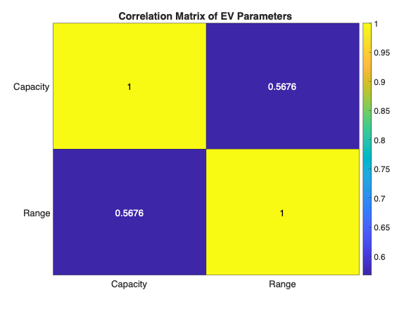
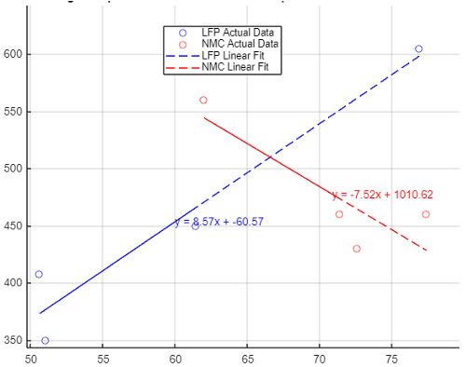
- Regression Correlation analysis of capacity and range
Figure 2 Correlation Regression analysis of capacity and range
(a) Correlation matrix, (b) Correlation regression
(a)
(b)

In general, Figure 2 show an increase in battery capacity usually goes hand in hand with an increase in the range of an electric vehicle. However, this correlation is not completely strong, indicating that other elements such as energy efficiency, vehicle condition and driving habits also play an important role in determining range. Nevertheless, the correlation values show that battery capacity remains the main factor to consider when seeking to improve the range performance of electric vehicles. The increase in battery capacity corresponds to the increased distance that an electric vehicle is capable of covering. This phenomenon applies to both types of batteries, where the increased capacity facilitates greater energy storage, thus enhancing the driving range. Regression analysis shows that the relationship between battery capacity and driving range can be effectively represented through a linear model, which states that increased battery capacity significantly increases driving range.

Figure 2. (a) shows correlation matrix between the two main parameters of electric vehicles, namely battery capacity and driving range. The dominant yellow color in the diagonal cells indicates a strong positive correlation between the two variables. The correlation coefficient value of 0.5676 strengthens these findings, indicating that the greater the battery capacity, the longer the electric vehicle can travel. Then figure 2. (b) visually shows the relationship between battery capacity and cruising range through a scatter plot and regression line. The regression lines for both battery types (LFP and NMC) show a similar trend to the correlation matrix results, namely a positive relationship between capacity and range. The LFP cell regression line has a flatter slope, indicating increasing capacity. The increase in range of LFP batteries is smaller than that of NMC batteries. Although the NMC battery regression line has a steeper slope, indicating that increasing NMC battery capacity can increase driving range more significantly, it can be said that the relationship between battery capacity and driving range is more complex for NMC batteries compared to LFP batteries. However, there is a relatively negative trend in the NMC curve, indicating that there are other factors to consider when designing electric vehicles using NMC batteries.

- Correlation analysis of capacity and charging time
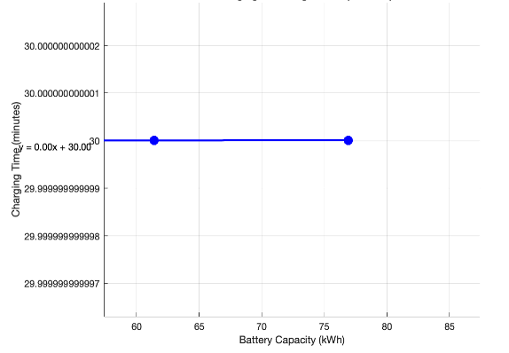
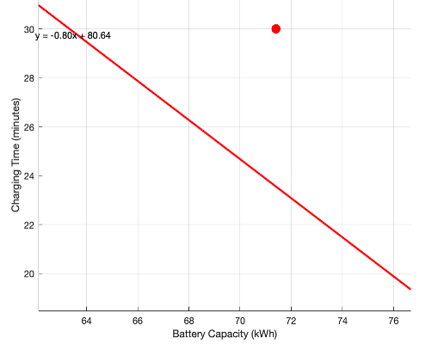
Figure 3 Correlation Regression analysis of capacity and charger time
(a) LFP, (b) MNC
(a)
(b)

Figure 3. shows that increasing battery capacity does not have a major impact on charging duration; therefore, it is important to consider additional elements, such as fast charging technology, to improve the charging time efficiency of electric vehicles. Furthermore, this analysis verifies that factors beyond battery capacity play a more significant role in determining charging time. Charging duration is also affected by battery capacity. Batteries with larger capacities generally require extended charging times, depending on the charging level used. The horizontal regression line in figure 3. (a) shows that there is no significant correlation between LFP battery capacity and charging time. This means that changes in battery capacity will not affect the time it takes for the battery to be fully charged. The LFP battery charging system can be optimized so that charging time remains relatively constant regardless of battery capacity. Figure 3(b) shows a downward sloping regression line, meaning that there is a negative correlation between NMC battery capacity and charging time. The larger the NMC battery capacity, the shorter the time it takes to fully charge. This may be because a ternary battery with a larger capacity may have a higher charging efficiency and so can be charged more quickly. Fast charging technology used in ternary batteries may be more effective if the capacity is larger, and batteries with larger capacities tend to have shorter charging times.
- Correlation analysis of range and charging time
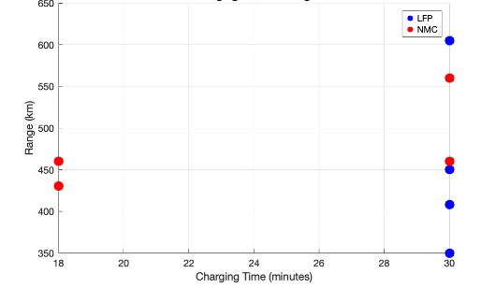
Figure 4 Correlation Regression analysis of range and charger time

Figure 4 shows a graph comparing the distance traveled by an electric vehicle versus the time it takes to charge the battery. The results show significant differences between lithium iron phosphate batteries and ternary batteries. LFP batteries do not show a clear correlation between driving distance and charging time, meaning charging time tends to be consistent regardless of driving distance. On the other hand, ternary batteries show a positive correlation, that is, the longer the distance traveled, the longer it takes to charge. This shows that vehicles with longer distances have larger batteries and require longer charging times. These findings have important implications for selecting electric vehicle battery types and planning charging infrastructure. Vehicles showing higher range may require long charging periods; However, with increased charging rates (as observed in NMC), users can reduce the time allocated for charging. Analysis reveals that, although NMC offers greater range, its accelerated charging duration makes it more practical for everyday use, especially in contexts where time efficiency is an important consideration. However, the charging efficiency may differ between LFP and NMC. In the empirical analysis, the NMC demonstrated a superior charging rate (20.86 km/min) compared to the LFP (15.11 km/min), implying that although the NMC potentially has a larger capacity, the charging duration may be more efficient relative to the LFP.

4. Conclusions
Electric vehicles with LFP batteries are more suitable for daily use where cost and long life are a priority, while NMC batteries are more suitable for high performance and long distances. Then the correlation results show a strong and significant relationship between parameters such as battery capacity, range, and charging time. Regression analysis provides numerical model that can predict the relationship between variables with good accuracy. From the results of the analysis, it can be concluded that 1) Correlation efficiency shows a positive relationship between battery capacity and distance traveled, this is proven by calculation with Pearson formula and MATLAB have same and positive value 0.576. 2) Relationship between battery capacity and charging time is very weak, correlation efficiency shows that an increase in battery capacity of 1 kWh will indicate that an increase in battery capacity will reduce the charging time by 0.0516 minutes. 3) Correlation efficiency shows Correlation between range and charging time for batteries LFP no relationship (charging time is constant) and for NMC batteries have positive relationship, meaning vehicles with longer charging times tend to have higher range. 4) The average energy efficiency for LFP batteries is 7.53 km/kWh, and NMC 6.84 km/kWh, this shows that LFP shows consistent performance regarding energy efficiency compared to NMC. Energy efficiency provides important insights into optimizing the energy use of electric vehicles. Thus, these results can be used for planning and developing more efficient electric vehicle battery systems. The combination of these statistical analyses provides a solid basis for decision making in future electric vehicle research and development.

References
[1] International Energy Agency (IEA), “Global EV Outlook 2021,” Global EV Outlook 2021, p. 101, 2021, [Online]. Available: https://iea.blob.core.windows.net/assets/ed5f4484-f556-4110-8c5c-4ede8bcba637/GlobalEVOutlook2021.pdf
[2] T. Gül, A. F. Pales, and E. Connelly, “Global EV Outlook 2024 Moving towards increased affordability,” Electric Vehicles Intitiative , p. 79, 2024, [Online]. Available: www.iea.org
[3] F. Alanazi, “Electric Vehicles: Beneﬁts Challenges and Potential Solutions,” Journal of Applied Scienc, vol. 13, pp. 1–23, 2023.
[4] AC Ventures, “Indonesia’s Electric Vehicle Outlook - Supercharging Tomorrow’s Mobility,” AC Ventures, no. July, 2023, [Online]. Available: https://acv.vc/wp-content/uploads/2023/07/Report-Indonesias-Electric-Vehicle-Outlook-Supercharging-Tomorrows-Mobility_NEW.pdf
[5] E. Yuliandari and L. N. Violie, “Electric Vehicle Policy Based on Juridical Foundation to Realize Environmental Resilience in Indonesia,” Proceedings of the International Conference For Democracy and National Resilience (ICDNR 2021), vol. 620, no. x, pp. 37–44, 2022, doi: 10.2991/assehr.k.211221.007.
[6] McKinsey Center for Future Mobility, “Making Electric Vehicles Profitable,” McKinsey & Company, no. March, 2019, [Online]. Available: https://www.mckinsey.com/~/media/McKinsey/Industries/Automotive and Assembly/Our Insights/Making electric vehicles profitable/Making-electric-vehicles-profitable.pdf
[7] M. A. Pradhana, “PENGISI DAYA BATERAI LiFePO4 SEBAGAI SUMBER ENERGI PADA SEPEDA LISTRIK,” Transient: Jurnal Ilmiah Teknik Elektro, vol. 11, no. 2, pp. 70–74, 2022, doi: 10.14710/transient.v11i2.70-74.
[8] R. O’Malley, L. Liu, and C. Depcik, “Comparative study of various cathodes for lithium ion batteries using an enhanced Peukert capacity model,” J Power Sources, vol. 396, no. February, pp. 621–631, 2018, doi: 10.1016/j.jpowsour.2018.06.066.
[9] S. Ohneseit et al., “Thermal and Mechanical Safety Assessment of Type 21700 Lithium-Ion Batteries with NMC, NCA and LFP Cathodes–Investigation of Cell Abuse by Means of Accelerating Rate Calorimetry (ARC),” Batteries, vol. 9, no. 5, 2023, doi: 10.3390/batteries9050237.
[10] L. V. Thomas, O. Schmidt, A. Gambhir, S. Few, and I. Staffell, “Comparative life cycle assessment of lithium-ion battery chemistries for residential storage,” J Energy Storage, vol. 28, no. June, 2020, doi: 10.1016/j.est.2020.101230.
[11] M. K. Tran, A. Dacosta, A. Mevawalla, S. Panchal, and M. Fowler, “Comparative study of equivalent circuit models performance in four common lithium-ion batteries: LFP, NMC, LMO, NCA,” Batteries, vol. 7, no. 3, Sep. 2021, doi: 10.3390/batteries7030051.
[12] B. Long, X. Gao, P. Li, and Z. Liu, “Multi-Parameter Optimization Method for Remaining Useful Life Prediction of Lithium-Ion Batteries,” IEEE Access, vol. 8, pp. 142557–142570, 2020, doi: 10.1109/ACCESS.2020.3011625.
[13] C. White, B. Thompson, and L. G. Swan, “Comparative performance study of electric vehicle batteries repurposed for electricity grid energy arbitrage,” Appl Energy, vol. 288, no. February, p. 116637, 2021, doi: 10.1016/j.apenergy.2021.116637.
[14] BYD, “BYD Han,” BYD Website. Accessed: Nov. 14, 2024. [Online]. Available: https:/www.byd.com/en/vehicles/han/specs
[15] Wuling, “Wuling Cloud Ev.” Accessed: Nov. 14, 2024. [Online]. Available: https://wuling.id/id/cloud-ev
[16] Chery International, “Chery Omoda 5.” Accessed: Nov. 14, 2024. [Online]. Available: https://www.cheryinternational.com/omoda5
[17] MG Motors, “MG 4.” Accessed: Nov. 14, 2024. [Online]. Available: https://www.mgmotors.id/mgmodels/mg4ev
[18] Hyundai, “Hyundai Ioniq 5.” Accessed: Nov. 14, 2024. [Online]. Available: https://www.hyundai.com/worldwide/en/eco/ioniq5/specs
[19] KIA, “KIA Ev 7.” Accessed: Nov. 14, 2024. [Online]. Available: https://www.kia.com/uk/new-cars/7-seat-family-electric-cars/
[20] Tesla, “Tesla Model 3.” Accessed: Nov. 14, 2024. [Online]. Available: https://www.tesla.com/model3
[21] Toyota, “Toyota bz4x.” Accessed: Nov. 14, 2024. [Online]. Available: https://www.toyota.com/bz4x/

APPENDIX
% Statistical Analysis of Electric Vehicles (LFP vs NMC)
%% Input Data
% LFP Vehicles Data
lfp_models = {'BYD Han', 'Wuling Cloud EV', 'Chery Omoda 5', 'MG 4 EV'};
lfp_capacity = [76.9, 50.6, 61.4, 51.0]; % kWh
lfp_range = [605, 408, 450, 350]; % km
lfp_charging = [30, 30, 30, 30]; % minutes

% NMC Vehicles Data
nmc_models = {'Hyundai Ioniq 5', 'KIA EV 7', 'Tesla Model 3', 'Toyota bZ4x'};
nmc_capacity = [72.6, 77.4, 62.0, 71.4]; % kWh
nmc_range = [430, 460, 560, 460]; % km
nmc_charging = [18, 18, 30, 30]; % minutes

%% 1. Correlation Analysis
% Combine data for correlation analysis
all_capacity = [lfp_capacity nmc_capacity];
all_range = [lfp_range nmc_range];

% Calculate correlation matrix
corr_matrix = corr([all_capacity' all_range']);

% Visualize correlation matrix
figure('Position', [100, 100, 800, 600]);
heatmap({'Capacity', 'Range'}, ...
{'Capacity', 'Range'}, ...
corr_matrix, 'Colormap', jet);
title('Correlation Matrix of EV Parameters');

%% 2. Regression Analysis
% Figure for capacity vs range regression
figure('Position', [100, 100, 1200, 400]);

% LFP Regression
subplot(1,2,1);
mdl_lfp = fitlm(lfp_capacity, lfp_range);
scatter(lfp_capacity, lfp_range, 100, 'filled', 'b');
hold on;
x_lfp = linspace(min(lfp_capacity), max(lfp_capacity), 100);
y_lfp = mdl_lfp.Coefficients.Estimate(1) + mdl_lfp.Coefficients.Estimate(2) * x_lfp;
plot(x_lfp, y_lfp, 'b-', 'LineWidth', 2);
xlabel('Battery Capacity (kWh)');
ylabel('Range (km)');
title(['LFP Regression (R² = ' num2str(mdl_lfp.Rsquared.Ordinary, '%.3f') ')']);
grid on;
text(min(lfp_capacity), max(lfp_range), ...
sprintf('y = %.2fx + %.2f', mdl_lfp.Coefficients.Estimate(2), ...
mdl_lfp.Coefficients.Estimate(1)), ...
'VerticalAlignment', 'top');

% NMC Regression
subplot(1,2,2);
mdl_nmc = fitlm(nmc_capacity, nmc_range);
scatter(nmc_capacity, nmc_range, 100, 'filled', 'r');
hold on;
x_nmc = linspace(min(nmc_capacity), max(nmc_capacity), 100);
y_nmc = mdl_nmc.Coefficients.Estimate(1) + mdl_nmc.Coefficients.Estimate(2) * x_nmc;
plot(x_nmc, y_nmc, 'r-', 'LineWidth', 2);
xlabel('Battery Capacity (kWh)');
ylabel('Range (km)');
title(['NMC Regression (R² = ' num2str(mdl_nmc.Rsquared.Ordinary, '%.3f') ')']);
grid on;
text(min(nmc_capacity), max(nmc_range), ...
sprintf('y = %.2fx + %.2f', mdl_nmc.Coefficients.Estimate(2), ...
mdl_nmc.Coefficients.Estimate(1)), ...
'VerticalAlignment', 'top');

%% 3. Battery Capacity vs Charging Time
% Scatter plot for LFP and NMC
figure('Position', [100, 100, 1200, 400]);

% LFP Analysis
subplot(1,2,1);
mdl_lfp_charging = fitlm(lfp_capacity, lfp_charging);
scatter(lfp_capacity, lfp_charging, 100, 'filled', 'b');
hold on;
x_lfp_charging = linspace(min(lfp_capacity), max(lfp_capacity), 100);
y_lfp_charging = mdl_lfp_charging.Coefficients.Estimate(1) + mdl_lfp_charging.Coefficients.Estimate(2) * x_lfp_charging;
plot(x_lfp_charging, y_lfp_charging, 'b-', 'LineWidth', 2);
xlabel('Battery Capacity (kWh)');
ylabel('Charging Time (minutes)');
title(['LFP Charging Time Regression (R² = ' num2str(mdl_lfp_charging.Rsquared.Ordinary, '%.3f') ')']);
grid on;
text(min(lfp_capacity), max(lfp_charging), ...
sprintf('y = %.2fx + %.2f', mdl_lfp_charging.Coefficients.Estimate(2), ...
mdl_lfp_charging.Coefficients.Estimate(1)), ...
'VerticalAlignment', 'top');

% NMC Analysis
subplot(1,2,2);
mdl_nmc_charging = fitlm(nmc_capacity, nmc_charging);
scatter(nmc_capacity, nmc_charging, 100, 'filled', 'r');
hold on;
x_nmc_charging = linspace(min(nmc_capacity), max(nmc_capacity), 100);
y_nmc_charging = mdl_nmc_charging.Coefficients.Estimate(1) + mdl_nmc_charging.Coefficients.Estimate(2) * x_nmc_charging;
plot(x_nmc_charging, y_nmc_charging, 'r-', 'LineWidth', 2);
xlabel('Battery Capacity (kWh)');
ylabel('Charging Time (minutes)');
title(['NMC Charging Time Regression (R² = ' num2str(mdl_nmc_charging.Rsquared.Ordinary, '%.3f') ')']);
grid on;
text(min(nmc_capacity), max(nmc_charging), ...
sprintf('y = %.2fx + %.2f', mdl_nmc_charging.Coefficients.Estimate(2), ...
mdl_nmc_charging.Coefficients.Estimate(1)), ...
'VerticalAlignment', 'top');

%% Statistical Tests and Metrics
fprintf('\nStatistical Analysis Results:\n');

% Correlation Analysis Summary
fprintf('\n1. Correlation Analysis:');
fprintf('\nCapacity-Range Correlation: %.3f', corr_matrix(1,2));

% Regression Analysis Summary
fprintf('\n\n2. Regression Analysis:');
fprintf('\nLFP Range-Capacity Model:');
fprintf('\n R-squared: %.3f', mdl_lfp.Rsquared.Ordinary);
fprintf('\n p-value: %.4f', mdl_lfp.Coefficients.pValue(2));
fprintf('\nNMC Range-Capacity Model:');
fprintf('\n R-squared: %.3f', mdl_nmc.Rsquared.Ordinary);
fprintf('\n p-value: %.4f', mdl_nmc.Coefficients.pValue(2));

% Performance Metrics Summary
fprintf('\n\n3. Performance Metrics:');
fprintf('\nEnergy Efficiency (km/kWh):');
fprintf('\nRange (km):');
fprintf('\n LFP Mean: %.2f, Std: %.2f', mean(lfp_range), std(lfp_range));
fprintf('\n NMC Mean: %.2f, Std: %.2f', mean(nmc_range), std(nmc_range));

% Statistical Analysis Summary
fprintf('\n4. Battery Capacity vs Charging Time Analysis:');
fprintf('\nLFP Regression Model:');
fprintf('\n R-squared: %.3f', mdl_lfp_charging.Rsquared.Ordinary);
fprintf('\n p-value: %.4f', mdl_lfp_charging.Coefficients.pValue(2));
fprintf('\nNMC Regression Model:');
fprintf('\n R-squared: %.3f', mdl_nmc_charging.Rsquared.Ordinary);
fprintf('\n p-value: %.4f', mdl_nmc_charging.Coefficients.pValue(2));

