THE INFLUENCE OF FINANCIAL LITERACY AND FINANCIAL BEHAVIOR ON INVESTMENT DECISION

Rifqi Kurnia Nugraha¹, Arlina Putri Eksanti², Yustus Odema Haloho³

¹⁾ rifqikurnia65@gmail.com, Faculty of Economics & Business, Universitas Mercu Buana, Jakarta, Indonesia
²⁾ yustushaloho98@gmail.com, Faculty of Economics & Business, Universitas Mercu Buana, Jakarta, Indonesia
³⁾ arlinaputri131@gmail.com, Faculty of Economics & Business, Universitas Mercu Buana, Jakarta, Indonesia

Article Informatin:  Keywords:  Financial Literacy  Financial Behavior  Investment Decision  Article History:  Received : December 19, 2021  Revised : December 24, 2021  Accepted : December 27, 2021  Article Doi:  http://doi.org/10.22441/profita.2020.v13i1.001 | Abstract  Abstract. This research is a quantitative research which aims to determine the effect of financial literacy and financial behavior on investment decisions. The population in this study were active students at Mercu Buana University, Jakarta. The sample is 43 respondents. Non-probability sampling method, purposive sampling. Data collection is done by distributing questionnaires to a predetermined sample via google form. The data analysis technique used the PLS (Partial Least Square) analysis method with SmartPLS 3.0 software. The results of this study indicate that: (1) Financial literacy has an influence on investment decisions with a path coefficient value of 0.338 (2) Financial behavior has an influence on investment decisions with a path coefficient value of 0.509.

INTRODUCTION
The capital market is a place used by investors and issuers in buying and selling bonds, stocks, mutual funds, and other instruments in the long term. The existence of the capital market as a place to make guaranteed investments provides benefits for investors to invest their capital. Investment is placing funds in the present hoping to get a profit in the future (Fridana & Asandimitra, 2020; Risman et al. 2017). Investment activity in Indonesia is always increasing. This is due to the promising profit opportunities on investment in the capital market. Investment is a commitment to a number of funds or other resources made at this time to gain profits in the future (Tandelilin, 2010 in Mutawally and Asandimitra, 2019).
Stock trading in Indonesia has increased from year to year. The number of stock investors referring to the Single Investor Identification (SID) as of August 31, 2021 has reached 2,697,832. This achievement is the highest record in history and is a tribute to 44 Years of Reactivation of the Indonesian Capital Market (idxchannel.com). This means that investment in the capital market, especially stock investment in Indonesia, is one of the things that people are interested in. Because of the high interest in investing in the community, this has attracted previous researchers to examine the factors that influence investment decisions.
According to Landang et al (2021) Financial literacy is a basic need that must be owned by everyone in order to avoid financial problems. Financial literacy and life are two components that cannot be separated because these components are the basic components that form the basis for individual decision making in financial management. A good financial understanding will make someone good at making decisions and vice versa. This result is supported by the research of Putri & Hamidi (2019)., Safryani, Aziz & Triwahyuningtyas (2020) stated that it has a positive influence on investment decisions. In contrast to the research conducted by Khairunizam and Isbanah (2019), Mutawally & Asandimitra (2019), the results of financial literacy have no effect on investment decisions.
According to Suryanto (2017) anda Risman et al (2021) financial behavior is a pattern of a person's habits and behavior when managing his personal finances. Every individual will always be faced with the problem of how much money is received and spent. And according to Risman et al (2021) behavioral finance seeks to explain and increase understanding of the mindset of investors, including the emotional processes involved and the extent to which they influence the decision-making process as well as financial behavior to explain the what, why, and how of finance and investment, from the perspective of investors. This result is supported by research by Baiq Fitriarianti (2018), Upadana & Herawati (2020) which states that it has a positive influence on investment decisions. In contrast to the research conducted by Safryani et al (2020), the results of financial behavior do not affect investment decisions.
Financial management plays a role and affects the fulfillment of human needs and desires. If someone manages finances well, their needs and desires will be fulfilled (Rahman & Risman, 2021). This study was conducted to determine the effect of financial literacy, financial behavior on investment decisions. So the formulation of the problem in this study is whether financial literacy, financial behavior affect investment decisions.

LITERATURE REVIEW
Financial Literacy
According to Rahman & Risman (2021) and the Program for International Student Assessment or PISA (2015) in Khairiyati (2019) defines financial literacy as knowledge and understanding of financial concepts and risks, along with the skills, motivation, and confidence to apply the knowledge and understanding they have in order to make financial decisions. effectively, improve the financial well-being of individuals and society, and participate in the economy. Knowledge, skills, and beliefs, which influence attitudes and behavior to improve the quality of decision making and financial management in order to achieve prosperity (OJK, 2017).

Financial Behavior
Financial behavior according to Sukandani et al (2019) states a theory that focuses on the psychological influence of investors in making financial decisions and the investor market sometimes makes a decision when market conditions are full of uncertainty. Meanwhile, Nofsinger (2001) in Upadana (2020) states that the definition of financial behavior is a science that observes how an individual behaves when making decisions, one of which is financial decisions. This understanding explains that there is a person's psychological influence when making investment decisions. It can be seen that financial behavior is a response from individuals regarding financial information.

Investation Decision
According to Risman et al (2017) and Rusdin (2006) in Fitriarianti (2018), investment decisions are individual and depend entirely on independent individuals. Therefore, before arriving at an investment decision, consider it carefully. In the context of investment decisions, a decision maker who receives negative feedback on previous investment decisions will be in a position or condition of loss, and will view the next decision as a choice between a definite loss that has already occurred (ie choosing not to continue the action to increase investment) and a loss in an uncertain future, namely taking the risk of adding funds in the hope of getting a positive return (Manurung, 2012 in the journal Arianti, 2020).

Hypothesis
H1 : Financial Literacy affects the investment decisions of Mercu Buana University students, Jakarta.
H2 : Financial Behavior influences investment decisions of Mercu Buana University students, Jakarta.

Conceptual Framework
Figure 1. Conceptual Framework
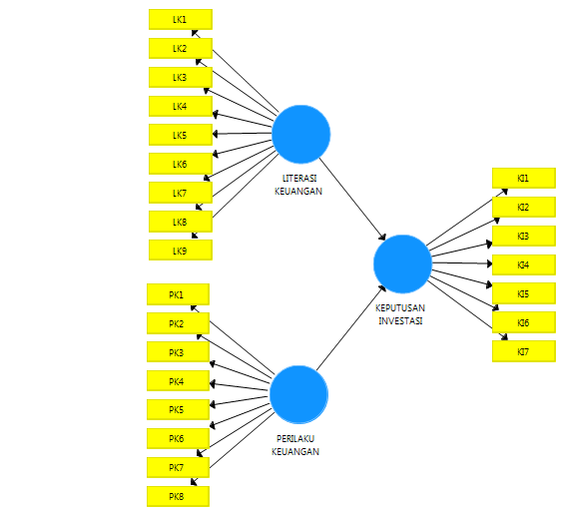

Source: Data processed via SmartPLS 3.0 (2021)

METHODOLOGY

Operational Definition
- Investment Decision (Y)
Investment decisions have the meaning of an action that is taken by someone in the present which is projected in the future in order to get a profit.
- Financial Literacy (X1)
Financial literacy is knowledge of finance in terms of financial institutions and financial concepts as a whole, as well as the ability to utilize financial products and manage personal finances in order to make short-term and long-term decisions.
- Financial Behavior (X2)
Financial behavior is a form of combining aspects of one's financial ability and psychological ability in managing and utilizing financial resources as a basis for making decisions for daily needs and financial planning in the future, or business activities owned.

Population of research
The population in this study were all active students at Mercu Buana University, Jakarta.
Sample of research
This research uses non-probability sampling technique with purposive sampling model. Non-probability sampling technique is a method related to taking a sample in a population by giving different opportunities or opportunities for each element of the population which will then be used. Purposive sampling was chosen as a sampling method, where this method is based on certain considerations in the selection of samples to be taken and used in research for certain efforts to be achieved.

Sample of research
This research uses non-probability sampling technique with purposive sampling model. Non-probability sampling technique is a method related to taking a sample in a population by giving different opportunities or opportunities for each element of the population which will then be used. Purposive sampling was chosen as a sampling method, where this method is based on certain considerations in the selection of samples to be taken and used in research for certain efforts to be achieved.

Data Collection Technique

Table 1. Likert Scale
Score | Question | Definition
5 | SA | Strongly Agree
4 | A | Agree
3 | NAND | Neither Agree Nor Disagree
2 | D | Disagree
1 | SD | Strongly Disagree
Source: made by the authors (2021)
The type of data used in this study is primary data, the data obtained directly through the distribution of questionnaires to all active students at the University of Mercu Buana Jakarta.

Data Analysis Techniques
In this study, the data analysis techniques used were descriptive data analysis and data analysis with PLS software.

Descriptive Data Analysis
Descriptive analysis is used to determine the respondents' description of financial literacy, financial behavior and investment decisions, based on the frequency distribution of respondents' answers and responses to the statements in the questionnaire.

Table 2. Average Categorization of Respondents' Assessment Score
Average Score | Criteria
1,00 – 1,80 | Very Low/Very Poor
1,81 – 2,60 | Low/Poor
2,61 – 3,40 | Enough/Medium
3,41 – 4,20 | High/Good
4,21 – 5,00 | Very High/Very Good
Source: made by the authors (2021)
Partial Least Square (PLS)
Partial Least Square is a Component analysis method or Variance Based Structural Equation Modeling where the data processing uses the Partial Least Square (Smart-PLS) version 3.0 program. PLS (Partial Least Square) is an alternative model of covariance based SEM. PLS is intended for causal-perdictive analysis in situations of high complexity and low theoretical support (Ghozali, 2014).

RESULTS AND DISCUSSION
Descriptive Data Analysis
The following are the results of the calculation of the answer index given by the respondents regarding the responses to the questions that have been submitted through the research questionnaire:
Table 3. Results of Respondents' Responses to Financial Literacy Variables
Financial Behavior (X₁) | Respondent's Answer Category |  |  |  |  | Average | Respondent Assessment Criteria 5
 | 1 | 2 | 3 | 4 | 5
LK1 | 0 | 0 | 2 | 12 | 29 | 4,63 | Very Good
LK2 | 0 | 0 | 1 | 15 | 27 | 4,60 | Very Good
LK3 | 0 | 0 | 4 | 21 | 18 | 4,33 | Very Good
LK4 | 0 | 0 | 5 | 14 | 24 | 4,44 | Very Good
LK5 | 0 | 2 | 11 | 17 | 13 | 3,95 | Good
LK6 | 0 | 5 | 15 | 20 | 3 | 3,49 | Good
LK7 | 0 | 1 | 9 | 17 | 16 | 4,12 | Good
LK8 | 0 | 1 | 19 | 14 | 9 | 3,72 | Good
LK9 | 0 | 1 | 8 | 16 | 18 | 4,19 | Good
Source: made by the authors (2021)

- Index analysis of respondents' answers to financial literacy
In this variable, the highest index value is found in LK1 questions (financial knowledge is very important for one's welfare and success both now and in the future) of 4.63 and has the most results with a score of 5 respondents' answers (Strongly Agree) as many as 29 respondents. Meanwhile, the lowest index value on LK6 questions (My knowledge is sufficient about finances so that it avoids financial doubts) is 3.49 and has the highest number of answers with a score of 4 (Agree) as many as 20 respondents. So it can be concluded that respondents have a high perception of each item of financial literacy.
Table 4. Results of Respondents' Responses to Financial Behavior Variables
Financial Behavior (X₂) | Respondent's Answer Category |  |  |  |  | Average | Respondent Assessment Criteria 5
 | 1 | 2 | 3 | 4 | 5
PK1 | 0 | 1 | 3 | 23 | 16 | 4,26 | Very Good
PK2 | 0 | 0 | 11 | 20 | 12 | 4,02 | Good
PK3 | 0 | 1 | 5 | 14 | 23 | 4,37 | Very Good
PK4 | 0 | 2 | 7 | 22 | 12 | 4,02 | Good
PK5 | 0 | 1 | 7 | 25 | 10 | 4,02 | Good
PK6 | 0 | 0 | 14 | 19 | 10 | 3,91 | Good
PK7 | 0 | 0 | 4 | 14 | 25 | 4,49 | Very Good
PK8 | 0 | 0 | 6 | 14 | 23 | 4,40 | Very Good
Source: made by the authors (2021)

- Index analysis of respondents' answers to financial behavior
In this variable, the highest index value is found in the question item PK7 (I will still pay taxes even though the people around me do not pay taxes) of 4.49 and have the most results with a score of 5 respondents' answers (Strongly Agree) as many as 25 respondents. Meanwhile, the lowest index value in question item PK6 (I always try to maintain adequate insurance coverage) is 3.91 and has the highest number of answers with a score of 4 (Agree) with 25 respondents. So it can be concluded that respondents have a high perception of each item of financial behavior.

Table 5. Results of Respondents' Responses to Investment Decision Variables
Investation Decision (Y) | Respondent's Answer Category |  |  |  |  | Average | Respondent Assessment Criteria 5
 | 1 | 2 | 3 | 4 | 5
KI1 | 0 | 0 | 6 | 18 | 19 | 4,30 | Very Good
KI2 | 0 | 0 | 14 | 19 | 10 | 3,91 | Good
KI3 | 0 | 0 | 10 | 17 | 16 | 4,14 | Good
KI4 | 0 | 1 | 4 | 23 | 15 | 4,21 | Very Good
KI5 | 0 | 0 | 5 | 20 | 18 | 4,30 | Very Good
KI6 | 0 | 0 | 3 | 21 | 19 | 4,37 | Very Good
KI7 | 0 | 0 | 6 | 20 | 17 | 4,26 | Very Good
Source: made by the authors (2021)

- Index analysis of respondents' answers to investment decisions
In this variable, the highest index value is found in the question item KI6 (I believe the capital market will develop a lot) of 4.37 and has the most results with a score of 4 respondents' answers (Agree) as many as 21 respondents. Meanwhile, the lowest index value in the KI2 question item (I think the investment that has the greatest risk is the money market) of 3.91 and has the highest number of answers with a score of 4 (Agree) as many as 19 respondents. So that it can be concluded that the respondents' perception is high on the question item on the investment decision variable.

Figure 2. Outer Model
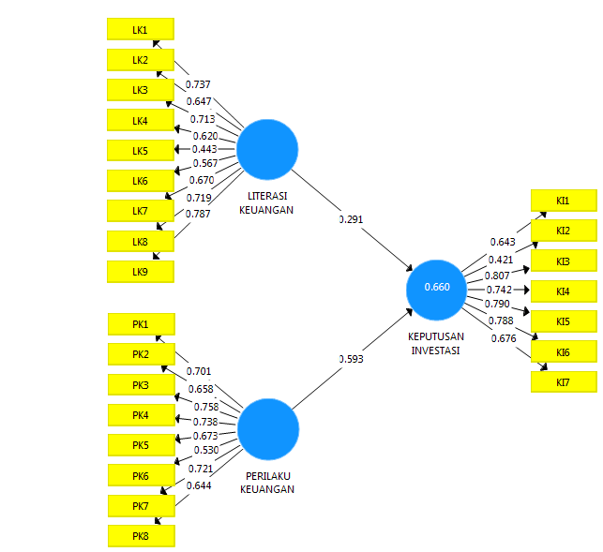
Source: Data processed via SmartPLS 3.0 (2021)

Figure 3. Outer Model After Re-estimation
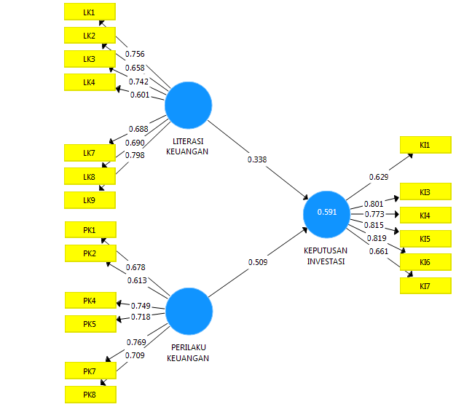
Source: Data processed via SmartPLS 3.0 (2021)

Data Analysis and Hypothesis Testing
According to Chin in Ghozali (2014), an indicator is said to have good reliability if its value is greater than 0.70, while a loading factor of 0.50 to 0.60 can be considered sufficient. LK5 which has a value of 0.443 and KI2 which has a value of 0.421 so that the results of the response are deleted and no longer used.
Based on the results in Figure 3, it can be concluded that all indicators are said to be valid and the data has been reprocessed by removing invalid indicators. So, it can be seen that the entire correlation value is the factor loading value of more than 0.50.

Discriminant Validity Test

Table 6. Average Variance Extracted (AVE)
Description | AVE
Investation Decision (Y) | 0.568
Financial Literacy (X1) | 0.500
Financial Behavior (X2) | 0.501
Source: Output Results SmartPLS 3.0 (2021)
The AVE value is above 0.50 and is considered valid. The highest value of AVE is the investment decision variable, which is 0.568, while the lowest value of AVE is the financial literacy variable of 0.500.

Reliability Test

Table 7. Composite Reliability and Cronbach’s Alpha
Variable | Composite Reliability | Cronbach’s Alpha
Investation Decision (Y) | 0.886 | 0.845
Financial Literacy (X1) | 0.874 | 0.832
Financial Behavior (X2) | 0.857 | 0.801
Source: Output Results SmartPLS 3.0 (2021)
The value of the variables in composite reliability and Cronbach's alpha is more than 0.7, which means that the construct has good reliability or the questionnaire used as a tool in this study is reliable or consistent.

R-Square
Table 8. R-Square
Variable | R-Square
Investation Decision (Y) | 0.591
Source: Output Results SmartPLS 3.0 (2021)
Based on the results of the value of R-Square (R2) the investment decision is 0.591. So it can be assumed that financial literacy and financial behavior contribute 59.1% to investment decisions and the remaining 40.9% explains that there is an influence on investment decisions by other variables or factors.

Hypothesis Test and T-Statistic Test
The results of the significance of the parameter coefficients can be calculated from the indicators that have been valid. To find out whether it is significant or not, it can be seen from the T-table at alpha 0.05 (5%) = 1.96, then the T-table is compared by T-count (T-statistics).

Table 9. Path Coefficients
Construct | Original Sample (O) | Sample Mean (M) | Standard Deviation (STDEV) | T Statistics (|O/STDEV|) | P Values
Financial Literacy -> Investation Decision | 0.338 | 0.347 | 0.136 | 2.494 | 0.013
Financial Behavior -> Investation Decision | 0.509 | 0.523 | 0.117 | 4.346 | 0.000
Source: Output Results SmartPLS 3.0 (2021)
The results of the original sample on the Financial Literacy variable according to the table above are 0.338 and Financial Behavior is 0.509. The results of the original sample for both variables are positive, in this case the results of the original sample are not negative. Based on Table 9 above, it shows that the financial literacy variable has a T-statistic of 2.494 (> 1.96) and a significance value (P Values) of 0.013 (< 0.05) and shows Ho is rejected and Ha is accepted. So financial literacy is concluded to have a positive and significant effect on investment decisions.
The table above shows that the financial behavior variable has a T-statistic of 4.346 (> 1.96) and a significance value (P Values) of 0.000 (< 0.005) and shows Ho is rejected and Ha is accepted. Therefore, financial behavior has a positive and significant impact on investment decisions.

Figure 4. Inner Model
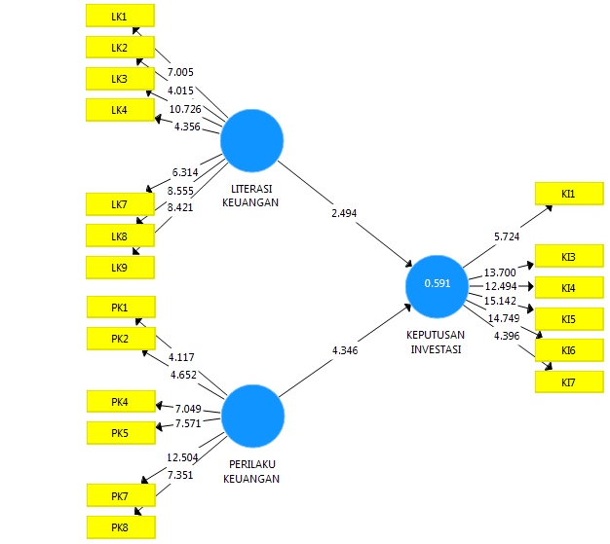
Source: Data processed via SmartPLS 3.0 (2021)

DISCUSSION
The Influence of Financial Literacy on Investment Decisions
Based on the results of research that has been carried out between the attachment of the two variables, the value of the financial literacy path coefficient on investment decisions is 0.338 and the T-Statistic test shows a value of 2.494 (> 1.96) and a significance value (P Values) of 0.013 (< 0.05 ). This shows that the financial literacy variable has a significant effect on investment decisions for all active students at Mercu Buana University, Jakarta. This means that in this case the indicators contained in financial literacy have contributed enough as their role to influence investment decisions. Thus, it can be interpreted that financial literacy has a significant positive influence on investment decisions or in other words H1 is accepted. These results support and are in line with the research hypothesis.
This research is in line with Safryani et al (2020)., Khairunizam., & Isbanah, Y. (2019)., Putri & Hamidi (2019)., Kumari (2020)., Kumala (2019)., which in their research concluded that financial literacy variable has a significant influence on investment decisions. So the results of this study are in accordance with the hypothesis that has been made, namely financial literacy affects investment decisions of Mercu Buana University students, Jakarta.
The Influence of Financial Behavior on Investment Decisions
Based on the results of research that has been carried out between the attachment of the two variables, the value of the path coefficient of financial behavior on investment decisions is 0.509 and the T-Statistic test shows a value of 4.346 (> 1.96) and a significance value (P Values) 0.000 (<0.05 ). This shows that the financial behavior variable has a significant effect on investment decisions for all active students at Mercu Buana University, Jakarta. This means that in this case the indicators contained in financial behavior, namely Financial Planning, Financial Management, contribute to their role in influencing investment decisions. Thus, it can be interpreted that financial behavior affects investment decisions or in other words H2 is accepted. The results of this study support the initial hypothesis proposed in this study, namely that financial behavior affects investment decisions.
This study is in line with Upadana & Herawati (2020)., Fitriarianti (2018)., Arianti (2018)., Sukandani et al. (2019)., Putri (2021) who in their research conclude that financial behavior variables have a significant influence on investment decisions. . So the results of this study are in accordance with the hypothesis that has been made, namely financial behavior affects investment decisions of Mercu Buana University students, Jakarta.
CONCLUSION
Through this research, the researcher intends to find out about the influence of financial literacy and financial behavior on the investment decisions of Mercu Buana University students, Jakarta. Based on the results of data processing along with the analysis and discussion that has been carried out in this study, conclusions can be drawn, namely:
- Financial literacy has a positive influence on the investment decisions of Mercu Buana University students, Jakarta.
- Financial behavior has a positive influence on investment decisions of Mercu Buana University students, Jakarta.
REFERENCE
Arianti, B. F. (2018). The influence of financial literacy, financial behavior and income on investment decision. EAJ (Economic and Accounting Journal), 1(1), 1-10.
Fitriarianti, B. (2018, February). Pengaruh literasi keuangan, perilaku keuangan dan pendapatan terhadap keputusan berinvestasi. In Proseding Seminar Nasional Akuntansi (Vol. 1, No. 1).
Fridana, I. O., & Asandimitra, N. (2020). Analisis Faktor Yang Memengaruhi Keputusan Investasi (Studi Pada Mahasiswi Di Surabaya). Jurnal Muara Ilmu Ekonomi Dan Bisnis, 4(2), 396-405.
Ghozali, Imam. 2014. Structural Equation Modeling, Metode Alternatif dengan Partial Least Square (PLS). Edisi 4. Semarang : Badan Penerbit Universitas Diponegoro.
Khairunizam, & Isbanah, Y. (2019). Pengaruh Financial Literacy Dan Behavioral Finance Factors Terhadap Keputusan Investasi (Studi Terhadap Investor Saham Syariah Pada Galeri Investasi Syariah Uin Sunan Ampel Surabaya). Jurnal Ilmu Manajemen (JIM), 7(2).
Kumala, A. N., & Susanti. (2019). Pengaruh Pembelajaran Manajemen Keuangan, Literasi Keuangan, dan Risk Finance Terhadap Perilaku Berinvestasi Mahasiswa Fakultas Ekonomi Universitas Negeri Surabaya. Jurnal Pendidikan Akuntansi. Vol 07, No. 02, 07(02), 197–203
Kumari, D. T. (2020). The Impact of Financial Literacy on Investment Decisions: With Special Reference to Undergraduates in Western Province, Sri Lanka. Asian Journal of Contemporary Education, 4(2), 110-126.
Landang, R. D., Widnyana, I. W., & Sukadana, I. W. (2021). Pengaruh Literasi Keuangan, Perilaku Keuangan Dan Pendapatan Terhadap Keputusan Berinvestasi Mahasiswa Fakultas Ekonomi Universitas Mahasaraswati Denpasar. EMAS, 2(2), 51-70.
OJK. (2017). Strategi Nasional Literasi Keuangan Indonesia (Revisit 2017). Otoritas Jasa Keuangan, 1–99.
Putri, L. P. (2021, August). Pengaruh Literasi Keuangan Terhadap Keputusan Investasi Melalui Perilaku Keuangan Sebagai Variabel Moderating. In Seminar Nasional Teknologi Edukasi Sosial dan Humaniora (Vol. 1, No. 1, pp. 772-778).
Putri, W. W., & Hamidi, M. (2019). Pengaruh literasi keuangan, efikasi keuangan, dan faktor demografi terhadap pengambilan keputusan investasi (studi kasus pada mahasiswa magister manajemen fakultas ekonomi universitas andalas padang). Jurnal Ilmiah Mahasiswa Ekonomi Manajemen, 4(1), 210-224.
Risman, A., Subhani, M., & Ushakov, D. (2021). Nexus between Financial Fundamentals and Automotive (Car) Industry. ARDL approach. E3S Web of Conferences, 244.
Risman, A & Salim, U & Sumiati, Sumiati & Indrawati, Lina. (2017). Commodity prices, exchange rates and investment on firm's value mediated by business risk: A case from Indonesian stock exchange. European Research Studies Journal, 20: 511-524.
Risman, A., Prowanta, E. & Siswanti, I. (2021). Behavioral Corporate Finance. Yogyakarta: Penerbit KBM Indonesia..
Safryani, U., Aziz, A., & Triwahyuningtyas, N. (2020). Analisis Literasi Keuangan, Perilaku Keuangan, Dan Pendapatan Terhadap Keputusan Investasi. Jurnal Ilmiah Akuntansi Kesatuan, 8(3), 319-332.
Sukandani, Y., Istikhoroh, S., & Waryanto, R. B. D. (2019). Behavioral Finance Pada Proses Pengambilan Keputusan Investasi. SNHRP, 150-156.
Suryanto. (2017). Pola Perilaku Keuangan Mahasiswa Di Perguruan Tinggi. Jurnal Ilmu Politik Dan Komunikasi, VII(1), 11–20.
Upadana, I. W. Y. A., & Herawati, N. T. (2020). Pengaruh Literasi Keuangan dan Perilaku Keuangan Terhadap Keputusan Investasi Mahasiswa. Jurnal Ilmiah Akuntansi dan Humanika, 10(2), 126-135.

