The Effect Of Financial Literature, Financial Behavior, & Regret Aversion Bias On Millennial Investment Decisions
Anita Dwi Octavia ¹⁾; Chyntia Chris Yuwono ²⁾; Filia Gabrilia Monangin ³⁾
¹⁾ Anitadwioctavia@yahoo.com, Economy and Business, Mercu Buana University, Indonesia
²⁾ Chyntiac28@gmail.com, Economy and Business, Mercu Buana University, Indonesia
³⁾ Filiagabrilia10@gmail.com, Economy and Business, Mercu Buana University, Indonesia

Article Information:  Keywords:  financial literacy, financial behaviour, regret aversion bias, investment decisions.  Article History:  Received : April 19, 2022  Revised : April 26 2022  Accepted : May 06, 2022  Article Doi: | Abstract  This study aimed to analyze the effects of financial literacy, financial behaviour and regret Aversion bias towards investment decisions among millennials in Indonesia. This study used primary data obtained by distributing questionnaires to 113 respondents with Maximum age of 30 years. The sampling method used in this research is purposive sampling. There were 78 out of 113 respondents who met the criteria to be sampled. The analysis method used in this study is Partial Least Square (PLS), with an R² value of 98.50%. The results showed that financial behaviour had a significant positive effect on investment decisions while financial literacy and regret aversion bias were not affected.

INTRODUCTION
During the COVID-19 pandemic, investment interest in Indonesia is growing. This situation is reflected in the number of investors that continues to increase over time. Financial Services Authority (OJK) noted that the number of investors in the capital market increased tremendously, by 96 per cent annually or year on year (YoY), reached 5.6 million in June 2021. From this number, as much as 70 per cent was dominated by retail investors from millennials (OJK, 2021). Similar conditions also occurred in the mutual fund industry. Even the growth trend from year to year is quite significant.
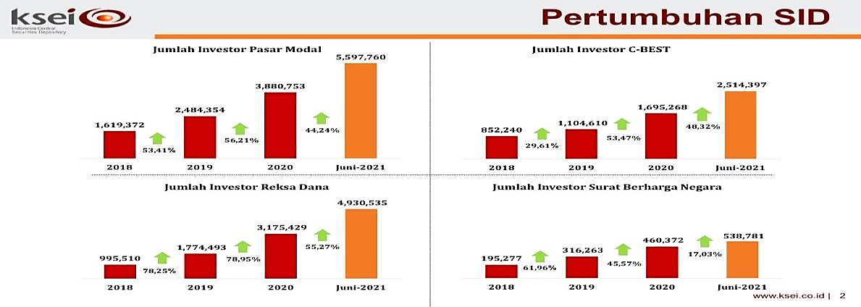

Figure 1 Growth of Single Investor Identification (SID)
Source: KSEI (2021)
Referring to the Indonesian Central Securities Custodian (KSEI) data above, in 2020, the number of 3.88 million investors rose to 5.59 million investors or up by 44.24% in the middle of 2021. In addition, the number of government securities investors in the middle of the year 2021 also increased by 48.32% compared to 2020. Based on KSEI data in terms of investor demographics, 58.38% of investors are under 30. Not just According to OJK, 70% of investors are dominated by millennials (KSEI, 2021).
Currently, in the middle of the pandemic, millennials can have a high income that can be done at home by investing. By making investments, their money will turnover and make a profit. Investing can be the main alternative to save money for millennials. The development of technology provides convenience for millennials to virtually invest their capital without coming directly to the issuer company (securities issuer) or stock exchange office.
Investment decisions among millennials are influenced by many factors, including government intervention that continues to educate the public about investment, one of their methods to educate the public by improving financial literacy. Financial literacy is essential for investors who become followers in the capital market to protect investors from illegal investments and mitigate investments that are only oriented to high short-term profits without considering the risks, aspects of product legality, and aspects of the fairness of the offer. Financial literacy has an important role and contributes to making investment decisions for both individuals and corporations. Alifah and Dalimunthe (2020) stated that financial literacy has a positive influence on investment decisions, while Gunawan (2020) noted that financial literacy negatively affects investment management, while Arianti (2018) stated that financial literacy does not affect the Investment decision.
Besides financial literacy, the increase in the number of investors to invest can be affected by financial behaviour. Financial behaviour is the science that studies how actual human behaviour in financial-related decisions. Financial behaviour is a point of view that explains how humans make Investments or financial-related activities influenced by psychological factors. Arianti (2018) stated that financial behaviour positively affects investment decisions, while Safryani and her companion (2020) noted that financial behaviour does not affect investment decisions. Another factor that influences investment decisions is regret aversion bias. This is caused by the fear that arises, which makes investors too conservative. Nurinda and her companion (2019) stated that Regret aversion bias could positively affect investment decisions, while Muslihat (2020) says regret aversion bias does not influence investment decisions.
Based on previous phenomena and results of prior research that didn't look consistent between the influences Financial Literacy, Financial Behaviour, and Regret Aversion Bias against Investment Decisions, the authors decided to conduct a re-study entitled "The Influence of Financial Literacy, Behaviour Finance, and Regret Aversion Bias against Millennial Investment Decisions".
The formulation of the problem of this study is as follows:
- Does financial literacy affect the investment decisions of millennials in Indonesia?
- Does financial behaviour affect the investment decisions of millennials in Indonesia?
- Does regret aversion bias affect investment decisions among millennials in Indonesia?
Based on the problems above, this research aims to know the influence of literacy, financial behaviour, and regret aversion bias on Investment decisions among millennials in Indonesia.

LITERATURE REVIEW
Prospect Theory
Kahneman and Tversky (2000) describe prospect theory as related to the idea that humans do not always behave socially. Emotional involvement, fondness, nature, and various things inherent in humans often cause humans not to act rationally in making decisions. Kahneman's research and Tversky (1991) on prospect theory shows that attitudes about risks are faced. Profit (gain) is different from the perspective about the risk of facing loss (loss). The level of loss experienced by most people is more prominent than the level of profit earned, assuming the story of loss and gain of its value. This theory assumes an inherent bias and influence of psychological factors that influence a person's choices in conditions of uncertainty.

Financial Literacy
According to Garman and Forgue (2000) in Cholid (2018), financial literacy is the act of knowing the facts and understanding needed to manage personal finances to manage finances well successfully. While According to Kim (2001) in Cholid (2018), financial literacy is the basic knowledge that people need to survive in modern society. This basic knowledge involves knowing and understand complex principles of spending, saving, and investing. Furthermore, Sugiyanto and his companion (2021) and Risman et al (2021) revealed that financial literacy could make informed judgments and effective decisions about using and managing money. Financial literacy is a combination ability of individual knowledge, attitudes and ultimately individual behaviours related to money. Financial literacy is also closely related to financial management.
Financial literacy in the form of understanding all aspects of personal finance is not aimed at restricting people from enjoying life. It’s the opposite actually, with financial literacy, individuals or families can enjoy life by properly utilizing their financial resources and achieving their personal financial goals. Financial literacy is a combination of personal knowledge, attitudes, and ultimately individual behaviors related to money. Financial literacy is also closely related to financial management. If a person has low financial literacy, then knowledge of finance is essential for an individual not to make a wrong investment decision. Lack of knowledge about finances inflict losses for individuals, either due to inflation, a decline in economic conditions both at home and abroad, or the development of an economic system. Following Wijaya's research and his companion (2017), there are five indicators of financial literacy, they are a) Knowledge of financial concepts, b) Ability to communicate on financial concepts, c) Ability to manage personal finances, d) Ability in making financial decisions, e) Confidence to make financial planning in the future.

Financial Behaviour
Financial behaviour is a behaviour related to financial applications. According to Ricciardi (2000) in Arianti (2018), financial behaviour is a discipline science inherent in the interaction of various science disciplines and continuously integrates. Therefore, the discussion is not isolated. Financial behaviour is an issue that is widely discussed nowadays. They tend to think it is short-term and synonymous with impulsive shopping practices. Often, individuals with income are still experiencing financial problems due to less responsible financial behaviour. Financial Behaviour is a person's ability to manage (planning, budgeting, checking, managing, controlling, searching and storage). Financial management behaviour can also be interpreted as a process of financial decision-making and harmonization of individual motives and company objectives.
Financial management behaviour is concerned with the effectiveness of fund management, where the flow of funds must be directed according to the established plan. As for the indicators in these variables are the types of planning and financial budgets possessed, techniques in preparing financial planning, saving activities, insurance activities, retirement and unexpected expense, investment activities, credit/ debt, and bills, monitoring financial management, and evaluation of financial management (Hesniati and Hendy, 2021). Nababan (2012) in Arianti (2018) shows indicators of financial behaviour or financial behaviour are a) Paying bills on time, b) Create a budget of spending and capital expenditure, c) Record expenditures and expenses (daily, monthly, etc.), d) Provide funds for unexpected expenses, e) Saving periodically, and f) Comparing prices between stores or supermarkets before deciding to make a purchase.

Regret Aversion Bias
Regret aversion bias is the decision to avoid the same mistake because of the fear of facing the same loss in a person (Yohnson, 2008). The researchers identified regret aversion bias in two components: experienced regret and anticipated regret. Experienced regret is a regret arising from past mistakes (Kinerson and Bailey, 2005). At the same time, anticipated regret is a regret that will make a person avoid the consequences that arise after the person makes the wrong decision (Bell, 1982).
Several studies have been conducted on the factors of investment decisions. Based on previous research on financial literacy, financial behaviour and regretful aversion bias were used as independent variables to analyze millennials' effect on investment decisions. The thought framework of this study can be seen in Figure 2.
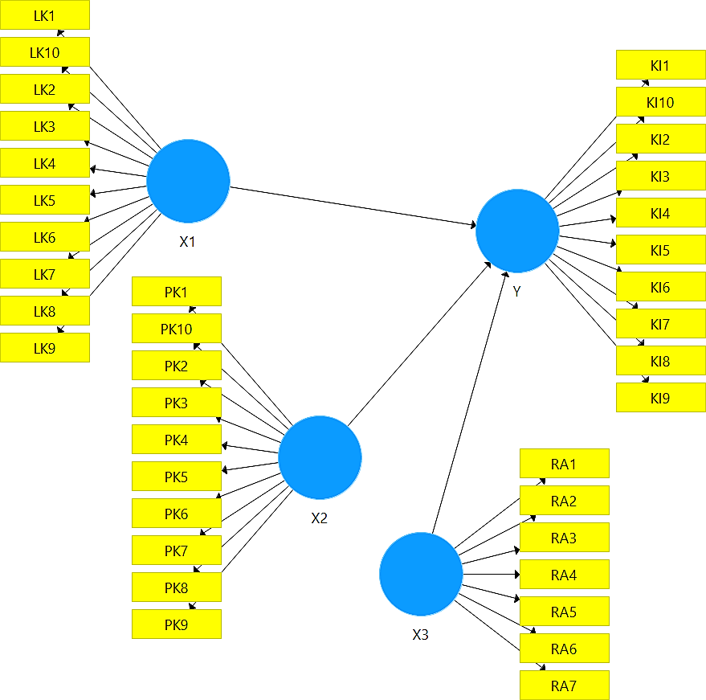

Figure 2. Thinking Framework
Source: Data processed by researchers (2021)

HYPOTHESIS DEVELOPMENT
The Effect of Financial Literacy on Investment Decisions
Financial literacy is the concept of understanding financial products and ideas with the help of information and advice, as the ability to identify and understand financial risks to make appropriate financial decisions (Vidovicova, in Faalih's research 2020). Arianti (2018), knowledge of finance is essential for an individual to not misunderstand in making their financial decisions. People's financial ability can be seen from how big the level of financial literacy they have. The higher the level of financial literacy that a person has, the more precise it is in determining the decision to take on financial products, especially with the credit system and later able to avoid financial risks. This is reinforced by research by Alifah and Dalimunthe (2020), Sugiyanto et al. (2021), Faalih (2020), which proves that financial literacy has a positive effect on investment decisions. Based on the description above, the hypotheses put forward are:
H₁: Financial literacy has a positive effect on investment decisions

The Influence of Financial Behavior on Investment Decisions
Understanding financial behaviour will help a person understand what is related to his relationship with money. Therefore, financial behaviour is defined as a state of mind, opinion, and judgment about finances. According to Triwahyuningtyas et al. (2020), financial behaviour is related to one's financial responsibilities related to managing finances. Because the research shows that a person generally does not have a great understanding of financial knowledge when financial knowledge is view objectively and subjectively, these results indicate that some people believe that they have more knowledge of reasonable and rational financial behaviour than someone who has a low level of knowledge (Safryani et al., 2020). This study is under research conducted by Arianti (2018), which shows that the financial welfare of the community depends on improving financial behaviour while this behaviour is contributed by financial literacy. So it can be concluded that financial behaviour has a significant effect on financial literacy. Furthermore, this research is also by the analysis of Rahmayanti et al. (2019), Arianti (2018), Suntoro and Anastasia (2014), showing that financial behaviour has a positive effect on financial literacy. Based on the description above, the hypothesis put forward is:
H₂: Financial behaviour has a positive effect on investment decisions among millennials

Effect of Regret Aversion Bias on Investment Decisions
Regret Aversion is the tendency to avoid making decisions for fear of experiencing regret. Regret aversion, in simple words, is a trend to avoid making decisions for fear of experiencing regret (Yohnson, 2018) and Risman et al (2021). In general, investors will be seen as self-harming as losers in the long term in the hope of selling the securities at a profit rather than selling profitable securities in a short time (Gupta and Ahmed, 2016). A person feels regret because of two things: someone takes action or makes a confident decision, and that person cannot do something (Asri, 2015). Nurinda et al. (2019), Addinpujoartanto, and Darmawan (2020) state that regrets aversion bias positively affects investment decisions. Therefore, the hypotheses put forward in the study are as follows:
H₃: Regret Aversion bias has a positive effect on investment decisions among millennials

RESEARCH METHODOLOGY
Types of research
In this study, the researcher used this type of quantitative research. Quantitative research is research devoted to processing data in the form of numbers (Ferdinand, 2014:8). Quantitative research can make it easier for researchers to process numbers which will later be carried out by regression analysis using the SmartPLS version 3.0 application.

Variable Operational Definition
Variable Operational Definition is a definition that is based on the number of references and the reasons for using the definition itself. Definition of Operational Variables in this study are described as follows:
- Investment Decision (Y)
Investment decisions have the meaning of an action taken by someone in the present, which is projected in the future to get a profit.
- Financial Literacy (X1)
Financial literacy is knowledge of finance in terms of financial institutions and concepts as a whole and the ability to utilize financial products and manage personal finances to make short-term and long-term decisions.
- Financial Behavior (X2)
Financial behaviour combines aspects of one's financial ability and psychological ability in managing and utilizing financial resources as a basis for making decisions for daily needs and financial planning in the future or business activities owned.
- Regret aversion bias (X3)
Regret aversion bias is a decision to avoid making the same mistake because there is a fear of facing the same loss in a person (Yohnson, 2018).

Variable Measurement
Table 1. Variable Measurement
Variables | Indicator Scale | Measurements Scale
Investment Decision (Y) | Rate of return | Likert
Return of risk | Likert
The relationship between return and  risk | Likert
Financial Literacy (X1) | Basic financial knowledge | Likert
Savings and loans | Likert
Insurance | Likert
Investment | Likert
Financial Behavior (X2) | Financial planning | Likert
Financial Budgeting | Likert
Financial Management | Likert
Financial Storage | Likert
Regret Aversion Bias (X3) | Feelings of Fear of Loss | Likert
Bad experience | Likert
Source: processed data (2021)

Population and Sample
The population selected in this study were millennials with a maximum age of 30 years. The sampling method in this study used a non-probability sampling technique with a purposive sampling model. The non-probability sampling technique is related to taking samples in a population by giving different opportunities or opportunities for each element of the people, which will then be used. Purposive sampling was chosen as a sampling method. This method is based on specific considerations in selecting samples to be taken and used in research to achieve certain efforts. Of the 113 respondents, 79 people have invested. Furthermore, we will make 79 respondents as samples in this study.
METHOD OF COLLECTING DATA
Data and Data Sources
The type of data used in this study is primary data. The data was obtained directly through the distribution of questionnaires to 113 respondents with a maximum age of 30 years. The scale used is the Likert scale. The Likert scale is as follows:

Table 2. Likert scale
Scales | Questions | Understanding
5 | SS | Strongly Agree
4 | S | Agree
3 | CS | Just Agree
2 | TS | Do Not Agree
1 | STS | Strongly Disagree
Source: Sugiyono (2016: 93)

DATA ANALYSIS TECHNIQUE
The data analysis technique used in this research is descriptive data analysis and data analysis using PLS software.
- Descriptive Data Analysis
The respondent's perception is described using a scoring technique, the scoring technique used consists of ranking in the form of numbers and forming answers from 1 to 5.
Table 3. Descriptive Analysis
Index Value | Interpretation
16-36 | Low
37-58 | Medium
59-80 | High
Source : Ferdinand (2014)

Partial Least Square (PLS)
The data obtained from the research results were then processed using data analysis techniques, namely Partial Least Square (PLS). According to Wold in Ghozali (2008), Partial Least Square or PLS is a powerful analytical method because it is not based on many assumptions. This study uses PLS as a data analysis technique with SmartPLS software version 3.0. The data used does not have to have a multivariate normal distribution (indicators covered with a categorical scale, ordinal to ratio can be used on the same model), the sample does not have to be large, can contain 30 to 100 samples and can be used to explain whether or not there is a relationship between latent variables. (measured indirectly). According to Syahputra and Urumsah (2019), there are two stages to test hypotheses using PLS: the measurement model testing stage and the structural model testing stage. The measurement of each step is described in table 3 and table 4.

Table 4. Testing the Measurement Model
Stages | Type of Measurement | Requirements | Source
Validity Test: Convergent | Average Variance Expected (AVE) | > 0.5 | Chin (1998)
The loading value of each item | > 0.5
Validity Test: Discriminant | AVE Analysis | The power of two of the AVE of each variable must be greater than the most considerable correlation between that variable and the others | Fornell, C. & Larcker (1981)
Reliability Tests | Value of Composite Reliability (CR) | > 0.7 | Chin (1998)
Source: processed data (2021)

Type of Measurement | Requirements | Sources
Coefficient of Determination | R2 > 0.10 | Falk, R.F. & Miller, (1992)
Hypothesis testing | T value of significance > 1.96 (alpha 5%) | Chin (1998); Fornell & Larcker (1981)
Table 5. Structural Model Testing
Source: processed data (2021)
RESULTS AND DISCUSSION
Demographics
Based on gender, most respondents were male, as many as 57 respondents, the rest were female. Based on age, most respondents were between 18 and 21 years old, as many as 80 respondents. Meanwhile, the number of respondents is at least 22 to 24 years old. Based on the type of work, most respondents came from students as many as 78 people. Based on investment experience, most respondents have less than one year of investment experience as many as 30 people.
Measurement Model Testing
According to Ghozali (2009) validity test needs to be done to measure whether a questionnaire is valid or not. Questionnaires can be helpful if the questions from a questionnaire can explain something that the questionnaire will measure. Using SmartPLS, the criteria to pass the validity test are that the Average Variance Extracted (AVE) value must be more than 0.50. When the researcher conducted a convergent validity test, the loading value was below 0.50 on the 5th Regret Aversion Bias indicator item. The item must be dropped so as not to affect the AVE value. The loading value of the convergent validity test is shown in table 6.

Table 6. Loading Value of Convergent Validity Test
Variable | Indicator Items | Loading Values
Financial Literacy | LK1 | 0.793
 | LK2 | 0.627
 | LK3 | 0.822
 | LK4 | 0.907
 | LK5 | 0.721
 | LK6 | 0.877
 | LK7 | 0.794
 | LK8 | 0.755
 | LK9 | 0.768
 | LK10 | 0.774
Financial Behavior | PK1 | 0.617
 | PK2 | 0.789
 | PK3 | 0.801
 | PK4 | 0.866
 | PK5 | 0.761
 | PK6 | 0.815
 | PK7 | 0.917
 | PK8 | 0.814
 | PK9 | 0.873
 | PK10 | 0.887
Regret Aversion Bias | RA1 | 0.831
 | RA2 | 0.571
 | RA3 | 0.903
 | RA4 | 0.748
 | RA6 | 0.938
 | RA7 | 0.861
Investment Decision | KI1 | 0.687
 | KI2 | 0.727
 | KI3 | 0.728
 | KI4 | 0.854
 | KI5 | 0.763
 | KI6 | 0.82
 | KI7 | 0.918
 | KI8 | 0.823
 | KI9 | 0.875
 | KI10 | 0.881

Source: processed data (2021)

In table 6, the loading value of each indicator item is above 0.5. While in table 7 shows that the AVE value for each variable used in the study is above 0.5. In addition, the correlation value for each variable (numbers written in bold) is greater than the correlation value for other variables, so it can be concluded that each variable has met the requirements for the discriminant validity test. Based on these results, it can be supposed that these variables have met the validity test requirements. In table 7, the CR value of each variable is above 0.7, so it can be concluded that each variable has met the reliability test.

Table 7. Value of AVE, CR, and Correlation Between Variables

 | AVE | CR | LK | PK | RA | KI
LK | 0.620 | 0.942 | 0.787 | 0.000 | 0.000 | 0.000
PK | 0.670 | 0.953 | 0.414 | 0.819 | 0.000 | 0.000
RA | 0.669 | 0.922 | 0.63  3 | 0.529 | 0.818 | 0.000
KI | 0.658 | 0.950 | 0.426 | 0.992 | 0.546 | 0.811

Source: Data processed by the researchers (2021)

Structural Model Testing
This test tests the hypothesis on the independent and dependent variables by looking at the T-statistical value. In conjunction with the test, thus displays the value of R₂ to see how much the influence of the variable can be explained. The results are shown in table 8.
 | Path | Path Coeff | T-Statistik | Results
H1 | LK → KI | 0.006 | 0.300 | Not significant
H2 | PK → KI | 0.976 | 51.888 | Significant
H3 | RA → KI | 0.025 | 1.019 | Not significant
R² Value | = 0.985
Table 8. Value of Path Coeff, T-Statistics, and R²

Source: Data processed by researchers (2021)

Table 8 shows that the first hypothesis (H1) to the fourth hypothesis (H4) has a clear path coeff value, and the t-statistic value for the second hypothesis is above 1.96, while for H1 and H3, it is below 1.96. These results can be concluded that the second hypothesis (H2) is accepted, while H1 and H3 are rejected. This means that financial behaviour significantly affects investment decisions, while financial literacy and regret aversion bias do not affect investment decisions. In comparison, the value of R² (coefficient of determination) is 0.985. This means that the ability of the independent variable to affect the dependent variable is 98.5%, and the rest is explained by variables that are not included in this study.
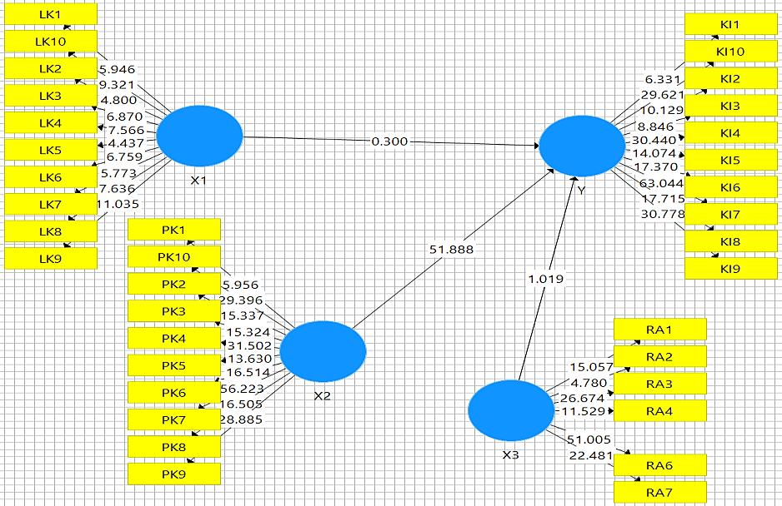

Figure 3. Analysis Results Using SmartPLS
Source: Data processed by Researchers (2021)
DISCUSSION
The Effect of Financial Literacy on Investment Decisions
Financial literacy has no effect on investment decisions among millennials, and this is evidenced by the t-statistic value of 0.300 < 1.96. In summary that financial literacy has no impact on investment decisions among millennials in Indonesia. This explains that a good understanding of finance is not the main factor for millennials determining an investment decision. There are still many other factors that are considered for millennials to invest in. These results align with Arianti's (2018) research, which states that financial literacy does not affect investment decisions.

The Influence of Financial Behavior on Investment Decisions
Financial behaviour has a significant positive effect on investment decisions among millennials; a positive path coeff value shreds of evidence this and a t-statistic value of 51.888 > 1.96. In essence, that financial behaviour has a positive effect on investment decisions among millennials in Indonesia. The higher the financial behaviour, the higher the investment decision. This explains that psychological factors strongly influence millennials in carrying out financial-related activities. This study is also following the research of Rahmayanti et al. (2019), Arianti (2018), Suntoro and Anastasia (2014), showing that financial behaviour has a positive effect on financial literacy.
Effect of Regret Aversion Bias on Investment Decisions
Regret Aversion Bias has no effect on investment decisions among millennials, and this is evidenced by the t-statistic value of 0.300 < 1.96. It's safe to assume that bias regret has no effect on investor decisions among millennials in Indonesia. This result aligns with Muslihat's (2020) research, which states that bias regret does not affect investment decisions. According to Yohnson (2008) in Muslihat (2020), four factors influence regret, bias is not the primary influence, including:
- Indonesian consumers have short-term memories that Indonesian investors expect to generate short-term returns, so regret is ignored.
- Indonesian consumers like to gather with their colleagues about investment decisions and are influenced by their colleagues who are so sure of their opinions that regrets can be ignored.
- Indonesian consumers, who contributed to the novelty and remorse given to respondents from educational universities with truth values).
- Indonesian consumers like to show off and prestige. This impacts investment behaviour that is only based on distinction so that regrets can be ignored.

CLOSING
Conclusion
Based on the results of research and discussion in previous chapters, several conclusions can be drawn as follows:
- Financial literacy has no effect on investment decisions among millennials in Indonesia
- Financial behaviour has a positive impact on investment decisions among millennials in Indonesia
- Regret aversion bias has no effect on investment decisions among millennials in Indonesia

Suggestion
In this study, the sample used was 79 respondents who had investment experience. This study shows that financial behaviour has a positive effect on investment decisions among millennials. In contrast, financial literacy and regret aversion bias have no impact on investment decisions among millennials in Indonesia. Hope for further research can increase the number of respondents so that the data is more valid and can add other variables that do not exist in this study.

REFERENCE EXAMPLE :
Addinpujoartanto, N. A., and Darmawan, S. (2020). Pengaruh Overconfidence, Regret Aversion, Loss Aversion, Dan Herding Bias Terhadap Keputusan Investasi Di Indonesia. Jurnal Riset Ekonomi dan Bisnis, 13(3), 175. https://doi.org/10.26623/jreb.v13i3.2863
Andrian, Sumtoro and Anastasia, Njo (2015). “Perilaku Keuangan dalam Pengambilan Keputusan Berinvestasi Properti Residensial di Surabaya”. Finesta Volume. 3, Nomor. 1, 41-45.
Arianti, Baiq Fitri. (2018). ”The Influence of Financial Literacy Financial Behavior and Income on Invesment Decision”. Economics and Accounting Journal. Volume. 1, No 1, January 2018.
Arifah, Jihan Nadra and Dalimunthe, Zuliani. (2020). “The Impact of Financial Literacy on the Investment Decision of Non-Donation-Based Crowdfunding in Indonesia”. International Journal of Business and Society. Volume 21, No 3, 1045-1057.
Artina, Nyimas and Cholid, Idham (2018). “Pengaruh Tingkat Literasi Keuangan dan Faktor Demografi terhadap Pengambilan Keputusan Investasi (Studi Kasus Pegawai Kantor Badan Kepegawaian Daerah Sumatera Selatan). Jurnal Keuangan dan Bisnis.
Baihaqqy, Mochammad Rizaldy Insan and Sugianto. (2020). “Investment Decisions of Investors Based On Generation Groups (A Case Study In Indonesia Stock Exchange). E-Journals : Volume X1 No 3. November 2020, 189-196. E-ISSN : 2615-4978. P-ISSN : 2086-4620.
Baihaqqy, Mochammad Rizaldy Insan Sugiyanto (2021). “Pengaruh literasi keuangan, locus of control, dan etnis terhadap pengambilan keputusan investasi”.
Faalih, Muhammad Faiz (2020). “Pengaruh Literasi Keuangan dan Faktor Demografi Terhadap Keputusan Investasi (Studi Pada Mahasiswa Fakultas Ekonomi dan Bisnis Universitas Brawujaya Malang).
Gunawan, Ade and Chaerani. (2019). “Effect Financial Literacy and Lifestyle of Finance Student Behavior”. International Journal of Business Economics. 1 (1), 76-86.
Hesniati, Hendy. (2021). “Perilaku Keuangan Terhadap Keputusan Investasi”. Volume 1, Nomor 1 (2021).
Kalsum, Ummy. et al. (2018). “Influences of Financial Literacy on Investment Decision in Small Business”. In Southest Sulawesi. International Journal of Scientific & Engineering Research. Volume 9.
Nur’Aini. et al. (2017). “Pengaruh Literasi Keuangan dan Faktor Demografi Terhadap Keputusan Investasi di Pasar Modal (Studi Kasus Karyawan PT. Semen Baturaja Persero Tbk).
Nurinda, Wahyu. et al. (2020). “Pengaruh Regret Aversion Bias dan Risk Tolerance Bagi Investor Muda Jawa Barat Terhadap Keputusan Investasi”. Jurnal akuntansi dan Keuangan. Volume 1 Nomor 1, januari 2020.
Pujiyanto, Nafi and Mahastanti, Linda Ariani. (2013). “Regret Aversion Bias dan Risk Tolerance dalam Keputusan Investasi”. Volume 3, Nomor 1.
Rahman, Aulia & Risman, Asep (2021). “Is Behavior Finance Affected By Income, Learning Finance and Lifestyle”. Journal on global socio-economic dynamics”. Volume 4 (29) ISSN 2539-5645.
Risman, A., Prowanta, E. & Siswanti, I. (2021). Behavioral Corporate Finance. Yogyakarta.
Penerbit KBM Indonesia.

