Performance Analysis of Protected Fund and Equity Fund Using Sharpe, Treynor, Jensen

Mersa Lestari Ningrum ¹⁾; Asep Risman ²⁾

¹⁾ mersalestari@gmail.com, Faculty of Economics and Business, Universitas Mercu Buana, Indonesia
²⁾ asep.risman@mercubuana.ac.id, Faculty of Economics and Business, Universitas Mercu Buana, Indonesia

Article Information:  Keywords:  Capital protected fund;  Equity fund;  Sharpe;  Treynor;  Jensen;  Article History:  Received : December 19, 2021  Revised : December 24, 2021  Accepted : December 27, 2021  Article Doi:  http://doi.org/10.22441/profita.2020.v13i1.001 | Abstract in English  This study was conducted to determine the mutual funds' performance of capital-protected and equity funds from February 2021 to August 2021. Return, risk, Sharpe index, Treynor index, and Jensen index are all used to evaluate mutual fund performance. Sample data consisted of 462 capital-protected fund products and 273 equity fund products. The performance of equities funds outperforms that of capital-protected funds, according to the average Sharpe index. The Treynor index showed that capital-protected funds outperformed the market. The Jensen index shows that capital-protected funds outperform equity funds. In March, April, and May, capital-protected funds outperform the market (JCI), whereas equities funds outperform in April and August. In April, capital-protected funds outpaced risk-free investments, whereas equity funds outperformed in February, July, and August. The Independent T-Test is the statistical approach used to test the hypothesis. The findings revealed no substantial differences between capital-protected funds and equity funds, allowing investors to invest in one or both.

INTRODUCTION
Mutual funds are one type of investment that novice investors can choose, with this type of investment fund being professionally managed by an investment manager. Mutual fund products are classified into various categories based on their investing aims and risks, including capital-protected funds and equity funds. Capital-protected funds are lower-risk mutual funds that use a buy-and-hold strategy on investment instruments such as debt securities or bonds to protect investors' initial investment value. Equity funds are higher-risk mutual funds that invest at least 80% of their assets in stocks. Return is the most crucial measure for investment decisions, according to Putro & Risman (2021). Risk and expected earnings (return) from assets are taken into account while making investment decisions (Risman et al, 2017). Where are the mutual funds with more active management, higher expenditure ratios, and greater turnover ratios, according to Livingston et al. (2019), are riskier.
According to Kim et al (2002), the three accessible indexes to quantify portfolio performance based on risk-adjusted are the Treynor index, Sharpe index, and Jensen index. Haugen (1997) recommends utilizing risk-adjusted-performance assessment. According to Wang et al (2020), mutual funds risk the market system to obtain excess gains in a short cycle, but they employ other elements to generate excess profits in long cycles and trends. Based on this problem, research is carried out with the aim to determine the performance of capital-protected funds and equity funds using the Sharpe, Treynor, and Jensen methods. This research will use this strategy to evaluate the performance of capital-protected funds and equity funds to the BI Rate as risk-free investments. Investing in mutual funds is more beneficial than risk-free investments if the mutual fund's performance is favorable. Next, compare the mutual fund's performance to its benchmark, the JCI, and present the findings of the number and product of capital-protected funds and which equity funds outperform the market (JCI).

LITERATURE REVIEW
Risk-Return Perspective.
The volatility of the return spread between long and short positions captures the amount of factor risk. As a result, we would anticipate a component with a big standard deviation in its related spread relative to the benchmark to have a strong widespread influence on stock returns (Chan et al, 1998). Portfolio and capital market theories provide a framework for defining and measuring investment risk, building correlations between expected security returns and risk, and evaluating the performance of managed portfolios such as mutual funds and pension funds (Modigliani & Pogue, 1974).

Sharpe Index.
The expected return per unit of risk is calculated using the Sharpe ratio. The outcome of such a strategy is the difference in the returns on two investment assets (Sharpe, 1994). Sharpe's ratio is calculated by dividing the average portfolio excess return over the sample period by the standard deviation of those returns. It calculates the investment's (total) volatility trade-offs (Bodie et al, 2014).

Treynor Index.
The Treynor measure produces larger returns per unit of risk since it concentrates on systematic risk rather than total risk (Bodie et al, 2014). The Treynor ratio is a straightforward modification of the Sharpe ratio that eliminates the first constraint by substituting total risk for beta risk (Sarker, 2015).

Jensen Index.
Jensen Alpha is the average return on a portfolio that exceeds the CAPM's prediction given the portfolio beta and average market return given the portfolio beta and average market return (Bodie et al, 2014). When measuring the performance of portfolios, the effects of varying degrees of risk on portfolio returns must be taken into account (Jensen, 1967).

METHOD
This research is a descriptive study with a quantitative approach. Quantitative data used is information on the sample's positive Net Asset Value (NAV), the Composite Stock Price Index (JCI), and Bank Indonesia Interest Rates (BI Rate) from February 2021 to August 2021. The data population contains 462 capital-protected fund products from 45 investment managers and 273 equity fund products from 68 investment managers. The Sharpe, Treynor, and Jensen indexes are used as a comparison factor for the performance of the mutual fund portfolio in this study's data analysis technique.

Table 1. Variable Calculation Using Market Model
No | Description | Formula
1 | Calculating actual return from the mutual fund (Ri) | Ri = $\frac{NABt-NABt-1}{NABt-1}$
2 | Calculating the level of risk of mutual funds (σ) | $σ= \sqrt{\frac{\sum{(Ri- {\overline{Ri)}}^{2}}}{n-1}}$
3 | Calculating the systematic risk of mutual funds (β) | β = $\frac{COVim}{σ^{2}m}$
4 | Calculating the Sharpe Index (Si) | Si = $\frac{Rit- Rf }{σit}$
5 | Calculating the Treynor Index (Ti) | Ti = $\frac{Rit -Rf }{β}$
6 | Calculating Jensen's Alpha (αp) | Rit – Rft = αp + βp(Rmt – Rft) + µt
Source: Hamzah & Yohanes (2014)

This research study uses path analysis along with the model:
H₁: In terms of return and risk, capital protected funds and equity funds perform significantly differently.
H₂: The Sharpe, Treynor, and Jensen index measurement models reveal that capital protected funds and equity funds perform very differently.
The difference t-test was used to examine if two unconnected samples had different mean values and a significant difference between the two independent samples at the 5% confidence level, assuming the data were normally distributed. If the significance value is less than 5%, the two samples are said to be significantly different.

RESULTS AND DISCUSSION
The Performance of Mutual Funds is Based on Their Average Return and Risk.
The average return generated by the mutual fund portfolio can be compared to its market return (JCI) benchmark to determine mutual fund performance. According to Table 2, the average market return is positive for the months of February, April, June, July, and August. Capital protected funds and equity funds, on the other hand, follow a different path. The market's highest average return (JCI) is 0.73 percent, and the average return for equity funds is higher than the average return for capital protection funds, according to the average return. If mutual fund returns are compared with market returns, it is known that capital-protected funds outperform the market in March, April, and May, while other months are still below the market (underperform). Meanwhile, equity fund mutual funds outperformed the market in April and August and underperformed in additional months.

Table 2. Average Return of Capital Protected Funds, Equity Funds, and Markets
 | February | March | April | May | June | July | August | Average
Capital Protected Fund | -0.0036 | -0.0108 | 0.0035 | -0.0014 | -0.0138 | -0.0050 | -0.0133 | -0.0064
Equity Fund | 0.0367 | -0.0415 | 0.0031 | -0.0086 | -0.0198 | 0.0032 | 0.0257 | -0.0002
JCI | 0.0647 | -0.0411 | 0.0017 | -0.0080 | 0.0064 | 0.0141 | 0.0132 | 0.0073
BI Rate | 0.0029 | 0.0029 | 0.0029 | 0.0029 | 0.0029 | 0.0029 | 0.0029 | 0.0029
Source: processed data (2021).

When a comparison is made with the BI Rate, it is known that capital-protected funds outperformed risk-free investments in April, while other months were still below risk-free investments (underperform). Meanwhile, equity funds outperformed risk-free investments in February, July, August, and additional underperforming months. Based on Table 3, it is known that, on average, an equity fund has a lower portfolio risk than the portfolio risk of a capital-protected fund. However, the capital-protected fund has less market risk than equity funds. By comparing portfolio risk with market risk, it can be seen that the capital-protected fund outperformed the market in the April period, and the rest underperformed the market. Meanwhile, equity funds outperformed the market in March, April, June, and August, and the rest underperformed the market.

Table 3. Mutual Fund Risk Comparison.
 | February | March | April | May | June | July | August | Average
Portfolio risk:  Capital Protected Fund | 0.0394 | 0.0769 | 0.1423 | 0.1112 | 0.0853 | 0.0638 | 0.0843 | 0.0862
Portfolio risk: Equity Fund | 0.0920 | 0.1001 | 0.0727 | 0.0444 | 0.0831 | 0.0477 | 0.0866 | 0.0752
Market risk:  Capital Protected Fund | 0.0001 | -0.0421 | 0.1811 | -0.0367 | -0.0742 | 0.0121 | -0.0438 | -0.0005
Market risk: Equity Fund | 0.0413 | 0.1793 | 0.7158 | 0.0270 | -1.2753 | -0.0402 | 0.5451 | 0.0276
Source: processed data (2021).

Sharpe, Treynor, and Jensen Indexes Were Used to Calculate Mutual Fund Performance.
According to the Sharpe index value in Table 4, equities funds outperform capital-protected funds on average. From February to August, the capital-protected fund had a negative return, but it nevertheless outperformed equity funds in March, May, June, and July. The performance of the equities fund was favorable in April and August but negative in the remaining months. Despite the negative value, equities funds outperformed capital-protected funds in February and August. According to Hamid & Cahyadi in Pratomo (2019), investment in mutual funds carries risks, but it is predicted to provide higher investment returns than risk-free investments. Sharpe calculates how much extra investment returns (risk premium) are earned for each unit of risk incurred. According to Rumintang & Azhari (2015), this positive number in Sharpe shows that mutual funds' rates of return are higher than the risk-free rate of return, in this case, Indonesia Bank Certificates (SBI) and Indonesia Sharia Bank Certificates (SBIS).
If a comparison is made between capital-protected funds and equity funds with the JCI, it is known that equity funds outperformed the market in February and August. Meanwhile, no capital-protected funds exceed the market performance. If a comparison is made between capital-protected funds and equity funds with the BI rate, it is known that equity funds have higher performance than risk-free investments in February and August. Meanwhile, no capital-protected funds exceed risk-free investment performance.

Table 4. Sharpe Index Mutual Funds
 | February | March | April | May | June | July | August | Average
Capital Protected Fund | -0.2383 | -0.3746 | -0.0507 | -0.1922 | -0.3863 | -0.0604 | -0.2386 | -0.2202
Equity Fund | 0.7967 | -1.1309 | -0.0074 | -0.3259 | -0.7664 | -0.1341 | 0.3283 | -0.1771
JCI | 0.0647 | -0.0411 | 0.0017 | -0.0080 | 0.0064 | 0.0141 | 0.0132 | 0.0073
BI Rate | 0.0029 | 0.0029 | 0.0029 | 0.0029 | 0.0029 | 0.0029 | 0.0029 | 0.0029
Source: processed data (2021).

Table 5. Treynor Index Mutual Funds
 | February | March | April | May | June | July | August | Average
Capital Protected Fund | 0.0477 | -0.0494 | 0.0058 | -0.0303 | 0.0560 | 0.0811 | -0.0133 | 0.0114
Equity Fund | -0.0730 | -0.1744 | -0.0319 | -0.0302 | 0.1089 | 0.0453 | 0.1500 | -0.0008
JCI | 0.0647 | -0.0411 | 0.0017 | -0.0080 | 0.0064 | 0.0141 | 0.0132 | 0.0073
BI Rate | 0.0029 | 0.0029 | 0.0029 | 0.0029 | 0.0029 | 0.0029 | 0.0029 | 0.0029
Source: processed data (2021).

Table 5 shows that, on average, capital-protected funds outperform the market and equity funds based on the Treynor index value. The average performance of capital-protected funds was positive in February, April, June, and July. Meanwhile, capital-protected funds underperformed in March, May, and August. Equity funds have performed well in June, July, and August but have struggled in other months. In May and August, the performance of equities funds was still stronger than that of capital-protected funds. Capital-protected funds beat the market (JCI) in April, June, July, and other disappointing months as compared to the market.
Meanwhile, equity funds outperformed the market in June, July, August, and other underperforming months. According to Paranita et al (2015), this will provide stock mutual fund performance statistics compared to the BI Rate as a risk-free investment using the Sharpe and Treynor methods. If the performance of a stock mutual fund is good, investing in it is better than making a risk-free investment. Furthermore, comparing the performance of a stock mutual fund to its benchmark, the JCI, reveals the number and types of stock mutual funds that can outperform the market (JCI).
If a comparison is made between capital-protected funds and equity funds with the BI rate, it is known that equity funds have higher performance than risk-free investments in June, July, and August. Meanwhile, capital-protected funds exceed risk-free investment performance in February, April, June, and July.
Based on the Jensen value in Table 6, it can be seen that, on average, capital-protected funds and equity funds have a negative value, which means that both mutual funds underperform. In April, the capital-protected fund had a positive performance, which means that the capital-protected fund outperformed the market. Meanwhile, equity funds in April and August had a positive Jensen index of 0.0011 and 0.0152. It implies that equities funds have outperformed the market. A positive Jensen index indicates that portfolio returns are higher than predicted, according to Putri & Worokinasih (2018). If investors are confident in the investment manager's ability to outperform the market, they can use this index. The following criteria are used to evaluate the performance of mutual funds based on the Jensen model, according to Rofiq & Santoso (2015): (a) if the resultant alpha value is positive, the mutual fund has outperformed the JCI; (b) if the resulting alpha value is negative, the mutual fund has underperformed the JCI; and (c) if the resulting alpha value is zero, then the mutual fund is said to have the same performance as the JCI.

Table 6. Jensen Index Mutual Funds
 | February | March | April | May | June | July | August | Average
Capital Protected Fund | -0.0088 | -0.0122 | 0.0006 | -0.0039 | -0.0169 | -0.0083 | -0.0166 | -0.0094
Equity Fund | -0.0119 | -0.0119 | 0.0011 | -0.0035 | -0.0253 | -0.0080 | 0.0152 | -0.0063
JCI | 0.0647 | -0.0411 | 0.0017 | -0.0080 | 0.0064 | 0.0141 | 0.0132 | 0.0073
BI Rate | 0.0029 | 0.0029 | 0.0029 | 0.0029 | 0.0029 | 0.0029 | 0.0029 | 0.0029
Source: processed data (2021).

If a comparison is made between capital-protected funds and equity funds with the JCI, it is known that equity funds outperformed the market in March, May, and August. Meanwhile, capital-protected funds exceed the market performance in March and May. If a comparison is made between capital-protected funds and equity funds with the BI rate, it is known that equity funds have higher performance than risk-free investments in August. Meanwhile, no capital-protected funds exceed risk-free investment performance.

Different Performance Test Results for Capital Protected Funds and Equity Funds.
According to Figures 1, 2, and 3, the highest capital-protected fund's performance is the Simas Gemilang Protected Mutual Fund 18 with Sharpe value of 8.4029, the Mandiri Protected Mutual Fund Series 157 with a Treynor value of 2.1424, and the Insight Protected Mutual Fund 2 with Jensen value of 0. 0.2771. According to Figures 4, 5, and 6, the highest equity fund's performance is the Foster Equity Fund Mutual Fund with Sharpe value of 1.5229, the Eastspring Investments Value Discovery Mutual Fund Class A with Treynor value of 1.2118, and the Manulife Equity Mutual Fund Mainstay with Jensen value of 0.2622.

Figure 1. Capital Protected Fund Performance Based on Sharpe Index  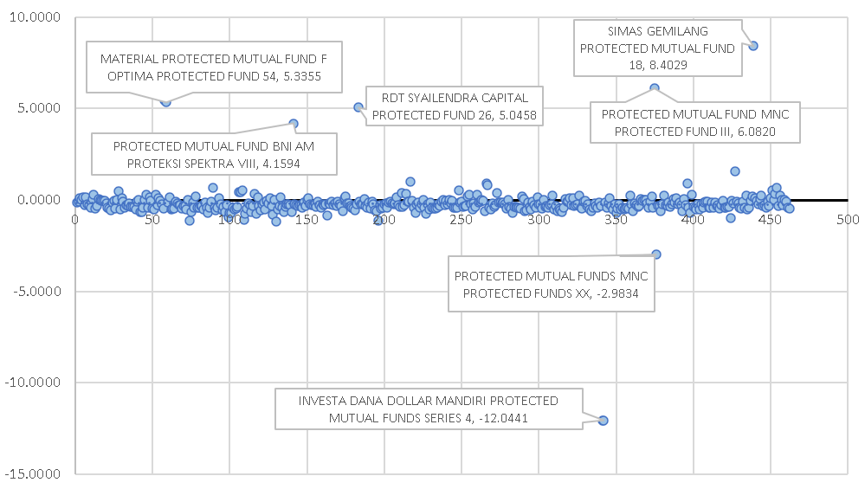  Source: processed data (2021). | Figure 2. Capital Protected Fund Performance Based on Treynor Index.  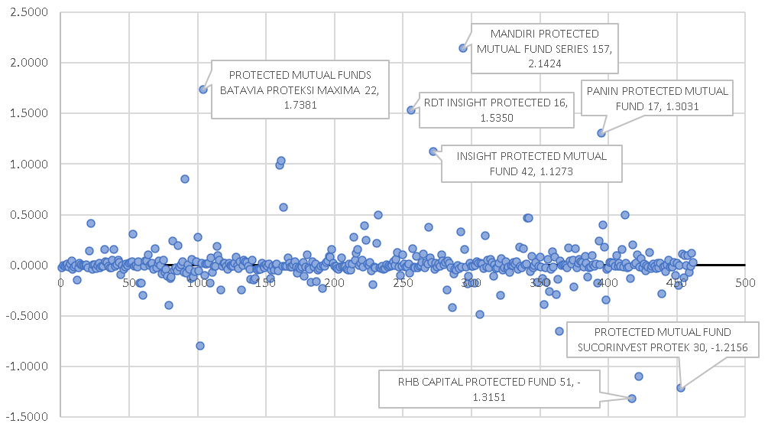  Source: processed data (2021).
Figure 3. Capital Protected Fund Performance Based on Jensen Index.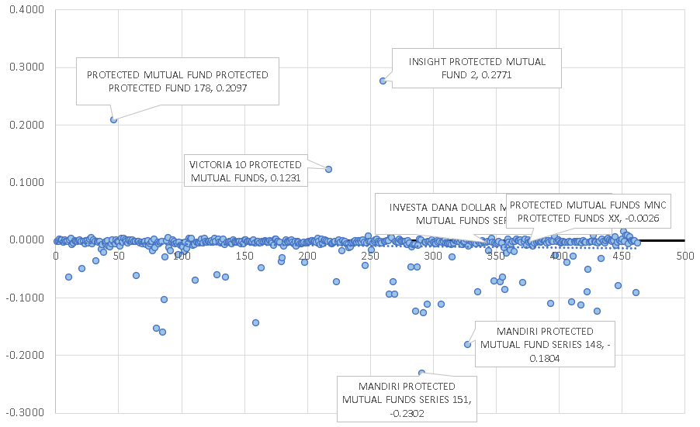  Source: processed data (2021). | Figure 4. Equity Fund Performance Based on Sharpe Index.  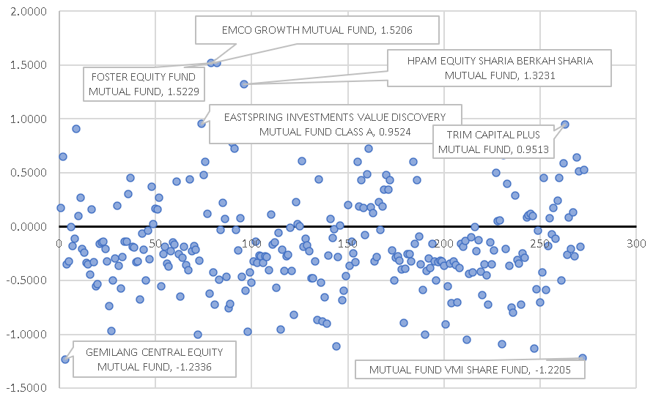  Source: processed data (2021).

An independent t-test was used to test the research hypothesis, with the results shown in Tables 7 and 8. H₁ is rejected because of the Sig. (2-tailed) value for Average Return, Portfolio Risk, and Market Risk is more than 0.05. It means that there is no difference in performance between capital-protected funds and equity funds based on average returns, portfolio risk, and market risk. An independent t-test is used to assess the H₂ hypothesis, with the findings shown in Tables 9 and 10. H₂ is rejected because the Sharpe, Treynor, and Jensen indexes have Sig. (2-tailed) values greater than 0.05. It means that there is no difference in performance between capital-protected funds and equities funds based on the Sharpe, Treynor, and Jensen indexes.
Figure 5. Equity Fund Performance Based on Treynor Index.  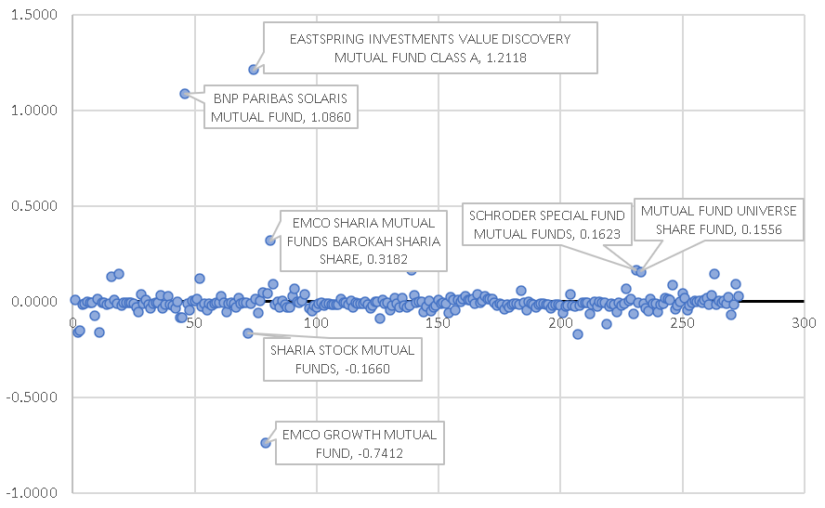  Source: processed data (2021). | Figure 6. Equity Fund Performance Based on Jensen Index.  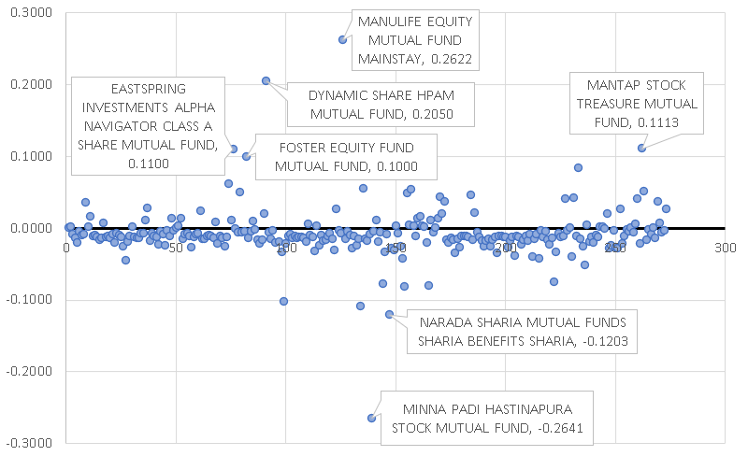  Source: processed data (2021).

Table 7. Hypothesis Test Results
 | Type | N | Mean | Std. Deviation
Average Return | Capital Protected Fund | 7 | -.006351 | .0065293
 | Equity Fund | 7 | -.000161 | .0265280
Portfolio Risk | Capital Protected Fund | 7 | .086169 | .0330381
 | Equity Fund | 7 | .075227 | .0216211
Market Risk | Capital Protected Fund | 7 | -.000481 | .0851268
 | Equity Fund | 7 | .027563 | .6411851
Source: processed data (2021).
Table 8. Results of the Independent Samples Test
 |  | Levene's Test for Equality of Variances |  | t-test for Equality of Means
 |  | F | Sig. | t | df | Sig. (2-tailed) | Mean Difference | Std. Error Difference
Average Return | Equal variances assumed | 5.782 | .033 | -.600 | 12 | .560 | -.0061904 | .0103259
 | Equal variances not assumed |  |  | -.600 | 6.724 | .568 | -.0061904 | .0103259
Portfolio risk | Equal variances assumed | .403 | .537 | .733 | 12 | .477 | .0109427 | .0149236
 | Equal variances not assumed |  |  | .733 | 10.343 | .480 | .0109427 | .0149236
Market risk | Equal variances assumed | 3.355 | .092 | -.115 | 12 | .911 | -.0280440 | .2444717
 | Equal variances not assumed |  |  | -.115 | 6.211 | .912 | -.0280440 | .2444717
Source: processed data (2021).
Table 9. Hypothesis Test Results
 | Type | N | Mean | Std. Deviation
Sharpe | Capital Protected Fund | 462 | -.220159 | 1.0954752
 | Equity Fund | 273 | -.177111 | .4411528
Treynor | Capital Protected Fund | 462 | .013952 | .2435737
 | Equity Fund | 273 | -.000761 | .1186306
Jensen | Capital Protected Fund | 462 | -.009427 | .0331128
 | Equity Fund | 273 | -.006316 | .0372779
Source: processed data (2021).

Table 10. Results of the Independent Samples Test
 |  | Levene's Test for Equality of Variances |  | t-test for Equality of Means
 |  | F | Sig. | t | df | Sig. (2-tailed) | Mean Difference | Std. Error Difference
Sharpe | Equal variances assumed | .215 | .643 | -.620 | 733 | .535 | -.0430485 | .0694201
 | Equal variances not assumed |  |  | -.748 | 663.996 | .455 | -.0430485 | .0575363
Treynor | Equal variances assumed | 19.425 | .000 | .935 | 733 | .350 | .0147131 | .0157440
 | Equal variances not assumed |  |  | 1.097 | 711.173 | .273 | .0147131 | .0134151
Jensen | Equal variances assumed | 2.247 | .134 | -1.174 | 733 | .241 | -.0031105 | .0026502
 | Equal variances not assumed |  |  | -1.139 | 518.287 | .255 | -.0031105 | .0027319
Source: processed data (2021).

Performance of Capital-Protected Funds Managed by Investment Managers Based on Sharpe, Treynor, and Jensen Indexes.
There are 45 investment managers sampled in this study. Based on Figure 7, it is known that capital-protected funds managed by 26 investment managers have positive performance, and 19 others have negative performance. The highest performance is the capital-protected fund managed by the investment manager Sinarmas Asset Management with a Sharpe index of 2.3267, where this value outperforms the market and the risk-free investment.
According to Figure 8, the capital-protected funds managed by 19 investment managers have positive performance. According to Figure 9, the capital-protected funds managed by 2 investment managers have positive performance. Capital-protected funds of UOB Asset Management Indonesia outperformed the market and risk-free investment with a Treynor index of 1.0868. Based on Figure 9, the highest performance of capital-protected fund managed by the investment manager Schroder Investment Management Indonesia with Jensen index of 0.0025, but this value has still underperformed the market and risk-free investment.

Figure 7. Performance of the Capital Protected Fund managed by Investment Manager Based on the Sharpe Index.  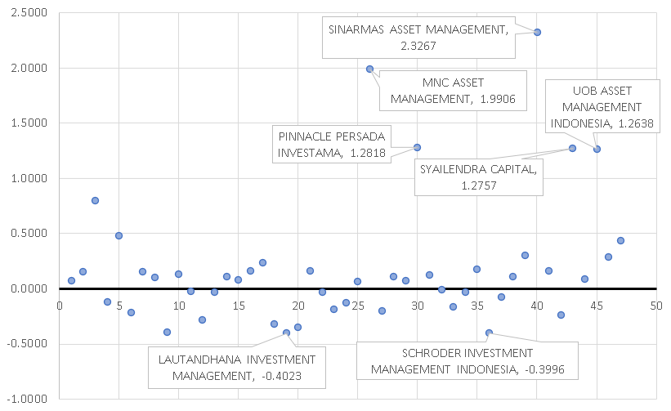Source: processed data (2021). | Figure 8. Performance of the Capital Protected Fund managed by Investment Manager Based on the Treynor Index.  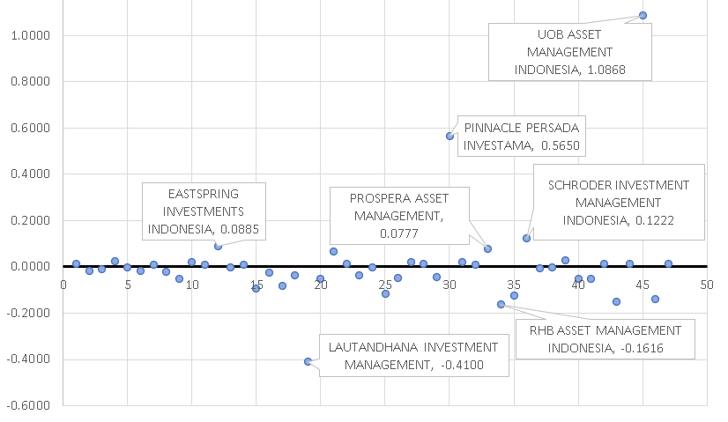Source: processed data (2021).

Performance of Equity Funds Managed by Investment Managers Based on Sharpe, Treynor, and Jensen Indexes
There are 68 investment managers sampled in this study. Based on Figure 10, it is known that equity funds managed by 25 investment managers have positive performance, and 43 others have negative performance. The highest performance is the equity fund managed by the investment manager Foster Asset Management with a Sharpe index of 1.5653, where this value outperforms the market and the risk-free investment.
According to Figure 11, the equity funds managed by 24 investment managers have positive performance. According to Figure 12, the equity funds managed by 59 investment managers have positive performance. Equity funds of the Eastspring Investments Indonesia outperformed the market and risk-free investment with Treynor index of 0.3079. Based on Figure 12, the highest performance of equity fund managed by the investment manager Berlian Asset Management, with Jensen index of 0.0069 and outperformed the risk-free investment.

Figure 9. Performance of the Capital Protected Fund managed by Investment Manager Based on the Jensen Index.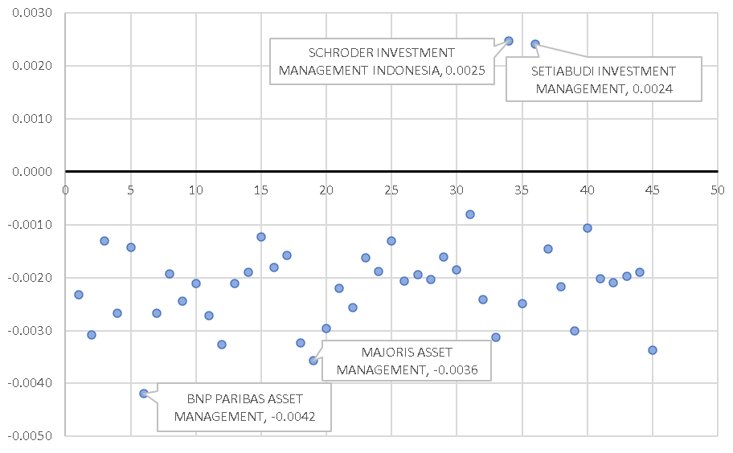Source: processed data (2021). | Figure 10. Performance of the Equity Fund managed by Investment Manager Based on the Sharpe Index.  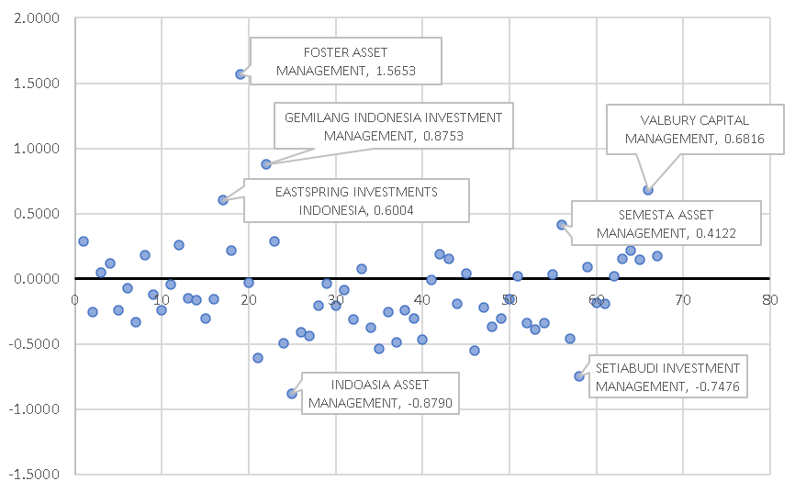 Source: processed data (2021).
Figure 11. Performance of the Equity Fund managed by Investment Manager Based on the Treynor Index.  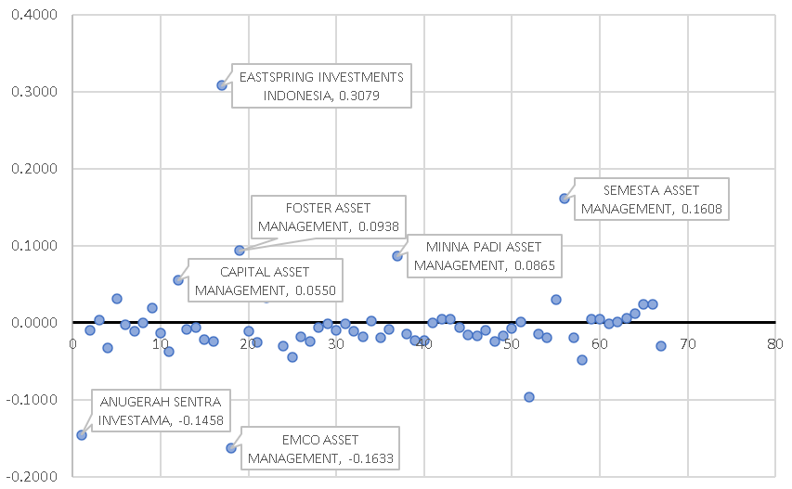 Source: processed data (2021). | Figure 12. Performance of the Equity Fund managed by Investment Manager Based on the Jensen Index.  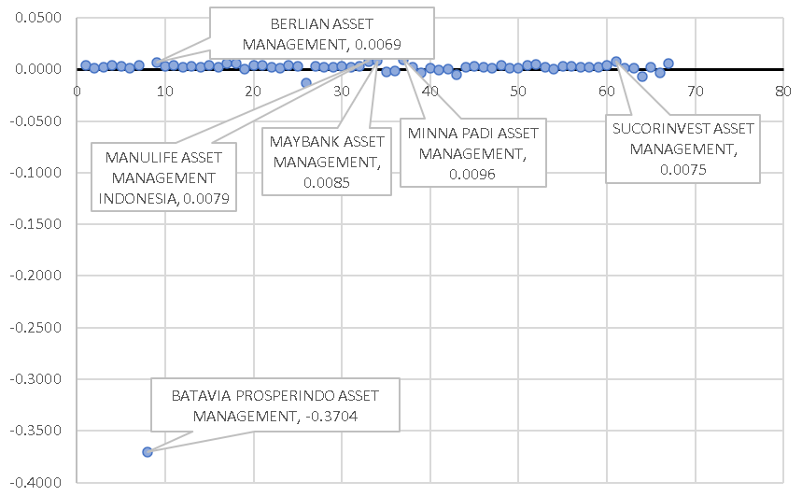  Source: processed data (2021).

CONCLUSION
The Sharpe, Treynor, and Jensen indexes were used to evaluate the performance of capital-protected funds and equity funds from February to August 2021, and the results demonstrate that:
- Based on the comparison of market returns, capital-protected funds outperform in March, April, and May, while equity funds outperform in April and August. Meanwhile, based on the BI Rate comparison, capital-protected funds outperformed from risk-free investment in April, while equity funds outperformed in February, July, and August.
- The Sharpe index of equity funds outperformed the market in February and August, but capital-protected funds underperformed. According to the Treynor index, capital-protected funds outperform equity funds in April, June, and July, while equity funds outperform in June, July, and August. Based on the Jensen index, equity funds outperformed in March, May, and August, while capital-protected funds outperformed in March and May.
- Capital protected funds with the best performance out of 462 products on the market, namely Simas Gemilang Protected Mutual Fund 18, Mandiri Protected Mutual Fund Series 157, and Insight Protected Mutual Fund 2, based on the Sharpe, Treynor, and Jensen indexes. Meanwhile, out of 273 products on the market, Foster Equity Fund Mutual Fund, Eastspring Investments Value Discovery Mutual Fund Class A, and Manulife Equity Mutual Fund Mainstay had the best performance based on Sharpe, Treynor, and Jensen indexes.
- According to Sharpe, Treynor, and Jensen indexes, the capital-protected funds managed by investment managers with the best performance are those managed by Sinarmas Asset Management, UOB Asset Management Indonesia, and Schroder Investment Management Indonesia. Meanwhile, Foster Asset Management, Eastspring Investments Indonesia, and Berlian Asset Management manage the best-performing equity funds based on Sharpe, Treynor, and Jensen indexes.
- According to the independent sample t-test, there is no difference in risk-return, Sharpe index, Treynor index, or Jensen index performance between capital-protected funds and equity funds so that investors can choose one or both types of mutual funds as an investment alternative.
This study is still limited to the performance of capital-protected and equity funds from February 2021 to August 2021. Further research should be conducted utilizing different methodologies such as the M-square measure, Henriksson-Merton approach, and Treynor and Treynor index to examine additional month periods. Money market funds, fixed-income funds, and discretionary funds are among the mutual fund kinds projected to be explored in the future.

REFERENCE
Bodie, Z., Kane, A., Marcus, A.J. (2014). Investments (10th ed.). New York: McGraw-Hill Education.
Chan, L K. C., Karceski, J., & Lakonishok, J. (1998). The Risk and Return from Factors. The Journal of Financial and Quantitative Analysis, 33(2), 159-188. DOI: 10.2307/2331306.
Hamid, A. K. A., & Cahyadi, I. F. (2019). Analisis Kinerja Reksadana Saham Syariah Di Pasar Modal Indonesia Menggunakan Metode Sharpe, Treynor, Dan Jensen Periode 2017-2018. MALIA: Journal of Islamic Banking and Finance, 3(2), 95-124. DOI: 10.21043/malia.v3i2.8408
Hamzah, A., & Yohanes, A. (2014). Analisis Perbandingan Kinerja Reksa Dana Syariah Dengan Reksa Dana Konvensional Jenis Saham Pada Periode 2008 - 2012. Jurnal MIX, 4(3), 396-409.
Haugen, R. A. (1997). Modern Investment Theory (4th ed.). NJ: Prentice-Hall.
Jensen, Michael C., The Performance of Mutual Funds in the Period 1945-1964 (May 1, 1967). Journal of Finance, 23(2), 389-416, DOI: 10.2139/ssrn.244153
Kim, H., Mattila, A. S., & Gu, Z. (2002). Performance of Hotel Real Estate Investment Trusts: A Comparative Analysis of Jensen Indexes. Hospitality Management, 21(1), 85-97. DOI: 10.1016/S0278-4319(01)00026-3
Livingston, M., Yao, P., & Zhou, L. (2019). The Volatility of Mutual Fund Performance. Journal of Economics and Business, 104(C), 1-19. DOI: 10.1016/j.jeconbus.2019.02.001
Modigliani, F., & Pogue, G. A. (1974). An Introduction to Risk and Return: Concepts and Evidence. Financial Analysts Journal, 30(2), 68-80.
Paranita, C., AR, M.H., & Hidayat, R.R. (2015). Analisis Kinerja Investasi Dalam Reksadana Saham (Equity Funds) Dengan Metode Sharpe Dan Treynor. Jurnal Administrasi Bisnis (JAB), 27(1), 1-7.
Putri, D. T. H.,& Worokinasih, S. (2018). Analisis Kinerja Investasi Reksa Dana Syariah di Indonesia Dengan Metode Sharpe, Treynor dan Jensen (Studi Pada Reksa Dana Saham Syariah yang Terdaftar di Otoritas Jasa Keuangan Periode 2015 - 2017). Jurnal Administrasi Bisnis (JAB), 59(1), 134-143.
Putro, D., & Risman, A. (2021). The Effect of Capital Structure and Liquidity on Firm Value Mediated by Profitability. The EUrASEANs: Journal on Global Socio-Economic Dynamics, 2(27), 26-34. DOI: 10.35678/2539-5645.2(27).2021.26-34.
Risman, A., Salim, U., Sumiati, S., & Indrawati, N. K. (2017). Commodity Prices, Exchange Rates and Investment on Firm's Value Mediated by Business Risk: A Case from Indonesian Stock Exchange. European Research Studies Journal, 20(3A), 511-524. DOI: 10.35808/ersj/725
Rofiq, A., Santoso, B. H. (2015). Analisis Kinerja Reksa Dana Dengan Menggunakan Model Sharpe, Treynor dan Jensen. Jurnal Ilmu dan Riset Manajemen , 4(7), 1-20.
Rumintang, A. G., & Azhari, M. (2015). Analisis Perbandingan Kinerja Reksa Dana Saham Konvensional Dan Reksa Dana Saham Syariah Dengan Menggunakan Metode Sharpe, Treynor, Dan Jensen Pada Tahun 2014 Comparative Analysis of The Performance of Conventional Equity Fund and Syariah Equity Fund Using Sharpe, Treynor, And Jensen Method In 2014. e-Proceeding of Management, 2(2), 1428-1435.
Sarker, R.M. (2015). Comparison among Different Models in Determining Optimal Portfolio: Evidence from Dhaka Stock Exchange in Bangladesh. Journal of Business Studies, 36(3), 39-56.
Sharpe, W. F. (1994). The Sharpe Ratio. The Journal of Portfolio Management, 21(1), 49–58.
Wang, H., Di, J., Yang, Z., & Han, Q. (2019). Assessment of Mutual Fund Performance Based on Ensemble Empirical Mode Decomposition. Physica A: Statistical Mechanics and Its Applications, 1-13. DOI:10.1016/j.physa.2019.122804

