Banking against Global Economic Crisis: Comparison of Covid-19 Pandemic and 2008 Recession

Putri Andari Ferranti¹⁾; Riska Rosdiana²⁾; Indra Raharja³⁾

¹⁾putri.andari@mercubuana.ac.id, Faculty of Economics & Business, Universitas Mercu Buana, Jakarta Indonesia
²⁾riska.rosdiana@mercubuana.ac.id, Faculty of Economics & Business, Universitas Mercu Buana, Jakarta Indonesia
³⁾indra.raharja@mercubuana.ac.id, Faculty of Economics & Business, Universitas Mercu Buana, Jakarta Indonesia

Article Information:  Keywords:  Banking  economic crisis  pandemic  capital adequacy ratio  loan to deposit ratio  non-performing loan  Article History:  Received : Sep 3, 2022  Revised : Sep 15, 2022  Accepted : Oct 1, 2022  Cite This Article:  http://dx.doi.org/10.22441/indikator.v7i1.16998 | Abstract  In the last twenty years, there has been two major global economic crises in Indonesia with very different origin, the 2008 global financial crisis was induced by failure of international banks while the 2020 global pandemic crisis was induced by economic slowdown due to worldwide infectious disease. Previous researches implied that the financial crisis had more tendency to deplete capital without slowing down credit distribution thus facing bigger risk of illiquidity while it had the opposite effect on the pandemic crisis where banks withhold their capital too much and distributed too little leading to less profitability. We found that the persistence of changes of CAR, LDR, NPL, and ROA as capital, liquidity, and profitability measures during both crises don’t differ significantly. Keywords: Banking; economic crisis; pandemic; capital adequacy ratio; loan to deposit ratio; non-performing loan.
INTRODUCTION
In any economic crisis situation, it is important to keep banks as liquid as possible. This is usually maintained through government regulations about minimum liquidity measures such as CAR, LDR, and NPL. With the increased risk during crises, banks’ overall liquidity and profitability tend to change drastically. However the crisis caused by covid-19 pandemic during 2020 might not possess identical effect across risk, liquidity and profitability measures of the banking system to other large scale economic crises, considering the extremely different sources of distress, as its cause cannot be traced to financial problems. Most economic crises of large scale can usually be traced back to financial mismanagement, which only afterwards affects the real economy, then the economic slowdown negatively affect the banking system back–for example subprime mortgage in 2008 and monetary crisis in 1998. Pandemic crisis is a rather unique case where there was no significant financial mismanagement nor economic bubble prior to the crisis. This study aims to compare the differences on how pandemic crisis impact risk, liquidity and profitability of the commercial banking system to other economic crisis of similar scale–the 2008 crisis–as the insight would help to identify the effect of real economic growth on stability of banking system, as a separate influence from the effect of banking sector’s systemic risk.
In the last twenty years, Indonesia has gone through two major economic crises, the global financial crisis in 2008 and now, global pandemic crisis in 2020. Both crises are caused by external factors stemming from foreign influence. Generally, the crisis in 2008 was due to faulty financial product innovation of the U.S. banking sector that caused public’s trust issues towards banks as well. While Indonesia lacks the particular financial innovation that caused the downfall, it still suffers the International domino effect–rise in fuel price and the soaring inflation that follows up to 11,06% and interest rate to 9,5%, causing recession as well as some loss of trust toward Bank Indonesia and liquidity problems in smaller banks that forced them to merge in order to survive (Yulianti, 2014). There were striking differences compared to 2020 pandemic-driven economic crisis, notably fuel prices were dropping instead, due to traveling restrictions, there has been no decrease in trust toward the banking system and interest rate was lessened by the government in an attempt to reignite the economy. Still, the extreme economic slowdown has the potential to ruin the banking and financial sector. Internationally,the covid pandemic also has different effects from the 2008 crisis as it was not led by credit boom and banks have stronger capital, on the other hand, it also has its unique threats in which banks’ and companies’ profitability are lower (Ari et al., 2020). Both crisis also have similarities in the form of real economic slowdown where the public reduces their business and consumption activities drastically. In both situations, banks also heavily reduce their credit distribution far below their actual capacity (Purba et al., 2016; Andreas, 2021).
This study aims to identify differences of financial sector-origin economic crisis and purely economic slowdown-origin economic crisis effects on Indonesia commercial banking performance, represented by 2008 financial crisis and 2020 pandemic crisis, respectively. Previous studies found that in the global financial crisis, banking equity and liquidity worsened (Haryati, 2008; Purba dkk, 2016) while during the global pandemic crisis, banking equity and liquidity actually improved (Sullivan and Widoatmodjo, 2021; Dasih, 2021) although quality of loan decreased in both events. However, these studies haven’t put into consideration the long-term stochastic characteristic of Indonesia commercial banks regarding these indicators. They also didn’t do side-by-side comparison of both crises. As such, they might not be completely unbiased in their historical comparisons of both economic crisis period values of these measurements. The purpose of this study is to examine the profitability, equity and liquidity performance of commercial banking in Indonesia to confirm if they perform better in global, yet non-financial sector-driven economic crisis in contrast of it’s antithesis, the global financial sector-driven economic crisis.

LITERATURE REVIEW
Causes of the economic crisis
The 2008 global financial crisis originated from U.S. banking crisis, the subprime mortgage. The cause of the widespread bankruptcy of financial institutions was the failure of correctly assessing the risk of housing credit vehicle, a popular financial innovation to mix-and-match and divert credit risks of housing loans into third parties. Loose standard and interest rates eventually burst the bubble of the easy housing credit boom with massive amounts of non-performing loans. This problem stretched out into non-housing financial institutions due to the aforementioned vehicle being widespreadly traded, leading to uncontrollable multiplier effects in financial sectors. Large commercial and investment banking of the time in U.S. such as Bear Sterns and Lehman Brothers didn’t diversify their portfolio enough from this kind of vehicle and ended in bankruptcy. As the bankruptcy causes systemic risk of failing loans, credit distribution almost froze up causing credit crunch (Berger and Kunt, 2021).
As the world's leading economy financially failed, economic crises spread throughout the world. While Asia in general suffered less consequence than the western world, for few years since late 2008 Indonesia suffered economic slowdown through high inflation up to 11% and increased SBI interest that drops public’s willingness to deposit. The depleting third party fund in bank capital puts it in risk of credit crunch. However, government policy for more deposit guarantee schemes and less tight reserve requirements had managed to solve it as credit growth rose beyond target by 5.5%, although it had consequences of plenty of bank having to spend their secondary reserves, with average excess liquidity exhausted by 30.18% (Haryanti, 2009).
On the other hand, 2020 global covid pandemic crisis affected the economy largely through Pemberlakuan Pembatasan Kegiatan Masyarakat (PPKM) and Pembatasan Sosial Berskala Besar (PSBB), which are restrictions of any kind of social gathering that are meant to limit the spread of the highly infectious coronavirus, implemented multiple times with long intervals since March 2020. As a consequence of this regulation, a lot of business and trades that require physical gathering and interaction such as various market, restaurant, accomodation, etc were forced to close their operation or experienced severe lack of customers. Revenues of these companies dropped drastically and were falling into bankruptcy, driving large scale increases in unemployment and non-performing loans.

Banking Health Indicators during the economic crisis
From the perspective of banking, the global pandemic crisis reduced the financial sector's tendency to distribute working capital and investment loans due to rising levels of unpaid debt during the economic slowdown (Darjana 2022). The amount of business credit being distributed fell drastically in just one month since the first case because banks chose to be risk averse. Because business opportunities are slim and customers have fewer options to spend, low credit demand also occurred. While banks’ capacity building for sustainable finance mainly depends on their own leadership and talent management (Christina et al, 2022), Sullivan dan Widoatmodjo (2021) that the crisis weakened banking capital, asset quality and income as measured by Capital Adequacy Ratio (CAR), non-performing loans, and operational efficiency ratio in span of the first three quarters of the year, despite no significant change in quality of management and liquidity. During non crisis period, stock prices are affected by debt to equity and price to book value ratio (Rosdiana, 2021). According to Dasih (2021) the most apparent feature of the pandemic crisis is the high bank liquidity measurements in capital and assets. The influence of capital to asset ratio toward growth of credit distribution was also heightened. This implies that banks are more cautious in distributing their credit as financial intermediaries during this period. Moreover, Andreas (2021) argues that the effect of Return on Asset (ROA) on banking systemic risk increased significantly during covid pandemic, especially credit risk of commercial banks, even after controlling the the influence of leverage level. There has been a significant effect of Capital Adequacy Ratio (CAR), Loan to Deposit Ratio (LDR), and ROA on credit risk, even though LDR didn’t have significant effect before the pandemic (Riani, 2021).
On the other hand, ROA was not a significant factor of credit distribution in the 2008 crisis (Purba dkk, 2016). The high inflation during the global financial crisis weakened public interest to deposit their savings, as a result liquidity might have depleted much more severely than in the pandemic crisis, although the capital growth in that period didn’t affect credit growth (Haryati, 2009).
Subsequently, we hypothesized that:
H1: There was a more persistent decrease in CAR in the global pandemic crisis than the global financial crisis.
H2: There was a more persistent decrease in ROA in the global pandemic crisis than the global financial crisis.
Even so, credit demand might’ve had a larger impact in the financial crisis. Especially since it’s common for such crises to include soaring interest rate. In Indonesia, the crisis was indeed led by rising inflation and SBI (Surat Berharga Indonesia) rate, as well as rapidly decreasing liquidity. Haryati (2009) found that the growth of excess liquidity, third party fund and deposit growth greatly reduced in 2007-2008, in both national and foreign-mixed banks. Those factors, along with interest rate, inflation, and exchange rate, strongly affect credit growth of the period. Similarly, Purba et al (2016) found that tightened credit distribution during the 2008 crisis was caused by fluctuations of Non-performing Loan (NPL), loan interest rate, LDR, operational efficiency ratio (BOPO) and third party funds.
There is an intriguing difference wherein pandemic crisis, inflation doesn’t strongly influence credit growth (Dasih, 2021) as well as LDR not affecting the aggregate level of credit risk during the start of pandemic and three years prior (Riani, 2021). Sullivan and Widoatmodjo (2021) also found that banking liquidity as indicated through LDR level, didn’t experience any significant change at early pandemic. These show that the 2008 crisis weakened banks’ liquidity level far below the pandemic crisis. Buyukbasaran (2019) argues that negative credit supply shocks are caused by sudden unexpected rise of credit spread. Because loan interest rates also experienced more drastic changes in case of global pandemic crisis, there was a larger potential of credit supply shock in the 2008 crisis. Andreas (2021) found that NPL level in pandemic doesn’t affect systemic risk. This is likely the result of responsive and efficient government intervention through loan restructuring policy to relieve the banking system from earlier brief escalation of problem loan at the start of pandemic spread.
Subsequently, we hypothesized that:
H3: There was a less persistent increase of LDR in the global pandemic crisis than the global financial crisis.
H4: There was a less persistent increase in NPL in the global pandemic crisis than the global financial crisis.

METHOD
We use secondary data from the official website of Otoritas Jasa Keuangan, the monthly published cumulative banking survey, Statistik Perbankan Indonesia (SPI). This study examines the level of CAR, ROA, LDR and NPL of Indonesia commercial banks’ since the earliest published SPI in 2004 until 2021 to build up the historical variance. However, our primary focus is on the period of global financial crisis and global pandemic crisis, which started in October 2008 and March 2020, respectively. The heaviest blows of the pandemic crisis happened during its first two years until 2021, as such we take the same timespan with the financial crisis to reduce bias. As such, we define the global financial crisis period as October 2008-July 2010 and the global pandemic crisis as March 2020-December 2021.
We first use descriptive analysis wherein we calculate the means of each variable and, to measure their rate of changes, the logarithmic return value, of the whole time period, the financial crisis period, and the pandemic crisis period. Then, we conduct tests of equality to find out if the measures and their return of each variable differ to each crisis. We use the Welch test and Mann-Whitney test, the former is t-test for unequal variances, but since the amount of data might not be enough to also assume normality, the latter test would produce more robust results. H1-4 would be accepted if the values of the tests of equality on the return values come out significantly negative.
Then, we conduct historical decomposition analysis through the vector autoregressive (VAR) method. This analysis provides interpretation of historic fluctuation on the VAR model from the perspective of identified shocks of its previous values. All return values passed the unit root test and then tested with various time lags to figure out their best VAR models, which are the ones with the smallest akaike and schwarz criterion values. The VAR models are as the following:

$${ret_CAR}_{t}=a_{1}+a_{2}{ret_CAR}_{t-1}+a_{3}ret_{CAR}_{t-2}+a_{4}ret_{CAR}_{t-3}+e_{t}$$
$${ret_ROA}_{t}=a_{1}+a_{2}{ret_ROA}_{t-1}+a_{3}{ret_ROA}_{t-2}+e_{t}$$
$${ret_LDR}_{t}=a_{1}+a_{2}{ret_LDR}_{t-1}+a_{3}{ret_LDR}_{t-2}+a_{4}{ret_LDR}_{t-3}+e_{t}$$
$${ret_NPL}_{t}=a_{1}+a_{2}{ret_NPL}_{t-1}+a_{3}{ret_NPL}_{t-2}+a_{4}{ret_NPL}_{t-3}+e_{t}$$

The analysis would have graphical and test of equality result interpretations. The former to gain insight on the scale and general direction of the fluctuations, while the former would test the hypothesis whether their stochastic differences are significant or not. As in the previous test, we use the Welch and the Mann-Whitney test and the hypothesis H1-4 would be accepted if the differences have significant negative values.
The last analysis is to measure impulse response during the whole, the financial crisis, and the pandemic crisis period. We use graphical interpretation to compare the variable’s reaction to the shock of its previous values. The result in the graph represents the change experienced by the variable at a time due to one unit of change in its previous values’ standard deviation. We examine their persistence for ten periods, the sooner they converge to zero, the less persistent their shocks are.

RESULTS AND DISCUSSION

Results

Table 1. Descriptive Analysis
 |  | CAR | ROA | LDR | NPL
Panel A: Raw data (in %)
All
 | Mean | 20.61537 | 2.640231 | 78.26199 | 3.64125
 | Std. Dev | 2.429329 | 0.402559 | 13.866 | 1.726076
Global Financial Crisis
 | Mean | 17.68682 | 2.759091 | 74.23 | 3.589545
 | Std. Dev | 0.724262 | 0.19753 | 1.450944 | 0.358668
Global Pandemic Crisis
 | Mean | 23.95773 | 1.924091 | 83.16318 | 3.124091
 | Std. Dev | 1.103557 | 0.215686 | 4.583211 | 0.141005
Welch test |  | -22.282***  (0.00) | 13.391***  (0.00) | -8.7158***  (0.00) | 5.6695***  (0.00)
Mann-Whitney test |  | 5.6686***  ( 0.00) | 5.624***  (0.00) | 5.6451***  (0.00) | 4.3073***  (0.00)
Panel B: Return data
All
 | Mean | 0.000352 | -0.00157 | 0.002806 | -0.00378
 | Std. Dev | 0.030157 | 0.090801 | 0.013648 | 0.057713
Global Financial Crisis
 | Mean | -0.00150 | 0.005354 | -0.00079 | -0.00431
 | Std. Dev | 0.034263 | 0.06206 | 0.013074 | 0.057402
Global Pandemic Crisis
 | Mean | 0.006318 | -0.0135 | -0.00805 | 0.003486
 | Std. Dev | 0.015002 | 0.084413 | 0.008373 | 0.029936
Welch test |  | -0.9803  (0.332) | 0.8442  (0.403) | 2.1943**  (0.034) | -0.5644  (0.576)
Mann-Whitney test |  | 1.3262  (0.184) | 1.4437  (0.148) | 2.1712**  (0.029) | 0.1056  (0.915)
*, **, and *** denote 10%, 5%, and 1% significance level, respectively

In table 1, we can see that the ratio’s long-term average in 2004-2021 is 20.61%. In the global financial crisis it dropped to an average of 17.68%, while during global pandemic crises it had risen by large margin into an average of 23.95%. This shows that in the pandemic period banks had much better ability to cover potential loss than during the financial crisis period, even better still from the average of the eighteen years worth of total period. It should be noted that each of those average numbers are still far above the required minimum CAR of 8%. It may also beneficial to keep in mind that in general, Indonesian banking’s CAR always tends to be higher than a lot of other countries; average CAR in ASEAN countries like Singapore and Malaysia usually only ranges between 13.6%-15.8%, while asian countries such as China and India are generally about 11% (Sitanggang, 2019). The CAR ratio during the pandemic is significantly larger than in the financial crisis, quite the contrary from what is suggested in H1–although to test the hypothesis we should turn to their return values.
The pandemic did not quite reduce Indonesian banks’ capital adequacy, as it might have as well escalated it. This notion is implied in Panel B that while CAR during the financial crisis, on average, was dropping, the average return during the pandemic was increasing by 0.6%. Even so, the difference is not statistically significant enough (18.4%). As such, H1 is not accepted.
While the large value of CAR suggests a bank's high capacity to absorb potential loss and less risk of bankruptcy, it is not always ideal as it might imply the bank’s slow or inefficient ability to distribute credit. To confirm if the pandemic's more persistent lack of credit distribution is the cause of higher CAR, we need to turn into a liquidity factor as indicated by LDR.
During the pandemic, LDR had a very high average value of 83.16%, this is higher than even the total average of 78.26%, while the financial crisis only had an average of 74.26%. This implies that the banking system had higher illiquidity in the pandemic that had more risk of the bank not being able to repay its customers if there were sudden massive withdrawals of funds from its depositors. On the other hand, lower LDR in the financial crisis period might also mean that banks were not efficient in achieving their credit growth target. However, this result needs to be interpreted carefully since there was not a minimum boundary regulation regarding LDR during the financial crisis yet. The lower bound was first implemented in 2010 at 75%-105% which then revised in 2013 into 78%-92%. For this complication we need to examine Panel B that shows average change of LDR each month. LDR in the pandemic period turns out to be experiencing more reduction than the financial crisis period with average of -0.8% and -0.07%, respectively. The negative growth also happened in a relatively more consistent manner with standard deviations of 0.008 and 0.013, respectively. To put things in perspective, the average total LDR growth was 0.2%. Test of equality proves that the difference is significant within the 5% level, supporting Dasih (2021) about the liquidity increase leading up to the pandemic, as well as accepting H3 that there was a less persistent increase of LDR in the global pandemic crisis than the global financial crisis.
Profitability of Indonesia commercial banks as measured by ROA is quite low in general, with just 2.64% of total average, yet the ratio increased during the financial crisis to 2.75% and fell during the pandemic into 1.92%. This factor, combined with the notion of rising CAR and declining LDR, shows that banking in pandemics suffered smaller profitability due to lower tendency of them to distribute credit. The ROA return shows more contrasting growth as there was a bit of positive average growth during the financial crisis and negative decrease during pandemic. However, their contrast doesn’t prove to be significant within the 10% level, thus we do not accept H2 that there was a more persistent decrease in ROA in the global pandemic crisis than the global financial crisis.
From perspective on non-performing loans, both crises less drastic gaps among themselves and the total average (3.12%, 3.58%, and 3.61%, respectively), relative to other variables, although they are still significantly different. In terms of their average percentage changes, only the pandemic period had a tendency of increasing the ratio of NPL while the others shows negative average (0.3%, -0.4%, and -0.3%, respectively. While this might suggest that the pandemic period had more persistent unpaid debt issues, the test of equality shows that this distinction in growth average is not statistically different from zero, as such we do not accept H4.

Figure 1. Historical Decomposition Graph
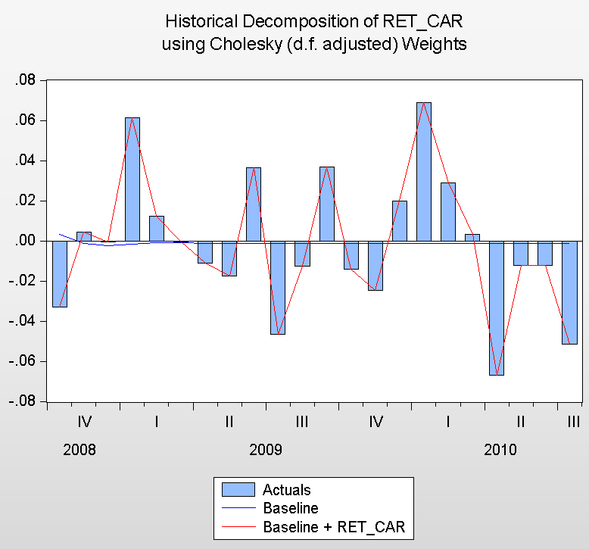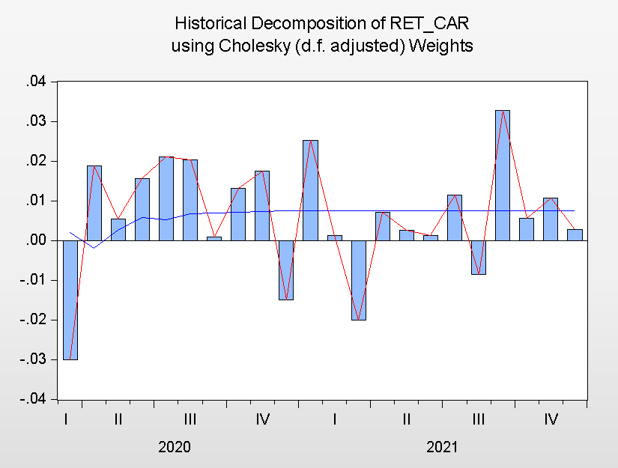
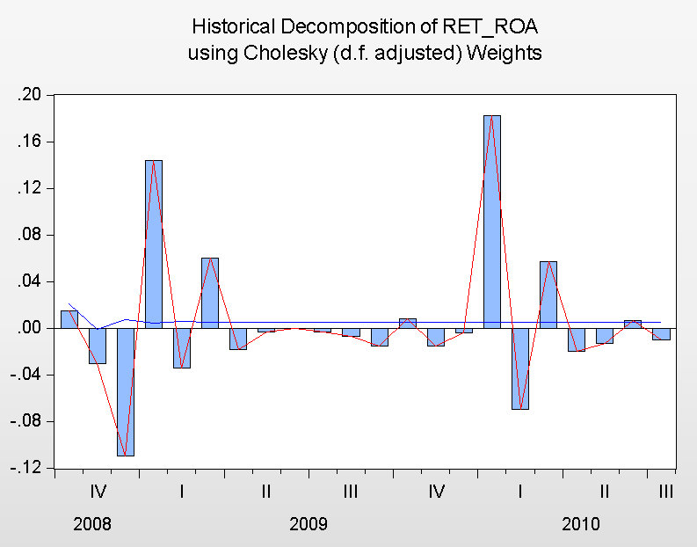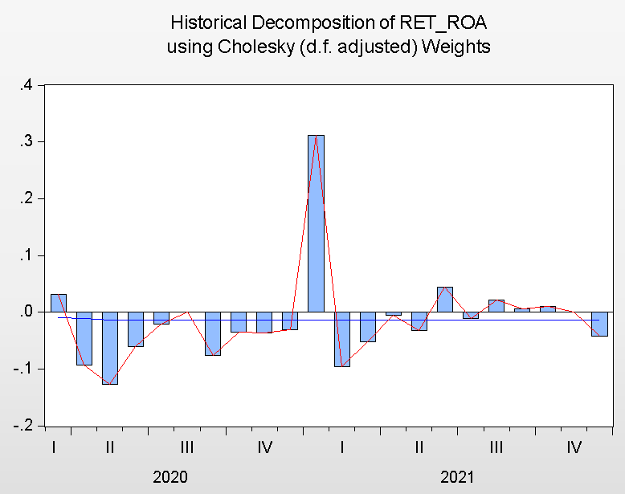
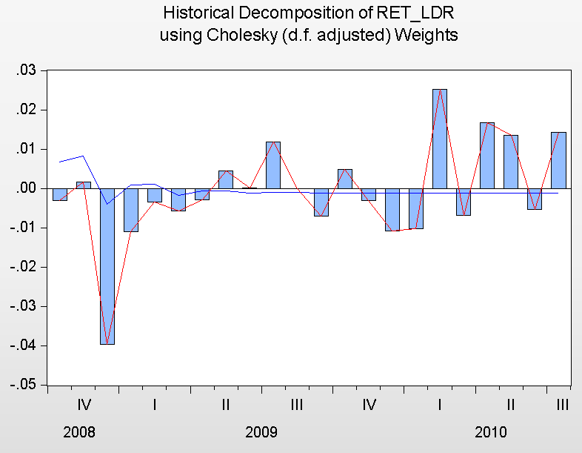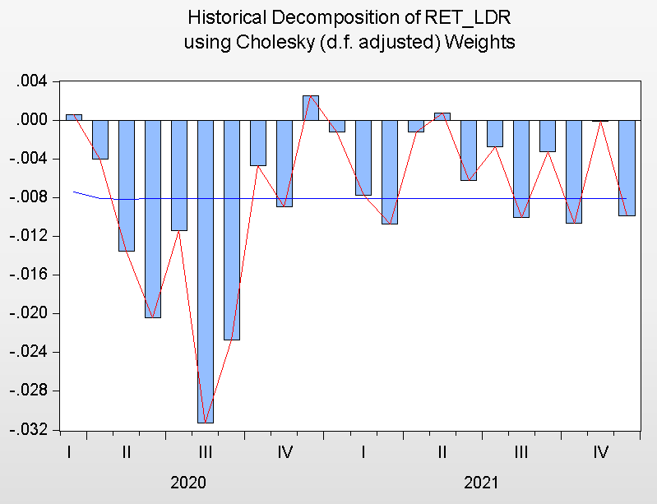
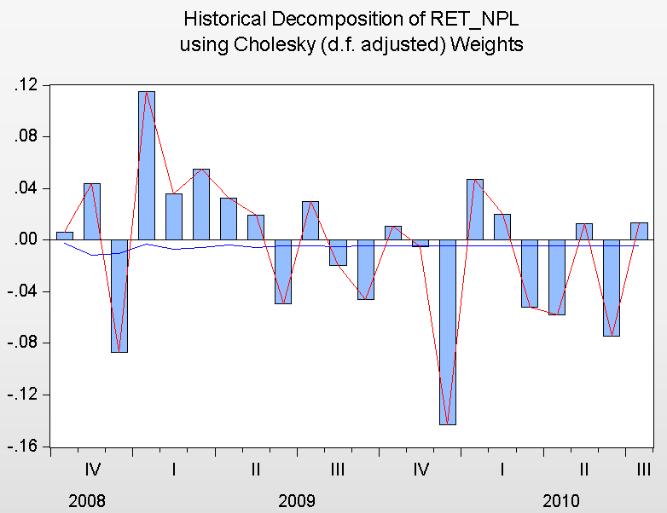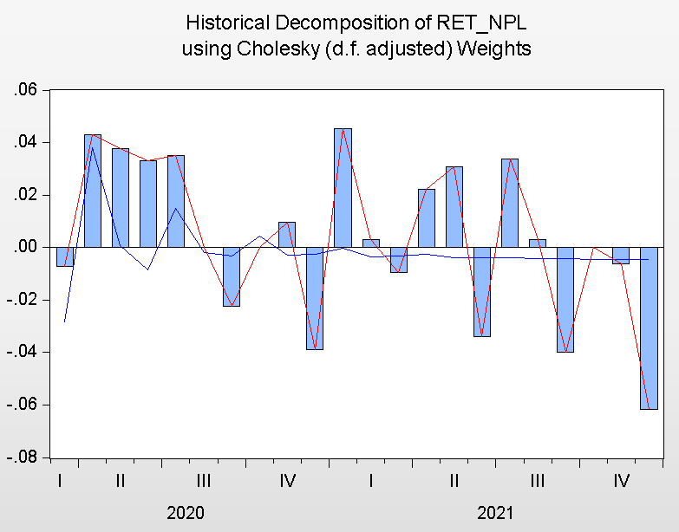

Figure 2 shows the historical decomposition graphs of each variable. In the CAR graph, there seems to be a drastic difference between both crises. In the financial crisis, its value mostly moved downward with few fluctuations, while during the pandemic, despite real economic recession, banks’ CAR ratio almost always increased–the opposite of the notion that is hypothesized in H1. The precarious position of CAR in the former period could have been caused by characteristic of the crisis’ origin wherein banks inadvertently took too many risks in its investment activity thus weakened its capital buffer when the losses were realized. However, considering that this crisis originated from the U.S. banking system and Indonesia did not have an excessive amount of U.S. based securities, the shock was experienced on a much smaller scale than the country of origin. Relatively, the growth of CAR tends to be consistently increasing during the pandemic. While it has the positive connotation for the banking system to be less likely to go bankrupt, it might also have the negative implication of excessive idle capital that didn’t actively utilized to produce profit.
ROA during the financial crisis had a similar pattern to the pandemic where it mostly had negative variations, their fluctuations are much smaller and there are comparatively more positive growth. While during the pandemic, it was dominated by negative movements on a larger scale with fewer positive variations. This shows that banking profitability consistently experienced downward growth more apparent during the pandemic. Similar pattern is also shown by historical decomposition of LDR growth where, although the average of the ratio during the pandemic is far above the financial crisis as demonstrated in the previous descriptive analysis, its movement is almost always consistently negative. This would support H2 but not H3. Even though they are still within the boundaries set by OJK about the ideal LDR ratio, the downward trend would suggest that banking during this period was not efficient in credit distribution.

Table 2. Historical Decomposition Test of Equality
 |  | CAR | ROA | LDR | NPL
Global Financial Crisis
 | Mean | -0.002 | 0.0064 | -0.0038 | 0.0001
 | Median | -0.0065 | -0.004 | -0.0065 | 0.015
 | Std. Dev | 0.0342 | 0.0619 | 0.0128 | 0.0572
Global Pandemic Crisis
 | Mean | 0.0054 | -0.0136 | -0.0098 | 0.0068
 | Median | 0.0055 | -0.025 | -0.0093 | 0.006
 | Std. Dev | 0.0153 | 0.0836 | -0.0082 | 0.0285
Welch test |  | -0.943  ( 0.351) | 0.9035  (0.371) | 1.8258*  (0.075) | -0.4867  (0.629)
Mann-Whitney test |  | 1.315  ( 0.188) | 1.2219  (0.221) | 1.421  (0.155) | 0.0352  (0.971)
*, **, and *** denote 10%, 5%, and 1% significance level, respectively

In Table 2 we see adjusted the returns through its historical stochastic decomposition and examine if the differences between the crises are statistically significant. CAR and NPL are larger in the pandemic crisis than in the financial crisis, but it is the other way around for ROA and LDR, which are larger in the financial crisis. It turns out that none of the variables are significantly different from each period. LDR has within 10% critical value difference in Welch test, but it’s no longer significant under the more robust Man-Whitney test, as such doesn’t support its hypothesis as well.

Figure 2. Impulse Reaction Graph

In Figure 2, the impulse response of changes in CAR return in the previous month tends to be neutralized within the next two months. This result does not support H1. Similar pattern applies to the pandemic period, with an even smaller first month’s reaction. According to Acharya dan Richardson (2009), the cause global financial crisis was American banks managing their business methods by dabbling on high risk financial activities while avoiding the penalty of minimum CAR, at least until the bubble bursted. In Indonesia, we also see high and volatile CAR values during this period. Although Indonesian banks did not experience as much deficit as the securitization loss in U.S., this volatility could suggest similar susceptibility on a smaller scale.
Impulse response of ROA return generally has similar overadjustment pattern in second period, although the pandemic period is much more stable. This supports H2. Response of LDR return during the pandemic is the most strikingly persistent one of all. Along with the descriptive analysis of negative mean of LDR changes, this implies more persistent decline during this period and as such, doesn’t support H3. A persistent response during the pandemic period is also shown in changes on NPL, which consistently above neutral point while in financial crisis period and all period have more spread out fluctuations. This doesn’t support H4.

Discussion
Financial crises are generally known to impact the banking sector by depleting their capital, cutting down credit distribution, increasing bad debts and lowering banks’ profitability. Dasih (2021) and Andreas (2021) argues that Indonesian banking system was deeply affected the covid-19 pandemic crisis that it experienced credit crunch where banks becomes heavily inefficient in its financial intermediary role of distributing credit, some of its indications are by high excess capital and low LDR. Sullivan dan Widoatmodjo (2021) notes rising NPL and lower profitability. On the other hand, Haryati (2009) and Johari (2014) didn’t find credit crunch happened during the 2008 financial crisis, although noted the increasing bad debts as well, the apparent difference is it depleted capital reserves and increased credit distribution instead, which led separate problem of increased risk of potential bankruptcy. Our study shows even though we checked that the base values of these capital, liquidity, and profitability measures are statistically very different, after putting adjusting their variations into their stochastic values of their return through historical decomposition analysis, we find their difference are not statistically significant.
This shows that despite the growth of capital and liquidity measures into opposing directions compared to each of their pre-crisis times, both the financial-sector and real-sector induced crises experiences similar impact on average.

CONCLUSION
During the pandemic crisis, Indonesian commercial banks had higher values of CAR and LDR yet lower values of ROA and NPL than the financial crisis. But in terms their returns in percentage changes each month, only LDR has statistically significant difference.
Generally, the CAR, ROA, and most notably LDR during pandemic crisis have less fluctuations during the pandemic than the financial crisis.
After adjusting for long term variations, the stochastic returns of CAR, ROA, LDR, and NPL of pandemic and financial crises are statistically equal on average.
Both crises have similar impulse response, although NPL shock during the pandemic persists the longest.
Our suggestions for the next researches of the topic of economic crisis impact on banking system are to include more complex model with the variables in question being endogenous to some others while controlling exogenous macroeconomic variables. Similar method may also be applied in larger sample of various world economic crises, although immense heterogeneity of each country would be obstacle.

REFERENCES
Acharya, V. V., & Richardson, M. (2009). Causes of the financial crisis. Critical review, 21(2-3), 195-210.
Andreas, Jansen, Eka Nurhalimatus Sifa (2021). Can Banking Credit Crunch Capture the Systemic Risk? Evidence in Indonesia During Covid-19 Outbreak. Bank Indonesia.
Büyükbaşaran, T., Can, G. K., & Küçük, H. (2019). Identifying Credit Supply Shocks in Turkey. Central Bank of the Republic of Turkey, Head Office, Structural Economic Research Department.
Christina, L., Siswanti, S., Hidayat, A., Maharini, Darwin (2022). Capacity Building in Indonesian Banking Sector: A Review on Sustainable Financial Affairs. MIX: Jurnal Ilmiah Manajemen, 12(2), 225-236
Darjana, D., Wiryono, S. K., & Koesrindartoto, D. P. (2022). The COVID-19 Pandemic Impact on Banking Sector. Asian Economics Letters, 3(Early View), 29955.
Dasih, K. Bank Capital dan Credit Crunch: Apakah Modal Memainkan Peran dalam Credit Crunch di Era Pandemi?.
Haryati, S. (2009). Pertumbuhan kredit perbankan di Indonesia: Intermediasi dan pengaruh variabel makro ekonomi. Jurnal Keuangan dan Perbankan, 13(2), 299-310.
Purba, N. N., Syaukat, Y., & Maulana, T. N. A. (2016). Faktor-Faktor Yang Memengaruhi Tingkat Penyaluran Kredit Pada Bpr Konvensional Di Indonesia. Jurnal Aplikasi Bisnis dan Manajemen (JABM), 2(2), 105-105.
Riani, R. (2021). Does COVID-19 Pandemic Affect Bank Credit Risk?. Ekonomi Islam Indonesia, 3(1).
Rosdiana, R. (2021). Analysis of the Effect of Stock Prices on Coal Sub- Sector on the Indonesia Stock Exchange 2014-2019. Dinasti International Journal of Economics, Finance & Accounting, 2(5), 528-539
Sitanggang (2019). CAR Perbankan Indonesia Paling Tinggi di Asia, Baik atau Buruk? Kontan. Diakses dari https://keuangan.kontan.co.id/news/car-perbankan-di-indonesia-paling-tinggi-di-asia-baik-atau-buruk
Sullivan, V. S., & Widoatmodjo, S. (2021). Kinerja Keuangan Bank Sebelum Dan Selama Pandemi (Covid–19). Jurnal Manajerial Dan Kewirausahaan, 3(1), 257-266.
Yuliana, A. (2014). Pengaruh LDR, CAR, ROA dan NPL Terhadap Penyaluran Kredit Pada Bank Umum di Indonesia Periode 2008–2013. Jurnal Dinamika Manajemen, 2(3), 169-186.

