The Determinants of Firm's Value through Capital Structure, Financial Performance, and Company Growth
(Case Study on the Agricultural Sector on the IDX 2016-2020)
Rahmah Alwan ¹⁾; Asep Risman²⁾

¹⁾ 43117110395@student.mercubuana.ac.id, Faculty of Economics and Business, Universitas Mercu Buana, Indonesia
²⁾ asep.risman@mercubuana.ac.id, Faculty of Economics and Business, Lampung University, Indonesia

Article Information:  Keywords:  Capital Structure;  Financial Performance;  Company Growth;  The Firm's Value;  Article History:  Received: Feb 2, 2023  Revised : Feb 18, 2023  Accepted: Feb 28, 2023  Cite This Article: | Abstract  This study aims to determine the influence of capital structure represented by Debt to Equity Ratio (DER), the financial performance represented by Return on Asset (ROA), and the growth of companies represented by Total Asset Growth (TAG) on the value of companies in the agricultural industry sector listed on the Indonesia Stock Exchange. The population used in this study was as many as 25 companies. The sampling method used is the purposive sampling method, so that 9 companies with 5 years of observation (2016-2020) were obtained so that 45 observational data were produced. The research data was obtained from the Indonesia Stock Exchange website. The data analysis techniques used are descriptive statistics and panel data. The results of the study partially showed that the capital structure (Debt to Equity Ratio) had a negative effect, financial performance (Return on Assets) had a positive effect, and company growth (Total Asset Growth) did not affect the value of the company.

INTRODUCTION
The agricultural sector plays an important role in national economic development and is one of the food providers for the community. Agriculture is the second largest supporting sector for the Indonesian economy, as recorded by the Central Statistics Agency (BPS) data, the gross domestic product (GDP) of the agricultural business sector at current prices (ADHB) in 2020 increased by 13.70% or an increase of 0.99 % over the previous year.
Agriculture sector companies are companies that process and utilize land to become useful land to meet needs. In Indonesia, agricultural sector companies consist of 6 sub-sectors: food crops and horticultural crops. Plantation crops, Livestock, Fisheries, (which consist of Aquaculture & capture fisheries), and Forestry. Agricultural sector companies also absorb many non-formal workers with low levels of human resources, to be employed on plantations or in companies' factories. A company is defined as an organization founded by individuals, groups of people, or other bodies. Companies carry out activities in the form of production and distribution with the aim of meeting human economic needs (Soemarso, 2004: 22).
In carrying out its business, every company strives to always be dynamic following market demands and opportunities as well as challenges that are increasingly developing which will affect the value of the company. According to Massie et al. (2017), a Firm’s Value is defined as the price that potential investors are willing to pay if a company is to be sold, Firm’s Value can reflect the value of company assets such as securities.
Firm’s value is also often interpreted as the value per share (Rose, 2012; Gitman, 2006), according to Ross et al. (2012) the goal of financial management is to maximize the present value per share of existing shares: "The goal of financial management is to maximize the current value per share of the existing shares". The higher the stock price, the higher the firm value, that by maximizing firm value means maximizing shareholder prosperity which is the company's goal (Maya, 2016).
One of the proxies of firm value is Tobin's Q method. Tobin's Q is a model as an investment decision maker where Tobin's Q summarizes future information that is relevant to a company's investment decisions. The company will increase its share capital if Q is high because if Tobin's Q is above 1, the company will generate a higher rate of return than that issued by the cost of assets (Damodaran, 2002).

LITERATURE REVIEW
Firm’s Value
A company is a legal entity whose activities accommodate and utilize various resources to produce products, goods, and services to have added value that can be offered and meet human needs and desires (Risman, 2021, p. 1).
According to Risman (2021), firm’s value is the present value of future cash flows, and future cash flows are influenced by risk factors that can cause the possibility of deviations. Firm’s value can also reflect the value of company assets, such as securities; the higher the firm's value indicates the greater the prosperity that will be received by the owner of the company.
Capital Structure Theory
The capital structure according to Mint Ha & Minh Tai (2017) is defined as the debt ratio and equity ratio to the company's total capital. The capital structure consists of short-term funding, long-term funding, and equity. Theories of capital structure that influence firm value are Traditional Theory, MM Theory, Signaling Theory, and Trade of Theory.
According to traditional theory, assumes that debt has a cost of capital that is cheaper than equity in fact, it is not absolute because the return expected by investors in the form of capital gains and dividends also depends on other factors for example, capital gains, general capital market conditions, and dividends depend on dividend policy. (not all company profits are used for dividends). MM II assumes that the capital structure is irrelevant or does not affect the value of the company, namely because there are no transaction costs, no agency costs, and no bankruptcy costs. And the signaling theory assumes that the capital market must be efficient, so that information, including the company's trust to be in debt, can be immediately responded to and reflected in the company's stock price. Meanwhile, Trade-Off explains that before reaching the maximum point, debt will be cheaper than selling shares because of the tax shield.
The research results of Pasaribu, et al. (2016) prove that capital structure has a negative effect on firm value, research by Siregar et al. (2019) and Putro & Risman (2021) also found that capital structure has a negative effect on company value, these studies show that an increase in capital structure (debt) will cause the company value to decrease. Based on these findings, the research hypothesis can be formulated as follows:
H1: Capital structure has a negative effect on firm’s value

Financial performance
According to Fahmi (2016), financial performance is an analysis carried out to see the extent to which a company has carried out using the rules of financial implementation properly and correctly. Company performance is a description of a company's financial condition which is analyzed using financial analysis so that it can be known about the good and bad financial condition of a company that reflects work performance in a certain period. This is very important so that resources are used optimally in dealing with environmental changes. According to Fahmi (2016), the benefits of performance appraisal are as follows:
- To measure the achievements achieved by an organization in a certain period which reflects the level of success in implementing its activities.
- Apart from being used to see an overall organizational performance, performance measurement can also be used to assess the contribution of a part in achieving overall company goals.
3) Can be used as a basis for determining the company's strategy for the future.
4) Guide in making decisions and organizational activities in general and divisions or parts of the organization in particular.
5) As a basis for determining investment policy in order to increase the efficiency and productivity of the company.
The results of Prena & Muliyawan's research (2020) state that financial performance has a significant positive effect on a Firm’s Value. Research conducted by Sri Mulyawati, et al (2015) showed the results that profitability has a positive effect on a Firm’s Value, and research conducted by Wawan Anggara (2019) shows results that profitability has a positive effect on a Firm’s Value. Based on these research findings, the research hypothesis can be formulated as follows:
H2: Financial performance has a positive effect on firm value

Company Growth
Company growth can be measured using asset growth or company sales growth. In this study, company growth is proxied through the growth of company assets. Asset growth is a change in the increase or decrease in the number of assets owned by a company in one period (Sugiyanti, 2017). Companies with high growth rates require larger funds to finance their operations. Internal funding sources may not be sufficient, therefore the company also needs external funds to be able to help the company's operations. A high level of sales growth shows the company's ability to generate stable profits.
The research results of Amanah (2020) and Wulanningsih & Agustin (2020) show that the company's growth rate has a positive effect on company value. Research conducted by Eli Safrida (2017) found results that the company's growth rate has a positive effect on firm value. Based on the results of these research findings, the research hypothesis can be formulated as follows:
H3: Company growth has a positive effect on firm value

METHOD
Research data
This study uses a ratio measurement scale. The population in this study are agricultural sector companies listed on the Indonesia Stock Exchange (IDX) in 2016-2020. The samples used in this study were 9 companies, with a total of 25 companies. The sampling technique used in this research is the purposive sampling method. Purposive sampling is a sampling technique with certain considerations. The data collection method used in this study is the literary method, namely by processing various literature from sources relevant to the research theme, and the documentation method, namely in the form of secondary data obtained from the official website of the Indonesia Stock Exchange.

Conceptual Models
The following is the development of a conceptual model of multiple regression analyst as Follows :
Figure 1. Conceptual Model
Capital Structure (X1)

The Firm’s Value (Y)

Financial Performance (X2)

Company Growth (X3)
Research design

This research is descriptive causality research, and the type of data used is quantitative or secondary data, namely using financial reports obtained from the official website of the Indonesia Stock Exchange or IDX. The method of analysis used is the panel data regression analysis method with the help of Eviews software version 10. The panel regression model of this study is as follows:
Yit = β₀ + β ₁ X 1it + β ₂ X 2it + β₃X _{3it} + e_{itu}
Information:
Y = Dependent Variable (Firm’s Value)
β0 = Constant
X1 = Independent Variable 1 (capital structure)
X2 = Independent Variable 2 (financial performance)
X3 = Independent Variable 3 (company growth)
β1 β2 β3 = Regression coefficient of each independent variable
e = Error Term = Time
iI = Company

In this study, the dependent variable used is Firm Value (Y), while the independent variables are Capital Structure (X1), Financial Performance (X2), and Company Growth (X3). The data analysis method used in this study is Descriptive Analysis, Stationarity Test, and Classical Assumption Test. Panel data regression method used in this study is the Common Effect Model, Fixed Effect Model, and Random Effects. The technique used is Chow Test, Hausman Test, Lagrange Multiplier Test, Test Model Feasibility (F Test), and Hypothesis Test (t-test).
RESULTS AND DISCUSSION
Descriptive Analysis
Table 1. Descriptive Statistical Analysis
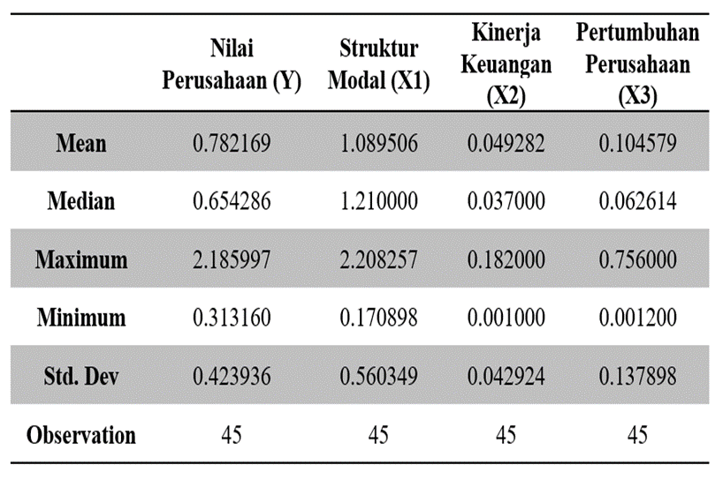
Source: Output results using Eviews 10 (2022)
Based on the results of the descriptive analysis test in table 1. In the descriptive statistical analysis test, it can be seen that the mean value of the firm value or Y variable is 0.78. Then the maximum value of 2.18 is owned by PT. BISI Internasional Tbk in 2016. Then the minimum value of 0.31 is owned by PT. Salim Ivomas Pratama Tbk in 2017.
The mean value for the capital structure or variable X1 is 1.08. The maximum value of 2.20 is owned by PT. Dharma Satya Nusantara Tbk in 2018. While the minimum value of 0.17 is owned by PT. BISI Internasional Tbk in 2016.
The mean value for financial performance or variable X2 is 0.04. The maximum value of 0.18 is owned by PT. Tunas Baru Lampung in 2017. While the minimum value of 0.001 is owned by PT. Sawit Sumbermas Sarana Tbk in 2019.
The mean value for company growth or variable X3 is 0.10. The maximum value of 0.75 is owned by PT. Sampoerna Agro Tbk in 2018. While the minimum value of 0.001 is owned by PT. Dharma Samudra Fishing Industry Tbk in 2019.

Normality Test
Table 2. Results Normality Test
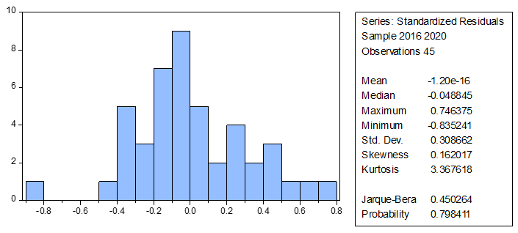
Source: Output using Eviews 10 (2022)
Based on table 2, it can be seen that the probability value of Jarque-Bera is greater than 0.05, which is 0.798411. So, the data used in this study are usually distributed, which means that the classical assumption test is related to the normality test fulfilled.
Multicollinearity Test
Table 3 .Multicollinearity Test Results
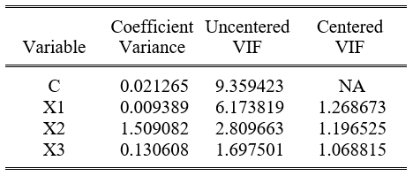
Source: Output of Eviews 10 (2022)
Table 3 shows that the results of the multicollinearity test are the three variables show a VIF value of less than 10 which concludes that the regression model is not there is a multicollinearity problem.
Uji Heterokesdastisitas
Table 4. Heteroscedasticity Test Results
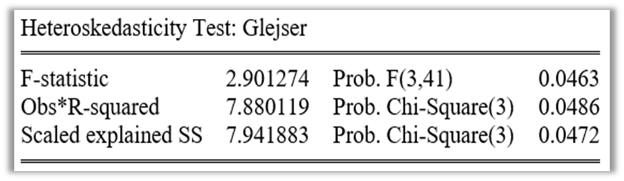
Source: Output of Eviews 10 (2022)
From the results of table 4, it shows that the heteroscedasticity test uses the Glesjer test seen that the probability value of Chi-Square (3) is smaller than 0.05, which is equal to 0.0486 which it was concluded that in this study there were no symptoms of heteroscedasticity.
Panel Data Regression Model Selection
Table 5 . Regression Model Selection test results
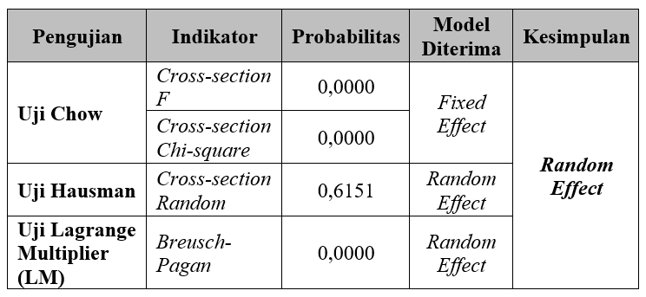
Source: Output of Eviews 10 (2022)
Table 5 shows the results of the regression model selection test and the selected model is a random effect model. The multiple regression equations (random effect model) are as follows: Y = 0.721116 - 0.219696 X1 + 2.772832 X2 + 0.032915 X3 + ε
Model Feasibility Test
Table 6 . F test results
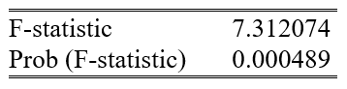
Source: Output using Eviews 10 (2022)
Based on table 6, the feasibility test of the model through the F test. It can be seen that the probability value (F-statistic) is 0.000489, smaller than the significance level of 0.05, and the F value of the count is 7.312074, greater than the F-table which is 2.83. It can be concluded that there is a simultaneous influence between Capital Structure, Financial Performance, and Company Growth on the Firms Value variable.
Research Hypothesis Test
Table7. T-test results
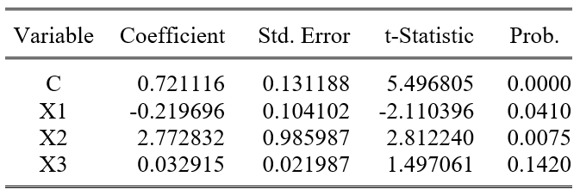
Source: Output of Eviews 10 (2022)
Based on table 7, the hypothesis test or t-test can be seen that the capital structure or X1 hurts the firm value or Y because the probability value is smaller than 0.05, namely 0.0410. Then the effect is negative because the resulting coefficient value is negative, namely -0.2196. The use of debt will increase the value of the company but only up to a certain point. Because the higher the proportion of debt set by the company at a certain level, the higher the value of the company, but if the level of the proportion of debt exceeds the proportion of debt set by the company then what happens is a decrease in the value of the company. The results of this study are in line with research conducted by Siregar, et al. (2019), Rahman and Sunarto (2019), and also Trisnawati, et al. (2020) who found that Capital Structure hurts Firm Value.
Then it can also be seen that financial performance or X2 has a positive effect on the firm value or Y because the probability value is smaller than 0.05, namely 0.0075. Then the resulting influence is positive because the resulting coefficient value is positive 2.7728. The higher the profit or level of profit earned company, the market will give the perception that the company is working well and will increase the demand for the company's shares which has a direct impact on increasing the value of the company. The results of this study are in line with research conducted by Rahman and Sunarto (2019), Prena and Muliyawan (2020), and also Wulanningsih and Agustin (2020) who found that financial performance has a positive effect on firm value.
Furthermore, the growth of the company or X3 does not affect the value of the company or Y because the probability value is greater than 0.05, namely 0.1420. For companies with a large growth rate of total assets, an increase occurs from an increase in the amount of corporate debt. An increase in the amount of debt will certainly be a burden for the company so the company must pay this burden from the profits earned each year. This condition results in a smaller dividend distribution policy for capital owners, which will reduce the response of investors in the stock market to company shares. The results of this study are in line with research conducted by Meidiawati and Mildawati (2016) which states that asset growth does not affect firm value.

CONCLUSION
This study aims to analyze the influence of Capital Structure, Performance Finance, and Company Growth on a Firm’s Value in the Agricultural sector listed on the Indonesia Stock Exchange for the 2016-2020 period, based on the results of this study produce the following conclusions: The first, increasing in debt actually encourages negative perceptions of investors that when the use of debt has reached a maximum point, then the use of debt by companies becomes unprofitable because companies have to bear agency costs, bankruptcy, and interest costs which cause the value of the company to fall. The third finding is that high growth causes the need for funds to increase, besides that the greater the company's growth rate, the higher the costs required for investment. Therefore, the higher the company's growth rate, the fewer funds are available to be distributed to shareholders. Investors have more confidence in companies that are already established and not growing. Therefore, even though the company's growth rate is high, it will not affect investor confidence so it will not affect the firm’s value either.

SUGGESTION
Based on the results of the research and discussion, several suggestions can be made submit is as follows:
- Companies in the agricultural sector are expected to be able to fulfill and optimize short-term and long-term debt obligations. When the Debt to Equity Ratio (DER) has decreased or is at its optimal point, the value of the company will increase which will have a good impact on the company, but vice versa, if The Debt to Equity Ratio (DER) has increased or exceeded its optimal point the value of the company will decrease which results in the value of the company, will decrease.
- For investors or potential investors. Investors must choose a company that has a good capital structure as a place to invest and generate maximum profits by understanding the financial reports of the company that will be invested as an investment.
- For further research. Further research should increase the sample research and add other independent variables that may affect firm value apart from the variables used in this study, and also put more emphasis on the analysis of the 2021 financial reports and Q1 financial reports 2022 so that causal-comparative research can be made and the differences in results between them can be seen before and after the pandemic, to obtain maximum results.

REFERENCE
Afandi, 2020, Pengaruh Return Ekuitas, LDER, Keputusan Investasi, dan Deviden Payout Ratio Terhadap Nilai Perusahaan.
Amalia, F. N, 2016, Analisis Faktor-Faktor yang Mempengaruhi Struktur Modal Perusahaan LQ 45 yang Terdaftar di Bursa Efek Indonesia. Skripsi, Universitas Negeri Yogyakarta, Yogyakarta.
Amanah 2020, Pengaruh Pertumbuhan Perusahaan dan Keputusan Investasi Terhadap Nilai Perusahaan Dengan Profitabilitas Sebagai Variabel Intervening.
Minh Ha, Nguyen and Minh Tai, Le. (2017). Impact of Capital Structure and Cash Holdings on Firm Value: Case of Firm Listed on the Ho Chi Minh Stock Exchange. International Journal of Economic and Financial. Vol. 7 (1), 24-30
Brealey, Richard A., Myers, Stewart C dan Marcus, Alan J., 2011, Dasar-Dasar Manajemen Keuangan Perusahaan. Jilid 2, Terjemahan oleh Bob Sabran. Jakarta: Erlangga.
Brigham, E. F., & Houston, J. F, 2011, Dasar-Dasar Manajemen Keuangan Buku 2. Jakarta: Salemba Empat.
Fahmi, Irham, 2016. Pengantar Manajemen Keuangan. Bandung: Alfabeta.
Fara 2020, Kepemilikan Institusional, Struktur Modal, Keputusan Investasi, dan Kinerja Keuangan Terhadap Nilai Perusahaan.
Ibrahim, Mahmoud, 2017, “Capital Structure and Firm Value in Nigerian Listed Manufacturing Companies: an Empirical Investigation Using Tobin's Q Model”. International Journal of Innovative Research in Social Sciences & Strategic Management Techniques, Vol. 4, No. 2, Hal. 112-125.
Pasaribu, M. Y., & Sulasmiyati, S. (2016). Pengaruh Struktur Modal, Struktur Kepemilikan dan Profitabilitas Terhadap Nilai Perusahaan pada Perusahaan Sektor Industri Dasar dan Kimia yang Terdaftar di BEI Tahun. Jurnal Administrasi Bisnis (JAB)| Vol, 35(1).
Mumtazah & Purwanto, 2020, Analisis Pengaruh Kinerja Keuangan dan Pengungkapan Lingkungan Terhadap Nilai Perusahaan.
Praytino, R. H., 2010. Peranan Analisa Laporan Keuangan dalam Mengukur Kinerja Keuangan Perusahaan: Studi Kasus pada PT. X. Jurnal Manajemen UNNUR Bandung Volume 2 No.1. Universitas Nurtanio. Bandung.
Prena & Muliyawan, 2020, Pengaruh Kinerja Keuangan terhadap Nilai Perusahaan dengan Pengungkapan Corporate Social Responsibility Sebagai Variabel Pemoderasi.
Putro, D. C., & Risman, A. (2021). The Effect of Capital Structure and Liquidity on Firm Value Mediated by Profitability. The EUrASEANs: journal on global socio-economic dynamics, (2 (27)), 26-34.
Rahman & Sunarto, 2019, Analisis Pengaruh Struktur Modal Terhadap Nilai Perusahaan Dengan Profitabilitas Sebagai Variabel Intervening.
Ramadhan, Widiastuti, & Fahria, 2020, Pengaruh Kinerja Keuangan, Ukuran Perusahaan dengan Corporate Social Responsibility Sebagai Variabel Moderating Terhadap Nilai Perusahaan.
Risman, A., Ali, A. J., Soelton, M., & Siswanti, I. (2023).The Behavioral finance of MSMEs in the advancement of financial inclusion and financial technology (Fintech). The Indonesian Accounting Review, 13(1), 91-101. doi:http://dx.doi.org/10.14414/tiar.v13i1.3213
Risman, 2021, Kurs Mata Uang dan Nilai Perusahaan , Purwokerto: CV. Pena Persana, Hal. 4-10.
Risma Azizah dan Regi Muzio Ponziani, 2017, Nilai Perusahaan Pada Perusahaan Non Keuangan Yang Terdaftar di BEI, Jurnal Bisnis dan Akuntansi, ISSN: 1410-9875, Vol.19, 200-2011.
Risman, A., Parwoto & Sulaeman, A., (2020).. The Mediating Role of Firm’s Performance on The Relationship between Free Cash Flow and Capital Structure, Psychology and Education Journal, Vol. 58 No. 1: 1209-1216..
Selin Lumoly, Sri Murni dan Victoria N. Untu, 2018, Pengaruh Likuiditas, Ukuran Perusahaan dan Profitabilitas Terhadap Nilai Perusahaan (Studi pada Perusahaan Logam dan Sejenisnya yang Terdaftar di Bursa Efek Indonesia), Jurnal EMBA, ISSN: 2303-1174 Vol. 6, 1108-1117.
Septyaningsih, V., & Risman, A. The Effect of Profitability and Free Cash Flow on Capital Structure Moderated by Firm Size (Studyon Food and Beverage Sub-Sector Companies on the IDXin 2011-2018).
Siregar, M. E. S., Dalimunthe, S., & Safri, R., 2019, Pengaruh Profitabilitas, Ukuran Perusahaan, Kebijakan Dividen dan Struktur Modal Terhadap Nilai Perusahaan pada Perusahaan Manufaktur yang Terdaftar di Bursa Efek Indonesia Periode 2015-2017.
Sugiyanti, 2017, Analisis Faktor-Faktor yang Mempengaruhi Struktur Modal pada Perusahaan Manufaktur yang Terdaftar di Bursa Efek Indonesia. Skripsi, Universitas Negeri Yogyakarta, Yogyakarta.
Trisnawati, Mardani, & Rizal, 2020, Pengaruh Struktur Modal, Kebijakan Dividen Dan Inflasi Terhadap Nilai Perusahaan (Studi Kasus Pada Perusahaan Sub Sektor Tekstil Dan Garmen Di Bei Pada ahun 2016-2018)..
Wulanningsih & Agustin, 2020, Pengaruh Investment Opportunity Set, Pertumbuhan Perusahaan dan Profitabilitas Terhadap Nilai Perusahaan.
Zani, J., Leites, E. T., Macagnan, C.B., & Portal, M. T., 2013, Interest on Equity and Capital Structure in the Brazilian Context. International Journal of Managerial Finance, Vol. 10 No.1, pp. 39-53.

