Business Intelligence Strategy for Company Business Development Using Online Analytical Processing

Rio Afrianda¹, Veithzal Rivai Zainal², Indra Siswanti³

¹⁾ rio.sttpln@gmail.com, Faculty of Economics and Business, Mercu Buana University
²⁾ veithzal147@gmail.com, Faculty of Economics and Business, Mercu Buana University
³⁾ indrasiswanti3@gmail.com, Faculty of Economics and Business, Mercu Buana University

Article Information:  Keywords  Business Intelligence,  Online Analytical Processing  Article History:  Received January 31, 2023  Revised : Pebruary 15, 2023  Accepted : March 2, 2023  Article Doi:  http://dx.doi.org/10.22441/indikator.v5i1.1123 | Abstract in English  The purpose of this article is to discuss Business Intelligence and its role in increasing a company's competitive advantage through the utilization of various data, information and knowledge owned by a company as a raw material in the decision-making process. The method used in this article uses Online Analytical Processing. The results of the research are (1) data analysis has become a major and vital requirement in efforts to increase the business competitiveness of an organization or company; (2) entrepreneur-style decision making that tends to rely on intuition becomes less suitable in the midst of an increasingly competitive and complicated business environment; (3) BI is an e-business application that functions to convert data within the company (operational, transactional, and other data) into a form of knowledge; (4) BI emphasizes the implementation of the 5 utilization of information for the purposes of data sourcing, data analysis, situation awareness, risk analysis, and decision support.

INTRODUCTION
Increasing global market flows, intense competition, increasing transaction speed, dynamic changes in market conditions and diverse customer needs, all market players and companies are facing new challenges. In the long term, companies are required to be able to adapt to these conditions in order to survive. Companies are also required to be able to respond flexibly and quickly to changes in the business environment that change very quickly and at the same time keep company costs under control. To be able to survive in the long term, the company must adopt the right knowledge so that with this, the company must be the company and the current market. Regarding dealing with changing situations, providing information systems was developed to build systems. Various sophisticated communication approaches are needed by management in planning and decision making (Chamoni, P. and Gluchowski, P. (2010).
In recent years, BI has become an important issue among global companies related to the use of information technology (information technology) as an important decision-making within the company. By using an enterprise system, it is facilitated in BI, collecting data and processing important company business information. Not only company leaders, by using BI, employees will also be able to make better decisions and achieve the required results more quickly. Another advantage of BI systems is that companies can make their customer and supplier relationships more profitable, reduce costs, minimize risks, and increase added value. Without the presence of a BI system, large amounts of company data will be meaningless and will ultimately complicate the company's business processes. (Kemper, H. G. and Baars, H. (2006).
Previously, only a few large companies showed interest, but now the use of BI for the smooth running of company business is becoming increasingly attractive to many companies. Because by utilizing BI all potential data and information can be extracted to be used for important company decisions. In the global market it is very easy to find cheap and affordable BI software for use by many companies. For example, BI software created by SAP, Oracle, IBM, SAS, Microsoft, and from open source sources that can be utilized by companies (Maier, R. (2004).
There are several problems that demand and encourage the development of BI applications, namely as follows, (1) how to collect and organize all internal company data in an Integrated Enterprise Information (data warehousing); (2) how to utilize company data into deep knowledge
company (data analytics); (3) how to provide customer-oriented knowledge (customer-centric), both different and specific information for each customer; (4) how analysis of company data can provide support for decision-making on the part of company management in accordance with the data; (5) what are the procedures and processes for integrating BI into the company's business processes; (6) factors that must be considered so that companies can integrate BI by considering the risks and difficulties that may be encountered.

LITERATURE REVIEW
The term Business Intelligence (BI) was first introduced by an analyst from the Gartner Group, Howard Dressner, around the mid-1990s. BI is defined as a collective term for the concepts and methods that support decision making through the analysis, delivery and processing of information. Until now, BI has become widespread in business practice and is widely used in many companies. However, the term BI still exists in disagreement in various academic circles. This difference in understanding the term BI has resulted in various definitions of BI being interpreted differently. In 1996, Business Intelligence (BI) was defined as data analysis, reporting, and data search tools that can help business users manage the abundance of data to turn data into information used in decision making (Anandarajan, Srinivasan, and Anandarajan, 2004).
First, the readiness of the company to answer questions that are questionable. BI provides an opportunity to answer problems in the company's business related to the use of company information. BI can analyze dynamic and changing data and information structures, create new combinations of information and only see changes based on existing data patterns. If the basic structure of the information is well structured, the technical conditions and organizational data can provide accurate information for corporate decision making (Zeng, L., Xu, L., Shi, Z., Wang, M. and Wu, W. ( 2006).
Business Intelligence (BI) increases the company's competitive advantage through the utilization of various data, information and knowledge owned by the company as raw material in the decision-making process. Unlike a number of other applications with similar purposes that were previously introduced, the BI concept emphasizes the application of 5 utilization of information for the first purpose, data sourcing. Related to the system's ability to access various data and information from a number of sources with different formats. Second, data analysis. Related to the ability of the system to assist the process of creating knowledge (knowledge) through data and information review activities owned by the company. Third, situation awareness. Related to the system's ability to search for and provide data and information related to business needs or contexts at certain times, for example when a company is fourth, risk analysis. Related to the ability of the system to calculate the ratio that will be faced by the company against various trends or possibilities that can occur in connection with certain conditions. Fifth, decision support. Related to the ability of the system to actively assist management in providing quality considerations based on a number of calculations and processing of internal and external data or information. Data mining is the process of analyzing data with an emphasis on finding hidden information in large amounts of data stored when running a company's business (Stackowiak, R., Rayman, J. and Greenwald, R. (2007).
Data mining techniques are specific implementations of algorithms, which are used in data mining operations. There are 6 common data mining techniques, including the following. First, associations. Used to identify the behavior of specific events or processes. The association link appears on every occurrence. Second, sequences. Similar to association, but linking events- Third, looking at the behavior and attributes of groups that have been data mining on new data by manipulating existing data, which is to provide a number of rules. These rules use supervised induction, which utilizes the test set of records to determine additional classes. Fourth, clusters. Can be used to analyze the grouping of data mining tools. Usually using neural network or statistical methods. Clustering divides items into groups based on what data mining tools find. Fifth, regression (forecasting). Uses values ​​from known data to estimate future values ​​or future events based on historical and statistical trends. Sixth, time series (Barc, 2012)
Data mining tools enable the building of analytical models which are the tools used during data mining operations. The results of data mining operations are tables with queries and reporting tools. There are 4 common data mining operations, namely as follows. First, predictive and used to predict have specific questions to ask. The model that determines the similarity of certain classes. Second, link analysis. Look for relationships between records in the database. Third, database segmentation. Group related records into segments. This grouping is the first step of data selection, before other data mining operations are carried out. Fourth, deviation detection. Look for records that are considered abnormal and provide reasons for the anomaly. as follows. First Step 1 is a business case assessment. Second, planning. Step 2 is enterprise infrastructure; step 3 is project planning. Third, business analysis. Step 4 is the project step 5 is data analysis; step 6 is application prototyping; step 7 is meta data repository analysis. Fourth, design. Step 8 is database design; step 9 is extract/transform/ load (ETL) design; step 10 is meta data repository design. Fifth, construction. Step 11 is ETL development; step 12 is application development; step 13 is data mining; step 14 is meta data repository development. Sixth, deployment. Step 15 is implementation; step 16 is release evaluation (Chamoni, P. and Gluchowski, P. (2010)
One of the tools used for developing Business Intelligence is SQL Server 2005, which consists of integration services, analysis services, and reporting services.

Table 1 Three Stages of BI Process on SQL Server 2005
Integration Services | Analysis Services | Reporting Services
- Data acquisition from source systems and integration | - Data enrichment with business logic, hierarchical views | - Data presentation and distribution
- Data | - Data discovery via data mining | - Data access for the masses

BI development process in SQL Server 2005 is divided into 3 stages, namely as follows. First, integration. This stage is the process of integrating various data from various sources and entering it into the data warehouse. Data from operational systems is validated, extracted, summarized, or given a certain formula according to the results of business analysis. This process is also known as extract, transform, loading (ETL) which uses SQL Server Integration Services (SSIS). Data sources are not limited to SQL Server, but also Oracle, and all ODBC or OLEDB compatible data sources. The data integration process is not just importing from data sources, but also includes validation, aggregation and calculation processes using various desired formulas. With this process, the data entered into the data warehouse is really ready to be analyzed. Second, analysis. In this stage, the data in the data warehouse is analyzed using Analysis Services. Analysis Services is a tool that contains various data mining and OLAP (Online Analytical Processing) methods. In the process of data mining, SQL Server 2005 provides 7 statistical methods that can be used to analyze data, namely Microsoft Association Rules, Microsoft Clustering, Microsoft Decision Trees, Microsoft Linear Regression, Microsoft Logistic Regression, Microsoft Naive Bayes, and Microsoft Neural Networks. Third, the presentation of reports. Reporting services are the main media in the report presentation stage. This tool is available in SQL Server 2005 and integrated with Business Intelligence Development Studio. On the server side, there is a report server that serves the processing and display of reports for end users. The reporting service runs in a web browser making it very easy to distribute on the intranet. Thus, there are no components that must be installed on the client side (M. Choirul Amri (2006).
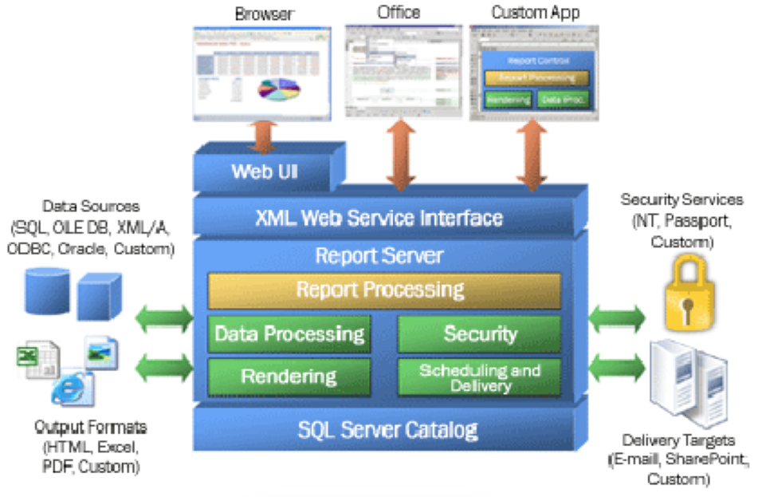
Figure 1 Reporting Service Architecture
Source: M. Choirul Amri (2006), Business Intelligence with SQL Server 2005 Making Data Meaningful

METHOD
In business, it is very important to have high-quality information that shows key performance indicators / Key Performance Index (KPI) as a basis for decision making. The biggest problem is utilizing and aggregating stored data in the process of storing data according to predetermined criteria. This process also includes components that enable Online Analytic Processing (OLAP) and data mining (Data Mining) components used to detect specially prepared for presentation of analysis results to users. For this purpose, different concepts are used, such as OLAP processing for a specific application or for a specific report. The following figure describes each process indicating which components are included in the Business Intelligence process step (Mertens, P, 2002).
Online Analytical Processing (OLAP) is the key to BI, used to enhance business analysis, is a Decision Support System (DSS) and Expert Information System (EIS) calculation performed by end-users in online systems. OLAP is used in many applications, from enterprise reporting to DSS. Some of the activities carried out by OLAP include generating queries, requesting ad hoc reports, supporting statistical analysis, interactive analysis, and building multimedia applications. To facilitate OLAP, a data warehouse is needed with a set of tools that have multidimensional capabilities. These tools can be in the form of query tools, spreadsheets, data mining tools, and data visualization (Suefert, A., and Schiefer, J, 2006)
Intelligent Business is about how to move the BI system to the core of the company and connect it to the operational system so as to reduce the possibility of implementing industry standard mechanisms (reducing operational costs). There are several ways to integrate BI into the company, including integrating analysis applications with operational applications using the company portal so that users can access and use them both internally and externally; unify analysis on operational applications during application development; introduction of web services to dynamically integrate analysis processes with internal and operational application partners to support sales collaboration; and build event-driven on-demand processes for user alerts, real-time recommendations and automated actions. This approach includes Business Activity Monitoring (BAM). (Tvrdikova, M, 2007)
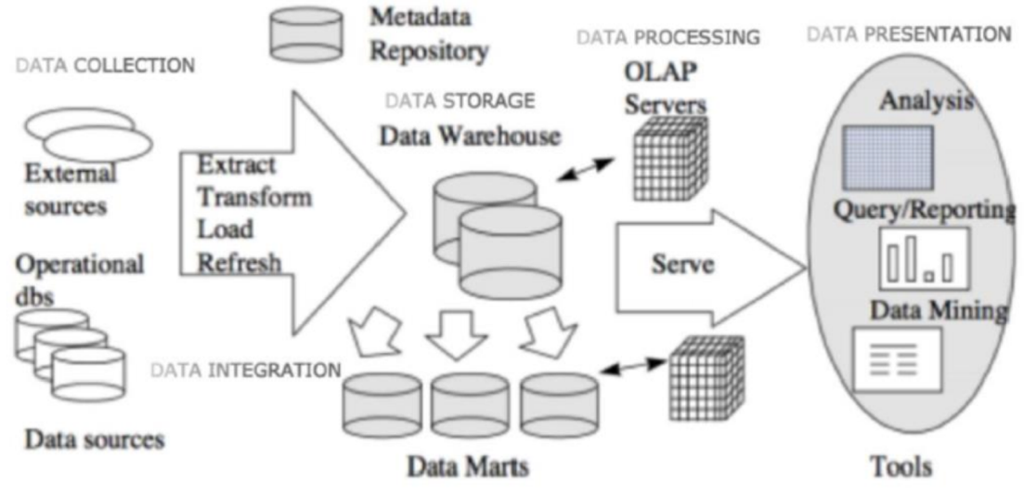
Figure 2 Intelligence Business Process
Source: Wang, J., Chen, T. and Chiu, S. (2005)

The main difficulty of implementing BI is its integration with the company, especially its business processes. The following are problems that may be encountered and can cause failure to integrate BI, namely (1) confusion about the meaning of the data, for example because there is no general understanding of the data; (2) changes in annual business goals even though the goals set in the previous year have not been achieved, the Business Intelligence application is unable to keep up with changes in the company's irregular goals; (3) inability to determine business scale due to lack of business process integration and automation. Fixed costs always increase along with the increase in business scale and a little variable cost. As a result, operational costs are too high due to too many manual activities and process errors due to non-integrated systems; (4) users of a system are not notified of events that occur in other systems; (5) not reacting directly to events in operational business processes, for example changes, order cancellations, late payments, out of stock, resulting in reduced business opportunities and inability to respond to problems when they arise; (6) re-matching data into different systems; (7) large, fragmented, and inconsistent data redundancy across different systems; (8) customer service, marketing and sales on different channels. (eBizzAsia, 2004).
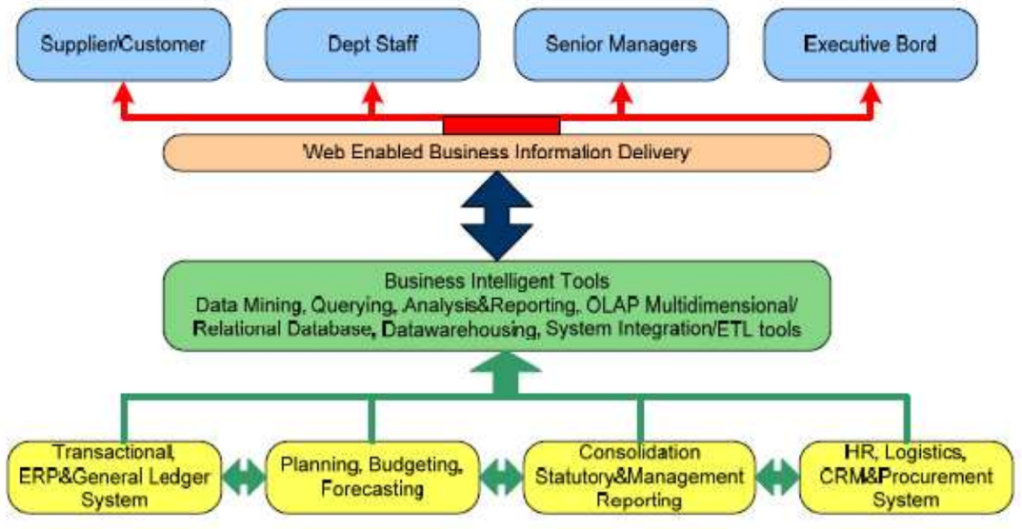
Figure 3 Buiness Intelligence in the Information Systems Architecture Framework
Source: eBizzAsia, 2004

Business Intelligence enables decision makers to act based on intelligence by using BI strategies. If knowledge or information is not used properly and in the right direction, then BI analysis is difficult to do. Business intelligence contains strategies to improve the operation of these business processes. Implementation of a BI system in a company or organization requires large investment costs incurred to build and implement BI systems and applications related to them. The highest leadership of an organization or company needs to create a Return on Investment (ROI) model to analyze the costs required for the implementation and maintenance of the BI model and determine methods to return investment costs that have been incurred quick. Appropriate business actions need to be carried out based on the strategy of the intelligence model. Sometimes BI models and wrong assumptions in making BI models can reduce the benefits that should be obtained from using the BI system itself. If the BI model has been designed properly and in accordance with the needs and goals of the organization or company, then the profit will be obtained by the company in accordance with the costs that have been incurred. (eBizzAsia, 2004)

RESULTS AND DISCUSSION
Business Intelligence (BI) from the discussion, namely (1) data analysis has become a major and vital requirement in efforts to increase the business competitiveness of an organization or company; (2) entrepreneur-style decision making that tends to rely on intuition becomes less suitable in the midst of an increasingly competitive and complicated business environment; (3) BI is an e-business application that functions to convert data within the company (operational, transactional, and other data) into a form of knowledge; (4) BI emphasizes the implementation of the 5 utilization of information for the purposes of data sourcing, data analysis, situation awareness, risk analysis, and decision support; (5) BI is a process that collects and transforms large amounts of existing data within an organization into useful information. The BI environment includes business models, data models, data sources, ETL, tools to organize and transform data into useful information, target data warehouses, data marts, OLAP analysis and reporting tools; (6) the analysis process functions to change raw data or summary data in the data warehouse into information for the company; (7) the information generated by the analysis can be utilized by a decision support system which is a source in making decisions on the part of management. To integrate BI into the company's business processes, it is necessary to carry out several Deployment system development cycle processes); (8) so that companies can integrate BI, several factors need to be considered, including understanding company goals, understanding the importance of this BI application to users, and positioning this BI application with other systems within the company; (9) implementation of a BI system in a company or organization requires large investment costs incurred to build and implement a BI system and applications related to it. The top management of an organization or company needs to create a Return on Investment (ROI) model to analyze the costs required for the implementation and maintenance of the BI model and determine methods to return investment costs that have been incurred immediately.

CONCLUSIONS AND SUGGESTIONS
Business Intelligence (BI) from the discussion, namely (1) data analysis has become a major and vital requirement in efforts to increase the business competitiveness of an organization or company; (2) entrepreneur-style decision making that tends to rely on intuition becomes less suitable in the midst of an increasingly competitive and complicated business environment; (3) BI is an e-business application that functions to convert data within the company (operational, transactional, and other data) into a form of knowledge; (4) BI emphasizes the implementation of the 5 utilization of information for the purposes of data sourcing, data analysis, situation awareness, risk analysis, and decision support; (5) BI is a process that collects and transforms large amounts of existing data within an organization into useful information. The BI environment includes business models, data models, data sources, ETL, tools to organize and transform data into useful information, target data warehouses, data marts, OLAP analysis and reporting tools; (6) the analysis process functions to change raw data or summary data in the data warehouse into information for the company; (7) the information generated by the analysis can be utilized by a decision support system which is a source in making decisions on the part of management. To integrate BI into the company's business processes, it is necessary to carry out several Deployment system development cycle processes); (8) so that companies can integrate BI, several factors need to be considered, including understanding company goals, understanding the importance of this BI application to users, and positioning this BI application with other systems within the company; (9) implementation of a BI system in a company or organization requires large investment costs incurred to build and implement a BI system and applications related to it. The top management of an organization or company needs to make a Return on Investment (ROI) model to analyze the costs required for the implementation and maintenance of the BI model and determine methods to return investment costs that have been incurred immediately

REFERENCES
Aly M., Khomh F., and Yacout S. (2021), What Do Practitioners Discuss about IoT and Industry 4.0 Related Technologies? Characterization and Identiﬁcation of IoT and Industry 4.0 Categories in Stack Overﬂow Discussions, Internet of Things, Vol. 14,100364, ISSN 2542–6605. DOI:10.1016/j.iot.2021.100364.
Ammar M., Haleem A., Javaid M., Bahl S., and VermanA.S. (2022), Implementing Industry 4.0 technologies in self-healing materials and digitally managing the quality of manufacturing, Materials Today: Proceedings, Vol. 52, Part 4, pp. 2285–2294, ISSN 2214–7853. DOI:10.1016/j.matpr.2021.09.248.
Bueechl J., Härting R.CH., and Schröder M. (2021), Inﬂuence of Digitization on Employee Satisfaction in Small and Medium-sized Enterprises, Procedia Computer Science, Vol. 192, pp. 2753–2760, ISSN 1877– 0509. DOI:10.1016/j.procs.2021.09.045.

Barberg, B. (2007). Building roads: getting to a shared understanding bussinessintelligence.com.
Choirul A.M. (2006). Business Intelligence dengan SQL Server 2005 membuat data menjadi bermakna. Diakses 22 Juli 2007 dari KWWSZZZilmukomputer.com.
Demir A.K., Döven G., and Sezen B. (2019), Industry 5.0 and Human-Robot Co-working, Procedia Computer Science, Vol. 158, pp. 688–695, ISSN 1877–0509. DOI:10.1016/j.procs.2019.09.104.
Dinardo G., Fabbiano L., and Vacca G. (2018), A smart and intuitive machine condition monitoring in the Industry 4.0 scenario, Measurement, Vol. 126, pp. 1– 12, ISSN0263–2241. DOI:10.1016/j.measurement. 2018.05.041.
eBizzAsia. (2004). Solution and strategies IT and communications: Business Intelligence bukan sembarang intel korporat. eBizzAsia, 1, 05 (Maret), 15.
Rifai, N., dan Gupta, K.A. (2004). Business Intelligence. Fakultas Teknologi Industri, Institut Teknologi Bandung.
Supply chain BI improves customer satisfaction. Diakses 9 Juli 2007 dari com
Zainudin, A., dan Sugianto, B. (2005). Aplikasi Business Intelligence untuk pemasaran. Diakses 5 Juli 2007 dari www.swa.co.id.

