The Relationship Between Food Quality and Customers’ Loyalty in Miramar Restaurant Jakarta

Dendy Rosman ¹⁾; Wiranto ²⁾

¹⁾ dendy.rosman@binus.ac.id, Hotel Department, Faculty of Digital Communication & Hotel and Tourism, Bina Nusantara University, Indonesia
²⁾ wiranto@binus.ac.id, Hotel Department, Faculty of Digital Communication & Hotel and Tourism, Bina Nusantara University, Indonesia

Article Information:  Keywords:  Food quality  Customer loyalty  Foodservice  Restaurant  Service industry  Hospitality  Article History:  Received : January 22, 2022  Revised : February 17, 2023  Accepted : March 2, 2023  Cite This Article:  http://dx.doi.org/10.22441/indikator.v7i1.18396 | Abstract  Currently, an increasing number of new restaurants are being established in Jakarta. This resulted in increasing competition in the food and beverage business. To be able to survive in the intense business competition, restaurant managers must improve and improve the quality of food so that customers are more loyal. Therefore, the purpose of this study was to determine the effect of food quality on customer loyalty at Miramar Restaurant. This research used a descriptive quantitative method. The data analysis method used simple linear regression analysis with IBM SPSS 25. The sampling technique uses judgemental sampling and involves 100 restaurant customers who have visited the restaurant at least once. The results of data processing using simple regression analysis shows that food quality has a positive and significant influence on the level of customer loyalty. The magnitude of the effect of food quality on customer loyalty is 48.1%. The results of this research are expected to provide input for the management of Miramar Restaurant in particular, and other restaurants in general regarding the importance of maintaining and improving food quality. By paying special attention to food quality, it will increase customer loyalty.

INTRODUCTION
The food and beverage industry are predicted to grow positively by up to 3% by the end of this year (Nasution et al., 2023). The positive growth of the food and beverage industry sector makes a significant contribution to the national economy (Kusumadewi, 2022). Compared to other industrial sectors, the food and beverage industry is one of the sectors that was in high demand during the COVID-19 pandemic. Based on a report from Ministry of Tourism and Creative Economy of the Republic of Indonesia, in the third quarter of 2019 the food and beverage industry were at 8.33%, experiencing a decrease of 0.38% to 7.95 in the fourth quarter of 2019 and experiencing a further decline of 4.01% to 3.94 in the first quarter in 2020 and decreased by 3.72% to 0.22 and experienced an increase of 0.44% to 0.66% in the third quarter of 2020. It can be concluded that the food and beverage industry has increased and has quite promising prospects.
Based on the discussion above, we can conclude that the business of providing and serving food and beverages has a positive trend even though the COVID-19 pandemic is currently hitting Indonesia. However, this also means that the level of business competition among businesses in the food and beverage service sector is increasing. For example, nowadays there are lots of new types of restaurants that have sprung up. These restaurants offer a wide variety products and services which had never existed before. They have made various innovations in products and services with the aim of increasing customer interest in visiting and buying and trying the types of food offered. However, in the end, this innovation will not have a significant impact on a restaurant's total income if they do not pay attention to the most fundamental thing for a restaurant's success, namely the quality of food. Food quality greatly influences not only the level of visits, but also customer loyalty. Therefore, this study will investigate the effect of food quality on customer loyalty at a restaurant called Miramar Restaurant located in Jakarta.
Miramar restaurant is a themed restaurant casual dining with Indonesian specialties, which are carried with the concept of a place like a restaurant in general, Miramar Restaurant is located on Jl. Raya Slate No. 52, Pecenongan, Central Jakarta. This restaurant was founded in 1972 with several food menus, including: grilled chicken, fried chicken, Miramar's signature gado-gado, fish pepes, and oxtail soup. To be able to compete with other restaurants, customer loyalty is needed by restaurants, loyal customers will purchase products more than once (Suchanek and Kralova, 2019). Loyalty is a customer commitment to make repeated purchases of goods or services (Isoraite, 2016). The following is revenue data for Miramar restaurants for the period 2018 – 2020.
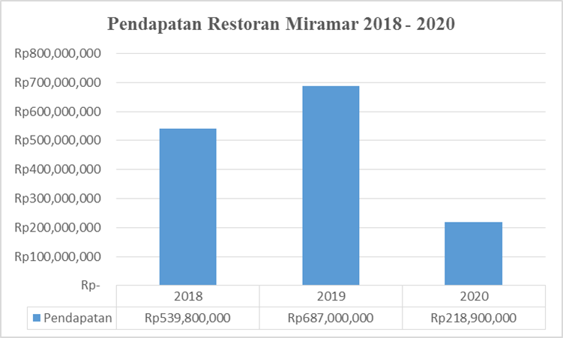
Figure 1. Revenue data Miramar Restaurant
Source: Restaurant Miramar, 2021
Based on Figure 1.2 above, Miramar Restaurant's revenue in 2018 was Rp. 539,800,000, then experienced an increase of Rp. 147,200,000 to Rp. 687,000 in 2019 and decreased by Rp. 468,100,000 to IDR 218,900,000 in 2020. It can be concluded that Miramar's restaurant revenue fluctuates and shows a negative trend. Even though the restaurant management has tried to improve the service provided by the waiters and provide attractive promotions to their customers, this has not been able to increase their income figures. Therefore, this research is expected to provide input and suggestions for Miramar Restaurant managers regarding the important role of food quality and what factors can increase customer loyalty.

LITERATURE REVIEW
Definition of Food Quality
Quality has become a key element for a company to survive competition and face challenges from competitors (Sadilek, 2019), while food is the main product of a restaurant. Quality is defined as the overall characteristics and nature of goods and services that affect the ability to meet stated and implied needs (Zardi, Wardi, Evanita, 2018). Food quality as the core product of a restaurant, food plays an important role in the experience of being in a restaurant (Takaya, 2017).
Food quality is the suitability of food for consumption by customers. Assessment of food quality for customers begins when customers taste the food served, then provide an assessment of the quality of the food (Winarjo and Japarianto, 2017). Customers evaluate food quality from various attributes including taste, temperature, portion size, menu variety and nutritional value (Majid, Samsudin, Noorkhizan, Zaki, Bakar, 2018). It can be concluded that the quality of food is very influential on customer satisfaction. And also customer satisfaction greatly affects customer loyalty to the restaurant.
According to Winarjo and Japarianto (2017) the dimensions and indicators of food quality are as follows: Presentation is the ability of a company to display food in a beautiful and attractive way. Menu Variety is the company's ability to provide a variety of food menus for customers to choose from. Health Options is the availability of food that is nutritious and beneficial to the health of customers. Taste is the ability of a food to provide pleasure to the customer. Freshness is the freshness of the food that makes the food suitable for consumption. Temperature is the temperature level of food that is appropriate and can be consumed by customers without making customers wait long.

Customer Loyalty
Loyalty is a commitment to repurchase a product or service according to the customer's choice (Kotler, et al., 2020). Customer loyalty is a kind of repeat behavior from customers. This is characterized in terms of repurchase or back patronage intent, recommendations, and word of mouth. Loyalty arises as a result of customers being satisfied with the organization and its goods and/or services (Yuanwei and Lertbuasin, 2018). Customer loyalty is the engine for the success of a business (Ramadhanty, Putri, Azzahra, 2019).
Customer loyalty is the level at which customers exhibit repeat purchase behavior from service providers, have a positive attitude toward the provider, and consider only using this provider when the need for this service exists (Samsudin, 2018). It can be concluded that customer loyalty is a commitment from customers to repurchase products or services and refer them to friends or family. According to Samsudin (2018) the concept of loyalty is as follows:
Behavioural Loyalty - Loyalty can be understood as a concept of purchase sequences, purchase proportions, purchase probabilities, and future purchases based on past purchases. Behavioral loyalty can also be measured easily through the observation technique of repeated transactions (or the percentage of total transactions in a category, or the total expenditure in a category). The behavioral aspect is represented by repeated purchases of products or services, including purchases of different products from a company.
Attitudinal Loyalty - This approach is understood as a customer's psychological commitment, partisanship, good faith towards a particular product or service. According to Samsudin (2018) dimensions and indicators of customer loyalty include: Make repeat purchases regularly, satisfied with the product, repeat purchase, referring to others, voluntarily tells the goodness of services that have been provided without any feedback from the company, recommend products to others, and inform the product to other customers about their experiences.

Relationship between Food Quality and Customer Loyalty
Winarjo and Japarianto (2017) food quality is the suitability of food for consumption by customers. Food quality assessment for customers begins when the customer tastes the food served, then gives an assessment of the quality of the food. According to Surnaryo, Prasetyo, Hardjomidjojo, Nurdianchah (2019) food quality is a basic component of a restaurant, food quality is important for restaurants.
This research is supported by Zhong and Moon (2020) food quality has a positive and significant effect on customer loyalty. Food quality refers to several aspects including food presentation, taste, menu diversity, health, a high level of food quality is the main marketing strategy that can satisfy, maintain and provide a happy buying experience for them. Food quality has a positive impact on customer loyalty. Customers will invite family or friends to return to the restaurant to buy high quality food. Moreover, this research is also supported by Majid, Samsudin, Noorkhizan, Zaki, Bakar, (2018) food quality has a positive and significant effect on customer loyalty. Food quality exceeds other determinations such as environment and service, food quality is a major determinant in building customer loyalty, especially in restaurants. So that the quality of food has a positive relationship with customer loyalty.
One of the factors that influence customer loyalty is food quality. Sugiharto and Are (2020). Quality is an overall evaluation, global assessment, or attitude towards purchasing a product which is the result of a comparison between expectations and the reality of a product or service. Adrian, Adriansyah, Sundayana, Ridwan, Tanuwijaya (2020) food quality is an important factor in facing business competition in the tourism sector, especially restaurants. Food quality is the main attribute of diner satisfaction in restaurants and a predictor of food safety (Mohaydin, Chand, Aziz, Bashir, Irfan, 2017). Food quality is an important factor for customers choosing restaurants, customers evaluate food quality from various attributes such as taste, temperature, portion size, menu variety and nutritional value (Majid, Syamsudin, Noorkhizan, Zacky, Bakar, 2018). Therefore, based on the discussion of the literature above, the study offers the following hypotheses:
Ho: There is no effect of food quality on customer loyalty at Miramar Restaurant
Ha: There is an effect of food quality on customer loyalty at Miramar Restaurant.

METHOD
Research Design
The research design used is descriptive quantitative. Quantitative method is a method that tests theory by connecting between variables. This variable is measured by instruments and the data is analyzed statistically (Creswell and Creswell, 2018). While descriptive is the formulation of the problem relating to the question of the existence of independent variables, whether only one variable or more (Sugiyono, 2019). The unit of analysis in this study is Miramar restaurant customers. The time approach used is approximation cross sectional. According to Sekaran and Bougie (2016) cross sectional research can be conducted in which data are collected once perhaps over a period of days or weeks or months to answer a research question.
Research Instruments, Population and Sample
Data collection techniques used a questionnaire. According to Thomas (2021) a questionnaire is a series of questions or statements predetermined by researchers to be answered by respondents. The questionnaire was measured using a Likert scale. According to Collis and Hussey (2021) the population is the right group of people. The population in this study was 6,133 Miramar restaurant customers. Customer data is obtained from the number of restaurant visitors recorded by Miramar Restaurant. This data can be obtained because one of the authors gets access to restaurant management. Based on this population, samples were taken for research. The sample is part of the population (Zikmund and Babin, 2016). Sampling technique using judgmental sampling. Judgmental sampling is a sampling technique with certain criteria, namely customers of the Miramar restaurant who have eaten at the Miramar restaurant at least once (Sugiarto, 2017).
In this study, there were 100 respondents involved. of the 100 respondents, 64% were male and 36% female, 61% were aged 17-27 years, 22% were aged 28-37 years, 9% were aged 38-47 years, and 8% were aged > 48 years. Also, 34% work as private employees, 27% as students, 8% as civil servants, 14% as housewives, and 17% as entrepreneurs. Regarding the frequency of visits, 76% of respondents visited the Miramar restaurant in a month 1 - 5 times and 24% of respondents 6 times - 10 times visited the Miramar restaurant in a month.
RESULTS AND DISCUSSION
Reliability, Validity and Normality Test
According to Sekaran and Bougie (2016), the validity test is used to determine the accuracy of the questionnaire. The basis for making a decision on the validity test in this study is the arithmetic ≥ r table. In this study, the variable 'food quality' has ten statements with a value of r count ≥ r table, then all food quality statement items are valid. And, for the variable 'customer loyalty' has nine statements with a value of r count ≥ r table, all items of the customer loyalty statement are valid. Besides that, according to Creswell and Creswell (2018) reliability is used to test the consistency of the questionnaire. The method used in reliability testing is to use Cronbach's Alpha method in which one variable is considered reliable if Cronbach's Alpha > 0.6. For food quality (X), it has a Cronbach Alpha value of 0.909 > 0.6, so food quality is declared reliable, while the consumer loyalty variable has a Cronbach Alpha value of 0.893 > 0.6, so consumer loyalty is declared reliable. Next, the Asymp. Sig. (2-tailed) 0.183 > 0.05, so based on these results, the data is considered normally distributed.
Moreover, this study aims to examine the relationship between food quality and customer loyalty at Miramar Restaurant Jakarta. Therefore, there are two research variables that will be tested using simple regression analysis. According to Priyatno (2018) simple linear regression analysis is an analysis to determine whether there is a significant influence between one independent variable and one dependent variable, to find out how the effect (positive or negative) is how big the effect is, and to predict the value of the dependent variable using the independent variable. In conducting data analysis, this study uses IBM SPSS software version 25.
Correlation Analysis
According to Priyatno (2018) correlation analysis is used to find out the relationship between two variables, namely, to find out how strong the relationship is, to find out whether the direction of the relationship is positive or negative. Based on Table 2. below, the correlation value r = 0.693 is in the range 0.60-0.799 which means there is a strong relationship between variables. The relationship between food quality and consumer loyalty is positive, which means that if the quality of food increases, it will have an impact on increasing consumer loyalty and vice versa if the quality of food decreases, it will have an impact on decreasing consumer loyalty.
Table 1. Correlation Analysis
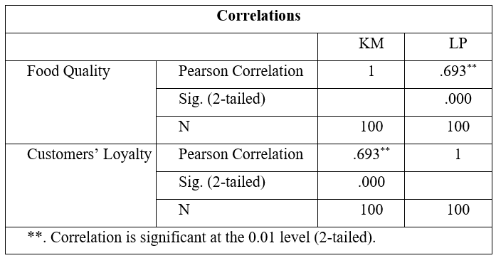

Simple Linear Regression Analysis
According to Priyatno (2018) simple linear regression analysis is an analysis to determine whether there is a significant effect between one independent variable and one dependent variable. The following is a discussion of the simple linear regression analysis equation as shown in Table 2 below. A constant value of 2.979 means that the value of food quality is 0, so customer loyalty is 2.797. Meanwhile, the value of the simple regression coefficient for the food quality variable is positive, which is equal to 0.627. This means that for every 1 unit increase in food quality, customer loyalty will increase by 0.627 units, assuming the other independent variables remain the same.

Table 2. Significance Test
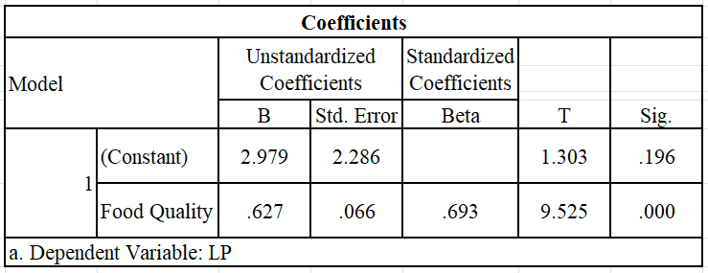
The next one, we analyze the coefficient of determination (R2); essentially measures how much influence the independent variables have on the dependent variable. R Square (R2) or the square of R, which shows the value of the coefficient of determination. This figure will be changed to the form of a percentage, which means the percentage of the contribution of the independent variable to the dependent variable. (Priyatno, 2018).
Table 3. Correlation Analysis
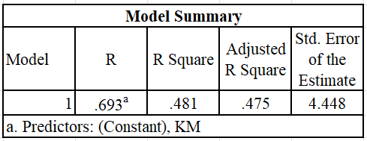
The next test is the t-test. According to Priyatno (2018) the t test or regression coefficient test is used to find out whether partially the independent variable has a significant effect or not on the dependent variable. The test criteria for the t test are if significance > 0.05, then Ho is accepted and if significance <0.05, then Ho is rejected. Based on Table 3, food quality has a sig value of 0.000 <0.05, so Ho is rejected, and Ha is accepted, which means that food quality affects customer loyalty.
According to Priyatno (2018) the t test or regression coefficient test is used to find out whether partially the independent variable has a significant effect or not on the dependent variable. The test criteria for the t test are if significance > 0.05, then Ho is accepted and if significance <0.05, then Ho is rejected. Based on table 4.4 below, food quality has a sig value of 0.000 <0.05, so Ho is rejected, and Ha is accepted, which means that food quality affects customer loyalty.
CONCLUSIONS AND SUGGESTIONS
This study examined the impact of food quality on customers’ loyalty in Miramar restaurant. According to the result of the study, the quality of the food that Miramar restaurant offer to its customers positively influence the level of loyalty from its customers. The findings of the study have several academic and managerial implications. First, the current study contributes to the literature in service quality for foodservice industry in Indonesia. The outcome of the current study confirmed the result from the previous studies that analysed the relationship between food quality and customers loyalty (Naini et al., 2022; Nasution et al., 2023).
Managerial implication, the finding of the study offers an insight for restaurant owner-managers about how important to maintain the food quality and consistently provide a good quality service to its customers. The quality of the food served in restaurant is an essential component that plays a role in maintaining loyal customers. Customers are willing to spend a higher price for products due to the high-quality standards of the food that the restaurant provide. It is vital to do study on this subject to ascertain the extent to which the quality of the cuisine offered at a particular restaurant influences the level of customer commitment to that establishment.
Furthermore, this investigation focused on the extent to which consumers' loyalty to restaurants is influenced by the quality of the cuisine provided. Customer loyalty can be greatly influenced by the quality of the food provided. People have a propensity to continue frequenting the same restaurant because it has provided them with positive experiences in the past. This can be due to several things, such as their individual preferences, the convenience with which they can obtain the product, and the kind of service they receive. Consequently, it is crucial for businesses in the hospitality industry to make an effort to keep up a consistently high level of quality in all they do.
This study has several limitations. As stated earlier in this article, the current study used a quantitative approach. The limitation of the quantitative research is that it does not allow for a better understanding of the whole picture. Hence, future research should be able to explore what are the unintended factors that influence customers’ loyalty.

REFERENCE
Adrian, I. G. A. W., Adriansyah, E., Ridwan, M., Sundayana, D., & Tanuwijaya, L. (2021). Pengaruh Food Quality, Restaurant Atmosphere, Price Terhadap Customer Satisfaction dan Implikasinya Terhadap Customer Loyalty Pada Restoran di Kawasan Puncak, Kabupaten Bogor. Barista: Jurnal Kajian Bahasa dan Pariwisata, 8(1), 1-10.
Creswell, J. W & Creswell, J. D. (2018). Research design: qualitative, quantitative, and mixed methods approaches. Los Angels: SAGE.
Collins, J., & Hussey, R. (2021). Business Research: A Practical Guide For Students Fifth Edition. London: Red Globe Press.
Gani, I., & Amalia, S. (2018). Alat Analisis Data Aplikasi Statistik Untuk Penelitian Bidang Ekonomi & Sosial. Yogyakarta: Andi.
Isoraite, M. (2016). Marketing mix theoretical aspects. International Journal of Research-Granthaalayah, 4(6), 25-37.
Kotler, P., Keller, K.L., Brady, M., Goodman, M., Hansen, T., (2020). Marketing Management 4 th Edition. New Jersey: Pearson.
Malhotra, N., Nunan, D., & Birks, D. (2017). Marketing research: An applied approach. New Jersey: Pearson.
Majid, M. A. A., Samsudin, A., Noorkhizan, M. H. I., Zaki, M. I. M., & Bakar, A. M. F. A. (2018). Service quality, food quality, image and customer loyalty: An empirical study at a hotel restaurant. International Journal of Academic Research in Business and Social Sciences, 8(10), 1432-1446.
Mohaydin, G., Chand, A., Aziz, B., Bashir, M., & Irfan, J. (2017). Effect of food quality on customer perceived satisfaction level and mediating effect of food safety on them. International Journal of New Technology and Research, 3(1), 34-41.
Priyatno, D. (2018). SPSS Panduan Mudah Olah Data. Yogyakarta: Andi.
Ramadhanty, V., Putri, D. J. U., & Azzahra, F. (2019). Pengaruh Kualitas Produk dan Pelayanan Terhadap Loyalitas Pelanggan pada Kedai Roti Bakar di Pamulang. Medium: Jurnal Ilmiah Fakultas Ilmu Komunikasi, 7(2), 68-79.
Sadilek, T. (2019). Perception of food quality by consumers: literature review. European Research Studies 22 (1). 57-67
Samsudin, S. (2018). Analisis Loyalitas Pelanggan Di Pt Nutrifood, Kotamadya Bogor. Transparansi: Jurnal Ilmiah Ilmu Administrasi, 1(2), 179-193.
Saunders, M., Lewis, P., & Thornhill, A. (2019). Research Methods for Business Students, eight edition. New Jersey: Pearson.
Sekaran, U., & Bougie, R. (2016). Research methods for business. New Jersey: Pearson.
Suchanek, P., & Kralova, M. (2019). Customer satisfaction, loyalty, knowledge and competitiveness in the food industry. Economic research-Ekonomska istrazivanja, 32(1), 1237-1255.
Sugiharto, H., & La Are, R. (2020). The Impact Of Food Quality And Price On Millennials Satisfaction In Mcdonald’s South Tangerang. Journal FAME: Journal Food and Beverage, Product and Services, Accomodation Industry, Entertainment Services, 3(1). 312-319.
Sugiyono. (2019). Metode Penelitian Kuantitatif, Kualitatif, R&D. Bandung: Alfabeta.
Sunaryo, I., Prasetyo, I. R., Hardjomidjojo, P .& Nurdianchah . (2019). Effects of food quality, service quality, price, environment, and location towards customer loyalty of Indonesia’s local fast food industry. J@ti Undip: Jurnal Teknik Industri, 14(3), 119-128.
Takaya, R. (2019). Analysis Of Atmospherics, Food Quality, Service Quality, And Perceived Value That Are Died By Asicicomic Satisfaction To Behavioral Intention. Business and Entrepreneurial Review, 17(1), 15-32.
Thomas, C. G. (2021). Research methodology and scientific writing. Jerman: Springer Nature.
Winarjo, H. & Japarianto, E. (2017). Pengaruh food quality dan atmosphere terhadap customer loyalty dengan customer satisfaction Sebagai Variabel Intervening Pada Café Intro di Surabaya. Jurnal Strategi Pemasaran, 4(2), 1-6.
Yuanwei, Q., & Lertbuasin, S. (2018). The Influence of Service Quality and Brand Equity on Customer Loyalty to 5 Star Hotels in the Yunnan Province of China. Journal of Global Business Review., 20(1), 35-47.
Zardi, H., Wardi, Y., & Evanita, S. (2019, April). Effect of Quality Products, Prices, Locations and Customer Satisfaction to Customer Loyalty Simpang Raya Restaurant Bukittinggi" Salero Nan Tau Raso". In 2nd Padang International Conference on Education, Economics, Business and Accounting. 572-581.
Zikmund, W., & Babin, B. (2016). Exploring Marketing Research Eleventh Edition. USA: Cengage Learning.
Zhong, Y., & Moon, H. C. (2020). What drives customer satisfaction, loyalty, and happiness in fast-food restaurants in China? Perceived price, service quality, food quality, physical environment quality, and the moderating role of gender. Foods, 9(4), 1-19.

