Comparative Analysis of Financial Performance of BUKU 4 Conventional Banks Before and During Covid-19 Pandemic

Mayuna Farah Wijayanti ¹⁾; Khoirul Hikmah ²⁾

¹⁾ mayunawijayanti@gmail.com, Fakultas Ekonomi dan Bisnis, UPN "Veteran" Yogyakarta, Indonesia
²⁾ khoirul.hikmah@upnyk.ac.id, Fakultas Ekonomi dan Bisnis, UPN "Veteran" Yogyakarta, Indonesia
Article Information:  Keywords:  Financial performance;  RGEC Analysis;  BUKU 4 Conventional Banks;  Covid-19 Pandemic;  Article History:  Received : January 22, 2022  Revised : February 10, 2023  Accepted : March 28, 2023  Cite This Article:  http://dx.doi.org/10.22441/indikator.v7i1.18396 | Abstract  Banks in Indonesia are facing a number of challenges amid the Covid-19 Pandemic. Banks will face several possible risks to financial performance. This study aims to determine the level of banking financial performance, especially in BUKU 4 Conventional Banks before and during the Covid-19 Pandemic for the 2019-2020 period using RGEC analysis (Risk Profile, Good Corporate Governance, Earnings, and Capital). The data used is secondary data obtained from the financial statements of banks included in the BUKU 4 category and processed using SPSS version 25. The results of the research on the financial performance of BUKU 4 Conventional Banks which can be seen from the Differential Test table (Paired Sample T-test and Wilcoxon test) show a decrease in several factors such as Risk profile and earnings factors. Meanwhile, the GCG and Capital factors show stable results both before and during the Covid-19 Pandemic.

INTRODUCTION
The Covid-19 pandemic has been going on since early 2020. The SARS CoV-2 virus attacks the respiratory system and the human immune system. On January 30, 2020, the World Health Organization (WHO) declared the Covid-19 pandemic a Public Health Emergency of International Concern (WHO, 2020). This happened because the number of Covid-19 patients has increased in a fairly fast period of time and there has been spread between countries, including Indonesia. Covid-19 virus It spreads so quickly that it disrupts health and daily activities, so the government implemented a lockdown policy to reduce exposure to the Covid-19 virus. However, the existence of a lockdown policy has had a negative impact on several sectors, including the economic sector.
Banking sector has received a significant influence from the impact of the Covid-19 pandemic (Ilhami & Thamrin, 2021). Banks are financial institutions that are important to the economy of a country and society. Initially, banks only functioned as places to save and borrow money, but now banks have developed into various types, such as credit banks, state-owned banks, private banks, conventional banks and Islamic banks, depending on the ownership and core capital of the bank (Hartanti , 2017).
In banking, maintaining healthy financial performance is very important. It spreads so quickly that it disrupts health and daily activities, so the government implemented a lockdown policy to reduce exposure to the Covid-19 virus. However, the existence of a lockdown policy has had a negative impact on several sectors, including the economic sector.Financial performance is the most important part in determining the overall health of a bank, which includes various aspects such as finance, fundraising and distribution, human resources, and technology. One way to assess the soundness of a bank's financial performance is through analysis of financial ratios calculated from periodic financial reports. The financial statements show the financial performance of a bank in a certain period. However, to determine the impact of the Covid-19 pandemic on a bank's financial performance, an objective and appropriate ratio benchmark is needed (Fatimah et al., 2023).
In general, the Covid-19 pandemic has caused a decline in banking performance in Indonesia, even BUKU 4 banks, which have a capital of more than IDR 30 trillion, have also been affected by the pandemic. Therefore, maintaining financial performance in uncertain economic conditions is very important to restore customer, public and investor confidence. Banking has an important role as an intermediary institution in the economy, so that during a pandemic, the role of banking is needed to support Indonesia's economic growth (Ariyani, 2021).
The government, through Bank Indonesia, has set standards for assessing the soundness of banks based on Bank Indonesia Regulation number 13/1/2011 and Bank Indonesia Circular Letter number 13.24/DPNP/2011 concerning assessing the soundness level of commercial banks. The Financial Services Authority also regulates this matter through OJK Regulation number 4/POJK.03/2016 concerning the rating of the soundness level of commercial banks.
In line with the complexity of the banking business, the RGEC method was introduced to replace the CAMELS method starting January 2, 2012. According to Bank Indonesia Regulation No 13/1/PBI/2011 it is explained that the basis for assessing bank performance uses a risk-based bank rating (RBBR) approach.The regulation requires all commercial banks to carry out a self-assessment of the level of financial performance using a risk -based bank rating (RBBR) either individually or on a consolidated basis, the calculations of which are guided by Bank Indonesia Circular Letter (SEBI) No. 13 /24/DPNP dated 25 October 2011. This approach includes the components of Risk Profile , Good Corporate Governance (GCG), Earnings (Rentability), and Capital (Capital).
Based on the explanation above, the purpose of this research is to compare the financial performance of conventional BUKU 4 banks in Indonesia before the pandemic and during the pandemic. This comparison is intended to see the impact caused by the Covid-19 pandemic on conventional BUKU 4 banks in Indonesia whether they have experienced a decline or have conventional banks carried out proper mitigation to minimize the impact of the Covid-19 pandemic.

LITERATURE REVIEW
Financial Performance
Banking performance in general reflects the achievements achieved by banks in
their operations, while banking financial performance is a picture of the bank's financial condition in a certain period both regarding aspects of raising funds and channeling funds (Munir, 2017). Financial performance is an analysis carried out to see the extent to which a company uses the rules of financial implementation properly and correctly. Assessment of a bank's financial performance is based on the results of the financial statements owned by the bank concerned which are reflected in the information on the balance sheet, income statement and cash flow statement as well as other matters that also support the assessment of the financial performance (Putri & Irradianti, 2020; Risman et al., 2020; Kurniawan et al., 2021)
Risk Profile
Risk profile assessment is an assessment of inherent risk and the quality of risk management implementation in bank operations. According to Bank Indonesia Regulation No 13/1/PBI/2011 there are several types of risks that must be assessed consisting of 8 risks namely credit risk, market risk, liquidity risk, operational risk, legal risk, strategic risk, compliance risk and reputation risk. In this study, only credit risk and liquidity risk indicators are used as proxies for this risk profile because these 2 types of risk can be accessed, while the other six risks are not used due to the lack of data availability.
H1: There are significant differences in banking financial performance before and during the Covid-19 pandemic at BUKU 4 Conventional Banks as measured by Risk Profile factors.
Good Corporate Governance
Good Corporate Governance arises because of the company's need to ensure that the funds invested by investors are used efficiently and appropriately. In addition, corporate governance also provides assurance that management is acting in the best interest of the company. Corporate governance generally provides protection for all parties related to the company (Syed & Safdar, 2009).
H2: There are significant differences in banking financial performance before and during the Covid-19 pandemic at BUKU 4 Conventional Banks as measured by Good Corporate Governance factors.
Earnings
Profitability factor assessment includes evaluation of profitability performance, profitability sources, profitability sustainability, and profitability management. The assessment is carried out by considering the level, trend, structure, stability of the Bank's profitability, and comparison of bank performance with peer group performance, both through analysis of quantitative and qualitative aspects. In determining the peer group, the Bank needs to pay attention to the business scale, characteristics and/or complexity of the Bank's business as well as the availability of data and information it has.
H3: There are significant differences in banking financial performance before and during the Covid-19 pandemic at BUKU 4 Conventional Banks as measured by Earnings factors.
Capital
Capital or Capital is a number of funds whose amount has been determined by the business owner as a business establishment that can be used in various bank activities. In banking, capital is a requirement that must be met so that all business operations can run according to plan (Rachmadi, 2011: 113). The capital ratio aims to measure a bank's ability to meet long-term obligations. Assessment of the capital factor includes evaluation of capital adequacy and capital management adequacy. The capital ratio that is often used to assess a bank's performance is the Capital Adequacy Ratio (CAR).
H4: There are significant differences in banking financial performance before and during the Covid-19 pandemic at BUKU 4 Conventional Banks as measured by Capital factors.

METHOD
This type of research is quantitative research that is comparative. Quantitative research is a research method for examining certain populations and samples, where data collection uses research instruments and data analysis is quantitative, and aims to test established hypotheses (Sugiyono, 2016).
This research is comparative, where this research will compare the financial performance of conventional book IV banks before and during the Covid-19 pandemic by using financial ratios as comparative indicators. The financial ratio used is the RGEC ratio.
Population refers to groups of people, events, or interesting things that researchers want to investigate (Sekaran & Bougie, 2016:236). In this study, the population used was all book IV conventional banks consisting of seven banks: BRI, BNI, BCA, CIMB Niaga, Danamon, Mandiri, and Panin. The sampling technique used in this study is the Saturated Sampling Technique, which is a sample selection technique when all members of the population are sampled (Sugiyono, 2019:133). Researchers determined seven banks: BCA, BNI, BRI, CIMB Niaga, Danamon, Mandiri, and Panin as the population as well as the sample.
Data analysis method for this research is descriptive analysis, normality test, and hypothesis test. In hypothesis test, two methods are used, namely paired sample T-test and wilcoxon test. The Wilcoxon test is used to analyze the results of paired observations of two data whether there is a difference or not. This test is an alternative to the Paired Sample T test if the data is not normally distributed.

RESULTS AND DISCUSSION
Results
Descriptive statistics
Based on NPL (Non Performing Loan), LDR (Loan to Ratio), GCG (Good Corporate Governance), NIM (Net Interest Margin), ROA (Return On Assets), ROE (Return On Equity), BOPO (Operating Costs Operating Income), and CAR (Capital Adequacy Ratio) at each BUKU 4 Conventional Bank for the 2019-2020 period which was then processed using SPSS (Statistical Package for Social Sciences) version 25 to obtain descriptive statistical results. Descriptive statistics in this study are used to describe research data in the form of average values (mean), minimum values, maximum values, and standard deviations.

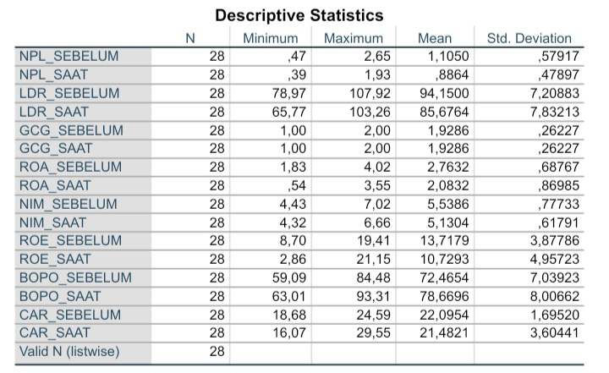

Normality Test
In this study, to find out whether the data was normally distributed or not, the researcher used the Shapiro Wilk test. The basis for decision making is that the data is normally distributed or cannot be seen from the Sig value. If p < 0.05 then the data is not normally distributed, if p > 0.05 then the data is normally distributed. The results of the normality test for the financial performance of BUKU 4 Conventional Banks before and during the Covid-19 Pandemic are as follows.

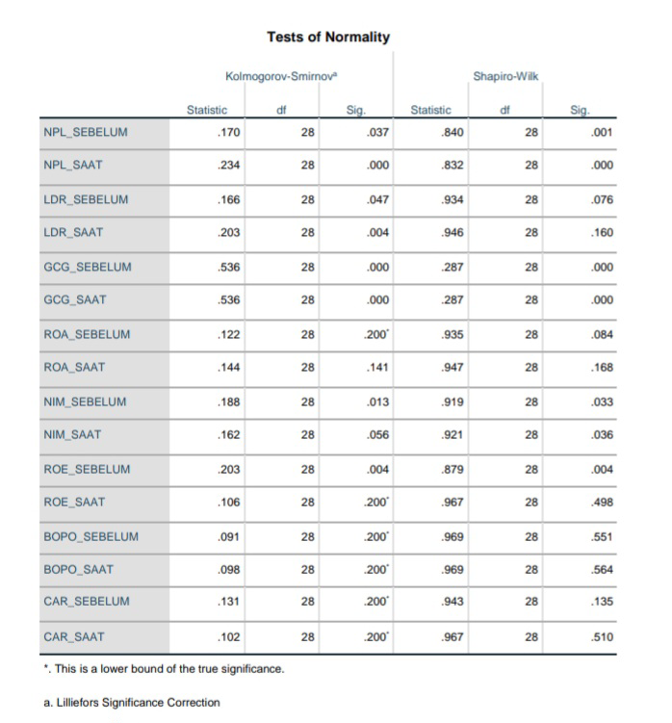

Difference Test
The different test carried out in this study was the Paired Sample T-testand the Wilcoxon test. The purpose of conducting this different test is to find out the differences in the financial performance of BUKU 4 Conventional Banks before and during the Covid-19 Pandemic.The following are the results of the Paired Sample T-test of the financial performance of Conventional Banks before and during the Covid-19 Pandemic:
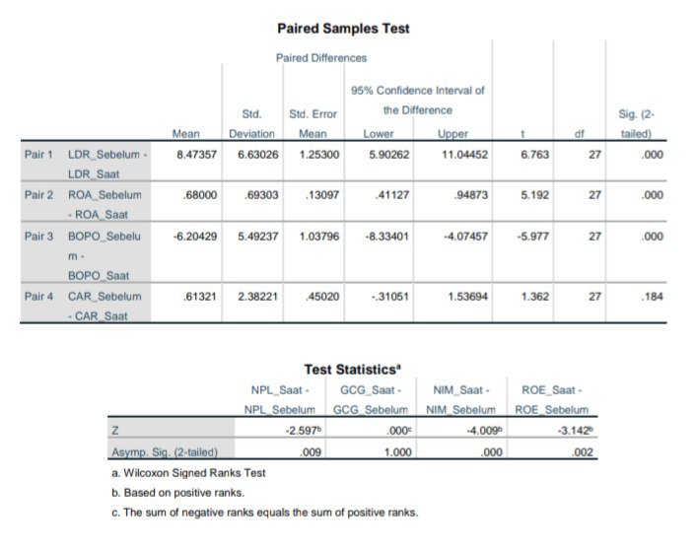

Discussion
Risk Profile Ratio Before and During the Covid-19 Pandemic
The results of descriptive statistics show that the average value of the ROA ratio before the Covid-19 Pandemic was 2.7632% and during the Covid-19 Pandemic it was 2.0832%. The results of the Paired Sample T-test show the Sig. the LDR ratio is 0.000, so the value of Sig. smaller than 5% or 0.05, it can be concluded that there is a significant difference in the LDR ratio before and during the Covid-19 Pandemic at BUKU 4 Conventional Banks.Good
Good Corporate Governance Ratio Before and During the Covid-19 Pandemic
The average value (mean) before the Covid-19 Pandemic was 1.9286, while during the Covid-19 Pandemic in 2020 it was also 1.9286. The results of descriptive statistics show that the average value of the ROA ratio before the Covid-19 Pandemic was 2.7632% and during the Covid-19 Pandemic it was 2.0832%. The results of the Paired Sample T-test show the Sig. the LDR ratio is 0.000, so the value of Sig. smaller than 5% or 0.05, it can be concluded that there is a significant difference in the LDR ratio before and during the Covid-19 Pandemic at BUKU 4 Conventional Banks. Based on an average of 1.9286 BUKU 4 Conventional Banks are ranked 2nd with a good predicate. This shows that before and during the Covid-19 Pandemic the management quality of BUKU 4 Conventional Banks on the assessment of GCG principles was going well. Determination of GCG will increase stakeholder confidence in conducting transactions at the bank, because by looking at a bank's GCG assessment, stakeholders can find out the governance that exists within that bank. Wilcoxon test results show the value of Asymp Sig. (2-tailed) of 1.000, which is greater than 5% or 0.05. So it can be concluded that there was no significant difference in the GCG ratio before and during the Covid-19 Pandemic at BUKU 4 Conventional Banks.
Earnings Ratio Before and During the Covid-19 Pandemic
The results of descriptive statistics show that the average value of the ROA ratio before the Covid-19 Pandemic was 2.7632% and during the Covid-19 Pandemic it was 2.0832%. The results of the Paired Sample T-test show the Sig. the LDR ratio is 0.000, so the value of Sig. smaller than 5% or 0.05, it can be concluded that there is a significant difference in the LDR ratio before and during the Covid-19 Pandemic at BUKU 4 Conventional Banks.
Descriptive statistical test results for the NIM ratio before the Covid-19 Pandemic was 5.5386% and during the Covid-19 Pandemic it was 5.1304%, there was a decrease of 0.4082% during the Covid-19 Pandemic. The greater the NIM value, it shows that the bank is successful in managing interest-bearing assets resulting in higher profits. Wilcoxon test data shows the value of Sig. of the NIM ratio is 0.000 which means the value of Sig. The NIM ratio is less than 5% or 0.05, it can be concluded that there is a significant difference in the NIM ratio before and during the Covid-19 Pandemic at BUKU 4 Conventional Banks.
Based on the descriptive statistical test, the average value before the Covid-19 Pandemic was 13.7179% and during the Covid-19 Pandemic it was 10.7293%. This result shows a decrease of 2.9886% during the Covid-19 Pandemic, a decrease in the ROE ratio can affect a decrease in profits for shareholders. The Wilcoxon test results showed that the Sig. of the ROE ratio is 0.002 which means the value of Sig. The ROE ratio is less than 5% or 0.05, it can be concluded that there is a significant difference in the ROE ratio before and during the Covid-19 Pandemic at BUKU 4 Conventional Banks.
Descriptive statistical test results for the average value of BOPO before the Covid 19 Pandemic was 72.4654% and during the Covid-19 Pandemic it was 78.6696%. During the pandemic, BOPO increased by 6.2042%, so it is known that the BOPO ratio for Conventional Book 4 Banks experienced an increase which resulted in inefficient operational costs incurred by banks during the Covid-19 Pandemic. The results of the Paired Sample T-test show the Sig. the BOPO ratio is 0.000 which means the value of Sig. The BOPO ratio is less than 5% or 0.05, it can be concluded that there is a significant difference in the BOPO ratio before and during the Covid-19 Pandemic at BUKU4 Conventional Banks.
The results of the CAR descriptive statistics show an average value (mean) of 22.0954% before the Covid-19 Pandemic and 21.4821% during the Covid-19 Pandemic. The average value during the Covid-19 Pandemic fell by 0.6133%, but it is still in the very good category because the average value in 2020 is still more than 12%. The higher the CAR ratio, the better the condition of the bank in that period. The results of the Paired Sample T-test show the Sig. CAR ratio is 0.184 which means the value of Sig. The CAR ratio is greater than 5% or 0.05, so it can be concluded that there is no significant difference in the CAR ratio before and during the Covid-19 Pandemic at BUKU 4 Conventional Banks.

CONCLUSION
- There are significant differences in banking financial performance between before and during the Covid-19 Pandemic at BUKU 4 Conventional Banks as measured by the Risk Profile ratio.
- There is no significant difference in banking financial performance between before and during the Covid-19 Pandemic at BUKU 4 Conventional Banks as measured by the Good Corporate Governance ratio.
- There are significant differences in banking financial performance between before and during the Covid-19 Pandemic at BUKU 4 Conventional Banks as measured by the Earnings ratio.
- There is no significant difference in banking financial performance between before and during the Covid-19 Pandemic at BUKU 4 Conventional Banks as measured by the Capital ratio.
Based on results study which got, writer realize that still there is many deficiency in study this, however with exists this research , the researcher hopes that this research can be useful for all parties and can contribute. If the next researcher is interested developing research with the same theme can consider adding other year periods and other banks.

REFERENCE
Ariyani, F. N. (2021). Analisis Tingkat Kesehatan Bank dengan Menggunakan Metode RGEC pada Bank BUKU 4 Sebelum dan Selama Pandemi Covid-19 di Indonesia. Jurnal Ilmiah Mahasiswa UB, Volume 9 No 2.
Brigham, E.F, dan J.F Houston. 2018. Dasar-Dasar Manajemen Keuangan. Jakarta: Salemba Empat.
Fatimah, S., Yacobus, A., & Nurohim, H. (2023). Analisis Perbandingan kinerja Keuangan Perbankan Sebelum dan Saat Pandemi Covid-19 Menggunakan Analisis RGEC Pada Bank BUMN (Bank Umum Persero) Yang Terdaftar di Bursa Efek Indonesia Periode 2019-2020. Sinomika Jurnal, Volume 1 No 5, 1295–1310. https://doi.org/10.54443/sinomika.v1i5.661
Febrianti, A. Y. (2021). Analisis Tingakat Kesehatan Bank dengan Menggunakan Metode RGEC pada Bank Umum BUMN yang Terdaftardi Bursa Efek Indonesia pada Masa Pandemi Covid-19. Jurnal Ilmiah Mahasiswa UB, 9 (2).
Ghozali. Imam. 2018. Aplikasi Analisis Dampak Multivariate Dengan Program IBM SPSS 25. Semarang: Badan Penerbit Universitas Diponegoro
Hartanti, H. (2017). Perbandingan Kinerja Keuangan Lima Bank Dengan Aset Terbesar. JURNAL ONLINE INSAN AKUNTAN, 2 (2), 237–248.
Ikatan Bangkir Indonesia. 2016. Manajemen Kesehatan Bank Berbasis Risiko. Jakarta: PT Gramedia Jakarta
Kurniawan, T., Mulyana, B., & Risman, A. (2021). Comparison of Financial Performance of Government Banks and National Private Banks in Book Category 4. The EUrASEANs: Journal on Global Socio-Economic Dynamics, (3(28), 24-36. https://doi.org/10.35678/2539-5645.3(28).2021.24-36
Muhammad, R., & Nawawi, M. (2022). Kinerja Keuangan Bank Syariah di Indonesia Sebelum dan Selama Pandemi Covid-19. Jurnal Kajian Ekonomi dan Bisnis Islam El-Mal, 3 (5), 853–867. https://doi.org/1047467/elmal.v3i4.1133
Ningrum, R. K. (2022). Penilaian Tingakt Kesehatan Bank Dengan Menggunakan Metode RGEC Sebelum Pandemi Sampai Saat Pandemi Pada Bank Cimb Niaga dan Bank Mandiri.
Ningsih, S., & Dewi, M. W. (2020). Pengaruh Rasio NPL, BOPO,Dan CAR Terhadap Kinerja Keuangan Bank Umum Konvensional yang Terdaftar di BEI. 21 (1), 71–78. http://dx.doi.org/10.29040/jap.v21i1.1159
Onoyi, Nona Jane, One Yantri, Ely Kurniawati, Diana Titik Windayanti, dan Gandhi Sutjahjo. 2022. “Tingkat Kesehatan Bank Sebelum Dan Selama Pandemi Covid-19 Pada BPR Di Batam.” Jurnal Manajemen, Organisasi, Bisnis Vol. 2 No.4: 627–38.
Otoritas Jasa Keuangan. Laporan Industri Perbankan. OJK. https://www.ojk.go.id/id/kanal/perbankan/data-dan-statistik/laporan-profil-industri-perbankan/Pages/-Laporan-Profil-Industri-Perbankan---Triwulan-III-2020.aspx. (Diakses 3 Januari 2023).
Otoritas Jasa Keuangan. Perkembangan restrukturisasi kredit/pembiayaan. https://www.ojk.go.id/id/berita-dan-kegiatan/Documents/Pages/informasi-covid-19/Perkembangan%20Restrukturisasi%20Kredit%20atau%20Pembiayaan.pdf. (Diakses 4 Januari 2023).
Otoritas Jasa Keuangan. Statistik Perbankan Indonesia. https://www.ojk.go.id/id/kanal/perbankan/data-dan-statistik/statistik-perbankan-indonesia/default.aspx. (Diakses 4 Januari 2023).
Peraturan Bank Indonesia Nomor 13/PBI/2011 Tentang Penilaian Tingkat Kesehatan Bank Umum
Peraturan Bank Indonesia Nomor 22/4/PBI/2020 Tentang Insentif Bagi Bank yang Memberikan Penyediaan Dana Untuk Kegiatan Ekonomi Tertentu Guna Mendukung Penanganan Dampak Perekonomian Akibat Wabah Virus Corona
Peraturan Otoritas Jasa Keuangan Nomor 4/POJK.03/2016 Tentang Penilaian tingkat Kesehatan Bank Umum
POJK Nomor 48/POJK.03/2020 Tentang Stimulus Perekonomian Nasional Sebagai Kebijakan Countercyclical Dampak Penyebaran Coronavirus Diseas 2019
Risman, A., Parwoto & Sulaeman, A. (2020). The Mediating Role of Firm’s Performance on The Relationship between Free Cash Flow and Capital Structure, Psychology and Education Journal, 58 (1), 1209-1216.

