The Effect of Motivation on Employee Performance with Work Discipline as Mediating Variable at Pos Indonesia Bekasi Main Branch

Syntia Dewi¹⁾; Aslam Mei Nur Widigdo²⁾
¹⁾ syntiadewi17@gmail.com, Faculty of Economics and Business, Mercu Buana University, Indonesia
²⁾ aslam.mei@mercubuana.ac.id, Faculty of Economics and Business, Mercu Buana University, Indonesia

Article Information:  Keywords:  Motivation;  Employee Performance;  Work Discipline;  Article History:  Received : Oct 20, 2023  Revised : Nov 10, 2023  Accepted : Nov 22, 2023  Cite This Article:  http://dx.doi.org/10.22441/indikator.v7i1.18396 | Abstract  The purpose of this research is to quantify and examine the impact of employee motivation on performance, with work ethics serving as a mediating factor. The population in this research amounted to 260 employees of PT Pos Indonesia Bekasi Main Branch. The sample used in the research amounted to 50 employees, calculated based on the Slovin formula. The technique used is probalility sampling and the sample method used is simple random sampling. The data collection method uses a survey method with data collection in the form of a questionnaire. Furthermore, the data is processed through SmartPLS version 3 and the Data Analysis Method with PLS-SEM. The results of this research concluded that Motivation has a positive and significant influence on Work Discipline; Work Discipline has a positive and significant influence on Employee Performance and Motivation has a positive and significant influence on Employee Performance. Then Motivation has a positive and significant influence on Employee Performance through mediation of Work Discipline.

INTRODUCTION
Human resources, both individually and in groups, are the main key to the continuation of all activities in the company. The progress or failure of a company is determined by human resources. Hence, every company must pay attention to the quality and quality of adequate Human Resources such as having knowledge, skills, work experience, discipline, motivation and high morale by quickly responding to mastering technology, being adaptive, and responsive to technological changes, to make the organization more influential and effective so that it can compete in the industrial world.
PT Pos Indonesia must have human resources that can help the company's productivity. But in reality PT Pos Indonesia faces several problems related to Human Resources. One of them involves discipline for numerous employees who are tardy to work. In addition, the number of employees who leave simultaneously makes employee performance decrease because many employees have to do the work of coworkers who leave even though sometimes it is not in accordance with their abilities. PT Pos Indonesia employee attendance data Bekasi Main Branch Office in the period January - December 2021 is as shown in Table 1

Table 1. Attendance Data January 2021 - December 2021
Month | Leave | Alfa | Number of Leave Days | Working Days 1 month | Leave / month % | Number of Employees
January | 127 | - | 933 | 6240 | 14,95% | 260
February | 136 | - | 946 | 6240 | 15,16%
March | 131 | - | 1119 | 6240 | 17,93%
April | 121 | - | 1020 | 6240 | 16,34%
May | 121 | - | 1089 | 6240 | 17,45%
June | 149 | - | 1153 | 6240 | 18,47%
July | 105 | - | 1070 | 6240 | 17,14%
August | 109 | - | 1057 | 6240 | 16,93%
September | 117 | - | 1094 | 6240 | 17,53%
October | 131 | 1 | 1177 | 6240 | 18,86%
November | 119 | 2 | 1293 | 6240 | 20,72%
December | 147 | - | 1314 | 6240 | 21,05%
Average | 126 | 1 | 1105 | 6240 | 17,71%
Source: PT Pos Indonesia Bekasi Main Branch General Support 1700, 2022 (Processed)

Table 1 shows that the average percentage of leave per month is 17.71%. The number of leaves taken simultaneously and the higher number of leaves makes some work neglected, so that many of the other employees have to handle one job with another job replacing colleagues who are on leave even though it is not in accordance with their abilities.
Based on observations made during 1 month, there are still many employees who are present every day but not in accordance with the specified working hours so that it can be seen that the work that should have been done is hampered to be completed. The existence of several employees who are often late in attendance shows that work discipline towards the company is relatively low. If employees cannot improve their performance through good work discipline, it means that employee performance tends to be low.

Table 2. Employee Performance Appraisal Data 2021 PT Pos Indonesia
Criteria | 1st Quarter |  | 2nd Quarter |  | 3rd Quarter |  | 4th Quarter
 | Number | Percent | Number | Percent | Number | Percent | Number | Percent
Very Good | 34 | 13.08% | 34 | 13.08% | 34 | 13.08% | 34 | 13.08%
Good | 62 | 23.85% | 64 | 24.62% | 63 | 24.23% | 62 | 23.85%
Fair | 104 | 40.00% | 104 | 40.00% | 106 | 40.77% | 106 | 40.77%
Deficient | 49 | 18.85% | 47 | 18.08% | 47 | 18.08% | 46 | 17.69%
Very Poor | 11 | 4.23% | 11 | 4.23% | 10 | 3.85% | 12 | 4.62%
Total | 260 | 100% | 260 | 100% | 260 | 100% | 260 | 100%
Source: PT Pos Indonesia Secondary Data, 2021 (processed)

Table 2 shows employees' performance atat PT Pos Indonesia Bekasi Main Branch during 2021. Performance with sufficient criteria shows an increase, while good criteria shows a decrease, and very good criteria shows stability. This shows that the performance of PT Pos Indonesia Bekasi Main Branch employees is still not optimal.
To find out what other factors allow a decrease in employee performance, the researcher conducted a pre-survey of 30 respondents of PT Pos Indonesia employees. From the results of the pre-survey said that indications of human resource problems are Work Discipline where as many as 66% or as many as 20 employees are present not exactly according to the operating hours determined by the company. Then there is a motivation factor with an average of 70% or as many as 21 respondents consider that the company does not appreciate its employees for their work achievements.
The results of Mahendra & Sadiartha's research (2021) and Kristianti et al., (2021) shows, there is an impact of motivation and work discipline on employee performance. Meanwhile, the results of Hidayat's research (2021) shows, motivation and competence have no impact on employee performance while work discipline has an impact on employee performance. In other research conducted by Djaya (2021) shows, High competence has not been able to boost employee performance, and low motivation has not either. The discrepancy between these study's findings demonstrates the necessity for further investigation into the impact of motivation and work ethic on performance.

LITERATURE REVIEW AND HYPOTHESIS DEVELOPMENT
Human Resources Management (HRM)
According to Sutrisno (2017) The task of managing human resources effectively in order to achieve a good workforce falls within the purview of human resource management, a subset of organizational management. Meanwhile, according to Hasibuan (2016) defines HRM as the practice of managing labor relations in a way that effectively and influencefully contributes to the achievement of organizational, employee, and societal goals.
From this opinion, HRM is part of organizational management which focuses on the element of human resources, especially related to managing human resources properly so that a qualified workforce is obtained to achieve company goals.

Motivation
Sudaryo et al., (2018) state that work motivation is a way to direct the power and potential to want to work together productively so as to successfully realize predetermined goals. Meanwhile, according to Hasibuan (2016) motivation is the process of influencing others' abilities and potential to wish to collaborate effectively in order to reach set goals.
According to Afandi (2016) motivation has 6 indicators, namely compensation, recognition from superiors, work facilities, working conditions, work performance, and the work itself.

Work Discipline
Afandi (2016) states that work discipline is an order or regulation established by management of an organization, approved by the board of commissioners or owners of capital, concurred upon by the trade union, and made known by the Manpower Office, after which the people who are members of the organization gladly comply with the current rules, forming it through a process of a series of behaviors that demonstrate the values of obedience, compliance, order, and order. Meanwhile, Ansory et al., (2018) said, discipline is an attitude of submission to authority and submission to the task at hand.
According to Singodimenjo in Sutrisno (2012) work discipline has 10 indicators, namely work entry hours, break hours, return hours, how to dress, manners, compliance with work, behavior, responsibility, suitability for work with abilities, and applicable norms.

Employee Performance
Wibowo (2014) said, "Performance refers to how the prepared plan is carried out. Human resources who are capable, competent, and motivated carry out performance, and people will have an influence on their attitudes and conduct”. Meanwhile, according to Silviani (2020), stating performance is "the real behavior that each person displays as a work achievement produced by employees in accordance with their role in the company’’.
According to Firdaus & Norawati (2022) employee performance has 3 dimensions, namely quantity of work, quality of work and timeliness and has 8 indicators, namely work performance, target achievement, skills, customer satisfaction, initiative, employee attendance rate, obedience to work, and on time.

The Influence of Motivation on Work Discipline
From the research of Pratama (2016), Ardhiansyah et al., (2021), Tody et al., (2022), Afiqiah & Diana (2022) said work motivation has a positive and significant influence on employee work discipline. Thus the hypothesis formed is:

H1 : Motivation has a positive and significant influence on Work Discipline

The Influence of Work Discipline on Employee Performance
From the research of Wachidah & Luturlean (2019), Yuliantini & Suryatiningsih (2021), Rizka Akbar et al., (2021), Mariani & Sariyathi (2017), Kristianti et al., (2021) said work discipline has a significant influence on employee performance. Thus the hypothesis formed is:

H2 : Work Discipline has a positive and significant influence on Employee Performance

The Influence of Motivation on Employee Performance
From the research of Tusholihah et al., (2019), Suprapto & Widigdo (2021), Apriansyah et al., (2022), Noniulpa & Widigdo (2023) said motivation has a significant influence on employee performance. Thus the hypothesis formed is:

H3 : Motivation has a positive and significant influence on Employee Performance

The Influence of Motivation on Employee Performance mediated by Work Discipline
From the research of Sulaefi (2017), Hasan (2021), Gusti et al., (2021), Mahendra & Sadiartha (2021), Jufrizen & Sitorus (2021), show that work discipline partially mediates the influence of motivation on employee performance because the direct influence of motivation on employee performance is positive and significant while work discipline has a positive and significant role in mediating the influence of motivation on employee performance. Thus, the hypothesis formed is:

H4 : Motivation has a positive and significant influence on Employee Performance with mediation of Work Discipline

Based on the development of the hypothesis, a research conceptual framework is prepared as in Figure 1.

Figure 1. Conceptual Framework
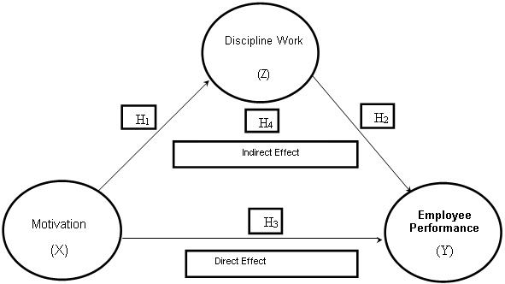

RESEARCH METHOD
This study employs a causal research design and a quantitative methodology. In causal research, the independent variable influences the dependent variable in a cause-and-effect connection. Motivation as an independent variable, Employee Performance as the dependent variable and Work Discipline as a mediating variable between the independent variable and the dependent variable. The type of data is primary data collected through questionnaires distributed to respondents.
The population in this research were employees of PT Pos Indonesia Bekasi Main Branch Office, totaling 260 employees. The sample size was 50 employees, calculated based on the slovin formula. The sampling technique is simple random sampling.
Data analysis using the Structural Equation Model (SEM). Data processing with the help of smartPLS software. The stages of analysis in the research include compiling a path diagram, testing the outer model and inner model.

RESULTS AND DISCUSSION
This research uses a quantitative approach with a causal research design. Causal research is a cause and influence relationship where the independent variable affects the dependent variable. Motivation as an independent variable, Employee Performance as the dependent variable and Work Discipline as a mediating variable between the independent variable and the dependent variable. The type of data is primary data collected through questionnaires distributed to respondents.
The population in this research were employees of PT Pos Indonesia Bekasi Main Branch Office, totaling 260 employees. The sample size was 50 employees, calculated based on the slovin formula. The sampling technique is simple random sampling.
Data analysis using the Structural Equation Model (SEM). Data processing with the help of smartPLS software. The stages of analysis in the research include compiling a path diagram, testing the outer model and inner model.

Outer Model
Convergent Validity
The Measurement Model or Outer Model is a model that analyzes the correlation from constructs (latent variables) and indicators by testing convergent validity, discriminant validity and reliability.

Figure 2. Convergent Validity Test Results Loading Factor (Outer Loading)
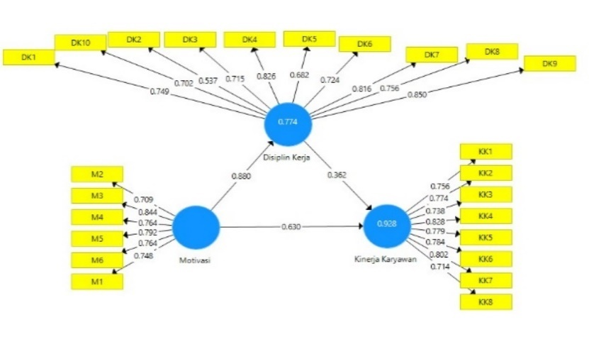
Source: Primary Data, 2023 (processed with smartPLS)

From the results of calculations with Smart-PLS, shows indicators DK2, DK5 produce a loading factor value of < 0.7. Hence, it will be excluded from the model. Then modification or retesting is carried out so that all indicators can fulfill convergent validity (valid data). Figure 3 shows that all outer loading values are above 0.7.

Figure 3. Convergent Validity Test Results: Loading Factor (Outer Loading) (Post Elimination)
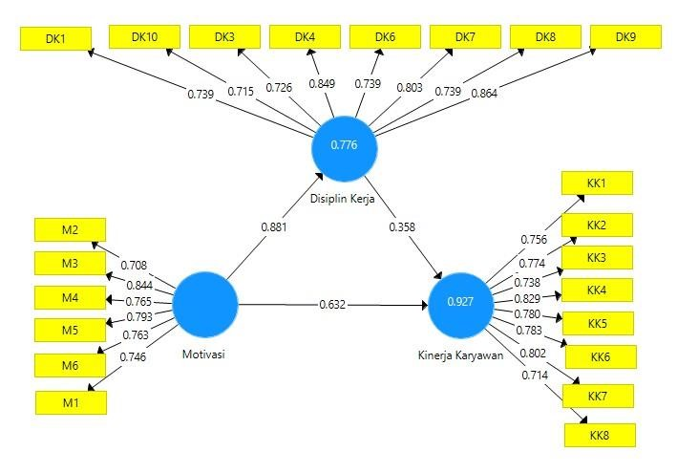
Source: Primary Data, 2023 (processed with smartPLS)
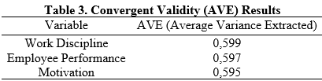
Source: Primary Data, 2023 (processed with smartPLS)

Testing the validity of the next model is by testing AVE to test convergent validity. Based on the test results as in table 3 shows that the AVE value of all variables is above 0,5. So, the model has good discriminant validity.

Table 4. Discriminant Validity (Cross Loading)
 | Work Discipline | Employee Performance | Motivation
WD1 | 0,739 | 0,635 | 0,538
WD3 | 0,726 | 0,604 | 0,605
WD4 | 0,849 | 0,849 | 0,869
WD6 | 0,739 | 0,697 | 0,623
WD7 | 0,803 | 0,684 | 0,646
WD8 | 0,739 | 0,608 | 0,615
WD9 | 0,864 | 0,811 | 0,844
WD10 | 0,715 | 0,712 | 0,623
EP1 | 0,708 | 0,756 | 0,662
EP2 | 0,729 | 0,774 | 0,748
EP3 | 0,626 | 0,738 | 0,728
EP4 | 0,685 | 0,829 | 0,782
EP5 | 0,696 | 0,780 | 0,744
EP6 | 0,676 | 0,783 | 0,729
EP7 | 0,791 | 0,802 | 0,806
EP8 | 0,711 | 0,714 | 0,646
M1 | 0,730 | 0,723 | 0,746
M2 | 0,596 | 0,627 | 0,708
M3 | 0,811 | 0,802 | 0,844
M4 | 0,651 | 0,712 | 0,765
M5 | 0,561 | 0,724 | 0,793
M6 | 0,689 | 0,718 | 0,763
Source: Primary Data, 2023 (processed with smartPLS)

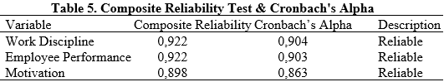
Cross loading value calculation can be used for discriminant validity testing. Table 4 illustrates discriminant validity testing using the cross loading value, with the conclusion that the latent construct predicts its indicators more accurately than other constructs because the construct correlation with each indication is higher than the correlation with other constructs (Ghozali & Latan, 2015).
Source: Primary Data, 2023 (processed with smartPLS)

From the Table, the composite reliability and Cronbach alpha values are > 0.7. Hence, all indicators are declared reliable.

Inner Model Measurement

1. R Square (R²)

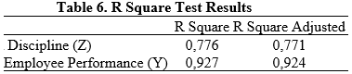
The R Square (R²) value is in the range of 0.0 to 1.0. If the value of R² is getting closer to 1, thus, in both cases, the independent variables supply all the data necessary to forecast the variance in the dependent variable. needed to predict variations in the dependent variable, and vice versa. Criteria of This R² value is grouped into three classifications, namely 0.67 (strong); 0.33 (moderate); and 0.19 (weak) (Ghozali & Latan, 2015).
Source: Primary Data, 2023 (processed with smartPLS)
In Table 6, the R Square value of the Work Discipline variable (Z) is 0.776, which means that the ability of the Motivation variables (X) to explain Work Discipline (Z) is 77.6%. Then, the R Square value of the Employee Performance variable is 0.927, which means that the ability of the Motivation (X) and Work Discipline (Z) variables to explain Employee Performance (Y) is 92.7%.

2. Predictive Relevance Q-Square (Q²)
Ghozali & Latan (2015) said, a Q-square value > 0 means that the model has a predictive relevance value. the model has a Predictive Relevance value. If it is < 0 then the model has less Predictive Relevance value. To calculate the Q-Square (Q2), the formula is used (Chin & Dibbern, 2010)
Q² = 0,984. With a Q² value of 0.984, so the model is considered relevant.

3. Uji Goodness of Fit (GoF)
Utilizing the Goodness Of Fit (GoF) Index, the overall model is validated. The performance of the Outer Model and Inner Model together is validated using this GoF Index as a single metric (Ghozali, 2015). The GoF value is in the range between 0 - 1 with interpretations including 0.10 (small), 0.25 (medium). 0.36 (large). Furthermore, the GoF value in SEM-PLS can be calculated by the following formula (Tenenhaus, 2004):
GoF 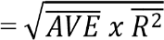
GoF 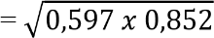
GoF = 0,713
From the above calculations, then the GoF value obtained is 0.713 (large), thus this model has a high ability to run empirical data, so the overall model formed is valid.

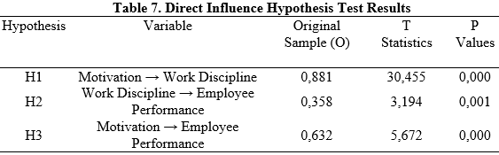

Source: Primary Data, 2023 (processed with smartPLS)
Hypothesis Test Analysis of Direct Influence
1. Motivation (X) → Work Discipline (Z): that the original sample path coefficient (O) is 0.881 (positive), and the P-Values are 0.000 (<0.05 = significant). Then, the influence of motivation (X) on work discipline (Z) is positive and significant. Thus, H1 is accepted
2. Work Discipline (Z) → Employee Performance (Y): that the original sample path coefficient (O) is 0.358 (positive) and P-Values worth 0.001 (<0.05 = significant). Then, the influence of Work Discipline (Z) on Employee Performance (Y) is positive and significant. Thus, H2 is accepted.
3. Motivation (X) → Employee Performance (Y): that the original sample path coefficient (O) amounted to 0.632 (positive), and P-Values worth 0.000 (<.0.05 = significant). Then, the influence of Motivation (X) on Employee Performance (Y) is positive and significant. Thus, H3 is accepted.

Table 8. Indirect Influence Hypothesis Test Results
Hypothesis | Variable | Original Sample (O)” | T Statistics | P Values
H4 | Motivation → Work Discipline → Employee Performance | 0,316 | 2,997 | 0,003
Source: Primary Data, 2023 (processed with smartPLS)
Indirect Influence Hypothesis Test Analysis
4. Motivation (X) → Work Discipline (Z) → Employee Performance (Y): that the original sample path coefficient (O) is 0.316 (positive), and the P-Values are 0.003 (<0.05 = significant), then Work Discipline (Z) successfully mediates positively and significantly the influence of motivation (X) on employee performance (Y). Thus, H4 is accepted.

Discussion
a) The Influence of Motivation on Work Discipline
From the results of hypothesis testing, hence motivation has a significant positive influence on Work Discipline. This implies that increasing motivation will have an influence on increasing the work discipline of employees of PT Pos Indonesia Bekasi Main Branch Office.
The results of this research are in line with previous research from Mahendra & Sadiartha (2021), Pratama (2016), Ardhiansyah et al., (2021), Afiqiah & Diana (2022) prove that work motivation has a significant positive influence on work discipline.

b) The Influence of Work Discipline on Employee Performance
From the results of hypothesis testing, hence Work Discipline has a positive and significant influence on Employee Performance. This implies that an increase in work discipline will have an impact on improving employees’ performance of PT Pos Indonesia Bekasi Main Branch Office.
These results are in line with previous research from Kristianti et al., (2021), Akbar et al., (2021), Wachidah & Luturlean (2019), Yuliantini & Suryatiningsih (2021), Indah Mariani & Sariyathi (2017), Ardianto & Putra (2022) prove that work discipline has a significant influence on employee performance.
c) Influence of Motivation on Employee Performance
From the results of hypothesis testing, hence Motivation has a positive and significant influence on employee performance. This implies that increasing motivation will have an impact on improving employee performance of PT Pos Indonesia Bekasi Main Branch Office.
These results are in line with previous research from Fadli & Hasanudin, (2020). Similarly, the research results of Tusholihah et al., (2019) Suprapto & Widigdo (2021), Apriansyah et al., (2022), (Noniulpa & Widigdo (2023) prove that motivation has a positive and significant influence on employee performance.

d) The Influence of Motivation on Employee Performance with mediation of Work Discipline
From the results of hypothesis testing, hence motivation has a positive and significant influence on employee performance with work discipline mediation. This implies that increasing motivation will have an impact on improving the performance of employees of PT Pos Indonesia Bekasi Main Branch Office mediated by work discipline.
These results are in line with previous research from Mahendra & Sadiartha (2021), Jufrizen & Sitorus (2021), Hasan (2021) and Sulaefi (2017) showing that work discipline plays a positive and significant role in mediating the influence of work motivation on improving employee performance.

CONCLUSION
1. Motivation has a positive and significant influence on the work discipline of employees of PT Pos Indonesia Bekasi Main Branch Office. Then, the increasing work motivation of employees, it will increase employee discipline.
2. Work discipline has a positive and significant influence on the performance of employees of PT Pos Indonesia Bekasi Main Branch. Then, the higher the work discipline of employees, the higher the performance of employees will be.
3. Motivation has a positive and significant influence on the performance of employees of PT Pos Indonesia Bekasi Main Branch. This means that with the increasing work motivation of employees, their performance will also increase.
4. Motivation has a positive and significant influence on employee performance through the mediation of work discipline at PT Pos Indonesia Bekasi Main Branch. Then, indirectly the presence of work discipline variables is able to complement the relationship that occurs between motivation and employee performance.

Suggestions
Suggestions to PT Pos Indonesia Bekasi Main Branch Office which are managerial implications are developed based on the highest loading factor value from the research results for each variable as follows:
- PT Pos Indonesia Bekasi Main Branch Office should consistently be able to increase the work motivation of its employees by providing health insurance, accidents and safety at work in accordance with the SOP set by the company.
- Regarding work discipline, employees should be able to continue to improve their work discipline by exerting their abilities to complete the work that is their duty and responsibility.
- Regarding employee performance, company management should be able to continue to improve the performance of its employees by appreciating the work of its employees and providing a conducive work environment so that employees can be comfortable at work.
REFERENCE
Afandi, P. (2016). Concept & Indicator Human Resources Management for Management Research. Deepublish.
Afiqiah, F. S., & Diana, I. N. (2022). Pengaruh Motivasi Kerja Terhadap Kinerja Pegawai Melalui Disiplin Kerja (Studi Kasus Pada Sekretariat DPRD Kabupaten Situbondo). EMabis: Jurnal Ekonomi Manajemen Dan Bisnis, 23(2), 1–12. https://doi.org/10.29103/emabis.v23i2.853
Ansory, Fadjar, A. H., & Indrasari, M. (2018). Manajemen Sumber Daya Manusia dan Motivasi. Indomedia Pustaka.
Apriansyah, R., Mei, A., & Widigdo, N. (2022). The Influence of Competence, Experience, and Placement on Employee Performance Bppsdm Ministry of Agriculture Jakarta with
Motivation as Mediation Variable. Budapest International Research and Critics InstituteJournal (BIRCI-Journal). https://doi.org/10.33258/birci.v5i2.4864
Ardhiansyah, R., Retno, M., & Rini, H. P. (2021). Pengaruh Motivasi Kerja dan Lingkungan Kerja Terhadap Disiplin Kerja Karyawan Pada CV. Pelita Offset Jombang. JISIP (Jurnal Ilmu Sosial Dan Pendidikan), 5(4), 46–55. https://doi.org/10.58258/jisip.v5i4.2366
Ardianto, R. E., & Putra, M. (2022). Pengaruh Sistem Informasi SDM, Pelatihan Kerja dan Disiplin Kerja Terhadap Kinerja Karyawan PT Mitra Global Kencana. JENIUS (Jurnal
Ilmiah Manajemen Sumber Daya Manusia), 5(2), 314. https://doi.org/10.32493/jjsdm.v5i2.16510
Chin, W., & Dibbern, J. (2010). An Introduction to a Permutation Based Procedure for MultiGroup PLS Analysis: Results of Tests of Differences on Simulated Data and a Cross Cultural Analysis of the Sourcing of Information System Services Between Germany and the USA. Springer.
Fadli, R., & Hasanudin, H. (2020). Pengaruh Motivasi Kerja Terhadap Kinerja Karyawan Pada
Yayasan Bait Qur’ani Ciputat. JENIUS (Jurnal Ilmiah Manajemen Sumber Daya Manusia), 4(1), 70. https://doi.org/10.32493/jjsdm.v4i1.6790
Firdaus, & Norawati, S. (2022). Peran Motivasi Sebagai Pemoderasi Pada Korelasi Kinerja Karyawan. CV. Adanu Abimata.
Ghozali, I., & Latan. (2015). Partial Least Square: Konsep, Teknik, dan Aplikasi menggunakan program SmartPLS 3.0. Untuk Penelitian Empiris (2nd ed.). Badan Penerbit Universitas Diponegoro.
Hasan, J. (2021). Pengaruh Motivasi Terhadap Kinerja Karyawan Dengan Disiplin Kerja Sebagai Variabel Intervening Pada Cv Fountain Medan. Literasi Jurnal Ekonomi Dan
Bisnis, 3(2), 31–39. https://lpbe.org/index.php/lpbe/article/view/69
Hasibuan, M. (2016). Manajemen Sumber Daya Manusia. Bumi Aksara.
Indah Mariani, L. M., & Sariyathi, N. (2017). Pengaruh Motivasi, Komunikasi Dan Disiplin Kerja Terhadap Kinerja Karyawan Warung Mina Peguyangan Di Denpasar. E-Jurnal Manajemen Universitas Udayana, 6(7), 244999.
Jufrizen, J., & Sitorus, T. S. (2021). Pengaruh Motivasi Kerja dan Kepuasan Kerja Terhadap Kinerja Dengan Disiplin Kerja Sebagai Variabel Intervening. Prosiding Seminar Nasional Teknologi Edukasi Sosial Dan Humaniora, 1(1), 841–856.
Mahendra, I. G. B., & Sadiartha, A. A. N. G. (2021). Pengaruh Motivasi terhadap Kinerja Karyawan dengan Disiplin Kerja sebagai Variabel Mediasi pada PT. Pos Indonesia (Persero) Kota Denpasar. Widya Amrita, Jurnal Manajemen, Kewirausahaan Dan Pariwisata, 1(3), 1043–1056.
Noniulpa, N., & Widigdo, A. M. N. (2023). The Influence of Organizational Culture and Competence on Employee Performance at Public Appraisal Service Office Andi Tiffani and Partners Through Motivation as a Mediation Variable. Dinasti International Journal of Education Management and Social Science, 4. https://doi.org/10.31933/dijemss.v4i4
Pratama, R. dan N. (2016). Pengaruh motivasi kerja terhadap disiplin kerja pegawai di kelurahan sukakarya kecamatan tarogong kidul kabupaten garut. Jurnal Pembangunan Dan Kebijakan Publik, 07, 10–19.
Rizka Akbar, I., Harjianto, P., Winata, H., Kunci, K., Kerja, D., & Karyawan, K. (2021).
Pengaruh Disiplin Kerja dan Motivasi Terhadap Kinerja Karyawan Pada PT. Pos Indonesia Kantor Cabang Pondok Aren
(Vol. 1, Issue 2).
Setyawati Kristianti, L., Affandi, A., Sunarsi, D., & Rozi, A. (2021). Pengaruh Motivasi
dan Disiplin Kerja Terhadap Kinerja Pegawai Pada Dinas Pariwisata Purwakarta. Jurnal Perkusi Pemasaran, Keuangan, Dan Sumber Daya Manusia , 1(1), 102–103.
Silviani, I. (2020). Komunikasi Organisasi. PT Scopindo Media Pustaka.
Sudaryo, Yoyo, Aribowo, Agus, & Nunung, A. (2018). Manajemen Sumber Daya Manusia: Kompensasi Tidak Langsung dan Lingkungan Kerja Fisik. ANDI.
Sulaefi, S. (2017). Motivasi Terhadap Kinerja Karyawan Dengan Kepuasan Dan Disiplin Kerja Sebagai Variabel Mediasi Pada Dinas Pertanian Dan Ketahanan Pangan, Kabupaten Tegal. Jurnal Analisis Bisnis Ekonomi, 15(1), 20–30. https://doi.org/10.31603/bisnisekonomi.v15i1.1001
Suprapto, D., & Widigdo, A. M. N. (2021). The Influence of Employee Empowerment,
Organizational Justice, Conflict, and Work Motivation on Employee Performance (Case Research of Bank Mandiri Indonesia). European Journal of Business and Management
Research, 6(5), 204–208. https://doi.org/10.24018/ejbmr.2021.6.5.1112
Sutrisno, E. (2012). Manajemen Sumber Daya Manusia. Kencana.
Sutrisno, E. (2017). Manajemen Sumber Daya Manusia (9th ed.). Jakarta.
Tusholihah, M., Hasyim, A. N., Novitasari, A., Oktavia, P., Lestari, F. I., Fadli, M., & Sobari,
A. M. (2019). Pengaruh Motivasi dan Disiplin Kerja Terhadap Kinerja Karyawan Outsourcing. 5(2). http://jurnal.manajemen.upb.ac.id
Wachidah, L. N., & Luturlean, B. S. (2019). Pengaruh Disiplin Kerja Terhadap Kinerja Karyawan Perum Bulog Divisi Regional Jawa Barat. Jurnal Ilmiah MEA (Manajemen,
Ekonomi, & Akuntansi), 3(2), 44–62. https://doi.org/10.31955/mea.vol3.iss2.pp51-57 Wibowo. (2014). Manajemen Kinerja. CAPS (Center For Academic Publishing Server).
Yuliantini, T., & Suryatiningsih, S. (2021). Pengaruh Disiplin Kerja dan Beban Kerja Terhadap Kinerja Karyawan (Studi Pada Karyawan Pt Iss Indonesia). Populis : Jurnal Sosial Dan Humaniora, 6(2), 104. https://doi.org/10.47313/pjsh.v6i2.1255

.

