The Positioning of Coffee Shops Based on Consumer Perceptions: Study of Coffee Shops in Brebes Regency

Muhamad Syahru Aziz¹⁾, Khalid Iskandar²⁾, Syariefful Ikhwan³⁾

¹⁾ muhamadsyahrulaziz9@gmail.com, Fakultas Ekonomi & Bisnis, Universitas Muhadi Setiabudi, Brebes, Indonesia
²⁾ iskandar.camantara@gmail.com, Fakultas Ekonomi & Bisnis, Universitas Muhadi Setiabudi, Brebes, Indonesia
^{n)} syarief97tmi@gmail.com, Fakultas Ekonomi & Bisnis, Universitas Muhadi Setiabudi, Brebes, Indonesia

Article Information:  Keywords:  Coffee shop;  Positioning;  Multidimensional scalling (MDS)  Article History:  Received : Dec 22, 2023  Revised : Dec 30, 2023  Accepted : Jan 10, 2023  Cite This Article:  http://dx.doi.org/10.22441/indikator.v7i1.18396 | Abstract  The aim of this research is to determine the mapping of consumer perceptions of 3 coffee shops in Brebes Regency, namely Kelirumologi Kopi, Rajaswa Coffee and Warkop 12 based on the attributes of service quality, brand, location, facilities, price, menu diversity and atmosphere. Research data was obtained from questionnaires, literature studies, and direct observation according to research objectives. The analysis technique uses multidimensional scaling ((MDS) with a sample of 86 respondents from consumers who have visited the 3 coffee shops. The research results show that consumers have their own perceptions of each brand based on the attributes of service quality, brand, location, facilities, price, variety of menu and atmosphere. On the perception map, the order is as follows: 1. Kelirumologi Kopi leads, in quadrant I with positive coordinates in each dimension; 2. Warkop 12 in quadrant III; 3. Rajaswa Coffee in quadrant IV. Coffee shop mapping results Kellirumologi Kopi leads with advantages in menu diversity, prices and facilities; but has weaknesses in brand attributes. Rajaswa Coffee coffee shop is in second place with advantages in brand and location attributes; but has weaknesses in service quality attributes and menu diversity. Warkop 12 coffee shop is in last place with advantages in service quality and atmosphere; weaknesses in the location and price attributes

INTRODUCTION
The culinary industry in Indonesia is growing all the time, especially in Brebes Regency, especially the coffee shop business which uses coffee as its main commodity. Based on data from FAO (2019), Indonesia is listed as the third largest coffee producer in the world after Brazil and Vietnam. According to the 2023 Indonesian Statistics report from the Central Statistics Agency (BPS), Indonesia's coffee production will reach 794.8 thousand tons in 2022, an increase of around 1.1% compared to the previous year.
Figure 1. Indonesian coffee production 2017-2022
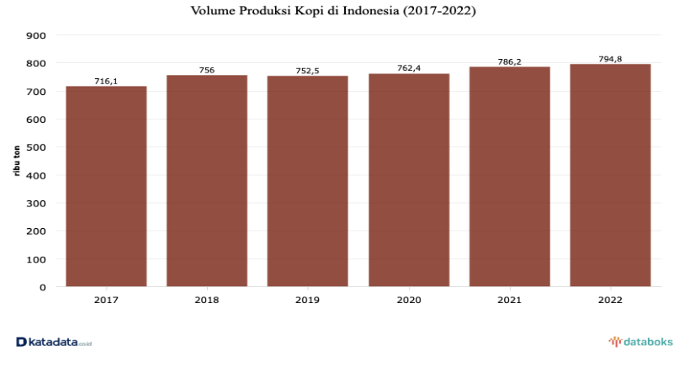
Source: Central Statistics Agency (2023)
In Brebes Regency itself, coffee is one of the regional superior products. With the large amount of coffee production in Indonesia, especially in the Brebes area, there are many ways to enjoy coffee, one of which is by visiting a coffee shop. The coffee shop itself is a place that is synonymous with neatly arranged tables and chairs and comfortable sofas, selling various types of coffee and snacks as a support accompanied by music and a comfortable atmosphere that can be felt by consumers (Rasmikayati et al., 2020 ). The phenomenon of the rise of coffee shops, especially in Brebes. Nowadays coffee is no longer a men's drink. Many women now enjoy coffee as part of their lifestyle. Therefore, business people are taking advantage of this opportunity to meet market needs and desires by following current trends (Raja Ainaya Alfatiha, 2021). The number of coffee shops in Brebes Regency, according to Cecep Dewantara (2023), from the head of the Brebes coffee hall, said "The number of coffee shops in Brebes is approximately 30, which alone does not include the coffee shops included in the data collection."
Table 1. Number of coffee shops in Brebes Regency

No | Nama Coffee Shop | Pemilik | Tahun Berdiri
1 | Kelirumologi Kopi | Cecep Dewantara | 2015
2 | Java Guci Dawuhan | Uzumaki Priyanto | 2015
3 | RongTjangkir | Fitriadi Prakoso | 2016
4 | Warkop 12 | Akhmad Syaroni | 2017
5 | Kopi Batursari | Abdul Gofur | 2018
6 | Rajaswa Coffee | Muhamad Syahrul Aziz | 2019
7 | He Kafei | Nova Kumalasari | 2020
8 | Sampul Kopi | Iif | 2020
9 | Sahala Coffee | Muhammad Syamsul | 2020
10 | Halona Micro Roastery | Faqih Agustian | 2020
11 | Mata Angin Kopi | Fajar Tiovanni | 2020
12 | Putri Bumi Catering | Salsabila | 2020
13 | Kara_Jo | Edi Sudrajat | 2020
14 | Brayan Café & Bistro | Brian Alfiansyah | 2020
15 | Jo’I Matcha & Coffee | Bang Jo | 2020
16 | Matada Coffee | Adityok Nugro | 2021
17 | Café Jeto | Hendri Sucipto | 2021
18 | Coffee Sirampog Estate | Abdul Basir | 2021
19 | Sleeping Forest Roastery | Ahmad Sudaryanto | 2021
20 | Kopiin Culture | Ricky Febria Aditya | 2021
21 | Joy Coffee | Faris Bachtiar | 2022
22 | Empoe Coffee | Ali Wahyudin | 2022
23 | Renjana | Pandu Miko | 2022
24 | Dala Coffee | Rizka Zahra Zakiyyah | 2022
25 | Haksagram | Alvian Galih Y | 2022
26 | Brayan Koffie | Boris | 2022
27 | Coffee OD | Ahmad Muhajiri | 2022
28 | Menuman Coffee | Adiman Hanif Septian | 2022
29 | Asmaralaya Coffee | Khaerul Anwar | 2023
30 | Antara Coffee | Yusuf | 2023
Source: 2023 coffee shop data collection

The emergence of many coffee shop industries in Brebes Regency has had a new impact on consumer lifestyles. With the new lifestyle created by the current generation, the competition in the coffee shop industry has reached a new level where the best can survive the competition. There are many new coffee shop brands offering new facilities and concepts to the community, especially in the Brebes Regency area, so every coffee shop entrepreneur must know Positioning to be able to survive in the competition. Positioning is where a company prepares a market offer to place a competitive position with competitors that can be embedded in the minds of consumers (Wijaya & Anggia Rizka, 2021).
Company positioning brings together market offerings to create a specific competitive position to establish a position within the competition. When a company defines competition, the company must determine how consumers perceive the competition and must think about what attributes consumers consider important when consumers evaluate products (Wardhana & Rustandi Kartawinata, 2019). To be able to find out the positioning of coffee shops in Kab. Brebes, it is necessary to carry out Positioning research based on consumer perceptions through perception maps. In determining positioning, coffee shop classifications that have the same capacity are also carried out.
Table 2. Coffee Shop Data Analyzed For Positioning

No | Nama Coffee Shop | Tahun Berdiri | Jumlah Meja | Omzet
 | Kelirumologi Kopi | 2015 | 8 - 10 Meja | 10 - 20 Juta
 | Rajaswa Coffee | 2019 | 8 - 10 Meja | 10 – 20 Juta
 | Warkop 12 | 2017 | 8-10 Meja | 10 – 20 Juta
Source: 2023 survey results

Based on the data above, it was found that the samples used for positioning analysis were the coffee shops Kelirumologi Kopi, Rajaswa Coffee, Warkop 12 because they have similarities in terms of number of places and turnover. Then the year of establishment has exceeded 4 years, especially in the Brebes area.
Based on the explanation previously explained, researchers are interested in conducting research on coffee shops in Brebes Regency. So this research attempts to analyze the positioning of the coffee shop based on consumer perceptions, so this research is entitled "Analysis of Coffee Shop Positioning Based on Consumer Perceptions in Brebes Regency". The problem can be formulated as follows: (1) What is the positioning of the attributes in the coffee shops Kelirumologi Kopi, Rajaswa Coffee and Warkop 12 in Brebes Regency? (2) What is the positioning of the Kelirumologi Kopi, Rajaswa Coffee and Warkop 12 coffee shops in Brebes Regency based on consumer perceptions? (3) What is the appropriate marketing strategy for coffee shops to implement in Brebes Regency?
The aim of this research is to analyze and determine the attributes of coffee shops that influence consumer perceptions, analyze the positioning of coffee shops and to find out the right marketing strategy to implement after knowing the positioning based on consumer perceptions.

LITERATURE REVIEW AND HYPOTHESIS DEVELOPMENT
Positioning
Positioning is the act of designing a company's offering and image so that it occupies a special place in the minds of the target market. The purpose of positioning is to place the brand in consumers' minds in order to maximize potential benefits for the company (Heriyadi, 2019). Positioning means gaining a special and unique place in the minds of the target market for the act of designing the company's offerings and image in such a way that it is perceived as superior to its competitors (Delfi Fitriani, 2019).
Consumer Perception
Perception is a process when a person selects, organizes and interprets the information that comes into its own meaning to create an overall picture (Yoana Amelia Dewi, 2019). Perception is a process carried out by individuals to select, organize and interpret stimuli into meaningful and reasonable images about the world (Bulan et al., 2020).
Coffee Shop
The definition of a coffee shop or coffee shop can be interpreted as "a small cafe or small restaurant that usually sells coffee and sometimes non-alcoholic drinks, simple food or snacks, with supporting facilities in that place." Coffee connoisseurs come to coffee shops easily and enjoy a quality cup of coffee. Of course, companies need to pay attention to this in creating coffee drink products that have good quality so that it will have an impact on consumer satisfaction (Fauzan Hanif, 2020). The definition of a coffee shop or coffee shop itself in the Big Indonesian Dictionary by Poerwadarwita is quoted as "A place that sells coffee and other types of drinks, as well as snacks at low prices (Fauzan Hanif, 2020).
Coffee Shop Attributes
The coffee shop attributes used in this research were taken from previous research, namely service quality, brand, location, facilities, price, menu diversity and atmosphere. The definition of service quality is the overall characteristics and properties of a product or service that influence its ability to satisfy stated or implied needs (Subhan et al., 2019). A brand is a symbol, sign, design or a combination of these three things which is intended as an identity for several sellers and then used as a differentiator from competitors on the market (Nurul Karimatun Mardiyah, 2022). Location also plays an important role in determining consumer preferences in choosing a coffee shop. The more strategic the business chosen, the higher the sales level and this will influence the success of the business. Vice versa, if the location chosen is not strategic then sales will not be very good (Triutami, 2022). In general, consumers will choose a comfortable coffee shop with complete facilities. These facilities include the availability of wifi, toilets, prayer rooms, parking lots and smoking areas. Facilities are features that are available in physical form to meet visitor needs so that visitors feel satisfied and all consumer expectations can be met (Triutami, 2022). Price is very determining in consumer preferences when choosing a coffee shop. Consumers will think twice about buying products that are too expensive or over priced. Prices that are too cheap will also raise questions about whether the product being sold is of good quality. However, the price of a cup of coffee that tastes delicious will make consumers not care about price (Triutami, 2022). Consumers need choices in choosing the food or drink they want. This is because consumers have different tastes from one another. This menu diversity is an important factor in being able to expand the target market and fulfill consumer desires (Utin Fitriana Saputri, 2019). Arranging the coffee shop, such as placing tables and chairs or installing other interiors both inside and outside the coffee shop, will create comfort for consumers (Triutami, 2022).

Table 3. Previous Research
No | Nama Peneliti (Tahun) | Metode Penelitian | Atribut Penelitian
1. | I Made Sukadana dan Komang Gita Krishna Murti (2019) | Deskriptif Kualitatif | Nilai, Keunikan, Kredibilitas
2. | Rini Kuswandari, Irvana Arofah, dan Tabah Heri Setiawan (2021) | Multidimensional Scalling | Harga, Merek, Kemasan, Warna, Ulasan, Kemudahan Memperoleh
3. | Fakhri Anggara (2019) | Analisis Regresi Berganda | Kemudahan Memperoleh, Harga, Kepopuleran Merek
4. | Nailiatul Fita Agustin, Feti Fatimah, Nursaidah (2019) | Multidimensional Scalling | Harga, Desain, Fitur, Kamera
5. | Muhammad Iqbal Juniartha (2020) | Multidimensional Scalling | Popularitas Merek, Kualitas Desain, Daya Tarik Harga, Kecepatan Prosesor, Kapasitas Memori, Daya Tahan Baterai, Kualitas Kamera, Layanan Purna Jual, Keandalan
6. | Delfi Fitriani (2019) | Deskriptif Kuantitatif | Proses Controllability, Costumer Service, Informasi Quality
7. | Aditya Wardhana, Budi Rustandi dan Syahputra (2019) | Analisis Deskriptif Multidimensional Scalling | Kualitas Pelayanan, Kualitas Kopi, Ragam Makanan & Minuman, Atmosphere (suasana), Keunggulan, Life Style, Harga
8. | Akbar Riansyah (2019) | Multidimensional Scaalling | Produk, Promosi, Lokasi, Proses, Bukti fisik, Harga, Orang
Source: 2023 theoretical study
The objects of this research are 3 coffee shops which will be compared using 7 attributes, namely: service quality, brand, location, facilities, prices, menu diversity, atmosphere. To measure consumer perceptions, the MDS analysis tool is used which will produce perceptual mapping. Perception mapping shows where consumers prefer to place coffee shops according to what they feel. With a perception map, each brand or coffee shop occupies a special place. Products or brands that are similar will be close to each other, while those that have many differences will be far from each other. After knowing the perception map, then determine the right marketing strategy for the coffee shop. The basis for creating a framework through modification of previous research.
Conceptual Framework
Figure 2. Research model
Source: 2023 theoretical study
RESEARCH METHOD
Types of research
The technique in this research uses MDS. Multidimensional scaling (MDS) is a technique for measuring and representing people's perceptions about various product objects, brands, shops, etc. (Wardhana & Rustandi Kartawinata, 2019). According to Churchill and Iacobucci Churchill and Iacobucci (2019) there are several key factors that must be considered when carrying out multidimensional scaling analysis, namely: determining the brand or product that will be used, determining how assessments of similarity can be contained and forming stimuli, deciding how the assessments will be summarized. , collect and analyze assessments to produce a perception map, and give names to the resulting dimensions (Wardhana & Rustandi Kartawinata, 2019).
Data type
Survey, population and sample data. The population is everything that needs to be observed, the population in this study is coffee shop consumers in 3 coffee shops. The type used is Accidental Sampling (Convenience Sampling), which is a sampling procedure that selects samples from people or units that are easiest to find. The sample from this research was decided to take as objects the consumers of the 3 coffee shops. To determine the number of samples appropriate to research needs, the following Slovin formula is used; n = N / (1 + (N x e²)). In the research, the average number of consumers of coffee shop was 200 people, Rajaswa Coffee was 250 people, Warkop 12 was 150 people. So the total population is 600 people. The error is set at 10%, then the sample size = 600 / (1 + (500 x 10 %²)) = 85.7 and ends up being 86 people. In collecting data, researchers used a questionnaire. Data is collected by providing online & offline questionnaires. The data results are not done manually, but through the SPSS application.
Table 4. Score Level
Information | Total score
STS | 1
TS | 2
RR | 3
S | 4
SS | 5
Source: 2023 research data
The scale used in this research is the Likert scale, which is a scale used to measure attitudes towards an object by asking a number of questions or statements. In the data management stage, the numbers are replaced with numbers one to five so they can be added up.
Instrument Testing Techniques
Validity test
Validity Test is a tool used to collect data so that the data obtained has a high level of accuracy and consistency, the research instruments used must be valid (Delfi Fitriani, 2019). The value uses the comparison method of r calculated against r table, if r calculated > r table and the value is positive, it can be determined that the test is reported as valid.
Reliability Test
The data reliability test is used to determine the consistency of the measuring instrument, whether the measuring instrument used is reliable and remains consistent if the measurement is repeated (Hasdar, 2019). The significance test is carried out at a significance level of 0.05, meaning that the instrument can be said to be reliable if the alpha value is greater than the r critics product moment. Or, we can use certain limits such as 0.6 (Hasdar, 2019).
MDS (Multi Dimensional Scaling) Analysis
The data analysis technique used in this research is multidimensional scaling analysis techniques using SPSS. Multidimensional Scaling Analysis is a procedure used to describe perceptions in a display. The purpose of multidimensional scaling (MDS) is to provide a visual depiction of proximity patterns in the form of similarities or distances between a set of objects. The application of MDS can be found in scientific visualization and data mining in cognitive science, information, marketing and ecology. For example, when potential consumers are asked to compare products and make assessments regarding the similarities of the products. MDS can show the dimensions of respondents' assessments directly into visualization patterns of closeness regarding product similarities, in contrast to factor or discriminant analysis which involves the researcher's assessments. Because of these advantages, MDS is the most commonly used tool in perceptual mapping.

Table 5. Operational Variables
Variabel | Dimensi | Indikator | Definisi
Persepsi Konsumen Terhadap Atribut  Coffee Shop | Interpretasi Terhadap Atribut | - Kualitas Pelayanan | Kualitas pelayanan merupakan upaya pemenuhan kebutuhan dan keinginan pelanggan serta ketepatan penyampaian dalam mengimbangi harapan pelanggan (Mulyana et al., 2019).
 |  | - Merek | Merek atau brand merupakan identitas suatu produk atau jasa, yang dapat menambah nilai bagi suatu produk (Yahya & Gunawan, 2021).
 |  | - Lokasi | Lokasi mengacu pada berbagai aktivitas pemasaran yang berusaha memperlancar dan mempermudah penyampaian atau penyaluran barang dan jasa dari produsen kepada konsumen (Alpine Mandala Putra, 2022).
 |  | - Fasilitas | Fasilitas adalah tempat yang menyediakan perlengkapan fisik untuk memenuhi kebutuhan pelanggan sehingga pelanggan bisa merasa lebih nyaman (Rumaisha Nur Azizah, 2022).
 |  | - Harga | Harga adalah jumlah uang yang harus dibayar pelanggan untuk memperoleh produk (Subhan et al., 2019)
 |  | - Keragaman Menu | Keragaman produk adalah kumpulan seluruh produk dan barang yang ditawarkan penjual tertentu kepada pembeli(Ikrar Cholik et al., 2020).
 |  | - Atmosphere (Suasana) | Atmosfer coffee shop berpengaruh terhadap persepsi juga emosional konsumen ketika menilai sebuah coffee shop (Chairina Yahya, 2021).
Source: Various scientific papers, theses and theses

RESULTS AND DISCUSSION

Validity test
Table 6. Questionnaire Validity Test Results
Nilai R | Atribut | Pertanyaan | Kelirumologi  Kopi | Rajaswa Coffee | Warkop 12 | Ket.
R Hitung | Kualitas Pelayanan | KPN 1  KPN 2  KPN 3  KPN 4  KPN 5 | 0,730  0, 771  0,439  0,782  0,752 | 0,820  0,710  0,225  0,814  0,766 | 0,804  0,801  0,281  0,775  0,794 | Valid
 | Merek | MR 1  MR 2  MR 3 | 0,774  0,592  0,727 | 0,723  0,570  0,699 | 0,760  0,642  0,721 | Valid
 | Lokasi | LK 1  LK 2  LK 3  LK 4 | 0,884  0,873  0,662  0,898 | 0,873  0,844  0,726  0,837 | 0,859  0,874  0,682  0,894 | Valid
 | Fasilitas | FS 1  FS 2  FS 3 | 0,778  0,883  0,859 | 0,908  0,901  0,892 | 0,890  0,938  0,880 | Valid
 | Harga | HG 1  HG 2  HG 3  HG 4 | 0,815  0,889  0,899  0,862 | 0,865  0,891  0,871  0,878 | 0,842  0,878  0,906  0,842 | Valid
 | Keragaman Menu | KM 1  KM 2  KM 3 | 0,860  0,939  0,886 | 0,868  0,911  0,878 | 0,927  0,882  0,903 | Valid
 | Atmosphere | ATM 1  ATM 2  ATM 3 | 0,907  0,863  0,894 | 0,842  0,912  0,908 | 0,839  0,926  0,904 | Valid
Source: SPSS 2023 data processing results
Based on the results of the SPSS data processing above, several calculated R numbers > R Table were obtained. Where the R Table in this study is 0.2120, obtained from df = (N – 2) = (86 - 2) = 84 which is then checked in the R Table section.

Reliability Test
Table 7. Alpha Reliability
 | Reliability Statistics
 | Cronbach's Alpha | N of Items
Kelirumologi Kopi | ,901 | 7
Rajaswa Coffee | ,935
Warkop 12 | ,932
Source: 2023 SPSS data processing results
Based on the table of reliability test results for the coffee shop brands Kellirumologi Kopi, Rajaswa Coffee and Warkop 12, the seven indicators have an alpha coefficient greater than 0.6. Based on the provisions above, the research is declared reliable.

Multidimensional Scaling Analysis
Figure 3. Mapping of Perceptions of Service Quality Attributes
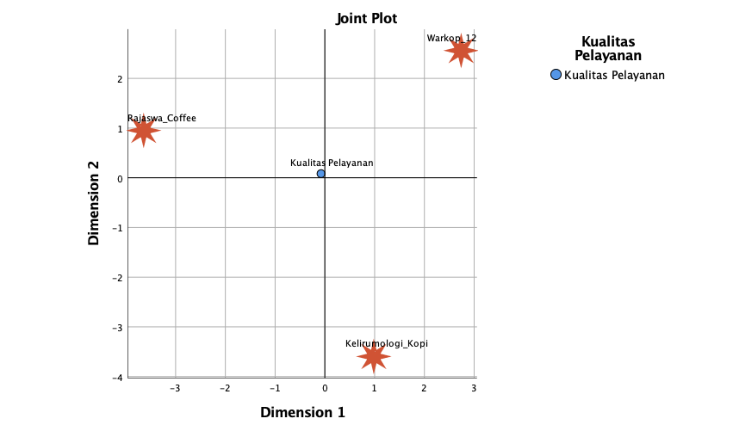
Source: 2023 data processing results
Quadrant 1 is occupied by Warkop 12 with positive dimension 1 and positive dimension 2 which means superior. In this quadrant Warkop 12 has coordinates (2.729 : 2.560). Quadrant 2 is occupied by Coffee Kelirumology with a positive dimension 1 value and negative dimension 2 which means less superior. In this quadrant, coffee kelirumology has coordinates (0.982 : -3.597). Quadrant 4 is occupied by Rajaswa Coffee with a negative dimension 1 value and a positive dimension 2 value which shows that it does not have advantages in the Service Quality attribute. In this quadrant, Rajaswa Coffee has coordinates (-3.463 : .953). According to Kotler (2019), service quality is a form of consumer assessment of the level of service received and the expected level of service. If the service received or felt is as expected, then the quality of service is perceived as good and satisfying. The satisfaction that has been formed can encourage consumers. to make repeat purchases and look forward to becoming loyal customers.

Figure 4. Brand Attribute Perception Mapping

Source: 2023 data processing results
Quadrant 1 is occupied by Rajaswa Coffee with positive dimension 1 and positive dimension 2 which means superior. In this quadrant, Rajaswa Coffee has coordinates (3.465 : .514). Quadrant 3 is occupied by Coffee Miscellaneous with negative dimension 1 and negative dimension 2 which means it does not have superiority in consumer perception. In this quadrant Coffee Kelirumology has coordinates (-1.299 : -3.220). Quadrant 4 is occupied by Warkop 12 with a negative dimension 1 value and a positive dimension 2 value which indicates that it is not superior in brand attributes. In this quadrant Warkop 12 has coordinates (-2.234 : 2.671). According to Kotler (2020), brand image is the perception and belief held by consumers, as reflected in the associations that occur in consumers' memories.
Figure 5. Location Attribute Perception Mapping
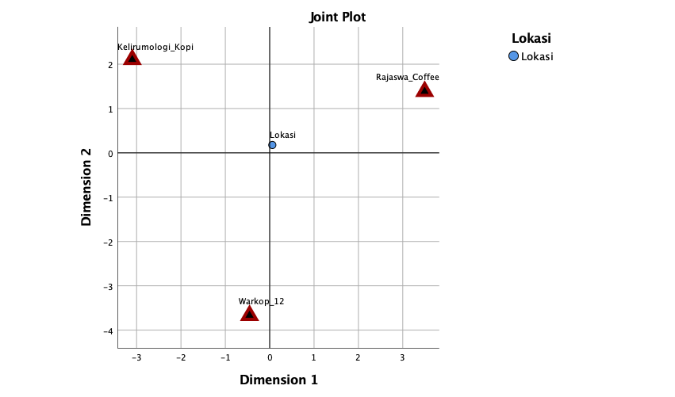
Source: 2023 data processing results
The perception map obtained from quadrant 1 is occupied by Rajaswa Coffee with positive dimension 1 and positive dimension 2 which means superior. In this quadrant, Rajaswa Coffee has coordinates (3.493 : 1.386). Quadrant 3 is occupied by Warkop 12 with a value of dimension 1 negative and dimension 2 negative, which means it does not have superiority in consumer perception. In this quadrant Warkop 12 has coordinates (-,455:-3,669). Quadrant 4 is occupied by Coffee Kelirumology with a negative dimension 1 value and a positive dimension 2 value which indicates that it is not superior in the Location attribute. In this quadrant Coffee Kelirumology has coordinates (-3.098: 2.105). According to Kasmir (2021), location is a place to serve consumers, it can also be interpreted as a place to sell merchandise. Consumers can more easily choose and make transactions or shop for products offered directly.
Figure 6. Perception Mapping of Facility Attributes
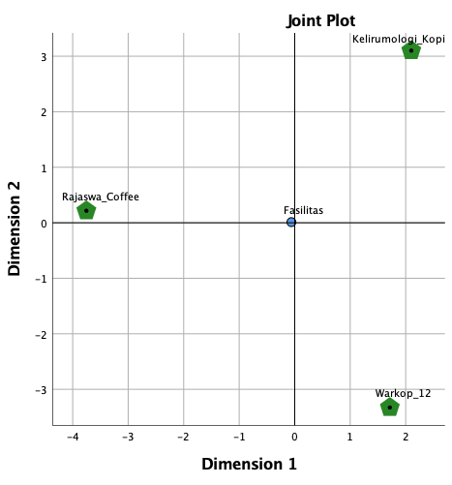
Source: 2023 data processing results
The perception map obtained from quadrant 1 is occupied by Coffee Kelirumology with a positive dimension 1 value and positive dimension 2 which means superior. In this quadrant Coffee Kelirumology has coordinates (2,100:3,101). Quadrant 2 is occupied by Warkop 12 with dimension 1 positive and dimension 2 negative which means less superior. In this quadrant Warkop 12 has coordinates (1.714:-3.327). Quadrant 4 is occupied by Rajaswa Coffee with a negative dimension 1 value and a positive dimension 2 value which shows that it is less superior in terms of facility attributes. In this quadrant, Rajaswa Coffee has coordinates (-3,754:,216). According to Tjiptono (2020) facilities are physical resources that must exist before a service is offered to consumers. Facilities are something important in a service business, therefore existing facilities, namely the condition of the facility, interior and exterior design and cleanliness must be considered, especially those that are closely related to what consumers feel directly. Perceptions obtained from customer interactions with service facilities influence the quality of the service in the eyes of consumers.
Figure 7. Mapping of price attribute perceptions
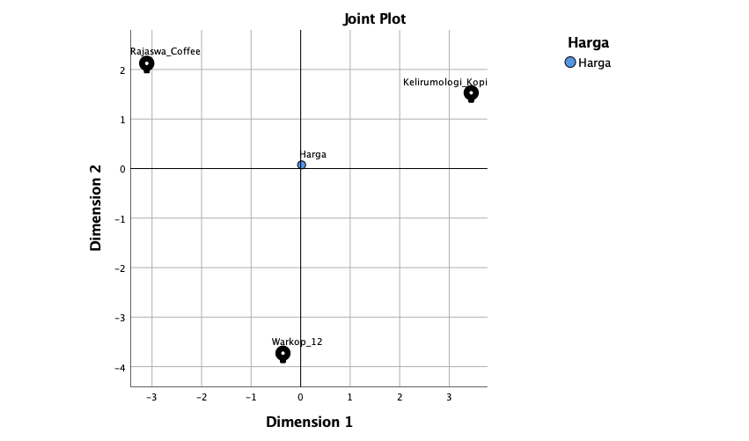
Source: 2023 data processing results
The perception map obtained from quadrant 1 is occupied by Coffee Kelirumology with a positive dimension 1 value and positive dimension 2 which means superior. In this quadrant Coffee Kelirumology has coordinates (3.444:1.530). Quadrant 3 is occupied by Warkop 12 with negative dimension 1 and negative dimension 2 which means weak. In this quadrant Warkop 12 has coordinates (-,357:-3,728). Quadrant 4 is occupied by Rajaswa Coffee with a negative dimension 1 value and a positive dimension 2 value which indicates that it is less superior in the Price attribute. In this quadrant, Rajaswa Coffee has coordinates (-3,107:2,124). According to Lee and Lawson Body (2020), price perception is a consumer's assessment and associated emotional form regarding whether the price offered by the seller and the price compared with other parties is reasonably acceptable or justifiable. Therefore, the first thing that interests or attracts consumers is how much value consumers spend to get the product offered.
Figure 8. Mapping of perceptions of menu diversity attributes
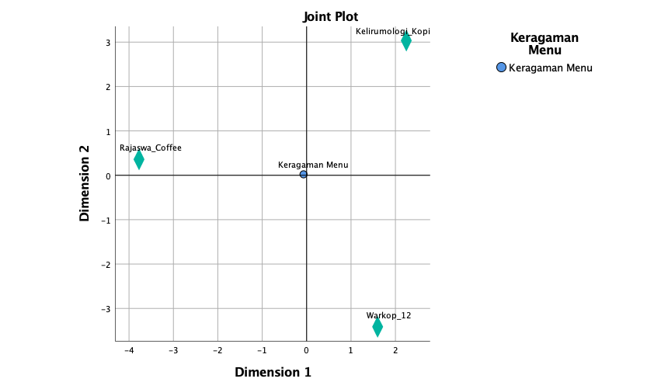
Source: 2023 data processing results
The perception map obtained from quadrant 1 is occupied by Coffee Kelirumology with a positive dimension 1 value and positive dimension 2 which means superior. In this quadrant Coffee Kelirumology has coordinates (2,246:3,035). Quadrant 2 is occupied by Warkop 12 with positive dimension 1 and negative dimension 2 which means superior quality. In this quadrant, Warkop 12 has coordinates (1,599:-3,414). Quadrant 4 is occupied by Rajaswa Coffee with a negative dimension 1 value and a positive dimension 2 value which shows that it is less superior in the Menu Diversity attribute. In this quadrant, Rajaswa Coffee has coordinates (-3,775:,358). According to Ali & Waluyo (2022). "Menu diversity starts from taste, size, quality and product availability, which has the same meaning as menu diversity. Meanwhile, according to researchers, they argue that consumers need various choices in choosing the food and drink they want. This is because consumers have different tastes. Menu diversity is an important factor in order to expand the target market and also fulfill different desires.
Figure 9. Mapping of perceptions of atmospheric attributes
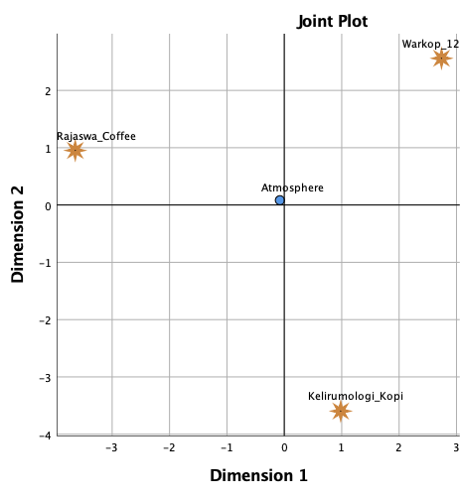
Source: 2023 data processing results
The perception map obtained from quadrant 1 is occupied by Warkop 12 with positive dimension 1 and positive dimension 2 which means superior. In this quadrant Warkop 12 has coordinates (2,739:2,560). Quadrant 2 is occupied by Coffee Kelirumology with a positive dimension 1 value and negative dimension 2 which means superior. In this quadrant Warkop 12 has coordinates (,983:-3,597). Quadrant 4 is occupied by Rajaswa Coffee with a negative dimension 1 value and a positive dimension 2 value which shows that it is less superior in the Atmosphere attribute. In this quadrant, Rajaswa Coffee has coordinates (-3,643:,953). According to Berman and Evan (2023) atmosphere refers to the physical characteristics of a store that are used to build an impression and to attract customers. With a good store atmosphere, retail companies can attract consumers to visit and buy.
Figure 10. Mapping of coffee shop perceptions in Brebes Regency
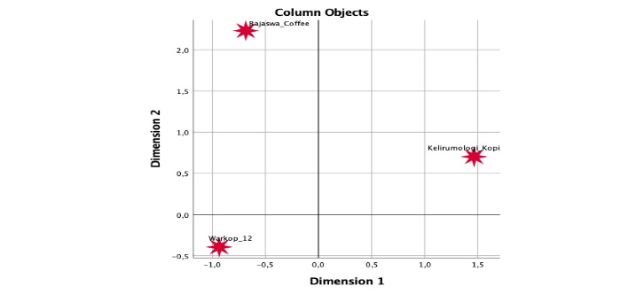
Source: 2023 data processing results
The coffee shop brand Kelirumologi Kopi leads because it is in quadrant I with positive coordinates in each dimension (1.465:.702). The attribute position in quadrant 1 means that the respondent is enthusiastic about coffee shops because of the attributes shown in quadrant 1. The Warkop 12 coffee shop brand is in quadrant III at coordinates (-,935:-,394). The next attributes are in quadrant 3, namely location. Attributes included in quadrant 3 have negative values for each dimension. The Rajaswa Coffee brand is in quadrant IV with coordinates (-,685:2,233). The attributes in quadrant 4 have negative values for dimension 1 and positive values for dimension 2. This happens because each respondent has a different interest in each attribute.

Marketing Strategy
Alternative steps that the Kelirumologi Kopi coffee shop can take is to maintain menu diversity, prices and facilities. Apart from that, Kelirumology Coffee must also maximize brand attributes so that they can be recognized by the wider community, especially in Brebes Regency. So that many consumers are able to recognize the Kelirumologi Kopi brand easily. Alternative steps that Rajaswa Coffee coffee shop can take is to maintain brand and location attributes. Apart from that, Rajaswa Coffee must improve the quality of service, menu diversity and prices provided to consumers. This is so that consumers feel satisfied and can increase the popularity of the coffee shop brand. Alternative steps that the Warkop 12 coffee shop can take is to maintain the quality of service and atmosphere of the coffee shop. Apart from that, Warkop 12 must improve the location and prices of its products to match what consumers want. So that consumers feel satisfied and can increase the popularity of the Warkop 12 coffee shop brand.

CONCLUSIONS AND RECOMMENDATIONS
Conclusion
From the results of this research, it was concluded that:
            - The positioning of coffee shop attributes shows that in terms of service quality attributes, brand, location, facilities, prices, menu diversity and atmosphere, each brand has its own advantages and weaknesses. Like Kelirumologi Coffee has several attributes that are superior to its competitors, namely menu diversity, prices and facilities, Rajaswa Coffee has attributes that are superior to its competitors, namely brand and location. Warkop 12 has advantages, namely in terms of service quality and atmosphere.
            - In the coffee shop positioning section, the Kelirumologi Kopi brand takes the lead because it is in quadrant I with positive coordinates in each dimension. The Warkop 12 brand is in quadrant III in the coordinates. The Rajaswa Coffee brand is in quadrant IV with its coordinate points. Ranked first by Kelirumologi Kopi, second by Rajaswa Coffee and third by Warkop 12.
            - The marketing strategy used for coffee shops is to maintain superior attributes from research results and improve weak aspects so that consumers are more satisfied and more able to compete with their competitors.
Suggestion
- The results of research according to consumer perception assess several attributes that are considered to be the choice of consumers to visit their coffee shop. Of course, this results in the positioning of the coffee shop. It is hoped that this will become material for evaluating and defending the coffee shop which is the location of this research. Both in terms of weaknesses that must be corrected and advantages that must be maintained.
- It would be better for future researchers to be more careful in collecting questionnaire data that will be used. The more valid the data used will support a more even form of perception map. The level of accuracy in calculating attributes is an important factor in describing the market competition that is formed.
- It is better to use more than 3 objects to carry out consumer perception mapping so that it can be carried out with better results and similarities can be found between each object in the field.

REFERENCE
Akbar Riansyah. (2019). Positioning Analysis of Cafe "The Kopi Lowo" Sumbersari Jember District. Thesis.
Aldella Anka Putri. (2022). The Influence of Product Quality, Facilities, and Price on Customer Satisfaction in Coffee Addiction. Faculty of Teacher Training and Education, University of Lampung, Bandar Lampung.
Ali Anhar, R., Haryati, I., Management, P., Bima, S., & Kunci, K. (2020). Analysis of Consumer Perception of Marketing in Online Media Consumer Perception Analysis of Marketing in Online Media. Dimensions, 9(3), 412–421.
Alpine Mandala Putra. (2022). The Influence of Price, Location, and Lifestyle on Purchase Interest in Samarinda Nusantara Coffee Shops Thesis. Thesis.
Asaretkha Adjane Annisawati and Aulia Qurata Ayuninda. (2019). The Influence of Consumer Attitudes and Perceptions on Interest in Using the Kai Access Application at PT Kereta Api Indonesia Using the Technology Accetence Model (Tam) Approach. Journal of Business And Marketing, 9.
Ayu Wulandari. (2020). Thesis on the Influence of Location and Price on Consumer Purchase Interest at Warpindo Coffee Shop.
Bulan, T. P. L., Chandra, R., & Amilia, S. (2020). Consumer Perception, Service Quality and Purchase Interest in Traditional and Modern Retail. Journal of Motivational Management, 16(1), 29. https://Doi.Org/10.29406/Jmm.V16i1.1568
Catherine Afryani. (2022). The Influence of Coffee Taste, Product Diversity on Kopitheory Customer Satisfaction in Makassar. Thesis.
Chairina Yahya, A. (2021). Consumer Perceptions of the Existence of Coffee Shops and Baristas in the Third Era of Coffee Marketing (Vol. 4, Issue 1).
Darmansyah, D., Agustia, D., Nugroho, Y., Khori, ), Maifianti, S., & Raidayani, ). (2020). Changes in Consumer Attributes in Choosing a Coffee Shop in Aceh Province During the Pandemic. Teuku Umar University, 6(1), 37–43. Https://S.Id/Oznos
Esa Dava Officer of Herlambang. (2022). The Influence of Product Quality, Brand Image and Price on Purchasing Decisions (Study on Surya Coffee in Purwodadi City). Thesis.
Faiz Mujahidin, A., & Verlandes, Y. (2022). The Influence of Menu Diversity, Cafe Atmosphere, and Worth of Mouth on Purchasing Decisions at Cafe Sabin Trawas, Mojokerto. Journal, 1(3), 141–148.
Fakhri Anggara. (2019). Analysis Of Brand Positioning Strategy Based On Preference, Perception, And Consumer Satisfaction Of Pertamina Lubricants Products Fakhri Anggara.
Fauzan Hanif. (2020). The Influence of Product Quality and Service Quality on Purchasing Decisions at the Pulang Coffee Shop, Palembang City. Thesis.
Fita Agustin, N., & Fatimah, F. (2019). Smartphone Positioning Analysis Based on Consumer Perception. Www.Topbrand-Award.Com
Flaurence Tarehy, J., Nuswantara, B., Agriculture, F., Business, D., Kristen, U., & Wacana -Salatiga, S. (2019). Analysis of Consumer Behavior Towards Coffee Purchasing Decisions in Kalimera Coffee Bar Salatiga. Analysis of Consumer Behavior Towards Coffee Purchasing Decisions in Kalimera Coffee Bar Salatiga. Agroinfo Galuh Student Scientific Journal, 8.
Gesta Nabilla, A., Tuasela, A., & Tinggiilmu Ekonomi Bulan Bridge, S. (2021). Marketing Strategy in Efforts to Increase Income at Diva Karaoke Singing House in Timika City. Critical Journal, 5.
Handayani, T., Sidiq, F., Nur, S., Management, P. S., Tinggi, S., Ekonomi, I., & Pemalang, A. (2021). Efforts to develop umkm through management management at Mutiara Convection UMkm. The Strategy Development of Smes Through the Management of Mutiara Convection. Jamu: Journal of Umus Community Service, 1(02), 44–51.
Hasdar. (2019). Thesis Mapping the Relative Perceptions of Nokia, Samsung, Blackberry and iPhone Brand Cellphone Consumers in Makassar.
Heriyadi. (2019). Positioning Strategy in Business Competition (Points of Difference and Points of Parity). In Ajie-Asian Journal Of Innovation And Entrepreneurship Https://Www.Gooto.Com/Read/1051222/Gai
Ika Purnama, N., Hanum Harahap, S., & Syahputri Siregar, D. (2022). The Influence of Price, Product Quality and Store Atmosphere on Consumer Loyalty of Ompu Gende Coffee.
Ikrar Cholik, F., Sari, B., & Economics and Business, F. (2020). The Influence of Price, Menu Diversity and Service Quality on Purchasing Decisions at Kusuma Catering in Bekasi.
Jenesya Afgiani Reza. (2021). Abstract Analysis Of Attributes Of Interest And Service Performance At Jou Coffeebar And Café Kiyo Bandar Lampung. Thesis.
Khadijah, S. N., & Dianasari, I. A. (2019). The Influence of Service Quality and Consumer Perception on Consumer Satisfaction in Using Services at Ibnu Sina Hospital, Gresik Regency. 07(02).
Kuswandari, R., Arofah, I., & Heri Setiawan, T. (2021). Lipstick Brand Positioning Analysis Based on Consumer Perception Using the Multidimensional Scaling Method. Journal of Health Sciences, 2(5), 890–901. https://Doi.Org/10.46799/Jsa.V2i5.236
Muhammad Iqbal Juniartha. (2020). Positioning Analysis of Top 5 Smartphone Brands Using Multidimensional Scaling Method Based on Consumer Perception (Study of Consumers of Students of the Faculty of Economics and Business, Muhammadiyah University of Surakarta) Scientific Publication By: Muhammad Iqbal Juniartha.
Mulyana, A., Program, F. A., Business, M., Management, S., Business, F., & Economy, D. (2019). The Influence of Product Quality and Service Quality on Shao Kao Kertajaya Customers' Repurchase Intention Through Customer Satisfaction (Vol. 7, Issue 2).
Murti, I. M. S. And K. G. K. (2019). Positioning Analysis of Consumer Perceptions of Online Transportation (Grab). Journal of Economics and Business Studies, 12.
Mustika Sari, R., & Piksi Ganesha, P. (2021). The Influence of Price and Product Quality on Purchasing Decisions (Customer Survey for Bed Sheet Rise Products). 5(3), 2021.
Nilasari, F., Ilmu, P., & Business, A. (2020). The Influence of Price, Product Diversity and Store Atmosphere on Consumer Satisfaction at the Jombang Culture Coffee Shop.
Novarianti, A. D., & Djuanda, G. (2022). Marketing Strategy Priorities Based on Consumer Perceptions in Purchasing Decisions on Xiaomi Smartphones Using the Analytical Hierarchy Process (AHP) Method. Journal Of Business And Economics Research (Jbe), 3(2), 215–224. https://Doi.Org/10.47065/Jbe.V3i2.1762
Nurul Karimatun Mardiyah. (2022). The Influence of Price, Promotion, Brand Image, and Product Quality on Consumer Satisfaction at the Naavagreen Beauty Clinic in Yogyakarta.
Oktavino Putra Hanidar. (2020). Positioning Analysis of Apple Cider Using the Mds (Multidimensional Scaling) Method in Malang City.
Raja Ainaya Alfatiha, I. S. (2021). Application of the Design Thinking Method to Product Marketing at Rimbun Coffee Shop. Journal of Innovation Ark, 5(1). https://Doi.Org/10.31629/Jg.V3i2.Xxx
Rasmikayati, E., Afriyanti, S., Rachmat, B., Agritekh, S., Agribusiness, J., Pangan, T., & Saefudin, B. R. (2020). Performance, Potential and Constraints in Coffee Shop Businesses in Jatinangor (Case of Belike Coffee Shop and Balad Coffee Works). Agritekh, 1(1), 26–45.
Rina. (2022). The Influence of Product and Service Quality on Café Coffee Moral Consumer Satisfaction in Makassar City. Thesis.

.

