The Behavioral Finance of MSMEs: Financial Inclusion and Financial Technology
(Case Study on MSMEs in West Jakarta)

Nurrizal Huda ¹⁾; Asep Risman ²⁾
¹⁾ nurrizalhuda23@gmail.com, Faculty of Economic and Business, Universitas Mercu Buana, Indonesia
²⁾ asep.risman@mercubuana.ac.id, Faculty of Economic and Business, Universitas Mercu Buana, Indonesia

Article Information:  Keywords:  Financial Inclusion  Financial Technology  Behavioral Finance of MSMEs  Behavioral Finance  Article History:  Received : April 10, 2024  Revised : April 17, 2024  Accepted : April 20, 2024  Cite This Article: | Abstract in English  This project is to gather empirical data on the topic to gain a better understanding of how financial technology, or Fintech, affects the financial behavior of micro, small, and medium-sized firms (MSMEs). 110 MSMEs spread over West Jakarta made up the sample in 2023. As part of the data gathering method, a random sample questionnaire with a 5-point Likert scale was created using the online tool Google Forms. The Structural Equation Modeling (SEM) model was applied to the data using Partial Least Squares (PLS) software. The results of the study show that financial inclusion and financial technology (Fintech) have a positive influence on MSMEs' financial behavior. Financial technology, or Fintech, may function as a mediator and positively influence MSMEs' financial behavior by promoting broader financial inclusion. This information will be useful to financial institutions, relevant governments, entrepreneurs, and business support organizations that aim to improve the financial behavior and practices of MSMEs. The significance of programs intended to promote good financial conduct, expand financial inclusion, and educate the public about the advantages of fintech in order to enable MSMEs to adopt more responsible financial practices.

INTRODUCTION
In every country, MSMEs (Micro, Small, and Medium Enterprises) perform a significant role in the economy. because more employees from other formal business sectors can be absorbed by MSMEs. The GDP of a nation is greatly influenced by the contribution of MSMEs. MSMEs, particularly micro and small enterprises, are adaptable to many business models and don't need a lot of funding. As a result, compared to other economic actors, particularly large enterprises, micro and small businesses exhibit unique characteristics (Risman et al., 2023).
Most MSMEs still face many problems, including in terms of financial management behavior among MSME players (Putri, 2020). According to Risman et al. (2023), MSMEs exhibit unique financial management traits when shifting from personal to corporate financial management. Researchers are interested in this phenomenon, especially those who study behavioral finance. The ability of an MSME owner to manage their company, including business expansion, raise capital or funding, and manage their attitudes about technical advancements, such as financial technology (Fintech), which will impact their ability to get funding, is crucial to the success of their enterprise. These elements have a big impact on how MSME management behaves financially. Most MSMEs never prepare a financial budget in their business management, especially in micro and small businesses. It appears that some MSMEs are still unaware that online payment options exist when it comes to the payment system. Additionally, relatively few MSME players are aware of credit. The lack of understanding among MSME players on the elements influencing creditworthiness makes it challenging for MSMEs to secure further funding.
Based on the 2022 National Survey of Financial Literacy and Inclusion (SNLIK) launched by the Financial Services Authority (OJK), Financial inclusion in Indonesia in 2022 amounted to an 85.10 percent increase in comparison in 2021 it is 83.6 percent. In three years this last happened increased access society towards products and services finance in Indonesia. Increased inclusion This finance is driven by various factors, especially technological innovation finance. The presence of this innovation creates products/services more affordable finances and easy to access. There is access to financial services easily via digital applications creating a society that previously did not have accounts and financial access to become educated to take advantage of it. Financial inclusion may have an impact on MSMEs' financial management practices by helping them make more sensible (heuristic) funding or financing decisions (Risman et al., 2023). Making finance decisions that are rapid, simple, and practical for MSME management is the aim of financial inclusion. This relieves them of the burden of carrying out labor-intensive financial computations, including capital structure determination, computation of the weighted average cost of capital (WACC), and extensive financial reporting and analysis.
There needs to be a means to mediate between financial inclusion and financial behavior, one of which is assistance from financial technology (Fintech). Financial management practices may expand in tandem with fintech growth (Kusumar and Mendari, 2021). Researchers conducted a pre-survey on 15 respondents aged 18-58 years and the results are that first the researcher will use Financial Inclusion as variable X1 or the independent variable because in point no. 1, the percentage who answered agree was 86.7%. Second, Financial Technology as variable X2 and as a mediator, the percentage who answered agree was 73.3%. This means that from the pre-survey results, these two variables influence the financial behavior of MSMEs. Financial behavior is how a person, whether personal or group, manages (planning, managing, controlling, budgeting, searching and storing) daily financial funds.
The variables studied are financial behavior as the dependent variable and financial inclusion as the independent variable as well financial technology as a mediating variable with a research period of 3 months from October – December 2023. This research aims to see whether the fintech mediation phenomenon can increase financial inclusion which will then influence the financial behavior of MSMEs in West Jakarta. It is hoped that the results of this research can contribute to MSMEs in obtaining capital loans or financing to develop their businesses.
LITERATURE REVIEW AND HYPOTHESIS DEVELOPMENT
Each country has its own definition for MSMEs. MSMEs are generally understood to be companies that are owned and operated by one or more people, that create things or add value to existing products, and that satisfy particular standards or parameters such as asset value, worker size, turnover, and so on (Risman et al., 2023). Accordingly, Government Regulation Number 7 of 2021 CHAPTER III Paragraph 4 Article 35 (President of the Republic of Indonesia, 2021) groups MSMEs according to business capital parameters or yearly sales profits.
Behavioral finance in MSMEs is separated into two categories: behavioral corporate finance and personal finance behavior. Personal financial behavior is behavior in managing individual and family finances, including behavior in managing income, consumption or spending, saving, investing, protection, or insurance. Theories including the Organ Stimulus Response Theory (Hovland et al., 1953), the Reasoned Action Theory (Fishbein & Ajzen, 1975), situational factors (Sampson, 1976), the Financial Planning Theory of Behavior (Ajzen, 1985), and the Technology Acceptance Model (Davis et al., 1989) are all used to study personal financial behavior. Company financial behavior, on the other hand, refers to how the business—in this example, the manager—behaves when making financial decisions on investments and financing. This is consistent with the equity market timing theory (Risman et al., 2021), managerial bias, framing effect, and heuristic theory of Tversky and Kahneman (cited by Luong and Ha, 2011).
Financial inclusion not only has an impact on the economic growth of a region or country but can also have an impact on the welfare of society. Financial inclusion refers to ensuring that individuals can readily access high-quality financial services conveniently and efficiently. By expanding the availability of financial products to the general public, we can diminish economic and social disparities, foster greater economic expansion, and ultimately enhance the well-being of communities (Risman et al., 2021). Everyone, especially the poor, must have access to the chance to move money, grow capital, and lowering risks in an inclusive financial system (Ozili, 2018; Shofawati, 2019). MSME financial behavior encompasses two viewpoints, namely financial behavior (Risman et al., 2023). Since MSMEs' financial management marks a shift from personal (home) to corporate finance, it bears particular characteristics, particularly for micro and small enterprises (UMK). Consequently, the real actions of MSME decision-makers when performing financial management tasks, such as financial planning, financing or capital decisions, investment or budget decisions, and controlling, can be characterized as the financial management behavior of MSMEs.
Financial inclusion offers significant advantages to micro, small, and medium enterprises (MSMEs), such as simplifying decision-making processes and access to funding, enabling convenient installment payments, and securing competitive interest rates on capital. Based on personal financial behavior, first according to the Theory of Planned Behavior that belief is an attitude that influences the intention to change behavior (Ajzen, 1985), in this case financial inclusion is a change that can trigger belief in convenience so that financial inclusion can change financial behavior. According to Hovland et al. (1953), human behavior often reacts or responds to stimuli. In the context of financial inclusion, convenient access to financial services can act as a stimulus, influencing changes in financial behavior. Enhanced accessibility to financial services simplifies and streamlines the process for MSMEs to meet their capital requirements, as it provides access to a variety of financing sources and convenient options.
This theoretical model is consistent with earlier research, such as works by Herispon (2019), Rahmawati et al. (2020), Pinem & Mardiatmi (2021), and Puspitasari & Astrini (2021). Prior studies' findings indicate that MSMEs' financial behavior is positively impacted by financial inclusion. Using the preceding theoretical explanation and empirical data as a basis, the following formulation of hypothesis 1 may be made:
H1: Financial inclusion influences the financial behavior of MSMEs
Fintech introduces a new wave of modern, digital company models by fusing financial services with technological innovations. Fintech is a rapidly developing field that aims to meet the changing needs of people's lifestyles due to the rapid advancement of technology. It is heavily influenced by the widespread use of gadgets and information technology, as well as the need for solutions that keep up with the fast-paced nature of modern life (Risman et al., 2021).
The use of loan or credit services and third-party payment platforms are examples of financial technology (Fintech) indicators, which show innovation and technological improvement in the finance industry. When analyzed from the perspective of individual financial behavior, fintech functions as a contextual factor that influences people's activities (Sampson, 1976). MSMEs can improve their product promotion by utilizing fintech, which offers a simple, quick, and efficient payment infrastructure. MSMEs can also use crowdfunding and peer-to-peer (P2P) lending platforms to meet their financing needs. This is consistent with the premise of the Technology Acceptance Model (TAM), which describes how the acceptance of information systems and technology affects financial behavior. Davis et al., (1989).
According to the aforementioned hypothesis and justification, MSMEs' financial conduct is typically positively impacted by financial technology, or Fintech. This is consistent with empirical data from earlier studies by Anisyah et al. (2021), Daqar et al. (2020), Singh et al. (2020), Junianto et al. (2020), and Anisyah et al. (2021) showing that financial technology (fintech) improves MSMEs' behavioral finance. Consequently, the following formulation of the second hypothesis is possible:
H2: Financial technology influence on the financial behavior of MSMEs
Financial inclusion entails simplifying the process for MSMEs to fulfill management needs in funding acquisition, Making installment payments easier, and securing affordable capital expenses. By granting easier access to financial services, financial inclusion streamlines funding procurement and reduces capital expenses for MSME managers. Consequently, this encourages swift and straightforward funding decisions without the necessity for intricate capital structuring calculations.
This supports the heuristic theory as rules of thumb which facilitates decision making by reducing the level of complexity in assessing possibilities and predicting values to make it easier. Therefore, in order to attain financial inclusion, a little bit of technology is required. People can handle their money more skillfully with the aid of fintech platforms and apps (Gomber et al., 2018). MSMEs will employ financial technology, or fintech, more frequently as a result of these needs. Using the foregoing theoretical justification and explanation, the following formulation of hypothesis 3 is possible:
H3: Financial inclusion has a positive effect on financial technology (fintech)
Innovative technology and financial services are combined to create financial technology, or fintech. People's lifestyles all over the world have changed to become completely online. Hal ini adalah transformasi dari model bisnis tradisional menjadi digital. Therefore, Fintech is here to serve the fast and instant needs and lifestyle of society using the internet and information technology. This is in line with the Technology Acceptance Model (TAM) theory which explains that individuals behave not only based on their perceptions but also pay attention to comfort, in this case, Fintech comfort (Davis et al., 1989). Convenience (usage: fintech, access, inclusion) and usefulness (usability) are part of psychological factors. TAM theory is also used to provide information regarding the factors driving a person's attitude and acceptance of information technology systems.
Achieving financial inclusion does not always have a direct impact on MSMEs, as previous research results describe that financial inclusion has no direct effect on MSMEs, including Kusumaningrum, SM, Wiyono, G., & Maulida, A. (2023). Therefore, a means (mediation) is needed that can link the development of financial inclusion to MSMEs. Based on the theoretical description and empirical findings above, The formulation of hypothesis 3 is as follows:
H4: Fintech mediates the effect of financial inclusion on MSME financial behavior.
Figure 1: Conceptual Model
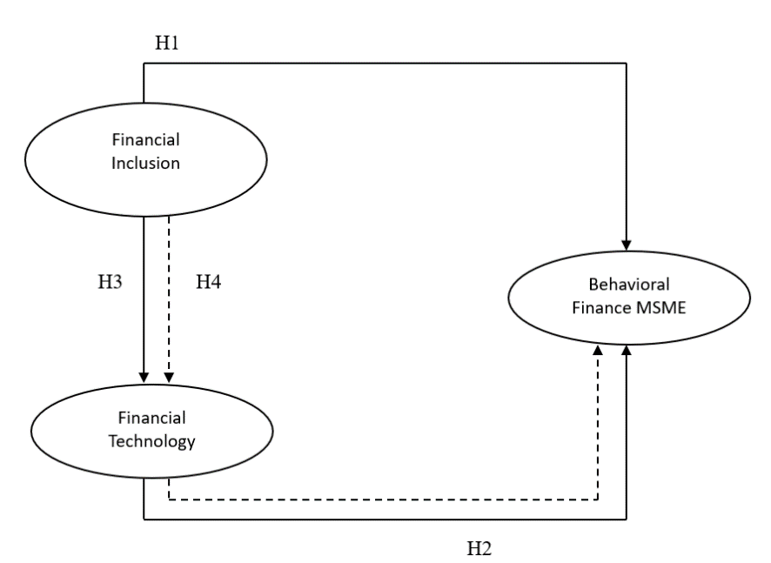

RESEARCH METHOD
Research design
To test theories on the impact of one or more variables (independent variables) on other variables (dependent variables), this research design employs a form of quantitative research with a causality design (Sugiyono, 2018). The purpose of this research is to demonstrate the degree to which the independent variable (financial inclusion) and the mediating variable (fintech) have an impact on the dependent variable (MSMEs' financial behavior) in West Jakarta.
Time and Place of Research
This research was conducted from October to December 2023 where the data used was MSMEs in West Jakarta by examining all scales of MSME businesses.

Research Population and Sample
The population of this research is all scale MSME businesses in West Jakarta in 2023, totaling 305,076 MSME players (BPS, 2022). The sampling technique used in this research was takensimple random sampling,because researchers will select samples randomly so that each member of the population has the same opportunity to provide answers that support the course of this research.Simple random samplingis taking samples from a population randomly without paying attention to the strata in the population and each member of the population has the same opportunity to be sampled. The criteria for this research sample are MSME actors in the West Jakarta area aged 18-60 years.
In this research, the technique for determining the sample size uses the Slovin formula as follows:
$$n= \frac{N}{1+N {(e)}^{2}}$$

Information:
n = Sample size
N = Population size
e = Percentage of allowance for inaccuracy or degree of tolerance (0.1)

The population in this study was 305,076 MSMEs in West Jakarta, so a 10% allowance percentage was used. The following is a sample calculation with the Slovin formula:

$$n= \frac{305.076}{1+305.076 {(0,1)}^{2}}=99,96$$

Based on the calculations above, the samples taken in this study were rounded up to 100 respondents.

RESULTS AND DISCUSSION
Test result Outer Model
An indicator-latent variable measurement model is a measurement model that links indicators. The outer model, sometimes called the outer relation or measurement model, specifies the relationship between each block of indicators and its latent variable.
Figure 2: PLS Algorithm Results (Modification)
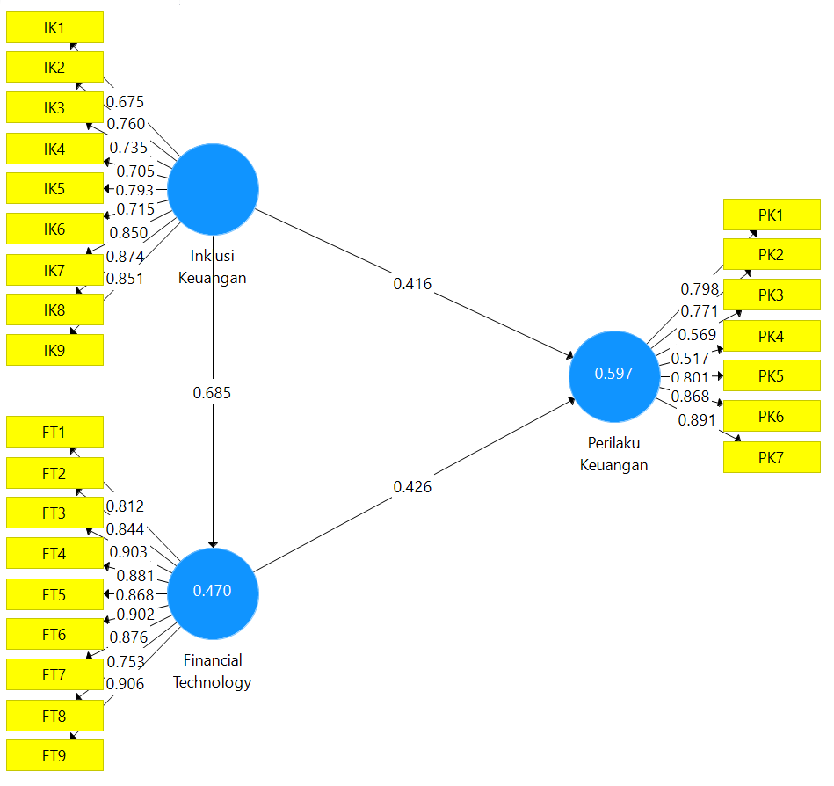

Source: Output PLS (2023)
If an indicator's correlation is more than 0.70, it is considered valid. However, loading values of 0.50 to 0.60 were still regarded as valid and acceptable throughout the early research phases of creating the measurement scale (Ghozali and Latan, 2015). It is evident from Figure 1 above that the value loading factor of the PK8 and PK9 indicators is less than 0.50. After that, the model will be adjusted by removing these signs.
Table 1: Average Variance Extracted (AVE) Test Results
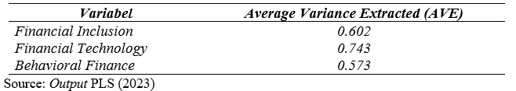

Average Variance Extracted (AVE) shows that each correlation between one construct and another construct is above 0.5, therefore this shows that the data has met the validity criteria.

Test result Discriminant Validity
Testing discriminant validity, indicators can be seen on cross loading between indicators and constructs. An indicator can be said to be valid if it has a value cross loading, construct correlation with items measuring the construct itself > other constructs.
Table 2: Discriminant Validity Test Results (Cross Loading)
Indicator | Financial Inclusion (X1) | Financial Technology  (X2) | Behavioral Finance (Y)
FT1 | 0,620 | 0,812 | 0,590
FT2 | 0,522 | 0,844 | 0,477
FT3 | 0,581 | 0,903 | 0,594
FT4 | 0,647 | 0,881 | 0,675
FT5 | 0,504 | 0,868 | 0,547
FT6 | 0,501 | 0,902 | 0,653
FT7 | 0,649 | 0,876 | 0,720
FT8 | 0,612 | 0,753 | 0,584
FT9 | 0,634 | 0,906 | 0,616
IK1 | 0,675 | 0,454 | 0,376
IK2 | 0,760 | 0,446 | 0,503
IK3 | 0,735 | 0,576 | 0,518
IK4 | 0,705 | 0,399 | 0,535
IK5 | 0,793 | 0,514 | 0,561
IK6 | 0,715 | 0,406 | 0,518
IK7 | 0,850 | 0,598 | 0,622
IK8 | 0,874 | 0,621 | 0,624
IK9 | 0,851 | 0,688 | 0,633
PK1 | 0,597 | 0,733 | 0,798
PK2 | 0,515 | 0,568 | 0,771
PK3 | 0,302 | 0,311 | 0,569
PK4 | 0,208 | 0,175 | 0,517
PK5 | 0,576 | 0,525 | 0,801
PK6 | 0,646 | 0,581 | 0,868
PK7 | 0,679 | 0,619 | 0,891

Source: OutputPLS (2023)
The correlation between each variable's constructs and its indicators is stronger than the correlation between each variable and other constructs, as can be seen in the above table. A different approach to determining discriminant validity is to compare values using the Square Root of Average Variance Extracted (AVE) method. It is declared valid if the AVE value for each construct is higher than the correlation between constructs in the model.

Test result Composite Realibility and Cronbach’s Alpha
The purpose of composite reliability and Cronbach's alpha is to evaluate the instrument's dependability within the study model. If the values of all latent variables are either composite reliability or Cronbach's alpha ≥ 0.7, it indicates that the construct has strong reliability or that the questionnaire employed in this study is consistent or reliable.

Table 3: Composite Reliability and Cronbach's Alpha Test Results
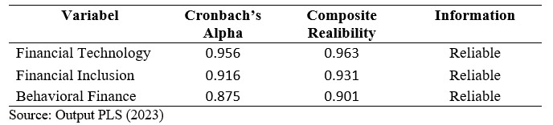
Based on the table above, it can be seen that the test results show good values because all variables have values Composite Reliabilitynor Cronbach's Alpha≥ 0.7, therefore it can be concluded that the questionnaire used as a research instrument is appropriate.

Hypothesis testing results
Table 4: Results of Direct Influence Hypothesis Testing

Variable | Original Sample (O) | Sample Mean (M) | Standar Deviation (STDEV) | T-Statistic  (|O/STDEV|) | P Values | Information
Financial Technology -> Behavioral Finance | 0.426 | 0.430 | 0.096 | 4.443 | 0.000 | Positive-  significant
Financial Inclusion-> Financial Technology | 0.685 | 0.688 | 0.058 | 11.731 | 0.000 | Positive-  significant
Financial Inclusion -> Behavioral Finance | 0.707 | 0.714 | 0.050 | 14.279 | 0.000 | Positive-  significant
Source: Output PLS (2023)

Table 5: Results of Indirect Influence Hypothesis Testing
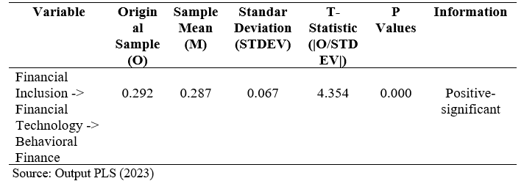

Discussion of Research Results
The research's t-statistic, which is larger than the value in the t-table of 1.96, the original sample value of 0.707, which shows a positive value, and the value P Values of 0.000, which is less than 0.05, were produced based on the hypothesis test. This demonstrates how financial behavior is positively impacted by financial inclusion. As a result, it is possible to support the first hypothesis (H1), which claims that financial inclusion affects MSMEs' financial behavior. For MSME managers, obtaining money at competitive rates and other advantages has become easier because of the accessibility of financial services. This makes quick and simple finance decisions possible, doing away with the need for intricate computations or in-depth capital structure research. The test results in this study corroborate findings from earlier studies by Pinem & Mardiatmi (2021), Rahmawati et al. (2020), Herispon (2019), Risman et al. (2023), and others that demonstrate the beneficial impact of financial inclusion on financial behavior.
According to the research's hypothesis test, the value results showed a t-statistic of 4,443, which is more than the value of the t-table, or 1.96; the value of the original sample was 0.426, indicating a positive value; and the value of P values was 0.000, which is less than 0.05. As a result, this illustrates how fintech positively affects financial behavior. The study's conclusions are consistent with the Technology Acceptance Model (TAM) theory, which holds that two factors perceived utility and perceived ease of use can influence a person's propensity to adopt technology and information systems. The test results in this study align with other research findings that fintech positively influences financial behavior, including those of Junianto et al. (2020), Anisyah et al. (2021), Daqar et al. (2020), and Singh et al. (2020).
The findings of this study were based on the hypothesis test. The initial sample value was 0.685, the T-statistic was 11,731, and the value of P was zero thousand. The T-table 1.96 value of the of the original sample suggests a positive value, and the statistical value is greater than the value of P-values, which shows less than 0.05. These results demonstrate that financial inclusion has a significant and beneficial impact on financial technology. MSMEs will use fintech more frequently as a result of the growing requirement for capital borrowing through online or fintech channels. The test results in this study corroborate those of earlier studies by Khusnah et al.. (2023), as well as by Risman et al. (2023), which demonstrated the beneficial impact of financial inclusion on financial technology.

CONCLUSION
The conducted research examines financial behavior within the context of MSMEs, specifically in relation to personal, corporate, and financial technology (Fintech) finance. The results of the quantitative analysis show that a number of factors affect how MSMEs behave financially. First, by streamlining access to financial services, financial inclusion helps managers of SMEs obtain funding at favorable rates and other benefits. This fosters prompt and simplified funding decisions, eliminating the necessity for intricate calculations or assessments of complex capital structures. This supports the heuristic theory as rules of thumb which facilitates decision making by reducing the level of complexity in assessing possibilities and predicting values to make it easier. Secondly, the findings of this study indicate a robust positive correlation between improved financial management practices in MSMEs and good financial inclusion. With the improving financial attitude of MSMEs, which is characterized by easier financial decision-making, and greater awareness of financial management for future business interests, this is in line with the theory of planned behavior which explains the role of attitude in shaping financial actions for the future.
In the present era, the expansion of financial inclusion is accelerated and evenly spread, largely facilitated by technology, specifically the integration of financial services with technological innovation, commonly referred to as financial technology (Fintech). Financial inclusion can be achieved and influence the financial behavior of MSMEs, one of which is due to the existence of Fintech intermediaries. So that MSMEs can meet their financial needs easily, quickly, and efficiently and can improve their financial management practices. Therefore, Fintech has a positive influence and can mediate financial inclusion on financial behavior.
This insight is important for financial institutions, related policymakers, and entrepreneur or business support organizations that aim to improve the financial behavior practices of MSMEs. The significance of a program designed to promote positive financial behavior, expand financial inclusion, and spread the advantages of fintech to MSMEs in order to enable them to adopt better financial practices. To put it briefly, this study provides actionable advice on how MSMEs can improve their financial performance and effectively contribute to the growth and prosperity of the nation's economy.

REFERENCE
Ajzen I. (1985). From intentions to actions A theory of planned behavior. 11–39.
Ajzen. i. & Fishbein, M. , (1975). Belief, attitude, intention and behavior: An introduction to theory and research.
Anisyah, E. N., Pinem, D., & Hidayati, S. (2021). Pengaruh literasi keuangan, inklusi keuangan dan financial technology terhadap perilaku keuangan pelaku UMKM di Kecamatan Sekupang. Management and Business Review, 5(2), 310–324. https://doi.org/10.21067/mbr.v5i2.6083
BPS. (2022) Jumlah dan Persentase UMK Provinsi DKI Jakarta Menurut Kabupaten/Kota. Badan Pusat Statistik Provinsi DKI Jakarta. https://jakarta.bps.go.id/statictable/2022/09/12/612/jumlah-dan-persentase-umk-provinsi-dki-jakarta-menurut-kabupaten-kota-2016.html
Daqar, M. A. M. A. , A. S. and K. S. A. (2020). Fintech in the eyes of Millennials and Generation Z (the financial behavior and Fintech perception). Banks and Bank Systems, 15(3), 20–28. https://doi.org/10.21511/bbs.15(3).2020.03
Davis,F.D. 1989. ”Perceived Usefulness, Perceived Ease of Use, and User Acceptance of Information Technology”. MIS Quarterly.Vol. 13 No. 5: pp319-339.
Ghozali I. (2015). Partial Least Square Konsep, Teknik, dan Aplikasi Menggunakan Program SmartPLS 3.0. Badan Penerbit.
Gomber, P., Kauffman, R. J., Parker, C., & Weber, B. W. (2018). On the Fintech Revolution: Interpreting the Forces of Innovation, Disruption, and Transformation in Financial Services. Journal of Management Information Systems, 35(1), 220–265. https://doi.org/10.1080/07421222.2018.1440766
Herispon, H. (2019). The Effect of Financial Inclusion and Banking Behavior on Household Debt Behavior. JEBI (Jurnal Ekonomi Dan Bisnis Islam), 4(1), 51. https://doi.org/10.15548/jebi.v4i1.205
Hovland, C. I., Janis, I. L., & Kelley, H. H. (1953). Communication and persuasion. In Communication and persuasion. Yale University Press.
Humaira, I. (2017). Pengaruh Pengetahuan Keuangan, Sikap Keuangan Dan Kepribadian Terhadap Perilaku Manajemen Keuangan Pada Pelaku Umkm Sentra Kerajinan Batik. Skripsi Universitas Negeri Yogyakarta.
Junianto, Y., Kohardinata, C., & Silaswara, D. (2020). Financial Literacy Effect and Fintech in Investment Decision Making. Primanomics : Jurnal Ekonomi & Bisnis, 18(3), 150. https://doi.org/10.31253/pe.v18i3.472
Kementerian Koperasi dan UKM. (2022). DATA UMKM. Https://Kemenkopukm.Go.Id/Data-Umkm
Khusnah, H., Jannah, S. I., & Anugraini, M. (2023). Efek Mediasi Penggunaan Financial Technology Pada Pengaruh Literasi Keuangan Terhadap Inklusi Keuangan. Jurnal Akuntansi AKUNESA, 12(1), 35-43.
Kusumaningrum, S. M., Wiyono, G., & Maulida, A. (2023). Pengaruh literasi keuangan, inklusi keuangan, dan financial attitude terhadap pengelolaan keuangan UMKM di Kapanewon Godean, Kabupaten Sleman. Jurnal Samudra Ekonomi dan Bisnis, 14(2), 227-238. doi: 10.33059/ jseb.v14i2.6867.
Kusumar, F., Mendari, A. S., & Kunci, K. (2021). FINTECH PAYMENT : PENGARUHNYA PADA PERILAKU MANAJEMEN KEUANGAN MAHASISWA DI PALEMBANG. https://keuangan.kontan.co.id/
Le Phuoc Luong Doan Thi Thu Ha. (2011). Behavioural factor influencing individual investor decisionmaking & Perfomance. Umea School Bussines. China.
Otoritas Jasa Keuangan (2022, 24 November). Infografis Hasil Survei Nasional Literasi dan Inklusi Keuangan Tahun 2022. https://ojk.go.id/id/berita-dan-kegiatan/info-terkini/Pages/Infografis-Survei-Nasional-Literasi-dan-Inklusi-Keuangan-Tahun-2022.aspx
Ozili, P. K. (2018). Impact of digital finance on financial inclusion and stability. Borsa Istanbul Review, 18(4), 329–340. https://doi.org/10.1016/j.bir.2017.12.003
Pinem, D., & Mardiatmi, B. D. (2021). Analisis Literasi Keuangan, Inklusi Keuangan dan Pendapatan terhadap Perilaku Pelaku UMKM Di Depok Jawa Barat. Syntax Literate ; Jurnal Ilmiah Indonesia, 6(1), 104. https://doi.org/10.36418/syntax-literate.v6i1.1650
Puspitasari, R., & Astrini, D. (2021). Dampak Literasi Dan Inkuisi Keuangan Terhadap Kinerja Pelaku UMKM Di Kota Bogor. Jurnal Ilmiah Manajemen Kesatuan, 9(2), 181–190. https://doi.org/10.37641/jimkes.v9i2.771
Putri, D. A. (2020). FAKTOR-FAKTOR YANG MEMPENGARUHI PERILAKU MANAJEMEN KEUANGAN PELAKU UMKM. https://ojs.stiesa.ac.id/index.php/prisma
Rahadian, A., & Thamrin, H. (2023). Analysis of Factors Affecting MSME in Using Fintech Lending as Alternative Financing: Technology Acceptance Model Approach. Brazilian Business Review, 20(3), 301–322. https://doi.org/10.15728/bbr.2023.20.3.4.en
Rahayu, F. S., Risman, A., Firdaus, I., & Haningsih, L. (2023). The Behavioral Finance of MSME in Indonesia: Financial Literacy, Financial Technology (Fintech), and Financial Attitudes. International Journal of Digital Entrepreneurship and Business, 4(2), 95–107. https://doi.org/10.52238/ideb.v4i2.127
Rahmawati, V. , W. W. W. , & N. N. (2020). Analisis Inklusi Keuangan Pada Keputusan Struktur Modal UMKM (Studi Kasus Gerai UMKM Bogor).
Risman, A., Ali, A. J., Soelton, M., & Siswanti, I. (2023). The behavioral finance of MSMEs in the advancement of financial inclusion and financial technology (Fintech). The Indonesian Accounting Review, 13(1), 91. https://doi.org/10.14414/tiar.v13i1.3213
Risman, A., Prowanta, E. & Siswanti, I. (2021). Behavioral Corporate Finance. Yogyakarta: Penerbit KBM Indonesia.
Risman, A., Subhani, M., & Ushakov, D. (2021). Nexus between Financial Fundamentals and Automotive (Car) Industry. ARDL approach. E3S Web of Conferences, 244. https://doi.org/10.1051/e3sconf/202124408015.
Risman, A., Mulyana, B., Silvatika, B., & Sulaeman, (2021), A. The Effect of Digital Finance on Financial Stability. Management Science Letters, 11(7), 1979-1984. https://doi.org/10.5267/j.msl.2021.3.012.
Sampson, E. E. (1976). Social Psychology and Contemporary Society. John Wiley and Sons, Inc.
Singh, S., M. M. Sahni, and R. K. Kovid. 2020. What Drives FinTech Adoption? A Multi-Method Evaluation Using an Adapted Technology Acceptance Model. Management Decision, 58 (8), 1675–97. https://doi.org/10.1108/MD09-2019-1318.
Sugiyono. (2018). Metode Penelitian Kuantitatif. Alfabeta.
Suryanto, Rusdin, & Dai, R. M. (2020). Fintech as a catalyst for growth of micro, small, and medium enterprise in Indonesia. Academy of Strategic Management Journal, 19(5), 1–12.

