THE INFLUENCES OF LEADERSHIP, WORK ENVIRONMENT ON EMPLOYEE PERFORMANCE THROUGH JOB SATISFACTION AS AN INTERVENING VARIABLE AT PT YAMAHA MUSIK CIKARANG BRANCH

Enok Omah, Kasmir
PT Yamaha Music, Indonesia
Magister Management, Mercu Buana University, Indonesia
enokomah2506@gmail.com

Abstract: The declined phenomenon of employee performance that occurs at PT Yamaha Music Manufacturing Asia or commonly referred to as YMMA. This research aims to examine and analyze the effect of leadership and work environment on employee performance through job satisfaction as a mediating variable at PT YMMA. The research design that has been used is quantitative descriptive with 84 respondents. Data analysis using the Smart PLS application consisting of an outer model and inner model test. Based on results of processing and analysis data it was obtained that the leadership variable has a significant positive effect on job satisfaction, work environment variables have a positive and significant effect on job satisfaction, job satisfaction has a positive and significant effect on employee performance, the leadership variable has a positive and significant effect on employee performance, Work environment variables have a positive and significant effect on employee performance, leadership has an indirect effect on employee performance through job satisfaction and work environment variables have an indirect effect on employee performance through job satisfaction.

Keywords: leadership, work environment, job satisfaction and employee performance.

- INTRODUCTION
  - Background Problems
In this 21st century, globalization is causing so much business competition. One result of the globalization era is the demand for all types of work to be able to optimize the output achieved. In an effort to increase human resources to improve performance, one of the ways undertaken by organizations / companies by giving an awards that are not only material but also non-material.
PT Yamaha Music is a company which engaged in electronic and pro audio instruments. PT Yamaha Music has international quality standards, some of which are products that have been exported to various parts of the world. Performance support from employees is needed by PT Yamaha Music to succeed the company's business but the current performance conditions of employees at PT Yamaha Music still not optimal. This can be seen from the low production achievements as set out in Figure 1.1 below.

Figure 1.1 Production Data of PT Yamaha Musik, April 2018 - March 2019
Source: PT Yamaha Music (2019)

From the source above, it can be concluded during the period April 2018 to March 2019 that the production output was less than optimal. Based on these data, during the one year period there was a production shortage which if averaged reached 65.74%, this was already far from the predetermined target so research must be conducted to address the problem.

Table 1.1 Achievements of Production Performance for the April 2018-March 2019 Period
Numb | Yearly Targets | Work Achievement Q1 | Work Achievement Q2 | Work Achievement Q3
1 | 100% | 71,4% | 77,15% | 47,13%
Source: PT Yamaha Music

In Table 1.1 explains that theres no success in the achievement of production output performance indicators at PT Yamaha Music. In other words, the achievement of production output indicators at PT Yamaha Music is not doing well. These conditions clearly indicate the low performance of employees of the organization, for that special attention is needed to which factors are likely to influence employee performance improvement.
The following are some of the factors that had thought to influence employees perfomance of PT Yamaha Music is based on pre-research results.

Table 1.2: Factors that Affected the Employees Perfomance of PT Yamaha Music
Numb | Factors thought to influence employee performance | Number of people | Precentage (%)
1 | Job Satisfaction | 11 | 37%
2 | Leadership | 7 | 23%
3 | Work Environment | 6 | 20%
4 | Work Behaviour | 4 | 13%
5 | Career Development | 2 | 7%
Source: Pre-research results (March - 2019)

From table 1.2 it is known that the factors which get predominantly affect employee performance are: 1) Job satisfaction, 2) Leadership, and 3) Work environment. On the basis of the pre-research results become a reference for researchers to focus on testing the factors that are suspected to affect the performance of employees of PT. Yamaha Music. Therefore, the authors are interested in pouring out these problems in this study with the title "The Influence of Leadership, Work Environment on Employee Performance through Job Satisfaction as Intervene Variables at PT Yamaha Music Cikarang Branch ".

  - Research Purposes
The purpose of this research apparently is to find out and analyze:
- The influence of leadership on job satisfaction at PT Yamaha Music.
- The influence of work environment on job satisfaction at PT Yamaha Music.
- The influence of leadership on the Employee perfomance at PT Yamaha Music.
- The influence of work environment on the employees perfomance at PT Yamaha Music.
- The influence of job satisfaction on the Employee performance at PT Yamaha Music.
- The indirectly influence of leadership on the Employee perfomance at PT Yamaha Music through Job Satisfaction
- The indirectly influence of work environment on the Employee Perfomance at PT Yamaha Music through Job Satisfaction

- LITERATURE REVIEWS, CONCEPTUAL FRAMEWORKS AND HYPOTHESES
  - Literature Reviews
    - Employee Performance
According to Kasmir (2016: 182) states that the performance is the result of work and work behavior that has been achieved in completing the tasks and responsibilities given in a certain period. From this definition, it can be concluded that performance is the work of employees both in terms of quality and quantity based on predetermined work standards.

    - Job Satisfaction
Job satisfaction refers to the attitude of an individual. According to Robbins (2015: 49) Job satisfaction is a positive feeling of work that is produced and evaluated on its characteristics. From this opinion, it can be concluded that essentially job satisfaction is a level of someone's pleasant or unpleasant feelings as an assessment of aspects of work and environment in which work is.

    - Leadership
Leadership according to Siagian (2011: 46) defines leadership as the ability and skills of someone who occupies a position as a leader of work unit to influence the others behave Based on this opinion, it can be concluded that leadership is the ability to influence and direct the behavior of a person or group of people to achieve certain goals in certain situations.

    - Work Environment
According to Sedarmayanti (2013: 26) defines the work environment in the sense of all conditions that exist around the workplace, will affect employees both directly and indirectly. Based on this opinion, it can be concluded that the work environment is a condition surround the workplace who will affect the employees both directly and indirectly.

  - Conceptual Framework
The research paradigm for The Leadership (X1) and Work Environment (X2) as exogenous variables, Employee Performance (Y2) as endogenous variables and Job Satisfaction (Y1) as intervene variables, this can be described as follows:

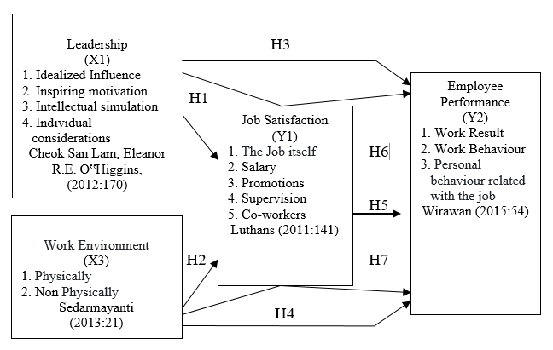
Figure 2.1 Conceptual Framework
Source: Theory Study

  - Hypothesis
Based on theoretical descriptions, and conceptual frameworks above the following hypotheses can be drawn:
H1: Leadership has a positive and significant effect on Job Satisfaction
H2: The work environment has a positive and significant effect on job satisfaction
H3: Job satisfaction has a positive and significant effect on Employee Performance
H4: Leadership has a positive and significant effect on Employee Performance
H5: The work environment has a positive and significant effect on Employee Performance
H6: Leadership has a positive and significant indirect effect on Employee Performance through Job Satisfaction
H7: The Work Environment has a positive and significant indirect effect on Employee Performance through Job Satisfaction

- METHODOLOGY

The type of research in this research is the type of explanatory research. The method used in this research is descriptive research method with a quantitative approach where the purpose of this research is to analyze the results of research and then examined the level of interrelation between variables. The variables which to be examined in this research are employee performance (Y2) as the dependent variable and leadership (X1), work environment (X2) as the independent variable and job satisfaction (Y1) as intervene variables At PT Yamaha Music, the production portion the number of employees or existing population is 513 employees and the number of samples in this research was set at 84 respondents (Slovin error tolerance 10%). The analytical method used is soft modeling because it does not assume the data must be with a certain scale measurement, with a small sample size (under 100 samples). The measurement tool uses smartPLS software version 3.0

- RESULTS AND DISCUSSION
4.1. Research Results
4.1.1. Outer Model Test
Evaluation of concergent validity from checking individual item reliability can be seen on the value of standardized loading factor. The standardized loading factor illustrates the magnitude of the correlation between each indicator measurement item and its constructed. The loading factor value of this research is > 0.7 so if the loading factor is < 0.7 then the indicators in this research would be excluded from the model.

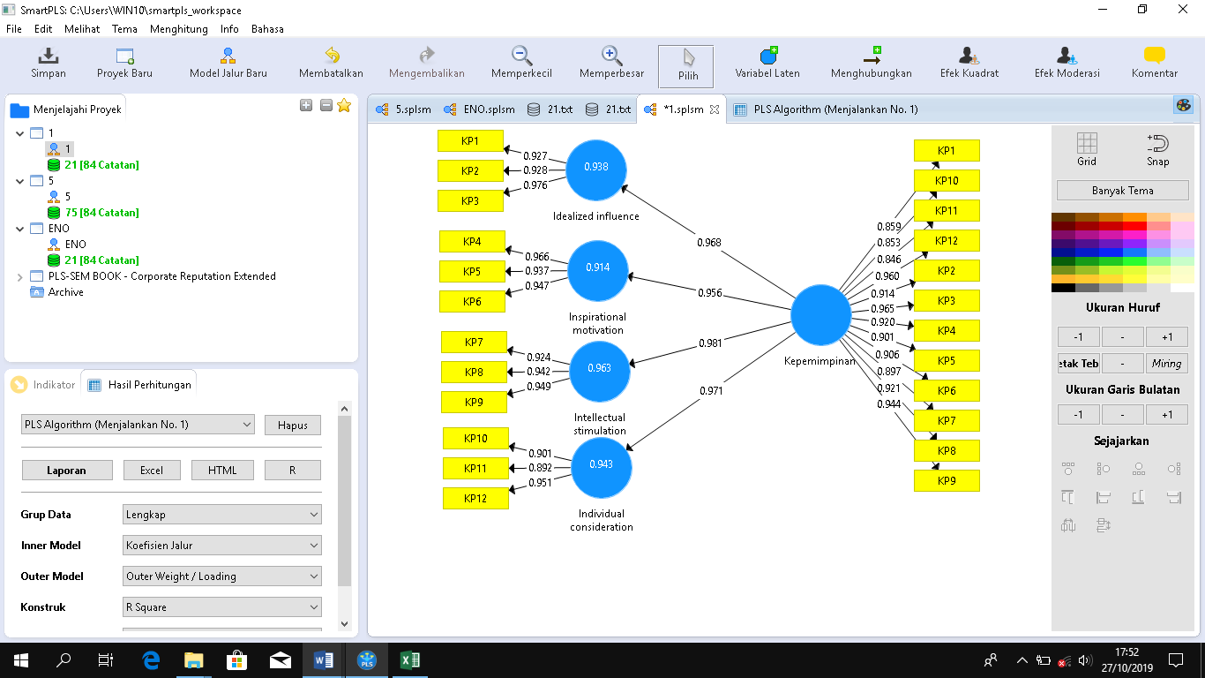
Figure 4.1 Outer Leadership Variable Model
Source: Smart PLS version 3.2.8

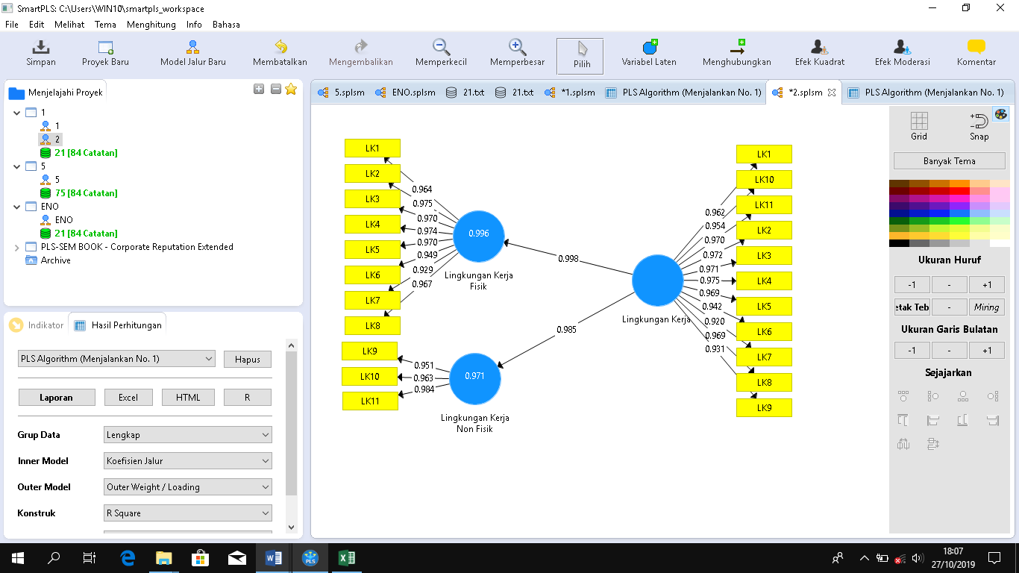
Figure 4.2 Outer Model of the Work Environment Variable
Source: Smart PLS version 3.2.8

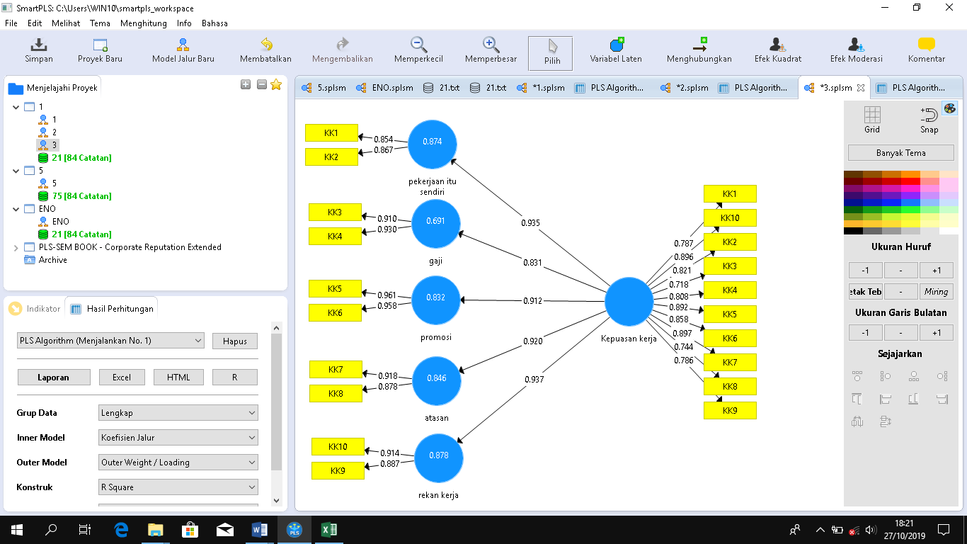
Figure 4.3 Outer Model Variable of Job Satisfaction
Source: Smart PLS version 3.2.8

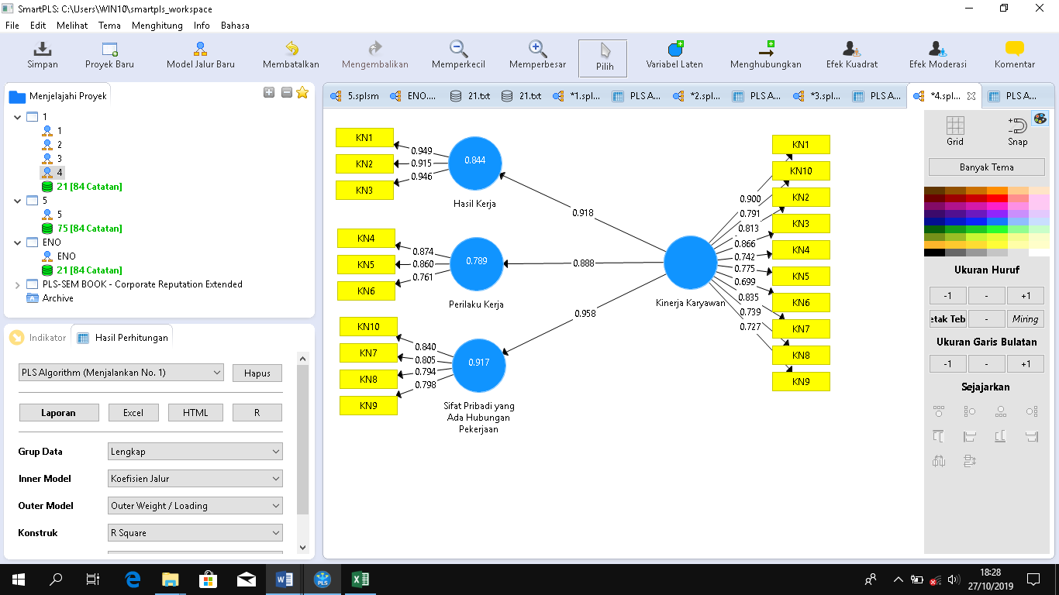
Figure 4.4 Outer Model of Employee Performance Variables
Source: Smart PLS version 3.2.8

From the convergent validity results using SmartPLs version 3.2.8 as it shown in Figure 4.1 through Figure 4.4, it can be seen that the indicators on leadership, work environment, job satisfaction and employee performance variables have a loading factor > 0.7, so that all indicators are declared valid and can be used in the model.

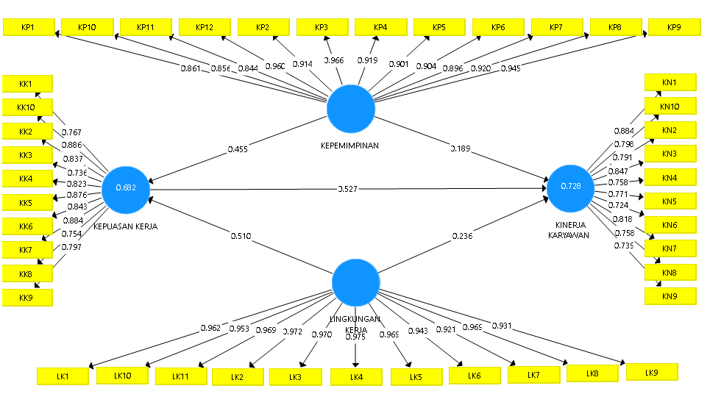
Figure 4.5 The value of models between constructs on employee perfomance research models
Source: Smart PLS version 3.2.8

Based on figure 4.5, which contained from the value of factor loading variable and Indicator for each construct and it will be used for further testing. Beside that, according to figure 4.5 the structural equations:
Job Satisfaction (Y1) = 0,455 ɤ1 + 0,510 ɤ2
Employee Performance (Y2) = 0.189 ɤ3 + 0.236 ɤ4 + 0.527 β

Table 3: Cronbach’s Coefficient Alpha Value and Composite Reliability (CR)
Variable | Composite Reliability | Term | Cronbach's Alpha | Term | Information
Leadership (X₁) | 0.983 | > 0,7 | 0.980 | > 0,6 | Reliable
Work Environment (X₂) | 0.954 | > 0,7 | 0.946 | > 0,6 | Reliable
Job Satisfaction (Y₁) | 0.943 | > 0,7 | 0.933 | > 0,6 | Reliable
Employee Performance (Y₂) | 0.992 | > 0,7 | 0.991 | > 0,6 | Reliable
Source: Smart PLS version 3.2.8

From Table 3 above, Cronbach’s Alpha values ​​for leadership, work environment, job satisfaction and employee performance values ​​have a value > 0.6 and the Composite Reliability value is > 0.7, so that all the variables in this research are declared reliable.

4.1.2. Inner Model Test
To evaluate the path coefficient value using calculate SmartPLS version 2.38 bootstrapping, the path coefficient results depict the strength of the variable relationship between constructs as shown in Table 4.2 below.

Table 4.2 Path Coefficient values, t-Statistics, and P-Values ​​
Correlation between the construction | Original Sample (O) | T  Statistics (|O/STDEV|) | P  Values
Direct
Leadership -> Job satisfaction | 0,455 | 6,477 | 0,000
Leadership -> Employee performance | 0,189 | 2,014 | 0,045
Job satisfaction -> Employee performance | 0,527 | 4,560 | 0,000
Work environment -> Job satisfaction | 0,510 | 7,388 | 0,000
Work environment -> Employee performance | 0,236 | 2,390 | 0,017
Tidak Langsung (Indirect)
Leadership -> Job satisfaction -> Employee performance | 0,240 | 3,283 | 0,001
Work environment -> Job satisfaction -> Employee performance | 0,269 | 4,777 | 0,000
Source: Smart PLS version 3.2.8
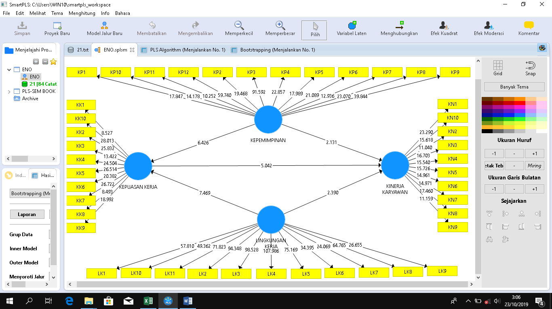
Figure 4.6. t-Statistics Value Results with the bootstrapping method
Source: Smart PLS version 3.2.8

The statistical calculation results obtained are presented in Table 4 for the structural model with the following hypotheses.
- Hypothesis 1– Leadership has influences on job satisfaction.
Obtained a path coefficient of 0.455 with p of 0.000, thus H1 is accepted (p <0.05). The significance level of this influence can be known through the T-statistic value of 6.447 which is greater than the value of t table = 1.66. This shows that significant effect. The magnitude of this influence can be known based on the value of the original sample which is positive that is equal to 0.455 This shows that the relationship between leadership variables with job satisfaction is positive with a value of influence of 45.5%. Thus it can be concluded that leadership has a positive and significant effect on job satisfaction.
- Hypothesis 2 - Work Environment has influences on Job Satisfaction.
Obtained a path coefficient of 0.510 with a p of 0,000. Thus H2 was accepted (p < 0.05). The significance level of this influence can be known through the T-statistic value of 7.388 which is greater than the value of t table = 1.66 Thus it can be concluded that the Work Environment has a positive and significant effect on Job Satisfaction.

- Hypothesis 3 - Leadership has influences on Employee Performance.
Obtained a path coefficient of 0.189 with a p of 0.045. Thus H3 is accepted (p <0.05). The significance level of this influence can be known through the T-statistic value of 2.014 which is greater than the value of t table = 1.66. Thats can be concluded that leadership has a positive and significant effect on employee performance
- Hypothesis 4 - Work environment has influences employee performance.
Obtained a path coefficient of 0.236 with a p of 0.017, thus H4 is accepted (p <0.05). The significance level of this influence can be known through the T-statistic value of 2.390 which is greater than the value of t table = 1.66. Thus it can be concluded that the Work Environment has a positive and significant effect on employee performance.
- Hypothesis 5 - Job Satisfaction has influences Employee Performance.
Obtained a path coefficient of 0.527 with p of 0.000, thus H5 is accepted (p <0.05). The significance level of this influence can be known through the T-statistic value of 4.560 which is greater than the value of t table = 1.66. Thats can be concluded that Job Satisfaction has a positive and significant effect on employee performance
- Hypothesis 6 - Leadership has an indirect effect on employee performance through job satisfaction.
Obtained a path coefficient of 0.240 with a p of 0.001, thus H6 is accepted (p <0.05) The significance level of the effect can be known through the T-statistic value of 3.283 which is greater than the value of t table = 1.66. Thats can be concluded that leadership has an indirect effect on employee performance through job satisfaction.
- Hypothesis 7 - Work Environment has an indirect effect on Employee Performance through Job Satisfaction.
Obtained a path coefficient of 0.269 with p of 0.000, thus H7 is accepted (p> 0.05). The significance level of this influence can be known through the T-statistic value of 7.777 which is greater than the value of t table = 1.66. Thus it can be concluded that the Work Environment has an indirect effect on Employee Performance through Job Satisfaction.
Theres the relationships between constructs based on R2 are as follows: 1) The R-square value of the Job Satisfaction variable (Y1) is 0.682 and is classified as strong. This shows that 68.2% of the Job Satisfaction variable (Y1) can be influenced by the Leadership variable (X1), and the Work Environment variable (X2) while the remaining 31.8% is influenced by other variables outside the study. 2) The R-square value on the Employee Performance variable (Y2) is 0.728 and is classified as strong. This shows that 72.8% of Employee Performance variable (Y2) can be influenced by the Leadership variable (X1), Work Environment variable (X2) and Job Satisfaction variable (Y1), while the remaining 27.2% has influenced by other variables outside this research.
Measurement effect size f2 to see the size of the influence of exogenous latent variables on endogenous latent variables or to see the goodness of the model.

Table 4.3 Calculation results of effect size f²
Variabel | Nilai F² | Kategori
Leadership (X1) → Job satisfaction (Y1) | 0,511 | Kuat
Work environment (X2) → Job satisfaction (Y1) | 0,642 | Kuat
Leadership (X1) → Employee performance (Y2) | 0,068 | Lemah
Work environment (X2) → Employee performance (Y2) | 0,098 | Lemah
Job satisfaction (Y1) → Employee performance (Y2) | 0,325 | Sedang
Source: Smart PLS version 3.2.8

From Table 4 it is known that 1) The leadership variable on job satisfaction has a f square value of 0.511. This can be means that the leadership variable has a strong influence on the structural level. 2) The work environment variable on job satisfaction has a f square value of 0.642. This can be means that the work environment variable has a strong influence on the structural level. 3) The leadership variable on employee performance has a f square value of 0.068. This can be means that the leadership variable has a weak influence on the structural level. 4) Work environment variables on employee performance have a f square value of 0.098. This can be means that the work environment variable has a weak influence on the structural level. 5) The variable of job satisfaction on employee performance has a f square value of 0.325. This can be means that the leadership variable has a moderate influence on the structural level.

4.4. Correlation Between Dimensions
The results of the correlation between dimensions in this research can be seen in Table 4.4 below.

Table 4.4 Correlations Between Dimensions
Variable / Dimension | Job satisfaction (Y1) |  |  |  |  | Kinerja (Y2)
Variable / Dimension | The work itsself (Y1.1) | Salary (Y1.2) | Promotion (Y1.3) | Supervision (Y1.4) | Co-workers (Y1.5) | Work Result (Y2.1) | Work Behaviour (Y2.2) | Personal behaviour related to work (Y2.3)
Leadership (X1)
Idealized Influence (X_{1.1}) | 0,649 | 0,784 | 0,515 | 0,541 | 0,565 | 0,457 | 0,707 | 0,636
Inspiring motivation (X_{1.2}) | 0,582 | 0,755 | 0,48 | 0,508 | 0,534 | 0,455 | 0,657 | 0,58
Intellectual Simulation(X_{1.3}) | 0,612 | 0,751 | 0,479 | 0,494 | 0,563 | 0,464 | 0,685 | 0,589
Individual Judgement (X_{1.43}) | 0,658 | 0,798 | 0,487 | 0,554 | 0,605 | 0,482 | 0,695 | 0,649
Work environment (X2)
Physically (X_{2.1}) | 0,659 | 0,647 | 0,565 | 0,717 | 0,688 | 0,601 | 0,626 | 0,709
Non Physically (X_{2.2}) | 0,77 | 0,601 | 0,541 | 0,769 | 0,783 | 0,579 | 0,601 | 0,681
Job satisfaction (Y1)
The Job itself (Y_{1.1}) |  |  |  |  |  | 0,535 | 0,77 | 0,704
Salary (Y_{2.1}) |  |  |  |  |  | 0,522 | 0,707 | 0,672
Promotion (Y_{3.1}) |  |  |  |  |  | 0,531 | 0,768 | 0,638
Supervision (Y_{4.1}) |  |  |  |  |  | 0,593 | 0,717 | 0,769
Co-workers (Y_{5.1}) |  |  |  |  |  | 0,641 | 0,783 | 0,819
Source: Smart PLS version 3.2.8

Based on Table 4.4 above, it can be concluded that:
- In leadership variable on the job satisfaction variable, the highest correlation dimension is the individual consideration of the salary dimension, amounting to 0.798. While the lowest correlation dimension on this variable is the leadership dimension of intellectual stimulation on the promotion dimension, which is equal to 0.479. Thus, the salary dimension is strongly influenced by the dimensions of individual consideration.
- In work environment variable on job satisfaction variables, the most important correlation dimension is the non-physical work environment on the colleague dimension of 0.783. It can be said that the correlation between the two variables is positive and significant. While the lowest correlation dimension on this variable is the non-physical work environment dimension to the promotion dimension, which is 0.541. Thus, the dimensions of co-workers are strongly influenced by the dimensions of the non-physical work environment.
- In leadership variable on employee performance variables, the highest correlation dimension is idealized influence on the dimensions of work behavior, amounting to 0.707. While the lowest correlation dimension on this variable is the leadership dimension of motivational inspiration towards the dimensions of work output, which is equal to 0.455. Thus, the dimension of work behavior is strongly influenced by the dimension of idealized influence.
- In work environment variable on employee performance variables, the most important correlation dimension is the physical work environment on personal traits that have to do with work of 0.709. It can be said, the correlation between the two variables is positive and significant. While the lowest correlation dimension on this variable is the dimension of non-physical work environment on work results, which is equal to 0.579. Thus, the dimensions of personal traits that have to do with work are strongly influenced by the dimensions of the physical work environment.
- In job satisfaction variable on employee performance variables, the most important correlation dimension is coworkers on the dimensions of personal behaviour that related to work, amounted to 0.819. While the lowest dimension correlation on this variable is the salary dimension to work output, which is 0.522. Thus, personal behaviour that related to work are strongly influenced by coworkers.

4.2. Discussion
Based on hypothesis test that has been done concludes that for hypothesis 1, Ho is rejected and Ha is accepted. The data shows that leadership has a positive and significant effect on employee job satisfaction with a 45.5% influence.
Based on the hypothesis test that has been done, it is known for hypothesis 2, The Ho is rejected and Ha is accepted. From these data it can be concluded that the work environment has a positive and significant effect on employee job satisfaction with a large influence of 51%.
Based on the hypothesis test that has been done concludes for hypothesis 3, Ho is rejected and Ha is accepted. The data shows that leadership has a positive and significant effect on employee performance with a large influence of 18.9%.
Based on the hypothesis test that has been done, it is known that for hypothesis 4, Ho is rejected and Ha is accepted. From these data it can be concluded that the work environment has a negative and significant effect on employee performance with a large influence of 23.6%.
Based on the hypothesis test that has been done concludes for hypothesis 5, Ho is rejected and Ha is accepted. The data shows that job satisfaction has a positive and significant effect on employee performance with a 52.7% influence.
has been done concludes for hypothesis 6, Ho is rejected and Ha is accepted. From these data it can be concluded that there is a positive and significant influence of work leadership on employee performance indirectly through job satisfaction, with a large effect of 24%.
Based on the hypothesis test that has been done, it is known for hypothesis 7, Ho is rejected and Ha is accepted. From these data it can be concluded that there is a positive and significant influence of the work environment on employee performance indirectly through job satisfaction, with a large effect of 26.9%.

- CONCLUSION
  - Practical Implication
The results show that work environment has the greatest effect on job satisfaction and also work environment has the greatest indirect effect on employee performance, while job satisfaction has the greatest influence on employee performance. This means that if the working environment in company is good, then the working atmosphere will also be more conducive. From this conducive atmosphere will increase job satisfaction so that employees will work wholeheartedly to complete their work. With increased job satisfaction, performance will also increase.

  - Theoretical Contributions
Leadership directly has a significant effect on job satisfaction, These results are in line with research conducted by Kaiman (2013) which stated that the leadership has a significant positive effect on job satisfaction.
Work Environment directly has a significant effect on job satisfaction, The results of this research are in line with previous research was conducted by Lukiana and Halima's research (2016) states that the work environment has a positive and significant influence on job satisfaction.
Leadership directly has a significant effect on employee performance. These results are in line with previous research whom conducted by Ayu Desi Indrawati (2013) which states that job satisfaction has a positive and significant effect on employee performance.
The work environment directly has a significant effect on employee performance. The results of this research currently in line with the results of another research which conducted by Emmanouil, Konsolas, Antasiou Osia and Loukeri paraskeviloana (2014) it said that the leadership has a positive and significant effect on employee performance.
Job Satisfaction directly has a significant effect on employee performance. The results of this research are in line with previous research which conducted by Bindu Anto Ollukaran and Rupa Gunaseelan (2012) They said that the work environment has a positive influence on employee performance.
Leadership indirectly has a positive and significant effect on employee performance through job satisfaction. The results of this research are in line with the results of research conducted by Nur Laili Aulia, Wiji Utami and Nyoman Gede Krishnabudi (2015) it said that the leadership indirectly has significant positive effect on employee performance through job satisfaction
Work environment indirectly has a positive and significant effect on employee performance. The results of this research are in line with previous research which conducted by Aurelia Potu (2013) work environment indirectly has a significant positive effect on employee performance through job satisfaction.

  - Research Limitations
This research does not include the other variables that affect employee performance such as work discipline, work culture, work commitment, work placement, and compensation. Beside that this research only examined one type of company which name PT Yamaha Music so it cannot be generalized for all companies in Indonesia.

  - Future Research Direction
In the future, this research will not only develop one company or manufacturing industry, but in another field. The following research is recommended to examine other factors besides leadership, and work environment that affected employee performance such as work discipline, work culture, work commitment, work placement, compensation, and others.

REFERENCE
Aulia, Nur Laili, Wiji Utami, Nyoman Gede Krishnabudi. (2015). Pengaruh Gaya Kepemimpinan Transformasional Dan Lingkungan Kerja Terhadap Kinerja Karyawan Melalui Kepuasan Kerja Sebagai Variabel Intervening. Journal Ekonomi Dan Bisnis. Vol. 4, No. 2.
Indrawati, Ayu Desi. (2013). Pengaruh Kepuasan Kerja Terhadap Kinerja Karyawan Dan Kepuasan Pelanggan Pada Rumah Sakit Swasta. Jurnal Manajemen, Strategi Bisnis Dan Kewirausahaan. Vol. 2, No. 1.
Kaiman. (2013). “The Effect of Leadership Behavior and Commitment Employee Job Satisfaction and Employee Performance.” International Journal of Business and Management Invention. Vol. 2, Issue 9.
Kasmir. (2016). Manajemen Sumber Daya Manusia (Teori Dan Praktik). PT Raja Grafindo Persada. Jakarta
Konsolas, Emmanouil, Antasiou Osia Dan Loukeri Paraskeviloana, (2014). “The Impact of Leadership on Teachers Effectiveness”. International Journal of Humanities and Social Science, Vol. 4, Issue 7.
Lukiyana dan Halima. (2016). Pengaruh Kompensasi Dan Lingkungan Kerja Terhadap Kinerja Karyawan Dengan Kepuasan Kerja Sebagai Variabel Intervening Pada PT. Pacific International Jakarta. Journal Ekonomi Dan Bisnis. Vol. 19, No. 2.
Ollukaran, Bindu Anto and Rupa Gunaseelan. (2012). “A Study on The Impact of Work Environment on Employee Performance” Namex International Journal of Management Research, Vol. 2, Issue. 2.
Potu, Aurelia. (2013). Kepemimpinan, Motivasi, Dan Lingkungan Kerja Pengaruhnya Terhadap Kinerja Karyawan Pada Kanwil Ditjen Kekayaan Negara Suluttenggo Dan Maluku Utara Di Manado. Jurnal EMBA. Vol.1 No.4.
Sedarmayanti. (2013). Manajemen Sumber Daya Manusia. Refika Aditama. Bandung.
Siagian, Sondang P. (2011). Manajemen Sumber Daya Manusia. Bumi Aksara. Jakarta.
Stephen, Robbins (2015). Perilaku Organisasi. Salemba Empat. Jakarta.

