Prapatantio Teteg Pringgodigdoyo, Adi Nurmahdi
Universitas Mercu Buana
Prapatantio@gmail.com, adi.nurmahdi@mercubuana.ac.id

ANALYSIS OF PURCHASE DECISION MODEL TOWARDS AIRLINES TICKET BOOKING IN TRAVELOKA (MERCU BUANA UNIVERCITY CASE STUDY)

Abstract. Traveloka is an airline ticket purchase application that has the most visitors in Southeast Asia, but starting in the first quarter of 2019 they experienced a decline in the number of visitors. The decline in the number of visitors was the most contributed by application users from Indonesia. The decline in the number of visitors is a phenomenon that needs attention because it can potentially affect ticket sales through the application. there are several factors that influence the pattern of ticket purchases through online applications, including internet knowledge, service quality, prices, trust, understanding of risk, and user perceptions. The objectives in this study is to determine the effect of price, service quality, brand image on purchase decisions on the Traveloka application. The samples of this study are a 100 post graduate students of Mercu Buana University. The results of this study show that price does not have a positive and significant effect on brand image on the Traveloka application. Price, service quality and brand image have a positive and significant influence on purchase decisions on the Traveloka application. Traveloka companies are advised to increase their responsiveness in providing quality services so that they will be able to create a better brand image.

Keywords: price, service quality, brand image, purchase decision, traveloka

Kata kunci: harga, kualitas pelayanan, citra merek, keputusan pembelian, traveloka

INTRODUCTION
Based on data from Similarweb.com, Traveloka is an airline ticket purchase application that has the most visitors in Southeast Asia, but starting in the first quarter of 2019 they experienced a decline in the number of visitors. The decline in the number of visitors was the most contributed by application users from Indonesia. The decline in the number of visitors is a phenomenon that needs attention because it can potentially affect ticket sales through the application. According to Wiryawan (2017), there are several factors that influence the pattern of ticket purchases through online applications, including internet knowledge, service quality, prices, trust, understanding of risk, and user perceptions. Sidauruk (2018) and Herlina & Mertayasa (2018) stated that Price and Quality of service are the determining factors for ticket purchases through online applications. Whereas Pratiwi (2018), saw that service quality, price and promotion had a positive effect on customer satisfaction of online plane ticket buyers.
According to Kotler and Armstrong (2012), price is one of the important variables in marketing, price can influence consumers in making decisions to buy a product or service for various reasons. Economic reasons will indicate the phenomenon of low prices or too competitive prices is one important trigger to improve marketing performance, but psychological reasons can show that prices are actually an indicator of quality, therefore prices are designed as one of the sales instruments as well as a decisive competition instrument the decision to buy a product or service.
In addition to price, one of the important instruments in the business industry is quality of service. According to Parasuraman (2005), Quality of service is an effort to deliver services to meet the needs and desires of consumers and the accuracy of delivery in order to offset consumer expectations. Quality of service provides an encouragement to customers to establish strong bonds with the company so that it can create a positive image in the minds of consumers. Service in this case is defined as services provided by service providers through applications in the form of ease, speed, friendliness shown through attitude and character in an effort to provide customer satisfaction and ultimately make consumers become loyal to the services offered in the Traveloka application.
According to Kotler and Keller (2012), brand image can be defined as a perception that arises in the minds of consumers when remembering a brand of a particular product. The way consumers think about a brand abstractly in their thinking, even when consumers think about it, consumers do not deal directly with products or services. Building a positive brand image can be achieved with strong marketing and satisfying service quality of the product or service so that it has the uniqueness and strengths that distinguish it from other products or services.
Competition between Traveloka and its competitors (tiket.com, tokopedia, trivago) is getting tougher, given the increasingly advanced development of the business world. The competition makes companies make various efforts to survive in the competition, for example promotions, discounts, facilities and so on. In the end the customer will choose which products and services are most satisfying and in accordance with their expectations. One indicator that a company's products are successful or not in the market is how far the growing buying interest of consumers towards the product. This makes the company must be able to innovate in the development of product service quality, competitive prices and build a good brand image in the eyes of the public so that it can create consumer buying interest created and ultimately have implications for the purchase of Traveloka flight ticket applications.

LITERATURE REVIEW
2.1 Price
Price is one of the things that is a challenge for all types of industries in the world because it deals with the regulation, information from buyers, global competition, market growth, and market opportunities. According to Tjiptono (2008), price is a monetary unit or other measure (including other goods and services) exchanged in order to obtain ownership or use rights of an item or service. Rarun (2013) states that the price is the amount of money set by the company used to obtain a number of physical or non-physical products. Actual price is one of the factors that must be controlled harmoniously and in line with the goals to be achieved by the company. All decisions related to price will greatly affect several aspects of business activities, whether related to sales activities or profit aspects to be achieved by a business.
According to Kotler and Armstrong (2013) price is the amount of money that must be paid by consumers to get a product or service that is needed or desired by consumers. In addition, Sunyoto (2013) states that the price is the value stated in a currency or medium of exchange for a particular product, then stated in reality the size or price is not only determined by physical factors that are taken into account but factors psychological factors and other factors also affect prices, so the understanding of prices is the amount of money needed to get a certain number of products or a combination of goods and services. The actual price is not only for a product that is being traded in the market but also applies to other products

  - Service Quality
The key to success in competition often lies in the addition of services that add value and enhance quality. The main service differentiator is the ease of ordering, shipping, installation, customer training, handling complaints, providing credit, maintenance, as well as technical assistance and information for consumers. This is supported by a US News and World report survey which states that customers move from one company to another due to 69% of poor employee service, 12% of inappropriate products, 10% of price and 9% due to location. Quality of service is very important to be developed to maintain the sustainability of a business (Suyanto 2007).
The quality of online services in companies engaged in e-commerce becomes something very important as determining the success of a company (Pratiwi 2018). Parasuraman (2005) states the definition of online service quality (e-service quality) in its interaction with the website is "the extent to which a website facilities are efficient and effective shopping, purchase and delivery". Explanation of the definition is defined as a level of a website that effectively and efficiently facilitates shopping, making purchases and the delivery process of products and services. Website quality assessment is not only the experience during interaction with the website but also the interaction after getting service. Some elements used to measure service quality include website design, reliability, responsiveness, trust and personalization.

2.3. Brand Image
Brand Image is a set of beliefs, ideas and impressions that a person has towards a brand, therefore the attitudes and actions of consumers towards a brand are largely determined by the brand image (Kurniawan 2018). According to Kotler and Keller (2012), image is a person's beliefs, ideas and impressions of something". For a company, a good image is absolutely necessary. So important is the meaning of the image itself that the company is willing to spend extra money and energy to achieve it. Image is a set of beliefs, ideas, and messages that a person has of an object. Image is the main goal and at the same time is a reputation and achievement to be achieved by public relations. Even so, the notion of image itself is abstract /intangible and cannot be measured. In addition, Kotler explains the notion of image is people's perception of the company or its products. Image is influenced by many factors outside the company's control.
There are 3 dimensions that compose a brand image, including brand strength, is how often someone thinks about a brand's information, or quality in processing all information received by consumers. Brand favorability, is the liking of a brand, trust and friendly feelings with a brand, and it will be difficult for other brands to be able to attract consumers who already love the brand. So at this stage, and brand uniqueness, is to make a unique impression and meaningful difference between other brands and make consumers have no reason not to choose that brand. Simply put, brand image is actually what consumers think and feel when they hear or see the identity of a brand, or in other words, brand image is a particular form or picture of a trace of meaning left in the minds of consumers (Arifki, 2018).

2.4. Purchase Decision
According to Hawkins et al (2010), a purchase decision is a process by consumers in the purchase of products or services. While Schiffman and Kanuk (2009), states that the purchase decision is the selection of two or more alternatives that become choices when deciding to buy. Something related to the decision to buy a particular product or service and how many units of the product are needed in the period. The tendency of the influence of the product, price, and brand image on purchase decisions made by these consumers, suggests that company management needs to consider aspects of consumer behavior, especially the process of making purchase decisions. Consumers have three main components, namely input, process, and output.
In measuring purchase decisions, Hawkins et al (2010) state that the dimension in measuring purchase decisions is
- Product selection, which is the selection of products that fit the needs of consumers
- Brand Selection, namely consumer preferences about a brand during the consumption process
- Store Selection, namely the selection of certain stores by consumers to buy a product.

RESEARCH METHODOLOGY

3.1. Research Structure
Based on the aims and relevant literature, this study proposes a research model of the effects of price, service quality, and brand image, on purchase intentions towards airlines ticket purchase via Traveloka on Mercu Buana University Student, and the model is showed in Figure 1:

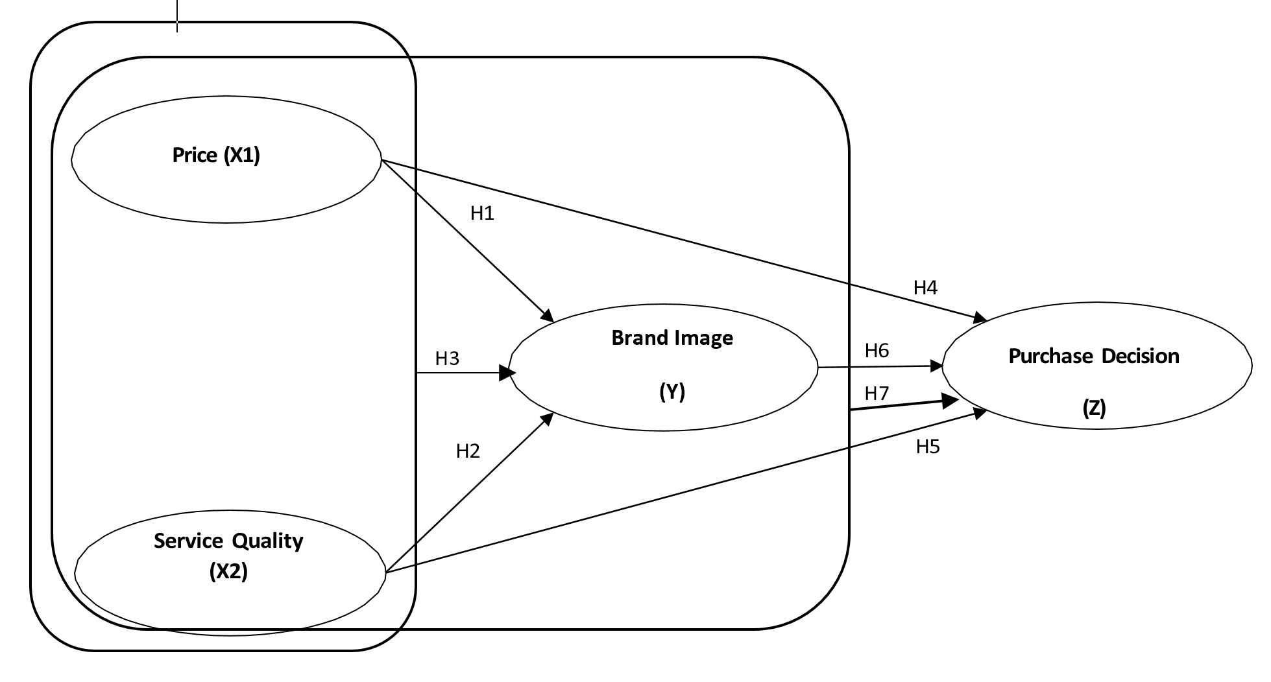

Figure 1: Research Framework

3.2. Research Hypotheses
According the results drawn from literature review, the following hypotheses are proposed:
H1: Price has a positive and significant effect on brand image in the Traveloka application.
H2: Service quality has a positive and significant effect on brand image in the Traveloka application.
H3: Price and service quality have a positive and significant effect on brand image in the Traveloka application.
H4: Price has a positive and significant effect on consumer purchasing decisions on the Traveloka application.
H5: Service quality has a positive and significant effect on consumer purchasing decisions on the Traveloka application.
H6: Brand image has a positive and significant effect on consumer purchasing decisions of airline ticket buyers on the Traveloka application.
H7: Price, service quality and brand image have a positive and significant effect on purchasing decisions on the Traveloka application.

3.3. Research Subjects and Research Tools
The research method used in this research is descriptive verification. This study uses a multi-variable where the observed variables consist of 4 (four) variables, namely independent variables are Price (X1) and, Service Quality (X2), and while the dependent variable in the nature of this research is Purcase Decision (Z) while the intervening variable in this study is Brand Image or what is called variable (Y). The population of this study is a post graduate student of Mercu Buana University. Sampling is selected by probability with random sampling technique, that is 100
Students. This study codifies the collected valid questionnaires, creates files with statistical software SPSS20.0, with multiple regression analysis.

4. RESULTS AND DISCUSSION
4.1 Sample Characteristics
The results showed that of the total 100 respondents there were 61 men and 39 women. Characteristics of respondents based on age seen in Table 1. were dominated by respondents aged 25-34 years, as many as 67 people or 67% of the total respondents. While the smallest respondent is aged under 25 years by 2% or as many as 2 people from the total respondents. Judging from these explanations, respondents aged 31-40 years have a tendency to make airplane ticket purchase decisions online at Traveloka. This means that prospective customers who buy airplane tickets are mostly people who are still young.
Characteristics of respondents based on their level of education appear to be dominated by respondents with an undergraduate level (S1) of 92 people or 92% of the total respondents. While at least there is at the level of master's education (S2) that is as many as 8 people or as much as 8% of the total respondents. So from the results of the study it appears that prospective customers who buy airplane tickets have a relatively good level of education with the title of bachelor (S1).

Tabel 1. Result of sample characteristics
No | Characteristic | Total |  | Percentages (%)
1 | Gender
 | Male | 61 |  | 61
 | Female | 39 |  | 39
 | Total | 100 |  | 100
2 | Aged
 | < 25 years | 2 |  | 2
 | 25 - 34 years | 67 |  | 67
 | 36 - 44 years | 16 |  | 16
 | >45 years | 15 |  | 15
 | Total | 100 |  | 100
3 | Education background
 | High school | 0 |  | 0
 | Diploma | 0 |  | 0
 | Bachelor | 92 |  | 92
 | Post Graduated | 8 |  | 8
 | Total | 100 |  | 100
4 | Vacancy
 | Private sector | 47 |  | 47
 | Student | 3 |  | 3
 | Government Officer | 16 |  | 16
 | Businessman | 17 |  | 17
 | Others | 17 |  | 17
 | Total | 100 |  | 100

4.2. Reliability and validity of questionnaire
From table 2 below show that the Cronbach's Alpha value for the price variable (X1), service quality (X2), brand image (Y), and purchase decision (Z) is above 0.6 so that it can be concluded that the questionnaire items can be said to be reliable or trusted as a data collection tool in research.

Tabel 2. Reliability test result
Variable | Cronbach’s Alpha | Cronbach’s  Alpha Standard | Result
Price (X1) | 0.764 | 0.6 | Reliabel
Service Quality(X2) | 0.769 | 0.6 | Reliabel
Brand Image (Y) | 0.786 | 0.6 | Reliabel
Purchase Decision (Z) | 0.792 | 0.6 | Reliabel

4.3. Normality test result
The results of tests on models 1 and 2 show that the points are not far from the diagonal line. This shows that the regeneration model is normally distributed.

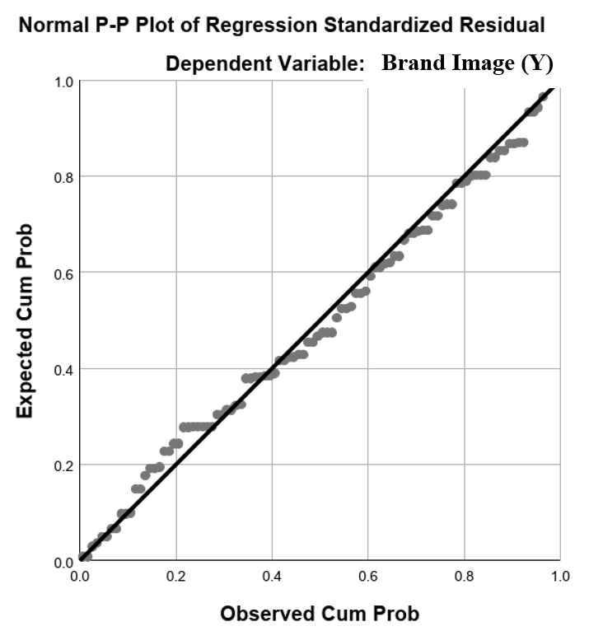
Figure 2. Normality Test Result Path 1
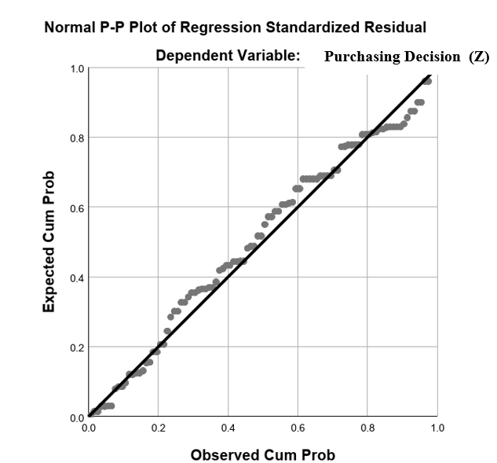
Figure 3. Normality Test Result Path 2

4.4. Kolmogorov Smirnov Test Result
The results of the Kolmogorov Smirnov test on models 1 and 2 show that the significance rate is greater than 0.05 (> 5%). This shows that the regeneration model is normally distributed, so it can

be concluded that the data is worthy of further analysis.

Tabel 3. One-Sample Kolmogorov-Smirnov Test
Dependent Variable Citra Merek
 |  | Unstandardized Residual
N |  | 100
Normal Parameters^{a,b} | Mean | ,0000000
 | Std. Deviation | 3,13617865
Most Extreme Differences | Absolute | ,065
 | Positive | ,057
 | Negative | -,065
Test Statistic |  | ,065
Asymp. Sig. (2-tailed) |  | ,200^{c,d}

Tabel 4. One-Sample Kolmogorov-Smirnov Test
Dependent Variabel Keputusan Pembelian
 |  | Unstandardized Residual
N |  | 100
Normal Parameters^{a,b} | Mean | ,0000000
 | Std. Deviation | 2,43318789
Most Extreme Differences | Absolute | ,073
 | Positive | ,068
 | Negative | -,073
Test Statistic |  | ,073
Asymp. Sig. (2-tailed) |  | ,200^{c,d}

4.5. Heteroscedasticity Test Result

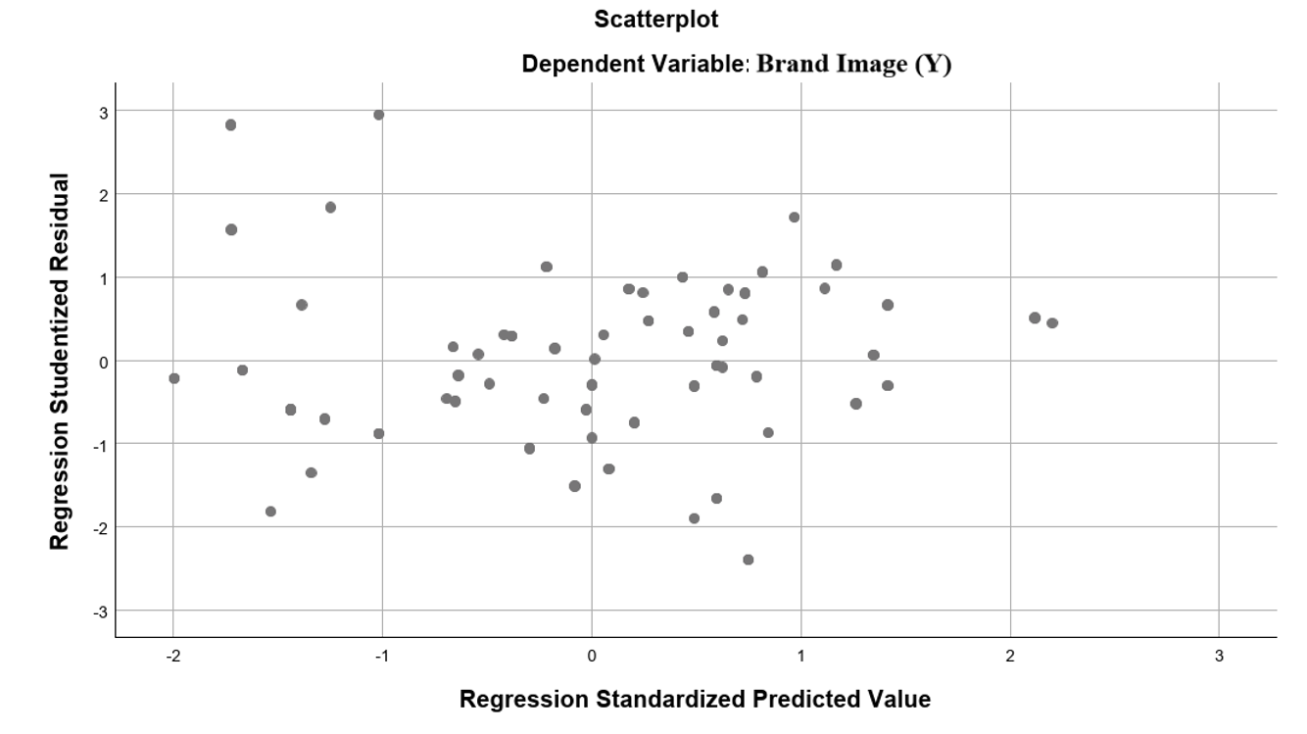
Figure 4. Heteroscedasticity Test Result 1

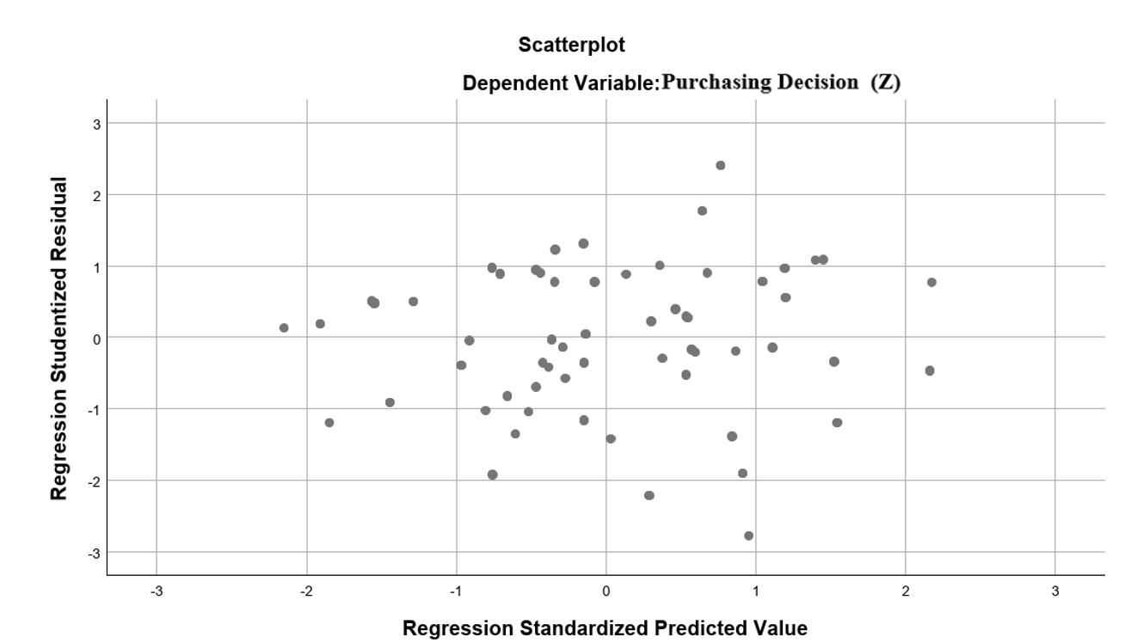
Figure 5. Heteroscedasticity Test Result 2

Based on Figure 3 heteroscedasticity test results show that the points spread above the number 0 (zero) and below the number 0 (zero). It can be concluded that the data in the regression path of model 1 and model 2 do not experience heteroscedasticity problems, or the data has homocedasticity.
So the conclusion of the validation of the research results is a regression model that has been made to meet all the required requirements, so that the path analysis model 1 and model 2 are feasible or correct.

4.6. Hypothesis Test Result
Based on the framework that is built like Figure 1, produces two substructure equations, namely the first substructure that looks at the influence between price variables, service quality on brand image (Path model 1) and the second substructure to see the effect between price variables, service quality and brand image to the purchase decision (Path model 2).

4.6.1 Path Model 1. The influence between price variables, service quality on brand image
The test results of the independent variables Price Perception, Quality of service to the dependent variable Brand Image using SPSS 24.0 with t-Test, as shown in the table

Table 5. t Test Path Model 1 Coefficients
Model 1 | Unstandardized  Coefficients | t | Sig
Constant | 7,243
X1 | 0.144 | 1.529 | 0.130
X2 | 0.203 | 3.837 | 0.000
R² | 0.316
F | 22.453 |  | 0.000
a: Dependent Variable Brand Image (Y)

The independent variables used are Price (X1), Service Quality (X2) and the dependent variable brand image (Y). thus the regression equation can be determined as follows:
Y= 7,243 + 0.144 X1 + 0.203 X2 + e
Based on table 4.4, the coefficient results can be interpreted as follows:

1. Effect of prices on brand image
The results of the analysis in seeing the effect of Price on Brand Image is that the price has no significant effect on Brand Image, where the magnitude of the Price effect on Brand Image is seen from the Unstandardized Coefficient value of 0.144 and sig 0,130.>0,05.
According to Kotler and Keller (2012) Brand image includes knowledge and trust in brand attributes (cognitive aspects), the consequences of the use of the brand, and the appropriate use situation, as well as evaluations, feelings and emotions associated with the brand (affective aspects). In this study the price variable does not affect the brand image because it is not related to consumers 'perceptions and preferences for the brand, as reflected by various brand associations (performance or imagination) that exist in consumers' memories. Traveloka as a market place provider of airline ticket purchase services has a brand image that is formed not by the price offered due to the phenomenon of the emergence of competition between market places and also all airlines have collaborated with other market places such as Tiket.com, pegipegi or airline ticket purchase services itself. With this phenomenon, the price offered by Traveloka or other Market Places is relatively the same so that it does not give consumers a perception of the Traveloka brand.

2. The effect of service quality on brand images
The results of the next analysis are looking at the effect of Service Quality variables on Brand Image which shows that Service Quality has a significant effect on Brand Image, where the magnitude of the effect of Service Quality on Brand Image is seen from the Unstandardized Coefficient value of 0.203 and sig. 0,00<0,005.
The value of R Square (R2) in the table is 0.316 where the number is used to see the magnitude of the effect of Price, Service quality simultaneously on brand image that is 31.6%. While the remaining 69.4% is influenced by other variables outside this model. Based on the F test results in this study obtained a sig of 0,000 <0.05, then the decision is H0 rejected and H1 accepted, meaning that the independent variables consisting of Price, Service quality simultaneously affect Brand Image. The magnitude of influence is 31.6% and the magnitude of influence outside other variables outside the regression is 69.4%.
The variable Price (X1) and service quality (X2) together (simultaneously) has a positive and significant effect on Brand Image (Y). This is consistent with the results of research conducted by Firdausy and Idawati (2017) which states that the price and quality of service has a positive and significant effect on brand image. In model 1 sub-structure, service quality is the most influential variable on brand image, followed by price, so that in order to increase sales in the future, Traveloka must be able to maintain its service quality, especially on the personalization side.

4.6.2 Path model 2. The effect between price variables, service quality and brand image to the purchase decision
The test results of the independent variables Price Perception, Quality of service and Brand to the dependent variable purchase decision using SPSS 24.0 with t-Test, as shown in the table 6.

Table 6. t Test Path Model 2 Coefficients
Model 2 | Unstandardized  Coefficients | t | Sig
Constant | -1.953
X1 | 0.178 | 2.393 | 0.019
X2 | 0.193 | 4.357 | 0.000
Y | 0.490 | 6.187 | 0.000
R² | 0.683
F | 69.088 |  | 0.000
b: Dependent Variable Purchase Decision (Z)

Based on Table 6 shows the magnitude of the coefficient value of each independent variable used, namely Price, Service Quality and Brand Image. Thus the regression equation can be determined as follows:

Z= -1.953 + 0,178X1 + 0,193X2 + 0,490Y + e
Based on these equations, it can be analyzed the effect of Price, Service Quality and each Brand Image individually on the Purchase Decision as follows:
1. Effect of Price on Purchase Decisions
To see the effect of Price on Purchase Decisions, in this case the correspondence that has purchased a plane ticket through the Traveloka application with a significant level of 0.05 with a total of 100 respondents, then the t table value of 1.9840 is obtained. then the calculated t value of 2.393> t table 1.9840, so that H0 is rejected and H1 is accepted. This is in line with research conducted by Firdausy and Idawati (2017) that consumers want competitive prices in terms of ability, whether the price offered is in accordance with the needs and capabilities provided by the product or not.

2. Effect of service quality on purchase decisions
In seeing the effect of service quality on Purchase Decisions with a significant level of 0.05 with a total of 100 respondents, the t-table of 1.9840 is obtained, the t-test of 4.357> t of 1.9840 is obtained, so that H0 is rejected and H1 is accepted. his is in line with research conducted by Ali and Nurmahdi (2018) that service quality have a positif and significant effect to drive the purchasing decision of services.

3. Effect of Brand Image on Purchase Decisions
Effect of Brand Image on Purchase Decisions with a significant level of 0.05 with the number of respondents 100, it can be seen from the number t table 1.9840, obtained t count of 6.187> t table 1.9840, so that H0 is rejected and H1 is accepted. This is in line with research conducted by Anselmsson and Bondesson (2014) and Choe and Zhao (2013) that when in the social environment we are able to remember a brand quite well, eating will influence consumer purchase decisions on a product because the environment recommends a brand that they remember other people.
The value of R Square (R2) is 69,088 where the number is used to see the effect of Price, Service Quality, and Brand Image simultaneously on Purchase Decisions. This means that Price, Service Quality and Brand Image have a simultaneous influence of 68,3% on Purchase Decisions. While the remaining 31,7% is influenced by other variables outside this model.
Based on the results of F test in this study obtained a sig value of 0,000 <0.05, and f arithmetic> F table (69,088> 1.39) then the decision is H0 rejected and H1 accepted, meaning that the independent variables consisting of Price, Service quality and Brand Image are simultaneous effect on Purchase Decisions. the magnitude of influence is 68,3% and the magnitude outside the other variables outside the regression is 31,7%.

Path model 1 and 2 Analysis
The following are the results of the calculation of influence on the path analysis models 1 and 2 as shown in the table 7.

Table 7. Partial and total effect analysis

Path Model | Hypothesis | Variable effect | Effect |  | Balance | Total
 |  |  | Direct | Indirect  via Y
1 | H1 | X1 Y | 0.144 |  |  | 0.144
 | H2 | X2 Y | 0.203 |  |  | 0.203
 | H3 | X1, X2 Y | 0.316 |  | 0.694 | 1
2 | H4 | X1 Z | 0.178 | 0.071
 | H5 | X2 Z | 0.193 | 0.1
 | H6 | Y Z | 0.490
 | H7 | X1, X2, Y Z | 0.683 |  | 0.317 | 1

By observing the Table, it can be seen that the effect of Price, Service Quality, partially and directly on Brand Image is positive and significant with values ​​of 0.144 and 0.203. Variable Quality of service has the greatest value among other variables. Next variable Price, Service quality simultaneously also affects the brand image with a value of 0.316. The influence of service quality on brand image is the most dominant path after simultaneous the influence of price and service quality.
Furthermore it is known that there is a significant influence between Price Effect, Service Quality on purchase decisions directly, it shows that the influence of Price, Service Quality, Brand Image individually influences Purchase Decisions. The influence of price and quality of service directly and positively and significantly influence the purchase decision with a total of 0.178 and 0.193.
Based on the results of the study note that the relationship between the influence of Price, Quality of service indirectly on Purchase Decisions through Brand Image has a large enough value that is 0.071, 0.1. Then the variable Price, Quality of Service and Brand Image simultaneously have a positive and significant influence on Purchase Decisions with a value of 0.683.

5. CONCLUSION AND SUGGESTIONS
5.1. Conclusion
From the results of research and opinions of respondents regarding the analysis of price, service quality and brand image on the purchase decision towards airlines ticket booking in traveloka (Mercu Buana univercity case study), it can be concluded as follows:
1. Price does not have a positive and significant effect on brand image on the Traveloka application.
2. Service quality has a positive and significant effect on brand image in the Traveloka application.
3. Price and quality of service have a positive and significant effect on brand image in the Traveloka application
4. Prices have a positive and significant effect on consumer purchase decisions on the Traveloka application
5. Service quality has a positive and significant influence on consumer purchase decisions on the Traveloka application.
6. Brand image has a positive and significant effect on the decision of consumers to buy airplane tickets on the Traveloka application.
7. Price, service quality and brand image have a positive and significant influence on purchase decisions on the Traveloka application

5.2. Suggestion
From the results of research and opinions of respondents regarding the analysis of price, service quality and brand image on the purchase decision towards airlines ticket booking in traveloka (Mercu Buana Univercity case study), there are some suggestions given, among others
1. Traveloka companies are advised to maintain price affordability to always get a good brand image in front of consumers
2. Traveloka companies are advised to maintain price competitiveness to gain customer loyalty
3. For Traveloka companies, it is suggested to increase price competitiveness to be able to maintain the reputation of the Traveloka brand image in front of consumers
4. Traveloka companies are advised to improve the quality of the airline selection (store selection) which has the highest score for potential buyers so that they can be more flexible in comparing and making purchases
5. Traveloka companies are advised to increase their responsiveness in providing quality services so that they will be able to create a better brand image
6. For further research is expected to examine other intervening variables such as the influence of e-trust or perceived value.

REFERENCES

Ali, H, Narulita, E dan Nurmahdi,A. 2018. The Influence of Service Quality, Brand Image and Promotion on Purchase Decision at MCU Eka Hospital. Saudi Journal of Business and Management Studies (SJBMS). Vol-3 Iss-1 (Jan 2018)
Anselmsson, J dan Bondesson, M. 2014. Brand Image And Customers' Willingness To Pay A Price Premium For Food Brands. Journal of Product & Brand Management. April 2014 : 23(2) ·
Arifki, Arifki (2018). Pengaruh Harga, Persepsi Kualitas, Dan Citra Merek Terhadap Keputusan Pembelian Melalui Minat Beli Konsumen Pada Produk Honda Spacy. Thesis, Universitas Mercu Buana Jakarta.
Choe P dan Zhao Y. 2013. The Influence of Airline Brand on Purchase Intention of Air Tickets in China. Journal of Industrial Engineering & Management Systems Vol 12, No 2, June 2013, pp.143-150
Firdausy, CM dan Idawati, R. 2017. Effects of Service Quality, Price and Promotion on Customers’ Purchase Decision of Traveloka Online Airline Tickets in Jakarta, Indonesia. International Journal of Management Science and Business Administration Volume 3, Issue 2, January 2017, Pages 42-49
Hawkins, Del I. dan David L. 2010. Mothersbaugh. Consumer behavior: Builsing Marketing Strategy. Elevent Edition. McGraw-Hill: New York.
Kotler, Philip dan Gary Armstrong. 2013. Prinsip-Prinsip Pemasaran. Terjemahan Bob Sabran.
Kotler, Philip dan Kevin Lane Keller. 2012. Manajemen Pemasaran. Edisi 14 . Erlangga. Jakarta
Kurniawan, Firman et al . 2018. Pengaruh Citra Merek Terhadap Keputusan Pembelian (Survei kepada para siswa SMAN 15 Surabaya kelas XII yang menggunakan Laptop ber Merek ASUS). Jurnal Administrasi Bisnis (JAB)|Vol. 56 No. 1 Maret 2018
Rarun, Wandy. 2013. Persepsi Kualitas, Persepsi Nilai, dan Niat Pembelian Terhadap Harga telepon Genggam Samsung Pada PT. Megamitra makmur Sejahtera. Jurnal EMBA. Vol. 4, No. 3, Hal 1111-1119.
Tjiptono, Fandi. 2008. Strategi Pemasaran, Edisi III.Andi. Yogyakarta
Parasuraman,A. Zeithaml., Valerie, A., Berry, Leonard L. (2005), Servqual : A Multiple-Item Scale for Measuring Consumer Perceptions of Service Quality, Journal of Retailing. Vol. 64 No.1. Hlm. 12-40.
Pratiwi, Hilda Aprialia. 2018. Pengaruh Kualitas Pelayanan, Harga dan Promosi terhadap Kepuasan Pelanggan Traveloka di Yogyakarta. Universitas Negeri Yogyakarta
Schiffman, L., & Kanuk, L. (2009). Consumer Behaviour (10th ed.). Prentice Hall
Sunyoto, D. 2013. Teori, Kuisioner dan Analisis Data. Yogyakarta : Graha Ilmu
Suyanto. 2007. Marketing Strategy Top Brand Indonesia. Andi. Yogyakarta

