Business Space Arrangement of Batik Iket Product Display For Permai Indonesia Participants in Pinang Malaysia

Rachmita Maun Harahap¹⁾; Mira Sulia Suriastuti ²⁾

¹⁾ rachmita.mh@mercubuana.ac.id , FDSK, Universitas Mercu Buana
²⁾ mira.zulia@mercubuana.ac.id , FDSK, Universitas Mercu Buana

Article Info:  Keywords:  content,  formatting,  article.  (Arial 7pt, Bold, Italic)  Article History:  Received : January 28, 2018  Revised : March 15, 2018  Accepted : Apr 25, 2018  Article Doi:  http://dx.doi.org/12.12244/jies.2019.5.1.001 | Abstract (Arial 10, Italic, Bold, spasi 1)  Workshop for Permai business actors in Penang, Malaysia on the arrangement of product displays for Batik Iket Celup. The goal of this workshop is to support traditional batik production's business development initiatives, particularly those related to Batik Iket. Offering goods displays, including open, shut, inside, nameplate, and product decorating, as well as delear and external displays, this layout configuration allows for an interior display of Batik Iket products.In order to increase the capacity of business players in the designing of Batik Iket product displays, this goal is accomplished via the employment of a workshop method that emphasizes cooperation and consultation. This workshop activity is expected to produce a process that helps business actors become more efficient in their present and future jobs by developing of appropriate habits of thought, action, skills, knowledge and attitudes. The result of this PKM will provide scientific insights both presentations and training on the process of making dyed Batik Iket.  Keywords: arrangement, display space, Batik, business actors, Permai

Abstrak
Workshop bagi pelaku usaha Permai di Penang, Malaysia tentang penataan display produk Batik Iket Celup. Tujuan dari lokakarya ini adalah untuk mendukung inisiatif pengembangan usaha produksi batik tradisional, khususnya terkait Batik Iket Celup. Menawarkan display barang antara lain tampilan terbuka, tertutup, bagian dalam, papan nama, dan dekorasi produk, serta tampilan delear dan eksternal, konfigurasi tata letak ini memungkinkan tampilan interior produk Batik Iket. Guna meningkatkan kapasitas pelaku usaha dalam mendesain Dalam pameran produk Batik Iket, tujuan tersebut dicapai melalui penggunaan metode workshop yang mengedepankan kerjasama dan konsultasi. Kegiatan workshop ini diharapkan dapat menghasilkan suatu proses yang membantu pelaku usaha menjadi lebih efisien dalam pekerjaannya saat ini dan masa depan dengan mengembangkan kebiasaan berpikir, bertindak, keterampilan, pengetahuan dan sikap yang tepat. Hasil dari PKM ini akan memberikan wawasan keilmuan baik presentasi maupun pelatihan proses pembuatan Batik Iket.

Kata Kunci: penataan, ruang display, Batik, pelaku usaha, Permai

INTRODUCTION
Workshop approaches that prioritize cooperation and consultation are used to accomplish the goal of increasing business owners' ability to develop Batik Iket product displays. It is anticipated that the workshop activities will produce a process that aids businesses in developing proper thought, action, skill, knowledge, and attitude habits in order to make their current and future work more efficient.
With an eye toward economic advancement, the PERMAI Indonesia Foundation in Pinang, Malaysia, works to foster and expand entrepreneurial endeavors. In order to address the demands of business people in growing entrepreneurial activities, PERMAI has built a product display inside its environment. Almost fifteen business people mentorship members make up PERMAI. But with little land and little knowledge of arranging product displays, the purpose of this community service activity is to assist the PERMAI Foundation in utilizing product display strategies and layouts to maximize the area. Indonesian Society (Permai) is an organization that aims to strengthen and unite Indonesian communities abroad. This organization is in Pulau Pinang, Malaysia. This organization is engaged in helping the growth of Indonesian people in Malaysia. Indonesian Society (Permai) is an NGO or non-political organization that was founded on April 17, 1977, under the auspices of the Indonesian Embassy in Malaysia. This organization is engaged in the social, educational, and cultural fields to maintain the interests of the Indonesian people who live in Malaysia. Permai members or experts consist of various layers of Indonesian society in Malaysia with various backgrounds, such as workers, expatriates, lecturers, teachers, students, and students. Permai as an ambassador of the nation overseas has the aim to help and support the Indonesian government in virtue services for the people of Indonesia in Malaysia through a program to improve professional skills and expand and deepen knowledge for its members.
In addition, Permai also aims to create synergy. Members who have the advantages of giving to the lack of, the strong helps the weak, and those who have the intelligence to teach other members who are still lay. To realize this goal, Permai collaborates with various parties from educational, professional, and private institutions to transfer knowledge, such as in the fields: of e-commerce, fintech, digital technology, and other special skills. Through various collaboration activities carried out with partners, Permai tries to become an incubator to give birth to a community that has special skills and skills to get a job in a higher position and salary or minimum equivalent to other nations.
Mercu Buana University, Jakarta, as part of Permai's cooperation partner, participated in taking a role in helping to encourage the growth of Indonesian people. One form of its contribution by collaborating to provide knowledge to help increase the creation of business actors at the Permai Foundation. The need for business incubation and business opportunities and special skills in promotion, and product marketing can be an opportunity for businesses at the Permai Foundation.
Knowledge on the design of ikat batik product displays is provided by the Faculty of Design and Creative Arts, Universitas Mercu Buana, in response to the various requirements of partners seeking support from business actors under the Permai Foundation. The information that needs to be supplied relates to setting up the retail display product display's interior layout, including open, closed, interior, nameplate, and product decorating, as well as delear and outside displays.

Because of her interest for the Indonesian population in Malaysia, Permai works closely with the Faculty of Design and Creative Arts at Mercu Buana University, particularly in the area of interior design, to help businesspeople succeed. Growing numbers of Indonesian businesspeople undoubtedly wish to live better abroad. Seeing the chances that are available can help with many things, like learning how to start a business in a foreign nation. In a foreign nation, finding work is not always easy. Therefore, one must learn to survive by seizing the opportunities that are presented to them. Starting a batik company and selling it abroad might be a thrilling prospect, but there are a number of obstacles to overcome. The workshop exercises meticulously arrange the design of Batik Iket Celup product dispaly to gain effectiveness in their current and future tasks through the development of appropriate habits of thought, action, skills, knowledge and attitudes.
Several workable alternatives were discovered during this workshop activity that focused on the layout of the Batik Iket Celup product display. Some of the solutions derived from the workshop results include the following:
- Providing Materials for Community Service
This material's presentation served as the starting point for a conversation on the evolution of product layout and display design, emphasizing the value of categorizing products.
- Working with partners to provide coaching, counsel, and collaboration
In order to optimize the available space and arrange a room that meets the needs of the product business, this application also executes a layout design that takes into account space requirements, traffic flow layouts, and space allocation.
- Evaluation of the execution of the program by direct consultation
In order to give partners insight into the knowledge of room layout and display of Batik IKet Celup products, which are useful in facilitating all these business activities, the Community Service Team evaluates all the results of the delivery of this service activity program.

METHOD
This service follows a multi-stage strategy that includes material exposure, consultation, simulation (trial), assistance, and evaluation. Here is a flow chart showing the steps involved in putting this service into operation. An outline of the plan for the PERMAI Foundation service may be seen below.
The schematic above shows that workshop approach of the arrangement of the Batik Iket Product Display Business Space for Permai Participants is divided into 3 (three) stages, namely 1) to accomplish the goal of increasing business owners' ability to develop Batik Iket product displays; 2) will produce a process that aids businesses in developing proper thought, action, skill, knowledge, and attitude habits in order to make their current and future work more efficient; and 3) Permai participants have the necessary competence and skills to plan the layout of the Batik Iket exhibition business space.

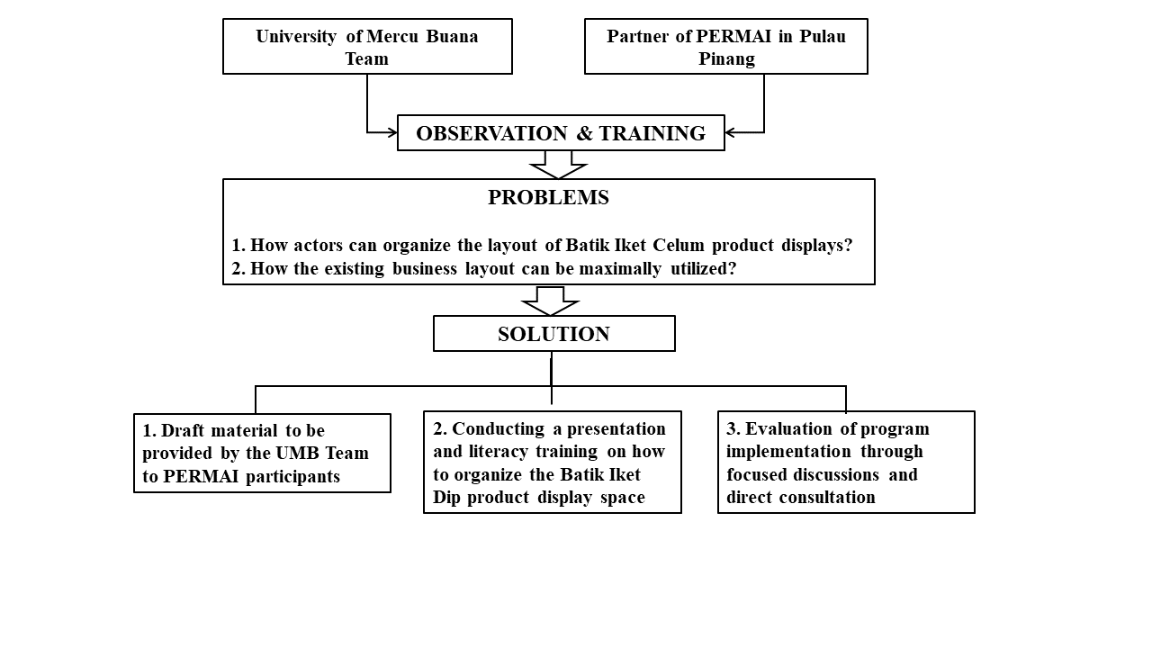
Figure 2. Roadmap of Implementation Methods

2. RESULT AND DISCUSSION
The implementation of community service for Permai participants as business actors has increased knowledge about the arrangement of product display spaces in small shops or at home, as well as how to coordinate the layout of batik iket product display spaces and other products. And how they can comprehend the interior design of the exhibition area. During the question-and-answer session, the business actors inquired about the layout of the display area and how to organize the interior of the display space so that consumers become attracted and then purchase their items.
Through the workshop activities of structuring the layout of the Batik product display space, it is hoped that the Permai business actor participants will have knowledge and insight as business actors who are skilled in managing the layout of product display spaces and are also able to find opportunities to increase family finances as provisions and improve their standard of living to be better and more efficient.
The information supplied assisted Permai business actors in leveraging the layout of the product display space, particularly understanding of the interior planning of the Batik product display space or other products. Many questions and comments were asked and transmitted during the implementation of the service activities, indicating that the activity was interesting and valuable to the service participants who took part.

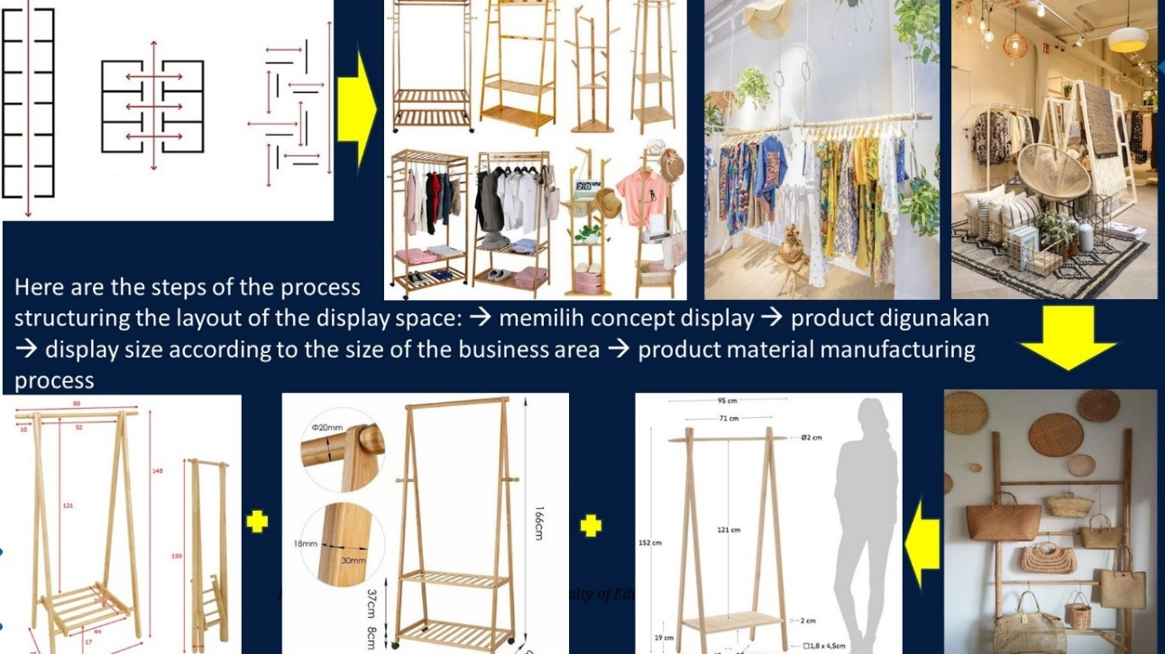

Figure 3 The steps of the process structuring the layout of the display space. (Source : Illustration Author, 2024)

CONLUSION
Many participants lack information and utilize the interior of the display space, in this case, to develop and arrange the layout of the product display space, to help them learn and apply it in their commercial activities. Responding to and paying attention to these conditions demonstrates that activities like this must continue and be carried out on an ongoing basis, which is consistent with member enthusiasm and requests for their continuation in the future. Participants in community service activities are unable to receive direct support due to distance limits, but they are given the option to communicate using communication technology such as Whatapp, video calls, and so on.

REFERENCES
Alfiyah, S. (2017). Pengaruh atmosfer toko, display toko, dan kelengkapan produk terhadap keputusan pembelian pada toko Samu Pace. Universitas Nusantara PGRI Kediri
Berman, B., Evans, J. R. (2007). Retail management: A strategic approach (10th ed.). New Jersey: Prentice Hall Inc
Berman, Evans. 2010. Pengaruh Eksterior Dan General Interior Display Terhadap Perilaku Pembelian Di Super Indo Singosari Malang. New York.
Barr, Vilma. Broudy, Charles E. (1986). Designing to Sell: A complete Guide to Retail Store Planning & Design. United States of America, 1986.
Fauzi, A.M.; Defianisa, R.L. Analysis for cleaner production implementation strategy in batik industry in Bogor. IOP Conf. Ser. Earth Environ. Sci. 2019, 325, 012005. [CrossRef]

Isma, A. (2020). The Interior Designing of Omah Batik in Bayat. Jurnal Pedhapa vol

11 no 2 . DOI: https://doi.org/10.33153/pendhapa.v11i2.3278
Kotler, Philip (2000). Prinsip – Prinsip Pemasaran Manajemen, Jakarta : Prenhalindo
Kusherawati.2013. Pengaruh Store Layout Toko Dan Tampilan Interior Display Terhadap Purchase Decision Pelanggan Di Multimart Tomohon. Manado.
Suptandar, J.Pamudji. 1982. Perancangan Tata Ruang Dalam (Interior Design). Jakarta: Penerbit PT Djambatan.
UFI. (2019). The Global Exhibition Industry is of Major Economic Importance. Utama, I Gusti Bagus Rai, 2017, Pemasaran Pariwisata, Yogyakarta: Penerbit Andi.

Acknowledgments
The authors would like to thank the Rector of Mercu Buana University and the Head of LPPM for providing community service money for workshop activities. The authors would like to thank the editor-in-chief of Abdi Masyarakat Journal (JAM) for accepting their manuscript. Hopefully, this essay will be very valuable to all communities.

