
Jurnal Doktor Manajemen, Vol. ... (…), Bulan, 2024

THE INFLUENCE OF TOURISM ATTRACTION, FACILITIES AND SERVICE QUALITY ON INTEREST IN REVISITING TO TOURISM TAMAN MINI INDONESIA INDAH, JAKARTA

Nur Aisyah Alawiyah¹⁾, Ririn Wulandari²⁾

¹⁾ naisyahalawiyah124@gmail.com, +62 895-3268-98650, University of Mercu Buana, Jakarta, Indonesia
²⁾ ririn.wulandari@mercubuana.ac.id, +62 811-1892-555, University of Mercu Buana, Jakarta, Indonesia

ARTICLE I N F O A B S T R A C T

Keyword:
Tourist Attration, Facilities, Service quality, Interest in Revisiting

Delivered: ………….
Received: ………......
Published: 1 April 2024

Author's email address correspondence: naisyahalawiyah124@gmail.com, ririn.wulandari@mercu buana.ac.id

This research aims to analyze and determine the influence of tourist attractions, facilities and service quality on interest in returning to the Taman Mini Indonesia Indah area, Jakarta. The population in this study were visitors to Taman Mini Indonesia Indah who had visited 2 or more times. The sample used in this research was 240 respondents, calculated based on the Hair Formula. This research uses a quantitative descriptive approach. The sampling method in this research is NonProbability Sampling with the technique used is Purposive sampling. The data collection method in this research uses a survey method, with the research instrument being an online questionnaire via Google Form. The data analysis method used in this research is statistical analysis in the form of SEM-PLS (Partial Least Square) version 3.0. The results of this research show that the tourist attraction variable has a positive and significant effect on interest in returning to visit. The facility variable has a positive and significant effect on interest in returning to visit and the service quality variable has a positive and significant effect on interest in returning to visit.

INTRODUCTION
Tourism is a trip or activity carried out by a person within a certain period of time, which can be carried out in the long term or short term from one place to another but not as a place where a person lives (Iswidyamarsha, 2020).
A person's goal of going on a tourist trip can be done in various ways by which his desires can be fulfilled. For example, someone goes to a tourist spot to have a picnic with their family during the end of year holidays, someone goes to a tourist spot to go on an educational trip, do sports, and to carry out worship and carry out their respective hobbies.
Recreation and entertainment are basically very important human needs. Even though recreation and entertainment are secondary needs, these activities really help someone to forget the problems they face in everyday life. Carrying out a busy daily routine definitely requires high concentration so that a person gets bored easily and definitely needs recreation and entertainment, especially during long holidays such as the End of Year Holidays, these holidays aim to refresh the body and mind, such as traveling to the desired tourist destination.
Therefore, researchers are interested in conducting research on recreational tourism objects, namely Taman Mini Indonesia Indah (TMII). Taman Mini Indonesia Indah (TMII) is a tourist park area and also a tourist attraction with an Indonesian cultural theme, which is located in East Jakarta. Taman Mini Indonesia Indah (TMII) is also a recreational park that fully depicts great Indonesia in a small and beautiful appearance which has an area of approximately 150 hectares or 1.5 square km, where this tourist attraction is considered very large. Taman Mini Indonesia Indah (TMII) provides an overview of Indonesian culture and islands which are realized through regional platforms representing every ethnic group in 33 provinces in Indonesia. Apart from that, Taman Mini Indonesia Indah (TMII) also has lots of rides and museums which are useful for entertainment and can increase insight and even provide education for students. (Source:www.tamanmini.com).
What is quite unfortunate is that in December 2019 the world was faced with problems regarding Health, where Indonesia experienced a Global Pandemic condition. In March 2020, Indonesia was confirmed for the first time to have cases of COVID-19, especially in the DKI Jakarta Province area where the impact was very large. Therefore, policies such as Large-Scale Social Restrictions (PSBB) were created with the aim of breaking the chain of spread of COVID-19 which had an impact on the decline in the number of tourist visitors, one of which was the decline in visitors to the Mini Indonesia Indah (TMII) park. According to research by Syarah & Prastika (2020), Taman Mini Indonesia Indah (TMII) was one of the tourist attractions that had a high level of visitors before the COVID pandemic occurred. According to TMII Head of Public Relations Sadah Silalahi, the average number of visitors on weekends is around 80,000 people. However, since the pandemic occurred, Taman Mini Indonesia Indah (TMII) has become one of the tourist locations affected.
However, in the midst of the pandemic, Taman Mini Indonesia Indah (TMII) has become one of the main tourist attractions for people to visit during the Christmas and New Year holidays (TMII Public Relations and Promotion). Even in the Pandemic Era, Taman Mini Indonesia Indah (TMII) is still one of the places used by the community as a place for recreation with family and closest relatives. However, it remains in accordance with government directions, namely by complying with the health protocols that apply at Taman Mini Indonesia Indah (TMII).
Based on the results of a Pre-Survey conducted on 30 respondents. There were three variables most frequently chosen by respondents, namely the Tourist Attraction variable with 30 respondents, the Service Quality with 28 respondents, and the Facilities variable with 29 respondents. From these results, respondents who choose these three variables can influence their "Intention to Visit Again".
Therefore, researchers then arose the desire to conduct research and study it more deeply with the title "The Influence of Tourist Attractions, Facilities and Service Quality on Interest in Revisiting to Tourism Taman Mini Indonesia Indah, Jakarta".

LITERATURE REVIEW
The first research was conducted by Aliyah (2017) in research by Susanto & Astutik (2020) explaining that a tourist attraction is anything that triggers a person or group of people to visit a place for some reason, it has a certain meaning, for example, the natural environment, heritage or historic sites. and certain events. Meanwhile, according to Law of the Republic of Indonesia no. 10 of 2009 states that tourist attraction itself is described as anything that has uniqueness, beauty and value in the form of a diversity of natural, cultural and man-made products that are targeted or visited by tourists.
The second research conducted by Sari & Wiyana (2017) stated that tourist facilities are a complement to tourist destination areas that are needed to meet the needs of tourists who are enjoying a tourist trip. Meanwhile, according to Ardiansyah & Ratnawili (2021), tourist facilities are facilities and infrastructure provided by tourism managers for tourists to use.
The third research conducted by Lutur (2020) stated that Service Quality is responding to consumer needs and desires as well as the accuracy of a delivery method to meet customer expectations and satisfaction. Meanwhile, according to research by Wulandari & Rusmahafi (2020), service quality greatly influences the creation of value for customers and companies, by providing quality experiences more efficiently to increase the company's long-term profits.
Furthermore, in the fourth study conducted by Rozak (2012; 67) in the research of Farikhin et.al (2020) stated that interest in revisiting is a person's mental state which reflects plans to carry out several actions within a certain period of time. Meanwhile, according to Otike et al., (2022) in research by Indaryani & Wulandari (2022) stated that satisfied consumers will make repeat visits in the future and tell other people about the service products they use.
Based on research results from previous research, it was concluded that:
  - Sugianto & Merpaung (2020): stating that tourist attractions have a positive and significant effect on intention to visit again.
  - Pratiwi, Soetjipto, & Hermawan (2018): stated that facilities have a significant positive influence on the intention to visit again.
  - Riyanti et.al (2020): stated that Service Quality has a positive and significant influence on Intention to Revisit.
Based on the explanation above, the hypothesis that will be proposed in this study is as follows:
- H1: Tourist Attraction has a positive and significant effect on interest in returning to visit.
- H2: Facilities have a positive and significant effect on interest in returning to visit.
- H3: Service quality has a positive and significant effect on interest in returning to visit..
The following is a thought model to strengthen the above hypothesis:

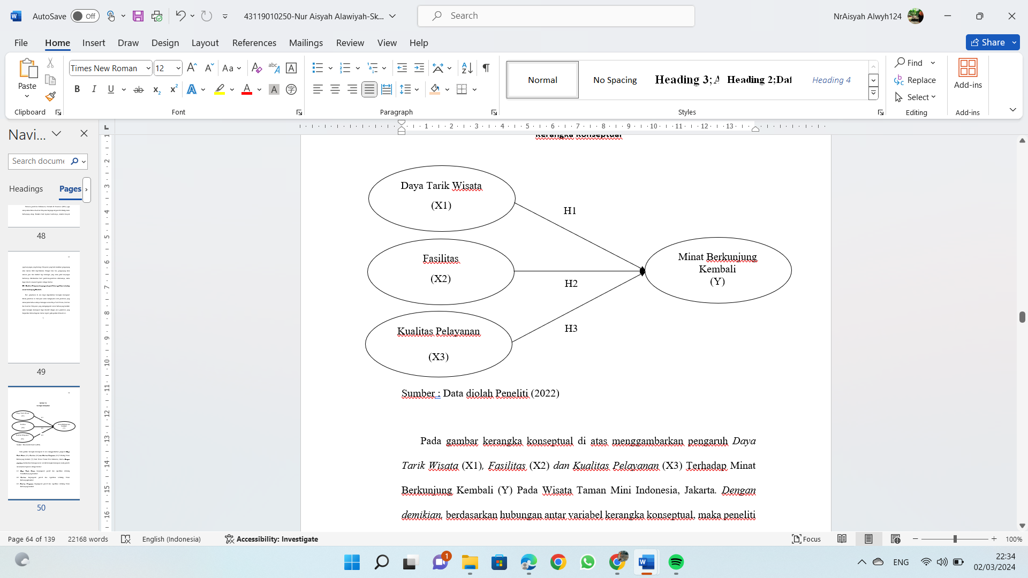
Figure 1: Hypothesis framework

METHODS
The research design used for this research is causal research. Causal analysis is useful for analyzing a relationship between one or more that influence several Independent variables (X) on the Dependent variable (Y). The population in this study were visitors to Taman Mini Indonesia Indah who had visited 2 or more times.
The sampling carried out in this research was a non-probability sampling technique, because the probability of an element being selected as a subject is unknown. According to Sugiyono (2017) Purposive sampling technique is a sampling technique with certain considerations or having specific characteristics. So, this research uses purposive sampling because sampling is carried out randomly by determining special characteristics according to the research objectives so that the data obtained can be more representative. Menurut Hair et al., (2017:39) menyatakan bahwa ukuran sampel yang ideal untuk digunakan sebagai representasi elemen populasi dapat ditentukan berdasarkan jumlah indikator penelitian dikali 5. Kemudian jumlah sampel dalam penelitian ini adalah: Sampel= Jumlah indikator x 5 = 48 x 5 = 240. Jadi, berdasarkan perhitungan di atas ukuran sampel penelitian ini adalah sebanyak 240 responden.
The data collection method used in this research is an online questionnaire technique via Google Form. According to Sugiyono (2016), a questionnaire is a data collection technique that is carried out by giving a series of questions or written statements to respondents to answer. In this study, the researcher asked a questionnaire containing a list of questions and respondents could only answer one of several answer choices provided. The questionnaire in this research consists of statements regarding the influence of tourist attractions, facilities and service quality on interest in revisiting to the tourism Taman Mini Indonesia Indah, Jakarta with a predetermined research sample.
The data analysis method used in this research is IBM SPSS Statistics 25 in Descriptive Analysis. This research also uses data analysis methods using SmartPLS software version 3.0. PLS (Partial Least Square).

RESULT AND DISCUSION RESULT
Items | Description | Frequency | Percentage
Gender | Man | 93 | 38.8%
Gender | Woman | 147 | 61.3%
Age | 17 - 27 Years | 162 | 67.5%
Age | 28 - 38 Years | 54 | 22.5%
Age | 39 - 49 Years | 20 | 8.3%
Age | >49 Years | 4 | 1.7%
Education | Senior High School | 11 | 4.6%
Education | Diploma | 12 | 5.0%
Education | Bachelor | 69 | 28.7%
Education | Other | 148 | 61.7%
Employment | Student / Learner | 59 | 24.6%
Employment | Housewife | 28 | 11.7%
Employment | Employee | 98 | 40.8%
Employment | Businessman | 28 | 11.7%
Employment | TNI/POLRI | 4 | 1.7%
Employment | Civil Servants (PNS) | 6 | 2.5%
Employment | Private sector employee | 10 | 4.2%
Employment | State Officials | 3 | 1.3%
Employment | Other | 4 | 1.7%
Income | < IDR 1.000.000 | 36 | 15.0%
Income | IDR 1.000.000 - IDR 5.000.000 | 155 | 64.6%
Income | IDR 6.000.000 - IDR 10.000.000 | 26 | 10.8%
Income | IDR 11.000.000 -IDR 50.000.000 | 15 | 6.3%
Income | >IDR 50.000.000 | 8 | 3.3%

Table 1. Characteristics of respondents

Source: SPSS Statistics 23 Processing Output (2023)

Based on the Table above, respondents are dominated by women with an average age of 17-27 years who are employees. Most respondents had an income < IDR 1,000,000 - IDR 5,000,000 per month.

Table 2. Description of Tourist Attraction Variables (X1)
Indicator | Answer Categories |  |  |  |  | Average Index
Indicator | 1/STS | 2/TS | 3/N | 4/S | 5/SS | Average Index
DTW1 | - | 2 | 31 | 52 | 155 | 4.50
DTW2 | 2 | 7 | 29 | 71 | 131 | 4.34
DTW3 | 1 | 5 | 31 | 65 | 138 | 4.39
DTW4 | - | 2 | 25 | 77 | 136 | 4.45
DTW5 | - | 4 | 29 | 89 | 118 | 4.34
DTW6 | - | 1 | 31 | 59 | 149 | 4.48
DTW7 | - | 3 | 27 | 83 | 127 | 4.39
DTW8 | - | 13 | 44 | 93 | 90 | 4.08
DTW9 | - | 2 | 39 | 107 | 92 | 4.20
DTW10 | - | 1 | 33 | 114 | 92 | 4.24
DTW11 | 1 | 1 | 29 | 81 | 128 | 4.39
DTW12 | - | 2 | 32 | 108 | 98 | 4.26
DTW13 | - | 2 | 31 | 94 | 113 | 4.33
DTW14 | - | 9 | 32 | 74 | 125 | 4.31
Source: SPSS Statistics 23 Processing Output (2023)

Based on the Table above, it shows the characteristics of the tourist attraction variable (X1). It can be seen that the respondents' answers to the 14 indicators in the tourist attraction variable show the highest average index of 4.50 in the DTW1 indicator, while the smallest average index is 4.08 in the DTW8 indicator.

Table 3. Description of Facility Variables (X2)
Indicator | Answer Categories |  |  |  |  | Average Index
Indicator | 1/STS | 2/TS | 3/N | 4/S | 5/SS | Average Index
F1 | 2 | 3 | 48 | 108 | 79 | 4.08
F2 | 1 | 5 | 38 | 100 | 96 | 4.19
F3 | 2 | 3 | 31 | 109 | 95 | 4.22
F4 | 3 | 8 | 50 | 97 | 82 | 4.03
F5 | 1 | 4 | 45 | 100 | 95 | 4.18
F6 | 2 | 6 | 48 | 94 | 90 | 4.10
F7 | 2 | 4 | 48 | 98 | 88 | 4.11
F8 | 1 | 8 | 52 | 85 | 94 | 4.10
F9 | 3 | 9 | 51 | 100 | 77 | 4.00
F10 | 1 | 11 | 50 | 92 | 86 | 4.05
F11 | 1 | 9 | 48 | 103 | 79 | 4.04
F12 | - | 8 | 40 | 101 | 91 | 4.15
F13 | - | 7 | 48 | 104 | 81 | 4.08

Source: SPSS Statistics 23 Processing Output (2023)

Based on the Table above, it shows the characteristics of the Facility variable (X2). It can be seen that the respondents' answers to the 13 indicators in the Facilities variable show the highest average index of 4.22 in indicator F3. Meanwhile, the smallest average index is 4.00 found in the F9 indicator

Table 4. Description of Service Quality Variables (X3)
Indicator | Answer Categories |  |  |  |  | Average Index
Indicator | 1/STS | 2/TS | 3/N | 4/S | 5/SS | Average Index
KP1 | - | - | 28 | 53 | 161 | 4.54
KP2 | 2 | 12 | 62 | 96 | 68 | 3.90
KP3 | - | 1 | 20 | 46 | 173 | 4.63
KP4 | - | 1 | 28 | 50 | 161 | 4.55
KP5 | - | - | 24 | 57 | 159 | 4.56
KP6 | - | 1 | 27 | 43 | 169 | 4.58
KP7 | - | 2 | 22 | 55 | 161 | 4.56
KP8 | - | 2 | 26 | 72 | 140 | 4.46
KP9 | - | 2 | 28 | 63 | 147 | 4.48
KP10 | 1 | 1 | 29 | 53 | 156 | 4.51
KP11 | - | 1 | 27 | 66 | 146 | 4.49
KP12 | 1 | - | 25 | 53 | 161 | 4.55
KP13 | - | 2 | 23 | 67 | 148 | 4.50
KP14 | - | 2 | 23 | 67 | 148 | 4.50
KP15 | - | 1 | 22 | 73 | 144 | 4.50
KP16 | - | 2 | 23 | 73 | 142 | 4.48

Source: SPSS Statistics 23 Processing Output (2023)

Based on the Table above, it shows the characteristics of the service quality variable (X3). It can be seen that the respondents' answers to the 16 indicators in the service quality variable show the highest average index of 4.63. Meanwhile, the smallest average index is 3.90 found in the KP2 indicator.

Table 5. Description of Return Visit Interest Variables (Y)

Indicator | Answer Categories |  |  |  |  | Average Index
Indicator | 1/STS | 2/TS | 3/N | 4/S | 5/SS | Average Index
MBK1 | - | 3 | 33 | 119 | 85 | 4.19
MBK2 | - | 2 | 25 | 77 | 136 | 4.45
MBK3 | 2 | 11 | 31 | 63 | 133 | 4.31
MBK4 | - | 4 | 34 | 66 | 136 | 4.39
MBK5 | - | 6 | 27 | 63 | 144 | 4.44

Source: SPSS Statistics 23 Processing Output (2023)

Based on the Table above, it shows the characteristics of the Interest in Returning (Y) variable. It can be seen that respondents' answers to the 5 indicators in the tourist attraction variable show the highest average index of 4.45 found in the MBK2 indicator. Meanwhile, the smallest index average of 4.19 is found in the MBK1 indicator.

Evaluation of the Measurement Model (Outer Model)

Metode analisis data dalam penelitian ini menggunakan PLS (Partial Least Square). PLS merupakan metode analisis Component atau Variance Based Struktural Equation Modeling, dimana dalam pengolahan datanya dengan menggunakan program Partial Least Square (SmartPLS) versi 3.0. PLS (Partial Least Square) adalah model alternative dari Covariance based SEM (Abdillah & Hartono, 2015).

The goal of PLS is to find optimal predictive linear relationships that exist in the data. PLS can also be used to explain whether or not there is a relationship between latent variables.
Convergent Validity, In testing the convergent validity of each construct indicator, it is calculated using Partial Least Square (PLS). According to Ghozali & Latan (2015), Convergent Validity testing of each construct indicator can be said to be valid or has good reliability if the value is greater than 0.70, while Outer loading of 0.50 to 0.60 can be considered sufficient. Based on this criterion, if there is an outer loading below 0.70, the indicator will be removed from the model. Following are the results of the initial Convergent validity test of the model in this research, which can be seen in Figure 2.

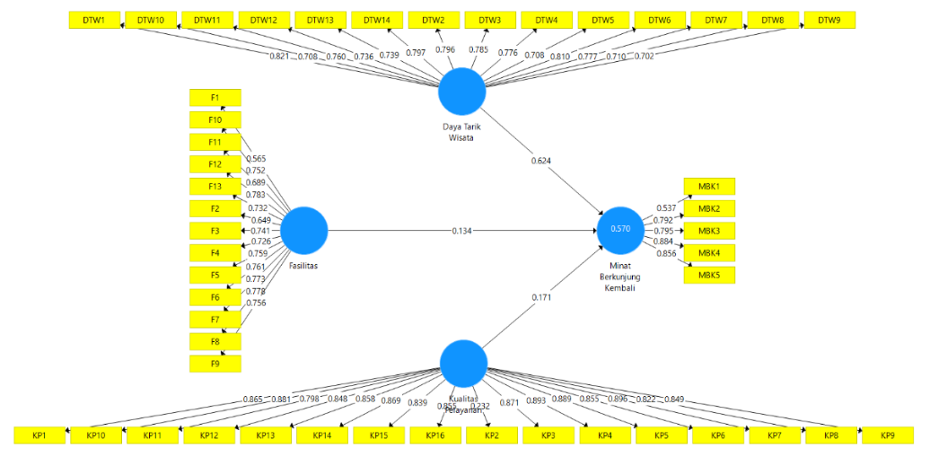
Figure 2. Initial Model Test Results
Source: Data Processing Results with SmartPLS 3.0. (2023)

Figure 2. Shows the results of indicators for the tourist attraction variable with a loading factor value of >0.7, with 14 indicators declared valid, meaning that the tourist attraction indicator meets the loading factor value, namely >0.7, so that nothing is dropped from the model. Of the 14 indicators for the facility variable, 11 indicators have a loading factor value of >0.7, meaning they are declared valid, while 3 indicators are invalid because the loading factor value is <0.7, including F1, F2, and F11, so they must be dropped from the model. Of the 16 service quality variable indicators, there are 15 indicators with a loading factor value of >0.7, meaning they are declared valid, while 1 indicator is invalid because <0.7, namely KP2, so it must be dropped from the model. Meanwhile, in the return visit interest variable, which consists of 5 indicators, there are 4 indicators that are valid because the loading factor value is >0.7, while 1 indicator is invalid because it is <0.7, namely MBK1, so it must be dropped from the model.

Figure 3. Convergent Validity Test Results (After Modification)
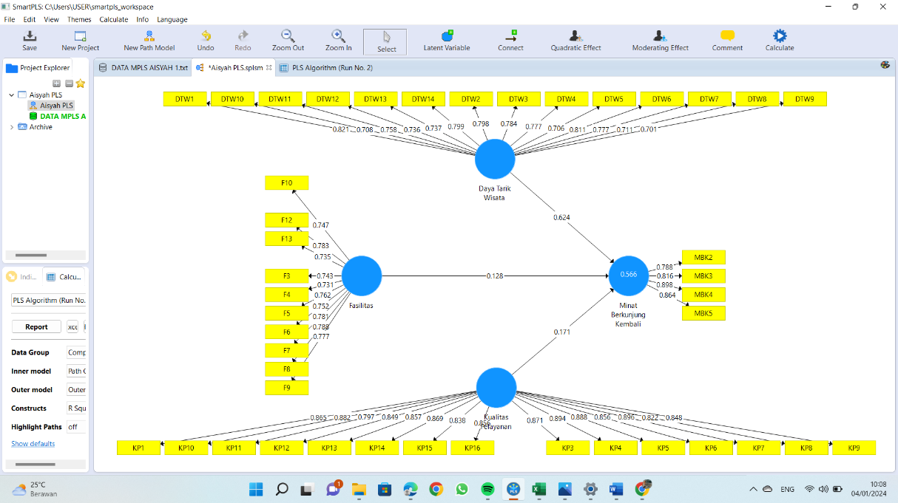

Source: Data Processing Results with SmartPLS 3.0. (2023)

Table 6. Convergent Validity Test Results
Variable | Indicator | Outer Loading |  | Description
Tourist Attraction (X1) | DTW1 | 0.821 |  | Valid
Tourist Attraction (X1) | DTW2 | 0.796 |  | Valid
Tourist Attraction (X1) | DTW3 | 0.785 |  | Valid
Tourist Attraction (X1) | DTW4 | 0.776 |  | Valid
Tourist Attraction (X1) | DTW5 | 0.708 |  | Valid
Tourist Attraction (X1) | DTW6 | 0.810 |  | Valid
Tourist Attraction (X1) | DTW7 | 0.777 |  | Valid
Tourist Attraction (X1) | DTW8 | 0.710 |  | Valid
Tourist Attraction (X1) | DTW9 | 0.702 |  | Valid
Tourist Attraction (X1) | DTW10 | 0.708 |  | Valid
Tourist Attraction (X1) | DTW11 | 0.760 |  | Valid
Tourist Attraction (X1) | DTW12 | 0.736 |  | Valid
Tourist Attraction (X1) | DTW13 | 0.739 |  | Valid
Tourist Attraction (X1) | DTW14 | 0.797 |  | Valid
Facility (X2) | F3 | 0.741 |  | Valid
Facility (X2) | F4 | 0.726 |  | Valid
Facility (X2) | F5 | 0.759 |  | Valid
Facility (X2) | F6 | 0.761 |  | Valid
Facility (X2) | F7 | 0.773 |  | Valid
Facility (X2) | F8 | 0.778 |  | Valid
Facility (X2) | F9 | 0.756 |  | Valid
Facility (X2) | F10 | 0.752 |  | Valid
Facility (X2) | F12 | 0.783 |  | Valid
Facility (X2) | F13 | 0.732 |  | Valid
Service Quality (X3) | KP1 | 0.865 |  | Valid
Service Quality (X3) | KP3 | 0.871 |  | Valid
Service Quality (X3) | KP4 | 0.893 |  | Valid
Service Quality (X3) | KP5 | 0.889 |  | Valid
Service Quality (X3) | KP6 | 0.855 |  | Valid
Service Quality (X3) | KP7 | 0.896 |  | Valid
Service Quality (X3) | KP8 | 0.822 |  | Valid
Service Quality (X3) | KP9 | 0.849 |  | Valid
Service Quality (X3) | KP10 | 0.881 |  | Valid
Service Quality (X3) | KP11 | 0.798 |  | Valid
Service Quality (X3) | KP12 | 0.848 |  | Valid
Variable | Indicator | Outer Loading | Description
 | KP13 | 0.858 | Valid
 | KP14 | 0.869 | Valid
 | KP15 | 0.839 | Valid
 | KP16 | 0.855 | Valid
Interest in Revisiting (Y) | MBK2 | 0.792 | Valid
Interest in Revisiting (Y) | MBK3 | 0.795 | Valid
Interest in Revisiting (Y) | MBK4 | 0.884 | Valid
Interest in Revisiting (Y) | MBK5 | 0.856 | Valid
Source: Data Processing Results with SmartPLS 3.0. (2023)

Figure 3 and Table 6 show that the results of the modified convergent validity test can be seen that all indicators have met convergent validity because the loading factor value is above 0.70 so that all indicators are declared valid.

Table 7. Hasl Uji Discriminant Validity (Cross Loading)
 | Tourist Attraction | Fasility | Service Quality | Interest  in Revisiting
DTW1 | 0,821 | 0,298 | 0,380 | 0,672
DTW2 | 0,798 | 0,268 | 0,320 | 0,577
DTW3 | 0,784 | 0,208 | 0,323 | 0,581
DTW4 | 0,777 | 0,202 | 0,326 | 0,601
DTW5 | 0,706 | 0,240 | 0,273 | 0,438
DTW6 | 0,811 | 0,191 | 0,326 | 0,621
DTW7 | 0,777 | 0,227 | 0,356 | 0,584
DTW8 | 0,711 | 0,163 | 0,200 | 0,497
DTW9 | 0,701 | 0,228 | 0,230 | 0,446
DTW10 | 0,708 | 0,290 | 0,237 | 0,514
DTW11 | 0,758 | 0,203 | 0,311 | 0,571
DTW12 | 0,736 | 0,217 | 0,285 | 0,465
DTW13 | 0,737 | 0,233 | 0,417 | 0,505
DTW14 | 0,799 | 0,183 | 0,373 | 0,632
F3 | 0,264 | 0,743 | -0,003 | 0,275
F4 | 0,193 | 0,731 | -0,065 | 0,245
F5 | 0,170 | 0,762 | -0,084 | 0,144
F6 | 0,104 | 0,752 | -0,175 | 0,131
F7 | 0,254 | 0,781 | -0,082 | 0,262
F8 | 0,235 | 0,788 | -0,061 | 0,208
F9 | 0,231 | 0,777 | -0,107 | 0,259
F10 | 0,208 | 0,747 | -0,062 | 0,146
F12 | 0,229 | 0,783 | -0,043 | 0,197
F13 | 0,262 | 0,735 | -0,075 | 0,253
KP1 | 0,404 | -0,085 | 0,865 | 0,408
KP3 | 0,425 | -0,097 | 0,871 | 0,405
KP4 | 0,365 | -0,071 | 0,894 | 0,393
KP5 | 0,380 | -0,061 | 0,888 | 0,392
KP6 | 0,350 | -0,085 | 0,856 | 0,365
KP7 | 0,396 | -0,089 | 0,896 | 0,403
KP8 | 0,334 | -0,053 | 0,822 | 0,278
KP9 | 0,313 | -0,096 | 0,848 | 0,307
KP10 | 0,362 | -0,071 | 0,882 | 0,374
 | Tourist Attraction | Fasility | Service Quality | Interest  in Revisiting
KP11 | 0,292 | -0,096 | 0,797 | 0,285
KP12 | 0,356 | -0,061 | 0,849 | 0,390
KP13 | 0,328 | -0,099 | 0,857 | 0,316
KP14 | 0,342 | -0,058 | 0,869 | 0,338
KP15 | 0,326 | -0,107 | 0,838 | 0,342
KP16 | 0,311 | -0,080 | 0,856 | 0,314
MBK2 | 0,634 | 0,184 | 0,343 | 0,788
MBK3 | 0,532 | 0,256 | 0,358 | 0,816
MBK4 | 0,681 | 0,290 | 0,356 | 0,898
MBK5 | 0,608 | 0,266 | 0,351 | 0,864
Source: Data Processing Results with SmartPLS 3.0. (2023)

Table 7 shows that the correlation value of indicators with their constructs is higher than the correlation values of indicators with other constructs. This shows that discriminant validity is valid. Thus, it can be concluded from the results of the cross loading analysis that there are no discriminant validity problems because the indicators in each variable block are better than the indicators in other blocks.
Discriminant validity Discriminant validity can be carried out by checking cross loading, namely if the correlation of the construct with the measurement items is greater than the size of other constructs. From discriminant validity analysis in research can be seen in Table 8.

Table 8. Discriminant Validity Test Results (Fornell-Larcker Criteria)
 | Tourist Attraction | Fasility | Service Quality | Interest  in Revisiting
Tourist Attraction | 0,760
Fasility | 0,295 | 0,760
Service Quality | 0,414 | -0,093 | 0,860
Interest in Revisiting | 0,733 | 0,296 | 0,417 | 0,843

Source: Data Processing Results with SmartPLS 3.0. (2023)

Table 8 shows that the Fornell Lacker Criterion value for each construct is greater than the correlation with each other variable. So it can be concluded that each construct meets the Discriminant Validity criteria.
Average Variance Extracted (AVE), Average Variance Extracted (AVE) is a value where each variable is recommended to be > 0.50. So it can be said to be valid.

Table 9. Average Variance Extracted (AVE) Test Results
Variable | Average Variance Extracted (AVE) | Description
Tourist Attraction | 0,578 | Valid
Fasility | 0,578 | Valid
Service Quality | 0,739 | Valid
Interest in Revisiting | 0,710 | Valid
Source: Data Processing Results with SmartPLS 3.0. (2023)

Table 9 shows that the results of testing the AVE values for all constructs have potential reliability, namely >0.5. So this is in accordance with the AVE requirement >0.5, so it can be said to be valid.
Composite Reliability To test the validity of a model, it is necessary to test convergent validity and discriminant validity. Apart from testing the validity of the model, it is necessary to test the model's reliability using a composite reliability test. If all latent variable values have Composite Reliability and Cronbach's Alpha values ≥ 0.70 then this construct has good reliability or in other words the questionnaire used is consistent. The Composite Reliability and Cronbach's Alpha values in this research can be seen in Table 10.

Table 10. Composite Reliability and Cronbach's Alpha Test Results
Variable | Cronbach's Alpha | Composite Reliability | Description
Tourist Attraction | 0,944 | 0,950 | Reliable
Fasility | 0,920 | 0,932 | Reliable
Service Quality | 0,975 | 0,977 | Reliable
Interest in Revisiting | 0,863 | 0,907 | Reliable
Source: Data Processing Results with SmartPLS 3.0. (2023)

Table 10 shows that all composite reliability and Cronbach's alpha test results show values above the cut off ≥ 0.70. So it can be concluded that the questionnaire used as a measuring tool for this research is consistent and good.

Evaluation of the Structural Model (Inner Model)
After the estimated model has met the criteria of the outer model, the next step is to test the structural model (Inner Model), namely testing the R-Square determinant coefficient (R2), effect sizes (F2), and Q-Square value (Q2).

Table 11. R-Square (R2) Value Test Results
Variable | R-Square (R²)
Interest in Revisiting | 0,566
Source: Data Processing Results with SmartPLS 3.0. (2023)

Table 11. Shows that the R-Square value is 0.566, meaning that the variable interest in returning to visit can be explained by the three independent variables in the model, namely tourist attraction, facilities, service quality of 56.6% and the remaining 43.4% is explained by other variables that are not studied in this research model.
Value Effect Size (F2), According to Sarstedt et al., (2017) an F-Square value of 0.02 is interpreted as having a small or weak influence, a value of 0.15 is interpreted as having a moderate influence, and a value of 0.35 is interpreted as having a large influence, while a value of less than 0.02 can be ignored or considered non-existent.
Table 12. Effect Size (F2) Value Test Results.
Variable | Interest in Revisiting
Tourist Attraction | 0,644
Fasility | 0,032
Service Quality | 0,052
Interest in Revisiting

Source: Data Processing Results with SmartPLS 3.0. (2023)

Table 12. Shows that the effect size value that has the highest value is the influence of the tourist attraction variable (X1) on interest in returning to visit, which is 0.644, meaning that it shows that the influence of goodness in the tourist attraction variable is relatively large. The resulting effect size value for the facility variable (X2) is 0.032, meaning that the effect of goodness in the facility variable is moderate. Meanwhile, for the service quality variable (X3), the resulting effect size value is 0.052, meaning it shows that the influence of goodness in the service quality variable is moderate.
Value Q-Square (Q²), Q2 testing uses a predictive – relevance value (Q2 – R-Square) > 0 (Zero) which indicates that the model has a predictive – relevance value. The Q2 value is used to see the relative influence of the structural model on the observational measurement of latent variables. Q2 in this research can be seen in Table 13.
Table 13. Predictive Relevance (Q2) Test Results .
Variable | Predictive Relevance (Q²)
Interest in Revisiting | 0,566
Source: Data Processing Results with SmartPLS 3.0. (2023)

Table 13. Shows that the Q2 value is 0.566 > 0, which means that 56.6% of the variation in the return visit interest variable (dependent variable) is explained by the independent variables used. Thus the model is said to be worthy of having relevant predictive value.
- Hypothesis Test Results (Path Coefficient Estimates)
Research hypothesis testing using PLS was carried out using the bootstrapping method. The estimated value for the path relationship in the structural model must be significant. Significant values can be obtained through the bootstrapping procedure. Seeing the significance of the hypothesis can be seen in the parameter coefficient values and the significance value of the T-statistic in the bootstrapping algorithm, considering the significance value of the T-statistic. To find out whether it is significant or not significant, you can see that the P value is smaller than the level of uncertainty, namely 0.05, or look at the significance of the T-statistic in the bootstrapping report algorithm. The significance value of the T-statistic must be > 1.96 (Ghozali, 2014).
This research contains two path coefficient test results, namely direct and indirect, which can be seen in the following hypothesis testing:
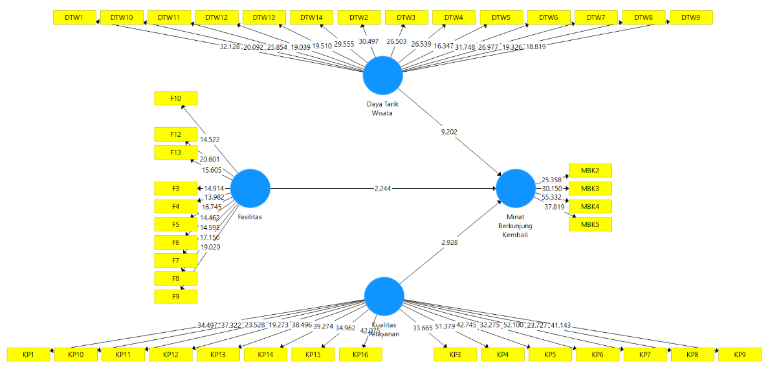
Figure 4. Bootstrapping Test Results

Table 14. Hypothesis Testing Results
Variable | Original  Sample (O) | Standard Devition (STDEV) | T Statistic (|O/STDEV|) | P Value | Description
DTW → MBK | 0.642 | 0.068 | 9.202 | 0.000 | Significant
F → MBK | 0.128 | 0.057 | 2.244 | 0.025 | Significant
KP → MBK | 0.171 | 0.058 | 2.928 | 0.004 | Significant

Source: Data Processing Results with SmartPLS 3.0. (2023)

Based on the p-value in Table 14, the test results for each hypothesis are as follows:
- Hypothesis 1 which states that the tourist attraction variable has an influence on the return visit interest variable which produces a T-statistic value of 9.202 >1.96, P-value of 0.000 < 0.05. So it can be concluded that hypothesis 1 (H1) is accepted where tourist attractions have a significant effect on intention to visit again.
- Hypothesis 2 which states that the Facility Variable has an influence on the Return Interest variable which produces a T-statistic value of 2.244 >1.96, a P-Value value of 0.025 <0.05. So it can be concluded that hypothesis 2 (H2) is accepted where facilities have a significant effect on intention to visit again.
- Hypothesis 3 which states that the Service Quality variable has an influence on the Intention to Revisit variable which produces a T-statistic value of 2.928 > 1.96, a P-Value value of 0.004 < 0.05. So it can be concluded that hypothesis 3 (H3) is accepted, where service quality has a significant effect on intention to revisit.

Discusion
This research aims to determine the influence of tourist attractions, facilities and service quality on interest in returning to the Taman Mini Indonesia Indah tourist attraction in Jakarta. This test is demonstrated through existing hypotheses so that you can find out how each variable influences other variables. Based on the results of data analysis and discussions that have been carried out, the conclusions of this research are as follows:
The Influence of Tourist Attraction on Intention to Return to Visit. Based on the results of hypothesis testing in this research, the results show that H1 is accepted. Testing the first hypothesis (H1) on the Tourist Attraction variable obtained a T-Statistic result of 9,202 > 1.96 and had a P-Value of 0.000 < 0.050, which means it is significant. Apart from that, the Original Sample value is 0.642 (64.2%) > 0, which means that the Tourist Attraction variable has a large positive influence on Interest in Returning to Visit. So it can be concluded that tourist attraction has a positive and significant effect on intention to visit again.
The results of this research are also strengthened by previous research by Sugianto & Merpaung (2020) which stated that tourist attraction has a positive and significant effect on intention to visit again. According to research by Ardiansyah & Ratnawili (2021), it is also stated that there is a positive and significant influence on the Tourist Attraction variable on Interest in Returning. According to Kurniawan et al., (2022) stated that tourist attraction has positive results and has a significant effect on interest in returning to visit, thus indicating that there is a unidirectional relationship between tourist attraction and interest in returning to visit.
The Influence of Facilities on Intention to Return to Visit. Based on the results of hypothesis testing in this research, the results show that H2 is accepted. Testing the second hypothesis (H2) on the Facility variable obtained a T-Statistic result of 2,244 > 1.96 and had a P-Value of 0.025 < 0.05, which means it is significant. Apart from that, the Original Sample value is 0.128 (12.8%) > 0, which means that the Facilities variable has a large positive influence on Interest in Returning to Visit. So it can be concluded that facilities have a positive and significant effect on interest in returning to visit.
The results of this research are also strengthened in previous research by Fajrin et al., (2021) which states that the Facility variable has a positive and significant effect on Interest in Returning. This shows that cleanliness is always maintained in the facilities at tourist attractions and determines tourists' interest in returning to visit, so that the better the facilities, the interest in returning to visit will increase. According to research by Iqbal & Sujanan (2021) it is also stated that facilities have a positive and significant influence on interest in repeat visits. According to Ardiansyah & Ratnawili (2021), facilities have a positive and significant influence on interest in repeat visits. This illustrates that the existence of good facilities will make visiting visitors feel comfortable and addicted to visiting again.
The Influence of Service Quality on Intention to Return to visit. Based on the results of hypothesis testing in this research, the results show that H3 is accepted. Testing the third hypothesis (H3) on the Service Quality variable obtained a T-Statistic result of 2,928 > 1.96 and had a P-Value of 0.004 < 0.05, which means it is significant. Apart from that, the Original Sample value is 0.171 (17.1%) > 0, which means that the Service Quality variable has a large positive influence on Intention to Visit Again. So it can be concluded that Service Quality has a positive and significant effect on Interest in Returning to Visits.
The results of this research were also strengthened by previous research by Dethan et al. (2021) stated that Service Quality has a positive and significant effect on Intention to Return to Visit through Tourist Satisfaction. According to research by Rahman et al,. (2019) also stated that Service Quality has a positive and significant effect on Intention to Revisit. According to research by Farikhin et al,. (2020) stated that Service Quality has a positive and significant effect on Intention to Return to Visit. If the quality of service is higher, tourist interest in return visits will also increase.

CONCLUTION
Based on the research results, discussion and conclusions above, the suggestions taken into consideration for this research are as follows:
- Suggestions for the Taman Mini Indonesia Indah Tourism Department
In increasing interest in returning visits, the Taman Mini Indonesia Indah tourism office must be able to help in meeting all the needs of tourists by increasing development at museums that are no longer suitable so that they can attract tourists to visit the TMII museum. In terms of facilities, the Taman Mini Indonesia Indah tourism office must add places of worship at several points in the TMII tourist area with the aim that tourists who visit the Taman Mini Indonesia Indah tourist attraction can worship easily and comfortably while traveling and can attract the interest of returning tourists. . Apart from that, the Taman Mini Indonesia Indah Tourism Department should further improve and expand the parking area where tourist visitors feel comfortable parking their vehicles. Because inadequate parking will cause many losses, including loss of time for tourist visitors.
- Suggestions for future researchers
Considering that this study has limitations in conducting research, it is recommended for future researchers that the variables include not only Tourist Attraction, Facilities and Service Quality on Interest in Returning, perhaps they can add and develop other variables that are more interesting and have the potential to be used as research variables, for example perception price, e-Wom and related experiences influence interest in visiting again. Future researchers must also be really careful in looking at the problems in determining the variables to be studied.

REFERENCES

Abdillah, W., & Hartono, J. (2015). Partial Least Square (PLS): alternatif structural equation modeling (SEM) dalam penelitian bisnis. Yogyakarta: Penerbit Andi, 22, 103-150.
Ardiansyah, Y., & Ratnawili. (2021). Daya Tarik, Citra Destinasi, Dan Fasilitas Pengaruhnya Terhadap Minat Berkunjung Ulang Pada Objek Wisata Wahana Surya Bengkulu Tengah. Jurnal Manajemen Modal Insani Dan Bisnis (JIMMIB), 2(2).
Dethan, A. G., Suryawardani, I. G. A. O., & Wiranatha, A. S. (2020). The Effect of Marketing Mix and Service Quality on Satisfaction and Revisit Intention to Kampung Coklat, Blitar Regency. E-Journal of Tourism, 7(2), 323-348.
Fajrin, A. R., Wijayanto, G., & Kornita, S. E. (2021). Pengaruh Fasilitas dan Lokasi terhadap Kepuasan dan Minat Berkunjung Kembali Wisatawan Candi Muara Takus Kecamatan XIII Koto Kampar Kabupaten Kampar. Jurnal Ekonomi KIAT, 32(1).
Farikhin, A., Mansur, M., & Priyono, A. A. (2020). Pengaruh Citra Destinasi Dan Kualitas Pelayanan Terhadap Minat Kunjungan Kembali Wisatawan. e – Jurnal Riset ManajemenProdi Manajemen.
Ghozali, I. (2014). SEM metode alternatif dengan menggunakan Partial Least Squares (PLS). Semarang: Badan Penerbit Universitas Diponegoro.
Ghozali, I., & Latan, H. (2015). Partial Least Squares Konsep, Teknik, dan Aplikasi Menggunakan Program SmartPLS 3.0 (2nd ed.). Universitas Diponegoro Semarang.
Hair,J.F., Hult, G. T. M., Ringle, C. M., & Sarstedt, M. (2017). A Primer on Partial Least Squares Structural Equation Modeling (PLS-SEM) Secound Etition. America: Sage.
Https://www.antaranews.com/berita/1925480/wisatawan-tmii-stabil-di-kisaran-11000-pada-akhir-pekan-pertama-2021.
Https://jdih.kemenparekraf.go.id/katalog-1-produk-hukum-Undang-Undang Republik Indonesia Nomor 10 Tahun 2009 Tentang Kepariwisataan.
Https://www.tamanmini.com/pesona_indonesia/tmii/menu/tentang_tmii.php.
Iqbal, M., & Sujana, S. (2021). Pengaruh Experiential Marketing Dan Fasilitas Terhadap Minat Kunjungan Ulang Pada Jungleland Advanture Theme Park. Jurnal Ilmiah Pariwisata Kesatuan, 2(2), 71-80.
Iswidyamarsha, C. (2020). Pengaruh Fasilitas Wisata Dan Promosi Terhadap Minat Berkunjung Di Dunia Air Tawar Dan Dunia Serangga TMII. Sadar Wisata: Jurnal Pariwisata, 3(2), 72-80.
Jarot, B. D. (2021, Januari 07). Jumlah Wisatawan Sebelum dan Saat Libur Natal dan Tahun Baru 2021. Retrieved from databoks.katadata.co.id: https://databoks.katadata.co.id/datapublish/2021/01/07/jumlah-wisatawan-meningkat-6859-saat-libur-natal-dan-tahun-baru
Kurniawan, A. E., Purwanto, H., & Asmike, M. (2022). Pengaruh Daya Tarik, Fasilitas Dan Kualitas Pelayanan Terhadap Minat Berkunjung Kembali Wisatawan Pada Mojosemi Forest Park Park Kabupaten Magetan. In SIMBA: Seminar Inovasi Manajemen, Bisnis, dan Akuntansi (Vol. 4).
Lutur, N. (2020). Promotion And Quality Of Service With Interest To Visit Tourist Objects: Sistematic Search. Eureka: Social and Humanities.
Pratiwi, Y. M., Soetjipto, B. E., & Hermawan, A. (2018). The Effect of Attraction and Facilities on the Revisit Intention by Tourists Satisfaction As An Intervening Variable (A Study in Banyuwangi Ijen Crater). International Journal of Social Science and Economic Research, 3(6), 2313-2326.
Rahman, R., Suryawardani, I. G. A. O., & Wiranatha, A. S. (2019). The Influence of Services’ Quality on Intention to Revisit through Mediation of Satisfaction of Visitors at Sasak Sade Village, Central Lombok, West Nusa Tenggara. E-Journal of Tourism, 322-341.
Rusmahafi, F. A., & Wulandari, R. (2020). The effect of brand image, service quality, and customer value on customer satisfaction. International Review of Management and Marketing, 10(4), 68.
Sugianto, S., & Merpaung, H. (2020). Pengaruh Word Of Mouth (WOM), Daya Tarik Wisata, Dan Fasilitas Terhadap Minat Berkunjung Ulang Wisatawan Pada Pemandian Air Panas Sumber Padi Kabupaten Batu Bara. Jurnal Manajemen, Ekonomi Sains, 2(1), 101-116.
Sugiyono. (2016). Metode Penelitian Kuantitatif, Kualitatif, dan R&D. Bandung: Alfabeta.
Sugiyono, P. D. (2017). Metode penelitian bisnis: pendekatan kuantitatif, kualitatif, kombinasi, dan R&D. Penerbit CV. Bandung: Alfabeta.
Susanto, B., & Astutik, P. (2020). Pengaruh Promosi Media Sosial Dan Daya Tarik Wisata Terhadap Minat Berkunjung Kembali Di Obyek Wisata Edukasi Manyung. RISK: Jurnal Riset Bisnis dan Ekonomi, 1(1), 36-46.
Syarah, M. M. (2020). Strategi Humas Dalam Menyampaikan Informasi Terkait Eksistensi Taman Mini Indonesia Indah (TMII) di Masa Pandemi COVID-19. Jurnal Public Relations (J-PR), 1(2), 97-101.

