Setelah Transformasi Data

Descriptive Statistics
 | N | Minimum | Maximum | Mean | Std. Deviation
SQRT_DPS | 58 | 2.45 | 6.00 | 3.7536 | .69867
SQRT_KA | 58 | 1.41 | 2.65 | 1.9186 | .28101
SQRT_IC | 58 | 1.00 | 1.73 | 1.3764 | .22152
SQRT_FRAUD | 58 | 1.00 | 5.00 | 1.9427 | .93760
Valid N (listwise) | 58

Variables Entered/Removedª
Model | Variables Entered | Variables Removed | Method
1 | SQRT_IC, SQRT_KA, SQRT_DPS^{b} | . | Enter
a. Dependent Variable: SQRT_FRAUD
b. All requested variables entered.

Model Summary^{b}
Model | R | R Square | Adjusted R Square | Std. Error of the Estimate
1 | .556ª | .309 | .270 | .80099
a. Predictors: (Constant), SQRT_IC, SQRT_KA, SQRT_DPS
b. Dependent Variable: SQRT_FRAUD

ANOVAª
Model |  | Sum of Squares | df | Mean Square | F | Sig.
1 | Regression | 15.463 | 3 | 5.154 | 8.034 | .000^{b}
 | Residual | 34.646 | 54 | .642
 | Total | 50.108 | 57
a. Dependent Variable: SQRT_FRAUD
b. Predictors: (Constant), SQRT_IC, SQRT_KA, SQRT_DPS

Coefficientsª
Model |  | Unstandardized Coefficients |  | Standardized Coefficients | t | Sig. | Collinearity Statistics
 |  | B | Std. Error | Beta |  |  | Tolerance | VIF
1 | (Constant) | .837 | 1.398 |  | .598 | .552
 | SQRT_DPS | -.308 | .163 | -.230 | -1.894 | .064 | .869 | 1.150
 | SQRT_KA | 1.611 | .381 | .483 | 4.226 | .000 | .980 | 1.020
 | SQRT_IC | -.601 | .516 | -.142 | -1.166 | .249 | .862 | 1.161
a. Dependent Variable: SQRT_FRAUD

Coefficientsª
Model |  | Unstandardized Coefficients |  | Standardized Coefficients | t | Sig.
 |  | B | Std. Error | Beta
1 | (Constant) | .837 | 1.398 |  | .598 | .552
 | SQRT_DPS | -.308 | .163 | -.230 | -1.894 | .064
 | SQRT_KA | 1.611 | .381 | .483 | 4.226 | .000
 | SQRT_IC | -.601 | .516 | -.142 | -1.166 | .249
a. Dependent Variable: SQRT_FRAUD

Coefficient Correlationsª
Model |  |  | SQRT_IC | SQRT_KA | SQRT_DPS
1 | Correlations | SQRT_IC | 1.000 | .131 | .359
 |  | SQRT_KA | .131 | 1.000 | .092
 |  | SQRT_DPS | .359 | .092 | 1.000
 | Covariances | SQRT_IC | .266 | .026 | .030
 |  | SQRT_KA | .026 | .145 | .006
 |  | SQRT_DPS | .030 | .006 | .027
a. Dependent Variable: SQRT_FRAUD

Collinearity Diagnosticsª
Model | Dimension | Eigenvalue | Condition Index | Variance Proportions
 |  |  |  | (Constant) | SQRT_DPS | SQRT_KA | SQRT_IC
1 | 1 | 3.934 | 1.000 | .00 | .00 | .00 | .00
 | 2 | .039 | 10.018 | .00 | .42 | .00 | .23
 | 3 | .022 | 13.278 | .00 | .14 | .60 | .22
 | 4 | .004 | 30.551 | 1.00 | .43 | .39 | .56
a. Dependent Variable: SQRT_FRAUD

Model Summary^{b}
Model | R | R Square | Adjusted R Square | Std. Error of the Estimate | Durbin-Watson
1 | .556ª | .309 | .270 | .80099 | 2.105
a. Predictors: (Constant), SQRT_IC, SQRT_KA, SQRT_DPS
b. Dependent Variable: SQRT_FRAUD

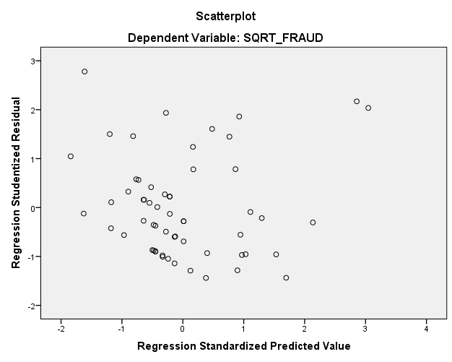

Residuals Statisticsª
 | Minimum | Maximum | Mean | Std. Deviation | N
Predicted Value | .9833 | 3.5286 | 1.9427 | .52084 | 58
Residual | -1.14038 | 2.05950 | .00000 | .77963 | 58
Std. Predicted Value | -1.842 | 3.045 | .000 | 1.000 | 58
Std. Residual | -1.424 | 2.571 | .000 | .973 | 58
a. Dependent Variable: SQRT_FRAUD

One-Sample Kolmogorov-Smirnov Test
 |  | Unstandardized Residual
N |  | 58
Normal Parameters^{a,b} | Mean | .0000000
 | Std. Deviation | .77962749
Most Extreme Differences | Absolute | .105
 | Positive | .105
 | Negative | -.080
Test Statistic |  | .105
Asymp. Sig. (2-tailed) |  | .170^{c}
a. Test distribution is Normal.
b. Calculated from data.
c. Lilliefors Significance Correction.

Statistics
Unstandardized Residual
N | Valid | 58
 | Missing | 0
Mean |  | .0000000
Median |  | -.1806805
Mode |  | -.70865ª
a. Multiple modes exist. The smallest value is shown

Unstandardized Residual
 |  | Frequency | Percent | Valid Percent | Cumulative Percent
Valid | -1.14038 | 1 | 1.7 | 1.7 | 1.7
 | -1.09413 | 1 | 1.7 | 1.7 | 3.4
 | -1.00760 | 1 | 1.7 | 1.7 | 5.2
 | -.99536 | 1 | 1.7 | 1.7 | 6.9
 | -.87214 | 1 | 1.7 | 1.7 | 8.6
 | -.81676 | 1 | 1.7 | 1.7 | 10.3
 | -.76990 | 1 | 1.7 | 1.7 | 12.1
 | -.76921 | 1 | 1.7 | 1.7 | 13.8
 | -.74719 | 1 | 1.7 | 1.7 | 15.5
 | -.74052 | 1 | 1.7 | 1.7 | 17.2
 | -.73625 | 1 | 1.7 | 1.7 | 19.0
 | -.71561 | 1 | 1.7 | 1.7 | 20.7
 | -.70865 | 2 | 3.4 | 3.4 | 24.1
 | -.69389 | 1 | 1.7 | 1.7 | 25.9
 | -.68228 | 1 | 1.7 | 1.7 | 27.6
 | -.53503 | 1 | 1.7 | 1.7 | 29.3
 | -.46341 | 1 | 1.7 | 1.7 | 31.0
 | -.45793 | 1 | 1.7 | 1.7 | 32.8
 | -.43935 | 1 | 1.7 | 1.7 | 34.5
 | -.43515 | 1 | 1.7 | 1.7 | 36.2
 | -.38377 | 1 | 1.7 | 1.7 | 37.9
 | -.32822 | 1 | 1.7 | 1.7 | 39.7
 | -.29444 | 1 | 1.7 | 1.7 | 41.4
 | -.27836 | 1 | 1.7 | 1.7 | 43.1
 | -.22632 | 1 | 1.7 | 1.7 | 44.8
 | -.21719 | 2 | 3.4 | 3.4 | 48.3
 | -.19315 | 1 | 1.7 | 1.7 | 50.0
 | -.16821 | 1 | 1.7 | 1.7 | 51.7
 | -.09959 | 1 | 1.7 | 1.7 | 53.4
 | -.09505 | 1 | 1.7 | 1.7 | 55.2
 | -.07126 | 1 | 1.7 | 1.7 | 56.9
 | .00754 | 1 | 1.7 | 1.7 | 58.6
 | .07491 | 1 | 1.7 | 1.7 | 60.3
 | .08378 | 1 | 1.7 | 1.7 | 62.1
 | .12145 | 1 | 1.7 | 1.7 | 63.8
 | .12488 | 1 | 1.7 | 1.7 | 65.5
 | .16957 | 2 | 3.4 | 3.4 | 69.0
 | .21101 | 1 | 1.7 | 1.7 | 70.7
 | .25573 | 1 | 1.7 | 1.7 | 72.4
 | .32857 | 1 | 1.7 | 1.7 | 74.1
 | .43701 | 1 | 1.7 | 1.7 | 75.9
 | .45663 | 1 | 1.7 | 1.7 | 77.6
 | .60722 | 1 | 1.7 | 1.7 | 79.3
 | .61333 | 1 | 1.7 | 1.7 | 81.0
 | .74874 | 1 | 1.7 | 1.7 | 82.8
 | .97079 | 1 | 1.7 | 1.7 | 84.5
 | 1.12291 | 1 | 1.7 | 1.7 | 86.2
 | 1.12824 | 1 | 1.7 | 1.7 | 87.9
 | 1.13178 | 1 | 1.7 | 1.7 | 89.7
 | 1.27106 | 1 | 1.7 | 1.7 | 91.4
 | 1.44833 | 1 | 1.7 | 1.7 | 93.1
 | 1.47135 | 1 | 1.7 | 1.7 | 94.8
 | 1.51819 | 1 | 1.7 | 1.7 | 96.6
 | 1.57005 | 1 | 1.7 | 1.7 | 98.3
 | 2.05950 | 1 | 1.7 | 1.7 | 100.0
 | Total | 58 | 100.0 | 100.0

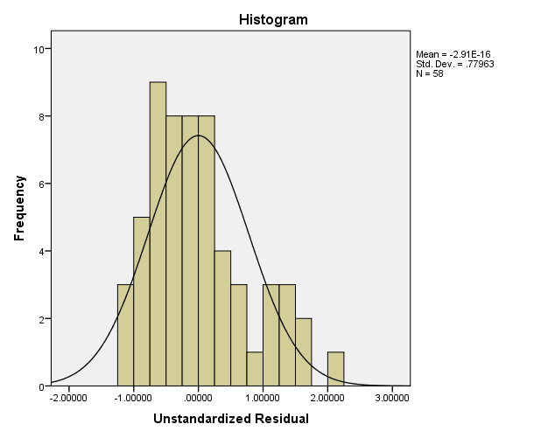

Sebelum Transformasi Data

Descriptive Statistics
 | N | Minimum | Maximum | Mean | Std. Deviation
Rapat DPS | 58 | 6.00 | 36.00 | 14.5690 | 5.63234
Komite Audit | 58 | 2.00 | 7.00 | 3.7586 | 1.15941
IC | 58 | 1.00 | 3.00 | 1.9428 | .61937
FRAUD | 58 | 1.00 | 25.00 | 4.6379 | 5.05652
Valid N (listwise) | 58

Variables Entered/Removedª
Model | Variables Entered | Variables Removed | Method
1 | IC, Komite Audit, Rapat DPS^{b} | . | Enter
a. Dependent Variable: FRAUD
b. All requested variables entered.

Model Summary^{b}
Model | R | R Square | Adjusted R Square | Std. Error of the Estimate
1 | .601ª | .361 | .326 | 4.15168
a. Predictors: (Constant), IC, Komite Audit, Rapat DPS
b. Dependent Variable: FRAUD

ANOVAª
Model |  | Sum of Squares |  |  | df | Mean Square |  | F |  | Sig.
1 | Regression | 526.627 |  |  | 3 | 175.542 |  | 10.184 |  | .000^{b}
 | Residual | 930.770 |  |  | 54 | 17.236
 | Total | 1457.397 |  |  | 57
a. Dependent Variable: FRAUD
b. Predictors: (Constant), IC, Komite Audit, Rapat DPS
Coefficientsª
Model |  |  | Unstandardized Coefficients |  |  |  | Standardized Coefficients |  | t |  | Sig.
 |  |  | B | Std. Error |  |  | Beta
1 | (Constant) |  | 1.742 | 3.549 |  |  |  |  | .491 |  | .625
 | Rapat DPS |  | -.186 | .103 |  |  | -.207 |  | -1.797 |  | .078
 | Komite Audit |  | 2.275 | .481 |  |  | .522 |  | 4.734 |  | .000
 | IC |  | -1.517 | .947 |  |  | -.186 |  | -1.601 |  | .115
a. Dependent Variable: FRAUD

Residuals Statisticsª
 | Minimum | Maximum | Mean | Std. Deviation | N
Predicted Value | -1.0029 | 14.1328 | 4.6379 | 3.03958 | 58
Residual | -7.25995 | 11.08025 | .00000 | 4.04095 | 58
Std. Predicted Value | -1.856 | 3.124 | .000 | 1.000 | 58
Std. Residual | -1.749 | 2.669 | .000 | .973 | 58
a. Dependent Variable: FRAUD

One-Sample Kolmogorov-Smirnov Test
 |  | Unstandardized Residual
N |  | 58
Normal Parameters^{a,b} | Mean | .0000000
 | Std. Deviation | 4.04095197
Most Extreme Differences | Absolute | .134
 | Positive | .134
 | Negative | -.081
Test Statistic |  | .134
Asymp. Sig. (2-tailed) |  | .011^{c}
a. Test distribution is Normal.
b. Calculated from data.
c. Lilliefors Significance Correction.

Statistics
Unstandardized Residual
N | Valid | 58
 | Missing | 0
Mean |  | .0000000
Median |  | -1.0476586
Mode |  | -2.30291ª
a. Multiple modes exist. The smallest value is shown

Unstandardized Residual
 |  | Frequency | Percent | Valid Percent | Cumulative Percent
Valid | -7.25995 | 1 | 1.7 | 1.7 | 1.7
 | -5.61297 | 1 | 1.7 | 1.7 | 3.4
 | -4.83672 | 1 | 1.7 | 1.7 | 5.2
 | -4.76368 | 1 | 1.7 | 1.7 | 6.9
 | -4.57798 | 1 | 1.7 | 1.7 | 8.6
 | -4.54974 | 1 | 1.7 | 1.7 | 10.3
 | -4.22778 | 1 | 1.7 | 1.7 | 12.1
 | -3.84533 | 1 | 1.7 | 1.7 | 13.8
 | -3.50612 | 1 | 1.7 | 1.7 | 15.5
 | -3.48115 | 1 | 1.7 | 1.7 | 17.2
 | -3.44757 | 1 | 1.7 | 1.7 | 19.0
 | -3.10273 | 1 | 1.7 | 1.7 | 20.7
 | -2.81458 | 1 | 1.7 | 1.7 | 22.4
 | -2.50517 | 1 | 1.7 | 1.7 | 24.1
 | -2.46904 | 1 | 1.7 | 1.7 | 25.9
 | -2.44757 | 1 | 1.7 | 1.7 | 27.6
 | -2.42400 | 1 | 1.7 | 1.7 | 29.3
 | -2.30291 | 2 | 3.4 | 3.4 | 32.8
 | -2.19675 | 1 | 1.7 | 1.7 | 34.5
 | -2.06142 | 1 | 1.7 | 1.7 | 36.2
 | -1.85305 | 1 | 1.7 | 1.7 | 37.9
 | -1.71612 | 1 | 1.7 | 1.7 | 39.7
 | -1.68882 | 1 | 1.7 | 1.7 | 41.4
 | -1.30291 | 1 | 1.7 | 1.7 | 43.1
 | -1.26162 | 1 | 1.7 | 1.7 | 44.8
 | -1.14497 | 1 | 1.7 | 1.7 | 46.6
 | -1.06142 | 2 | 3.4 | 3.4 | 50.0
 | -1.03390 | 1 | 1.7 | 1.7 | 51.7
 | -.63168 | 1 | 1.7 | 1.7 | 53.4
 | -.52643 | 1 | 1.7 | 1.7 | 55.2
 | -.46975 | 1 | 1.7 | 1.7 | 56.9
 | -.35891 | 1 | 1.7 | 1.7 | 58.6
 | -.05560 | 1 | 1.7 | 1.7 | 60.3
 | .15112 | 1 | 1.7 | 1.7 | 62.1
 | .21947 | 1 | 1.7 | 1.7 | 63.8
 | .55662 | 1 | 1.7 | 1.7 | 65.5
 | .69544 | 1 | 1.7 | 1.7 | 67.2
 | .83754 | 1 | 1.7 | 1.7 | 69.0
 | .84174 | 1 | 1.7 | 1.7 | 70.7
 | 1.09793 | 2 | 3.4 | 3.4 | 74.1
 | 1.44090 | 1 | 1.7 | 1.7 | 75.9
 | 2.02770 | 1 | 1.7 | 1.7 | 77.6
 | 2.24096 | 1 | 1.7 | 1.7 | 79.3
 | 2.49225 | 1 | 1.7 | 1.7 | 81.0
 | 3.66209 | 1 | 1.7 | 1.7 | 82.8
 | 4.00294 | 1 | 1.7 | 1.7 | 84.5
 | 4.09652 | 1 | 1.7 | 1.7 | 86.2
 | 5.21365 | 1 | 1.7 | 1.7 | 87.9
 | 5.87139 | 1 | 1.7 | 1.7 | 89.7
 | 6.05804 | 1 | 1.7 | 1.7 | 91.4
 | 7.09046 | 1 | 1.7 | 1.7 | 93.1
 | 7.32240 | 1 | 1.7 | 1.7 | 94.8
 | 9.93808 | 1 | 1.7 | 1.7 | 96.6
 | 10.86723 | 1 | 1.7 | 1.7 | 98.3
 | 11.08025 | 1 | 1.7 | 1.7 | 100.0
 | Total | 58 | 100.0 | 100.0

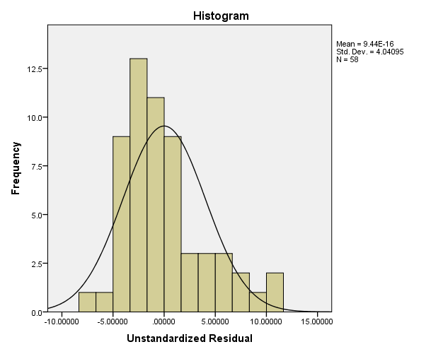

Model |  | Collinearity Statistics
 |  | Tolerance | VIF
1 | (Constant)
 | SQRT_DPS | .869 | 1.150
 | SQRT_KA | .980 | 1.020
 | SQRT_IC | .862 | 1.161

