One-Sample Kolmogorov-Smirnov Test
 |  | Unstandardized Residual
N |  | 58
Normal Parameters^{a,b} | Mean | 0E-7
Normal Parameters^{a,b} | Std. Deviation | .22843763
Most Extreme Differences | Absolute | .169
Most Extreme Differences | Positive | .169
Most Extreme Differences | Negative | -.113
Kolmogorov-Smirnov Z |  | 1.284
Asymp. Sig. (2-tailed) |  | .074
a. Test distribution is Normal.
b. Calculated from data.

Coefficientsª
Model |  | Collinearity Statistics
 |  | Tolerance | VIF
1 | NPF | .436 | 2.296
1 | BOPO | .484 | 2.065
1 | Fraud | .888 | 1.126
1 | Rapat DPS | .980 | 1.020
1 | Komite Audit | .866 | 1.155
a. Dependent Variable: ROA

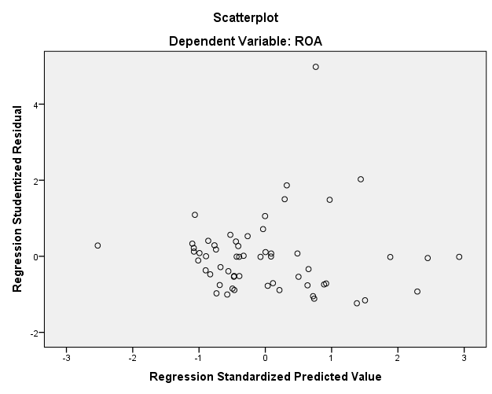

ANOVAª
Model |  | Sum of Squares | df | Mean Square | F | Sig.
1 | Regression | 37.163 | 5 | 7.433 | 129.938 | .000^{b}
1 | Residual | 2.974 | 52 | .057
1 | Total | 40.138 | 57
a. Dependent Variable: ROA
b. Predictors: (Constant), Komite Audit, BOPO, Rapat DPS, Fraud, NPF

Coefficientsª
Model |  | Unstandardized Coefficients |  | Standardized Coefficients | t | Sig.
 |  | B | Std. Error | Beta | t | Sig.
1 | (Constant) | 12.102 | .624 |  | 19.400 | .000
1 | NPF | .042 | .032 | .076 | 1.334 | .188
1 | BOPO | -.121 | .007 | -.987 | -18.197 | .000
1 | Fraud | .322 | .184 | .070 | 1.747 | .087
1 | Rapat DPS | -.009 | .008 | -.046 | -1.200 | .236
1 | Komite Audit | -.061 | .028 | -.087 | -2.152 | .036
a. Dependent Variable: ROA

