**PERFORMANCE ASSESSMENT OF PT. INDOFOOD SUKSES MAKMUR CBP TBK 2018-2020 BASED ON VALUE CREATION FOR FINANCIAL STRATEGY AND INVESTMENT DECISIONS**

Helmina Ardyanfitri1, Eka Mega Pertiwi2

1, 2 Universitas Islam Negeri Sunan Ampel Surabaya, Jalan Ahmad Yani No. 117, Surabaya, Jawa Timur

Email: eka19mp@gmail.com

***Abstract***

The Covid-19 condition brought changes to the company's performance and this situation was also felt by PT. Indofood Sukses Makmur CBP, Tbk. Thus, performance appraisal is needed by companies to evaluate and decide policies and take the right strategy. Performance appraisal for public companies can encourage value creation into stable growth, so that companies have good performance both from operations and finance and the public can invest in these companies. The purpose of this study is to assess the company's internal performance in order to assist the company in determining strategies that are appropriate to the company's circumstances and assessing the company's external performance for investment decision making for investors. This research method is a qualitative research with postpositivism method. The results of this study indicate that PT. Indofood Sukses Makmur CBP Tbk in 2018-2020 is in quadrant II in the financial strategy matrix by having a positive value in MVA and being in the excellent value manager quadrant in GVM, so that PT. Indofood Sukses Makmur CBP Tbk is very suitable for long term investment.

**Article info**

Article history:

Received 22 December 2019

Received in revised form 19 June 2020

Accepted 2 July 2020

Available online 27 July 2020

**Keywords:** Performance, investment, FSM, GVM

**INTRODUCTION**

The global economy is being hit by a crisis caused by the covid-19 virus and as a result many policies or decisions are issued by companies to maintain and stabilize company performance during the pandemic and post-pandemic. Making these policies or decisions has a long-term impact on the sustainability of a company. In this case, the company must have a policy that is in accordance with the current problems, including the Covid-19 condition. PT. Indofood CBP Sukses Makmur, Tbk is a large company in the consumer goods industry. PT. Indofood CBP Sukses Makmur, Tbk has a variety of products that are very popular with the public. The company forms a quality work culture by establishing the commitment of its employees using the principles of excellence, discipline, perfect, integrity, and innovative (Hermayanti & Rahmawati, 2015). Thus, being able to create a harmony in the company's atmosphere and able to improve the performance of its human resources even though it is being hit by Covid-19. To maintain the health of its employees, PT. Indofood CBP Sukses Makmur, Tbk always applies the 5M and 3T health protocols (Abdullah, 2021).

When Covid-19 occurred, PT. Indofood CBP Sukses Makmur, Tbk focuses on continuously supplying its products to consumers safely and on time. Products PT. Indofood CBP Sukses Makmur, Tbk, which are very popular with the public during Covid-19 are instant noodles and cooking spices. In addition, the quality and brand of PT. Indofood CBP Sukses Makmur, Tbk is able to increase and maintain customer loyalty (Handoko, 2015). PT. Indofood CBP Sukses Makmur, Tbk is included in the LQ-45 and JII stock indexes. In the LQ-45 stock index, ICBP has a portfolio investment prospect that shows progress (Hanifah dkk., 2020). This can be seen from the return on ROA, ROE, and similar forms of yield calculation. Meanwhile, on the JII index, PT. Indofood CBP Sukses Makmur, Tbk has a portfolio with a proportion of 44.89% of funds. In this case, ICBP is combined with BRPT, CPIN, EXCL, INDF, KLBF, PGAS, PTBA, SMRA, and UNVR so as to produce an optimal portfolio at an expected return value of 1.61% with a risk level of 3.49% (Mulya dkk., 2020). With the meaning that ICBP is an attractive and potential stock in the consumer goods industry sector because the level of public consumption is very high, both during Covid-19 and after Covid-19.

Viewing the financial statements of PT. Indofood CBP Sukses Makmur, Tbk from 2014-2019, companies need to increase the cash ratio value by efficiently controlling current asset inventory (Ramdaniansyah, 2020). In addition, companies need to increase the value of DER which can provide benefits for companies and investors. In 2018 before Covid-19 occurred, ICBP was able to create added value for its outstanding shares by showing a positive MVA value and this made ICBP a good investment choice for the long term (Thomas, 2020). However, this is the opposite during Covid-19. When the President of the Republic of Indonesia, Ir. Joko Widodo issued the news that COVID-19 entered Indonesia, ICBP shares decreased by 12.14% in the range of March 15 to April 12 2020. However, on August 12, 2020 PT. Indofood CBP Sukses Makmur, Tbk, distributed ICBP dividends of Rp. 215 per share. The dividend distribution had a positive impact on ICBP's share price, so that ICBP's shares increased by 7.83% in the range of August 2, 2020 to January 24, 2021. In technical analysis using the MACD, RSI, SO, and OBV indicators, it shows that the current trend of ICBP's stock price covid-19 is in the bad category (Kevin, 2020). Based on the Capital Asset Pricing Model (CAPM) method, ICBP has an individual rate of return that is less than the expected rate of return on individual shares (Mustika, 2021). This can affect investors in making investment decisions.

In 2016-2017, ICBP was never predicted to go bankrupt (Kartikosari & Puspita, 2020). Then, during the Covid-19 pandemic, ICBP is predicted to not experience non-financial distress (Wulandari & Maslichah, 2021). With this prediction, the company still has to think about its financial performance, especially considering the condition of ICBP's stock price amid the pandemic. The company also needs to think about the synergies of financial consolidation between ICBP and Pinehill, considering that in August 2020 after the dividend distribution, ICBP acquired Pinehill and at the same time it was seen that ICBP's share price touched Rp. 1,025 per share, but the share price did not last long and experienced a fluctuating decline. Seeing the movement of ICBP's stock price which is very volatile and in a bad category, even though large dividends have been distributed and have acquired Pinehill, the ICBP company must issue the right financial strategy so that the company's finances are stable and increase investor interest.

Based on this, the authors conducted a study entitled "PERFORMANCE ASSESSMENT OF PT. INDOFOOD SUKSES MAKMUR CBP TBK 2018-2020 BASED ON VALUE CREATION FOR FINANCIAL STRATEGY AND INVESTMENT DECISIONS" with the aim of assessing the company's internal performance so that it can assist the company in determining strategies that are in accordance with the company's circumstances and assessing the company's external performance for investment decision making for investors.

**METHOD**

**Types of Research**

This research includes qualitative research. The method used is postpositivism by using multiple methods in capturing realistic conditions in quantitative procedures such as computer assisted, basic statistics for analysis, and descriptive analysis (Sugiyono, 2018). The object of research studied by the author is PT. Indofood Sukses Makmur CBP, Tbk using Growth in sales, SGR, ROIC, WACC, and EVA spreads to determine FSM, as well as analyzing MVA and GVM for the period 2018 to 2020, then analyzing the matrix's financial strategy on financial performance and investment decisions using several cases of companies from 2018 to 2020 with reinforced financial statements for that period.

**Data Types and Sources**

In this study, the type of data used is quantitative secondary data of companies in the form of annual financial reports for the period 2018 to 2020. In addition, using qualitative descriptive data of companies in the form of annual reports for the period 2018 to 2019 and a summary of questions and answers to public exposes in 2020.

**Data Collection Technique**

The data collection technique in this research is through documentation by downloading the 2018 to 2020 annual financial reports, 2018 to 2019 annual reports, and a summary of the 2020 public expose questions on the official website of PT. Indofood Sukses Makmur CBP, Tbk.

**Operationalization of Research Variables**

Operationalization of variables describes the concept and condition of variables in general and provides other information about indicators, measures, diagrams, and variable measurement scales.

**Growth In Sales**

Growth in sales is a growth rate that is determined by looking at financial capabilities. Growth in sales is the maximum growth rate that can be achieved by a corporate without the need for external funds and growth is only obtained from retained earnings. The actual growth value is lower than the SGR value because the actual growth value does not allow the addition of long-term debt or the issuance of debt securities (Hestinoviana, 2013). Corporate growth in financial management is measured based on changes in sales, even financially how much growth should be (sustainable growth rate) by looking at the alignment of investment and financing decisions. If the growth in sales is too high, there will be a cash deficit in the company. Mathematically, growth in sales=(net sales after-net sales before)/net sales before.

**Sustainable Growth Rate (SGR)**

Sustainable Growth Rate (SGR) is the maximum growth rate that a company can achieve without capital financing but by maintaining a ratio between debt and capital (Jegers, 2003). Mathematically the Sustainable Growth Rate (SGR) can be calculated by (ROE x b)/1-(ROI x b), ROE is Return on Equity and b is the percentage of retained earnings in the company. The high or low SGR number is influenced by four factors, namely profit margin, dividend policy, financial policy, and asset turnover.

**Return on Invested Capital (ROIC)**

Return on Invested Capital (ROIC) is the rate of return on investment used. Return on Invested Capital (ROIC) measures real cash on cash return. Return on Invested Capital (ROIC) is used as an analysis of asset utilization linking earnings to assets (Zhu, 2017). The effectiveness of investment decisions can be seen based on the ROI or ROIC achieved, meaning that if the company is able to generate ROIC figures as desired or exceed the industry average, then the investment decision has reached the target.

**Weighted Average Cost of Capital (WACC)**

Funds in the Weighted Average Cost of Capital (WACC) can be obtained through four means, namely the capital market, money market, banks, and institutional investors (Shen dkk., 2016). Financial management decides on the financing policy by selecting the four sources of funds that have the lowest cost impact on the use of funds. The source of funds chosen by financial management must incur costs for the use of funds that can be met by the rate of return on investment. The average cost of using funds (Weighted Average Cost of Capital) comes from two components, namely creditors (bondholders) and shareholders. Companies that are financed with debt will have consequences for the cost of debt. Financing with debt provides an advantage because interest can reduce taxable income. Therefore, in calculating the cost of debt multiplied by tax savings. The effectiveness of financing decisions can be seen based on the amount of the use of funds (WACC). If the combination of debt and capital chosen in order to finance the investment results in a low cost of using the funds, it means that the financing decision has been made effectively.

**Economic Value Added (EVA)**

Economic Value Added is used to measure operating profit able to cover the cost of using the funds used in investing. Another term for EVA is economic profit or economic profit. With EVA, companies can consider whether investment decisions are in line with financing decisions. In the sense that the expected level of return on investment is able to cover the costs of the funds used to invest. Looking at the ROIC number and the WACC number, it will be more identified if you subtract the ROIC number from the WACC to produce EVA. In general, EVA is positive because if the company has an ROIC greater than WACC, then the company experiences an increase in economic added value or the rate of return on investment exceeds the costs incurred to finance the investment (Brewer dkk., 1999).

**Market Value Added (MVA)**

Market Value Added is the difference between the market value of a company's equity and the book value. MVA is used to assess the success or failure of the company in creating wealth for its shareholders. If the MVA value is positive, it describes the company has succeeded in creating added value or wealth and it can be said that the company's performance is good (Peters & Kramer, 2001). However, if the MVA is negative, it indicates the company has not succeeded in creating added value or wealth and it can be said that the company's performance is poor.

**Growth Value Map (GVM)**

GVM is a measurement used to assess strategies and describe strategies in value creation. GVM uses standard capital market indicators for corporate and general performance whose data is available from Bloomberg, data streams, and annual reports, as well as stock price data. GVM can be seen from the overall performance (measured by M/B value), profitability, and growth. GVM is needed by investors because PER, M/B, and MVA do not explicitly describe the company's growth.

Figure 1 Growth Value Map

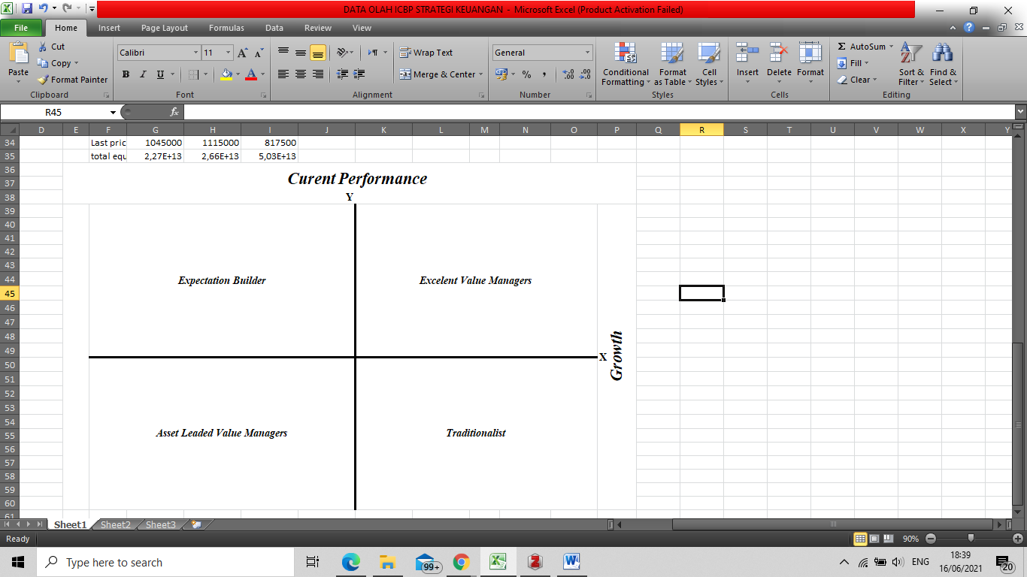

There are four groups in GVM (Jensen, 2010). First, Excellent Value Managers explain that capital market conditions expect companies in this quadrant to exceed their limits in profitability and growth. Second, Expectation Builders explain that the capital market expects relatively low profits in the short term, but has high growth expectations for companies in this quadrant and this position is risky, so companies in this quadrant can be considered bad because they have low or below average profitability performance. industry or competitors, but has high growth expectations if it can increase growth above the average index. Third, traditionalists explain that capital markets have low expectations for the potential growth of companies in this quadrant, even though they have superior profits from companies in the short term, so that management aspirations are low or poor or low investor relations make the market underestimate the value of the company. Fourth, Asset Loaded Value Managers explain that companies in this quadrant have low performance or profitability and growth in the future. In this quadrant, the company's shares are said to fail to provide wealth for shareholders and there are no business prospects in the future, so the company needs to restructure management and form a new strategy to gain and achieve profitability and growth opportunities.

**Data Analysis Technique**

**Descriptive Analysis**

Descriptive analysis is used to analyze and explain the Financial Strategy Matrix (FSM), Moving Value Added (MVA), and Growth Value Map (GVM) at PT. Indofood Sukses Makmur CBP, Tbk in 2018-2020 or before being affected by Covid-19 until affected by Covid-19. The formulations used in each are as follows.

Table 1 Variable Formulation

|  |  |  |
| --- | --- | --- |
| No. | Variable | Formulation |
| 1 | Growth in Sales | (Net Sales After-Net Sales Before)/Net Sales Before |
| 2 | SGR | b x ROE |
| 3 | ROIC | NOPAT/Total Asset |
| 4 | WACC | (D x rd (1-tax))+(E x re) |
| 5 | Spread EVA | ROIC –WACC |
| 6 | MVA | Market Value-Invested Capital |
| 7 | GVM | Horizontal Axis (EPS/E(Ri))/BVS |
| Vertikal Axis (SP-(EPS/E(Ri))/BVS |

Based on Table 1 Variable Formulation, the variable data obtained from the 2018-2020 ICBP Financial Statements are obtained as follows.

Table 2 Variable Data

|  |  |  |  |  |  |  |  |  |  |  |  |  |  |  |  |  |  |  |  |
| --- | --- | --- | --- | --- | --- | --- | --- | --- | --- | --- | --- | --- | --- | --- | --- | --- | --- | --- | --- |
| Year | *Growth in Sales* | | SGR | | ROIC | | WACC | | | | | | MVA | | | GVM | | | |
| *Net Sales After* | *Net Sales Before* | b | ROE | NOPAT | *Total Assets* | *Cost of Equity* | *Cost of Debt* | *Total Market Value* | *% Cost Equity* | *% Cost Debt* | *Tax Rate* | *Share Out* | *Last Price* | *Total Equity* | EPS | E(Ri) | BVS | SP |
| 2018 | 122,66 | 384,14 | 46,59% | 20,15% | 4,5E+12 | 3,43E+13 | 2,27E+13 | 11660003 | 1,218E+14 | 0,51 | 0,34 | 0,1789 | 11,7 | 10450 | 22,7 | 391,09 | 22,7 | 1947,12 | 10450 |
| 2019 | 144,05 | 422,97 | 53,61% | 18,89% | 5E+12 | 3,87E+13 | 2,66E+13 | 12038210 | 1,3E+14 | 0,45 | 0,31 | 0,2077 | 11,7 | 11150 | 26,6 | 430,67 | 26,6 | 2287,03 | 11150 |
| 2020 | 172,25 | 466,42 | 74,19% | 13,09% | 6,5E+12 | 1,035E+14 | 50318053 | 53270272 | 9,53E+13 | 1,06 | 0,51 | 0,2541 | 11,7 | 8175 | 50,3 | 562,98 | 50,3 | 4314,74 | 8175 |

**Source: Financial Statement PT. Indofood Sukses Makmur CBP Tbk 2018-2020**

**RESULTS AND DISCUSSION**

In Table 2 Variable Data shows the components that generate growth in sales, SGR, ROIC, and WACC to determine the FSM of PT. Indofood Success Prosperous CBP 2018-2020. In addition, it shows the components that generate MVA to determine the success of the company for shareholders or investors, so that investors decide to invest in ICBP. In Table 2 Variable Data also shows the components that generate GVM to explain the strategy in creating corporate value through the company's financial statements.

Table 3 Variable Results from ICBP 2018-2020

|  |  |  |  |  |  |  |  |  |  |  |
| --- | --- | --- | --- | --- | --- | --- | --- | --- | --- | --- |
| No. | Year | Growth in Sales | SGR | Cash Surp/Def | ROIC | WACC | Spread EVA | MVA | GVM | |
| X | Y |
| 1 | 2018 | -0,68 | 0,094 | 0,775 | 13,12% | 9,50493% | 0,036 | 122242,3 | 0,009 | 5,358 |
| 2 | 2019 | -0,66 | 0,101 | 0,761 | 12,92% | 9,20769% | 0,037 | 130428,4 | 0,007 | 4,868 |
| 3 | 2020 | -0,63 | 0,097 | 0,728 | 6,28% | 0,00008% | 0,063 | 95597,2 | 0,003 | 1,892 |

**Source: Processed data**

Table 3 Variable Results from ICBP 2018-2020 in Growth in sales show that in 2018 the company succeeded in making actual sales and increasing growth through financial capability by 0.68, while in 2019 and 2020 there was a decrease in actual sales so that the growth rate through capacity financial statements decreased by 0.66 and 0.63, respectively. Then, SGR shows PT. Indofood Sukses Makmur CBP Tbk succeeded in increasing the company's growth, although in 2020 it experienced a decline. The low value of SGR in 2020 was due to the large dividend distribution in August 2020 carried out by ICBP. Looking at the results of the comparison between Growth in sales and SGR in 2018-2020, namely SGR > Growth in sales, the value in the comparison is positive and indicates that there is a cumulative cash surplus of 0.775 each in 2018; 0.761 in 2019; and 0.728 in 2020.

Sustainable Growth Rate (SGR) describes the company's retention rate policy, net profit margin capability, asset turnover efficiency, and financial leverage strategy which is the key to maximizing company sales without spending financial resources (Saputro & Purwanto, 2013). So, by looking at Table 3 Variable Results from ICBP 2018-2020, it shows that ICBP companies are able to maximize sales without spending their financial resources, but in 2020 it decreased because the company used these funds to increase sales during the pandemic. In 2020, ICBP increased sales by using its funds through corporate steps, namely acquiring Pinehill and issuing a new product, namely spinach supermi. This move had a positive impact on ICBP's stock price movements and many investors bought ICBP's shares.

Furthermore, the results of the 2018-2020 ROIC show that the company managed to increase the return on investment used, but in 2020 experienced a sizeable decline. Year 2020 PT. Indofood Sukses Makmur CBP Tbk was only able to generate an ROIC value of 6.28% and the decline in ROIC affected investment decisions to be achieved. Meanwhile, the results of the 2018-2020 WACC show that the financing carried out by PT. Indofood Sukses Makmur CBP Tbk is very effective and this is supported by the capital market and institutional investors. Although, the share price of PT. Indofood Sukses Makmur CBP Tbk experienced a drastic decline, especially during the Covid-19 pandemic, this situation brought benefits to the company, namely the company received investment capital from investors who bought ICBP, but this situation also brought losses to old investors because of the capital gains they received. get very small. Looking at the results of the comparison between ROIC and WACC, namely ROIC > WACC, it indicates that the company has a positive value creation.

Companies that have positive value creation indicate that the company has succeeded in providing value creation for shareholders (Gusaptono, 2010). As a result, the company is more ogled and in demand by investors because the company has high profitability and has a small debt value. It is the same as PT. Indofood Sukses Makmur CBP Tbk, investors are interested in this company because the company has a fairly high profitability as evidenced by the assets and profits they have from 2018-2020. In addition, this company is in demand because it has the power or pilot of the cooking ingredients industry with products that are favored by the world community. Another thing that makes this company attractive is that although during Covid-19 the stock price decreased, the company was able to distribute quite a lot of dividends and the dividend distribution had no effect on its financial condition. PT. Indofood Sukses Makmur CBP Tbk has an additional 45% in assets from the acquisition of Pinehill in August 2020 and the acquisition received a positive response from investors, they invested their funds in company shares, so that the company was able to increase company value (Indofood CBP, 2020).

The results of the comparison between ROIC > WACC, the value of a positive EVA Spread or EVA Spread > 0 in 2018-2020 has increased, so the company in 2018-2020 experienced an increase in added value economically and the rate of return on investment. Thus, the company is able to align investment decisions with financing decisions or in the sense that the company is able to increase the expected returns from investments to cover the costs of these investment funds. Efforts that can be made by companies to maintain these achievements are companies can invite subsidiaries of companies that are abroad to innovate product development. This is done because the innovation is part of an investment in the future, especially if the innovation is in demand by overseas customers.

Through SGR > Growth in sales and generate cumulative cash surplus. Then, ROIC > WACC and shows the company has a positive value creation. Also, the value of Spread EVA is positive or Spread EVA > 0 then PT. Indofood Sukses Makmur CBP Tbk in 2018-2020 is in quadrant II in the Financial Strategy Matrix explaining that the company's condition has succeeded in increasing value added (value creation) but has excess funds because the company's actual growth is smaller than the actual growth. Steps that must be taken by PT. Indofood Sukses Makmur CBP Tbk in this condition is using the excess funds in order to grow more. Companies that have more funds but cannot optimize the allocation of these funds, then the company can be said to have not succeeded in growing (Riyanto, 2001).

Ways that can be done by PT. Indofood Sukses Makmur CBP Tbk so that the excess funds can grow is to buy back the outstanding shares and issue securities to the public such as global bonds and stocks. In addition, PT. Indofood Sukses Makmur CBP Tbk may acquire large businesses or companies that are still related to PT. Indofood Sukses Makmur CBP Tbk. The other way is PT. Indofood Sukses Makmur CBP Tbk opened a new business subsidiary abroad whose people are very loyal to ICBP products. PT. Indofood Sukses Makmur CBP Tbk can also make new investments both in Indonesia and abroad. The company can also use the excess funds to distribute dividends and stimulate the movement of ICBP's share price so that ICBP's share price does not drop too much. On the other hand, companies can take advantage of the excess funds to support CSR needs for the community, for example PT. Indofood Sukses Makmur CBP Tbk issued a Covid-19 scholarship to support Indonesian education during Covid-19. Companies can also take advantage of the excess funds to innovate product sales specifically for people who have Covid-19.

In Table 3 Variable Results from ICBP 2018-2020 resulted in a positive value for the MVA of PT. Indofood Sukses Makmur CBP Tbk in 2018-2020, so that the company succeeded in creating added value or wealth and the company's performance was very good. The year 2018 showed that the company succeeded in creating added value to the company's wealth and performance of 122243.3. The year 2019 showed that the company succeeded in creating added value to the company's wealth and performance of 130428.4. Meanwhile, in 2020 it decreased slightly, which was 95597.2. Even though the 2018-2020 MVA was positive, 2020 experienced a decline. So, companies must maximize operational performance in order to add and increase the value of the company. Thus, the company gets a large profit and can distribute the profit to investors so that investors are more interested in investing in the company.

Figure 2 Matrix of ICBP Financial Strategy 2018-2020

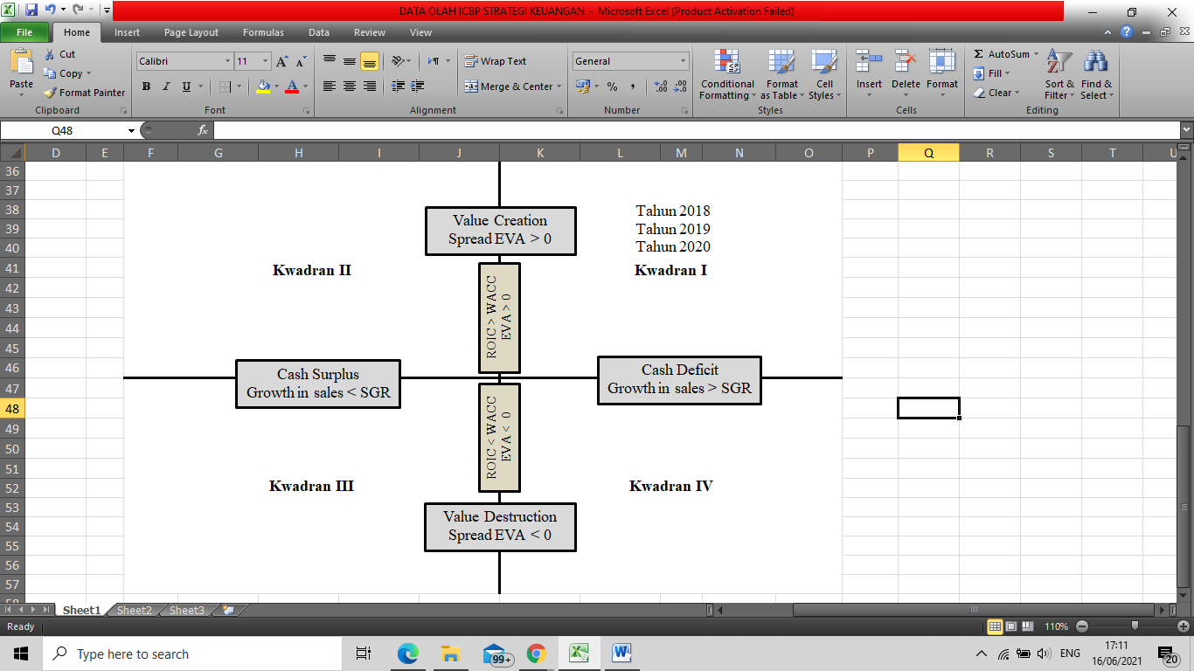

Tahun 2018

Tahun 2019

Tahun 2020

**Source: Processed data**

A good investment is to consider the company's financial statements (Rudiwantoro, 2018). Investors can see the side of cash flow, liabilities, and profits because these three things can be used as reasons for investment decisions. The cash flow side will show that the company has large assets, so that these assets can be optimized, and with the large number of assets, the company can distribute large dividends. This is the same as the amount of profit received by the company, if the company's profit is large, then the company can distribute quite large dividends. On the other hand, investors must also pay attention to the amount of debt the company has. After considering the financial statements, investors should look at technical analysis with the appropriate timeframe to achieve maximum profit.

Table 3 Variable Results from ICBP 2018-2020 shows GVM PT. Indofood Sukses Makmur CBP Tbk in 2018-2020 is in an excellent value manager condition. In 2018, the company had a growth of 0.009 and a current performance of 5.358. In 2019, the company had a growth of 0.007 and a current performance of 4.868. Meanwhile, in 2020 the company has a growth of 0.003 and a current performance of 1.892. In these conditions the capital market expects companies to exceed their limits and profitability and growth. This condition also illustrates that the company is in a good category for investment, so that shareholders have good growth and profit expectations from the company.

A strategy is needed so that the company can increase the positive value of MVA and especially the company is in the excellent value manager quadrant in GVM. One strategy that can be done is to innovate on products with the aim of increasing the value of sales, so that the profits obtained are large and if the company's profits are large, investors will get large dividends and the company can move stock prices to be stable. This situation can attract investors to invest in companies and the capital market is in a balanced area.

Figure 3 ICBP Growth Value Map (GVM) 2018-2020

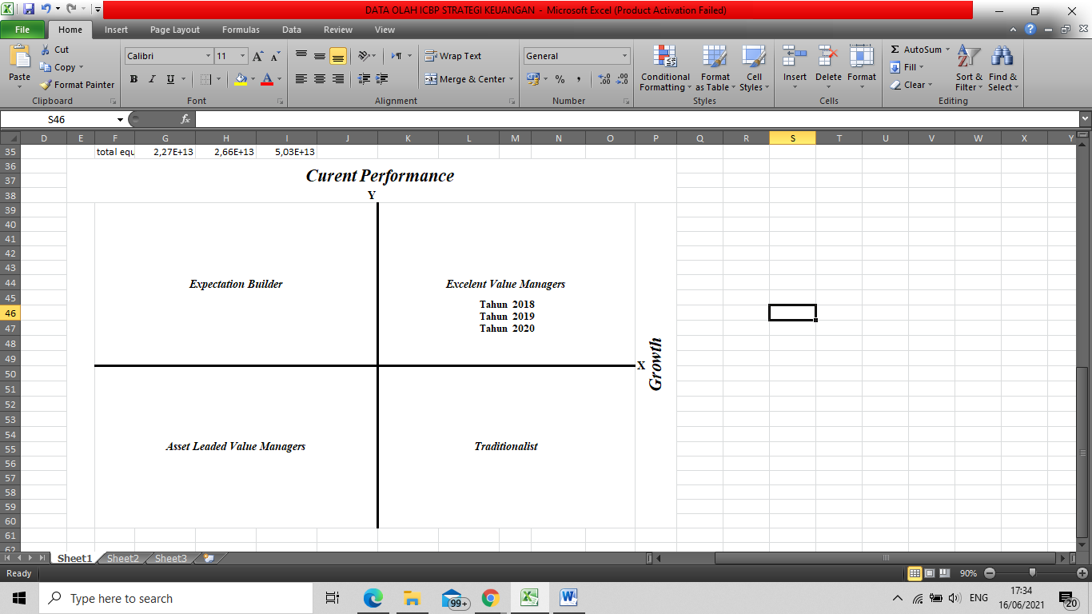

**Source: Processed data**

In increasing investor interest in the company, the company must have good financial reports and have stable stock price movements and large dividends (Samsul, 2015). At PT. Indofood Sukses Makmur CBP Tbk 2018-2019 had good financial reports and stable stock price movements, but in 2020 ICBP's stock price fell and this was detrimental to old investors. The company must take steps to return the stock price to its original level, so the steps that the company can take are analyzing risks and conducting market research and overcoming negative market sentiment. One of the right ways is for the company to see the people's purchasing power for their products and provide a positive stimulus to that purchasing power, so that the company can publish news that the company is still popular with the public with evidence that people still like to use the company's products. In addition, financial analysts can move or fry stock price movements to their fair prices.

**CONCLUSION**

PT. Indofood Sukses Makmur CBP Tbk 2018-2020 has good internal company performance. PT. Indofood Sukses Makmur CBP Tbk in 2018-2020 is in quadrant II in the Financial Strategy Matrix explaining that the company's condition has succeeded in increasing value added (value creation) but has excess funds because the company's actual growth is smaller than the actual growth. Steps that must be taken by PT. Indofood Sukses Makmur CBP Tbk in this condition is using the excess funds in order to grow more. PT. Indofood Sukses Makmur CBP Tbk 2018-2020 has a good external performance of the company. PT. Indofood Sukses Makmur CBP Tbk in 2018-2020 has a positive value on MVA and the company is in the excellent value manager quadrant in the GVM explaining that the company is in a good category if investors invest in the company. Steps that must be taken by PT. Indofood Sukses Makmur CBP Tbk in this condition is to increase investors' confidence in the company.

Companies need to form the right strategy so that company funds can be realized properly, so that companies have good operational and financial performance and investors can be more confident and loyal to the company. One of them is that companies can innovate product development, increase the number of outstanding shares, and issue securities to the public such as global bonds, as well as make acquisitions of similar companies. Meanwhile, investors need to have good money management and are sensitive to the company's performance so that investors can minimize the risks that will occur. Investors also need to look at several ratios such as ROA, ROE, and DER to decide on investments and investors must also pay attention to the technical aspects of the company and be sensitive to market sentiment.

**REFERENCES**

Abdullah, A. (2021). Strategi, Dampak dan Kinerja Karyawan di Masa Pandemi dan New Normal pada PT. INDOFOOD. *Fakultas Ekonomi Bisnis dan Ilmu Sosial Universitas Pelita Bangsa, Cikarang, Indonesia*, *4*.

Brewer, P. C., Chandra, G., & Hock, C. A. (1999). Economic value added (EVA): Its uses and limitations. *S.A.M Advanced Management Journal*, *64*(2), 4–11.

Gusaptono, R. H. (2010). FAKTOR-FAKTOR YANG MENDORONG PENCIPTAAN NILAI PERUSAHAAN DI BEI. *Bulletin Ekonomi*, *8*(2), 70–170.

Handoko, B. (2015). PENGARUH KUALITAS PRODUK DAN MEREK TERHADAP LOYALITAS PELANGGAN (STUDI KASUS PADA PT.INDOFOOD CBP SUKSES MAKMUR TBK) TANJUNG MORAWA. *Jurnal Ilmiah Manajemen dan Bisnis*, *15*.

Hanifah, H. S., Harahap, E. F., & Rosmayati, I. (2020). Analisis Makroekonomi Imbal Hasil Saham LQ45 Dalam Membentuk Fortopolio Investasi Pada Masa Pandemi Covid-19. *Jurnal Wacana Ekonomi Fakultas Ekonomi Universitas Garut*, *19 (03)*, 178–185.

Hermayanti, A., & Rahmawati, S. (2015). Pengaruh Budaya Kerja terhadap Komitmen Karyawan PT Indofood CBP Sukses Makmur Tbk Cabang Bandung Divisi Noodle. *Jurnal Manajemen dan Organisasi*, *6*.

Hestinoviana, V. (2013). THE INFLUENCE OF PROFITABILITY, SOLVABILITY, ASSET GROWTH, AND SALES GROWTH TOWARD FIRM VALUE (EMPIRICAL STUDY ON MINING COMPANIES WHICH LISTED ON INDONESIA STOCK EXCHANGE). *JURNAL ADMINISTRASI BISNIS BRAWIJAYA*, *4 (1)*.

Indofood CBP. (2020). *Public Expo 2020* [Question and Answer]. Question Public Expo 2020.

Jegers, M. (2003). The Sustainable Growth Rate of Non–profit Organisations: The Effect of Efficiency, Profitability and Capital Structure. *Financial Accountability & Management*, *19*(4), 309–314.

Jensen, P. A. (2010). The Facilities Management Value Map: A conceptual framework. *Emerald Group Publishing Limited*, *19*(3).

Kartikosari, Z., & Puspita, E. (2020). Prediksi Kebangkrutan dengan Z-Score. *Fakultas Ekonomi dan Bisnis UNP Kediri*, *4 (4)*(Seminar Nasional Manajemen, Ekonomi dan Akuntasi), 560–565.

Kevin, T. (2020). *PREDIKSI TREN HARGA SAHAM HARIAN MENGGUNAKAN ARTIFICIAL NEURAL NETWORK (Studi Kasus: PT Indofood CBP Sukses Makmur Tbk.)* [Skripsi]. Universitas Brawijaya Malang.

Mulya, S. A., Aziz, A., & Permadhy, Y. T. (2020). PEMBENTUKAN PORTOFOLIO OPTIMAL DENGAN MODEL MARKOWITZ SEBAGAI DASAR KEPUTUSAN INVESTASI. *PROSIDING BIEMA*, *1*(Business Management, Economic, and Accounting National Seminar), 1242–1256.

Mustika, N. S. (2021). ANALISIS CAPITAL ASSET PRICING MODEL (CAPM) DAN REWARD TO VARIABILITY RATIO (RVAR) SEBAGAI DASAR PENGAMBILAN KEPUTUSAN INVESTASI SAHAM (Studi pada Perusahaan yang Terdaftar dalam Indeks LQ45 Periode Agustus 2019-Januari 2020). *Jurnal Manajemen Keuangan*, *2 (1)*.

Peters, J. R., & Kramer, J. K. (2001). An Interindustry Analysis of Economic Value Added as a Proxy for Market Value Added. *Journal of Applied Finance*, *16*(5).

Ramdaniansyah, M. R. (2020). Pengaruh Likuiditas dan Solvabilitas terhadap Profitabilitas pada PT. Indofood CBP Sukses Makmur TBK. Yang terdaftar di Bursa Efek Indonesia. *Universitas Nusa Putra*, *2 (1)*(JURNAL AKTIVA : RISET AKUNTANSI DAN KEUANGAN), 1–7.

Riyanto, B. (2001). *Dasar-Dasar Pembelanjaan Perusahaan* (4 ed.). BPFE Yogyakarta.

Rudiwantoro, A. (2018). Langkah Penting Generasi Millennial Menuju Kebebasan Finansial Melalui Investasi. *BSI Karawang*, *V*(Jurnal Moneter), 44–51.

Samsul, M. (2015). *Pasar Modal dan Manajemen Portofolio*. Erlangga.

Saputro, A. W., & Purwanto, A. (2013). Pengaruh Hubungan Kinerja, Likuiditas dan Return Saham Terhadap Deviasi Actual Growth Rate Dari Sustainable Growth Rate Pada Perusahaan Manufaktur di Bursa Efek Indonesia. *Diponegoro Journal Of Accounting*, *2*(3).

Shen, T., Frank, & Murray Z. (2016). Investment and The Weighted Average Cost of Capital. *Journal of Financial Economics*, *119*(2), 300–315.

Sugiyono. (2018). *Metode Penelitian Kuantitatif, Kualitatif, dan Kombinasi (Mixed Methods)*. Alfabeta.

Thomas, M. Y. (2020). IPTEKS PENGHITUNGAN NILAI MARKET VALUE ADDED ATAS KEPUTUSAN INVESTASI. *Jurnal Ipteks Akuntansi bagi Masyarakat*, *4 (02)*, 44–48.

Wulandari, E. Y., & Maslichah. (2021). PENGGUNAAN MODEL SPRINGATE, OHLSON, ALTMAN Z-SCORE, DAN GROVER SCORE UNTUK MEMPREDIKSI FINANCIAL DISTRESS PADA MASA PANDEMI COVID 19 (Studi pada Perusahaan Manufaktur yang Terdaftar di Bursa Efek Indonesia). *E-JRA*, *10 (05)*, 90–103.

Zhu, J. L. (2017). Return to Invested Capital and the Performance of Mergers and Acquisitions. *Management Science*, *2*(3).