ANALYSIS OF REGIONAL EXPENDITURE IN THE GOVERNMENT OF DKI JAKARTA DIY, ACEH, PAPUA, WEST PAPUA FOR THE 2020 FINANCIAL YEAR
Dyah Mutiarin¹ Misran² Dicky Izmi Syahputra³
^{1,2,3}Department of Government Affairs and Administration, Jusuf Kalla School of Government, University of Muhammadiyah Yogyakarta, Yogyakarta, Indonesia
Email: misranalfarabi@gmail.com
Abstract
This study aims to find out the analysis of local government spending in DKI Jakarta Special Region of Yogyakarta, Banda Aceh City, Papua, West Papua for the 2020 Fiscal Year in managing the 2018-2020 regional budget. This research is descriptive. The results of the study show that the spending variance of the Regional Government Expenditures (DKI Jakarta, DIY, Banda Aceh City, Papua, and West Papua) in 2018-2020 is an average of 25.5% -27.7% included in the favorable category variance because the realization of expenditure does not exceed the set budget. Furthermore, from the Harmony Ratio, most regional expenditures are allocated for Operational Expenditures. The average operating expenditure in 2018-2020 is 33.35%, while capital expenditure is 40.16%. The average is taken from the percentage of the five regional governments, and the Regional Expenditure Efficiency Ratio shows that the realization of the expenditure budget never exceeds the budget. The average efficiency ratio is 2018-2020 is 80.88%. This shows that the five regional governments are pretty efficient in making savings or spending efficiency.
Keywords: Financial Performance; Regional Spending; Cost Management.
Article info
Article history:
Received 22 December 2019
Received in revised form 19 June 2020
Accepted 2 July 2020
Available online 27 July 2020

INTRODUCTION
The implementation of fiscal decentralization in Indonesia refers to Law No. 32 of 2004 concerning Regional Government and Law No. 33 of 2004 concerning Financial Balance between the center and the regions. The broad autonomy authority requires local governments to improve public services and welfare in a democratic, fair, equitable, and sustainable manner. Regions have obligations that must be fulfilled to the public. These obligations can be in building various public facilities and improving the quality of public services. To carry out these obligations, regional expenditures are required. Regional expenditures are related to regional obligations that can be valued in money.
The value of expenditures made by local governments for the benefit of the community is referred to as local government expenditures, namely expenditures for education and health care, police and military, salaries of government employees, and infrastructure development, all for the benefit of the community (Haryanto, 2013). Rostow and Musgrave established a model of government spending development that links the growth of government spending with stages of economic development, which are divided into early, intermediate, and advanced stages (Garrett & Mitchell, 2001). Since the government must provide infrastructure, such as education, health, and transportation infrastructure, the ratio of government investment to total investment is higher in the early phase of economic growth. In the middle phase of the economic development phase, government investment is still needed to encourage economic growth and let it take off. However, private investment is becoming more critical at this point (Haryanto, 2013). At the intermediate stage, government involvement remains significant because the growing role of the private sector results in many market failures, forcing the government to offer public goods and services in more significant quantities and of higher quality.
The revenue budget is an integral part in the preparation of the APBD, wherein the preparation of the revenue budget has an essential meaning for local governments in helping the smooth wheels of development and providing content and meaning to the responsibilities of local governments in particular to create effective planning and implementation. The preparation of a revenue budget is a plan that is compiled systematically, in which all government or agency activities are expressed in monetary units (value of money) for a certain period in the future.
Regional expenditure is a regional expenditure burden allocated fairly and equitably so that it can be relatively enjoyed by all community groups without discrimination, especially in the provision of public services. Zebua (2014) that regional expenditures allocated adequately to expenditure posts needed by the community will encourage positive growth to improve people's welfare. Regional expenditure analysis is conducted to evaluate whether the local government has used the Regional Revenue and Expenditure Budget (APBD) economically, efficiently, and effectively. Mahmudi's (2010:142) analysis of spending growth helps know spending from year to year. Local governments must be able to control regional spending, make spending efficient, and budget savings.
Several previous studies have examined local government spending. For example, Bachmid (2012), in his research on Analysis of Regional Expenditures in the Manado City Government, in his research saw that Manado City's Revenue and Expenditures had been carried out efficiently and effectively compared to 2007-2010 there was no significant increase or decrease in expenditure realization due to no programs or activities that affect the regional budget. Another research we can see is Kaine's research (2012), entitled Analysis of Variance and Regional Expenditure Growth in Bitung City Government. The aim is to determine the value of variance and growth of spending between 2009-2012.
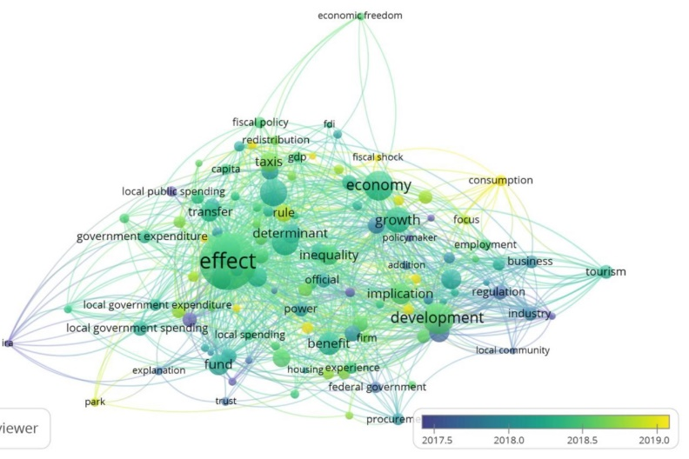
In the picture above, we can find studies that have been studied previously related to local government spending. For example, in 2017, researchers researched growth, regulation, and regional expenditure revenues. While in 2018, local government spending was studied a lot in terms of effects, taxes, implications, benefits, local government spending, and several others. In 2019, local government spending was widely seen in development, growth, economy, GDP, taxis, and fiscal shock. Entering the year 2020-2021, research on local government is still lacking. In this study, the researchers wanted to see local government spending in five areas of DKI Jakarta, Special Region of Yogyakarta, Aceh, Papua, West Papua. The five regions that adhere to the particular autonomy system
LITERATURE REVIEW
Regional Revenue and Expenditure Regional
Budget revenue and Expenditure Budget (APBD) is the regional government's annual financial plan discussed and approved jointly by the regional government and DPRD and stipulated by regional regulations (Regulation of the Minister of Home Affairs of the Republic of Indonesia Number 64 of 2021, 2021). The elements of the regional budget include 1) The activity plan of a region and its detailed description, 2) The existence of a source of revenue which is the minimum target to cover costs related to the activity and the existence of a cost which is the maximum limit of expenditure to be carried out, 3) Type of activity and projects that are stated in the form of numbers, 4) The budget period is usually one year (Halim (2012: 22) Minister of Home Affairs Regulation No: 13 of 2006 states that the APBD has an authorization function, a planning function, a supervisory function, an allocation function, a distribution function, and stability function
Regional Expenditure Regional
Expenditure is expenditure by the State General Treasurer or Regional General Treasurer, which reduces the budget balance in the relevant fiscal year, which the regional government will not repay (PP No. 71 of 2010). According to Local government expenditures, regional expenditure plays a role in meeting community demands with only the provision of facilities and infrastructure not fulfilled by the private sector (Goethe, Irdha Anisyah Marsudi Masinambow & Engka, 2014). The budget can be said to be the manager of government spending activities for the government and provides a way of obtaining revenue and financing. The Regional Revenue and Expenditure Budget consists of three main components, namely, elements of routine expenditure receipts and development expenditures (Harliza & Anitasari, 2017). Based on PP No. 71 of 2010, spending is classified into three (Suhaedi, 2019).
- Economic classification is a grouping of spending based on the type of spending to carry out an activity. Based on the economic classification, expenditure is divided into 4, namely: operating expenditure, capital expenditure, other/unexpected expenditure, and transfer expenditure.
- According to the organization in the regional government includes, among others, the expenditures of the DPRD Secretariat, the Regional Secretariat of the provincial or city or regency government, provincial or city or regency level government agencies, and provincial/city/district technical institutions.
- Classification by function is a classification based on the main functions of the central/regional government in providing services to the community. The classification of spending by function includes public service spending, defense spending, order, and security spending, economic spending, environmental protection spending, housing and settlement spending, health spending, tourism and culture spending, religious spending, education, and social protection. Furthermore, the Regional Revenue and Expenditure Budget consists of three main components, namely elements of revenue, routine expenditure, and development expenditure.
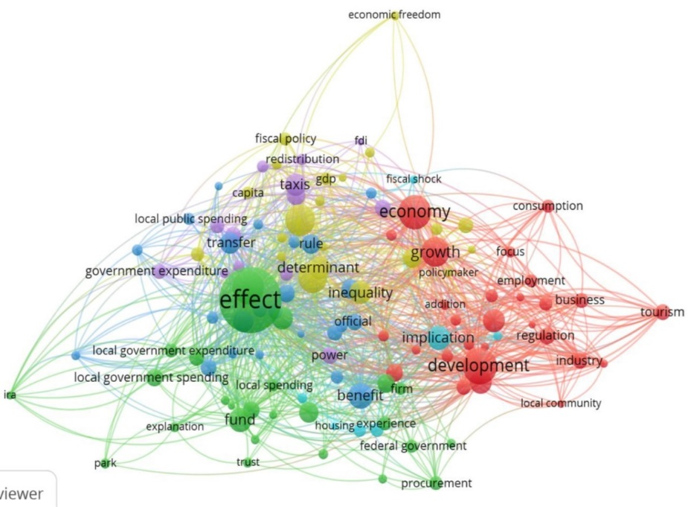
In the picture above, we can see and interpret regional spending. Regional spending sees a lot in terms of growth, economy, impact, policy development, and income, and there are several others that we can see in analyzing regional spending. More specifically, the study of local government spending we can see in the figure:
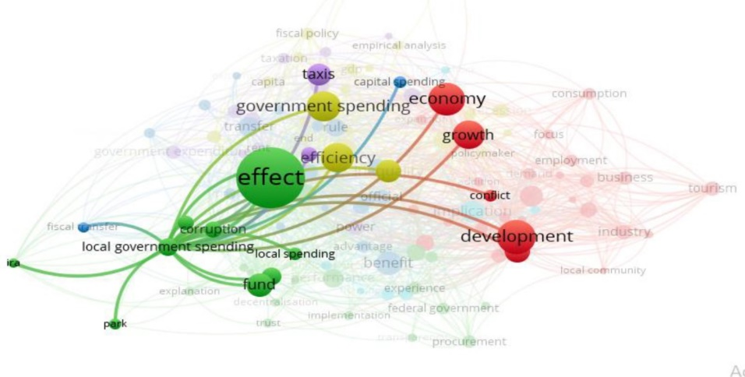
Special Allocation Fund (DAK)
The Special Allocation Fund (DAK) is a fund provided to regions to meet particular needs. According to the Ministry of Finance (2009), DAK is a type of transfer of balancing funds allocated to certain local governments to fund special activities that become national priorities and become regional affairs. Specific needs for DAK allocation include:
- The need for infrastructure and physical facilities in remote areas that do not have adequate access to other areas.
- The need for infrastructure and physical facilities in areas that accommodate transmigration. 3. The need for infrastructure and physical facilities is located in the islands' coastal areas and does not have adequate infrastructure and facilities.
- The need for infrastructure and physical facilities in the area to overcome the impact of environmental damage. 5. Construction of roads, hospitals, irrigation, and clean water.
General Allocation Fund (DAU)
The General Allocation Fund transfers funds from the central government to regional governments intended to close the fiscal gap and equal distribution of fiscal capacity between regions to help local governments carry out their functions and duties independently to serve the community. The DAU aims to equalize financial capacity between regions, which is intended to reduce inequality in financial capacity between regions by applying a formula that considers regional needs and potential. Each region receives an unequal amount of DAU because it must be allocated based on the fiscal gap and the basic allocation. DAU allocations for regions with sizeable fiscal potential but small fiscal needs will receive relatively small DAU allocations. On the other hand, regions with small fiscal potential but significant fiscal needs will receive relatively large DAU allocations. Implicitly, this principle emphasizes the function of the DAU as a factor for equitable distribution of fiscal capacity.
Original Regional Revenue (PAD)
PAD is one of the components of regional revenue/income and balancing funds and other legitimate regional revenues. Saragih (2003), in Bangun (2009), states that the increase in PAD must impact the regional economy. The increase in PAD shows an increase in public participation in the running of the government in their area. One of the local government's tasks is to improve the community's welfare, requiring PAD as a form of independence in the era of regional autonomy. The types of income classified as district/city PAD are local taxes, regional retributions, the results of separated regional wealth management, and other legitimate PAD. From the above provisions, it is clear that regional financial sources, apart from being given by the central government, are also sourced from the management and use of specific financial sources whose management and use are handed over to the regions called Regional Original Revenue (PAD). Thus, local governments are required to have the ability to obtain sources of income to finance their household affairs. Therefore, the existing PAD sources continue to increase their revenue to the maximum.
Regional Financial
Performance Government Financial Performance is the output or result of activities or programs that will be or have been achieved in connection with the use of regional budgets with measurable quantity and quality; regional capabilities can be measured by assessing the efficiency of services provided to the community (Hendro Sumarjo, 2010). As the party is given the task of running the government, development, and public services, the Regional Government is obliged to report financial accountability for the resources collected from the community as the basis for evaluating its financial performance. One of the tools to analyze the Financial Performance of Local Governments in managing their regional finances is to conduct a financial analysis of the APBD determined and implemented (Halim, 2007: 231).
METHOD
The This study is a descriptive study to provide an overview of the performance of government spending in DKI Jakarta, DIY, ACEH, Papua, West Papua in 2018-2020
Data Collection Technique
In this study, the authors collected data through searches on five local government websites. Here we can see the process of collecting data.
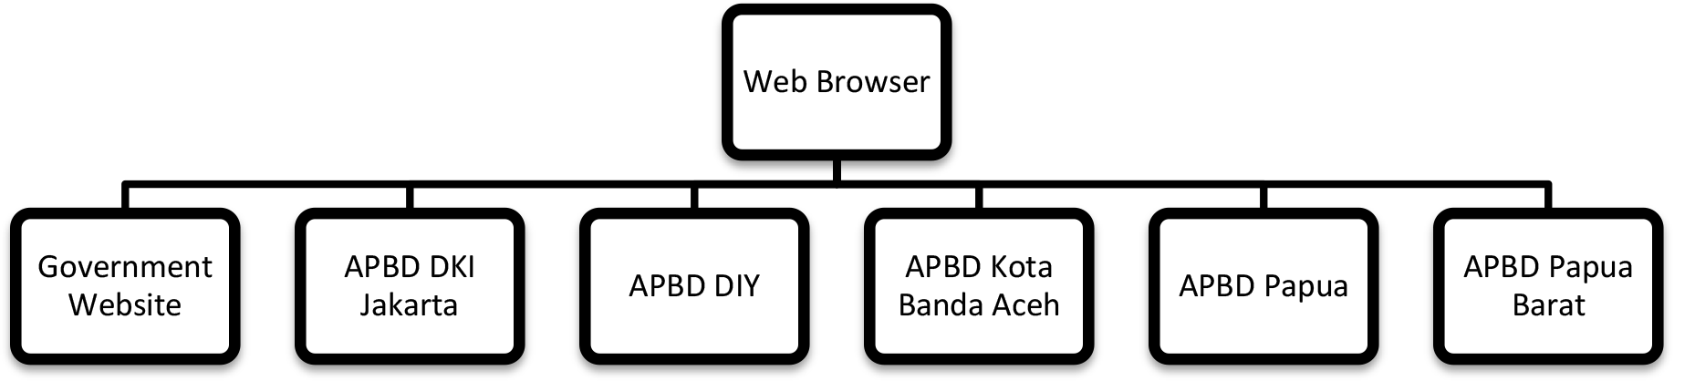
Data Analysis
Shopping Variants
Shopping Variant: Actual Expenditure Year t X 100%
Budget year t
The difference in the expenditure budget is categorized into two types, namely:
- The favorable variance if the actual expenditure is smaller than the budget.
- Unfavorable variance, if the realization of expenditure is greater than the budget
Harmony Ratio
In this Harmony Ratio, there is two Expenditure Analysis used to determine the Financial Performance of Local Governments, namely as follows:
Analysis of Operational Expenditure on Total
Operating Expenditure Ratio: Actual Operating Expenditure X100%
Total Regional Expenditure
Capital Analysis to Total
Capital Expenditure Ratio: Capital Expenditure Realization X100%
Total regional shopping
Efficiency
Efficiency Ratioratio: Realization of regional expenditure X100%
Budget
Criteria efficiency
Table 1: Criteria efficiency
Presentation Of Efficiency | Efficiency Criteria
100% And Above | Inefficient
90%-100% | Less Efficient
80%-90% | Fairly Efficient
60%80% | Efficient
Less Than 60% | Very Efficient
RESULTS AND DISCUSSION
Using the regional expenditure analysis formula below, the calculation process uses data from the Budget Realization Report (LRA) for the Government of DKI Jakarta, DIY, ACEH, Papua, West Papua for the 2015-2019 Fiscal Year. Before using the data in the LRA, make sure that the report has been audited to ensure that the examination of the government's financial statements has been carried out so that the use of the data becomes more reliable and trustworthy. The figures presented in the LRA are then entered according to the calculation formula that has been explained in the data analysis section.
Regional Expenditure Analysis
Analysis of Expenditure Variances
Analysis of regional expenditures using the regional expenditure variance formula shows the difference (variance) between the realization of expenditures and the budget of the Governments of DKI Jakarta, DIY, Banda Aceh City, Papua, West Papua for the 2018-2021 Fiscal Year. During 2018-2021 the balance was negative. This means that the actual expenditure is smaller than the budget that has been set. If the actual expenditure is smaller than the budget, it is called the favorable variance. The significant difference between the realization and the budget provides two possibilities. First, it can indicate an efficient use of the budget. Second, suppose the difference is significant enough. In that case, it indicates that there has been a weakness in budget planning so that the estimated expenditure becomes inaccurate or could occur because of programs or activities that are not implemented.
Table 2: Analysis of the Jakarta Government Expenditure Variance, DIY, Banda Aceh City, Papua, West Papua Fiscal Year 2018-2021.
Local Government | Year | Budget | Total Regional Spending
DKI Jakarta | 2018 | 16.995.195.576.641 | 5.139.658.977.161
DKI Jakarta | 2019 | 18.355.384.155.928 | 6.125.344.204.491
DKI Jakarta | 2020 | 18.041.247.738.352 | -2.585.559.158.620
DIY | 2018 | 1.185.735.851.757 | 361.362.143.394
DIY | 2019 | 1.147.122.557.501 | 304.894.501.899
DIY | 2020 | 1.090.561.434.298 | 364.533.302.752
Banda Aceh City | 2018 | 83.314.430.569 | 3.200.000.000
Banda Aceh City | 2019 | 154.032.332.684 | 22.200.000.000
Banda Aceh City | 2020 | 224.263.427.273 | 2.200.000.000
Papua | 2018 | 2.432.322.905.043 | 543.260.000.000
Papua | 2019 | 2.811.607.952.619 | -50.000.000.000
Papua | 2020 | 1.145.341.020.698 | 544.990.678.582
West Papua | 2018 | 1.680.227.984.566 | 629.648.580.572
West Papua | 2019 | 1.708.112.805.985 | 150.000.000.000
West Papua | 2020 | 2.184.125.505.565 | 250.979.883.999
Based on the analysis of capital expenditures on total expenditures, the average capital expenditure used by the DKI Jakarta Regional Government in -2018-2020 is 10.15%. The average expenditure budget is Rp. 5,33518227515. In contrast, the average total regional expenditure is Rp. 1.38505623E13, then the DIY regional government in 2018-2020 is 33.91%, the average budget is Rp. 3,423,419,843,556, while the average total regional expenditure is Rp. 3,423,419,843,556. Rp 1,030,789,948,045. Furthermore, the Banda Aceh regional government in 2018-2020 was 25.5%. The average expenditure budget was RP 459,773,105,976, while the average total regional expenditure was Rp 27,600,000,000. then the Papuan regional government in 2018-2020 was 25.5% the average expenditure budget was RP 6,389,271878,360 while the average total regional expenditure was Rp 1.13825068E14 and finally, the West Papua regional government in 2018-2020 was 27.7% on average -the average expenditure budget is RP 5,572,476,296,166 while the average total regional expenditure is Rp 1,030,625,464,571. This variant is categorized as a favorable variance because expenditure does not exceed the set budget. This means that the government can control and save spending not to exceed the predetermined budget. 10.15%. 33.91%25.5% 27.7%
Capital Expenditure Analysis on Total Expenditure
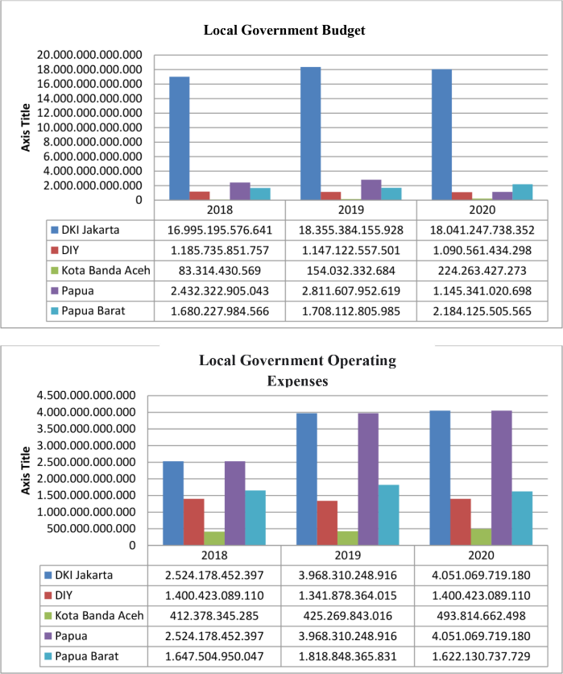
Figure 1. Government Expenditure Harmony of DKI Jakarta, DIY, Banda Aceh City, Papua, West Papua.
Based on the graph above, overall, from 2018-2020, the DKI Jakarta Government allocated an average of 25.95% used for operational expenditures and used for capital expenditures. For the allocation of operating expenses every year, there is a slight increase in terms of quantity. Furthermore, the DIY government as a whole from 2018-2020 allocated an average of 35.35% used for operational expenditures and 34.6% used for capital expenditures. For the allocation of operating expenditures every year, there is a slight increase in terms of amount but has decreased in percentage. In 2020, there was a decrease in operating expenditure followed by an increase in capital expenditure.
Furthermore, the Banda Aceh government as a whole from 2018-2020 allocated an average of 31.9% used for operational expenditures and 38.6% used for capital expenditures. For the allocation of operating expenses every year, there is a slight increase in terms of quantity. Then for the Papuan government as a whole from 2018-2020, an average of 32.5% was used for operational spending and 25.70% used for capital expenditure. For the allocation of operating expenses each year, there is a slight increase in terms of quantity. The latest for the West Papua government from 2018-2020 allocates an average of 34.5% used for operational expenditures and used for capital expenditures of 52.16%. For the allocation of operating expenditures every year, there is a slight increase in terms of amount but has decreased in percentage. In 2020, there was a decrease in operating expenditure followed by an increase in capital expenditure.
Efficiency Ratio
Ratio Expenditure efficiency ratio is a comparison between actual expenditure and budget. This spending efficiency ratio is used to measure the level of budget savings made by the government.
Table 2. Efficiency Ratio
Local Government | Year | Budget | Shopping Realization | Ratio Efficiency
DKI Jakarta | 2018 | 16.995.195.576.641 | 14.118.608.087.643 | 83,07 %
DKI Jakarta | 2019 | 18.355.384.155.928 | 11.551.927.779.590 | 62,93 %
DKI Jakarta | 2020 | 18.041.247.738.352 | 0 | 0,00 %
DIY | 2018 | 1.185.735.851.757 | 1.132.827.726.328 | 95,54 %
DIY | 2019 | 1.147.122.557.501 | 1.035.203.185.485 | 90,24 %
DIY | 2020 | 1.090.561.434.298 | 0 | 0,00 %
Banda Aceh City | 2018 | 83.314.430.569 | 100.757.750.369 | 120,94 %
Banda Aceh City | 2019 | 154.032.332.684 | 148.964.382.239 | 96,71 %
Banda Aceh City | 2020 | 224.263.427.273 | 0 | 0,00 %
Papua | 2018 | 2.432.322.905.043 | 1.918.505.428.472 | 78,88 %
Papua | 2019 | 2.811.607.952.619 | 2.236.551.423.151 | 79,55 %
Papua | 2020 | 1.145.341.020.698 | 0 | 0,00 %
West Papua | 2018 | 1.680.227.984.566 | 1.539.271.668.428 | 91,61 %
West Papua | 2019 | 1.708.112.805.985 | 1.757.983.373.816 | 102,92 %
West Papua | 2020 | 2.184.125.505.565 | 0 | 0,00 %
Overall, suppose you look at the average percentage of regional efficiency ratios from 2018 to 2019. In that case, the DKI Jakarta Regional Government is 83.07% and 62.93%, which means that the government's performance is considered quite efficient because the realization is that almost 100% of the budget expenditures amounted to Rp. 14,118,608,087,643 and 11,551,927,779,590 of the budget of 16,995,195,576,641 and 16,995,195,576,641. This means that the DKI Jakarta Government has not made savings. The smaller the value of this ratio means the more efficient it is. But not necessarily, in this case, the Regional Government has good performance because it could be that the Regional Government makes savings so that the realization of spending is less than optimal, or it could be because there is an unrealized budget. Regional governments can also make large budgets to realize expenditures do not reach the set budget.
Furthermore, the percentage of the regional efficiency ratio from 2018 to 2019, the DIY Regional Government is 95.54% and 90.24%, which means that the government's performance is considered less efficient in its spending because the realization is almost 100% of the budget where the realization of expenditure is Rp. 1,132 .827,726,328 and 1,035,203,184,485 of the budget of 1,185,735,851,757 and 1,147,122,557,501.
Then the percentage of the regional efficiency ratio from 2018 to 2019, the Banda Aceh Regional Government is 120.94% and 96.71%, which means that the government's performance is considered inefficient in its spending because the realization is almost 100% of the budget where the expenditure realization is Rp. 100,757,750,369 and 148,964,38239 of the budget of Rp. 83,314,430,569 and Rp. 154,032,332,684. Furthermore, the percentage of regional efficiency ratios from 2018 to 2019, the Papua Regional Government is 78.88% and 79.55%, which means that the government's performance is considered quite efficient in its spending because the realization is almost 100% of the budget where the realization of expenditure is Rp. 1,918,505,428,472 and 2,236,551,423,151 of the budget of Rp. 2,432,322,905,043 and 2,811,607,952,619
And the last is the percentage of the regional efficiency ratio from 2018 to 2019, the West Papua Regional Government is 91.61% and 102,92%, which means that the government's performance is considered inefficient in spending because the realization is almost 100% of the budget where the realization of expenditure is Rp. 1,539,271,668,428 and 1,757,983,373,816 of the budget of Rp. 1,680,227,984,566 and Rp. 1,708,112,805,985. For the percentage of efficiency ratios, the five local governments both have 0.00% of the efficiency ratio, which means the smaller the value of this ratio means the more efficient. But not necessarily, in this case, the Regional Government has good performance because it could be that the Regional Government makes savings so that the realization of spending is less than optimal, or it could be because there is an unrealized budget. Regional governments can also make large budgets to realize expenditures do not reach the set budget.
- CONCLUSION
Based on the results of the expenditure ratio analysis of the five regional governments (DKI Jakarta, DIY, Banda Aceh City, Papua, and West Papua) in 2018-2020, it can be concluded as follows:
- Analysis of the Expenditure Variance in Regional Governments (DKI Jakarta, DIY, City of Banda Aceh, Papua, and West Papua) in 2018-2020, an average of 25.5% -27.7% included in the category of favorable variance because the realization of spending did not exceed the set budget.
- From the Harmony Ratio, most regional expenditures are allocated for Operational Expenditures. The average operating expenditure in 2018-2020 is 33.35%, while capital expenditure is 40.16%. the average is taken from the percentage of the five local governments
- The Regional Expenditure Efficiency Ratio shows that the realization of the expenditure budget never exceeds the budget. The average efficiency ratio is 2018-2020 is 80.88%. This shows that from the five regional governments, it can be concluded that they are pretty efficient in making savings or spending efficiency
REFERENCES
Butkiewicz, J. L., & Yanikkaya, H. (2011). Institutions and the impact of government spending on growth. Journal of Applied Economics, 14(2), 319–341. https://doi.org/10.1016/S1514-0326(11)60017-2
Galí, J., López-Salido, J. D., & Vallés, J. (2007). Understanding the effects of government spending on consumption. Journal of the European Economic Association, 5(1), 227–270. https://doi.org/10.1162/JEEA.2007.5.1.227
Garrett, G., & Mitchell, D. (2001). Globalization, government spending, and taxation in the OECD. European Journal of Political Research, 39(2), 145–177. https://doi.org/10.1023/A:1011043120145
Gorahe, Irdha Anisyah Marsudi Masinambow, V., & Engka, D. (2014). Analisis Belanja Daerah dan Faktor-Faktor Yang Mempengaruhinya di Provinsi Sulawesi Utara. Jurnal Berkala Ilmiah Efisiensi, 14(3), 1–12.
Harliza, T., & Anitasari, M. (2017). Analisis Belanja Daerah Kabupaten/Kota Di Bengkulu. EKOMBIS REVIEW: Jurnal Ilmiah Ekonomi Dan Bisnis, 5(2), 133–140. https://doi.org/10.37676/ekombis.v5i2.382
Haryanto, T. P. (2013). Pengaruh Pengeluaran Pemerintah Terhadap Pertumbuhan Ekonomi Kabupaten/Kota Di Provinsi Jawa Tengah Tahun 2007-2011. Economics Development Analysis Journal, 2(3), 148–158. https://doi.org/10.15294/edaj.v2i3.1989
oeraturan menteri dalam negeri republik indonesia nomor 64 tahun 2021, (2021).
Sari, M., Syechhalad, M. N., & Majid, S. A. (2016). Pengaruh Investasi, Tenaga Kerja Dan Pengeluaran Pemerintah Terhadap Pertumbuhan Ekonomi Di Indonesia. Jurnal Ekonomi Dan Kebijakan Publik Indonesia, 3(2), 109–115.
Suhaedi, W. (2019). Analisis Belanja Daerah. Jurnal Riset Akuntansi Aksioma, 18(2), 63.
Butkiewicz, J. L., & Yanikkaya, H. (2011). Institutions and the impact of government spending on growth. Journal of Applied Economics, 14(2), 319–341. https://doi.org/10.1016/S1514-0326(11)60017-2
Galí, J., López-Salido, J. D., & Vallés, J. (2007). Understanding the effects of government spending on consumption. Journal of the European Economic Association, 5(1), 227–270. https://doi.org/10.1162/JEEA.2007.5.1.227
Garrett, G., & Mitchell, D. (2001). Globalization, government spending, and taxation in the OECD. European Journal of Political Research, 39(2), 145–177. https://doi.org/10.1023/A:1011043120145
Gorahe, Irdha Anisyah Marsudi Masinambow, V., & Engka, D. (2014). Analisis Belanja Daerah dan Faktor-Faktor Yang Mempengaruhinya di Provinsi Sulawesi Utara. Jurnal Berkala Ilmiah Efisiensi, 14(3), 1–12.
Harliza, T., & Anitasari, M. (2017). Analisis Belanja Daerah Kabupaten/Kota Di Bengkulu. EKOMBIS REVIEW: Jurnal Ilmiah Ekonomi Dan Bisnis, 5(2), 133–140. https://doi.org/10.37676/ekombis.v5i2.382
Haryanto, T. P. (2013). Pengaruh Pengeluaran Pemerintah Terhadap Pertumbuhan Ekonomi Kabupaten/Kota Di Provinsi Jawa Tengah Tahun 2007-2011. Economics Development Analysis Journal, 2(3), 148–158. https://doi.org/10.15294/edaj.v2i3.1989
oeraturan menteri dalam negeri republik indonesia nomor 64 tahun 2021, (2021).
Sari, M., Syechhalad, M. N., & Majid, S. A. (2016). Pengaruh Investasi, Tenaga Kerja Dan Pengeluaran Pemerintah Terhadap Pertumbuhan Ekonomi Di Indonesia. Jurnal Ekonomi Dan Kebijakan Publik Indonesia, 3(2), 109–115.
Suhaedi, W. (2019). Analisis Belanja Daerah. Jurnal Riset Akuntansi Aksioma, 18(2), 63.

