THE INFLUENCE OF JOB RESOURCEFULNESS ON JOB CRAFTING MEDIATED BY WORK ENGAGEMENT AT EMPLOYEES IN SHERATON HOTEL SURABAYA RESTAURANT
Ekawati Putri
University of Airlangga , Surabaya, Indonesia
Email: ekawatiputrinf@gmail.com
Abstract
This study aims to explain how the relationship between job resourcefulness towards individual crafting and collaborative crafting is mediated by work engagement. Respondents used in this study were employees of the Sheraton Surabaya Hotel & Towers restaurant, amount of 53 respondents. This research uses a quantitative method with a census sampling and uses Partial Least Square (PLS) analysis method. The test results show that job resourcefulness has a significant effect on work engagement. The effect of job resourcefulness on individual crafting and collaborative crafting has a significant effect. Then, the test results show that work engagement can mediate the relationship of job resourcefulness with individual crafting and collaborative crafting.

Keywords: Job Crafting, Individual Crafting, Collaborative Crafting, Job Resourcefulness, Work Engagement
Article info
Article history:
Received 22 December 2022
Received in revised form 19 December 2022
Accepted 2 July 2023
Available online 27 July 2023
DOI :
How to Cite: Putri, E (2023). The influence of job resourcefulness on job crafting mediated by work engagement at employees in Sheraton hotel Surabaya restaurant. Journal Ilmiah Manajemen dan Bisnis, x (x), xx-xx.

INTRODUCTION ← 11pt, bold, UPPERCASE
Chefs at restaurants use their creative abilities to make food and try their best in preparing food to meet customer needs. A hotel chef does not only work in preparing the main menu (main course). The chef also works on making appetizers (appetizers) and desserts (desserts). Chefs need to have the technical ability to make food with the same taste. In addition, creative ideas are needed to develop new menus. Chefs often spend their time experimenting in the kitchen (Wrzesniewski and Dutton, 2001). Chefs also use their own standards in trying to create appropriate food or drinks and sometimes chefs are also required to work as creatively as possible in creating new food innovations (Wrzesniewski and Dutton, 2001). Work engagement is important because it provides benefits for employees as well as the company. The benefits for employees are to increase organizational commitment, OCB and job satisfaction (Saks, 2006). In addition, the benefits of work engagement for companies are to increase productivity, customer satisfaction, work safety, customer loyalty and employee turnover rates (Harter et al, 2002). Schaufeli et al. (2002) define work engagement as behavior that shows a positive state related to work. Vigor, Dedication and Absorption are the main components of work engagement. Vigor is the level of employee enthusiasm and mental resilience at work, Dedication is the dedication and enthusiasm of employees at work, Absorption is employees who are fully concentrated at work (Bakker et al., 2012). According to the conservation of resources (COR) theory, employees who have jobs resourcefulness can affect work engagement because it has a tendency to be able to achieve work goals.
Sheraton Surabaya Hotel & Towers is a five-star international standard hotel on Jalan Embong Malang No. 25-31 Surabaya, East Java. Sheraton Surabaya Hotel & Towers itself has 4 restaurants. There four restaurants at Sheraton Surabaya Hotel & Tower are faced with job demands to have accuracy, creativity and quality in serving food and beverages. Not only providing services and products, quality can also be seen from the restaurant layout, communication and implementation standards that have been determined to meet customer needs (Rei and Ferdinand, 1985). Restaurant employees are also required to provide the best quality and taste of food because the quality and taste of food is considered important to produce the best possible food. Therefore, this study considers whether work engagement can mediate job resourcefulness and job crafting for restaurant employees at Sheraton Hotel Surabaya.
Job Resourcefulness
Employees who have high job resourcefulness tend to fulfill their work goals even though the resources they have are sometimes lacking and insufficient (Semedo, Coelho, & Ribeiro, 2016). Therefore, job resourcefulness at work is positioned as a situational trait, it is the individual ability of employees to be able to achieve individual or organizational targets which are influenced by personality and experience (Licata et al., 2003). In addition, job resourcefulness is very important in hospitality settings because frontline employees must be skilled in the art of personal interaction with clients (Karatepe and Douri, 2012). Licata et al., (2003) said that employees who have a lot of job resourcefulness can effectively cope with situations of limited resources and they are expected to find creative methods to satisfy customers.
Work Engagement
When employees are engaged or tied to their work, the employee will try to achieve success and feel enthusiastic and unmitigated in expending his energy for the success of his work (W. Schaufeli et al., 2002). Based on the theory and definition of work engagement, work engagement is concluded as a positive employee engagement with their work as indicated by vigor, dedication, and absorption, as well as being actively involved in work. Vigor is characterized by high work ethic and resilience in the face of difficulties at work. While dedication is characterized by the nature of involvement, enthusiasm, courage to face challenges, and pride. Then absorption is characterized by full concentration which causes employees to lose track of time so that they have difficulty separating from work.
Job Crafting
Job crafting in this study uses a change approach based on the initiative that employees have to make changes to job demands and their own job resources that are used to achieve and optimize their work goals. These changes involve small changes that can affect the achievement of work goals in the short term (Tims et al., 2012). This study uses job crafting suggested by Leana et al., (2009) namely individual crafting and collaborative crafting and by using the dimensions of job crafting to anticipate and problems that may occur, namely increasing structural job resources, increasing challenging job demands, increasing challenging jobs. demands and decreasing hindering job demands (Tims et al., 2012). Wrzesniewski & Dutton (2001) say job crafting is an individual activity carried out by employees to adapt their needs and circumstances to their work. In individual crafting, employees play an active role in changing the boundaries of their work (Carrie Leana et al., 2009). Orr (1996) and others such as (Brown & Duguid, 1991; Orlikowski, 1996) found that job crafting can also be a collaborative activity carried out by a group of employees, where employees jointly determine how to change jobs to meet a common goal. In collaborative crafting, employees work together to adjust task boundaries to achieve common work-related goals (Carrie Leana et al., 2009)

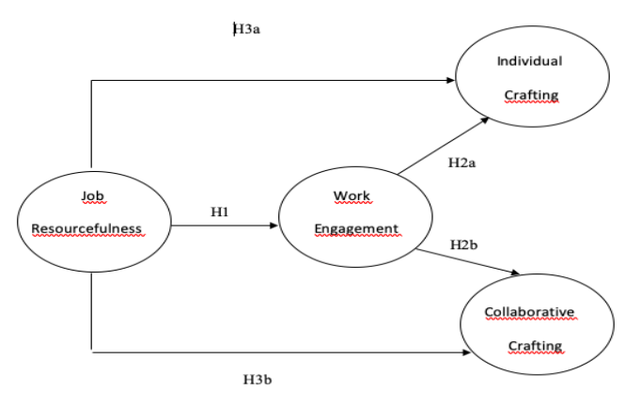

METHOD
This study uses a quantitative approach in testing hypotheses and generating conclusions. The approach that has been chosen is based on the research objective, namely, to determine the effect between the variables in this study. According to Techo, (2016) the purpose of research using a quantitative approach is to explain, predict or investigate relationships, describe current conditions, or examine the possible impact on the specified results.
Job resourcefulness is the ability of employees to overcome obstacles and collect scarce personal resources in carrying out work-related goals, this ability is usually used by employees of the Sheraton Surabaya Hotel & Towers restaurant to achieve individual or organizational targets. Measurement of Job Resourcefulness uses four indicators adapted from Licata et al., (2003). Each item measured will use a five-point Likert scale showing 1 = "strongly disagree" and 5 = "strongly agree" in taking the measurement.
Work engagement is a positive and satisfying individual state of mind, and is related to the full involvement of Sheraton Surabaya Hotel & Towers restaurant employees which is characterized by vigor, dedication, and absorption in the work carried out. Work engagement is measured using the Utrecht Work Engagement Scale (UWES).
Individual Crafting is an individual activity on a job that employees do to adapt their needs and circumstances to their work. In addition, the Sheraton Surabaya Hotel & Towers restaurant employees also play an active role in changing the boundaries of their work personally. Individual crafting measurements use measurements developed by Leana et al., (2009). Each item measured will use a five-point Likert scale showing 1 = "strongly disagree" and 5 = "strongly agree" in taking the measurement.
In collaborative crafting, Sheraton Surabaya Hotel & Towers restaurant employees work together to adjust task boundaries to achieve common work-related goals and determine with colleagues how to change work to meet goals. Measurement of collaborative crafting uses measurements developed by Leana et al., (2009). Each item measured will use a five-point Likert scale showing 1 = "strongly disagree" and 5 = "strongly agree" in taking the measurement.
Tabel 1
Indikator | Loading Factor
Job Resourcefulness
When I encounter obstacles, I quickly overcome them | 0,827
I have the ability to achieve targets while working | 0,891
I have many ideas when doing work | 0,844
I am skilled in overcoming obstacles to my work | 0,823
Work Engagement - Vigor
I feel excited at work | 0,803
I feel energized at work | 0,861
When I wake up in the morning, I want to go to work | 0,776
I can work long hours | 0,822
I feel very mentally strong at work | 0,783
I will always focus, even if something doesn't go well | 0,827
Work Engagement - Dedication
I feel challenged by the work | 0,809
I feel enthusiastic about the work | 0,885
I feel inspired by my work | 0,87
I am proud of the work I do | 0,882
I do work with meaning and purpose | 0,814
Work Engagement – Absorption
I forget things around me at work | 0,827
I feel time flies when I'm working | 0,849
I feel carried away when I'm working | 0,818
I find it hard to stay away from work | 0,819
I deepen the work I do | 0,891
I feel happy when I work intensely | 0,861
Individual Crafting
I have the freedom to choose new ideas at work | 0,881
I have the initiative in managing my work | 0,832
I have the opportunity to change my work process | 0,835
I have autonomy in managing my work | 0,809
Collaborative Crafting
Me and my co-workers have the freedom to choose new ideas at work. Me and my co-workers have the initiative when organizing work | 0,910
Me and my co-workers have the initiative when organizing work | 0,903
Me and my co-workers have the autonomy to manage work | 0,874
Me and my co-workers have the opportunity to change work processes | 0,846

The analysis is based on data obtained from research instruments, namely, from the results of questionnaires distributed and then processed by statistical methods. Statistical testing on the path analysis model was carried out using the Partial Least Square (PLS) method. PLS is part of Structural Equation Modeling (SEM). PLS-SEM can be used to analyze and explain whether or not there is a relationship between the variables to be used. PLS-SEM also has a focus on being able to explain the variance in the dependent variable when examining the model (Hair et al., 2017).
In this study, the steps taken in finding a hypothetical relationship between variables when using software from PLS-SEM were the outer model evaluation and the inner model evaluation. Outer model evaluation is a measurement related to the relationship between indicator variables and latent variables. The outer model evaluation will go through an evaluation of convergent validity, discriminant validity, and composite reliability. While the inner model evaluation is a measurement related to the ability to predict the relationship between constructs. The inner model evaluation will go through an evaluation of convergent validity, discriminant validity, and composite reliability.
RESULTS AND DISCUSSION
Outer Model TEST

The evaluation of the outer model aims to determine the validity and reliability of the measurement instrument in the research model. This is done to find out how well the questionnaire items measure the nature and concept of the variables being measured and to determine the consistency of the questionnaire items in measuring the same variables in different times and places. The analysis of the outer model can be seen from the values of converget validity, construct validity, discriminant validity, and composite reliability. The outer model is shown as follows.

The first outer model analysis is to look at the convergent validity. Convergent validity test in PLS can be done by looking at the value of each loading factor. The loading factor value describes the magnitude of the correlation between each measurement item (an indicator on the questionnaire) and the latent variable (the construct). An indicator item is said to have met convergent validity if the loading score on each path (path) between components (latent variables) and manifest variables should be > 0.5 (Ghozali, 2014).
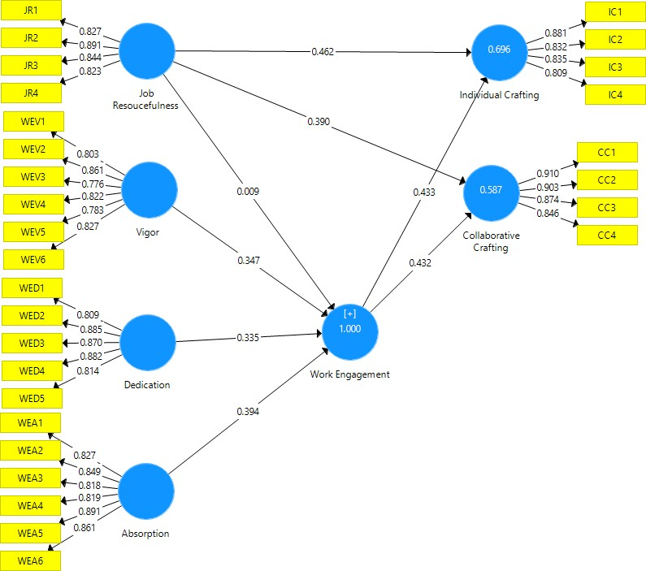
Construct Validity
Construct Validity is the validity that shows the extent to which a test is used to measure the construct of the theory that forms the basis for the preparation of the test. The construct is said to have good construct validity if the average variance extracted (AVE) value above is 0.5 (Ghozali, 2008). The results of the construct validity test obtained are as follows:
Average Variance Extracted (AVE)
Tabel 2
 | Average Variance Extracted (AVE) | Description
Job Resourcefulness | 0.717 | Valid
Vigor | 0.660 | Valid
Dedication | 0.727 | Valid
Absorption | 0.937 | Valid
Work Engagement | 0.594 | Valid
Individual Crafting | 0.705 | Valid
Collaborative Crafting | 0.781 | Valid

The results of data processing with an AVE value in each variable, where all variables show an AVE value greater than 0.5 which indicates that this study has good construct validity because it has met the requirements of good construct validity, which has an AVE value greater than 0.5
Discriminant Validity
Discriminant validity is a test conducted to see whether each indicator that composes a latent variable has a higher loading value than the indicators for other latent variables. In the discriminant validity test, the parameter used is to compare the roots of the AVE of a construct that must be higher than the correlation between the latent variables, or by looking at the value of cross loading (Jogiyanto,2016). Discriminant validity is a test conducted to see whether each indicator that composes a latent variable has a higher loading value than the indicators for other latent variables. In the discriminant validity test, the parameter used is to compare the roots of the AVE of a construct that must be higher than the correlation between the latent variables, or by looking at the value of cross loading (Jogiyanto,2016).

Cross Loading
Tabel 3
Indicator | Job Resourcefulness | Work Engagement | Individual Crafting | Collaborative Crafting | Description
JR 1 | 0,827 | 0,654 | 0,624 | 0,563 | Valid
JR 2 | 0,891 | 0,676 | 0,658 | 0,603 | Valid
JR 3 | 0,844 | 0,598 | 0,688 | 0,663 | Valid
JR 4 | 0,823 | 0,567 | 0,676 | 0,567 | Valid
WEV 1 | 0,47 | 0,829 | 0,54 | 0,495 | Valid
WEV 2 | 0,471 | 0,735 | 0,446 | 0,417 | Valid
WEV 3 | 0,625 | 0,632 | 0,585 | 0,55 | Valid
WEV 4 | 0,625 | 0,767 | 0,634 | 0,563 | Valid
WEV 5 | 0,532 | 0,702 | 0,502 | 0,452 | Valid
WEV 6 | 0,604 | 0,702 | 0,557 | 0,572 | Valid
WED 1 | 0,491 | 0,759 | 0,573 | 0,583 | Valid
WED 2 | 0,566 | 0,815 | 0,659 | 0,604 | Valid
WED 3 | 0,608 | 0,787 | 0,613 | 0,572 | Valid
WED 4 | 0,612 | 0,854 | 0,628 | 0,625 | Valid
WED 5 | 0,547 | 0,775 | 0,56 | 0,513 | Valid
WEA 1 | 0,492 | 0,78 | 0,565 | 0,515 | Valid
WEA 2 | 0,599 | 0,779 | 0,656 | 0,617 | Valid
WEA 3 | 0,578 | 0,709 | 0,616 | 0,53 | Valid
WEA 4 | 0,466 | 0,737 | 00.54 | 0,431 | Valid
WEA 5 | 0,72 | 0,896 | 0,747 | 0,718 | Valid
WEA 6 | 0,605 | 0,799 | 0,644 | 0,592 | Valid
IC 1 | 0,698 | 0,687 | 0,881 | 0,783 | Valid
IC 2 | 0,678 | 0,626 | 0,832 | 0,751 | Valid
IC 3 | 0,663 | 0,588 | 0,835 | 0,749 | Valid
IC 4 | 0,581 | 0,695 | 0,809 | 0,742 | Valid
CC 1 | 0,66 | 0,641 | 0,804 | 0,91 | Valid
CC 2 | 0,657 | 0,66 | 0,821 | 0,903 | Valid
CC 3 | 0,577 | 0,633 | 0,761 | 0,874 | Valid
CC 4 | 0,607 | 0,61 | 0,801 | 0,846 | Valid
Shows the correlation value of the job resourcefulness construct with its indicators higher than other constructs, this also applies to other variables, namely work engagement, individual crafting, and collaborative crafting so that it can be said to have good discriminant validity
Composite Reliability
The reliability test can be seen from the value of Cronbach's alpha and Composite reliability. A construct can be said to be reliable, if it has Cronbach's alpha value it must be > 0.6 and the Compositereliability value must be > 0.7 (Jogiyanto, 2016). Composite reliability measures the real reliability valueof a variable while Cronbach's alpha measures the lowest value (lower bound) of the reliability of a variable so that the Composite reliability value is always higher than Cronbach's alpha value (Jogiyanto,2016).

Composite Reliability & Cronbach’s Alpha
Tabel 4
 | Composite Reliability | Cronbach's Alpha | Description
Job Resourcefulness | 0,91 | 0,868 | Reliable
Vigor | 0,66 | 0,897 | Reliable
Dedication | 0,93 | 0,906 | Reliable
Absorption | 0,937 | 0,92 | Reliable
Work Engagement | 0,961 | 0,957 | Reliable
Individual Crafting | 0,905 | 0,86 | Reliable
Collaborative Crafting | 0,935 | 0,96 | Reliable
Testing of Hypothesis
The following is a path coefficient table to see the T-statistic value
 | Originsl  Sample | T Statistics  (IO/STDEVI) | Description
Job Resourcefulness ->Work Engagement (H1) | 9 | 1.775 | Significant
Work Engagement -> Individual Crafting  (H2a) | 433 | 4.367 | Significant
Work Engagement -> Collaborative Crafting  (H2b) | 432 | 2.956 | Significant
Job Resourcefulness -> Work Engagement -> Individual Crafting  (H3a) | 462 | 4.656 | Significant
Job Resourcefulness -> Work Engagement Collaborative Crafting  (H3b) | 390 | 2.794 | Significant
Source: data processing using PLS

CONCLUSION
The results of this study are in line with previous research conducted by Karetape and Aga (2012) which said that the importance of job resourcefulness in the workplace and the higher job resourcefulness of employees can basically increase work engagement which can have a significant positive effect on achieving work goals. In addition, employees with high job resourcefulness can basically be motivated to collect resources in their work environment and have a tendency to achieve work goals and motivate employees who also have job resourcefulness to collect alternative resources to achieve their work goals and basically to improve work. their engagement (Karatepe & Aga, 2012)
Employees who work in a social context or are highly dependent on the work of others may engage a lot in Collaborative Crafting and are less likely to engage in Individual Crafting (Carrie Leana et al., 2009). According to Times et al (2011) and Kanten (2014) also said that job crafting is a proactive work behavior perspective, in which employees try to adapt their work to be more in line with their needs and skills. Proactive work behavior can be seen from the existence of employee initiatives, such as the activeness and independence of employees in managing work even beyond the formal tasks that must be done. So this is in line with the characteristics of respondents who have an average age range of 26-30 years belonging to Generation Y with the characteristics of being very fond of change and liking feedback on their performance (Zopiatis et al., 2012). This is in line with the Sheraton Surabaya Hotel & Towers restaurant employees who like the feedback or input given by customers to improve performance in order to improve the quality of the restaurant.
The results of this study are in line with previous research conducted by Bakker et al., (2012) which provides research results that job crafting is very important in increasing work engagement and has a significant positive effect. Leana et al., (2009) strengthen the argument that Individual Crafting and Collaborative crafting behaviors play an active role in changing work boundaries and employees work together to adjust work in order to achieve the company's common goals and be able to increase sustainable work engagement. Bakker et al. (2012a) said that work engagement is related to job crafting. That is, employees with high job involvement are committed to their work (Arasli et al., 2017) and in turn will change the boundaries of their own work (i.e. through individual crafting) or modify the boundaries of work with their coworkers to achieve goals. work together (that is, through collaborative crafting).
Leana at al., (2009) suggested two job crafting behaviors, namely individual crafting and collaborative crafting. In collaborative crafting, employees work together to adjust work in order to achieve the company's common goals. For employees of the Sheraton Surabaya Hotel & Tower restaurant, the results of the description of the employee's answers indicate that the mean value of the collaborative crafting variable is higher than that of individual crafting. collaborative crafting has a mean value of Collaborative crafting which is done by the Sheraton Surabaya Hotel & Tower restaurant employees, the same as individual crafting behavior, but is done together with colleagues. With the mean value of collaborative crafting being higher than individual crafting, this indicates that Sheraton Surabaya Hotel Towers restaurant employees who have work engagement tend to be more involved in collaborative crafting behavior than individual crafting.
According to Times et al (2011) and Kanten (2014) also say that job crafting is a proactive work behavior perspective, in which employees try to adjust their work to be more in line with their needs and skills. Proactive work behavior can be seen from the existence of employee initiatives, such as the activeness and independence of employees in managing work even beyond the formal tasks that must be done. Employees who work alone or who are not affected by the help of their co-workers are less likely to engage in collaborative crafting. On the other hand, employees who work in a social context or are highly dependent on the work of others may engage a lot in collaborative crafting.
Work engagement is also an important antecedent that can influence employee work behavior (Garg & Dhar, 2017). Baker & Daniels (2013) say job crafting is an effort based on employee initiative in changing perceptions of work, job characteristics, and work relationships, in a way that is useful and in accordance with what employees want Wrzesniewski & Dutton (2001) say job crafting as individual activities undertaken by employees to adapt their needs and circumstances to their work. According to Chen et al., (2014) these job characteristics often require employees to meet customer expectations and independently provide services to customers.
Thus, Chen et al., (2014) said that work engagement showed a mediating effect on the job resourcefulness – individual crafting relationship rather than the job resourcefulness – collaborative crafting relationship. However, the results in this study, the mean value generated from individual crafting is 3.69 and a significant level is 1.815. This shows that the employees of the Sheraton Surabaya Hotel & Tower restaurant are involved in individual crafting which is the completion of work carried out on their own initiative in order to meet the expectations and targets to be achieved. Thus, employees are required to be able to independently provide services to customers and can play an active role in changing the boundaries of work in order to achieve company goals.
These job characteristics often require employees to meet customer expectations and independently provide services to customers. Based on the mean result of collaborative crafting of 3.71 with a significant level of 2.869, which shows a higher number when compared to individual crafting, this shows that this study shows the mediating role of work engagement - collaborative crafting is higher than work engagement - individual crafting. Thus the Sheraton Surabaya Hotel & Tower restaurant is more involved in collaborative crafting which is the completion of work done together with colleagues in order to meet the expectations and targets to be achieved.

REFERENCES
Bakker, A. B., Tims, M., & Derks, D. (2012). Proactive personality and job performance: The role of job crafting and work engagement. Human Relations, 65(10), 1359–1378. https://doi.org/10.1177/0018726712453471
Barnes, D. C., & Collier, J. E. (2013). Investigating work engagement in the service environment. Journal of Services Marketing, 27(6), 485–499. https://doi.org/10.1108/JSM-01-2012-0021
Berg, J. M., & Dutton, J. E. (2007). What is Job Crafting and Why Does It Matter?
Associate Professor of Organizational Behavior-Yale School of Management
Carrie Leana, Eileen Appelbaum, & Iryna Shevchuk. (2009). Work process and quality of care in early childhood education: The role of job crafting. Academy of Management Journal, 52(6), 1169–1192. Retrieved from http://web.b.ebscohost.com/ehost/pdfviewer/pdfviewer?sid=de7848cd-d070- 471f-998d-f6fb4eba229c%40sessionmgr102&vid=1&hid=128
Chen, C. Y., Yen, C. H., & Tsai, F. C. (2014). Job crafting and job engagement: The mediating role of person-job fit. International Journal of Hospitality Management, 37, 21–28. https://doi.org/10.1016/j.ijhm.2013.10.006
Chen, C. Y. (2019). Does work engagement mediate the influence of job resourcefulness on job crafting?: An examination of frontline hotel employees. International Journal of Contemporary Hospitality Management, 31(4), 1684– 1701. https://doi.org/10.1108/IJCHM-05-2018-0365
Cheng, J. C., & O-Yang, Y. (2018). Hotel employee job crafting, burnout, and satisfaction: The moderating role of perceived organizational support. International Journal of Hospitality Management, 72(February), 78–85. https://doi.org/10.1016/j.ijhm.2018.01.005
Ghozali, Imam. 2014. Structural Equation Modeling, Metode Alternatif dengan Partial Least Square (PLS). Edisi 4. Semarang : Badan Penerbit Universitas Diponegoro.
Jogiyanto, H. M. 2011. Konsep dan Aplikasi Structural Equation Modeling Berbasis Varian Dalam Penelitian. Yogyakarta: UPP STIM YKPN.
Karatepe, O. M., & Aga, M. (2012). Work Engagement as a Mediator of the Effects of Personality Traits on Job Outcomes: A Study of Frontline Employees. Services Marketing Quarterly, 33(4), 343–362. https://doi.org/10.1080/15332969.2012.715053
Yulianti, P., & Widyaswendra, K. A. (2019). Building organizational citizenship behavior through procedural justice, trust, and work engagement. Bussecon Review of Social Sciences (2687-2285), 1(2), 10–17. https://doi.org/10.36096/brss.v1i2.129
Tims, M., Bakker, A. B., & Derks, D. (2012). Development and validation of the job crafting scale. Journal of Vocational Behavior, 80(1), 173–186. https://doi.org/10.1016/j.jvb.2011.05.009Carrie Leana, Eileen Appelbaum, & Iryna Shevchuk. (2009). Work process and quality of care in early childhood education: The role of job crafting. Academy of Management Journal, 52(6), 1169–1192. Retrieved from http://web.b.ebscohost.com/ehost/pdfviewer/pdfviewer?sid=de7848cd-d070- 471f- 98d-f6fb4eba229c%40sessionmgr102&vid=1&hid=128
Wrzesniewski, A., & Dutton, J. E. (2001). Crafting a Job: Revisioning Employees as Active Crafters of Their Work. The Academy of Management Review, 26(2), 179. https://doi.org/10.230

