ATTACHMENT
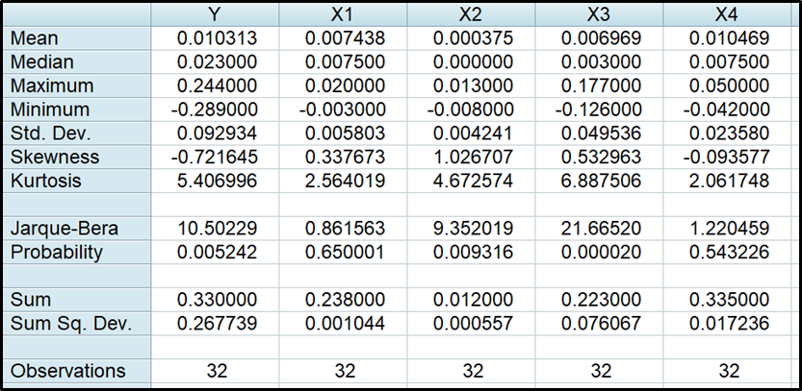
Source: Research output using EViews (2025)
Figure 3
Eviews Descriptive Statistics Output

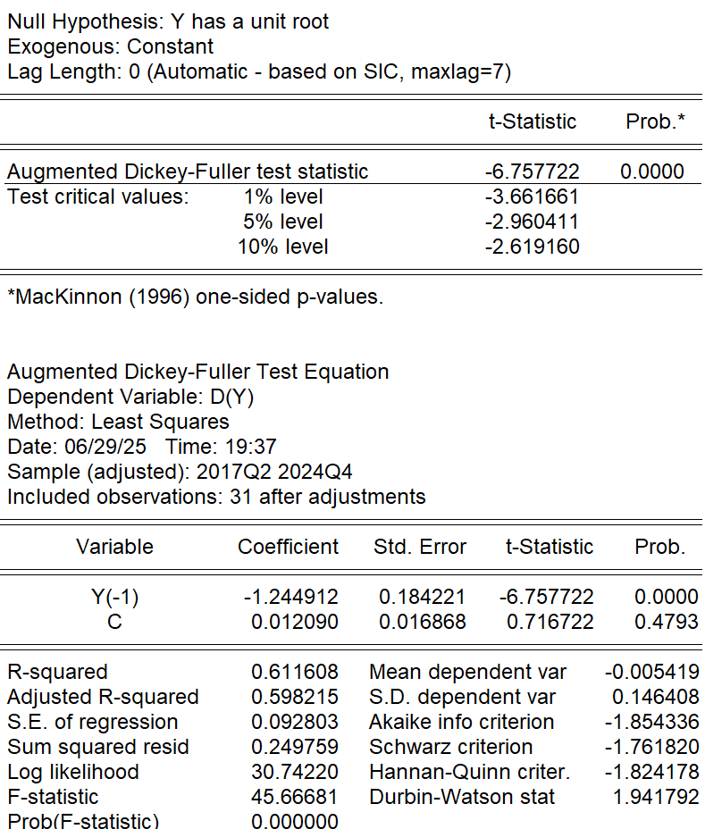
Source: Research output using EViews (2025)
Figure 4
ADF Unit Root Test Output on Variabel Y

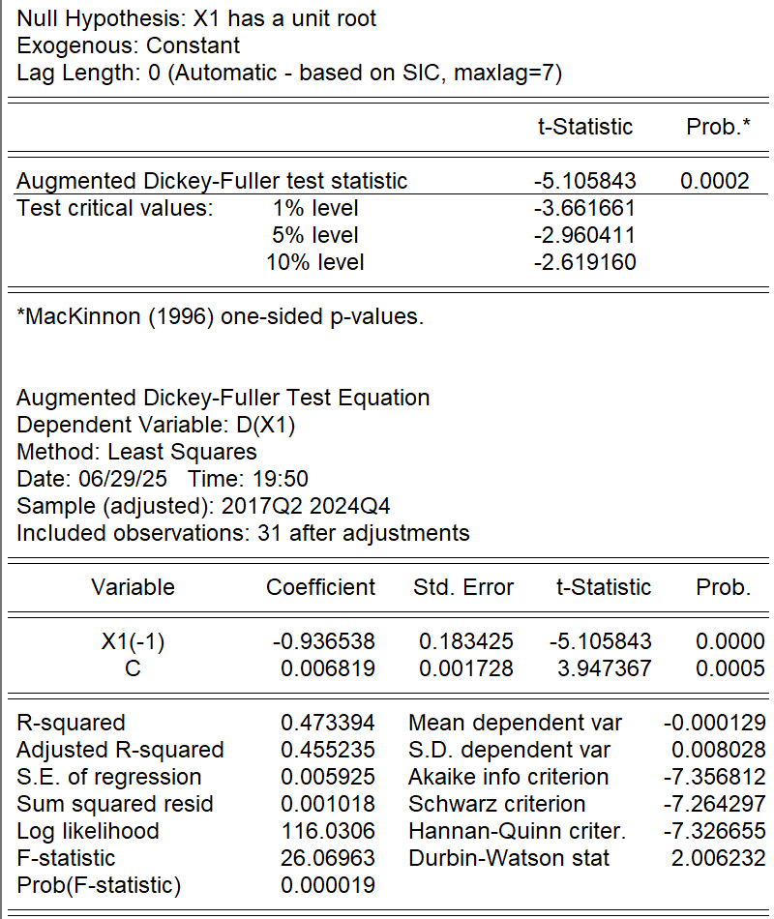
Source: Research output using EViews (2025)
Figure 5
ADF Unit Root Test Output on Variabel X1

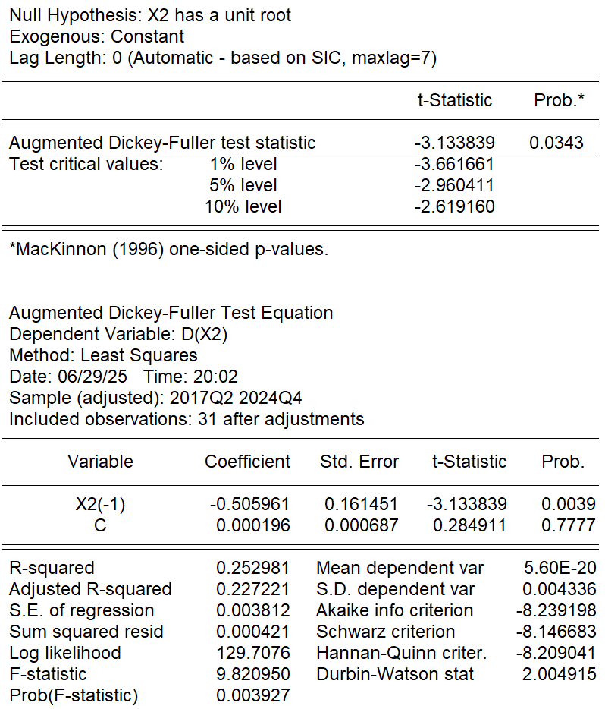
Source: Research output using EViews (2025)
Figure 6
ADF Unit Root Test Output on Variabel X2
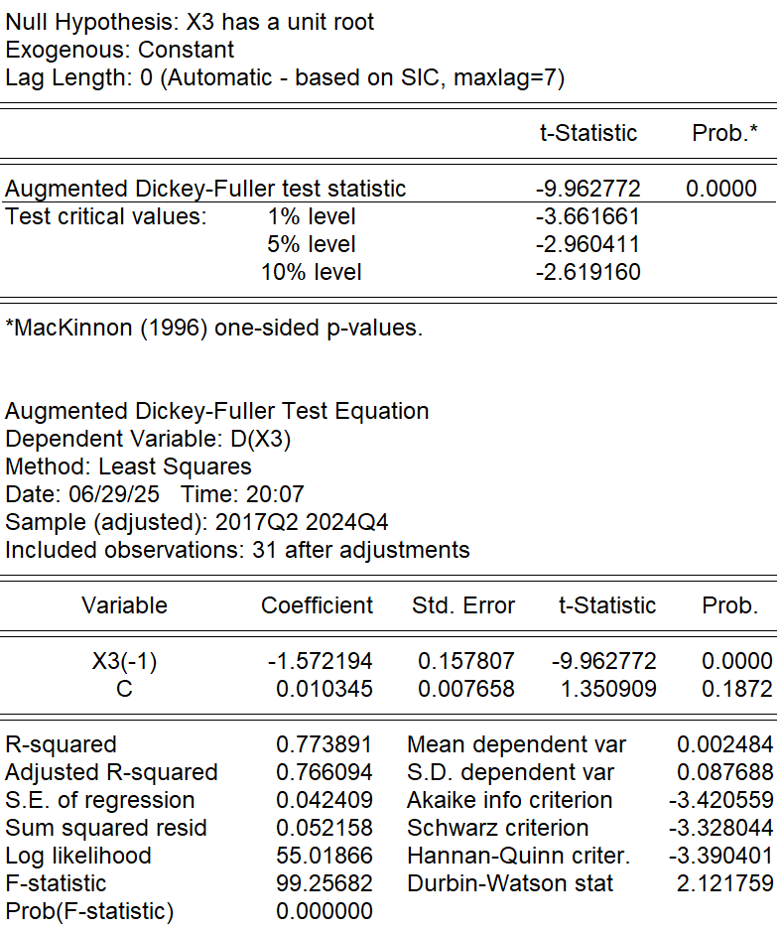
Source: Research output using EViews (2025)
Figure 7
ADF Unit Root Test Output on Variabel X3

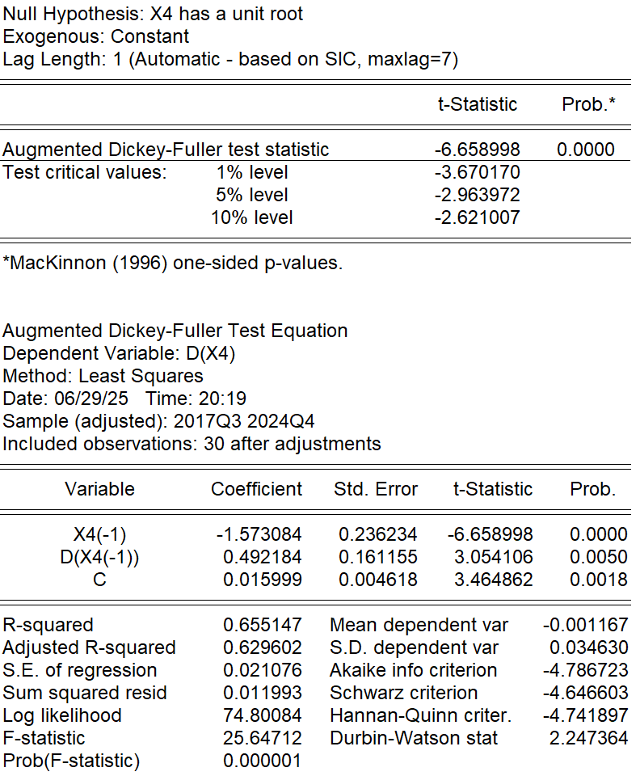
Source: Research output using EViews (2025)
Figure 8
ADF Unit Root Test Output on Variable X4
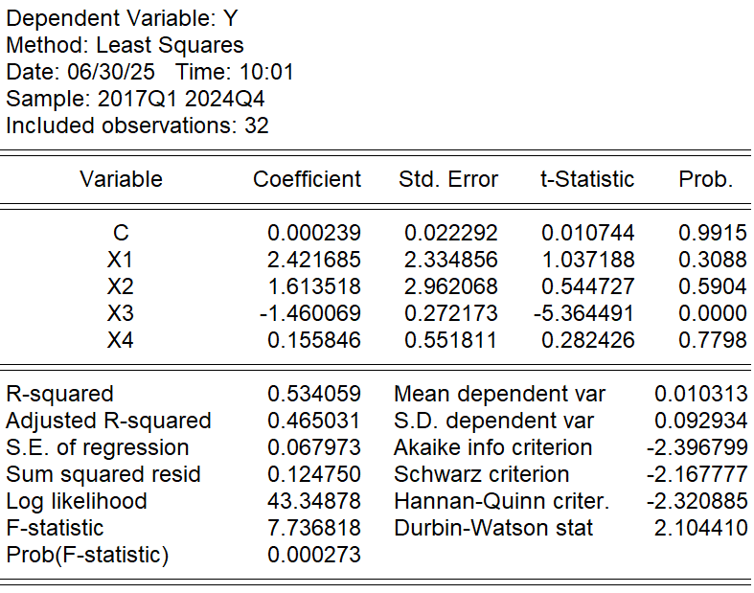
Source: Research output using EViews (2025)
Figure 9
Multiple Linear Regression Estimation Analysis Output

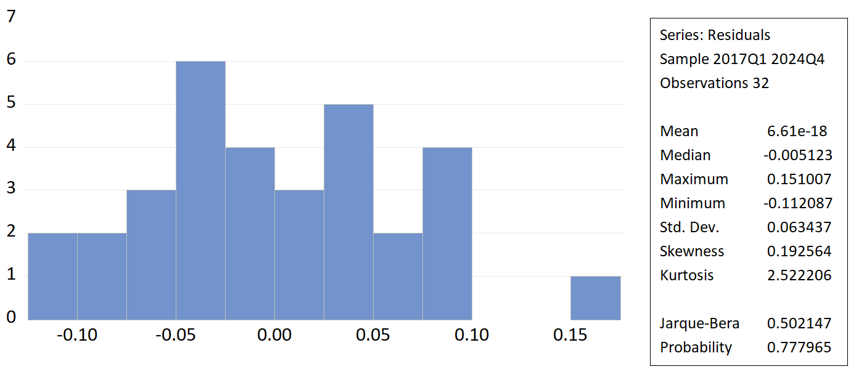
Source: Research output using EViews (2025)
Figure 10
Output of Normality Test, Jarque-Bera Test

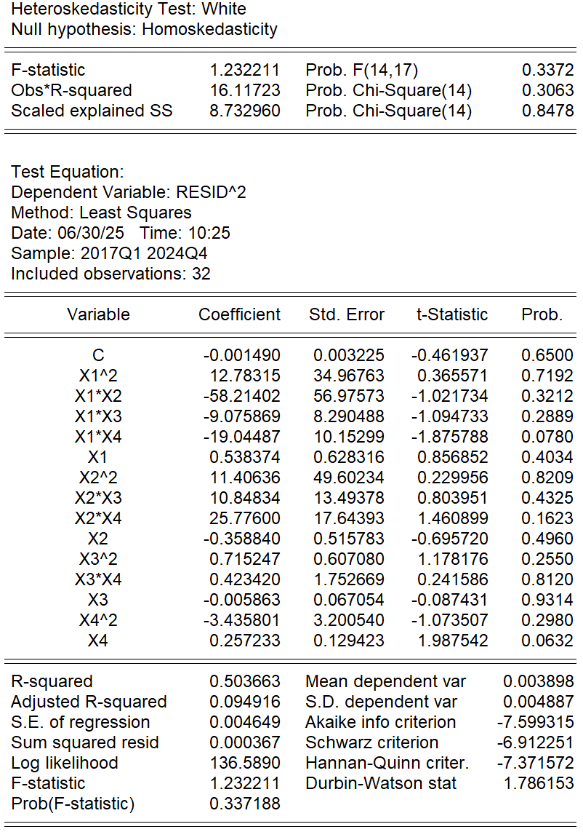
Source: Research output using EViews (2025)
Figure 11
Heteroscedasticity Test Output, White Test

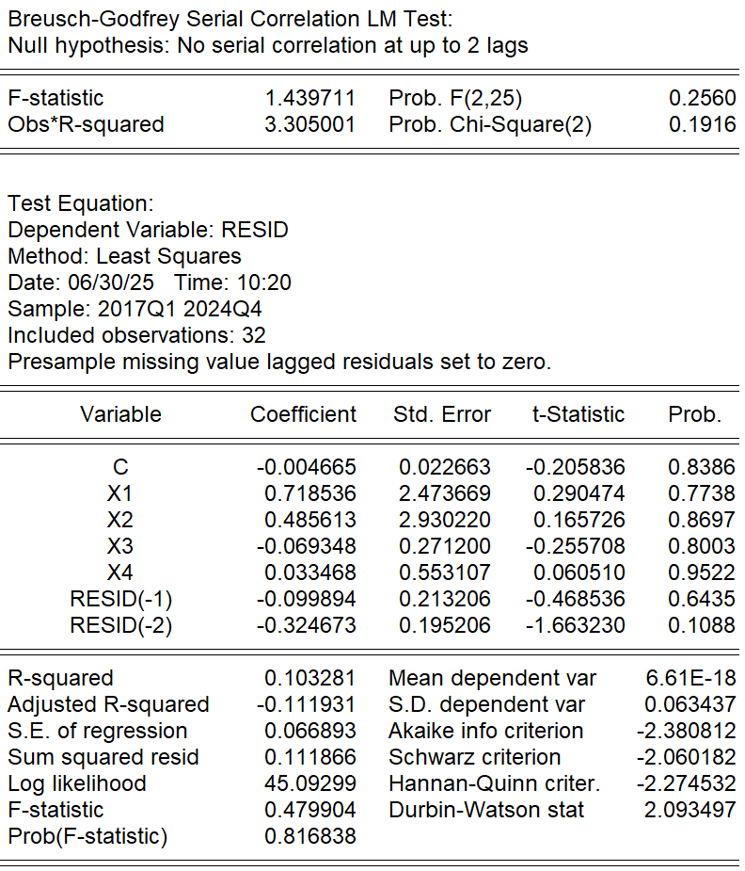
Source: Research output using EViews (2025)
Figure 12
Autocorrelation Test Output, Breusch-Godfrey Test

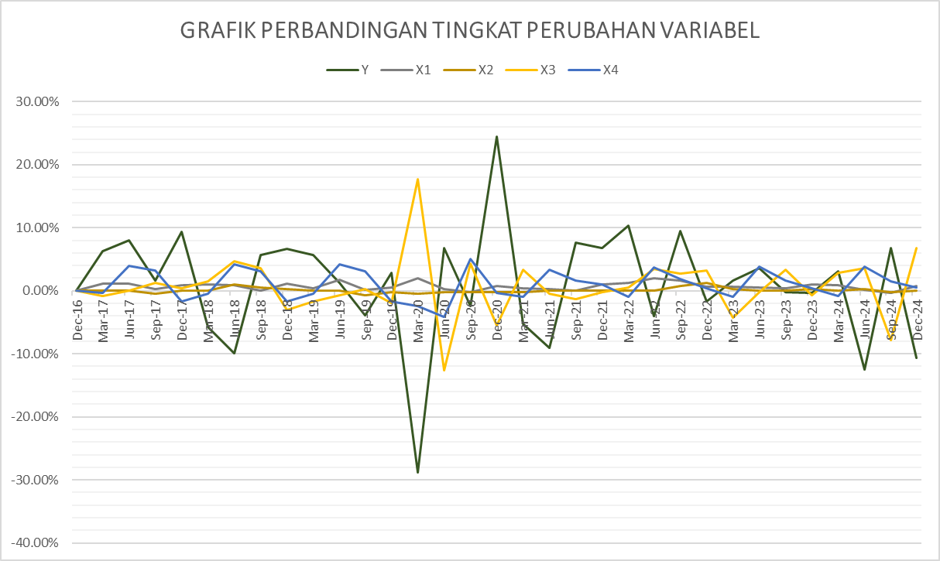
Source: Research output using EViews (2025)
Figure 13
Comparison Chart of Variable Y and Variable X

