RISKS IDENTIFICATION IN CONSTRUCTION OF JETTY PROJECTS: LITERATURE REVIEW

Kiki Patricia Dewi¹, Jatmiko Kurniawan², Herman Irawan³, Humiras Hardi Purba⁴

¹Departemen Teknik Sipil, Universitas Mercubuana Jakarta, Indonesia
²Departemen Teknik Sipil, Universitas Mercubuana, Jakarta, Indonesia
³Departemen Teknik Sipil, Universitas Mercubuana, Jakarta, Indonesia
⁴Departemen Teknik Industri, Universitas Mercubuana, Jakarta,Indonesia

¹Email: kiki.patricia.dewi@gmail.com
²Email: jatmiko.kurniawan72@gmail.com

Abstract
Delays in project development often occur due to various risk factors that have not been identified during project implementation, resulting in increased project delays and unexpected costs. However, each construction project has different risks depending on the type of project and project environmental conditions, so it requires handling different project implementation methods.
In a jetty project, risk assessment is carried out from both technical and non-technical perspectives. From a technical point of view, risks are assessed starting from soil conditions, water level, weather, installation methods, design changes, etc. Meanwhile, from a non-technical perspective, the risks arising from the environment, social and social aspects are assessed. economic, legal, and institutional aspects as well as finance and investment.
This summary literature review shows that Technical Risk has the greatest impact on jetty projects in the internal and external project category.
Keywords: Jetty, risk management, construction, technical, non technical, risk, dredging
Abstrak
Keterlambatan dalam proyek sering terjadi karena berbagai faktor risiko yang belum teridentifikasi selama pelaksanaan proyek, yang mengakibatkan meningkatnya keterlambatan proyek dan biaya yang tidak terduga. Namun, setiap proyek konstruksi memiliki risiko yang berbeda-beda tergantung dari jenis proyek dan kondisi lingkungan proyek, sehingga memerlukan penanganan metode pelaksanaan proyek yang berbeda.
Dalam proyek dermaga, penilaian risiko dilakukan baik dari perspektif teknis maupun non teknis. Dari segi teknis, risiko dinilai mulai dari kondisi tanah, ketinggian air, cuaca, metode pemasangan, perubahan desain, dan lainnya.
Sedangkan dari segi non teknis dinilai risiko yang timbul dari aspek lingkungan, dan sosial, aspek ekonomi, hukum, dan kelembagaan serta keuangan dan investasi.
Ringkasan tinjauan pustaka ini menunjukkan bahwa risiko teknis memiliki dampak terbesar pada proyek dermaga dalam kategori proyek internal dan eksternal.
Kata kunci: Dermaga,manajemen risiko, konstruksi, teknis, non teknis, risiko,pengerukan

- INTRODUCTION
The word Risk is often assumed to imply a negative outcome and it is commonplace that risk is uncertain. Risks may have positive or negative results. Negative risk is defined as a threat while positive risk is defined as opportunity (Cretu et al., 2011). In construction projects, hazard matrices are very sensitive as well as risk-averse. This sensitivity is due to several characteristics inherent to construction projects (Bunni, 2003). Risk is a combination of the probability or frequency of hazards that occur and the magnitude of the consequences of that event. Risk assessment is an integrated analysis of the likelihood of events occurring and their effects in general as well as in significant respects. The probability, extent, and significance of an event can be assessed either from previous experience or from calculations using probability theory (Bunni, 2003). Risk management is an ongoing process and should cover all phases of the project as the project is divided into separate phases. Construction projects are dynamic so a risk assessment is required at the end of the project phase before activities continue into the next phase (Smith et al., 2006)

- METHOD
The journal is compiled by conducting a search looking for other journals on trusted source sites and then selecting journals based on "risk assessment", "risk analysis", "risk identification" in the construction of jetty projects. The risks reviewed are technical and non-technical risks from external, internal or project. The following is the research framework in this paper:
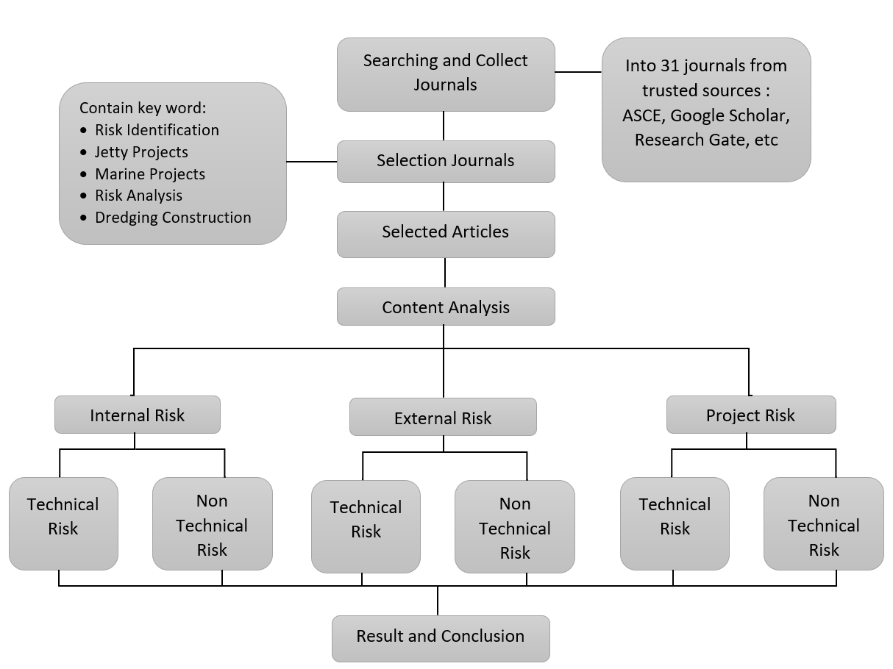
Figure 1. Research Framework
- RESULT & DISCUSSION
Research has found that contractors show more willingness to accept contract and legal risks than any other type of risk (Kartam &Kartam, 2000).
This literature review aims to identify risks during the construction of jetty projects that are the object of research and group those risks into specific categories, determine the level of risk from identified risks and determine the risk response to high-risk risks.
The benefits of this review are beneficial for businesses in the construction industry, especially for contractors who do similar work with the object of this research, namely knowing in advance what risks have a high level of risk on the jettys, by knowing therisks. In addition, this analysis is also useful for researchers who are interested in risk analysis so that it can be used as a reference in terms of risk identification to develop further research, especially in similar fields.
In this study, a risk assessment was conducted which was divided into 3 (three) categories in accordance with (Petr Rehacek, 2017), namely: (a) Internal risk; Internal risks may be divided by parties that may be the originator's risk events such as stakeholders, designers,contractors, and others. Internalrisk in project construction such as resource risk, project member risk, stakeholder risk, designer risk, contractor risk, subcontractor risk, supplier risk, team risk, construction site risk and document and information risk, (b) External risk; External risks are risks beyond the control of the project management team such as political risks, economic risks, social risks, and weather risks, (c) Project risks; Construction criteria of project risk are time risk, cost risk, work quality, construction risk, and technology risk.
The above three categories are divided into 2 (two) categories including (a) Technical risk; Technical risk assessment relates to assessing the probability that the system embodied in design when built meets technical/performance requirements, and if there is an expected performance deficiency, how serious the impact is (Klein &Cork, 1998) (b) Non-technical risks; Non-technical risk (NTR) is a risk that can directly affect a particular project, the cause of which is an unplanned and unexpected event resulting in an undesirable deviation from the original project delivery site carried out by an external (non-contractor) stakeholder. a clear relationship between risk and external stakeholders distinguishes NTR from technical risks in the context of the project. In other words, NTR (also known as above-ground risk) usually comes from external stakeholders/environments (Ite, 2016). In this article, non-technical risks related to financial risk, operational institutions, land acquisition, risk from stakeholders or governments, political risks, law, partnerships, socioeconomic, weather risk, etc.(Ite, 2016)
- Internal Technical Risks
The results of research on Safety at the Pier Project show the most dominant risk priority in girder bridge construction is the girder falling off during mobilization, and daydreaming is the most dominant cause. 4 (four) factors have been identified as sources that cause accident risk which are personal factors, managerial factors, technical and related tool factors and environmental factors. (Aulady et al., 2018)
- Internal Non-Technical Risks
There are risk factors that are at a very high level, namely the understanding of contract documents, different location conditions, equipment productivity, material quality, cash flow, sub-contractor competence, and weather effects (Nugroho, 2019)
- External Technical Risks
The highest risks are aspects of environmental change, design incomprehension, aspects of workers' inadestruction, aspects of environmental change, aspects of employment, technical aspects of employment, aspects of price increases and mobilization of equipment, aspects of negligence and work accidents (Tangdiembong et al., 2013)
- External Non-Technical Risks
Risk management is important and useful for marine projects. Six categories of risk factors include: i) acts of god;ii) physical; iii) financial and economic; iv) politics and the environment; v) design and vi) related construction (Tam &Shen, 2012)
- Project Technical Risks
Risk analysis on a high scale, namely: a. There was a machine failure. b. Delay in procurement of materials and equipment. c. Incompatibility of implementation results with specifications. Risk analysis above that on a medium scale, namely: a. The influence of erratic weather factors. b. Shop drawing work and design work are not detailed. (Anwar &Adi, 2015)
- Project Non-Technical Risks
Designing low-cost port construction to achieve acceptable results. Work with local agencies and ship operators to combine worldwide technical knowledge with local practices and customs. Reducing risk in local communities is associated with strengthening the knowledge, skills and motivation of people in vulnerable communities and supporting their initiatives to create safe conditions and practices (Connor et al., 2011).
The list of journals of options conducted by review and analysis of the risk identification aspects in the jetty project is shown in Table 1 below:

Table 1. Risk Management Identification
No | Paper Indentity | Risk Identification |  |  |  |  |  | Results
No | Paper Indentity | Internal |  | External |  | Project |  | Results
No | Paper Indentity | T | NT | T | NT | T | NT | Results
 | (Gudmestad, 2002) | V | X | V | X | V | X | For deep-water facilities, the vulnerability to the weather during the installation period has been emphasized, in particular as newer project management principles focus more and more on cost effective project execution
 | (Tam & Shen, 2012) | V | V | V | V | V | V | Risk management is important and useful for marine projects Six categories of risk factors were investigated:  i) acts of god; ii) physical; iii) financial and economical; iv) political and environmental; v) design; and vi) construction related.
 | (Ismiyati et al., 2020) | V | X | V | X | V | X | there are five high risks from the perspective of a construction provider, namely: sea tides, disruption of the loading and unloading process, design changes due to changes in field, contradiction in construction methods between consultants and contractors, and heavy equipment damage
 | (Wayan et al., 2012) | V | V | V | V | V | X | there are 6 risk variables that exist  at level High is risk due to nature/ weather, settlement is not on time, penalties for late arrival, there is an increase in the price of iron, occurs an increase in the price of concrete sand, occurred increase in cement prices
 | (Nugroho, 2019) | V | V | V | X | V | V | There are 7 risk factors that are at a very high level, namely understanding contract documents, different site conditions, equipment productivity, material quality, cash flow, sub-contractor competence, and weather effects
 | (Ergin & Balas, 2002) | X | X | V | X | X | X | The reliability-based structural risk assessment model provides a valuable tool in the design of coastal structures, which are characterised by large failure consequences and substantial capital expenditures
 | (Tangdiembong et al., 2013) | V | X | V | X | V | X | The results of the analysis show that the highest risk is the aspect of environmental change, incomprehension design, aspects of Worker Inability, aspects of Environmental Change, aspects Manpower, technical aspects of work, aspects of price increases and equipment mobilization, aspects of negligence and work accidents
 | (Indraswari P, I Nyoman Norken, 2018) | V | V | V | V | V | V | The results showed 39 identified risks, namely 9 unacceptable risks, 25 unwanted risks, 3 acceptable risks and 2 ignored risks. Risk mitigation for 34 dominant risks (9 unacceptable risks, namely limited waterways, licensing problems and accessibility problems and also for unwanted risks, namely design problems, natural disasters and worker coordination)
 | (Aulady et al., 2018) | V | X | V | X | V | X | The results of this research show the most dominant risk priority in the girder bridge construction is the girder fall from during the mobilization. And daydream is the most dominant causes. 4 factors have been identified as the sources that cause the accident risk which are personal factor, managerial factor, technical and tool-related factor and environmental factor.
 | (Balas & Ergin, 2002) | X | X | X | X | V | X | It is found that structural risk of damage in the construction period can be an important factor to be  considered in the reliability-based project management, because coastal projects involve considerable damage risk during the construction  phase
 | (Yuan et al., 2017) | X | X | V | X | V | X | Possible seismic failure modes of such structures considering the effects of the specific corrosion phenomenon in the long-term service period
 | (Simm & Camilleri, 2001) | V | V | V | V | V | V | Modern generic risk methods can, and should, be applied to the construction of river and coastal-engineering projects to ensure the proper definition of risks and their allocation to the party which is best able to manage them. Particular emphasis and care are required in dealing with weather (wind, wave-water level and river flow) and ground conditions
 | (Siswanto, 2012) | V | V | V | V | V | V | There are 10 risks that have a high level of risk that need attention are extreme weather (heavy rain, strong currents, strong winds, lightning), work completion (sub-contractors) is not timely, extreme climate disturbs productivity, incomplete / unsuitable data investigations in the field, unforseen problems (rocks in the ground, mines, utility networks), another party's ship crashing into construction, pontoon barges and tug boat collision with another ship during operation, due to errors working conditions different from the contract, changes in the scope of the contract
 | (Connor et al., 2011) | V | V | V | V | V | V | Designing low cost harbor developments that achieve acceptable outcomes  Working with local agencies and boat operators to marry worldwide technical knowledge with local practices and customs  Reducing risk in local associated communities by strengthening the knowledge, skills and motivation of people in vulnerable communities and supporting their initiatives to create safe conditions and practices  Proposing an integrated approach which doesn’t look at a harbor in isolation but combines harbor works with flood and typhoon planning, community based disaster risk management and overall economic development objectives.
 | (Skibniewski & Vecino, 2012) | V | V | V | V | V | V | Use of the PMFD (management framework for dredging projects) is key in assisting dredging project stakeholders in their corresponding management responsibilities. In addition, the PMFD creates a foundation for the planning, forecasting, and assessment of future projects. These features are essential because they release managers from the burden of manually processing information, allowing more time for analysis, planning, inspection, and supervision. These key features of the PMFD are summarized in the following paragraphs
 | (Kresna Rizki, 2018) | V | X | V | V | V | X | The dredging that will be carried out at the APBS has internal risks and external risks whose risks are divided based on the stages of dredging activity, namely the risk when dredging is carried out, the risks when sending sediment material to the discharge location, and the risk of  removing sediment material.  Another risk in dredging activities in the APBS that is not found in other dredging activities is the presence of submarine pipes and cables and mines scattered around the dredging area.
 | (Joubert & Pretorius, 2020) | V | V | V | V | V | V | The checklist is categorized according to the project work breakdown structure (WBS) and includes risks associated with (1) breakwater, (2) reclaimed land, (3) entrance canal and basin, (4) quay wall, (5) container yard and buildings, (6) power supply, and (7) project management office. Since the research outcome was developed by subject matter experts during an actual project, it can be used during risk identification, as a completeness check after risk identification on similar projects, or for individual activities (e.g., quay wall construction) per the required project scope.
 | (Al-Bahar & Crandall, 1990) | V | V | V | V | V | V | Risk category:  - Acts of God  - Physical  - Financial and economic  - Political and environmental  - Design  - Construction-related
 | (Kartam & Kartam, 2000) | V | V | V | V | V | V | The research found that contractors show more willingness to accept risks that are contractual and legal-related rather than other types of risks
 | (Thompson et al., 1996) | V | V | V | V | V | V | The following conclusions are reached regarding risk-based analysis of coastal projects:  • Risk-based approaches provide a powerful tool for analyzing coastal projects.  • Risk-based analyses can lead to improved decision-making for project optimization.  • The life cycle approach is especially well-suited to coastal engineering
 | (Liew & Lee, 2012) | X | X | V | X | V | X | the ongoing supply chain system that is being applied in this industry consists of a lot of loopholes rendering the supply chain system inefficient and vulnerable to many different types of risk. the risk of raw  material price fluctuation is studied and a mathematical model is then developed so as to quantify the risks.
 | (Khan, 2013) | V | V | V | V | V | V | This paper describes the effect of identified risks on schedule, scope and budget of the project through quantitative and qualitative analysis using database of two actual construction projects. These risks have been causing scope out of control, cost over budget, time over run or quality default.
 | (Jaber, 2015) | V | V | V | V | V | V | The study revealed that the most ten important factors are: Security measures, loss incurred due to corruption and bribery, loss due to bureaucracy for late approvals, un-official holidays, loss incurred due to political changes, increase of materials price, unfairness in tendering, improper project planning and budgeting, design changes and increase of labor costs
 | (Iswanto et al., 2017) | V | V | V | V | V | V | The 12 main risk factors are effect on time performance are: Unstable socio-political environment, Big waves, Accidents that occurred to workers, Denial of implementation projects from the surrounding community caused by environmental pollution the surrounding community who does not support the construction project, Difficulty use of new technology, error in estimating the time of work in the field or wrong regulation, Uncertainty of the surrounding government policies on project activities, The process of land acquisition for problematic projects, Material damage, Lack of support from the local government for the project, The occurrence of disputes with the local community
 | (Anwar & Adi, 2015) | V | X | V | V | V | X | Risk analysis is on a high scale, namely:  a. There is a heavy equipment failure  b. Delays in procuring materials and equipment  c. Incompatibility of implementation results with specifications  The risk analysis above which is on a moderate scale, namely:  a. The influence of erratic weather factors.  b. Shop drawing and design work is not detailed.
 | (Roubos et al., 2019) | X | X | X | X | V | X | The target reliability indices derived in this study were determined from several risk acceptance criteria. This section presents the reliability indices found for an arbitrary teq ≥ 20. This means that the expected consequences of a specific failure mode will generally be lower due to some additional measures for improving system robustness
 | (Mondoro et al., 2017) | V | V | V | V | V | V | Minimizing lifecycle costs and minimizing the maximum lifecycle  risk are conflicting objectives in which repair and retrofit actions increase the lifecycle cost but decrease the maximum lifecycle risk. The risk likely : hurricane, traffic hazards, and deterioration mechanisms, The increased cost of construction materials and labor in a postdisaster region, Economic conditions such as the real interest rate
 | (Chou & Chiu, 2020) | V | V | V | V | V | V | a knowledge-based system is created, covering 170 risk events and solutions for various dredging projects, and a graphical user information system is built in a programming language, to enable the WRA to save engineering experience systematically for future exploitation
 | (Suedel et al., 2008) | V | V | V | V | V | V | Combining risk assessment and multi-criteria decision analysis allows development of a framework for an  objective process consistent with recommendations by the National Academy of Sciences for setting environmental windows
 | (Song et al., 2020) | V | V | V | V | V | V | The harbor constructions affect the coastal storm surge mainly through  nonlinear tide-surge-wave interaction. In addition, the quarter-diurnal variation of storm surge induced by the harbor constructions is due to the influences of the harbor constructions on the local quarter-diurnal tidal  constituents and their modulation of wave momentum transfer to coastal circulation.
 | (Keerthana & Pradeep, 2019) | V | V | V | V | V | V | Technology risk, design risk, construction risk, procurement risk , management risk are considered to be more important. To overcome the above hurdles certain risk identification approach i.e. Formal approach, informal approach, and static approach. From the responses collected, it was observed that constructability risk i.e. Non availability of labours during construction, weather condition play a vital role in completion of project, demand of specific material, Wrong assumptions during design leads to risk, etc., creates major impact on the project.
Note: Technical (T) ,Non-Technical (NT)

Figure 2. Barchart Analysis of Research Articles By Risk Category in Jetty Project

In the bar chart above it appears that the amount of risk caused by technical problems has a greater amount compared to non-technical, and the highest risk is project risk.
While the risk recapitulation in the jetty project based on the review of the article is shown in the table below:
Table 2. Journal Recapitulation
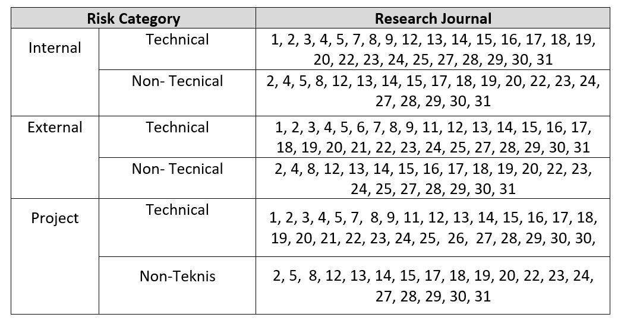

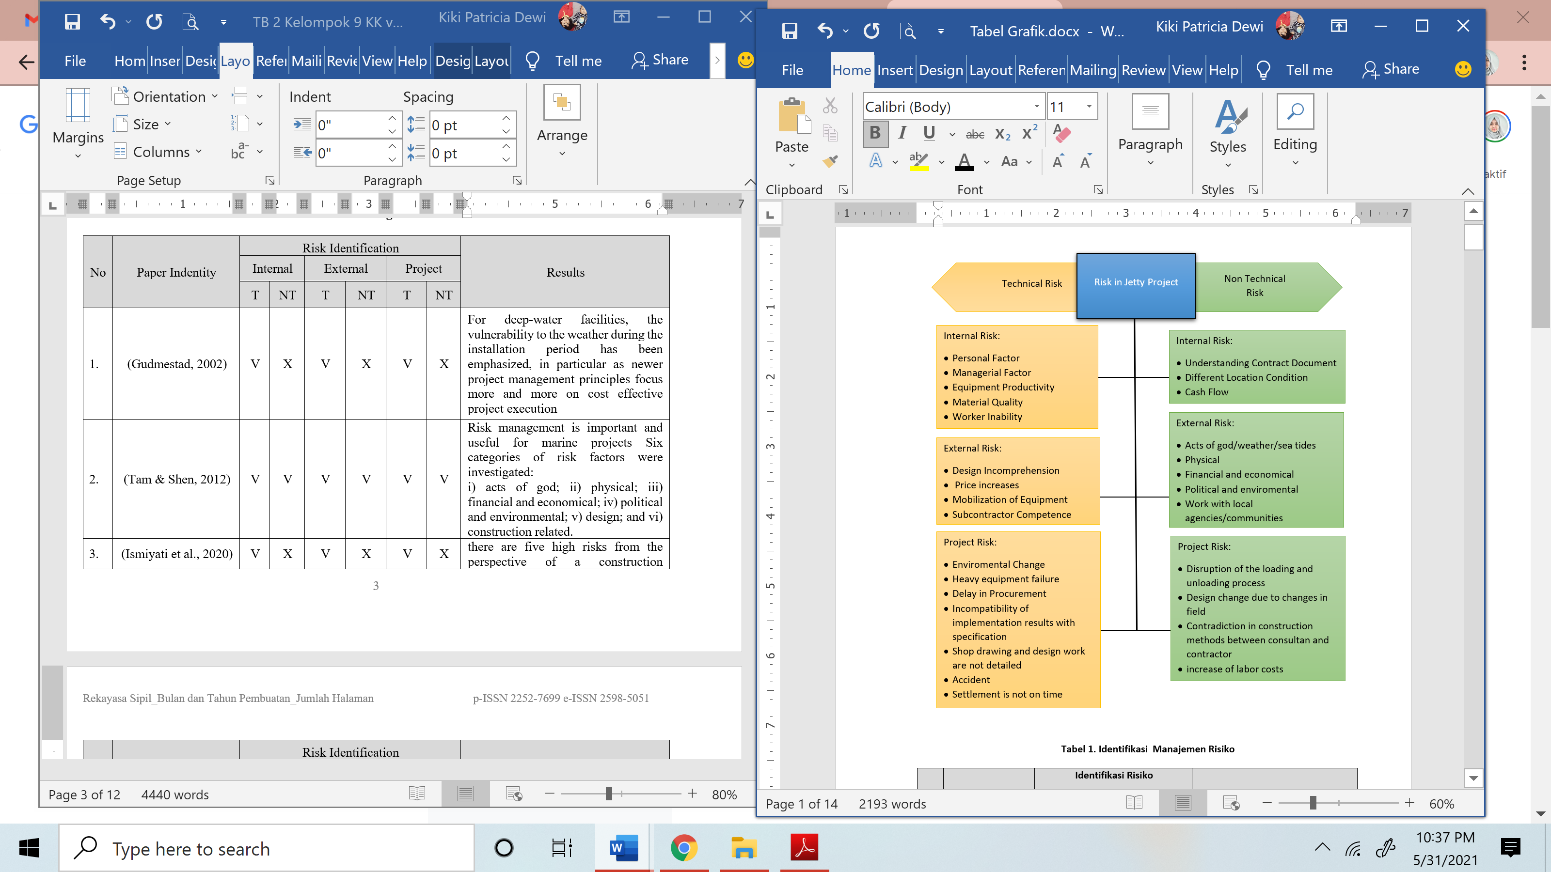
Based on the picture above, it can be seen that technical risks are more common than non-technical risks, but it can also be concluded that these two categories have almost the same effect on the jetty project.
- CONCLUSION
The following conclusions are obtained regarding the risk-based analysis of the jetty project:
- This literature review summary shows that Technical Risks have the greatest impact on jetty projects in internal and external project categories
- The risk-based approach provides a powerful tool for analyzing jetty projects.
- Risk-based analysis can lead to better decision making for project optimization.
- The life cycle approach is perfect for jetty engineering.
Figure 3. Risk in Jetty Project Based on Articles Review

REFERENCES
Al-Bahar, J. F., & Crandall, K. C. (1990). SYSTEMATIC R I S K MANAGEMENT A P P R O A C H FOR CONSTRUCTION P R O J E C T S. Engineering, 116(3), 533–546.
Anwar, & Adi, T. J. W. (2015). Analisa Resiko Teknis Yang Mempengaruhi Kinerja Waktu Proyek Pembangunan Pengaman Pantai Di Provinsi Sulawesi Barat. Seminar Nasional Manajemen Teknologi XXII, 1–7. http://repository.its.ac.id/59848/
Aulady, M. F. N., Nuciferani, F., & Wicaksono, S. (2018). Application of Failure Mode Effects Analysis (FMEA) Method and Fault Tree Analysis (FTA) Towards Health and Occupational Safety on Jetty Project, Gresik, Indonesia. Journal of Advanced Civil and Environmental Engineering, 1(2), 100. https://doi.org/10.30659/jacee.1.2.100-108
Balas, C. E., & Ergin, A. (2002). Case Study in Turkey. Middle East, April, 52–61.
Bunni, N. G. (2003). Risk and Insurance in Construction. In Risk and Insurance in Construction (Second). Spon Press. https://doi.org/10.4324/9780203476543
Chou, J. S., & Chiu, Y. C. (2020). Identifying critical risk factors and responses of river dredging projects for knowledge management within organisation. Journal of Flood Risk Management, 14(1), 1–16. https://doi.org/10.1111/jfr3.12690
Connor, T., Cummings, P., Imrie, J., & Pouusard, W. (2011). LOW COST BOAT HARBOR PROTECTION AS AN INTEGRAL ELEMENT OF NATURAL DISASTER RISK MANAGEMENT IN VIET NAM. Solutions to Coastal Disasters, 233–245.
Cretu, O., Stewart, R., & Berends, T. (2011). Risk Management for Design and Construction. Journal of Chemical Information and Modeling, 53(9).
Ergin, A., & Balas, C. E. (2002). Reliability-Based Risk Assessment of Rubble Mound Breakwaters under Tsunami Attack. Journal of Coastal Research, 36, 266–272. https://doi.org/10.2112/1551-5036-36.sp1.266
Gudmestad, O. T. (2002). Risk assessment tools for use during fabrication of offshore structures and in marine operations projects. Journal of Offshore Mechanics and Arctic Engineering, 124(3), 153–161. https://doi.org/10.1115/1.1492825
Indraswari P, I Nyoman Norken, P. A. S. (2018). PELABUHAN BENOA Pande Pt Anggi Indraswari P . J , I Nyoman Norken dan Putu Alit Suthanaya RISK MANAGEMENT OF INFRASTRUCTURE DEVELOPMENT PLANNING. 6(2), 144–151.
Ismiyati, I., Sanggawuri, R., & Handajani, M. (2020). Penerapan Manajemen Resiko pada Pembangunan Proyek Perpanjangan Dermaga log (Studi Kasus: Pelabuhan DalamTanjung Emas Semarang). Media Komunikasi Teknik Sipil, 25(2), 209. https://doi.org/10.14710/mkts.v25i2.19467
Ite, U. E. (2016). Non-Technical Risks Management: A Framework for Sustainable Energy Security and Stability. Society of Petroleum Engineers.
Jaber, K. F. (2015). ESTABLISHING RISK MANAGEMENT FACTORS FOR CONSTRUCTION PROJECTS IN IRAQ. March 2015.
Joubert, F. J., & Pretorius, L. (2020). Design and Construction Risks for a Shipping Port and Container Terminal: Case Study. Journal of Waterway, Port, Coastal, and Ocean Engineering, 146(1), 05019003. https://doi.org/10.1061/(asce)ww.1943-5460.0000537
Kartam, N. A., & Kartam, S. A. (2000). Risk and its management in the Kuwaiti construction industry: A contractors’ perspective. International Journal of Project Management, 19(6), 325–335. https://doi.org/10.1016/S0263-7863(00)00014-4
Keerthana, S., & Pradeep, T. (2019). Constructability Risk Assessment in Construction Projects. International Journal of Engineering and Advanced Technology, 9(2), 4979–4985. https://doi.org/10.35940/ijeat.b2358.129219
Khan, A. H. (2013). The contractors’ perception of risk management in pakistan. Proceedings of the Pakistan Academy of Sciences, 50(3), 189–200.
Klein, J. H., & Cork, R. B. (1998). An Approach to Technical Risk Assessment. International Journal of Project Management, 16(6), 345–351.
Liew, K. C., & Lee, C. K. M. (2012). Modelling and risk management in the offshore and marine industry supply chain. International Journal of Engineering Business Management, 4(1), 1–7. https://doi.org/10.5772/45738
Mondoro, A., Frangopol, D. M., & Soliman, M. (2017). Optimal Risk-Based Management of Coastal Bridges Vulnerable to Hurricanes. Journal of Infrastructure Systems, 23(3), 04016046. https://doi.org/10.1061/(asce)is.1943-555x.0000346
Nugroho, B. P. (2019). Risk Management in Construction of Dry Bulk Jetty At Teluk Lamong Multipurpose Terminal. IJTI (International Journal of Transportation and Infrastructure), 2(2), 67–76. https://doi.org/10.29138/ijti.v2i2.785
Nurjama, H. N., I, U. P. I. Y. A., Raya, J., & No, S. (2017). MANAJEMEN RISIKO TERHADAP PENGENDALIAN WAKTU PROYEK PEMBANGUNAN PELABUHAN DERMAGA : Study Kasus Dermaga Pelabuhan Halmahera Utara Propinsi Maluku Utara. 1–10.
Roubos, A., Peters, D., & Steenbergen, R. (2019). Target Reliability Indices for Quay Walls, Jetties, and Flexible Dolphins. 1, 400–408.
Simm, J. D., & Camilleri, A. J. (2001). Construction risk in coastal and river engineering. Journal of the Chartered Institution of Water and Environmental Management, 15(4), 258–264. https://doi.org/10.1111/j.1747-6593.2001.tb00351.x
Siswanto, P. A. W. (2012). MULTIPURPOSE TELUK LAMONG SURABAYA DARI PERSEPSI. 69.
Skibniewski, M. J., & Vecino, G. A. (2012). Web-Based Project Management Framework for Dredging Projects. Journal of Management in Engineering, 28(2), 127–139. https://doi.org/10.1061/(asce)me.1943-5479.0000070
Smith, N. J., Merna, T., & Jobling, P. (2006). Managing Risk in Construction Projects (Second). Blackwell Publishing.
Song, H., Kuang, C., Gu, J., Zou, Q., Liang, H., Sun, X., & Ma, Z. (2020). Nonlinear tide-surge-wave interaction at a shallow coast with large scale sequential harbor constructions. Estuarine, Coastal and Shelf Science, 233(December 2019), 106543. https://doi.org/10.1016/j.ecss.2019.106543
Suedel, B. C., Kim, J., Clarke, D. G., & Linkov, I. (2008). A risk-informed decision framework for setting environmental windows for dredging projects. Science of the Total Environment, 403(1–3), 1–11. https://doi.org/10.1016/j.scitotenv.2008.04.055
Tam, V. W. Y., & Shen, L. Y. (2012). Risk Management for Contractors in Marine Projects. Organization, Technology and Management in Construction: An International Journal, 4(1), 403–410. https://doi.org/10.5592/otmcj.2012.1.5
Tangdiembong, O., Sompie, B. F., Timboeleng, J. A., Pascasarjana, D., & Sam, U. (2013). RESIKO PADA PROYEK-PROYEK DERMAGA DI SULAWESI UTARA. 3(2), 115–119.
Thompson, E. F., Wutkowski, M., & Schesher, N. W. (1996). Risk Based Analysis of Coastal Project. 4440–4450.
W, R. K. (2018). Maritime safety risk analysis in Alur Pelayaran Barat Surabaya (APBS) during dredging process. Journal of Advances in Technology and Engineering Research, 4(4), 176–185. https://doi.org/10.20474/jater-4.4.4
Wayan, I., Staf, S., Smk N, P., Sompie, T. B. F., & Tarore, H. (2012). Analisis Resiko Proyek Pembangunan Dermaga Study Kasus Dermaga Pehe Di Kecamatan Siau Barat Kabupaten Kepulauan Sitaro. Jurnal Ilmiah MEDIA ENGINEERING, 2(4), 257–266.
Yuan, W., Guo, A., & Li, H. (2017). Seismic failure mode of coastal bridge piers considering the effects of corrosion-induced damage. Soil Dynamics and Earthquake Engineering, 93(August 2016), 135–146. https://doi.org/10.1016/j.soildyn.2016.12.002

