5G Channel Model for Frequencies 28 GHz, 73 GHz and
4 GHz with Influence of Temperature in Bandung
Ismalia Rahayu^{1*}, Ahmad Firdausi, S.T., M.T
¹Teknik Elektro, Universitas Mercu Buana, Jakarta
²Teknik Telekomunikasi, Universitas Mercu Buana, Jakarta
*rahayuismaliaa@gmail.com and ahmad.firdausi@mercubuana.ac.id

Abstract — The 5G channel model is the latest research on future cellular communication by considering the proposed millimeter wave (mmwave) as an enabling technology for the realization of connectivity in the 5G era. However, mmwave signal propagation suffers a high propagation loss to sensitivity to delay, resulting in a high probability and a low signal to signal ratio (SNR). This can take into account the potential for millimeter wave (mmwave) frequencies of 28, 73 and 4 GHz which are capable of meeting wide bandwidth requirements and data rates of up to Gbps for various scenarios such as Urban Microcell (UMi) and Urban Macrocell (UMa). The area used to conduct this research is in Indonesia because it is a tropical region that has high rainfall so that it can determine the effect that occurs when it is at maximum and minimum temperatures in each month. Therefore, to determine the characteristics of the 28, 73 and 4 GHz channels in the city of Bandung. This study discusses large-scale mmwave characteristics such as path loss, delay spread and power delay profile for line-of-sight (LOS) and non-line-of-sight (NLOS) cases and compares directional and omnidirectional propagation. In this study the Urban Microcell (UMi) scenario was carried out at a distance of 20 meters to 200 meters with a frequency of 28 GHz and 73 GHz, then for the Urban Macro cell (UMa) scenario at a frequency of 4 GHz with a distance of 50 meters to 500 meters.
Keywords — 5G; mmWave; NYUSIM; channel modelling; channel simulator outdoor-to-indoor loss;
DOI: 10.22441/jte.20xx.vxxix.xxx

INTRODUCTION
5G is the latest technology which is the fifth generation of wireless model network. This technology offers high speed internet. 5G has a function to develop technology in various fields ranging from academics in 2020 [1]. 5G will be allocated on milli meter wave (mmWave) channels. According to the International Telecommunication Union (ITU) in 2015 which there were 11 frequencies with a range of 24.25 – 86 GHz for wireless communication, including the frequencies of 26/28, 32, 38/39 and 60 GHz. In the calculation of millimeter wave (mmWave) channels, it usually uses a bandwidth of 500 MHz, with average distance of 300 m for indoor and outdoor areas, and the type of antenna used is a single antenna [2].
5G implementation in Indonesia requires good infrastructure preparation, especially parameter design based on model channels. The channel model is the most important part in the wireless communication system because the capacity (per-link) depends on the channel [3]. Many factors are considered in building channel modelling, such as carrier frequency, bandwidth, transmitter and receiver locations, and weather conditions [4].
The channel is a medium between the sending antenna and the receiving antenna, where the channel needs modelling so as to produce a communication system design that minimizes errors and maximizes information transmission or bit rate [5] In this study using an opensource channel simulator named NYUSIM. Developed based on the measurement of the propagation channel, namely milli mater-wave (mmWave) with a frequency of 28 GHz [6]. This research is focused on finding innovative solutions to overcome the limited attenuation, antenna design and propagation for 5G channels. Therefore, this research is focused on the propagation characteristics with frequencies of 28 GHz, 73 GHz and 4 GHz [7].

5G Channel Models

5G millimeter wave (mmWave) technology
Millimeter Wave is a very supportive band because it has a large bandwidth and is very promising [8]. The mmWave channel has statistical channels that are very different from the semi-omnidirectional microwave and sector microwave channels. mmWaves greatly influences 5G from its design and wireless communication system [9]. Millimeter Wave is in the frequency spectrum between 30-300 GHz with wavelengths ranging from 1-10 millimeters, according to the ITU referred to as Extremely High Frequency (EHF). However, in the 3-30 GHz range, it is called Super High Frequency (SHF). Because the propagation is similar to 5G, it is also known as millimeter wave which has waves in the 3-300 GHz range [7].
According to the 2015 World Radio Conference (WCR-15), candidate bands for 5G are: 24.25 – 27.5 GHz, 31.8 – 33.4 GHz, 37 – 43.5 GHz, 45.5 – 50.2 GHz, 50.4 – 52.6 GHz, 66 – 76 GHz, and 81 – 86 GHz. In addition, the 2019 World Radio Conference (WCR-19) agreed that the 60 GHz frequency could be used. So that all frequencies can be used according to the desired capacity and these frequencies cover UHF frequencies or lower waves can cover a wider area [9].

LOS Probability Model
LOS probability determines the level of how often the optical path is used to pair the sender (Tx) and the receiver (RX). Probability is a basic feature of channel model because it is a characteristic of highly variable propagation. For the calculation of LOS does not depend on the frequency and a function of the distance between the transmitter and receiver, which can be affected by the layout of the environment [9].
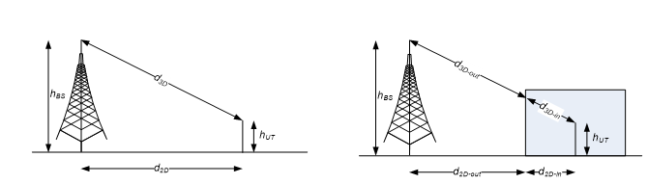
Figure 2.1 Parameter Definition of d2D and d3D [10]

Urban Microcell (UMi)
Urban Microcell (UMi) scenario is defined for high user density areas with a site-to-site distince (ISD) up to 200 m and a distance between TX and RX of at least 10 meters [10]. Tabel 2.1 is the UMI LOS probability models developed by the various parties
Urban Macrocell (UMa)
In the Urban Macrocell (UMa) scenario, the height is on the ground at 1.5 m and the BS is usually installed on the roof at a height of 25-30 m with an ISD of 500 m [10].

POWER DELAY PROFILE (PDP)
The Power Delay Profile (PDP) represents the average power associated with delays given as a function of propagation delays. PDP is obtained as the mean spatial response impulse in the canal complex. The multipath intensity profile can be referred to as PDP because it is defined as an automatic correlation so that it can be expressed as follows [12].

NYUSIM
The Simulation of Channel Model is using NYUSIM with the minimum and maximum temperatures. The Data for NYUSIM used parameter data obtained from BMKG in Bandung, and the output used in the file type like Omnidirectional PDP dan Directional PDP.
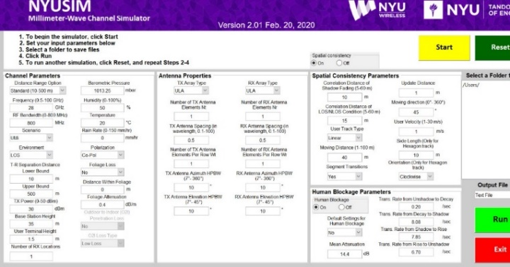
Figure 2.2 Display NYUSIM
Figure 2.3 is the display of NYUSIM application. The parameters that can be changed in NYUSIM to get a good result are bandwidth, power transmit, frequency, scenario and distance between transmitter and receiver sides.

Research Location
Bandung is used as the location on this research, the area of Bandung according to the Agency Statistics of West Java Province in 2018 is 157,67 KM2, with a percentage of 0,47% of the total area West Java. Then, based on survey from Indonesian Internet Service Providers Association (APJII) in 2020, data on internet users in West Java was occupied by city of Bandung with a presentation of 82.5.

method

FLOWCHART

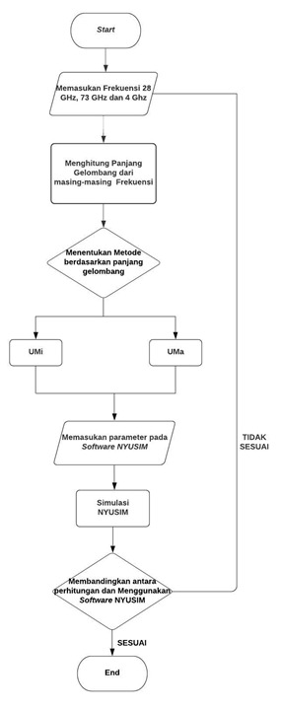
Figure 3.1 Flow Chart Channel Model

Channel model simulator is used for mmWave with a frequency of 28 GHz, 73 GHz and 4 GHz. In this study, it was implemented using the New York University (NYU) Wireless Simulator version 3.0 software. Calculations and simulations were carried out using the Matlab 2017b application.

TEMPERATURE
In this research, implementing by using maximum and minimum temperature since April 2020 until April 2021 which the data from Badan Meteorologi Klimatologi and Geofisika (BMKG), in Geofisika station Bandung. For minimum temperature after do analysis and compare the temperature is in August 2020 and for maximum temperature in October 2020. Table 3.1 is detail for temperature rate since April 2020 until April 2021.

Table 3.1 Temperature Rate from April 2020 to April 2021

Keterangan | Minimum |  |  | Maximum |  |  | Barometric Preassure (mbar)
Keterangan | Suhu ('C) | Kelembaban (%) | Curah Hujan  (mm) | Suhu ('C) | Kelembaban (%) | Curah Hujan(mm) | Barometric Preassure (mbar)
Apr-20 | 22,3 | 92 | 4 | 25,6 | 78 | 0 | 1010
May-20 | 22,9 | 88 | 4 | 25,9 | 72 | 0 | 1009,7
Jun-20 | 22,4 | 84 | 8888 | 25,1 | 77 | 0 | 1010
Jul-20 | 21,4 | 79 | 4 | 24,4 | 72 | 0 | 1009,6
Aug-20 | 22,1 | 69 | 0 | 25,1 | 76 | 0 | 1010,1
Sep-20 | 23,2 | 75 | 0 | 25,6 | 67 | 0 | 1010,3
Oct-20 | 21,6 | 94 | 3,1 | 28,9 | 46 | 1 | 1009,6
Nov-20 | 22,4 | 93 | 15,4 | 26,1 | 67 | 8888 | 1009,6
Dec-20 | 22 | 87 | 0,7 | 24,8 | 76 | 3,1 | 1008,5
Jan-21 | 21,6 | 87 | 3,6 | 24,9 | 68 | 0,8 | 1008,4
Feb-21 | 21,6 | 88 | 8,4 | 25 | 73 | 0 | 1008,9
Mar-21 | 22,5 | 84 | 20 | 25,9 | 65 | 0 | 1009,1
Apr-21 | 21,2 | 91 | 5,8 | 25 | 74 | 0 | 1000

PARAMETER OF SIMULATION
Table 3.2 is detail parameter are used in simulation with UMi and UMa scenario [10].
Tabel 3.2 Detail parameter UMi and UMa [10]
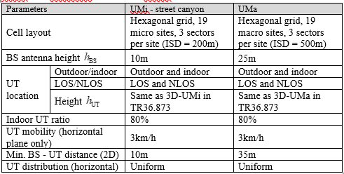

In this simulation, are uses channel and antenna parameter in outdoor conditions. The frequencies used for the simulation are 28 GHz and 73 GHz using the Urban Microcell (UMi) scenario with a bandwidth of 800 MHz using an antenna of 1x1 ULA array antenna. Then using the Urban Macrocell (UMa) scenario with a frequency of 4GHz with a bandwidth of 200 MHz. This simulation uses the NYUSIM application and has all the parameters affecting the system from mmWave including large-scale parameters such as Line of Sight (LOS) and Non-Line of Sight (NLOS).
In the NYUSIM simulator for the UMi and UMA scenarios, Line of Sight (LOS) and Non-Line of Sight are considered with the distance between TX – RX in the range of 20 – 200 m for the UMi scenario and a range of 50 – 500 m for the UMa scenario. Atmospheric effects including barometric pressure, humidity, temperature and rain rate are described in Table 3.2. Table 3.3 is specification of channel parameter for UMi ad UMa which the parameter are needed in this simulation [7].
Table 3.3 Specification of Channel Parameter [7]
Channel Parameter | Spesifikasi
Channel Parameter | UMi Scenario | UMa Scenario
Frekuensi Carrier | 28 GHZ, 73 GHz | 4 GHz
Bandwidth | 800 MHz | 200 MHz
Height of BS | 10 m | 35 m
Tx-Rx Separation | 20 – 200 | 50 – 500
Foliage attenuation | 0,4 dB/m
TX Power | 30 dBm
TX Array Type, Nt | ULA, 1 | ULA, 1
RX Array Type, Nr | ULA. 1 | ULA, 1
Modulasi | OFDM

Hasil dan Analisa
- Urban Microcell Scenario (UMi)
Based on characteristic from Urban Microcell (UMi) scenarios which there is an outdoor and outdoor-to-indoor characteristics with high traffic loads, this simulation are focuses on the outdoor UMi scenarios with frequency 28 GHz and 73 GHz with distance between receiver (RX) and Transmitter (TX) is 20-200 meters for LOS and NLOS cases. From this simulation, it will reconsider for omnidirectional and directional conditions with the PDP value in each condition using the calculated transmitter and receiver distances.
FREQUENCY 28 GHZ with Minimum Temperature.
The results of this simulation are directional and omnidirectional path loss, the aggregated path loss exponential (PLE) and PLE results from the LOS and NLOS cases which are shown in Figure 4.1 using the minimum temperature in August 2020 with a temperature of 22.1 0C with humidity by 69%, with rainfall of 0 mm, and barometric pressure of 1010.1 mbar. Then in Figure 4.1 using 10 selected RX using the NYUSIM application, and with a distance range of 20 m to 200 meters.
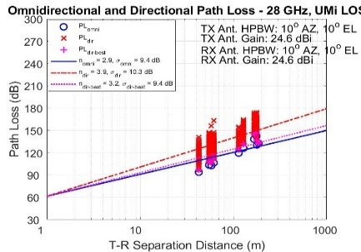
- Omnidirectional and directional Path Loss with LOS Case
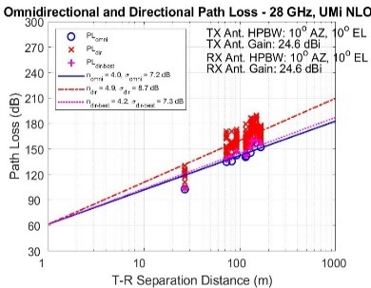
- Omnidirectional and directional Path Loss with LOS Case
Figure 4.1. Omnidirectional and directional with LOS and NLOS case
Figure 4.1 shows that the path loss increases linearly with increasing distance and propagation height. Figure 4.1 (a) shows that the PLE is 3.9 with a shadowing factor (SF) dir of 10.3 dB higher than the omnidirectional PLE of 2.9 and a shadowing factor of 9.4 dB. In Figure 4.1 (b) , path loss increases faster for the NLOS scenario, PLE increases to 4.9 and the shadow factor is 8.7 dB with an omnidirectional value of 4.0 and a shadowing factor of 7.2 dB.The results show that the PLE direction is higher in the LOS cases and NLOS is present in the NLOS cases. This happens because the arrangement or direction of the antenna is often not aligned, so it can be overcome by using a steerable beam antenna.
FREQUENCY 28 GHZ with Maximum Temperature.
The results of this simulation are directional and omnidirectional path loss, the aggregated path loss exponential (PLE) and PLE results from the LOS and NLOS cases which are shown in Figure 4.2 using the maximum temperature in October 2020 with a temperature of 28.9 0C with humidity by 46%, with rainfall of 1 mm, and barometric pressure of 1009.6 mbar. Then in Figure 4.4 using 10 selected RX using the NYUSIM application, and with a distance range of 20 m to 200 meters.
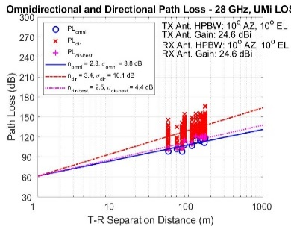
- Omnidirectional and Directional PDP with LOS case
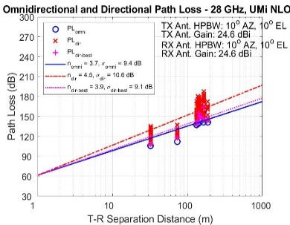
- Omnidirectional and Directional PDP with NLOS case
Figure 4.2 Omnidirectional and directional with LOS and NLOS cases
Figure 4.2 shows that the path loss increases linearly with increasing distance and propagation height. Figure 4.2 (a) shows that the PLE is 3.4 with a shadowing factor (SF) dir of 10.1 dB higher than the omnidirectional PLE of 2.3 and omni of 3.8 dB. In Figure 4.4 (b), path loss increases faster for NLOS scenarios, PLE increases to 4.5 and shadow factor is 10.6 dB for directional values ​​and PLE is 3.7 and shadowing factor is 9.4 dB for omnidirectional values
The results show that the PLE direction is higher in the LOS cases and NLOS is present in the NLOS cases. This happens because the arrangement or direction of the antenna is often not aligned, so it can be overcome by using a steerable beam antenna. Then based on Omnidirectional PDP and Directional PDP with LOS and NLOS cases compared to calculations have very far differences. Because the results of the calculation of the calculated parameters are not as complete as in the simulation, so that the calculation and simulation do not match.
FREQUENCY 73 GHZ with Minimum Temperature.
In this first simulation, using a frequency of 73 GHz and using the minimum temperature from the results of data collection for 1 year in Bandung City to take an analysis. The results of this simulation are directional and omnidirectional path loss, the aggregated path loss exponential (PLE) and PLE results from the LOS and NLOS cases which are shown in Figure 4.3 using the minimum temperature in August 2020 with a temperature of 22.1 C with humidity by 69%, with rainfall of 0 mm, and barometric pressure of 1010.1 mbar. Then in Figure 4.3 using 10 selected RX using the NYUSIM application, and with a distance range of 20 m to 200 meters.
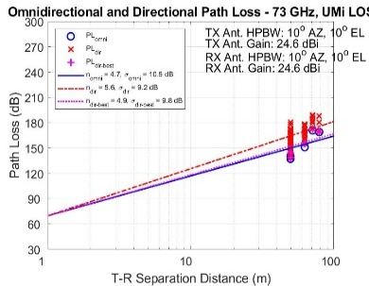
- Omnidirectional and Directional PDP with LOS case
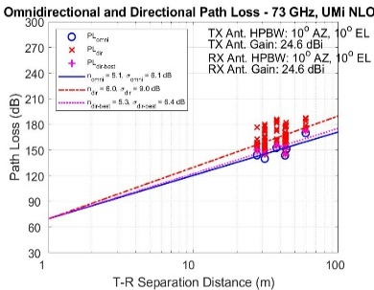
- Omnidirectional and Directional PDP with NLOS case
Figure 4.3 Omnidirectional and directional with LOS
Figure 4.3 shows that the path loss increases linearly with increasing distance and propagation height. Figure 4.7 (a) shows that the PLE is 5.6 with a shadowing factor (SF) dir of 9.2 dB higher than the omnidirectional PLE of 4.7 and omnidirectional of 10.5 dB. In Figure 4.3 (b), path loss increases faster for the NLOS scenario, PLE increases to 6.0 and the shadow factor is 9 dB for directional values ​​and PLE is 5.1 and shadowing factor is 6.1 dB for omnidirectional values.
Then based on Omnidirectional PDP and Directional PDP with LOS and NLOS cases compared to calculations have very far differences. Because the results of the calculation of the calculated parameters are not as complete as in the simulation, so that the calculation and simulation do not match.
FREQUENCY 73 GHZ with Maximum Temperature.
In this simulation, using a frequency of 73 GHz and using the maximum temperature from the results of data collection for 1 year in the city of Bandung to take an analysis. The results of this simulation are directional and omnidirectional path loss, the aggregated path loss exponential (PLE) and PLE results from the LOS and NLOS cases which are shown in Figure 4.4 using the maximum temperature in October 2020 with a temperature of 28.9 0C with humidity by 46%, with rainfall of 1 mm, and barometric pressure of 1009.6 mbar. Then in Figure 4.4 using 10 selected RX using the NYUSIM application, and with a distance range of 20 m to 200 meters.
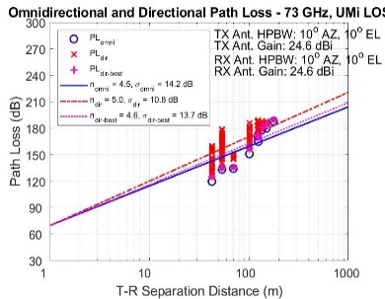
- Omnidirectional and Directional PDP with LOS case
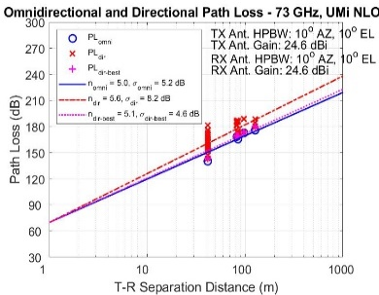

- Omnidirectional and Directional PDP with NLOS case
Figure 4.4 Omnidirectional and directional with LOS and NLOS cases
Figure 4.4 Omnidirectional and directional pathloss with simulation of 10 times at 73 GHz frequency UMIi scenario, (a) LOS and (b) NLOS. n is Path Loss Exponent (PLE), is standard deviation of shadow fading, “omni” represents omnidirectional, “dir” indicates direction, “dir-best” means direction with received directional strength, “Ant: indicates antenna, “AZ” and “EL” indicates the azimuth and altitude.
Figure 4.4 shows that the path loss increases linearly with increasing distance and propagation height. Figure 4.4 (a) shows that the PLE is 5.3 with a shadowing factor (SF) dir of 10.1 dB higher than the omnidirectional PLE of 4.5 and omni of 15.3 dB. In Figure 4.4 (b), path loss increases faster for the NLOS scenario, PLE increases to 5.4 and the shadow factor is 9.2 dB. The results showed that PLE was higher in LOS cases and NLOS was higher in NLOS cases.
- Urban Macrocell Scenario (UMa)
Based on the characteristics of the Urban Macrocell (UMa) scenario where there are outdoor and outdoor-to-indoor characteristics with high traffic loads, this simulation focuses on the characteristics of the outdoor UMa scenario with a frequency of 4 GHz with a distance between the sender (Tx) and the receiver (Rx). in the range of 50 – 500 meters for LOS and NLOS cases. From this simulation, it will be reconsidered for omnidirectional and directional conditions with the PDP value in each condition using the calculated TX and RX distances.
FREQUENCY 4 GHZ with Minimum Temperature.
In this first simulation, using a frequency of 4 GHz and using the minimum temperature from the results of data collection for 1 year in the city of Bandung to take an analysis. The results of this simulation are directional and omnidirectional path loss, the aggregated path loss exponential (PLE) and PLE results from the LOS and NLOS cases which are shown in Figure 4.5 using the minimum temperature in August 2020 with a temperature of 22.1 0C with humidity by 69%, with rainfall of 0 mm, and barometric pressure of 1010.1 mbar. Then in Figure 4.5 using 10 selected RX using the NYUSIM application, and with a distance range of 50 m to 500 meters
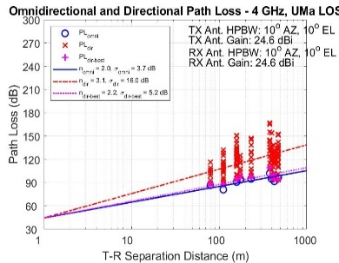
- Omnidirectional and Directional PDP with LOS case
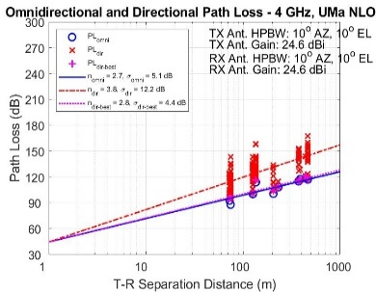
- Omnidirectional and Directional PDP with NLOS case
Figure 4.5 Omnidirectional and directional with LOS and NLOS cases
Figure 4.5 Omnidirectional and directional pathloss with simulation of 10 times at 4 GHz frequency UMa scenario, (a) LOS and (b) NLOS. In this simulation the path loss increases linearly with increasing distance and propagation height. Figure 4.5 (a) shows that the PLE is 3.1 with a shadowing factor (SF) dir of 16 dB greater than the two previous frequencies. The same as the shadowing factor (SF) in NLOS is greater than the two previous frequencies.
Then based on Omnidirectional PDP and Directional PDP with LOS and NLOS cases compared to calculations have very far differences. Because the results of the calculation of the calculated parameters are not as complete as in the simulation, so that the calculation and simulation do not match.
FREQUENCY 4 GHZ with Minimum Temperature.
In this simulation, using a frequency of 4 GHz and using the maximum temperature from the results of data collection for 1 year in the city of Bandung to take an analysis. The results of this simulation are directional and omnidirectional path loss, the aggregated path loss exponential (PLE) and PLE results from the LOS and NLOS cases which are shown in Figure 4.6 using the maximum temperature in October 2020 with a temperature of 28.9 0C with humidity by 46%, with rainfall of 1 mm, and barometric pressure of 1009.6 mbar. Then in Figure 4.6 using 10 selected RX using the NYUSIM application, and with a distance range of 50 m to 500 meters.
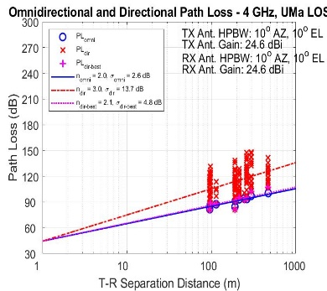
- Omnidirectional and Directional PDP with LOS case
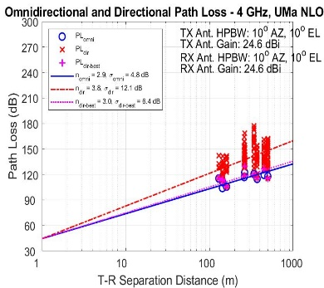
- Omnidirectional and Directional PDP with NLOS case
Figure 4.6 Omnidirectional and directional with LOS and NLOS cases
Figure 4.6 shows that the path loss increases linearly with increasing distance and propagation height. Figure 4.6 (a) shows that PLE of 3 with shadowing factor (SF) dir of 13.7 dB is higher than that of omnidirectional PLE of 2.0 and omni of 2.6 dB. In Figure 4.6 (b), path loss increased faster for the NLOS scenario, the PLE increased to 3.8 and the shadow factor was 12.1 dB. The results showed that PLE was higher in LOS cases and NLOS was higher in NLOS cases.

conclusion
Based on the simulation and analysis of the comparison between directional and omnidirectional PDP, it is known that the directional PDP value exceeds the omnidirectional PDP value, this is because the directional antenna can reach the damaged path so that the value is greater than omnidirectional, then for the time span obtained by using urban microcell simulation and urban macrocel at minimum and maximum pressure temperature, it is found that the simulation using urban microcell is faster than the urban microcell scenario, this is because the range using the urban microcell scenario is smaller than that of the urban macrocel. for temperatures between the maximum and minimum, when the minimum temperature the delay in the simulation is greater than the maximum temperature.
In detail, the channel model for the urban environment has tested at frequencies of 28 GHz, 73 GHz, and 4 GHz using a dense UMi and UMa scenario where the results show that propagation in this environment in the case of LOS and NLOS has a compensable range in propagation, but pathloss in the case of NLOS for directional propagation is higher than that of omnidirectional pathloss and increases very fast with the effect of increasing distance. The large-scale characteristics of mmWave studied and analyzed have shown good potential for use in dense urban areas. Gain antenna A directional array is considered to be able to overcome severe path loss in certain circumstances
REFERENCES
- Bengawan Alfaresi, Z. N. (2020). Humidity Effect to 5G Performances Under Palembang Channel Model At i28 GHz. Doctrol Program of Engineering Science, University Sriwijaya, Departement of Eletrical Eng, Universitas Muhammadiyah Palembang, School of Electrical Engineering, Telkom University.
- Michael Peter, R. J. (2016). Channel Measurement and Modeling for 5G Urban Microcellular Scenarios. Departement of Eelectrical and Electronic Engineering, Tokyo Institute of Technology, Tokyo, Japan.
- Alfaroby, EM., Ardiansyah, N.M,& Anwar K (2018). Study on channel model for Indonesia 5G networks.2018 International Conference on Signals and system, ICSigSys 2018 Proceedings,(pp.125-130)
- Cheng-Xiang Wang, F. (2018). A Survey Of 5G Channel Measurements and Models. IEEE COMMUNICATIONS SURVEYS & TUTORIALS.
- Khoirun Ni’amah, S. N. (2020). Model Kanal 5G Frekuensi 28 GHz dengan Pengaruh Suhu di Kota Yogyakarta. Institut Teknologi Telkom Purwokerto.
- Shu Sun, G. R. (2017). A Novel Millimeter-Wave Channel Simulator iand Applications for 5G Wireless Communications. NY, USA: NYU WIRELESS and NYU Tandon School of Engineering New York University, Brookly.
- Seraj, A. S. (2019). Study on Propagarion Characteristics of 5G Millimeter-Wave Wireless Communication Systems for Dense Urban Evironments. Fundamental Science and Engineering of Waseda University.
- Shu Sun, G. R. (2017). A Novel Millimeter-Wave Channel Simulator iand Applications for 5G Wireless Communications. NY, USA: NYU WIRELESS and NYU Tandon School of Engineering New York University, Brookly.
- Theodore S Rappaport, S.SUnd dan M. Shafi (2017). Investigation and Comparation of 3GPP and NYUSIM Channel Models of 5G Wireless Communications. IEEE 86th Vegucyakr Technologi Conference (VTC Fall), Toronto, Canada, 2017.
- 3GPP, “Discussion on procedure A for spatially-consistency UT mobility modeling,” ZTE, TDOC R1-1707267, May 2017.
- Evander Christy, R. P. (2018). Telkom University 5G Channel Models Under Foliage Effect and Their Performance Evaluation. School of Electrical Engineering Telkom University Bandung., 1-18.

