Development of an Ultrasonic System for Repelling and Detecting Rat Pests in Boarding Houses
Rizki Wahyu Pratama^{1*}, Syahlan Habib ², Wahyu Prastia ³, Muhammad Dimas Faisal⁴, Muhammad Fadly Pasaribu⁵, Dean Corio⁶
^{1,2,3,4,5}Department of Electrical Engineering, Faculty of Engineering, Andalas University
Jl. Campus Limau Manis, Pauh District, Padang City, West Sumatra, 25164
⁶Department of Electrical Engineering, Faculty of Industrial Technology, Institut Teknologi Sumatera
Jl. Terusan Ryacudu, Way Huwi, Jati Agung District, South Lampung Regency, Lampung, 35365
*rizkiwahyupratama@eng.unand.ac.id

Abstract— This paper presents the development of an ultrasonic rat repellent device that integrates a Passive Infrared (PIR) sensor with an Arduino Uno microcontroller. The PIR sensor detects rat presence within a 5-meter range, transmitting this information to the Arduino Uno. In response, Arduino activates a buzzer to emit ultrasonic waves at frequencies specifically chosen to repel rats. The device also includes an LED as a visual indicator and an LCD for a real-time status display. The design incorporates jumper cables and a breadboard for assembling the circuit, with additional components, such as a potentiometer and battery connectors, for efficient operation. The effectiveness of the device depends on the precise programming of the Arduino, which controls the activation and intensity of ultrasonic emission. This innovative approach offers a noninvasive, environmentally friendly alternative for managing rat infestations in various settings.
Keywords: Ultrasonic Rat Repellent, PIR Sensor, Arduino Uno, Environmental Management, Pest Control.
DOI: 10.22441/jte.20xx.vxxix.xxx

Introduction
In their respective studies, [1] and [2] explored the multifaceted effects of rodents on human health and agriculture. [1] research delves into the role of mice as vectors for various pathogens detrimental to human health, including leptospirosis, plague, murine typhus, salmonellosis, richettsial pox, rabies, and trichinosis. This study further investigated the mouse population at the Port of Soekarno Hatta Sea, examining their density, species, capture success, and ectoparasites. Conversely, [2] focused on the significant harm inflicted on rice crops, identifying them as principal pests responsible for considerable crop damage and loss. This study draws a correlation between the density of field rat populations and the severity of damage to rice plants, noting a peak in destruction during the early generative phase when food is the most plentiful.
[3] also contributed to this discourse by examining the specific impact of Rattus argentiventer on rice fields. This research not only quantifies the agricultural damage caused, but also analyzes environmental factors fostering rat population growth, such as the state of rice field bunds and the availability of sustenance and shelter. This study extends to the behavioral patterns of rats, including their feeding habits and movement, and emphasizes the necessity for effective pest control strategies employing the kernel density method for its analysis.
In a related study, [3] investigates the efforts of Pucakwangi Village, Lamongan Regency, in rat management were investigated. This study outlines the various methods employed by the community, including the use of poison, physical striking, glue, snap traps, and air rifles. A significant aspect of this study is the emphasis on the rise in community awareness regarding zoonotic diseases transmitted by rats after educational intervention. However, [3] also raises concerns about certain rat capture methods in contrast to animal welfare principles, particularly the Five Freedoms, which encompass freedom from fear, distress, pain, injury, and disease. The study acknowledges the challenges encountered during the educational sessions, such as the limitations imposed by the COVID-19 pandemic and the difficulties faced by some community members with poor vision. [3] research has underscored the successful execution of these community service activities, marked by robust community participation and adherence to health protocols. The study closes on a hopeful note, envisaging increased community vigilance and awareness of the hazards posed by rats in their surroundings.
[4] delves into various innovative and traditional methods of pest control in agricultural settings, primarily focusing on rat infestations that severely affect crop yield and quality. A noteworthy approach is the use of owls, particularly Tyto alba, as natural predators in Tanjung Village. These owls, which are capable of controlling pests over a 12-hectare area and consume several rats nightly, offer an environmentally friendly solution. Additionally, traditional methods, such as chemical fogging with sulfur smoke and mechanical rat traps, are discussed, highlighting their effectiveness and raising concerns regarding environmental sustainability [5][6].
[7] further explored technological advancements in pest control. It describes an automatic mouse-trap device equipped with an ultrasonic sensor HC-SR04 and an Arduino Uno microcontroller. This innovative trap can capture multiple mice by detecting their presence and closing the trap door using a servo motor [8]. Another significant development is the IoT-based bird repellent tool designed for rice fields, which combines hardware such as solar cells and Arduino Uno with software solutions such as the Arduino IDE, demonstrating a blend of technology and agriculture [9].
The use of Gadung Tubers (Dioscorea hispida) is a biological approach to control rat populations. These tubers, which contain disorienting alkaloids and cyanides, have been explored as natural pest control agents, with efforts focused on educating farmers about their application. This natural method aligns with the growing trend towards sustainable and environmentally conscious pest management practices [10].
Another section of the study introduces a prototype for an automated plant protection system using a NodeMCU as a microcontroller. This system detects the presence of pests and employs a buzzer to deter them, showcasing the potential of technology in agricultural pest management. They described a pest control device utilizing motion sensors and an Arduino Uno to electrify a wire, effectively repelling pests from corn fields effectively [11][12][13].
[14] and [15] examined the Trap Barrier System (TBS) in rice fields, combining physical traps with chemical treatments and the rice mina system used in Lara Village, Southeast Sulawesi. The latter integrates rice cultivation with fish farming, using an insulation pool both as a rat barrier and a habitat for Nila fish, exemplifying an innovative and integrated approach to pest management [16]. These diverse methods underscore a shift towards more sustainable, environmentally friendly, and efficient strategies for agricultural pest control [17].
In both dormitory and residential settings, the prevalence of rat infestation poses significant concerns, necessitating the adoption of technology-based solutions for effective pest control. The presence of rats not only increases the risk of disease transmission, but also leads to potential damage to personal belongings and furniture due to their gnawing behavior. To mitigate these risks, the use of an ultrasonic rat repellent device has emerged as a critical solution. This device functions by emitting ultrasonic waves, specifically in the frequency range of 20–50 KHz, in rats. The design of these waves is intended to disrupt the auditory senses of rats, causing discomfort and ultimately compelling them to leave the affected area. The strategic selection of this frequency range is aimed at maximizing disturbance to the rats, thereby providing a humane and environmentally friendly method to deter these pests from dormitories and homes.

Theory

Ultrasonic
Sound waves, also known as acoustic waves, are a form of mechanical wave capable of propagating through various media such as solids, liquids, and gases. The frequency range of sound waves can be categorized into three distinct types [18]. Infrasonic waves have frequencies below 20 Hz. By contrast, ultrasonic waves are characterized by frequencies above 20 kHz, which are beyond the upper limit of human hearing. When ultrasonic waves encounter an obstacle, they undergo various interactions; a portion of these waves is reflected, another part is absorbed, and the remainder passes through the obstacle [19]. The absorbed waves were quantified using a comparator and subsequently converted into binary numbers.
Previous research has demonstrated that ultrasonic waves can significantly affect pests, particularly rats, making them a viable basis for developing a device to repel these pests in residential areas, such as boarding houses and dormitories [20]. The application of ultrasonic technology offers a non-intrusive and potentially effective method for managing rat infestations in such environments, capitalizing on the discomfort caused to rats by these high-frequency sound waves.

Microcontroller
A microcontroller is a compact integrated circuit (IC) that functions by receiving input signals, processing them, and producing output signals in accordance with preprogrammed instructions. While microcontrollers generally have lower data processing speeds than personal computers (PCs), they are sufficiently capable of a wide range of applications, particularly owing to their compact size. Microcontrollers are ideally suited for systems that are not overly complex and that do not require high computational power. They typically operate at speeds ranging from 1 to 16 MHz, which are considerably slower than the gigahertz (GHz) speeds of PC microprocessors [21].
The ATMega328P microcontroller, a product of Atmel, is a notable example of the microcontroller spectrum. It is an 8-bit Complementary Metal Oxide Semiconductor (CMOS) device based on a Reduced Instruction Set Computer (RISC) architecture. This series stands out for its efficiency in executing programs as it completes nearly all instructions in a single clock cycle. ATMega328P features an 8 Kbyte in-System Programmable Flash, enabling the program memory to be reprogrammed (read/write) via Serial Peripheral Interface (SPI) connections [22].
One of the key advantages of AVR (Alf and Vegard's RISC processor) microcontrollers, such as ATMega328P, is their execution speed. Most instructions are executed in one clock cycle, making it faster than microcontrollers from the MCS-51 family, which use a Complex Instruction Set Computer (CISC) architecture. This efficiency allows ATMega328P to achieve a throughput of approximately 1 Million Instructions Per Second (MIPS) per MHz. This high instruction execution rate contributes to the microcontroller's low power consumption relative to its processing speed, making it an advantageous choice for various applications in which energy efficiency and compact design are crucial [23].

Mesthod

Design Specifications
The device, designed for detecting and repelling rats using ultrasonic waves, incorporates a Passive Infrared (PIR) sensor as the primary detection mechanism. The PIR sensor was capable of identifying the presence of rats within an effective range of 5 m. In conjunction with this, the device employs a buzzer to generate ultrasonic waves, which are essential for repelling pests.
Rats have a hearing range that typically spans from 5 Hz to 60 KHz; in some circumstances, it can even exceed 100 KHz. The device capitalizes on this sensitivity to high-frequency sounds. When exposed to high-frequency ultrasonic waves, rats experience discomfort, which is the underlying principle employed in the operation of this device. By generating sound waves within these high frequencies, the device effectively disturbed the rats, thereby serving as a deterrent and encouraging them to vacate the vicinity. This method of pest control is noninvasive and utilizes the natural aversion of rats to certain sound frequencies to achieve its objective.
The ultrasonic rat detection and repulsion device operates through a series of interconnected components, beginning with a power supply unit that provides the necessary energy to run the entire system. Following this, the Passive Infrared (PIR) sensor plays a crucial role, as it serves as the input device for detecting the movement of rats. This detection is the initial trigger for the device operation. The specifications of these components are listed in Table 1 and presented in Fig. 1.

Table 1. Ultrasonic System for Repelling and Detecting Rat Pests Component Specifications.
No | Component | Specification
1 | Arduino ATmega 328p | 8-bit AVR microcontroller, Clock speed of 16 MHz, Flash Memory 32 KB, SRAM 2 KB, EEPROM 1 KB
2 | Buzzer Speaker | Piezoelectric type, Operating Voltage 3-12V, Frequency range 2KHz-4KHz
3 | LCD 16x2 | 16 characters, 2 lines display, 5x8 dot character size, HD44780 controller
4 | LED | Light Emitting Diode, Forward Voltage 1.9-3.3V, Current 20mA, various colors available
5 | Sensor PIR | Passive Infrared Sensor, Detection range up to 7 meters, Detection angle 110°, Operating Voltage 5-20V

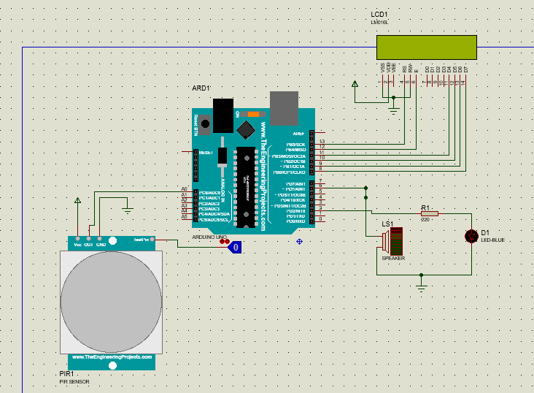
5
4
3
2
1
Fig. 1. Components of the circuit in this research, (1) Arduino ATmega 328p, (2) Buzzer Speaker, (3) LCD 16x2, (4) LED, and (5) Sensor PIR

Upon detecting rat movement, the PIR sensor sends a signal to the Atmega system. This microcontroller was responsible for processing the signal received from the sensor. After processing, the Atmega system displays detection information on an LCD screen, alerting the user to the presence of a rat. Subsequently, the mega microcontroller sends a signal to a switch component. This switch then activates the module responsible for powering the buzzer. Once activated, the buzzer produces ultrasonic waves. These waves were specifically calibrated to disturb and repel rats, capitalizing on their sensitivity to high-frequency sounds.
The integration of these components – the power supply, PIR sensor, Atmega microcontroller, LCD display, switch, and buzzer – forms a cohesive and effective system, as shown in Fig. 1. This system not only detects the presence of rats, but also actively repels them using ultrasonic waves, providing a non-toxic and humane solution to pest control challenges.The Arduino program was created to run the tool design, as shown in Table 2.

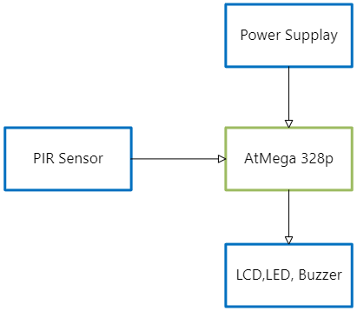
Fig. 2. Design of rat pests repelling and detecting tools

Table 2. Source Code for Arduino
#include <LiquidCrystal.h>

// Initialize LCD with the pins it is connected to
LiquidCrystal lcd(13, 12, 11, 10, 9, 8);

// Define constants for the pins used
#define PIR A0 // Pin for PIR sensor
#define buzz 6 // Pin for buzzer
#define led 2 // Pin for LED

// Variable to hold the sensor state
int sensor;

void setup() {
// Set the modes for each pin
pinMode(led, OUTPUT);
pinMode(buzz, OUTPUT);
pinMode(PIR, INPUT);

// Initialize the LCD
lcd.begin(16, 2);
}
void loop() {
// Read the state from the PIR sensor
sensor = digitalRead(PIR);

// Clear the LCD and set the initial message
lcd.clear();
lcd.setCursor(0, 0);
lcd.print("Mendeteksi");
lcd.setCursor(0, 1);
lcd.print("Tikus...");

// Check if the sensor is HIGH (detects motion)
if (sensor == HIGH) {
// Sound the buzzer and turn the LED on
tone(buzz, 120000);
digitalWrite(led, HIGH);

// Update the LCD message
lcd.clear();
lcd.setCursor(0, 0);
lcd.print("Terdeteksi...!");
lcd.setCursor(0, 1);
lcd.print("ada tikus");
}
else {
// Turn off the buzzer and LED
noTone(buzz);
digitalWrite(led, LOW);

// Update the LCD message
lcd.clear();
lcd.setCursor(0, 0);
lcd.print("Mendeteksi...");
lcd.setCursor(0, 1);
lcd.print("tidak ada tikus");
}
}

Result and Discussion

Circuit Implementation

A simulation circuit is applied and covered using a plastic box. The status LED appears outside the box such that it can be read by the user. The circuit application is illustrated in Fig. 3.

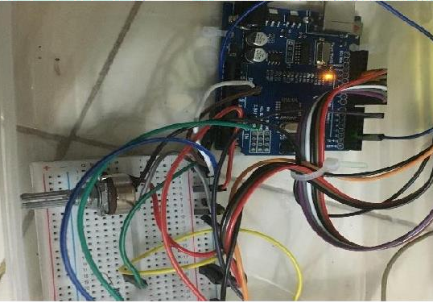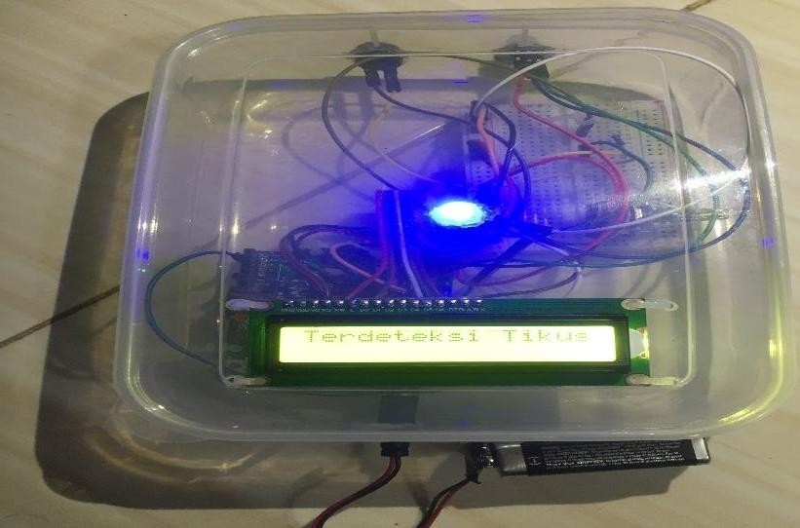
a
b
Fig. 3. Application of a series of ultrasonic systems to repel and notify rat pests, (a) without box, (b) with plastic box

Ultrasonic Frequency Wave Variation Testing

Testing of the ultrasonic rat repellent device involves experimenting with three different frequency ranges: 20 – 50 KHz, 60 – 100 KHz, and 110 – 120 KHz, shown in Table 3 and Fig. 4. This approach allowed for a comparative analysis of rat behavior in response to each frequency range, providing insights into the most effective frequencies for repelling rats. The performance of a Passive Infrared (PIR) sensor is a critical aspect of this testing. The primary function of the PIR sensor was to detect the presence of rats within a range of approximately 5 m. When a rat is detected, the sensor captures its thermal signature, which is then processed as an input signal. This signal was transmitted to an Arduino UNO microcontroller via jumper cables for further processing. The Arduino UNO serves as the central processing unit of the device, executing a preprogrammed code that dictates the functionality of the device. As a basic yet versatile microcontroller in electronics, the Arduino UNO can process and execute one or more programming instructions. It features 14 pins, including input, output, and other functional pins, each with a unique purpose.

Table 3. Table of Frequency Variation Experiments on Rats
Frequency range (KHz) | Rat Behavior
20 – 50 | Not distracted and continue eating
60–100 | A little distracted, but continued eating
110 – 120 | Disturbed and doesn't want to eat.
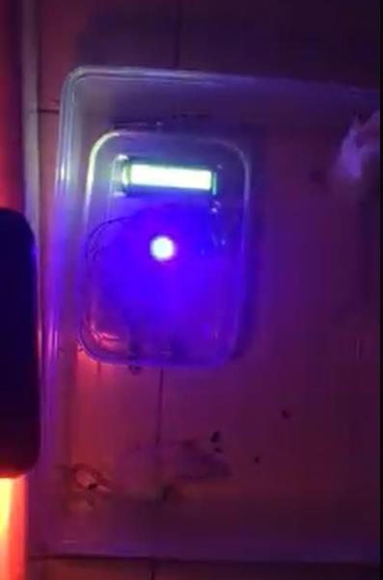
c
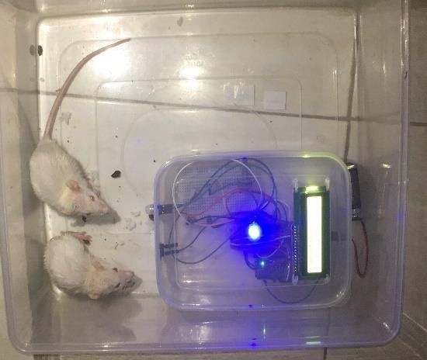
a
b
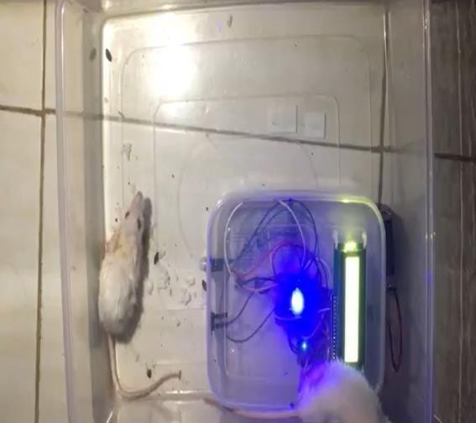
Fig. 4. Rat behavior towards changes in system frequency, (a) 20 – 50 KHz—the rat was not distracted and continued eating, (b) 60 – 100 KHz—the rats were slightly distracted, but continued eating, and (c) 110 – 120 KHz—the rats were disturbed and did not want to eat.
For operation, the Arduino UNO requires power that is typically supplied by a battery. Upon receiving the input signal from the PIR sensor, the Arduino processes the data and executes the programmed instructions, which involves sending commands to the output components through the jumper cables. The output components of the device include LEDs, an LCD display, and a buzzer, each set of which operates based on the test data frequencies. When the PIR sensor detects a rat, the LED lights up and the LCD displays a notification. These outputs facilitate easy monitoring of device performance. The efficacy of the device was evaluated by observing the rats' reactions to different frequency ranges using a smartphone camera for recording and analysis. This testing method allows for a practical assessment of how effectively the device repels rats using various ultrasonic frequencies, thereby contributing to the optimization of the device for real-world applications.
To monitor the performance of the ultrasonic rat repellent device, a 16x2 LCD (Liquid Crystal Display) widget was employed as an indicator. This display provides real-time feedback by showing the output when the device successfully detects the presence of a rat. This LCD feature enhances the user interface, allowing immediate visual confirmation of the device operation. In addition to the LCD, the device incorporates two other output components to indicate its functionality: a light-emitting diode (LED) and a buzzer. The LED serves as a visual indicator: it lights up when the PIR sensor detects a rat, providing a clear and immediate signal that the device has been triggered.
The Buzzer plays a crucial role in the actual repelling mechanism of a device. Upon activation by sensor detection, the buzzer emitted ultrasonic waves at a frequency of 120KHz. This specific frequency was selected based on experimental testing and is believed to be the most effective in disturbing and repelling rats. The use of this high-frequency sound leveraged the sensitivity of rats to ultrasonic noise, thereby acting as a deterrent.
The combination of these indicators–LCD, LED, and Buzzer–ensures a comprehensive monitoring system. They allow users to not only know when the device detects a rat, but also confirm that the repelling mechanism (ultrasonic sound emission) is active and functions at the optimal frequency determined through experimental trials. This multi-faceted approach to feedback helps ensure the effectiveness and reliability of the device in real-world applications. In the conceptualization of an ultrasonic rat repellent device, the arrangement and connectivity of various components are fundamental. The design commences with the connection of a Passive Infrared (PIR) sensor to an Arduino Uno using jumper cables. The Arduino Uno functions as the central processing unit by analyzing signals from the PIR sensor to coordinate the actions of the device. These connections are facilitated on a breadboard that acts as the base for assembling the electronic circuit, allowing for the integration of the device components. The setup includes input and output components: the PIR sensor as the input and the LED (Light Emitting Diode), LCD (Liquid Crystal Display), and buzzer as outputs. The LED serves as a visual indicator that lights up upon rat detection, whereas the LCD provides detailed operational feedback. The Buzzer is crucial for generating ultrasonic waves that repel rats. Supporting elements such as additional jumper cables, potentiometers for adjustments, batteries with connectors, and other miscellaneous components are also integral to the functionality and power management of the device.
The role of the Arduino program is central to the operationalization of this design. It interprets the PIR sensor's signals, manages the output components, and ensures efficient performance of the device. The program determines how the device reacts to rat detection, activating the ultrasonic repelling mechanism at the required frequency. Meticulous programming is essential for the accuracy and effectiveness of the device in detecting and repelling rats. By seamlessly integrating these components and ensuring their coordinated operation through the Arduino program, the device aims to provide an efficient and reliable solution for rat deterrence.
Conclucion
The development of an ultrasonic rat repellent device, as explored in this study, represents a significant stride in pest control technology. By efficiently integrating a Passive Infrared (PIR) sensor with an Arduino Uno microcontroller, the device capitalizes on the sensitivity of rats to ultrasonic frequencies, thereby offering an effective and humane method for repelling these pests. The inclusion of a visual LED indicator and LCD screen enhances the user interface, allowing for real-time monitoring and adjustment. The successful operation of this device, as governed by the precision programming of the Arduino Uno, not only underscores the potential of combining simple electronic components for practical applications, but also highlights a sustainable and environmentally friendly approach to pest management. This innovation serves as a promising alternative to traditional pest control methods, aligning with the growing need for noninvasive and eco-conscious solutions in urban and agricultural settings.

Reference
- S. Kusumarini R, C. L. Annadhifa, F. P. Zuhria, F. A. S. Billa, and P. D. Lestari, “Pengetahuan dan Sikap Masyarakat terhadap Bahaya Tikus sebagai Agen Global Penular Penyakit Zoonosis,” Jurnal Inovasi Hasil Pengabdian Masyarakat (JIPEMAS), vol. 5, no. 2, p. 234, Apr. 2022, doi: 10.33474/jipemas.v5i2.13955.
- B. G. Putra and R. T. Arjunet, “TEKNOLOGI GEOSPATIAL UNTUK INVESTIGASI PENYERANGAN RATTUS ARGENTIVENTER, SEBAGAI UPAYA MITIGASI LAHAN PERTANIAN,” JURNAL SWARNABHUMI : Jurnal Geografi dan Pembelajaran Geografi, vol. 4, no. 2, p. 108, Aug. 2019, doi: 10.31851/swarnabhumi.v4i2.2951.
- S. Sulasmi and S. Hastuti, “OBSERVASI TINGKAT KEPADATAN TIKUS DI LINGKUNGAN BUFFER DAN PERIMETER PELABUHAN SOEKARNO HATTA MAKASSAR,” Sulolipu: Media Komunikasi Sivitas Akademika dan Masyarakat, vol. 17, no. 1, p. 15, Feb. 2019, doi: 10.32382/sulolipu.v17i1.674.
- M. D. Pusparini and I. K. Suratha, “EFEKTIVITAS PENGENDALIAN HAMA TIKUS PADA TANAMAN PERTANIAN DENGAN PEMANFAATAN BURUNG HANTU DI DESA WRINGINREJO KECAMATAN GAMBIRAN KABUPATEN BANYUWANGI, PROVINSI JAWA TIMUR,” Jurnal Pendidikan Geografi Undiksha, vol. 6, no. 2, Aug. 2018, doi: 10.23887/jjpg.v6i2.20683.
- F. Ardigurnita, N. Frasiska, and E. Firmansyah, “Burung Hantu (Tyto alba) Sebagai Pengendali Tikus Sawah (Rattus argentiventer) di Desa Parakannyasag Kota Tasikmalaya,” Jurnal Abdimas Kartika Wijayakusuma, vol. 1, no. 1, Mar. 2020, doi: 10.26874/jakw.v1i1.13.
- A. T. A. Andi taufiq, A. Latief Arda2, and I. Taufiq, “Alat Pengusir Burung Pada Tanaman Padi Berbasis IoT,” JURNAL ILMIAH ILMU KOMPUTER, vol. 8, no. 2, pp. 101–107, Sep. 2022, doi: 10.35329/jiik.v8i2.234.
- F. Ardigurnita, N. Frasiska, and E. Firmansyah, “Burung Hantu (Tyto alba) Sebagai Pengendali Tikus Sawah (Rattus argentiventer) di Desa Parakannyasag Kota Tasikmalaya,” Jurnal Abdimas Kartika Wijayakusuma, vol. 1, no. 1, Mar. 2020, doi: 10.26874/jakw.v1i1.13.
- E. B. Tamia and A. Zafia, “Rancang Bangun Prototype Pengusir Hama Kera Pada Perkebunan Berbasis Internet Of Things,” LEDGER : Journal Informatic and Information Technology, vol. 1, no. 1, pp. 25–38, Feb. 2022, doi: 10.20895/ledger.v1i1.775.
- D. Hidayatullah and S. Sulistiyanto, “Perancang Alat Pengusir Hama Burung Pipit Pada Tanaman Padi Menggunakan Gelombang Kejut Otomatis Berbasis Internet of Things (IoT),” JEECOM Journal of Electrical Engineering and Computer, vol. 4, no. 2, pp. 74–78, Oct. 2022, doi: 10.33650/jeecom.v4i2.4464.
- P. Airlangga, A. Susanti, A. M. Zahro, S. H. Choir, and W. Wina, “Pemanfaatan Umbi Gadung untuk Pengendalian Tikus di Desa Jatiwates Kecamatan Tembelang Jombang,” Jumat Pertanian: Jurnal Pengabdian Masyarakat, vol. 3, no. 1, pp. 6–12, Apr. 2022, doi: 10.32764/abdimasper.v3i1.2474.
- F. S. Harahap, “EVALUASI STATUS KESUBURAN N P K TANAH SAWAH TADAH HUJAN DI KECAMATAN BERINGIN KABUPATEN DELI SERDANG,” JURNAL AGROPLASMA, vol. 5, no. 1, Oct. 2019, doi: 10.36987/agr.v5i1.177.
- M. Sepe and S. Suhardi, “Pengendalian Tikus Sawah (Rattus Argentiventer) dengan Sistem Bubu Perangkap dan Perangkap Bambu Pada 3 Zona Habitat Tikus di Kabupaten Pinrang Kota Makassar,” AGROVITAL : Jurnal Ilmu Pertanian, vol. 6, no. 1, p. 38, Jun. 2021, doi: 10.35329/agrovital.v6i1.2004.
- H. M. Siregar, S. Priyambodo, and D. Hindayana, “Preferensi Serangan Tikus Sawah (Rattus argentiventer) Terhadap Tanaman Padi,” Agrovigor: Jurnal Agroekoteknologi, vol. 13, no. 1, pp. 16–21, Feb. 2020, doi: 10.21107/agrovigor.v13i1.6249.
- Elisabet and Agussalim, “Prototype Perangkap Hama Hewan Liar Berbasis Arduino Uno,” Jurnal Informatika dan Sistem Informasi, vol. 2, no. 2, pp. 495–502, Oct. 2021, doi: 10.33005/jifosi.v2i2.407.
- N. Katrina Pandjaitan, “Representasi Profesional Petani Padi-Sawah dalam Hubungannya dengan Praktek Pengendalian Hama,” Sodality: Jurnal Sosiologi Pedesaan, vol. 4, no. 2, May 2010, doi: 10.22500/sodality.v4i2.5843.
- J. J. J. Sheela, M. Logeshwaran, S. Saida, S. D. J, S. K, and S. R, “Design of Rat Trap based on Ultrasonic Waves using Bluetooth Technology,” in 2023 2nd International Conference on Applied Artificial Intelligence and Computing (ICAAIC), May 2023 [Online]. Available: http://dx.doi.org/10.1109/icaaic56838.2023.10141014. [Accessed: Nov. 17, 2023]
- D. Priyanto, J. Raharjo, and R. Rahmawati, “Domestikasi Tikus: Kajian Perilaku Tikus Dalam Mencari Sumber Pangan dan Membuat Sarang,” BALABA: JURNAL LITBANG PENGENDALIAN PENYAKIT BERSUMBER BINATANG BANJARNEGARA, pp. 67–78, Jun. 2020, doi: 10.22435/blb.v16i1.2601.
- H. Khon, O. V. Bashkov, S. V. Zolotareva, and D. B. Solovev, “Modeling the Propagation of Elastic Ultrasonic Waves in Isotropic and Anisotropic Materials when Excited by Various Sources,” Materials Science Forum, vol. 945, pp. 926–931, Feb. 2019, doi: 10.4028/www.scientific.net/msf.945.926.
- H. Tanaka, “Ultra-sonic distance sensor system and method with correction feature for sensor value,” The Journal of the Acoustical Society of America, vol. 82, no. 1, pp. 404–404, Jul. 1987, doi: 10.1121/1.395464.
- H. Tassery and S. Koubi, “Minimally Invasive Dentistry Using Sonic and Ultra-sonic Devices in Ultraconservative Class 2 Restorations,” The Journal of Contemporary Dental Practice, vol. 9, no. 2, pp. 155–165, 2008, doi: 10.5005/jcdp-9-2-155.
- M. Bates, “More PIC Microcontrollers,” in PIC Microcontrollers, Elsevier, 2011, pp. 261–284 [Online]. Available: http://dx.doi.org/10.1016/b978-0-08-096911-4.10012-6. [Accessed: Nov. 17, 2023]
- “FINGERPRINT BASED ATTENDANCE SYSTEM USING ATMEGA328P,” International Research Journal of Modernization in Engineering Technology and Science, Jan. 2022, doi: 10.56726/irjmets32915.
- D. Corio, R. A. Andanu, A. Miranto, and R. W. Pratama, “Rancang Bangun Alat Pendeteksi Status Pentanahan pada Instalasi Listrik Bangunan Berbasis Arduino Mega 2650 Pro,” ELECTRON Jurnal Ilmiah Teknik Elektro, vol. 3, no. 2, pp. 01–09, Nov. 2022, doi: 10.33019/electron.v3i2.21.

