The Effect of Reducing Vibration Of Lathe to Aisi 4340 Surface Roughness

Gilang Awan Yudhistira^{1*}, Muhamad Fitri¹, Adlan Mizan², Muhammad Miftah Rafi², Hasan Anugrah²

¹ Department of Mechanical Engineering, Faculty of Engineering, Universitas Mercu Buana
² Department of Research and Development, Andalan Fluid Sistem Company

E-mail: gilang.awan@mercubuana.ac.id

Abstract--One of the quality affected factors of machined products is surface roughness, which is affected by several factors, like force and vibration. Vibration is the derivation of deflection. To improve efficiency of double chuck, in this experiment will modify the holder of double chuck to decrease the vibration. The modifications are divided into used wood to decrease length force from clamp and change the entry angle from 45° to 90°. The vibration was measured by a vibrometer at the vertical axis. Each modification succeeded to decrease the vibration at a reduction of 1.5 mm, where the highest decrease was changed the entry angle from 0.21-0.23 m/s2 to 0.10 m/s2. Modification on changed the entry angle has better surface roughness which the value of 1.3 µm

Keywords: Machining, double chuck, entry angle, vibration, roughness

1. INTRODUCTION

PT Andalan Fluid Sistem is an engineering company specialized in hydraulic and pneumatic cylinders. The products and services are cylinder upgrade, cylinder contract service program, custom and standard designed cylinder, machined seal program, part shop, and system design. To make products and provide services, there is one important machine like machining [1]. Machining is a manufacturing process which includes casting, forming, powder metallurgy, and joining [2].
The machining process will shape the workpiece as desired and it is usually done using machines [2]. The parameters are necessary to improve the efficiency of parts machining. There are surface roughness and surface defects as machining parameters to determine product quality [3], [4]. For mechanical systems, the surface of different parts has specific characteristics. The existence of the surface micromorphology of the surface affects the mechanical properties to a certain extent [5].
Refers to Harun Akkus et al., to determine the effectiveness of surface roughness and energy consumption, there is an influence of the vibration parameter. It has been observed that the surface roughness and energy consumption increase as the vibration value increases [6]. According to Riadh Chaari et al., vibration suppression can attenuate the dynamic response of the milled workpiece and decrease the dynamic effect on the resulting machined roughness [7]. Refers to S. Sun et al, the entry angle will affect force supply to material [8]. In this experiment, the machining machine double chuck will be modified with 2 different modifications. Wood to increase the overhang and as suppression material and changing an entry angle to determine the value of vibration which affects the surface roughness of the products.

2. METHOD

The experiment methods are divided into holder modification, vibration measurement, and roughness measurement. Holder modification divided into increasing the overhang and reducing force from entry angle (RFEA) by using different inserts.

2.1. Material
The materials used are AISI 4340 which has a dimension of inner radius 168 ± 7 mm, Wood for damping the vibration, insert VNMG 160404 MH, and Insert TNMG 160404 PM. The tools used in this experiment are a double chuck ZGMM C13 machine and a vibrometer.

2.2. Experiments
First modification is used simple materials with higher damping usually have lower stiffness. The damping material is attached around the cylinder [9], [10]. The damping material is wood, can be seen in Figure 1. The insert used to reduce the surface on inner diameter is VNMG 160404 MH. Second modification is changed the insert to TNMG 160404 PM.

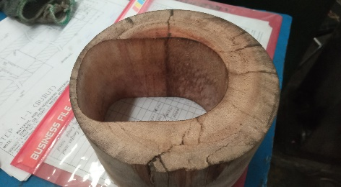
Figure 1. Geometry of wood which installed to holder

Fixed parameter that used in this experiment presented in Table 1.

Table 1. Parameters of operation double chuck
Parameters | Value
Diameter of Holder | 90 mm
Length of Overhang | 600 mm
Holder’s Material | AISI 1045
RPM | 160 rpm

For the vibration measurement, the vibrometer is placed at the top of the cylinder holder to determine vertical’s vibration of the machining process. After the reduction is finished, determine surface roughness in the inner diameter with the distance of 10 mm, 200 mm, and 400 mm from the entry holder.

3. RESULTS & DISCUSSION

Vibration is one of common phenomena in industry. It may harm the stability of structures or lead to error precision instrumentS. Vibration related to deflection, which the distribution of vibration amplitude is a form of deflection [11]. Exact equation of the deflection affected by moment force, modulus of elasticity, and cross-sectional inertia [12]. The deflection equation can be seen in equation (1).

$δ=M/{EI}$ (1)

First experiment is using a double chuck machine before the modification. The machine is set to reduce 1.5 mm in the surface on the inner diameter of the product. The insert is VNMG 160404 MH with an entry angle 45°. The clamp holder is divided into existing and new. The result of the vibration presented in Table 2. Maximum vibration and average vibration of the machine for each type of holder are the same. So, the result can be used as an initial comparison.

Table 2. Vibration of holder before modification with reduce 1.5 mm
Parameters | Maximum Vibration (m/s²) | Average Vibration (m/s²)
Existing | 0.65 | 0.21
New | 0.63 | 0.23

First modification is to increase the overhang with shortening the length of the holder from the new clamp. The material is wood and attached around the holder. The wood around the holder can be seen in Figure 2. If the length from force to clamp decreases, moment force that occurs in the holder will decrease as described in equation 2 [12]. Wood also can be used as a damping material to suppress vibrators. The insert is VNMG 160404 MH with an entry angle 45°. This experiment uses surface of inner diameter reduction of 1.5 mm and 2.5 mm to determine the effect of grinding force to the vibration of the holder.

$M=F.L$ (2)

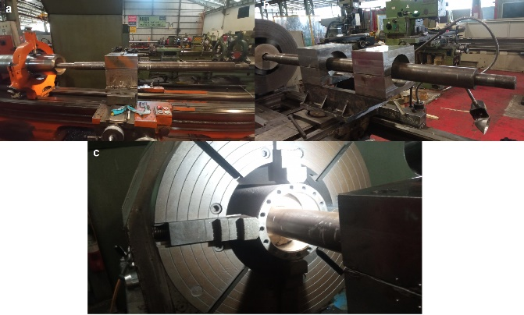
Figure 2. Variations of modification of double chuck which a. existing holder, b. new holder, and c. with wood

There is a decrease in the value of vibration of holder modification using wood as damping material. The result can be seen at Table 3. Modulus of elasticity of AISI 1045 is about 190-210 GPa and wood is about 10 GPa [13], [14]. Wood has lower modulus of elasticity than steel. Wood as damping material can suppress the vibration from average vibration about 0.21-0.23 m/s² to 0.14 m/s².
There is a different result on average vibration and maximum vibration with the different reduction on surface of inner diameter, where the higher the reduction the higher the vibration of the holder. When the reduction is higher, the force given to the holder is higher too. Force affects the moment of the holder, as in (2). Higher moments will have higher deflection, where the vibration will be higher too [15].

Table 3. Vibration of holder with wood
Parameters | Maximum Vibration (m/s²) | Average Vibration (m/s²)
Reduction 1.5 mm | 0.42 | 0.14
Reduction 2.5 mm | 0.61 | 0.22

Last modification in this experiment is to reduce the force experienced by the holder by changing the design of the entry angle to 90° which changes the insert to TNMG 160404 PM. In this modification, wood as damping material is not used. Reduction on the surface of the inner diameter uses 1.5 mm and 2.5 mm. The result can be seen at Table 4. The vibration can be reduced by changing the tool entry angle. With the entry angle of 90°, feed of materials equals the maximum thickness. Rigidity of the insert will increase with entry angle increase, however decreasing the entry angle will decrease the feed of materials [16]. Vibration decreases from 0.21-0.23 m/s to 0.10 m/s. Also, on a surface of inner diameter of 2.5 mm, vibration decreases from 0.22 m/s² to 0.15 m/s².

Table 4. Vibration of holder after changing entry angle to 90º
Parameters | Maximum Vibration (m/s²) | Average Vibration (m/s²)
Reduction 1.5 mm | 0.65 | 0.10
Reduction 2.5 mm | 0.85 | 0.15

The effect of changing the entry angle will decrease the vibration of the holder too. The comparison of the vibration for each modification can be seen in Figure 3. The wood increases the overhang and works to suppress the vibration with the lower stiffness and entry angle of 90° making the insert become more rigid.

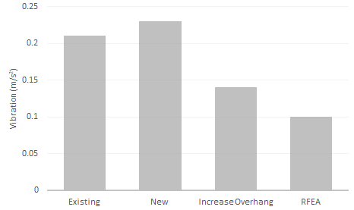
Figure 3. Comparison between holder’s vibration with 1.5 mm reduction

The vibration of the holder will affect the roughness of the surface on the inner diameter. With the reduction of surface on inner diameter of 1.5 mm, the comparison between the double check before modification and after modification has different surface roughness. After modification with wood, the surface roughness is still the same as before at 3 µm, However, the modification with changing the entry angle decreases the surface roughness than before from 2.2-3.1 µm to 1.3 µm. This result can be seen in Table 5.

Table 5. Surface roughness of inner diameter with 1.5 mm reduction
Holder | Average Roughness (µm)
Existing | 2.2
New | 3.1
Increase Overhang | 3
RFEA | 1.3

The comparison of the result can be seen in Figure 4. RFEA is the most promising result from the vibration and surface roughness. The relation for the vibration and surface roughness also proportional which the lower of vibration, the lower the surface roughness.
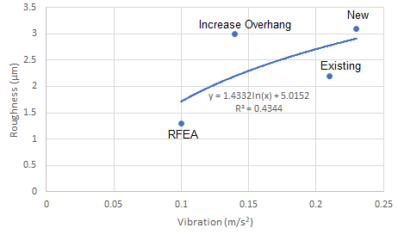
Figure 4. Comparison for each modification of holder

4. CONCLUSION

The modifications on double chuck are divided into addition of wood and changing the entry angle into 90°. With the reduction of 1.5 mm, the vibration which changes the entry angle has the highest value in decreasing from 0.21-0.23 m/s2 to 0.10 m/s2. However, addition of wood decreases the vibration from 0.21-0.23 m/s2 to 0.14 m/s2. The surface roughness for changing entry angle is decreased from before the process from 2.2-3.1 µm to 1.3 µm. The surface roughness with the reduction of 2.5 mm is still not yet determined. This will be the prospect of the development from modification of double chuck to reduce the vibration and increase the quality of surface roughness of the products at higher reduction.

REFERENCE

[1] https://www.andalanfluids.com/ (accessed Jul. 05, 2022).
[2] N. Yusup, A. M. Zain, and S. Z. M. Hashim, “Evolutionary techniques in optimizing machining parameters: Review and recent applications (2007-2011),” Expert Syst. Appl., vol. 39, no. 10, pp. 9909–9927, 2012, doi: 10.1016/j.eswa.2012.02.109.
[3] A. W. Hashmi, H. S. Mali, A. Meena, I. A. Khilji, M. F. Hashmi, and S. N. binti M. Saffe, “Machine vision for the measurement of machining parameters: A review,” Mater. Today Proc., vol. 56, pp. 1939–1946, 2022, doi: 10.1016/j.matpr.2021.11.271.
[4] W. Komatsu and K. Nakamoto, “Machining process analysis of multi-tasking machine tools based on form-shaping motions,” Precis. Eng., vol. 73, no. October 2021, pp. 332–346, 2022, doi: 10.1016/j.precisioneng.2021.10.006.
[5] X. Mu, W. Sun, C. Liu, Y. Wang, B. Yuan, and Q. Sun, “Study on rough surfaces: A novel method for high-precision simulation and interface contact performances analysis,” Precis. Eng., vol. 73, no. April 2021, pp. 11–22, 2022, doi: 10.1016/j.precisioneng.2021.08.017.
[6] H. Akkuş and H. Yaka, “Experimental and statistical investigation of the effect of cutting parameters on surface roughness, vibration and energy consumption in machining of titanium 6Al-4V ELI (grade 5) alloy,” Meas. J. Int. Meas. Confed., vol. 167, no. July 2020, 2021, doi: 10.1016/j.measurement.2020.108465.
[7] R. Chaari, M. Haddar, F. Djemal, F. Chaari, and M. Haddar, “Passive vibration absorber effect on the machining surface quality of a flexible workpiece,” Comptes Rendus - Mec., vol. 347, no. 12, pp. 903–911, 2019, doi: 10.1016/j.crme.2019.11.014.
[8] S. Sun, M. Brandt, and M. S. Dargusch, “Characteristics of cutting forces and chip formation in machining of titanium alloys,” Int. J. Mach. Tools Manuf., vol. 49, no. 7–8, pp. 561–568, 2009, doi: 10.1016/j.ijmachtools.2009.02.008.
[9] D. Yano, S. Ishikawa, K. Tanaka, and S. Kijimoto, “Vibration analysis of viscoelastic damping material attached to a cylindrical pipe by added mass and added damping,” J. Sound Vib., vol. 454, pp. 14–31, 2019, doi: 10.1016/j.jsv.2019.04.023.
[10] S. Yin and N. Rayess, “Characterization of Polymer-metal Foam Hybrids for Use in Vibration Dampening and Isolation,” Procedia Mater. Sci., vol. 4, pp. 311–316, 2014, doi: 10.1016/j.mspro.2014.07.564.
[11] Y. Sun, Z. Song, and F. Li, “Theoretical and experimental studies of an effective active vibration control method based on the deflection shape theory and optimal algorithm,” Mech. Syst. Signal Process., vol. 170, no. November 2021, p. 108650, 2022, doi: 10.1016/j.ymssp.2021.108650.
[12] R. C. HIBBELER, Mechanics of Materials, 8th ed. Pearson Prentice Hall, 2011.
[13] M. Mahendran, “The modulus of elasticity of steel - Is it 200 GPa?,” Int. Spec. Conf. Cold-Formed Steel Struct. Recent Res. Dev. Cold-Formed Steel Des. Constr., pp. 641–648, 1996.
[14] P. R. G. Hein and J. T. Lima, “Relationships between microfibril angle, modulus of elasticity and compressive strength in Eucalyptus wood,” Maderas Cienc. y Tecnol., vol. 14, no. 3, pp. 267–274, 2012, doi: 10.4067/S0718-221X2012005000002.
[15] P. Khatake and P. Nitnaware, “Vibration mitigation using passive damper in machining,” Int. J. Mod. …, vol. 3, pp. 3649–3652, 2013, [Online]. Available: http://files.figshare.com/1605801/BZ3636493652.pdf.
[16] J. Jin et al., “Magnetic-responsive CNT/chitosan composite as stabilizer and adsorbent for organic contaminants and heavy metal removal,” J. Mol. Liq., vol. 334, p. 116087, 2021, doi: 10.1016/j.molliq.2021.116087.

