Design Of Automatic Citrus Fertilizer Irrigation System Based On Photocell Timer

Yusuf Hariandi ¹, Dianta Ginting
¹ Master of Mechanical Engineering Program, Faculty of Engineering, Mercu Buana University Jakarta, 11650, Indonesia

E-mail: dianta.ginting@mercubuana.ac.id

Abstract-- Climate has a significant influence on nearly all aspects of plant growth, including that of citrus plants. To overcome the uncertain environment, a reliable irrigation system is essential in citrus gardens, with optimization achieved through the use of an automated irrigation system. The engineering of this automatic citrus garden fertilization irrigation system is carried out in groups on citrus plants using a photocell timer and PVC stop valve on each plant group path to facilitate maintenance and repairs if damage occurs to the automatic irrigation system without disrupting the main pipe irrigation system and other plant groups. This automatic irrigation system, in the driving engine and sprayer pump section, utilizes a machine and a sprayer pump with spare parts readily available in each region, thereby facilitating maintenance and repairs as needed. The machine and sprayer pump function to pump water and fertilizer that have previously been mixed in the mixing tank. Then the water and fertilizer will be distributed through the main pipe distribution line and the fertilization system pipe in groups using ½ inch PVC pipes and using a sprayer hose to the citrus trees. Engineering an automatic citrus fertilization irrigation system and processing carried out in groups on citrus plants will speed up the work of farmers in the garden, so that it can be more effective and more efficient, and save labor. | Article History:  Received: xxxx, xxx  Revised: xxxx, xxx  Accepted: xxxx, xxx  Published: xxxx, xxxx
Keywords: irrigation; photocell timer; valve PVC
This is an open access article under the CC BY-SA license


1. INTRODUCTION

Indonesia is known as an agricultural country, and most of its population works in the agricultural sector, so the majority of this population has a source of income derived from agricultural products. One of them is Simalungun Regency, where most of the population works as farmers. However, the way and pattern of work of farmers in this area still tend to be conventional by pulling the hose when spraying each orange tree and still relying on a rain-fed system that will affect planting and fertilization patterns, so that it will later affect the harvest [1].
Climate has a significant influence on almost all aspects of plant growth, including citrus [2],[3]. As one of the crops produced in the agricultural sector in the Simalungun region, North Sumatra, citrus is a green plant that requires water throughout the year, and sometimes a lack or excess of water can trigger a physiological response that allows the plant to adapt to the overall reduction in water availability [4].
Fruit size and net weight are greatly influenced by water volume. Reduced water volume tends to produce thinner skin than usual, and this may occur due to the lack of water supply that inhibits the growth of fruit skin tissue [5]. Therefore, producing optimal citrus production technology requires involvement between climate aspects, soil management, irrigation techniques, selection of plant variety seeds, and appropriate post-harvest technology on an ongoing basis [6].
Previous research from several journals related to irrigation systems, among others, includes:
Optimization of irrigation and fertigation in smart agriculture involves an internet-based automatic irrigation system, whereby farmers monitor the system via a mobile application and twin digital technology to manage water and fertilizer consumption. The system operates via the internet and pushes and pulls between the IoT and cloud services. It consists of a piezometer, temperature, soil moisture, and weather sensors [7],[8], [9], [10].
This system has weaknesses because it requires a good internet connection and infrastructure at the plantation site to operate properly. However, in the Simalungun region of North Sumatra, internet coverage is not yet widespread or comprehensive in farmers' plantations. In addition to a reliable internet connection, specialized labor and human resources with expertise in the technology of the system to be operated are required, as this system is internet-based (Internet of Things/IoT), and implementing such technology involves significant costs.
Therefore, in the automated irrigation and fertilization system for orange plantations, the technology to be developed is a system based on the use of sunlight, employing solar-powered timers. To operate it, farmers only need to ensure the availability of water and fertilizer in the mixing tank, which will be sprayed onto the orange trees in groups.
Validation of the FERTI-drip model for the evaluation and simulation of fertigation events in drip irrigation, which uses a method of water reserves entering irrigation pipes and reaching plants through several drippers. This method is used to evaluate drip irrigation fertigation systems that characterize fertilizer distribution and dynamics during irrigation activities. This drip irrigation model predicts fertilizer dosage, application time, and cleaning at the dripper level, thereby improving application efficiency and reducing issues and time management challenges. This drip irrigation system uses a low-pressure irrigation system [11], [12], [13], [14].
This system has a disadvantage in that it can only be used at low pressure. Then, water will continue to flow to the plants.
Therefore, in an automatic fertilization irrigation system for citrus orchards, the technology to be developed can also be used for spraying using a sprayer equipped with a PVC stop valve and supporting technology. It is hoped that this will simplify the maintenance of the citrus orchard fertilization irrigation system, as it is equipped with a photocell timer that can regulate the amount of water and fertilizer applied to each citrus plant. Solar-powered irrigation (SPDI) is a potential solution that can enhance sustainable agricultural productivity [15].
Based on the results of several journals reviewed, there is no irrigation system that uses photocells and PVC stop valves in groups to control the water and fertilizer sprayed onto citrus trees, presenting an opportunity to engineer an automated irrigation and fertilization system for orange trees.

2. METHODOLOGY

The development of an automatic citrus fertilization irrigation system using a photocell timer was carried out at a citrus orchard in the Simalungun area with a land area of ​​approximately 1 ha.

  - Innovation of an Automatic Citrus Fertilization Irrigation System Using a Photocell Timer
This paper aims to design an automatic irrigation system that uses a photocell timer and a PVC valve in groups of plants in a citrus orchard with a land area of ​​approximately 1 ha, and in it, there are 230-250 citrus trees.
- Mixing Tank: The material used is a 3000-liter water tank, which functions to mix water and fertilizer before being pumped into the automatic irrigation system.
- Pump Drive Engine: The type of engine used to drive the sprayer pump is a 6.5 HP gasoline type.
- Sprayer Pump: Selection of the Tanika TWN 22 brand sprayer pump, which functions to pump water and fertilizer into the main irrigation system and the group irrigation system.
- PVC Valve and Photo Cell Timer: These components are found in each group of citrus plants, and after the valve is equipped with a photocell timer in each group of plants, these two combinations of components function to regulate how long water and fertilizer are distributed to each group of plants.
- Sprayer/Sprinkle: This component functions to spray water and fertilizer onto each citrus tree.

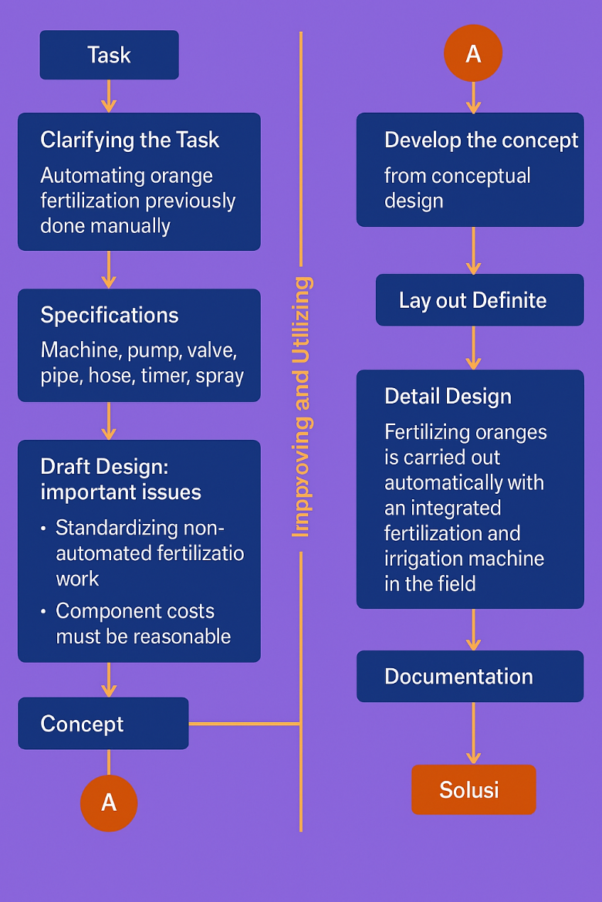

Figure 1: Flow Chart Methodology

  - Study
Conducting a Literature Review to determine the method of agricultural irrigation systems, photocell timers, and PVC valves, including their advantages, costs, efficiency, and effectiveness of operating time, which are then compared with conventional fertilization systems. Sources of information include scientific journals, technical reports, and related articles.

  - Comparison of Conventional Fertilization Time with Automatic Irrigation System Design
Conducting a comparison calculation of conventional fertilization time with automatic citrus fertilization irrigation system design using photocell timers and PVC valves in groups of plants.

Table 1. Calculation of Conventional Fertilization Time:

Number of Citrus Trees  (a) | Spraying Time  (b) | Number of Spraying Times  (c) = (a) x (b)
230 | 2 minutes | 460 minutes
7 hours and 40 minutes
(average 8 Hours)

Table 2. Fertilization Time Calculation: How to Design an Automatic Irrigation System Using Photo Cell Timer and PVC Valve in Groups of Plants:
Number of Citrus Trees in One Group | Number of Plants  (a) | Spraying Time  (b) | Number of Spraying Times  (c) = (a) x (b)
10 | 23 | 2 minutes | 46 minutes

  - Irrigation Engineering
Conducting irrigation system engineering using a photocell timer and PVC Valve in groups of plants will speed up the fertilization time of citrus trees, because watering of citrus trees is done simultaneously in a group of plants. When carrying out maintenance and repair of fertilization irrigation, the PVC valve also functions to regulate the flow of water into a group of plants and when there is damage to the irrigation of a group of plants, the PVC valve can be closed without disrupting the main irrigation line and irrigation of other groups of plants.

3. RESULTS AND DISCUSSION

  - Objective Tree

Figure 2: Objective Tree Automatic Citrus Fertilization Irrigation System

  - Function Structure

Figure 3: Function Structure of the Automatic Citrus Fertilization Irrigation System

  - Morphology Chart Irrigation System
Table 3. Morphology Chart Irrigation System :

No | Parameter / Criteria | Option 1 | Option 2 | Option 3 | Option 4
1 | Cost Estimate | Low-cost | Medium cost | High cost
2 | Choose Type of Machine | Benzine 3 HP | Benzine 4.5 HP | Benzine 6.5 HP | Diesel 10 HP
3 | Storage Fertilizer | Sump Basin 1000 liters | Tank 1000 liters | Tank 3000 liters | Tank 5000 liters
4 | How to Operate a System | Daily workers | Semi-automatic (Daily worker + system) | Automatic
5 | Implementation on the farm | Easy | Middle | Complicated
6 | Working Flexibility | Not flexible | Flexible | Complicated
7 | Selecting an alternative fertilizer channel for materials | Hose | PVC pipe  size ½ “ | Combination hose and PVC pipe
8 | Selecting a pump available in stores in the Simalungun district | Wimpro Pump Power Sprayer PSP-28 | Yamamoto Pump  YM 120-A | Sumura Pump  PS 30 | Tanika Pump  TWN-22
9 | Select Valve | Brass ball valve | PVC pipe ball valve | Digital timer valve | Selenoid water valve automatic
10 | Select Sprayer/Sprinkle | Spray stick | Flexible micro sprayer | Nozzle sprayer gun | Misting sprinkler 4 spray 4 hole

  - Specific Data for Planning an Automatic Citrus Fertilization Irrigation System

Table 4. Specification Planning Table:

No | Name | Type | Amount | Spesification | Prize | Description
1 | Land ± 1 Ha | Trees | 230 | 8 years of planting age |  | Citrus tree
2 | Storage Tank | Storage TB 5000 Litres | 1 unit | Tank | 7,799,000 | Big Capacity
 |  | or Storage TB 3000 litres | 1 unit | Tank |  | Medium Capacity
3 | Machine | Benzine 6.5 HP | 1 unit | Benzine | 3,799,000 | Medium capacity
4 | Sprayer Pump | Tanika TWN 22 | 1 unit | Sprayer Pump | 750,000 | Sprayer is available at the shop and around the farm in the Simalungun district.
5 | Valve / Control | Digital timer valve | 1 unit | Timer valve | 499,000 | Using a solar cell
6 | Sprayer / Sprinkle | Misting Sprinkle 4 hole | Pcs | Pcs | 6,500 | Required 230 x 6 pcs
7 | Alternative fertilization channels (Hose/PVC Pipe) | Tanika hose | 1 unit | 50 meters in length | 620,000 | Length as required
 |  | PVC Pipe size ½” | 1 rod | 4 meters | 26,000 | The quantity of pipe as required
 |  | Pipe and hose combination |  |  |  | Main lines using PVC pipe and for spraying citrus trees using a hose

  - Automatic Orange Fertilization Irrigation System Design Planning

Figure 4: Design of an Automatic Citrus Fertilization Irrigation System

Figure 5: Design for a Group of Plants

4. CONCLUSIONS

The use of an automatic citrus fertilization irrigation system using a photocell timer and PVC stop valve for groups of plants, can still be done in areas with limited infrastructure and resources in the area because it uses sunlight to drive the irrigation system automatically.
The citrus fertilization irrigation system for groups of plants can speed up the fertilization process carried out by farmers because fertilization is carried out together in one group of plants.
The photocell timer, as an automatic system regulator, can be set according to the needs of how long the spraying time is for the group of plants.
When carrying out maintenance and repairs in a group of plants, the PVC stop valve can close the irrigation line of that group of plants without disturbing the main irrigation line and the irrigation lines of other groups of plants.

RERERENCES
[1] A. J. Zapata-Sierra and F. Manzano-Agugliaro, “Controlled deficit irrigation for orange trees in Mediterranean countries,” J Clean Prod, vol. 162, 2017, doi: 10.1016/j.jclepro.2017.05.208.
[2] L. K. Silveira, G. C. Pavão, C. T. dos Santos Dias, J. A. Quaggio, and R. C. de M. Pires, “Deficit irrigation effect on fruit yield, quality and water use efficiency: A long-term study on Pêra-IAC sweet orange,” Agric Water Manag, vol. 231, 2020, doi: 10.1016/j.agwat.2020.106019.
[3] J. G. Pérez-Pérez, J. M. Robles, and P. Botía, “Influence of deficit irrigation in phase III of fruit growth on fruit quality in ‘lane late’ sweet orange,” Agric Water Manag, vol. 96, no. 6, pp. 969–974, Jun. 2009, doi: 10.1016/J.AGWAT.2009.01.008.
[4] S. Consoli, F. Stagno, D. Vanella, J. Boaga, G. Cassiani, and G. Roccuzzo, “Partial root-zone drying irrigation in orange orchards: Effects on water use and crop production characteristics,” European Journal of Agronomy, vol. 82, 2017, doi: 10.1016/j.eja.2016.11.001.
[5] M. T. Treeby, R. E. Henriod, K. B. Bevington, D. J. Milne, and R. Storey, “Irrigation management and rootstock effects on navel orange [Citrus sinensis (L.) Osbeck] fruit quality,” Agric Water Manag, vol. 91, no. 1–3, 2007, doi: 10.1016/j.agwat.2007.04.002.
[6] I. F. García-Tejero, V. H. Durán-Zuazo, J. Arriaga, and J. L. Muriel-Fernández, “Relationships between trunk- and fruit-diameter growths under deficit-irrigation programmes in orange trees,” Sci Hortic, vol. 133, no. 1, 2012, doi: 10.1016/j.scienta.2011.10.022.
[7] T. Adamo, D. Caivano, L. Colizzi, G. Dimauro, and E. Guerriero, “Optimization of irrigation and fertigation in smart agriculture: An IoT-based micro-services framework,” Smart Agricultural Technology, vol. 11, Aug. 2025, doi: 10.1016/j.atech.2025.100885.
[8] B. Nsoh et al., “Internet of Things-Based Automated Solutions Utilizing Machine Learning for Smart and Real-Time Irrigation Management: A Review,” Sensors, vol. 24, no. 23, p. 7480, Nov. 2024, doi: 10.3390/s24237480.
[9] P. Kalpana, L. Smitha, D. Madhavi, S. A. Nabi, G. Kalpana, and S. Kodati, “A Smart Irrigation System Using the IoT and Advanced Machine Learning Model-A Systematic Literature Review,” Oct. 02, 2024, Prof.Dr. İskender AKKURT. doi: 10.22399/ijcesen.526.
[10] A. El Mezouari, A. El Fazziki, and M. Sadgal, “Smart Irrigation System,” IFAC-PapersOnLine, vol. 55, no. 10, pp. 3298–3303, Jan. 2022, doi: 10.1016/J.IFACOL.2022.10.125.
[11] M. Morcillo, M. Á. Moreno, R. Ballesteros, R. Arias, and J. F. Ortega, “Validation of the FERTI-drip model for the evaluation and simulation of fertigation events in drip irrigation,” Smart Agricultural Technology, vol. 10, Mar. 2025, doi: 10.1016/j.atech.2025.100803.
[12] S. Xing et al., “Effect of dynamic pressure and emitter type on irrigation and fertigation uniformity of drip irrigation systems,” Agric Water Manag, vol. 312, p. 109418, May 2025, doi: 10.1016/J.AGWAT.2025.109418.
[13] J. Patel, A. Dubey, A. Singh, and B. Mathew, “Automatic Drip Irrigation using IoT and Machine Learning,” International Journal for Research in Engineering Application & Management (IJREAM), vol. 07, p. 2, 2021, doi: 10.35291/2454-9150.2021.0222.
[14] D. Bhavsar, B. Limbasia, Y. Mori, M. Imtiyazali Aglodiya, and M. Shah, “A comprehensive and systematic study in smart drip and sprinkler irrigation systems,” Smart Agricultural Technology, vol. 5, Oct. 2023, doi: 10.1016/j.atech.2023.100303.
[15] C. Sheline, F. Grant, S. Gelmini, S. Pratt, and A. G. Winter V., “Designing a predictive optimal water and energy irrigation (POWEIr) controller for solar-powered drip irrigation systems in resource-constrained contexts,” Appl Energy, vol. 377, Jan. 2025, doi: 10.1016/j.apenergy.2024.124107.

