 Translated from Indonesian to English - www.onlinedoctranslator.com
INTERPERSONAL APPRAISAL COMMUNICATION STRATEGY IN IMPROVING SERVICE QUALITY
(Case Study BRI Regional Jakarta 1)

Kristyawan
Mercu Buana University
kristyawankristyawan68399@gmail.com

Afdal Makkuraga Putra
Mercu Buana University
afdal.makkuraga@mercubuana.ac.id

Abstract

The development and growth of housing loans (KPR), especially at BRI, is very fast, so qualified collateral appraisal is needed. Much research has been done on interpersonal communication strategies. The implementation of an interpersonal communication strategy that is not yet optimal and the quality of the appraisal staff that has not been achieved at the BRI Regional Office Jakarta 1 Consumer Loan Factory (CLF) form the basis of this research. As the main theoretical foundation of this research, social exchange theory and DeVito's interpersonal communication theory are used to provide more operational dimensions in viewing the structure of social exchange. The research objective to be achieved is to determine interpersonal appraisal communication strategies in improving service quality. In this study, researchers used a qualitative method (Case Study). Researchers use the constructivist paradigm as a structure of thought. The results in this study show that communication carried out by an BRI appraisal takes place in two directions and vice versa. Communication carried out by an appraisal has an influence on improving the quality of services performed. Appraisal is an official who is responsible for evaluating credit collateral and monitoring other matters related to collateral. The strategies undertaken include prudent, maneuverable, accurate. Communication carried out by an appraisal has an influence on improving the quality of services performed. Appraisal is an official who is responsible for evaluating credit collateral and monitoring other matters related to collateral. The strategies undertaken include prudent, maneuverable, accurate. Communication carried out by an appraisal has an influence on improving the quality of services performed. Appraisal is an official who is responsible for evaluating credit collateral and monitoring other matters related to collateral. The strategies undertaken include prudent, maneuverable, accurate.

Keywords: Interpersonal communication strategy, Appraisal, Service quality, Social exchange, Case study.

PRELIMINARY

In this case the quality of an appraisal worker is needed, especially in terms of communicating with other people. Interpersonal communication is the process of exchanging information or communication that is carried out by two people directly so that the communicant can see the impact and reactions given by the interlocutor verbally and nonverbally. The research objective to be achieved is to determine interpersonal appraisal communication strategies in improving service quality.

LITERATURE REVIEW
Much research has been done on interpersonal communication strategies. Each researcher departs from a different focus. This study aims to compare the realities in the field with relevant theories, the research approach used in this study is based on previous research. Dwiyan Asgarwijaya (2015) entitled “Interpersonal communication strategies between PAUD teachers and students (descriptive study of interpersonal communication between teachers and students of Tunas Laut PAUD in teaching and learning activities). The aim of this study was to determine interpersonal communication strategies between teachers and early childhood students in learning activities teach class. Rahmat Aulia, Ade irma (2017) entitled “Interpersonal communication strategies of parents and children in increasing the self-confidence of children with disabilities” supporters and obstacles faced by parents in increasing the self-confidence of children with disabilities in the mentally retarded category. Hikmah eva trisnantari, Prim masrokan mutohar, and Sulastri rini rindrayani (2019) Journal title "Management of improving the quality of character-based learning with a full day school system (FDS)". This study aims to describe the management of improving the quality of character-based learning with the full day school (FDS) system.
Interpersonal Communication
According to Joseph De Vito, in his book The interpersonal communication book (Devito, 1989:4), interpersonal communication is a process of sending and receiving messages between two people or between a small group of people with some effects and some feedback (the process of sending and receiving messages between two persons or among a small group of persons, with effect and some immediate feedback). Interpersonal communication according to Hardjana (2003: 85) is face-to-face interaction between two people or several people, and the sender of the message can convey the message directly while the recipient of the message can receive the message directly. Effective communication is communication that causes certain effects in accordance with the goals expected by the communicator.
Interpersonal Communication Models
In the process of interpersonal communication or interpersonal communication the flow of communication that occurs is circular or rotating, meaning that each individual has the same opportunity to become a communicator and communicant. Because in interpersonal communication effects or feedback can occur instantly.
Devito Interpersonal Communication Model Chart
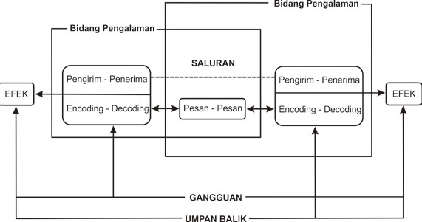

Definition of Communication Strategy
An understanding of a strategy is an idea or conception, in which these ideas or conceptions are used as standards and boundaries for steps. The word strategy itself comes from the Greek word "stratos" which means army and the word "agein" which means leader (Cangara, 2013:61). But here what is meant is not the strategy that is used to draw up forces for war or to fight the enemy, but the strategy here that is meant is a plan, method, tactic, or strategy so that the communication conveyed by the communicator to the listener can be well received (Cangara, 2013: 61) . Meanwhile, according to Anwar Arifin in the book "Communication Strategy" (1984: 10) states that: In fact, a strategy is a whole conditional decision about the actions to be carried out, in order to achieve goals.
Social Exchange Theory (Social exchange)
As the main theoretical foundation of this research, social exchange theory is used. However, in this study the authors also try to combine social exchange theory with DeVito's interpersonal communication theory to provide more operational dimensions in viewing the structure of social exchange. The structure of social exchange according to West is based on the idea that people view their relationship in an economic context and they calculate the sacrifices and compare them with the rewards obtained by continuing the relationship (West & H. Turner 2011: 216). The notion of sacrifice is an element of a relationship that has a negative value for someone (West & H. Turner 2011: 216).
Appraisal Review
appraisalaccording to the meaning of the word in the Indonesian - English dictionary is an assessment or assessment (Baedowi, 2016). Appraisal also has the meaning of the work process of an appraiser (appraiser) to provide estimates and opinions on the economic value of an object of appraisal at a certain time in accordance with Indonesian appraisal standards (SPI) and applicable regulations (SPI, 2015: KEPI 3.7.2) . The Indonesian Appraisal Standards Committee (KPSPI) will continue to prepare new standards or revise old standards according to developments in market needs or users of appraisal services and the needs of the appraisal profession (SPI, 2015). Appraiser is responsible for the appraisal of a project. They estimate the market value of the property and prepare a formal document called an appraisal document. Valuation documents can be used to estimate property values ​​before and after development. The Ministry of Finance has ordered appraisers to work on most of the projects that the state has to permit and approve, thus ensuring tighter state control over appraisers. Therefore, it is very important that appraiser education in Indonesia is coordinated by MAPPI (Indonesian Appraiser Profession Society).
Quality Concept
At the abstract level, quality has been defined by two important experts in the field of quality, namely Joseph Juran and Edward Deming. Both of them have succeeded in making quality a mindset that continues to grow in management studies, especially quality management (Juran and Deming, 1998). According to Juran (1998), quality is fitness for use, this means that a product or service should be in accordance with what is required or expected by the user.

RESEARCH METHODS
In this study, researchers used a constructivist paradigm as a structure of thought. The constructivist paradigm is a paradigm that holds that knowledge is not only the result of experience with facts, but also the result of the construction of the subject's thoughts under study (Wibowo, 2011: 5).This research is used to find out how interpersonal appraisal communication strategies are in improving service quality (Case Study BRI Kanwil Jakarta 1).In this study, researchers used qualitative methods (case study). This study uses qualitative research methods as an approach to gain an understanding of the phenomena and cases that the researcher has chosen. Qualitative research does not prioritize the size of the population or informants, even the population and informants taken are very limited, because they are focused on problems that have been determined by the researcher. Qualitative research aims to describe and summarize various conditions, phenomena, and social realities that exist in the educational environment which is the object of research

RESEARCH RESULTS AND DISCUSSION
Along with the intense business competition related to the development of financial technology (fintech) where BRI has responded by compiling several strategic initiatives and implementing BRIVolution 2022, it is necessary to re-design the property ownership credit business process, especially in providing convenience to the public and customers in get BRI property ownership credit (KPP) services that are fast, easy, informative and profitable. In response to this, the office transformation team has prepared business process changes for property ownership credit services, from the original decentralization pattern to a centralized pattern with the Consumer Loan Factory (CLF) system. Besides that, the office transformation team has also carried out Design Clinic I and Design Clinic II with related work units and divisions in formulating an ideal business process design in property credit services. All BRI branch offices can serve and market BRI property ownership loans (KPP). The function of BRI branch offices is as a marketing network for BRI consumer loans. The process of granting KPP BRI (initiative, pre-screening, review, analysis and decision) is carried out digitally through a (paperless) system. BRI's property ownership credit (KPP) process uses the Consumer Loan Factory (CLF) concept where the credit analysis and decision process is carried out centrally by work units under the regional/regional office. In its implementation, the work unit/Kanca functions as the initiator, recommendation, disbursement, work unit. and credit documentation so that the current centralization of the credit process does not eliminate the function and advantages of BRI's work unit network which has been widespread as the initiating work unit. Meanwhile, the Consumer Loan Factory (CLF) functions as a work unit that specifically performs credit analysis, both collateral and financial, and provides credit decisions. This aims to increase mortgage productivity in work units while maintaining credit quality. The stages of the KPP BRI credit granting process can be monitored through the system, both carried out by authorized officials and by customers through application status tracking. Meanwhile, the Consumer Loan Factory (CLF) functions as a work unit that specifically performs credit analysis, both collateral and financial, and provides credit decisions. This aims to increase mortgage productivity in work units while maintaining credit quality. The stages of the KPP BRI credit granting process can be monitored through the system, both carried out by authorized officials and by customers through application status tracking. Meanwhile, the Consumer Loan Factory (CLF) functions as a work unit that specifically performs credit analysis, both collateral and financial, and provides credit decisions. This aims to increase mortgage productivity in work units while maintaining credit quality. The stages of the KPP BRI credit granting process can be monitored through the system, both carried out by authorized officials and by customers through application status tracking.

ORGANIZATIONAL STRUCTURE
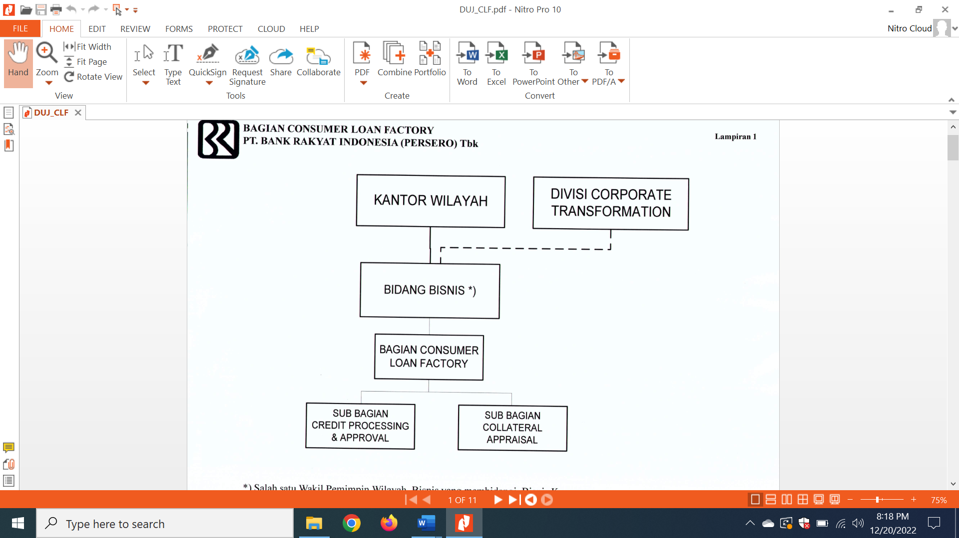

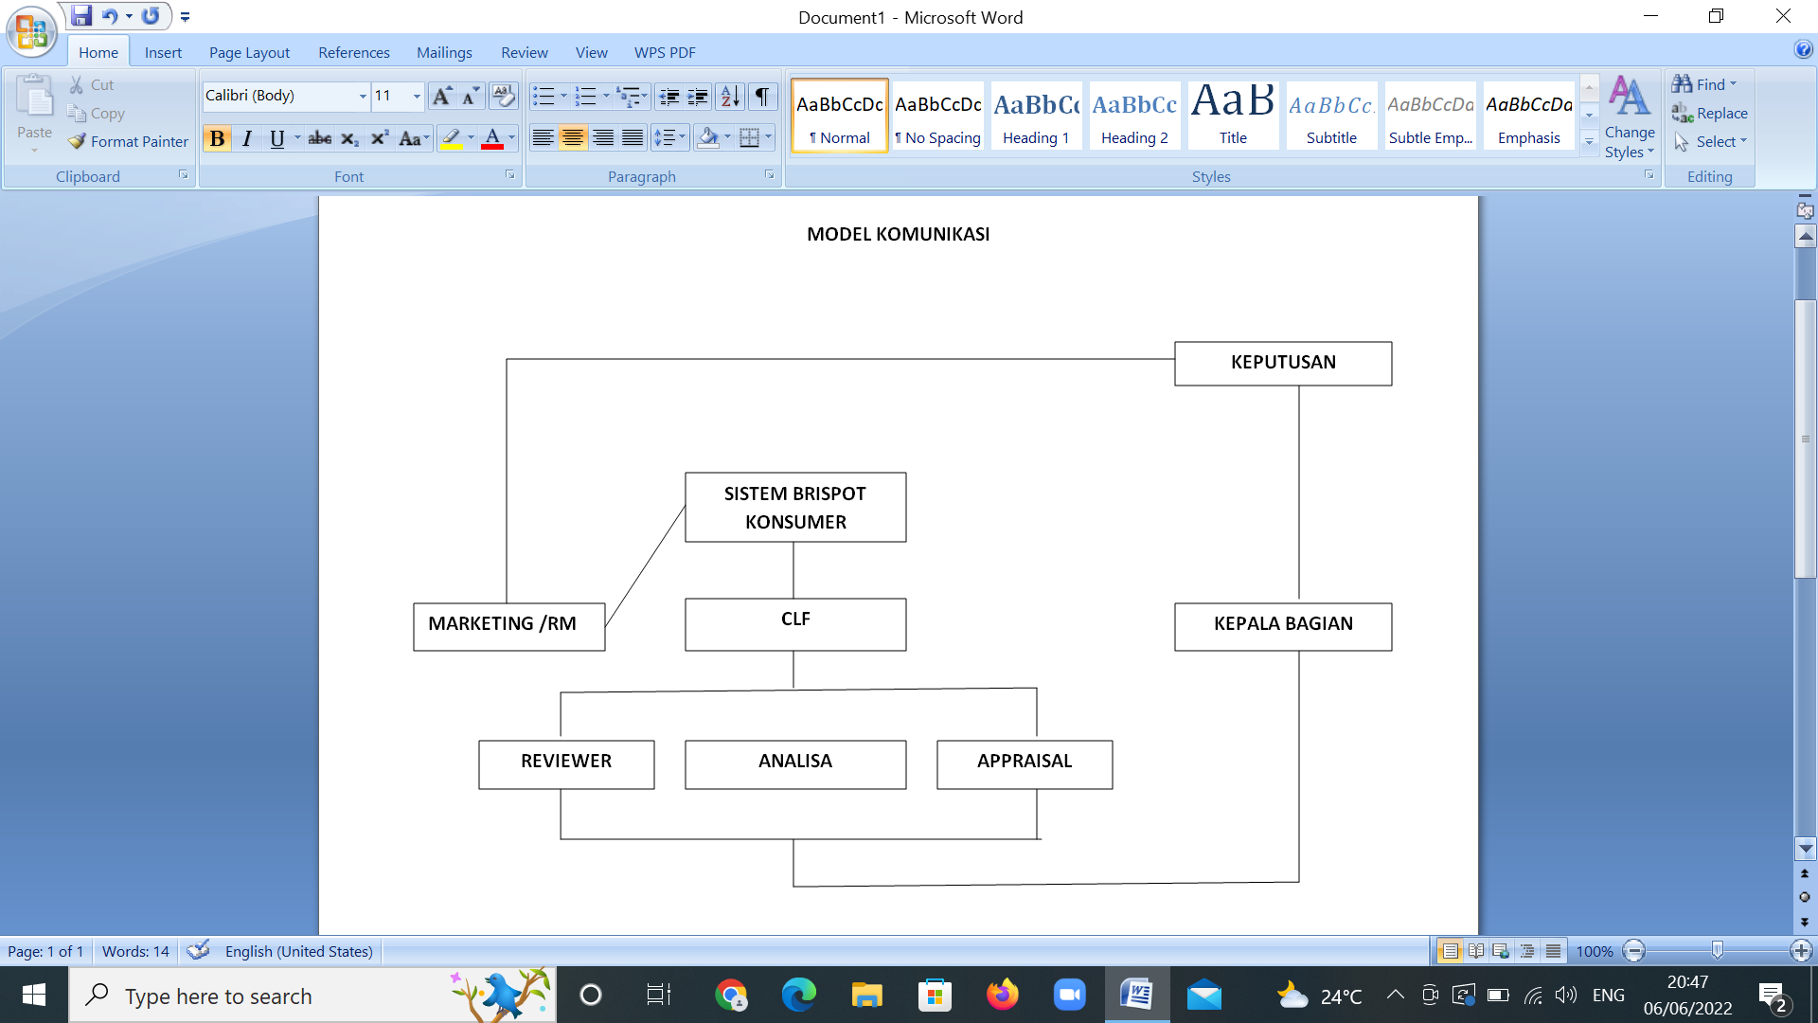
The valuation of credit collateral can be assessed using existing methods and methods, to produce a fair and accountable value. Assessment of credit collateral must be carried out objectively, honestly, responsibly and present a fair value. The collateral valuation method is a way of evaluating credit collateral systematically and producing a value that is closest to the truth about the fair market value (economic value, not book value) of the related collateral. Approach methods that can be used by appraisers in assessing collateral are as follows: market data approach, cost approach, income approach. The collateral appraiser is fully responsible for the results of the appraisal carried out. From the research results obtained from various sources including interviews, observations and existing sources both written and non-written, the Consumer Loan Factory (CLF) functions as a work unit that specifically performs credit analysis both collateral and financial and provides credit decisions. This aims to increase mortgage productivity in work units while maintaining credit quality.
"The formation of CLF is based on the evaluation and quality of consumer credit which is felt to be able to be improved further in terms of sales or in terms of credit quality, from the sales side it is hoped that RM will focus on marketing and acquiring prospective new debtors, while the processing is carried out by a different organization, here CLF's organizational form is not the same as Monoline where CLF's organization of marketing and acquisition credit initiatives is carried out by RM located in each branch office, while for the processing itself, from the analysis of collateral assessment and up to a credit decision, it is under the Regional Office, CLF is responsible for under the head office in the CLSD division. On a daily basis, CLF is under the monitoring of the Regional CEO and Consumer Banking Head,the intention is for RM to focus on marketing while being analyzed and the decision at CLF is only processing."(Interview with Mr Hrdiyanto, 2 September 2022).
The visible communication or communication model is when an RM (Relation Manager/Marketing) submits data through the consumer brispot application, the prospective KPR customer, the data is then received by CLF (Consumer Loan Factory) and received by the Deputy Head of Department, then the job is positioned to the appraisal and analysis section , in this case the appraisal is to conduct collateral appraisal and the analyst is to carry out financial analysis, then the results of the collateral appraisal and financial analysis produce a mortgage assessment which will later be used as a credit decision which will be decided by the head of the CLF section, while the process is being carried out a review of the correctness of the data by new reviewer officer KPR decision is produced and ready to be realized at the initiating branch.
"In the process, we usually get an assessment disposition directly from the Department head which is divided into Collateral Appraisals. The first time we do this is to confirm with the seller or directly with the prospective debtor to find out where the location is, then we first check whether the documents that are usually We ask whether it has been completed or not such as Certificates, IMB and PBB, after we check and confirm with the prospective buyer/seller/prospective debtor then we determine the schedule for us to survey On The Spot to the location "
(Interview with Mr. Didit Kurniawan, 8 June 2022)
For the appraisal process itself, when an appraiser gets a job disposition that can be accessed through the KPR application, namely consumer brispot, an appraiser then gets data such as copies of certificates, imb and pbb that have been uploaded by RM into the consumer brispot system, besides that the appraisal also gets data information prospective KPR consumer customers from the application which contains detailed customer data from telephone number to address
"Actually the communication was not carried out directly to Marketing / RM but the communication started with prospective debtors / sellers / buyers / property agents where the appraisal made a direct visit schedule according to the data on the brispot application, but the problem is that almost some of the data listed is not valid, for example no the prospective debtor's phone is not listed or the number is inactive or cannot be contacted so that communication is often interrupted and finally a Collateral Appraisal asks for confirmation from Marketing (RM) of each branch according to what is stated on the consumer brispot application.(Interview with Mr. Didit Kurniawan, 8 June 2022).
Appraisal communicates in two directions to the prospective customer to make a visit schedule when it can be visited, after making an appointment and the agreed time.
“Just helping to make an appointment between Appraisal and prospective Debtor/Seller/buyer/Property Agent and help support complete documents. Most Marketing (RM) are lazy to tidy up documents that will be submitted to the brispot application so that it seems random."(Interview with Ms. Fina Ferdyana, 2 June 2022).

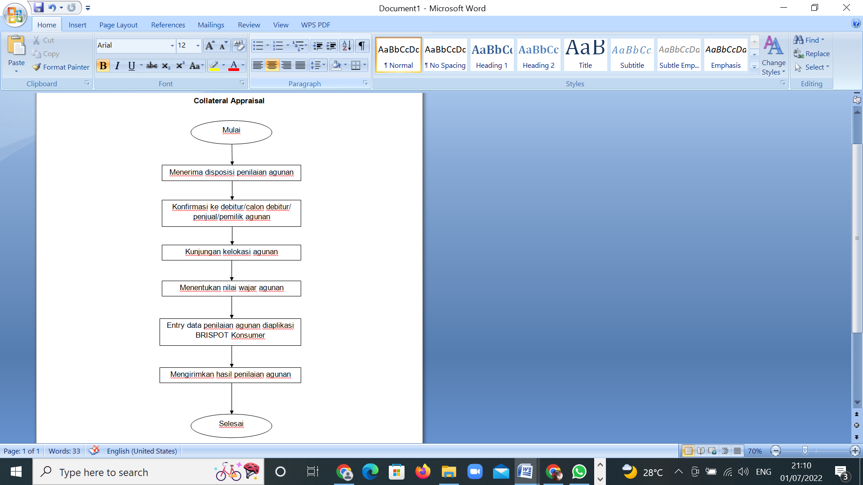
After all the processes are carried out by a collateral appraisal then formulate an assessment fairly by means of a minimum comparison that is used is a comparison with the three collateral values ​​around the location usually obtained from on the spot field or comparison from the internet which was explained by Mr Didit from the results of the interview with the author. After the assessment or the results obtained, it was then entered into the consumer strategy Brispot application, which was carried out by Mr. Hardi as the head of the CLF section, including approaching friends in the work unit about what needed to be repaired at CLF Jakarta 1, both from collateral appraisal and from a credit analyst perspective, the strategy is only 1 to improve how to become the best CLF, CLF performance depends on friends at the branch office by establishing effective and efficient communication at the branch with marketing (RM) and consumer banking managers (CBM) as well as educating marketing friends (RM) so that any documents submitted, especially the collateral already the standard required by a collateral appraisal in conducting an assessment. One form of establishing communication as well as an evaluation which was carried out on Thursday 9 September 2022 in the Simpedes regional Jakarta 1 room with RM, CBM, collateral appraisal, rivewer, analyst, deputy and head of department, regional CEO, regional head.

DISCUSSION
Communication carried out at CLF (Consumer Loan Factory), namely communication carried out in two directions, including from marketing representing branches and CLF (analyst, reviewer and appraisal), this communication is established through digital media in the form of an application called consumer Brispot. Of course, this communication has experienced many special problems in conveying wishes that are not in accordance with what the marketing (branch office) wants without maximum confirmation. This is due to the lack of intensity carried out by each part, both from the branch office and the CLF itself, of course, this causes differences in perceptions, including poor communication. In this case, specifically in the Appraisal section, where the communication formed between the appraisal and marketing (RM) seems to be quite intensive in relation to the valuation of collateral. Communication that is carried out when an appraiser gets a job disposition/appraisal from a superior, in this case the head of a section, this communication is formed when an appraiser opens the consumer brispot application which contains a job message that must be assessed according to what is written on the application. Job dispositions are usually given in the morning through the consumer brispot application, then an appraisal makes an appointment on the same day for a visit to the location of the prospective borrower's collateral if it can be visited that day, but if it cannot be visited that day, a visit is scheduled according to the agreement.In the communication that takes place at the CLF (Consumer Loan Factory) usually the miscommunication that is formed arises from marketing (RM) and collateral appraisal because the communication that takes place usually only through communication is not carried out directly so that the perception or message conveyed is sometimes not captured properly , when a miscommunication occurs at that time it can also be resolved, this is where the difference in communication is carried out directly or indirectly. Appraisal can be considered as the recipient of the message as well as the sender of the message, for the recipient of the message usually gets a job disposition given by the head of section and deputy head of section, as a messenger usually communicates or schedules visits with prospective debtors/sellers/buyers/agents, The communication that is formed must be clear, for example in receiving input from superiors or communicating with RM so as not to cause miscommunication or misperceptions, for example in conveying appraisal results and doing work quickly and accurately without delaying work. In addition, communicating messages to prospective debtors must also be careful. Be careful not to offend with the words that we sometimes do over the telephone because there are lots of distractions, for example when we talk, the sound is intermittent, the signal sometimes disappears. The competence of an appraiser is obtained from the experience carried out, the more often you do the appraisal the more experience you get, In this case, according to Mr. Didit Kurniawan as the BRI appraisal for the Jakarta 1 regional office, the average appraisal here has experience in conducting an assessment, meaning that their flying hours are almost average, they are good, more or less their experience is over 3 years, competence is no doubt. . In the process of activities at CLF, especially activities carried out by an appraiser using message media through an application called the Consumer Brispot application, besides that, face-to-face with prospective buyers/sellers/agents, sometimes directly communicating with marketing or RM to confirm submitted documents or Make appointments to visit prospective customers. For feedback on an appraisal, it usually comes from the response to the form of communication that is formed, for example when making a visit schedule with a quick response, sometimes waiting for confirmation from the prospective debtor, this feedback is in the form of a response to a visit to the collateral location. Disturbances in communication are unavoidable, The direct impact of communication that can be felt at the Consumer Loan Factory itself is from a marketing perspective where they have different knowledge, for example marketing with more than one year of service, usually the way to communicate is better than marketing whose working period is under one year or less. contract because it still requires more work experience and less communication methods in dealing with technical problems both in terms of sending messages or receiving messages. From an appraisal point of view, it also has an impact in terms of ability in the field in terms of assessing, the more assessments are carried out, the more new experiences and cases are obtained and how to analyze the field to provide an assessment as well as analysts and reviewers.

CONCLUSION
Based on the results of the research and discussion regarding the interpersonal appraisal communication strategy in improving service quality (Case Study of the BRI Regional Jakarta 1), the researchers draw the conclusion that:
- Communication carried out by a BRI appraisal takes place in two directions and vice versa, the communication is formed from messages received through the consumer Brispot application which are inputted by a marketing then positioned by the section head to the appraisal to carry out a collateral appraisal then an appraiser makes a report and sends back the results report to the head of section for approval and the results of the approval are returned to marketing in the form of a collateral valuation decision. Communication carried out by an appraisal has an influence on improving the quality of services performed.
- Appraisal is an official who is responsible for evaluating credit collateral and monitoring other matters related to collateral. Communications made related to services both internally and externally include good communication with department heads and representatives, credit analysts, reviewers, marketing, prospective debtors, property agents, buyers and sellers.
- The communication strategy undertaken includes: approaching marketing friends, one of which is by visiting branches to conduct coaching and education as well as holding events/gathering marketing friends at the branch, apart from providing information, they also evaluate the performance of each marketing. Prudent (Selective for several incoming mortgage applications by working carefully and quickly, responding to problems dynamically as a support for business processes, maintaining credit with low DPK and zero NPL). Maneuverable (help accelerate support business processes, synergize with developers with the 1 day approval program, provide a target of 3 credit decisions every day). Accurate (target achieved and credit quality can be maintained properly).

REFERENCES

Asgarwijaya, D. (2015). Interpersonal Communication Strategy Between Teachers and Students of PAUD (Descriptive Study of Interpersonal Communication Between Teachers and Students of PAUD Tunas Bahari in Teaching and Learning Activities). E-Proceedings of Management, 2(1), 1008–1027.
Aulia, R., & Irma, A. (2017). Interpersonal communication strategies between parents and children in increasing the self-confidence of children with disabilities. Unsyiah FISIP Student Scientific Journal, 1(1), 1–7. http://www.jim.unsyiah.ac.id/FISIP/article/download/2313/1148
Language, J., Saniah, S., & Bakar, A. (2017). Interpersonal Communication of Language Teachers in Germany Interpersonal Communication of Language Teachers in Germany Keywords: interpersonal communication; teacher communication; Malay language ; language class discourse; The Politeness Principle of Leeches Plays a very important role. 17(2), 245–262.
Garvin. (1995). Quality Quality Concept. 5–21.
González Alafita, ME (2019). Interpersonal Communication in Dual Income Couples: Challenges and Strategies of Mexican Women to communicate with their partners. 1(September), 3–12.
Hunuganahalli Paramesh, A., Samartha, V., Thekkekutt Mathukutti, R., & Hawaldar, IT (2020). Manifestation of idiosyncratic rater effect in employee performance appraisal. Problems and Perspectives in Management, 18(3), 224–232. https://doi.org/10.21511/ppm.18(3).2020.19
Ruiz Moral, R., García De Leonardo, C., Cerro Pérez, A., Caballero Martínez, F., & Monge Martín, D. (2020). Barriers to teaching communication skills in Spanish medical schools: A qualitative study with academic leaders. BMC Medical Education, 20(1), 1–10. https://doi.org/10.1186/s12909-020-1944-9
Strumska-cylwik, L. (2014). Expression of Fear and Anger in the Context of. 7(1), 173–200.
Subhan AB, VSH (2020). TEACHER INTERPERSONAL COMMUNICATION STRATEGY IN IMPROVING THE PERSONALITY DEVELOPMENT OF CHILDREN WITH DISABILITIES Descriptive Study at SLB Qalbun Insanni, Celala District, Central Aceh District. Journal of Journalism, 9(1), 109–134. https://ojs.unimal.ac.id/jurnalism/article/view/3102
Trisnantari, HE, Mutohar, PM, & Rindrayani, SR (2019). Character-Based Learning Quality Improvement Management With Full Day School (Fds) System. Journal of Character Education, 1, 116–132.
(Trisnantari et al., 2019)

(Asgarwijaya, 2015)Alafita, G., & Eugenia, M. (nd). Interpersonal Communication in Dual- Income Couples : Challenges and Strategies of Mexican Women to communicate with their partners C OUPLES : C HALLENGES AND S TRATEGIES OF M EXICAN.
Hafner, J., & Krajnc, M. (nd). Comparison of Interpersonal Communication and Interpersonal Relationship Between Early Years Educators and Children in Selected English and Slovenian Nurseries.
Hunuganahalli Paramesh, A., Samartha, V., Thekkekutt Mathukutti, R., & Hawaldar, IT (2020). Manifestation of idiosyncratic rater effect in employee performance appraisal. Problems and Perspectives in Management, 18(3), 224–232. https://doi.org/10.21511/ppm.18(3).2020.19
Koponen, J., Julkunen, S., Gabrielsson, M., & Pullins, EB (2021). An intercultural, interpersonal relationship development framework. International Marketing Reviews. https://doi.org/10.1108/IMR-11-2019-0267
Susanti, MS, Prakoso, CT, & Rifayanti, R. (2018). Therapist Interpersonal Communication Strategy with Parents of Children with Special Needs at Jayamatja Clinic Samarinda. World of Communication: Journal of Communication Studies, University of Mulawarman, 6(3), 688–702.
Trisnantari, HE, Mutohar, PM, & Rindrayani, SR (2019). Character-Based Learning Quality Improvement Management With Full Day School (Fds) System. Journal of Character Education, 1, 116–132.

